Deep learning- Fashion MNIST

**Describe in the readme file how to train each setting, and how to test it**

**with the saved weights.**

We implemented the Fashion MNIST by Google COLAB. In order to run the model for training and evaluation, press Cntrl+ F9 . In the Moodle website we submitted our training and evaluation results in PDF format .

For each one of the settings we wrote a model and we ran each of the models separately. After obtaining the results we printed a table which summarizes the accuracy of the models.

* In order to train each model, we implemented a sequential architecture for each one of the following models:

- “Regular” model without additional techniques

- model_Dropout

- model_WD

- model_BN

* In the next step, in order to fit x and y of the train dataset and the test dataset, we used the model.fit() function. During the execution of each epoch by the fit() function, we printed the accuracies by implementing the parameter verbose=1.
* In the final step, we presented the accuracies curves of each model by a plot and summary via table:

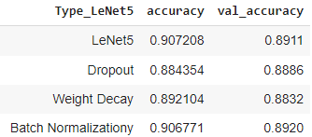

We notice that all the test accuracies are at list 88% and they are approximately equal.