COMMUNITY HEALTH OUTREACH REPORT
Knowledge, Attitude, and Preventive Practices Regarding Malaria
Madi Community, Ilorin — 20 December 2025
A KAP cross-sectional survey | N = 122 respondents

Executive Summary
This report analyses 122 valid responses from a malaria Knowledge, Attitude and Preventive Practices (KAP) survey. The headline finding is a pronounced knowledge–practice gap: community members understand malaria well and hold positive attitudes, yet protective behaviours remain weak.
Domain | “Good” level | Interpretation
Knowledge | 86.9% | Strong – most know mosquitoes cause/transmit malaria
Attitude | 76.2% | Positive – malaria seen as serious & preventable
Practice | 3.3% | Critical weakness – protective behaviour rarely adopted

Bottom line: Education alone is not the bottleneck. The intervention priority is converting existing knowledge into consistent action – chiefly nightly net use, environmental management of stagnant water, and discouraging self-medication.

1. Background & Methods
A cross-sectional KAP survey was administered via Google Forms during a one-day community health outreach in Madi Community, Ilorin, on 20 December 2025. Responses were anonymous and collected for research purposes only.
- Design: Cross-sectional, self-/interviewer-administered questionnaire.
- Sample: 122 community members (convenience sample).
- Domains: Socio-demographics; Knowledge (5 items); Attitude (4 items); Preventive Practices (3 items); optional malaria RDT result.
- Scoring: Each correct/positive response = 1 point. Bloom’s cut-offs applied: Good ≥ 80%, Moderate 60–79%, Poor < 60%.

Data Cleaning Performed
Before analysis the raw export was cleaned to senior-analyst standard:
- Age: 60+ entries had birth years (e.g. 1980, 2007) instead of ages; these were converted to age = 2025 − birth-year, and impossible values removed.
- Occupation/text fields: trailing spaces stripped, casing standardised, and typographic duplicates merged (e.g. “Hair deesser”/“Hair dersser” → “Hair dresser”; “Nill” → missing).
- A blank trailing column (“Option 1”) carrying no information was removed.
- Optional RDT blanks were recoded as “Not Tested” rather than treated as missing.

2. Respondent Profile
Characteristic | Category | n (%)
Sex | Female | 76 (62.3%)
 | Male | 46 (37.7%)
Marital status | Married | 103 (84.4%)
 | Single | 19 (15.6%)
Education | Tertiary | 49 (40.2%)
 | Secondary | 47 (38.5%)
 | Primary | 14 (11.5%)
 | No formal education | 11 (9.0%)
Age | Mean (SD) | 37.5 (15.2) years

3. Key Findings

3.1 Knowledge – strong
Knowledge of malaria aetiology was high: 90% correctly identified the mosquito bite as the cause and 91% as the route of transmission. 87% correctly affirmed that insecticide-treated nets prevent malaria. Only a small minority answered “Don’t know” across knowledge items.

3.2 Attitude – positive
Attitudes were favourable: 92% agreed malaria is a serious illness, 97% agreed early treatment is important, and 90% agreed prevention is a shared responsibility. A notable 12% preferred not to use a health facility for symptoms, hinting at a care-seeking weak spot.

3.3 Practice – the critical gap
Despite strong knowledge, protective practice collapsed. This disconnect is the central public-health concern of the survey:
Behaviour | Performing it | Gap vs knowledge
Know nets prevent malaria | 92.6% | — (reference)
Actually sleep under net every night | 27.9% | − 64.7 pts
Clear stagnant water around home | 18.9% | Major environmental risk
First fever action: self-medicate at chemist | 45.9% | Delays proper diagnosis
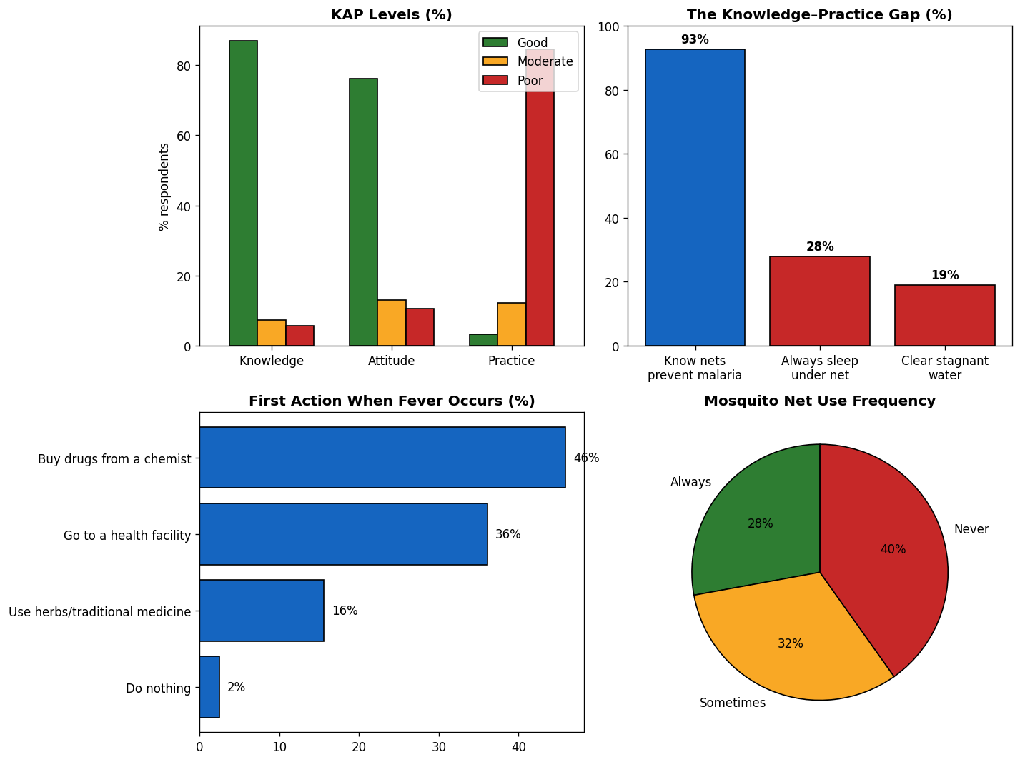
Figure 1. KAP levels, the knowledge–practice gap, fever-response behaviour, and net-use frequency.

3.4 Statistical associations
- Education vs Knowledge level: χ² = 6.24, df = 6, p = 0.40 — no significant association; knowledge was high across all education groups.
- Education vs Practice level: χ² = 7.97, df = 6, p = 0.24 — not significant; poor practice cut across all groups.
- Knowledge score vs Practice score: Spearman ρ = 0.16, p = 0.08 — only a weak, non-significant correlation, confirming that knowing more did not translate into doing more.
Consultant note: The absence of an education or knowledge gradient on practice is itself the key insight – behaviour-change barriers here are structural/motivational (access, cost, habit), not informational.

3.5 Malaria RDT (optional)
Of 122 respondents, 62 underwent a Rapid Diagnostic Test; all 62 returned negative results, consistent with a dry-season, low-transmission survey context. 60 declined the optional test.

4. Recommendations
Interventions should target the conversion of knowledge into practice rather than basic awareness:
- Net-use behaviour change: pair net distribution with hang-up demonstrations and follow-up reminders; address reasons for non-use (heat, discomfort, perceived low risk in dry season).
- Environmental management: community clean-up campaigns focused on clearing stagnant water, since only ~19% currently do so.
- Care-seeking: discourage chemist self-medication as a first response; promote testing-before-treatment and facility/RDT use, given ~46% self-medicate first.
- Targeting: deliver uniformly across education levels – the data show no group is protected by education alone.
- Monitoring: repeat the KAP survey in wet season to capture transmission-period behaviour and measure intervention impact.

5. Limitations
- Convenience sample from a single community and single day – not generalisable to all of Ilorin.
- Self-reported practices may be over-stated (social-desirability bias).
- Dry-season timing likely lowers both RDT positivity and perceived urgency of net use.
- Age field required reconstruction for ~50% of records; treat age estimates as approximate.
Prepared by HayMedics Academy as a biostatistical & public-health analysis of the Madi Community malaria KAP outreach. Cleaned dataset supplied separately (Malaria_KAP_Cleaned.xlsx).

