Hayden Ross and Ashley Scappaticci

Introduction to Computer Programming

J.F Briere, Jonathon Sumner, Sameer Bhatnagar

May 22nd, 2019

**Blackjack Strategy with GA**

Casinos manage to make an amazing amount of money off of gamblers. Not only are their winnings consistent, they are growing. According to Toni Repetti, “Gross gaming revenue for commercial casinos in the United States has increased $8.9 billion, or 34%” from 2001 to 2011 (Repetti 2011). Within ten years, casinos in the U.S. have managed to increase their profits off of players a significant amount. The games that people lose money on include every game they would allow people to play. It wouldn’t make sense for a casino to play a game with rules that favor the player, but what would happen if an individual played the game perfectly? Can an optimal player that makes all the right moves playing blackjack win money? How much money can they win? We hypothesize that even the greatest player with rules that are pretty generous for the player cannot win money consistently, but the odds won’t be aggressively low that the player wins. Hypothetically, a player can be bad enough to lose every single hand they play, giving the casino an edge of 1, which just means they will lose a dollar for every dollar they bet. According to Randy Ray, a perfect player following basic strategy (the optimal way of playing with a certain ruleset) against a casino with rules that shift a lot into their favor can lower this edge to .5 (Ray 2017). This can make blackjack one of the more forgiving games in a casino, if it’s played perfectly. Jackson Black is the name of our genetic algorithm that will push the definition of talented player to the next level and attempt to beat the casino.

Description of the Model

The game of blackjack that Jackson Black will be playing is a simplified version of blackjack with classic rules. The dealer and player both get 2 cards each and only one of the dealer’s cards is visible. The player’s goal in blackjack is to get closer to 21 than the dealer without going over, or in other words, busting. The player can either ask for more cards (hit) or decide to stay at his current total. If the dealer busts and the player doesn’t, he wins. If the player gets 21, he wins with a “blackjack” hand and gains 1.5% of his original bet. The only choices Jackson will make will be to either hit or stick and this will be determined by the genetic algorithm. Jackson won’t be able to split, double, or surrender, which are typical options in a casino. These options are taken out of the game to avoid complications, keeping the game as simple as possible while staying true to how blackjack is played.

Jackson will start with 1000 dollars and play 100 hands with a standard bet of 10 dollars per hand. Parameters will be modified so that he will play more games to get more accurate data, like having one-dollar bets instead of ten and playing 1000 hands. Bet varying is often used with strategies like card counting. Jackson isn’t trying to count cards but instead learning what to do in each situation perfectly therefore his bet can stay constant. The game will be played with one deck and it will be shuffled after every hand to avoid varying the odds and running out of cards. Classic rules state that dealers must hit until they have at least a 17 or higher, soft or hard. The dealer will play his hand after Jackson to ensure that the core advantage is still in play; the player can bust before the dealer gets a chance to hit. The dealer will have one up card and Jackson will know both of his cards. The game of blackjack will be coded into a method and will be used to run the genetic algorithm.

Description of Numerical Method

A genetic algorithm will be used to optimize the player’s strategy in order to end the game with the most money possible. In the game of blackjack, there are only two main moves a player can make: hit or stay. In this analysis of the game, moves such as splitting, doubling down or quitting will not be taken into account, therefore the number of possible moves is determined only by whether the player has a soft or hard hand. In other words, the ace can be worth one (hard) or 11 (soft) in any given hand. This gives 400 different possibilities based on the player’s count and the dealer’s showing card. As a result, the length of the chromosome in the genetic algorithm will be 400. We will define our two alleles as staying (0) and hitting (1). When the genetic algorithm determines the optimal strategy, each gene (each different case) will be associated with the allele zero or 1 and so the optimal chromosome will be a string of 400 alleles. To determine the best strategy, a blackjack game will be programmed in which the player bets a set amount against the dealer and plays a predetermined number of hands. The game will be run over and over again and the best solutions (those that return the highest payout) in a given generation will be kept. A large enough initial population of different chromosomes will be randomly initialized. Then, each generation will be looped, in which new child chromosomes will be created from. This will be done when the “parent” chromosomes undergo crossing over, where genetic information is swapped between them. In addition, the possibility of mutation will be given to each individual allele in which the value of the allele is swapped. The two newly created child chromosomes will be copied as solutions and will be parents in the subsequent loop. This will occur for a predetermined number of generations. Since randomness has a big impact on the genetic algorithm, it will have to be run multiple times and parameters will be modified accordingly (# generations, population size, probability of mutation, number of hands per game, etc) in order to obtain the best result. By running the genetic algorithm multiple times and comparing the amounts of money the player is left with at the end, the optimal strategy can be determined.

Results

After running the genetic algorithm multiple times and manipulating the parameters used in the model, we can accurately report an average maximum net total of between 95 to 106%. This means that the majority of the time, the simulated player with the optimal strategy ended the blackjack game with anywhere from 5% less to +6% more than the amount of money they originally had. By analyzing these results, it is obvious that while playing optimally the probability of losing money is still very high. Even in winning circumstances, the gains total to only 6 cents for every dollar. In addition, the average net total ranged from only 80-86%, again showing a loss of money. Every time the genetic algorithm was run, a different optimal strategy was found. This is due to the fact that a perfect strategy does not exist. For every possible hand, there is not one move that will ensure a win every single round. This is because a winning hand is conditional on the dealer’s total which is only determined after the player stands or busts. A strategy may work one round and result in a loss the next. The best results we obtained from the genetic algorithm was a net total of 120.5%. Figure 1 shows the optimal strategy that resulted in the gain of 20%. Although this strategy was successful, there are flaws that are evident in practice and that conflict with other accepted strategies. While a player is in the range of a hard 2-11, the genetic algorithm should show that it is most effective to hit. This optimal strategy mostly supports this although there are a few scattered zeros in this range. In analyzing the hard 21 row of the table, the genetic algorithm determined that we should hit while the dealer has a 2 showing. This is clearly not a good strategy as that move would result in a bust. Results in the strategy such as these can be blamed on the same fact that not all moves work in a certain situation. In addition, factors such as mutation and certain situations never arising in a game can also cause the algorithm to display incorrect results or counter-intuitive results. Figure 2 shows a basic strategy for blackjack. This table includes splitting and doubling down, however also gives information on alternate moves (hitting or staying) if those moves are not allowed in a given game. The strategy suggests hitting on all hard hands up to and including 11, staying at a 17 or higher, with scattered results from 12-16. For soft hands, it recommends hitting until at least a 17, then staying at anything above. The strategy determined by the genetic algorithm was accurate for the hard hands, however differed with the basic strategy on the soft hands. Since the hands are soft, we believe that there is a lot more flexibility when it comes to busting since a soft ace can always be taken. The algorithm runs for both the soft and hard hands and selects the strategy that works. This can be what contributed to the added variance in our soft strategy.

**Figure 1**: Optimal Strategy determined by Jackson Black, resulting in 120.5% maximum fitness and 86.47% average fitness after 1000 generations.

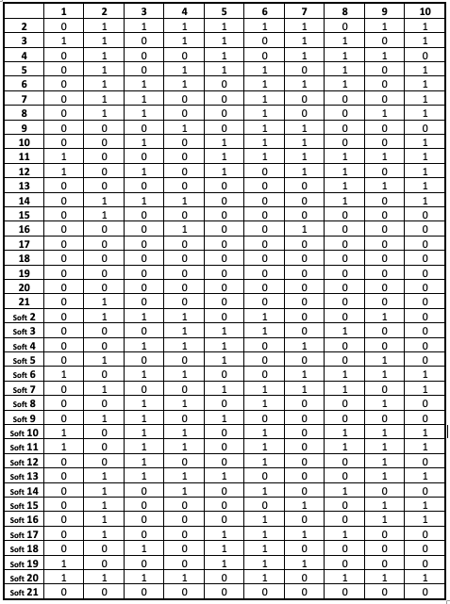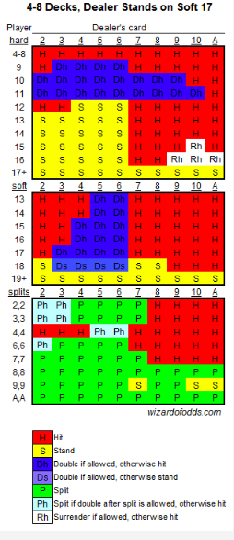

Figure 2: Basic Blackjack strategy by Wizards of Odds Consulting, Inc. 1.

Discussion

The results we obtained show that even while playing blackjack optimally, you are most likely to leave with 20-14% less money than you started with. It is important to take into account that randomness plays a huge role in blackjack. Since the odds favour the dealer in most cases, winning a lot of money in blackjack is very difficult. Although we observed results that showed gains, we attributed them mostly to luck of the draw. We determined that while it is possible to win at blackjack, winning streaks usually do not last long. The result is almost always a loss, breaking even, or a slight gain.

References

1. “4-Deck to 8-Deck Blackjack Strategy.” *Wizards of Odds Consulting, Inc.* 2019. Retrieved from <https://wizardofodds.com/games/blackjack/strategy/4-decks/>.
2. Goykhman, M. *On evolutionary selection of blackjack strategies*. 2017. Retrieved from http://dc153.dawsoncollege.qc.ca:2052/login.aspx?direct=true&db=edsarx&AN=edsarx.1711.05993&site=eds-live&scope=sit.
3. Ray, Randy. “The House Edge in Blackjack - Facts You Need to Know.” *GamblingSites.com*, 8 June 2017, www.gamblingsites.com/blog/the-house-edge-in-blackjack-28277/.
4. Repetti, Toni. “Recent Research Trends in the Gaming Industry: A Content Analysis of Research Literature on Casino Profits.” *UNLV Gaming Research & Review Journal*, vol. 15, no. 2, Oct. 2011, pp. 91–108. *EBSCOhost*, search.ebscohost.com/login.aspx?direct=true&db=a9h&AN=69735832&site=eds-live&scope=site.