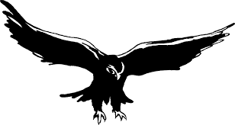

KINGDOM OF SAUDI ARABIA

Ministry of Higher Education

KING ABDULAZIZ UNIVERSITY

Faculty of Engineering

Final Project Report

**Falcon Airlines Management System**

IE322 – Computer Applications II

|  |  |
| --- | --- |
| **Student Name** | **ID** |
| Bayan Sami Balkhair | 1420156 |
| Haya Raji Almehmadi | 1420339 |
| Majeda Saeed Alzahrani | 1420005 |
| Nouf Abdullah Alharbi | 1420169 |

Team#5 – Section: EAG

Submitted Date:

12 / 5 / 2016

Instructor Name:

Eng.Tania Tasmin

Instructor's remarks:

Table of Contents

Introduction………………………………………………………………………………3

Gantt chart …………………………………………………………………….…………4

Team meeting…………………………………………………………………..…………5

Task management…………………………………………………………………..……..6

Project Forms………………………………………………………………………..…7-11

Pseudocode……………………………………………………………………...……11-13

Project code……………………………………………………………………..……13-34

Conclusion………………………………………………..………………………...……33

References……………………………………………………………………..………...34

Introduction:

This report to discuss and explain our final project in IE 322 – Computer Applications II course. The goals of this project are: to apply what we have learned in C# course and designed a complex application based on our understanding and search on the internet to learn more features. We designed application with some constraints in rubric like: we have at least seven forms with different tools, methods and function. Our project about a Falcon Airlines management system. We designed a flight management system for airline company to facilitate the reservation of tickets, payment it, table to display the flights, flight services for passengers and evaluate our services(rating). We would like to implement the flight project, because Bayan and Majeda made simple project about the flight system by Dreamweaver, so we like the idea. We choose this project to implement the application with affordable price tickets and services, and make some special offers to attract the passengers.

We have designed the application forms, created data “array…” we need, linked between the forms and used different tools, methods and function for this project. The work was divided between us equally and we hold many meetings to work on the project.

Gantt chart:

The Gantt chart is a method that can monitor the team's work schedule through different tasks. The next figure shows the tasks that we applied in this assignment among different time.

|  |  |  |  |  |  |  |  |  |  |  |  |
| --- | --- | --- | --- | --- | --- | --- | --- | --- | --- | --- | --- |
| Date | | | | | | | | | | | |
| 10 May | 8 May | 6 May | 4 May | 2 May | 30 Apr | 28 Apr | 26 Apr | 24 Apr | 22 Apr |  | Tasks |
|  |  |  |  |  |  |  |  |  |  | Project selection and Writing proposal |
|  |  |  |  |  |  |  |  |  |  | Designing forms |
|  |  |  |  |  |  |  | |  |  | Writing the codes |
|  |  |  |  |  |  |  |  |  |  | Linking between the forms |
|  |  |  |  |  |  |  |  |  |  | Presenting the project |
|  |  |  | |  |  |  |  |  |  | Modification some forms |
|  | |  |  |  |  |  |  |  |  | Writing the project report |

Figure 1: Gantt chart of our project design process

Team meeting:

|  |  |  |  |
| --- | --- | --- | --- |
| Team meeting | Time | Meeting Duration | Meeting Objectives |
| First meeting | 4/17/2016 | 1 hour | * Choosing the topic of our project |
| Second meeting | 4/19/2016 | 2 hours | * Working on the proposal of the project |
| Third meeting | 4/21/2016 | 3 hours | * Designing the forms * Converting the database into two dimensional arrays. * Searching for c# tutorial |
| Forth meeting | 4/25/2016 | 4 hours | * Working on the forms * Editing the errors * Editing the final look |
| Fifth meeting | 5/5/2016 | 1 hour | * Dividing the work of the report between us * Add some changes on the project |

Table(1):Team meating.

Task management:

|  |  |  |
| --- | --- | --- |
| Team members | Roles | Forms |
| Majeedh AL-Zahrani | * Writing the steps of pseudocode * Designing the windows forms * Using different toolbox * Linking forms together * Writing the proposal | * Flight Services * Tickets Payment * Beginning Page |
| Bayan Balkhair | * Converting the database to two dimensional arrays * Designing the windows forms * Editing the final project * Writing the steps of pseudocode | * Home Page * Beginning Page * Contact Page * Log In Page |
| Nouf AL-Harbi | * Gantt chart * Editing the final project * Designing the windows forms * Writing the steps of pseudocode | * Tickets Payment * Beginning Page * Log In Page |
| Haya AL-Mehmadi | * Converting the database to two dimensional arrays * Writing the survey of customer satisfaction * Coordinate the final report * Writing the steps of pseudocode | * Table of Flights * Evaluate the services (Rating) * Beginning Page |

Table(2):Task management.

Project Forms:

1. Beginning Page

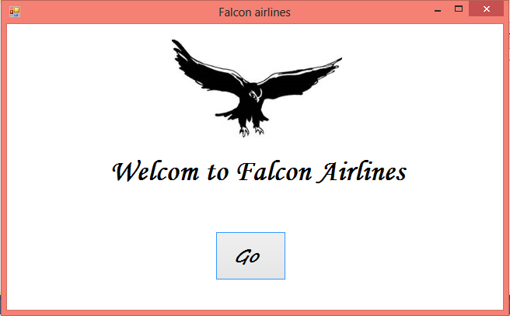

1. Log In Page

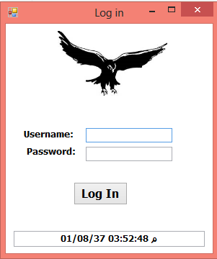

1. Home Page

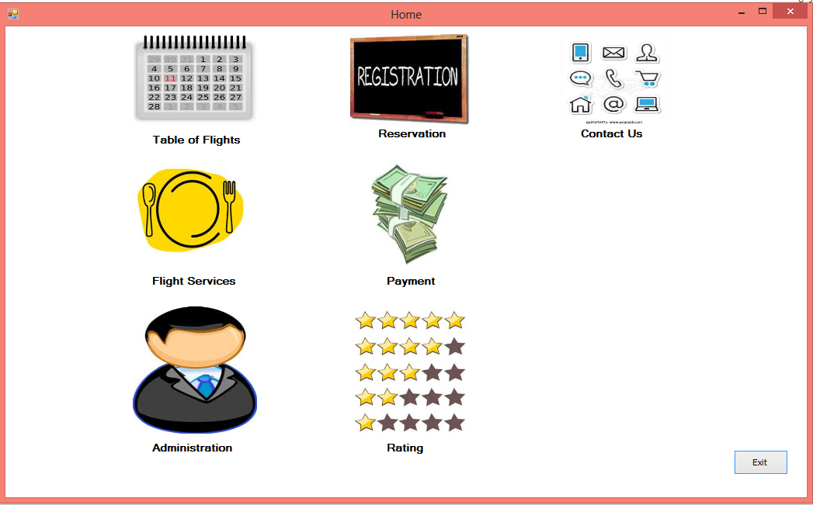

1. Table of Flights

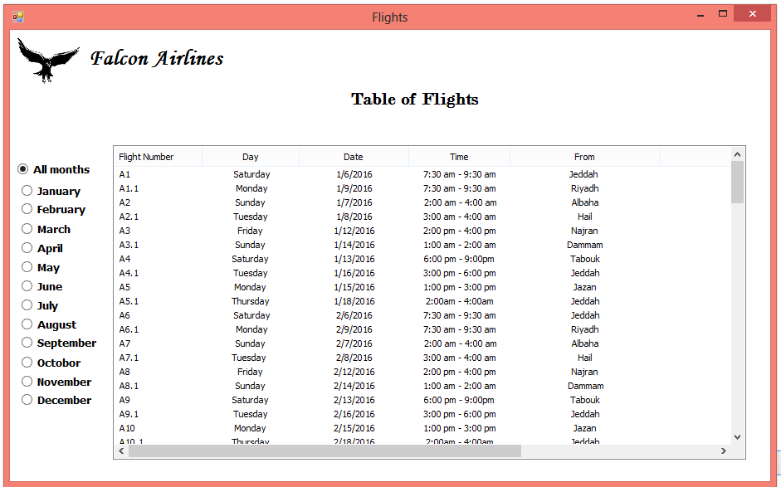

1. Reservation

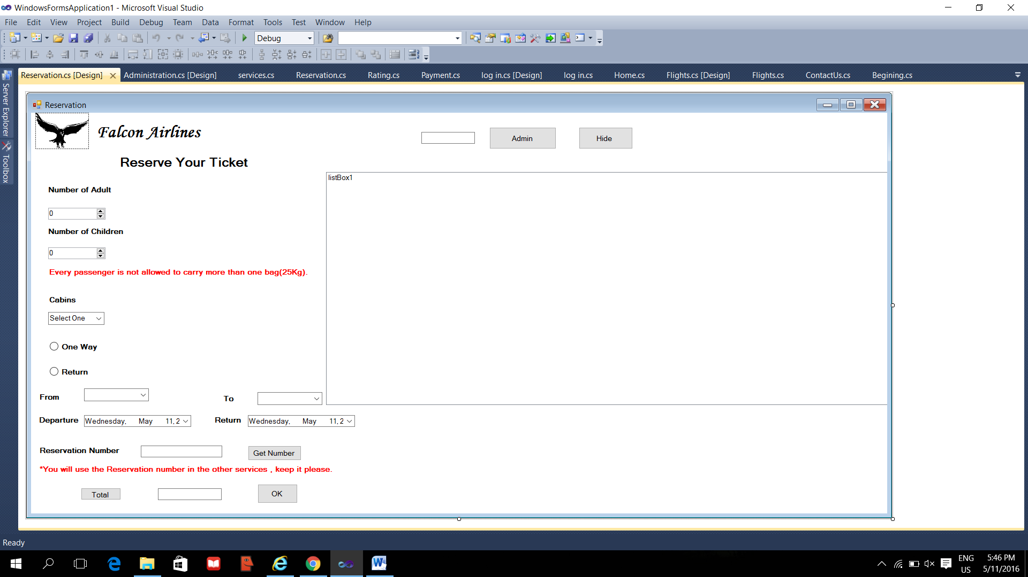

1. Flight Services

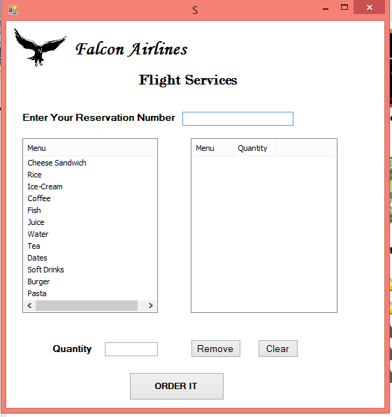

1. Tickets Payment

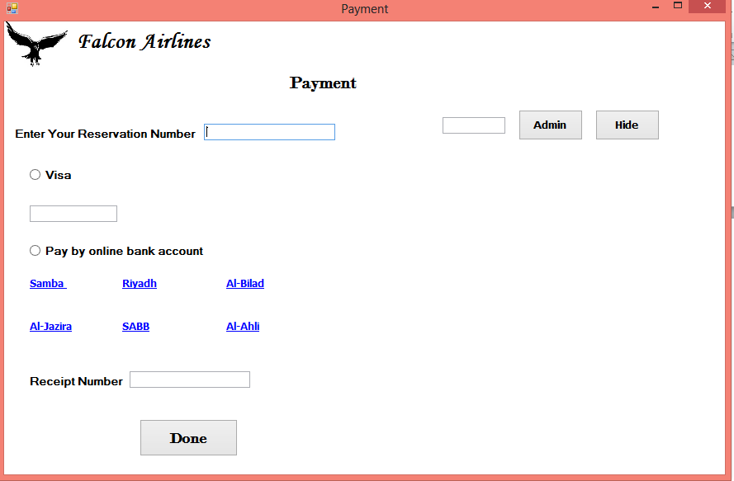

1. Administration

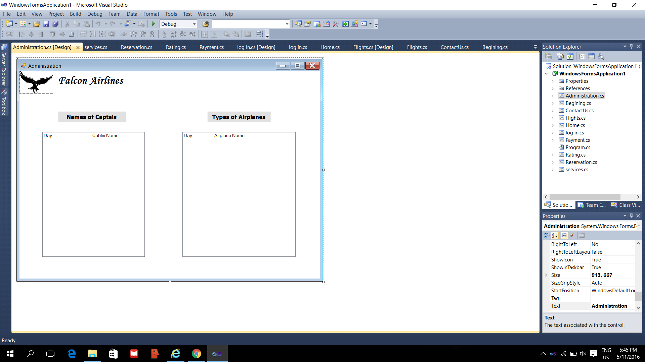

1. Evaluate the services (Rating)

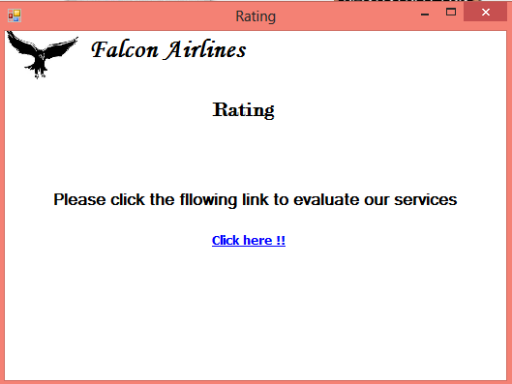

1. Contact Page

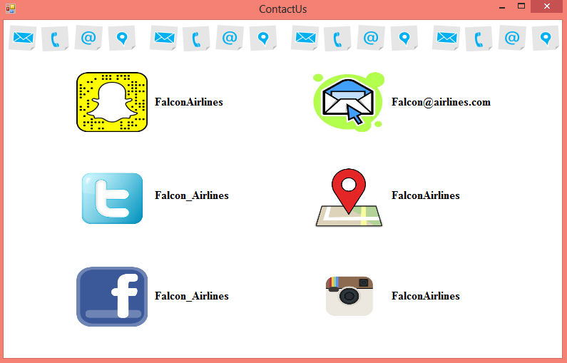

Pseudocode:

**Beginning form:**

* Simple form consists of the statement “Welcome to Falcon Airlines”.
* Button open the second form which is log in form.

**Log in Form:**

* Consists of textbox for the username which is (user) and another textbox for the password which is (123).
* Button open the home form if the username and the password are correct, if not a message box will appear to tell the user there is a wrong username or password.
* Textbox has the current date and the current time.

**Flights Form:**

* This form will be accessed from the Home form.
* Twelve radio buttons, each radio button to a specific month to show the table of flights for each month
* Radio button to show the flights for all the months.

**Reservation form:**

After you choose your flight from the flights form, now you will be able to select more details about it:

You will choose from the numerical up down if you are an adult or children

The second numerical up down you will choose from it the kind of cabin you prefer and if you choose the guests cabin your total will be multiply by 200 if you are an adult and 100 for children, if you choose a business your total will be multiply by 400 if you are an adult and 200 for children and if you choose a first class your total will be multiply by 500 if you are an adult and 250 for children

For the radio buttons if you choose on way the second date time picker will be hide and if you choose the return button the second date time picker will be showed.

**Flight Services form:**

* Enter your reservation number.
* Select your favorite food and drink from first list view “menu” and inter the quantity for each, like you want.
* Then, press the “order it “, to add the type of food and drink you selected in the second list view.
* If you select item from the second list view and click on “remove”, that should delete it from the list view
* If you click on “clear”, that should delete or clear all the items from the second list view and clear the number quantity you entered before.

**Payment form:**

* Enter your reservation number that you got it from the reservation form to complete payment procedures.
* Select your preferred payment method by Visa or online bank account.
* If you select a Visa, you must enter your Visa number to withdraw the owed amount of the ticket.
* If you select an online bank account you choose what bank you usually used and it's open to you the online bank account, then after you finish you must enter the receipt number that you got from the bank account.
* Click on done button to make sure you finish from this step.
* If you are the administrator, you can check on the cases of payment by enter a password(admin) and see all the information about all registered.

**Rating form:**

* After clicking on “Rating picture” on the home page, this form will appear, that contain a google form online survey to evaluate the services provided by the falcon airlines.

**Administration Form:**

* This form will be accessed from the Home form.
* Button to show the week days and the name of the captain in that day.
* Button to show the week days and the name of the airplane in that day.

**Contact Us form:**

This form will appear after clicking on “Contact Us picture” from the home page and the form contain the information required to contact falcon airlines company, such as social media.

Project code:

* **Administration Form**

public partial class Administration : Form

{

public Administration()

{

InitializeComponent();

}

private void button1_Click(object sender, EventArgs e)

{

string[] flight = { "Saturday Cabtin\t\tMohammad Ali", "Sunday Cabtin\t\tOsamah Rashed", "Monday Cabtin\t\tSaeed Saad", "Tuesday Cabtin\t\tSami Ahmad", "Wednesday Cabtin\t\t Sultan Salem", "Thursday Cabtin\t\tMansour Saeed", "Friday Cabtin\t\tNaif Nasser" };

for (int i = 0; i < flight.Length; i++)

{

listBox1.Items.Add(flight[i]);

}

}

private void button2_Click(object sender, EventArgs e)

{

string[] airplanes = { "Saturday\t\tBoeing 747", "Sunday\t\tDreamline 747", "Monday\t\tBoeing 777", "Tuesday\t\tboeing 874", "Wednesday\tDreamline 747", "Thursday\t\tBoeing 777", "Friday\t\tAirbus 445" };

for (int i = 0; i <airplanes.Length; i++)

{

listBox2.Items.Add(airplanes[i]);

}

}

private void Administration_Load(object sender, EventArgs e)

{

}

}

}

* **Beginning Form**

public partial class Begining : Form

{

public Begining()

{

InitializeComponent();

}

private void button1_Click(object sender, EventArgs e)

{

Form1 form = new Form1();

form.Show();

this.Hide();

}

* **Contact Us Form**

public partial class ContactUs : Form

{

public ContactUs()

{

InitializeComponent();

}

}

* **Flights Form**

public partial class Flights : Form

{

public Flights()

{

InitializeComponent();

}

int i;

private void Form2_Load(object sender, EventArgs e)

{

}

string [,] array =

{{"A1"," Saturday" ,"Jan","1/6/2016" , "7:30 am - 9:30 am" , "Jeddah ", "Riyadh",},

{"A1.1"," Monday","Jan","1/9/2016","7:30 am - 9:30 am", "Riyadh", "Jeddah"},

{"A2","Sunday","Jan","1/7/2016"," 2:00 am - 4:00 am","Albaha","Almadinah"},

{"A2.1","Tuesday","Jan","1/8/2016", "3:00 am - 4:00 am","Hail","Jeddah"},

{"A3","Friday","Jan","1/12/2016","2:00 pm - 4:00 pm","Najran","Dammam"},

{"A3.1","Sunday","Jan","1/14/2016","1:00 am - 2:00 am","Dammam","Najran"},

{"A4","Saturday","Jan","1/13/2016","6:00 pm - 9:00pm","Tabouk","Jeddah"},

{"A4.1","Tuesday","Jan","1/16/2016","3:00 pm - 6:00 pm","Jeddah","Tabouk"},

{"A5","Monday","Jan","1/15/2016","1:00 pm - 3:00 pm","Jazan","Jeddah"},

{"A5.1","Thursday","Jan","1/18/2016","2:00am - 4:00am","Jeddah","Jazan"},

{"A6"," Saturday" ,"Feb","2/6/2016" , "7:30 am - 9:30 am" , "Jeddah", "Riyadh" },

{"A6.1"," Monday","Feb","2/9/2016","7:30 am - 9:30 am", "Riyadh", "Jeddah"},

{"A7","Sunday","Feb","2/7/2016"," 2:00 am - 4:00 am","Albaha","Almadinah"},

{"A7.1","Tuesday ","Feb","2/8/2016", "3:00 am - 4:00 am","Hail","Jeddah"},

{"A8","Friday","Feb","2/12/2016","2:00 pm - 4:00 pm","Najran","Dammam"},

{"A8.1","Sunday","Feb","2/14/2016","1:00 am - 2:00 am"," Dammam","Najran"},

{"A9","Saturday","Feb","2/13/2016","6:00 pm - 9:00pm","Tabouk","Jeddah"},

{"A9.1","Tuesday","Feb","2/16/2016","3:00 pm - 6:00 pm","Jeddah","Tabouk"},

{"A10","Monday","Feb","2/15/2016","1:00 pm - 3:00 pm","Jazan","Jeddah"},

{"A10.1","Thursday","Feb","2/18/2016","2:00am - 4:00am","Jeddah","Jazan"},

{"A11","Saturday" ,"March","3/6/2016", "7:30 am - 9:30 am" , "Jeddah", "Riyadh "},

{"A11.1","Monday","March","3/9/2016","7:30 am - 9:30 am", "Riyadh", "Jeddah"},

{"A12","Sunday","March","3/7/2016"," 2:00 am - 4:00 am","Albaha","Almadinah"},

{"A12.1","Tuesday ","March","3/8/2016", "3:00 am - 4:00 am","Hail","Jeddah"},

{"A13","Friday","March","3/12/2016","2:00 pm - 4:00 pm","Najran","Dammam"},

{"A13.1","Sunday","March","3/14/2016","1:00 am - 2:00 am","Dammam","Najran "},

{"A14","Saturday","March","3/13/2016","6:00 pm - 9:00pm","Tabouk","Jeddah"},

{"A14.1","Tuesday","March","3/16/2016","3:00 pm - 6:00 pm","Jeddah","Tabouk"},

{"A15","Monday","March","3/15/2016","1:00 pm - 3:00 pm","Jazan","Jeddah"},

{"A15.1","Thersday","March","3/18/2016","2:00am - 4:00am","Jeddah","Jazan"},

{"A16"," Saturday" ,"April","4/6/2016" , "7:30 am - 9:30 am" , "Jeddah", "Riyadh"},

{"A16.1","Monday","April","4/9/2016","7:30 am - 9:30 am", "Riyadh", "Jeddah"},

{"A17","Sunday","April","4/7/2016"," 2:00 am - 4:00 am","Albaha","Almadinah"},

{"A17.1","Tuesday ","April","4/8/2016", "3:00 am - 4:00 am","Hail","Jeddah"},

{"A18","Friday","April","4/12/2016","2:00 pm - 4:00 pm","Najran","Dammam"},

{"A18.1","Sunday","April","4/14/2016","1:00 am - 2:00 am","Dammam","Najran"},

{"A19","Saturday","April","4/13/2016","6:00 pm - 9:00pm","Tabouk","Jeddah"},

{"A19.1","Tuesday","April","4/16/2016","3:00 pm - 6:00 pm","Jeddah","Tabouk"},

{"A20","Monday","April","4/15/2016","1:00 pm - 3:00 pm","Jazan","Jeddah"},

{"A20.1","Thursday","April","4/18/2016","2:00am - 4:00am","Jeddah","Jazan"},

{"A21"," Saturday","May","5/6/2016", "7:30 am - 9:30 am" , "Jeddah ", "Riyadh "},

{"A21.1","Monday","May","5/9/2016","7:30 am - 9:30 am", "Riyadh", "Jeddah"},

{"A22","Sunday","May","5/7/2016"," 2:00 am - 4:00 am","Albaha","Almadinah"},

{"A22.1","Tuesday","May","5/8/2016", "3:00 am - 4:00 am","Hail","Jeddah"},

{"A23","Friday","May","5/12/2016","2:00 pm - 4:00 pm","Najran","Dammam"},

{"A23.1","Sunday","May","5/14/2016","1:00 am - 2:00 am","Dammam","Najran"},

{"A24","Saturday","May","5/13/2016","6:00 pm - 9:00pm","Tabouk","Jeddah"},

{"A24.1","Tuesday","May","5/16/2016","3:00 pm - 6:00 pm","Jeddah","Tabouk"},

{"A25","Monday","May","5/15/2016","1:00 pm - 3:00 pm","Jazan","Jeddah"},

{"A25.1","Thursday","May","5/18/2016","2:00 am - 4:00am","Jeddah","Jazan"},

{"A26"," Saturday" ,"June","6/6/2016" , "7:30 am - 9:30 am" , "Jeddah", "Riyadh"},

{"A26.1","Monday","June","6/9/2016","7:30 am - 9:30 am", "Riyadh", "Jeddah"},

{"A27","Sunday","June","6/7/2016"," 2:00 am - 4:00 am","Albaha","Almadinah"},

{"A27.1","Tuesday","June","6/8/2016", "3:00 am - 4:00 am","Hail","Jeddah"},

{"A28","Friday","June","6/12/2016","2:00 pm - 4:00 pm","Najran","Dammam"},

{"A28.1","Sunday","June","6/14/2016","1:00 am - 2:00 am","Dammam","Najran"},

{"A29","Saturday","June","6/13/2016","6:00 pm - 9:00pm","Tabouk","Jeddah"},

{"A29.1","Tuesday","June","6/16/2016","3:00 pm - 6:00 pm","Jeddah","Tabouk"},

{"A30","Monday","June","6/15/2016","1:00 pm - 3:00 pm","Jazan","Jeddah"},

{"A30.1","Thursday","June","6/18/2016","2:00am - 4:00am","Jeddah","Jazan"},

{"A31"," Saturday" ,"July","7/6/2016" , "7:30 am - 9:30 am" , "Jeddah", "Riyadh "},

{"A31.1","Monday","July","7/9/2016","7:30 am - 9:30 am", "Riyadh", "Jeddah"},

{"A32","Sunday","July","7/7/2016"," 2:00 am - 4:00 am","Albaha","Almadinah"},

{"A32.1","Tuesday ","July","7/8/2016", "3:00 am - 4:00 am","Hail","Jeddah"},

{"A33","Friday","July","7/12/2016","2:00 pm - 4:00 pm","Najran","Dammam"},

{"A33.1","Sunday","July","7/14/2016","1:00 am - 2:00 am","Dammam","Najran"},

{"A34","Saturday","July","7/13/2016","6:00 pm - 9:00pm","Tabouk","Jeddah"},

{"A34.1","Tuesday","July","7/16/2016","3:00 pm - 6:00 pm","Jeddah","Tabouk"},

{"A35","Monday","July","7/15/2016","1:00 pm - 3:00 pm","Jazan","Jeddah"},

{"A35.1","Thursday","July","7/18/2016","2:00am - 4:00am","Jeddah","Jazan"},

{"A36"," Saturday" ,"Aug","8/6/2016" , "7:30 am - 9:30 am" , "Jeddah ", "Riyadh "},

{"A36.1","Monday","Aug","8/9/2016","7:30 am - 9:30 am", "Riyadh", "Jeddah"},

{"A37","Sunday","Aug","8/7/2016"," 2:00 am - 4:00 am","Albaha","Almadinah"},

{"A37.1","Tuesday","Aug","8/8/2016", "3:00 am - 4:00 am","Hail","Jeddah"},

{"A38","Friday","Aug","8/12/2016","2:00 pm - 4:00 pm","Najran","Dammam"},

{"A38.1","Sunday","Aug","8/14/2016","1:00 am - 2:00 am"," Dammam","Najran "},

{"A39","Saturday","Aug","8/13/2016","6:00 pm - 9:00pm","Tabouk","Jeddah"},

{"A39.1","Tuesday","Aug","8/16/2016","3:00 pm - 6:00 pm","Jeddah","Tabouk"},

{"A40","Monday","Aug","8/15/2016","1:00 pm - 3:00 pm","Jazan","Jeddah"},

{"A40.1","thersday","Aug","8/18/2016","2:00am - 4:00am","Jeddah","Jazan"},

{"A41"," Saturday" ,"Sep","9/6/2016" , "7:30 am - 9:30 am" , "Jeddah ", "Riyadh "},

{"A41.1"," Monday","Sep","9/9/2016","7:30 am - 9:30 am", "Riyadh", "Jeddah"},

{"A42","Sunday","Sep","9/7/2016"," 2:00 am - 4:00 am","Albaha","Almadinah"},

{"A42.1","Tuesday ","Sep","9/8/2016", "3:00 am - 4:00 am","Hail","Jeddah"},

{"A43","Friday","Sep","9/12/2016","2:00 pm - 4:00 pm","Najran","Dammam"},

{"A43.1","Sunday","Sep","9/14/2016","1:00 am - 2:00 am","Dammam","Najran"},

{"A44","Saturday","Sep","9/13/2016","6:00 pm - 9:00pm","Tabouk","Jeddah"},

{"A44.1","Tuesday","Sep","9/16/2016","3:00 pm - 6:00 pm","Jeddah","Tabouk"},

{"A45","Monday","Sep","9/15/2016","1:00 pm - 3:00 pm","Jazan","Jeddah"},

{"A45.1","thersday","Sep","9/18/2016","2:00am - 4:00am","Jeddah","Jazan"},

{"A46"," Saturday" ,"Oct","10/6/2016" , "7:30 am - 9:30 am" , "Jeddah ", "Riyadh"},

{"A46.1","Monday","Oct","10/9/2016","7:30 am - 9:30 am", "Riyadh", "Jeddah"},

{"A47","Sunday","Oct","10/7/2016"," 2:00 am - 4:00 am","Albaha","Almadinah"},

{"A47.1","Tuesday","Oct","10/8/2016", "3:00 am - 4:00 am","Hail","eddah"},

{"A48","Friday","Oct","10/12/2016","2:00 pm - 4:00 pm","Najran","Dammam"},

{"A48.1","Sunday","Oct","10/14/2016","1:00 am - 2:00 am"," Dammam","Najran"},

{"A49","Saturday","Oct","10/13/2016","6:00 pm - 9:00pm","Tabouk","Jeddah"},

{"A49.1","Tuesday","Oct","10/16/2016","3:00 pm - 6:00 pm","Jeddah","Tabouk"},

{"A50","Monday","Oct","10/15/2016","1:00 pm - 3:00 pm","Jazan","Jeddah"},

{"A50.1","thersday","Oct","10/18/2016","2:00am - 4:00a","Jeddah","Jazan"},

{"A51"," Saturday" ,"Nov","11/6/2016" , "7:30 am - 9:30 am" , "Jeddah", "Riyadh"},

{"A51.1"," Monday","Nov","11/9/2016","7:30 am - 9:30 am", "Riyadh", "Jeddah"},

{"A52","Sunday","Nov","11/7/2016"," 2:00 am - 4:00 am","Albaha","Almadinah"},

{"A52.1","Tuesday","Nov","11/8/2016", "3:00 am - 4:00 am","Hail","Jeddah"},

{"A53","Friday","Nov","11/12/2016","2:00 pm - 4:00 pm","Najran","Dammam"},

{"A53.1","Sunday","Nov","11/14/2016","1:00 am - 2:00 am"," Dammam","Najran"},

{"A54","Saturday","Nov","11/13/2016","6:00 pm - 9:00pm","Tabouk","Jeddah"},

{"A54.1","Tuesday","Nov","11/16/2016","3:00 pm - 6:00 pm","Jeddah","Tabouk"},

{"A55","Monday","Nov","11/15/2016","1:00 pm - 3:00 pm","Jazan","Jeddah"},

{"A55.1","thersday","Nov","11/18/2016","2:00am - 4:00am","Jeddah","Jazan"},

{"A56"," Saturday" ,"Dec","12/6/2016" , "7:30 am - 9:30 am" , "Jeddah ", "Riyadh "},

{"A56.1"," Monday","Dec","12/9/2016","7:30 am - 9:30 am", "Riyadh", "Jeddah"},

{"A57","Sunday","Dec","12/7/2016"," 2:00 am - 4:00 am","Albaha","Almadinah"},

{"A57.1","Tuesday ","Dec","12/8/2016", "3:00 am - 4:00 am","Hail","Jeddah"},

{"A58","Friday","Dec","12/12/2016","2:00 pm - 4:00 pm","Najran","Dammam"},

{"A58.1","Sunday","Dec","12/14/2016","1:00 am - 2:00 am","Dammam","Najran"},

{"A59","Saturday","Dec","12/13/2016","6:00 pm - 9:00pm","Tabouk","Jeddah"},

{"A59.1","Tuesday","Dec","12/16/2016","3:00 pm - 6:00 pm","Jeddah","Tabouk"},

{"A60","Monday","Dec","12/15/2016","1:00 pm - 3:00 pm","Jazan","Jeddah"},

{"A60.1","thersday","Dec","12/18/2016","2:00am - 4:00am","Jeddah","Jazan"}};

private void radioButton13_CheckedChanged(object sender, EventArgs e)

{

listView1.Items.Clear();

if (radioButton13.Checked == true)

{

for (i = 0; i < array.GetLength(0); i++)

{

string number = array[i, 0];

string day = array[i, 1];

string date = array[i, 3];

string time = array[i, 4];

string from = array[i, 5];

string to = array[i, 6];

// string m = array[i, 2];

ListViewItem lv = new ListViewItem();

lv.Text = number;

lv.SubItems.Add(day);

lv.SubItems.Add(date);

lv.SubItems.Add(time);

lv.SubItems.Add(from);

lv.SubItems.Add(to);

// lv.SubItems.Add(m);

listView1.Items.Add(lv);

}

}

}

private void listView1_SelectedIndexChanged(object sender, EventArgs e)

{

}

private void Form2_Load_1(object sender, EventArgs e)

{

}

private void radioButton1_CheckedChanged(object sender, EventArgs e)

{

listView1.Items.Clear();

if (radioButton1.Checked == true)

{

for (i = 0; i < array.GetLength(0); i++)

{

if (array[i, 2] == "Jan")

{

string number = array[i, 0];

string day = array[i, 1];

string date = array[i, 3];

string time = array[i, 4];

string from = array[i, 5];

string to = array[i, 6];

// string m = array[i, 2];

ListViewItem f = new ListViewItem();

f.Text = number;

f.SubItems.Add(day);

f.SubItems.Add(date);

f.SubItems.Add(time);

f.SubItems.Add(from);

f.SubItems.Add(to);

// lv.SubItems.Add(m);

listView1.Items.Add(f);

}

}

}

}

private void radioButton2_CheckedChanged(object sender, EventArgs e)

{

listView1.Items.Clear();

if (radioButton2.Checked == true)

{

for (i = 0; i < array.GetLength(0); i++)

{

if (array[i, 2] == "Feb")

{

string number = array[i, 0];

string day = array[i, 1];

string date = array[i, 3];

string time = array[i, 4];

string from = array[i, 5];

string to = array[i, 6];

// string m = array[i, 2];

ListViewItem lv = new ListViewItem();

lv.Text = number;

lv.SubItems.Add(day);

lv.SubItems.Add(date);

lv.SubItems.Add(time);

lv.SubItems.Add(from);

lv.SubItems.Add(to);

// lv.SubItems.Add(m);

listView1.Items.Add(lv);

}

}

}

}

private void radioButton3_CheckedChanged(object sender, EventArgs e)

{

listView1.Items.Clear();

if (radioButton3.Checked == true)

{

for (i = 0; i < array.GetLength(0); i++)

{

if (array[i, 2] == "March")

{

string number = array[i, 0];

string day = array[i, 1];

string date = array[i, 3];

string time = array[i, 4];

string from = array[i, 5];

string to = array[i, 6];

// string m = array[i, 2];

ListViewItem lv = new ListViewItem();

lv.Text = number;

lv.SubItems.Add(day);

lv.SubItems.Add(date);

lv.SubItems.Add(time);

lv.SubItems.Add(from);

lv.SubItems.Add(to);

// lv.SubItems.Add(m);

listView1.Items.Add(lv);

}

}

}

}

private void radioButton4_CheckedChanged(object sender, EventArgs e)

{

listView1.Items.Clear();

if (radioButton4.Checked == true)

{

for (i = 0; i < array.GetLength(0); i++)

{

if (array[i, 2] == "April")

{

string number = array[i, 0];

string day = array[i, 1];

string date = array[i, 3];

string time = array[i, 4];

string from = array[i, 5];

string to = array[i, 6];

// string m = array[i, 2];

ListViewItem lv = new ListViewItem();

lv.Text = number;

lv.SubItems.Add(day);

lv.SubItems.Add(date);

lv.SubItems.Add(time);

lv.SubItems.Add(from);

lv.SubItems.Add(to);

// lv.SubItems.Add(m);

listView1.Items.Add(lv);

}

}

}

}

private void radioButton5_CheckedChanged(object sender, EventArgs e)

{

listView1.Items.Clear();

if (radioButton5.Checked == true)

{

for (i = 0; i < array.GetLength(0); i++)

{

if (array[i, 2] == "May")

{

string number = array[i, 0];

string day = array[i, 1];

string date = array[i, 3];

string time = array[i, 4];

string from = array[i, 5];

string to = array[i, 6];

// string m = array[i, 2];

ListViewItem lv = new ListViewItem();

lv.Text = number;

lv.SubItems.Add(day);

lv.SubItems.Add(date);

lv.SubItems.Add(time);

lv.SubItems.Add(from);

lv.SubItems.Add(to);

// lv.SubItems.Add(m);

listView1.Items.Add(lv);

}

}

}

}

private void radioButton6_CheckedChanged(object sender, EventArgs e)

{

listView1.Items.Clear();

if (radioButton6.Checked == true)

{

for (i = 0; i < array.GetLength(0); i++)

{

if (array[i, 2] == "June")

{

string number = array[i, 0];

string day = array[i, 1];

string date = array[i, 3];

string time = array[i, 4];

string from = array[i, 5];

string to = array[i, 6];

// string m = array[i, 2];

ListViewItem lv = new ListViewItem();

lv.Text = number;

lv.SubItems.Add(day);

lv.SubItems.Add(date);

lv.SubItems.Add(time);

lv.SubItems.Add(from);

lv.SubItems.Add(to);

// lv.SubItems.Add(m);

listView1.Items.Add(lv);

}

}

}

}

private void radioButton7_CheckedChanged(object sender, EventArgs e)

{

listView1.Items.Clear();

if (radioButton7.Checked == true)

{

for (i = 0; i < array.GetLength(0); i++)

{

if (array[i, 2] == "July")

{

string number = array[i, 0];

string day = array[i, 1];

string date = array[i, 3];

string time = array[i, 4];

string from = array[i, 5];

string to = array[i, 6];

// string m = array[i, 2];

ListViewItem lv = new ListViewItem();

lv.Text = number;

lv.SubItems.Add(day);

lv.SubItems.Add(date);

lv.SubItems.Add(time);

lv.SubItems.Add(from);

lv.SubItems.Add(to);

// lv.SubItems.Add(m);

listView1.Items.Add(lv);

}

}

}

}

private void radioButton8_CheckedChanged(object sender, EventArgs e)

{

listView1.Items.Clear();

if (radioButton8.Checked == true)

{

for (i = 0; i < array.GetLength(0); i++)

{

if (array[i, 2] == "Aug")

{

string number = array[i, 0];

string day = array[i, 1];

string date = array[i, 3];

string time = array[i, 4];

string from = array[i, 5];

string to = array[i, 6];

// string m = array[i, 2];

ListViewItem lv = new ListViewItem();

lv.Text = number;

lv.SubItems.Add(day);

lv.SubItems.Add(date);

lv.SubItems.Add(time);

lv.SubItems.Add(from);

lv.SubItems.Add(to);

// lv.SubItems.Add(m);

listView1.Items.Add(lv);

}

}

}

}

private void radioButton9_CheckedChanged(object sender, EventArgs e)

{

listView1.Items.Clear();

if (radioButton9.Checked == true)

{

for (i = 0; i < array.GetLength(0); i++)

{

if (array[i, 2] == "Sep")

{

string number = array[i, 0];

string day = array[i, 1];

string date = array[i, 3];

string time = array[i, 4];

string from = array[i, 5];

string to = array[i, 6];

// string m = array[i, 2];

ListViewItem lv = new ListViewItem();

lv.Text = number;

lv.SubItems.Add(day);

lv.SubItems.Add(date);

lv.SubItems.Add(time);

lv.SubItems.Add(from);

lv.SubItems.Add(to);

// lv.SubItems.Add(m);

listView1.Items.Add(lv);

}

}

}

}

private void radioButton10_CheckedChanged(object sender, EventArgs e)

{

listView1.Items.Clear();

if (radioButton10.Checked == true)

{

for (i = 0; i < array.GetLength(0); i++)

{

if (array[i, 2] == "Oct")

{

string number = array[i, 0];

string day = array[i, 1];

string date = array[i, 3];

string time = array[i, 4];

string from = array[i, 5];

string to = array[i, 6];

// string m = array[i, 2];

ListViewItem lv = new ListViewItem();

lv.Text = number;

lv.SubItems.Add(day);

lv.SubItems.Add(date);

lv.SubItems.Add(time);

lv.SubItems.Add(from);

lv.SubItems.Add(to);

// lv.SubItems.Add(m);

listView1.Items.Add(lv);

}

}

}

}

private void radioButton11_CheckedChanged(object sender, EventArgs e)

{

listView1.Items.Clear();

if (radioButton11.Checked == true)

{

for (i = 0; i < array.GetLength(0); i++)

{

if (array[i, 2] == "Nov")

{

string number = array[i, 0];

string day = array[i, 1];

string date = array[i, 3];

string time = array[i, 4];

string from = array[i, 5];

string to = array[i, 6];

// string m = array[i, 2];

ListViewItem lv = new ListViewItem();

lv.Text = number;

lv.SubItems.Add(day);

lv.SubItems.Add(date);

lv.SubItems.Add(time);

lv.SubItems.Add(from);

lv.SubItems.Add(to);

// lv.SubItems.Add(m);

listView1.Items.Add(lv);

}

}

}

}

private void radioButton12_CheckedChanged(object sender, EventArgs e)

{

listView1.Items.Clear();

if (radioButton12.Checked == true)

{

for (i = 0; i < array.GetLength(0); i++)

{

if (array[i, 2] == "Dec")

{

string number = array[i, 0];

string day = array[i, 1];

string date = array[i, 3];

string time = array[i, 4];

string from = array[i, 5];

string to = array[i, 6];

// string m = array[i, 2];

ListViewItem lv = new ListViewItem();

lv.Text = number;

lv.SubItems.Add(day);

lv.SubItems.Add(date);

lv.SubItems.Add(time);

lv.SubItems.Add(from);

lv.SubItems.Add(to);

// lv.SubItems.Add(m);

listView1.Items.Add(lv);

}

}

}

}

}

}

* **Home Form**

public partial class Home : Form

{

public Home()

{

InitializeComponent();

}

private void pictureBox1_Click(object sender, EventArgs e)

{

Flights form = new Flights();

form.Show();

}

private void pictureBox2_Click(object sender, EventArgs e)

{

Reservation form = new Reservation();

form.Show();

}

private void pictureBox3_Click(object sender, EventArgs e)

{

services form = new services();

form.Show();

}

private void pictureBox5_Click(object sender, EventArgs e)

{

Payment form = new Payment();

form.Show();

}

private void pictureBox6_Click(object sender, EventArgs e)

{

Administration form = new Administration();

form.Show();

}

private void pictureBox7_Click(object sender, EventArgs e)

{

Rating form = new Rating();

form.Show();

}

private void button1_Click(object sender, EventArgs e)

{

Application.Exit();

}

private void pictureBox4_Click(object sender, EventArgs e)

{

ContactUs form = new ContactUs();

form.Show();

}

}

}

* **Log In Form**

Public partial class login: Form

{

public login()

{

InitializeComponent();

}

private void button1_Click(object sender, EventArgs e)

{

if (textBox1.Text == "user" && textBox2.Text == "123")

{

Home Form = new Home();

Form.Show();

this.Hide();

}

else

MessageBox.Show("Incorrect user name or password");

}

private void Form1_Load(object sender, EventArgs e)

{

DateTime localDate = DateTime.Now;

textBox3.Text=localDate.ToString();

* **Payment Form**

public partial class Payment : Form

{

public Payment()

{

InitializeComponent();

}

private void linkLabel1_LinkClicked(object sender, LinkLabelLinkClickedEventArgs e)

{

System.Diagnostics.Process.Start("https://sambaonline.samba.com");

}

private void linkLabel2_LinkClicked(object sender, LinkLabelLinkClickedEventArgs e)

{

System.Diagnostics.Process.Start("http://www.riyadonline.com");

}

private void linkLabel3_LinkClicked(object sender, LinkLabelLinkClickedEventArgs e)

{

System.Diagnostics.Process.Start("http://www.baj.com.sa");

}

private void linkLabel4_LinkClicked(object sender, LinkLabelLinkClickedEventArgs e)

{

System.Diagnostics.Process.Start("http://www.sabb.com");

}

private void linkLabel5_LinkClicked(object sender, LinkLabelLinkClickedEventArgs e)

{

System.Diagnostics.Process.Start("http://bankalbilad.com");

}

private void linkLabel6_LinkClicked(object sender, LinkLabelLinkClickedEventArgs e)

{

System.Diagnostics.Process.Start("http://www.alahli.com");

}

string way;

private void button1_Click(object sender, EventArgs e)

{

string reserno = textBox1.Text;

string Visa = textBox2.Text;

string Bank = textBox3.Text;

if (radioButton1.Checked == true)

{

way = "Visa";

listBox1.Items.Add("reservation no.\t way \t No. Visa \t\t\t state");

listBox1.Items.Add(reserno + "\t"+way + "\t" + Visa +"\t\t"+"Done");

}

if (radioButton2.Checked == true)

{

way = "Bank";

listBox1.Items.Add("reservation no\t way\tReceipt number \t\t\tstate");

listBox1.Items.Add(reserno + "\t" + way + "\t" + Bank + "\t\t\t" + "Done");

}

textBox1.Clear();

textBox2.Clear();

textBox3.Clear();

radioButton1.Checked = false;

radioButton2.Checked = false;

}

private void button2_Click(object sender, EventArgs e)

{

if (textBox4.Text == "admin")

{ listBox1.Show(); }

}

private void button3_Click(object sender, EventArgs e)

{

listBox1.Hide();

textBox4.Clear();

}

private void Payment_Load(object sender, EventArgs e)

{

listBox1.Hide();

}

private void textBox4_TextChanged(object sender, EventArgs e)

{

radioButton1.Checked = false;

radioButton2.Checked = false;

}

}

}

* **Rating Form**

public partial class Rating : Form

{

public Rating()

{

InitializeComponent();

}

private void linkLabel1_LinkClicked(object sender, LinkLabelLinkClickedEventArgs e)

{

System.Diagnostics.Process.Start("https://docs.google.com/forms/d/1dzI0lDbv5tIIOiqYW-v8fbOgUcMupGISuhM0FvNF7rM/edit ");

}

}

}

* **Reservation Form**

public partial class Reservation : Form

{

public Reservation( )

{

InitializeComponent();

}

private void radioButton1_CheckedChanged(object sender, EventArgs e)

{

if (radioButton1.Checked == true)

{

dateTimePicker2.Hide();

label8.Hide();

}

}

string adult;

string children;

string cabin;

string from;

string way;

string to;

string departure;

string Return;

string reservation;

double total=0;

string[,] reser = new string [200, 10];

private void button1_Click(object sender, EventArgs e)

{

double number;

Random random = new Random();

number = random.Next(000000001, 999999999);

textBox1.Text = number.ToString();

}

private void radioButton2_CheckedChanged(object sender, EventArgs e)

{

dateTimePicker2.Show();

label8.Show();

}

private void button2_Click(object sender, EventArgs e)

{

adult=numericUpDown1.Value.ToString();

children=numericUpDown2.Value.ToString();

cabin=comboBox1.Text;

from=comboBox2.Text;

to=comboBox3.Text;

reservation=textBox1.Text;

departure = dateTimePicker1.Text;

Return = dateTimePicker2.Text;

if (cabin == "Guest")

{

total = Convert.ToDouble(adult) * 200 + Convert.ToDouble(children) * 100;

textBox2.Text = total.ToString();

}

if (cabin == "Business")

{

total = Convert.ToDouble(adult) * 400 + Convert.ToDouble(children) * 200;

textBox2.Text = total.ToString();

}

if (cabin == "First Class")

{

total = Convert.ToDouble(adult) * 500 + Convert.ToDouble(children) * 250;

textBox2.Text = total.ToString();

}

if (radioButton1.Checked == true)

{

way = "one way";

listBox1.Items.Add("adult \tchildren \t cabin \t \t way \t\tfrom \t to\t\t Depature\t\t\t\treservation#\t\ttotal");

listBox1.Items.Add(adult + "\t" + children + "\t" + cabin + "\t\t" + way + "\t\t" + from + "\t" + to + "\t\t" + departure + "\t\t"+ reservation + "\t\t" + total);

}

if (radioButton2.Checked)

{

way = "return";

listBox1.Items.Add("adult \tchildren \t cabin \t \t way \t\t from \t to\t\t Depature\t\t\tReturn\t\t\t\treservation#\t\ttotal");

listBox1.Items.Add(adult + "\t" + children + "\t" + cabin + "\t\t" + way + "\t\t" + from + "\t" + to + "\t\t" + departure + "\t" + Return + "\t\t" + reservation + "\t\t" + total);

}

private void Reservation_Load(object sender, EventArgs e)

{

listBox1.Hide();

}

private void button3_Click(object sender, EventArgs e)

{

if (textBox3.Text == "admin")

{

listBox1.Show();

}

}

private void button4_Click(object sender, EventArgs e)

{

listBox1.Hide();

textBox3.Clear();

}

private void button5_Click(object sender, EventArgs e)

{

textBox1.Clear();

textBox2.Clear();

comboBox1.ResetText();

comboBox2.ResetText();

comboBox3.ResetText();

numericUpDown1.ResetText();

numericUpDown2.ResetText();

radioButton1.Checked = false;

radioButton2.Checked = false;

dateTimePicker1.Value = dateTimePicker1.MinDate;

dateTimePicker2.Value = dateTimePicker2.MinDate;

}

}

}

* **Services Form**

public partial class services : Form

{

public services()

{

InitializeComponent();

}

private void button2_Click(object sender, EventArgs e)

{

listView2.Items.Clear();

textBox2.Clear();

}

private void button1_Click(object sender, EventArgs e)

{

listView2.Items.Remove(listView2.SelectedItems[0]);

}

private void button3_Click(object sender, EventArgs e)

{

string food = listView1.SelectedItems[0].Text;

string quantity = textBox2.Text;

ListViewItem lv = new ListViewItem();

lv.Text = food;

lv.SubItems.Add(quantity);

listView2.Items.Add(lv);

textBox2.Clear();

}

}

}

Conclusion:

At the end of the work, we have learned lots of C sharp programming commands that help in designing great helpful applications to facilitate the work of any an organization such as the flight field. Also, we learned more about the forms and how to connect between them. In addition, this project helps us to improve our skills in the concepts of teamwork which is so important thing in the future. On the other and, this project accomplished by lots of team meetings to design the forms and write the codes by our background from this course (IE 322) and by searching on the internet. Then, edit the fonts and colors. For the report, we divide the tasks between us and then collect the individual work in one word file. Now, we will be able to use C sharp to design any an application after this helpful course because we learned a lot about the programming by using C sharp.

References:

Deitel, Paul J and Harvey M Deitel. *Visual C♯ 2012*. Boston: Prentice Hall, 2014. Print.

"How To Transfer Information Between Forms - C# C Sharp Visual Studio 2008". *YouTube*. N.p., 2016. Web. 11 May 2016.

"Saudia > Welcome To Saudi Arabian Airlines". *Saudiairlines.com*. N.p., 2016. Web. 2 May 2016.