LAB 2 Report

In this lab we implement the following search algorithms:
- DFS (both iterative and recursive implementations)
- BFS (both iterative and recursive implementations)
- Dijkstra
- A*
One graph was analyzed.
Figure 1 shows the screen shot of the program output.
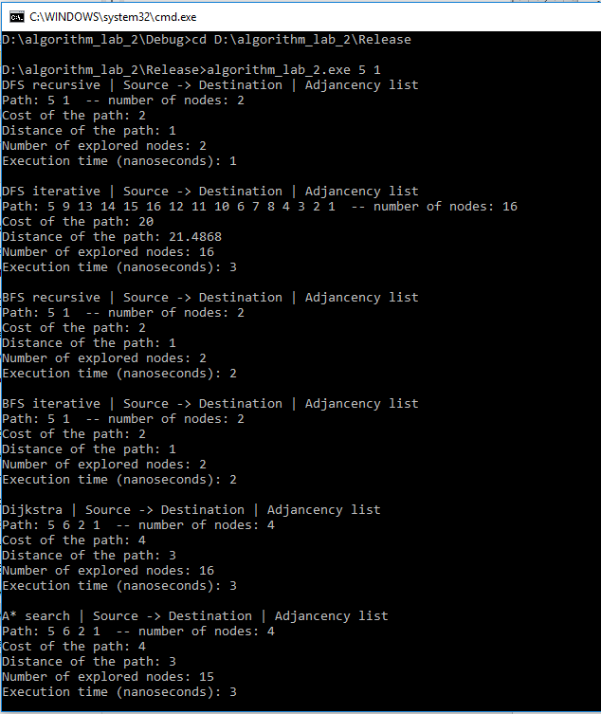
Figure 1. Lab 2 program output

We performed 100 tests of running each search algorithm with randomly selected sorce and destination nodes. Each search was performed in both directions (source to destination and destination to source) on both adjacency matrix and list. Tables 1-4 shows the average normalized results of different ways of implementation of the algorithm

Table 1. Average normalized results: Adjacency Matrix, Source -> Destination
 | DFS Iterative | DFS Recursive | BFS Iterative | BFS Recursive | Dijkstra | A*
Nodes in Path | 0.693961 | 0.646944 | 0.271468 | 0.271468 | 0.271468 | 0.271468
Nodes Explored | 0.5062 | 0.47076 | 0.596384 | 0.596384 | 0.885265 | 0.370596
Execution Time | 0.287756 | 0.389778 | 0.490264 | 0.479197 | 0.867596 | 0.530855
Distance | 0.655559 | 0.605772 | 0.17222 | 0.17222 | 0.17222 | 0.17222
Cost | 0.656457 | 0.593838 | 0.209419 | 0.209419 | 0.209419 | 0.209419

Table 2. Average normalized results: Adjacency List, Source -> Destination
 | DFS Iterative | DFS Recursive | BFS Iterative | BFS Recursive | Dijkstra | A*
Nodes in Path | 0.673623 | 0.673314 | 0.271468 | 0.271468 | 0.296134 | 0.296134
Nodes Explored | 0.482633 | 0.480925 | 0.589383 | 0.589383 | 0.885265 | 0.441444
Execution Time | 0.079722 | 0.226042 | 0.235238 | 0.253705 | 0.609037 | 0.505123
Distance | 0.631813 | 0.638775 | 0.17222 | 0.17222 | 0.205265 | 0.205265
Cost | 0.672129 | 0.610198 | 0.209419 | 0.209419 | 0.238933 | 0.238933

Table 3. Average normalized results: Adjacency Matrix, Destination -> Source
 | DFS Iterative | DFS Recursive | BFS Iterative | BFS Recursive | Dijkstra | A*
Nodes in Path | 0.693961 | 0.646944 | 0.271468 | 0.271468 | 0.271468 | 0.271468
Nodes Explored | 0.5062 | 0.47076 | 0.596384 | 0.596384 | 0.885265 | 0.370596
Execution Time | 0.284401 | 0.372067 | 0.457292 | 0.471509 | 0.854171 | 0.531019
Distance | 0.655559 | 0.605772 | 0.17222 | 0.17222 | 0.17222 | 0.17222
Cost | 0.656457 | 0.593838 | 0.209419 | 0.209419 | 0.209419 | 0.209419

Table 4. Average normalized results: Adjancecy List, Destination -> Source
 | DFS Iterative | DFS Recursive | BFS Iterative | BFS Recursive | Dijkstra | A*
Nodes in Path | 0.673623 | 0.673314 | 0.271468 | 0.271468 | 0.296134 | 0.296134
Nodes Explored | 0.482633 | 0.480925 | 0.589383 | 0.589383 | 0.885265 | 0.441444
Execution Time | 0.066442 | 0.17929 | 0.200607 | 0.202058 | 0.526326 | 0.443757
Distance | 0.631813 | 0.638775 | 0.17222 | 0.17222 | 0.205265 | 0.205265
Cost | 0.672129 | 0.610198 | 0.209419 | 0.209419 | 0.238933 | 0.238933

Figures 2-6 shows the performance metrics which were measured in the tests.

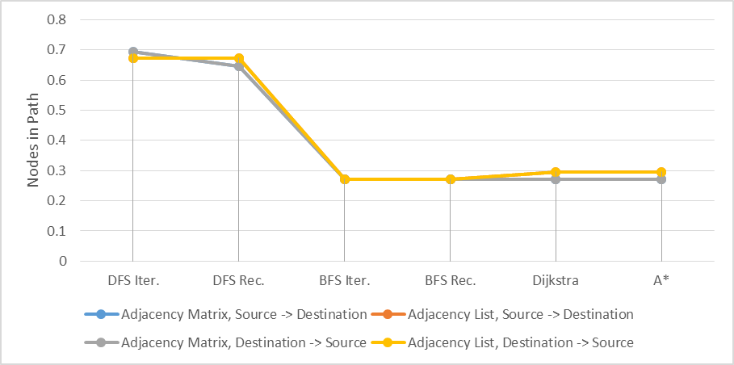
Figure 2. Nodes in Path

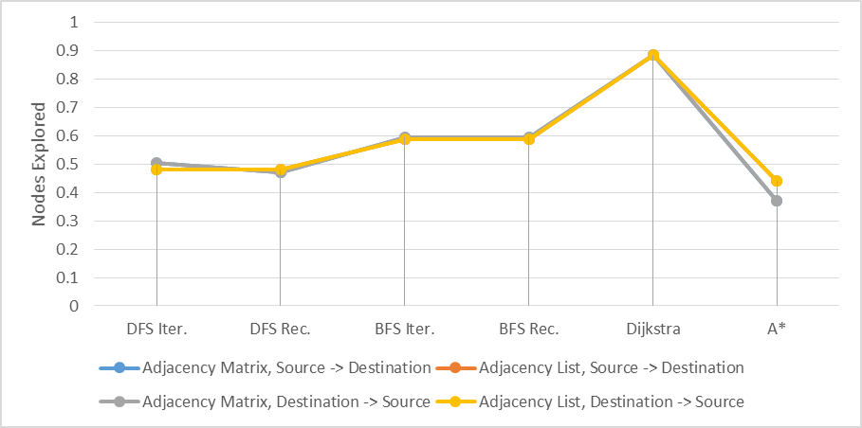
Figure 3. Nodes in Explored

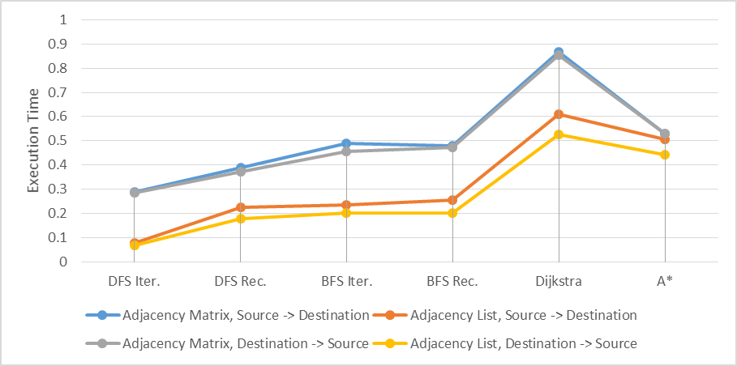
Figure 4.Execution Time

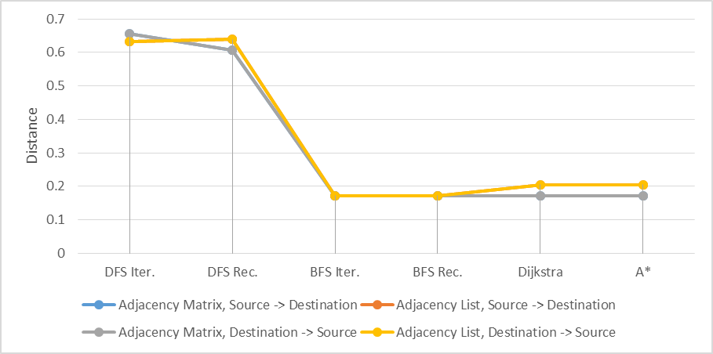
Figure 5. Distance

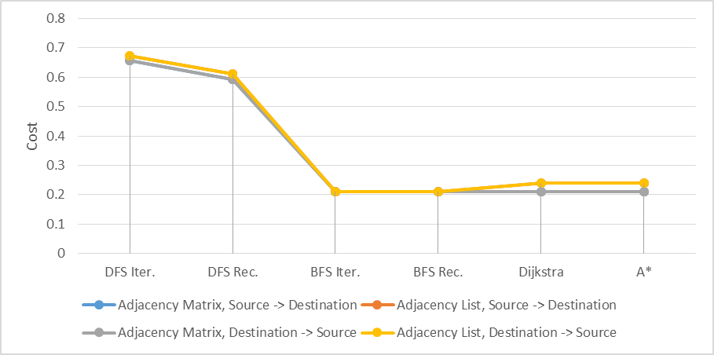
Figure 6. Cost

As we can see, DFS algorithm is the most optimal. It performs search using the optimal way and consumes the minimal time for execution.

