SHULL SCIENCE · JAMES A. GARFIELD LOCAL SCHOOLS
UNIT 1 · MOTION IN ONE DIMENSION
GUIDED NOTES · 4 SECTIONS · S1.1 – S1.4

NAME ______________________________________ DATE ______________ PERIOD _______

UNIT LEARNING TARGETS  ▸ I can tell distance from displacement and speed from velocity, using signs.  ▸ I can calculate acceleration and choose the right kinematic equation.  ▸ I can read velocity, acceleration and displacement off motion graphs.  ▸ I can solve free-fall problems with a = −9.81 m/s², taking up as positive. |  | KEY TERMS  ▸ Position, origin, displacement, distance  ▸ Scalar, vector, magnitude, direction  ▸ Average speed, average velocity, instantaneous velocity  ▸ Acceleration, kinematic equation, free fall, g

HOW THESE NOTES WORK
▸ The left column holds the questions you should be able to answer from the notes beside them. Cover the right side and quiz yourself with it later.
▸ A ✎ line with a green bar is must-write. Copy it exactly.
▸ Every worked example has a bordered work area. Show enough that I can follow your reasoning, and carry units the whole way.
▸ Each section ends with a summary box. Close your notes before you write it.

SECTIONS IN THIS UNIT
☐ S1.1 Distance, Displacement & Velocity
☐ S1.2 Acceleration & the Kinematic Equations
☐ S1.3 Position, Velocity & Acceleration Graphs
☐ S1.4 Free Fall

Distance, Displacement & Velocity | U1 / S1.1

LEARNING TARGET I can tell distance from displacement and speed from velocity, and I can use the sign of a number to state a direction.

POSITION  What do you have to choose before any position number means anything?  What does the sign of a position tell you? | POSITION AND THE COORDINATE AXIS  Position x is where an object is, measured from a chosen __________ .  Before writing any number, you choose an origin and a _______________________________ .  The sign of a position tells you which _______ of zero the object is on. It does not mean fast or slow.  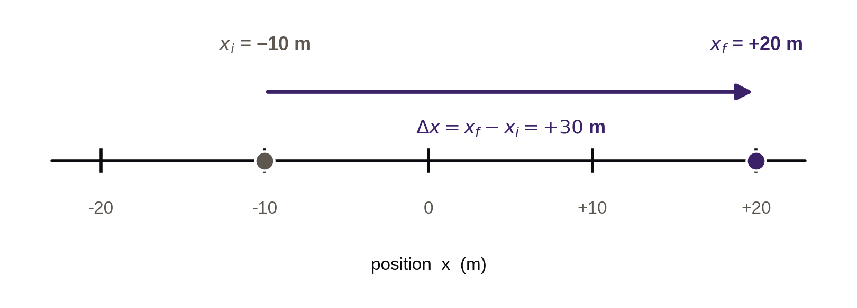  Displacement Δx = final position − initial position. Above: Δx = (+20 m) − (−10 m) = _________ .
DISTANCE VS. DISPLACEMENT  Which one can be negative?  A runner does one full lap. What is the displacement? | TWO DIFFERENT QUESTIONS ABOUT THE SAME TRIP  Distance is the total ___________________ travelled. It is a scalar and it is never negative.  Displacement is the change in position, ________________________________ . It is a vector, so it carries a sign.  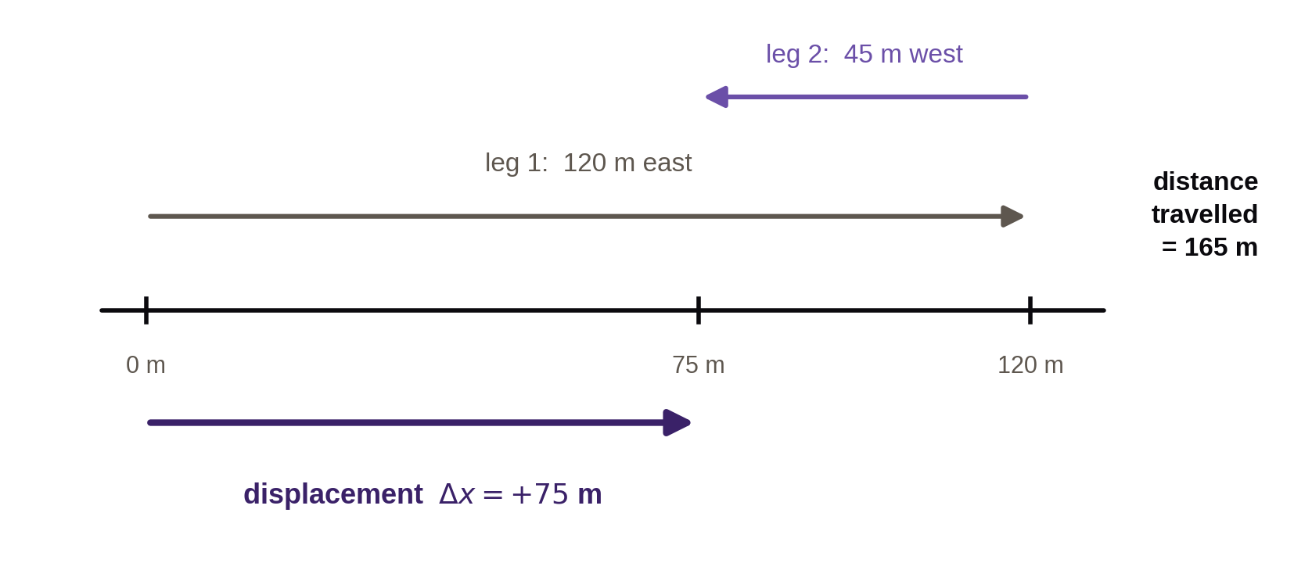  Runner: 120 m east, then 45 m west. Distance = _________ . Displacement = _________ .  ✎ Displacement depends only on the endpoints. Distance depends on the whole path.
SPEED VS. VELOCITY  Which of the two needs a direction?  When are the two numbers equal? | AVERAGE SPEED AND AVERAGE VELOCITY  average speed = ______________ ÷ total time (scalar)  average velocity = ____________________ ÷ total time (vector)  They are equal only when the motion never _____________________________ .  Instantaneous velocity is the velocity at _________________ — what a photogate estimates over a very short distance.  ✎ A speedometer reads speed, not velocity. It does not know which way the car points.
WORKED EXAMPLE  What is the first thing written down, before any number? | EXAMPLE — A TRIP WITH A TURNAROUND  A student walks 40. m east from the door, turns, and walks 15 m west. The trip takes 22 s. Take east as positive.  GIVEN leg 1 = 40. m east · leg 2 = 15 m west · Δt = 22 s  NEED distance · displacement · average speed · average velocity  WORK — CARRY UNITS  Answers: distance _______ , displacement _________________ , speed ____________ , velocity ____________________ .

SECTION SUMMARY — close your notes before you write this
In your own words: two students take different routes from the door to the flagpole and arrive at the same time. What must be the same about their trips, and what can be different?

SELF-CHECK
☐ I can state the positive direction before I start a problem.
☐ I can find distance and displacement for a trip with a turnaround.
☐ I can say why average speed and average velocity can differ.

Acceleration & the Kinematic Equations | U1 / S1.2

LEARNING TARGET I can calculate acceleration from a change in velocity, and I can choose the kinematic equation that fits the givens.

ACCELERATION  What exactly is changing when something accelerates?  What do the units m/s² actually mean, in words? | WHAT ACCELERATION MEASURES  a = Δv ÷ Δt — the change in ______________ divided by the time it took.  Units: m/s per second, written _______ . In words: every second, the velocity changes by that many m/s.  Acceleration is a vector, so it carries a _______ .  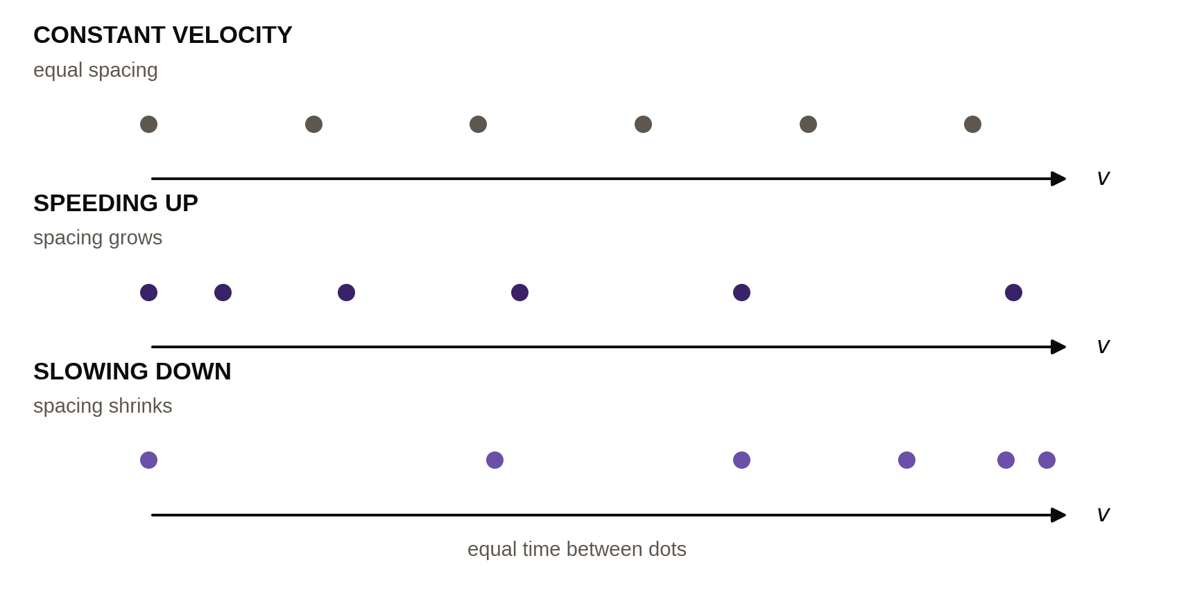  Equal time between dots. Spacing that grows means the object is ___________________ .
SIGNS  Does a negative acceleration always mean slowing down?  Give one case where both v and a are negative. | COMPARING THE SIGN OF a TO THE SIGN OF v  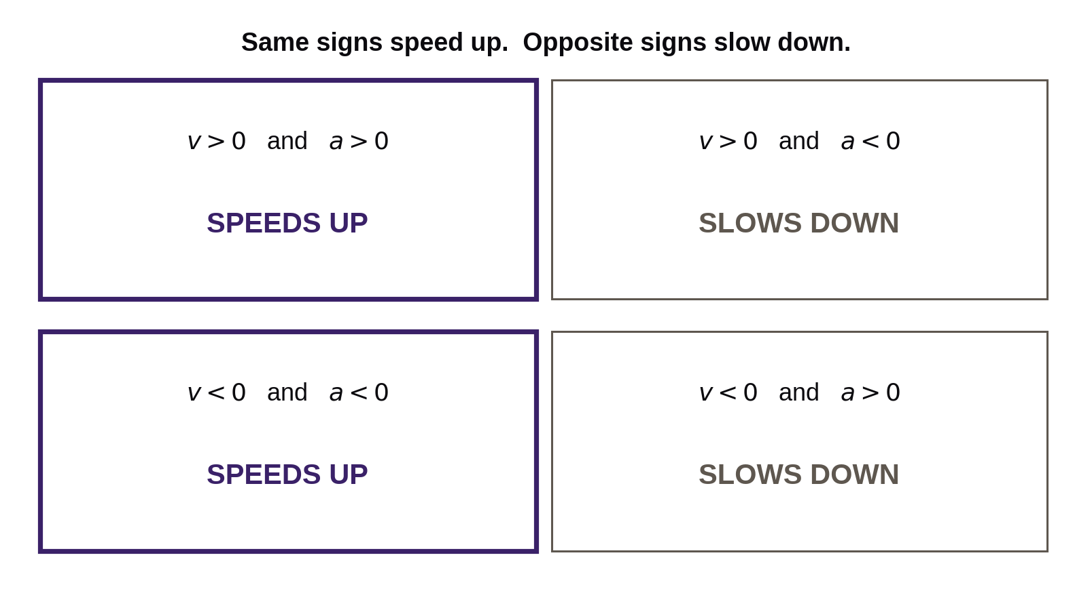  Same signs → the object _______________ . Opposite signs → the object _________________ .  ✎ Negative acceleration does not mean slowing down. Compare it to the sign of v.
THE FOUR EQUATIONS  Which quantity does each equation leave out?  What must be true about a for these to work? | CONSTANT ACCELERATION ONLY  A zero subscript marks a starting value: v₀ is the velocity at the start, v is the velocity at time t.  1 v = v₀ + at leaves out _______  2 Δx = v₀t + ½at² leaves out ____________  3 v² = v₀² + 2aΔx leaves out _______  4 Δx = ½(v₀ + v)t leaves out _______  ✎ List the givens, circle the unknown, then pick the equation missing the quantity you neither have nor want.
WORKED EXAMPLE  Why does part (b) not need the acceleration? | EXAMPLE — MERGING ONTO THE HIGHWAY  A car on an entrance ramp speeds up from 12 m/s to 26 m/s in 5.0 s. Direction of travel is positive.  GIVEN v₀ = 12 m/s · v = 26 m/s · Δt = 5.0 s  NEED (a) acceleration (b) distance covered on the ramp  WORK — CARRY UNITS  Answers: a = ______________ and Δx = _______ .
WORKED EXAMPLE  Which given is missing here, and which equation does that point to? | EXAMPLE — NO TIME GIVEN  A cart enters a 24 m stretch of track at 3.0 m/s and speeds up at a steady 1.5 m/s². Find its velocity at the end of the stretch.  GIVEN v₀ = 3.0 m/s · a = 1.5 m/s² · Δx = 24 m  NEED v at the end of the stretch  WORK — TAKE THE SQUARE ROOT LAST  Answer: v = ____________ .

SECTION SUMMARY — close your notes before you write this
In your own words: how do you decide which of the four equations to use, without trying all four?

SELF-CHECK
☐ I can calculate acceleration and give it a sign.
☐ I can say when a negative acceleration speeds something up.
☐ I can pick the right kinematic equation from the givens.

Position, Velocity & Acceleration Graphs | U1 / S1.3

LEARNING TARGET I can read velocity, acceleration and displacement off motion graphs, and I can sketch all three graphs for a described motion.

POSITION–TIME  What quantity is the slope?  What does a flat line mean? | SLOPE OF A POSITION–TIME GRAPH  Slope = rise ÷ run = Δx ÷ Δt, which has units of _______ — so the slope is the ______________ .  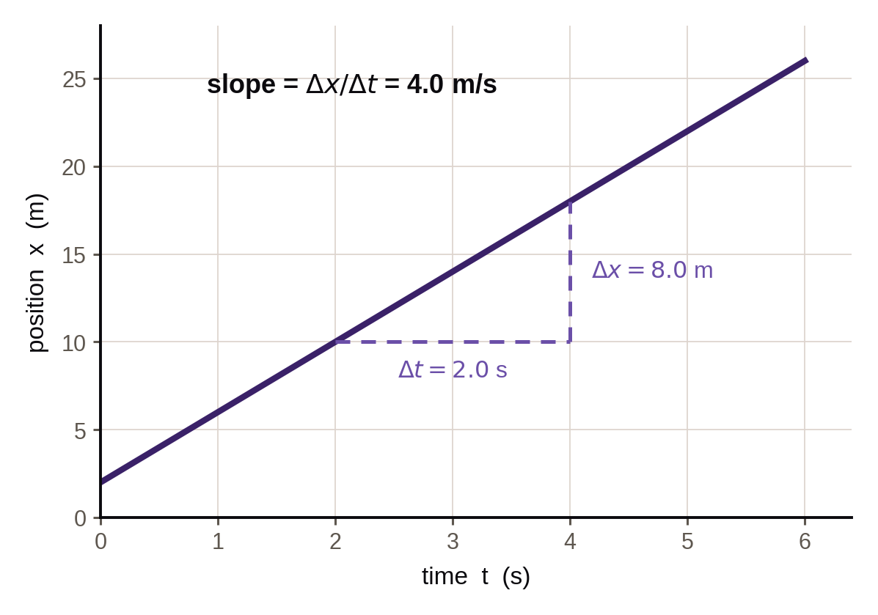  Straight line → constant velocity. Curved line → the velocity is ______________ , so there is an acceleration.  A flat line means the object is ____________ — not that it is at the origin.
VELOCITY–TIME  What quantity is the slope?  What quantity is the area? | SLOPE AND AREA ON A VELOCITY–TIME GRAPH  Slope = Δv ÷ Δt, in (m/s) per s, so the slope is the ____________________ .  Area = height × width = (m/s)(s) = m, so the area is the ____________________ .  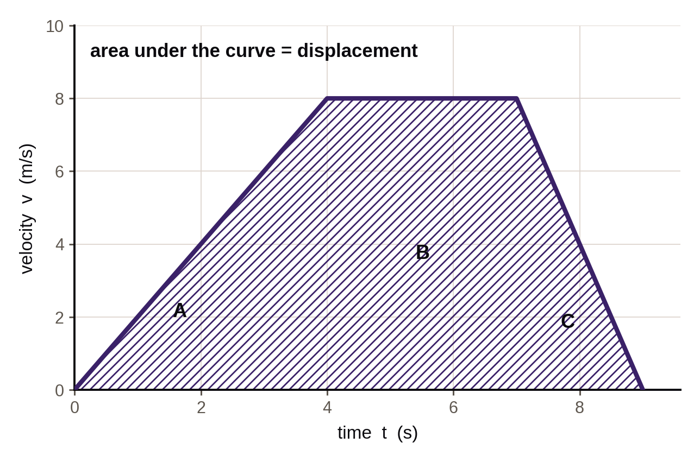  Break the shape into triangles and rectangles, then add. Area below the time axis counts as ______________ displacement.  ✎ Slope of x–t is velocity. Slope of v–t is acceleration. Area under v–t is displacement.
THREE MOTIONS  Sketch all three graphs for a cart moving at constant speed.  Which row is a straight line in all three? | ONE MOTION, THREE GRAPHS  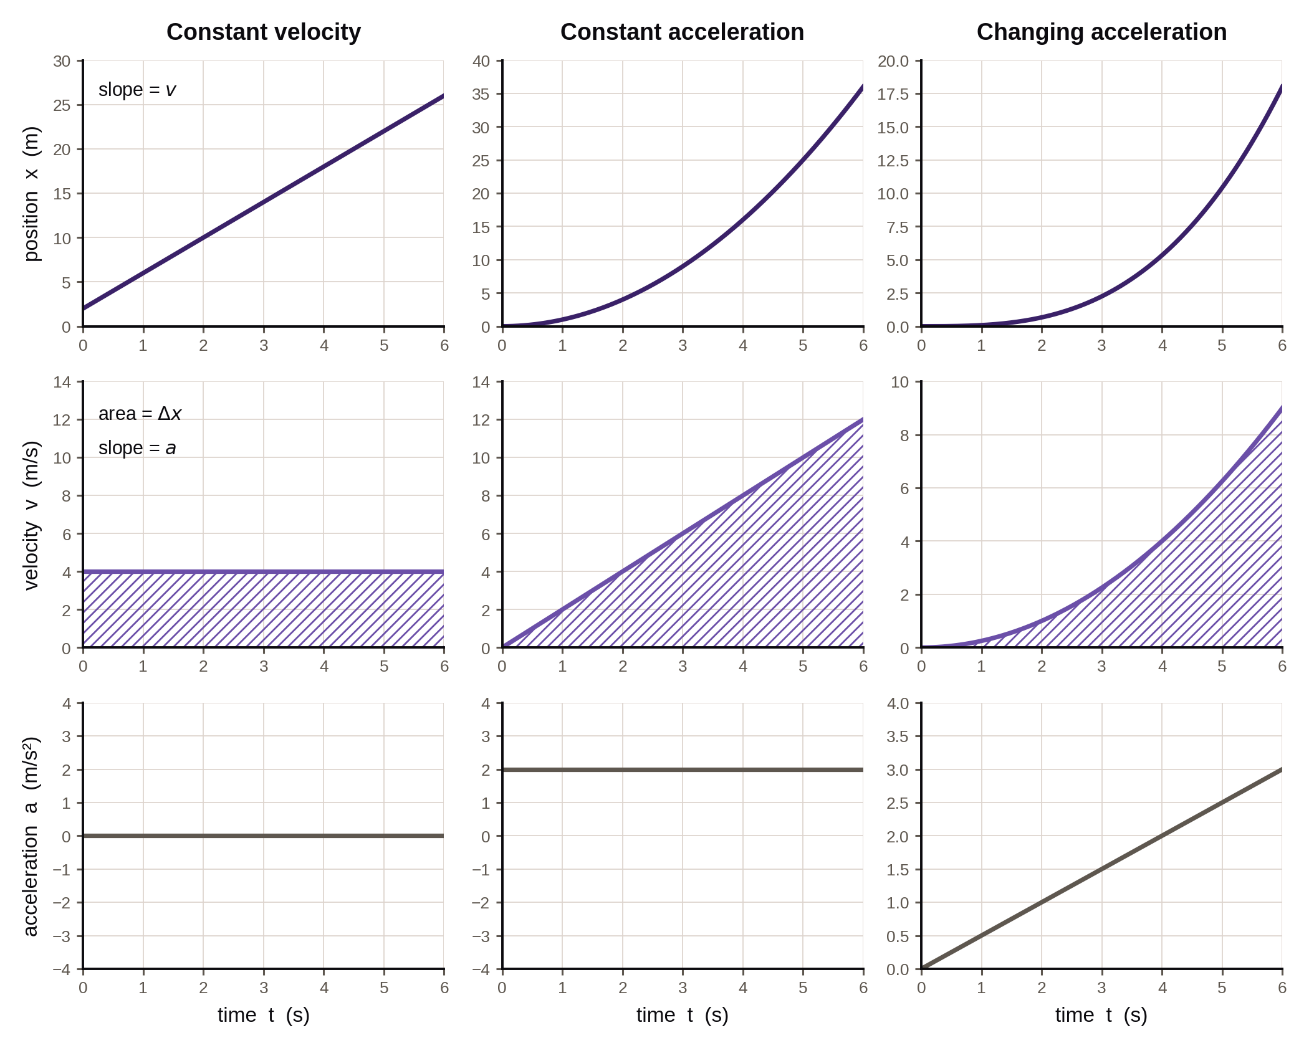  Constant velocity: x–t straight, v–t flat, a–t at _______ .  Constant acceleration: x–t curved, v–t ______________ , a–t flat but not zero.  Changing acceleration: a–t is itself a __________ line.
WORKED EXAMPLE  Why is no kinematic equation needed here? | EXAMPLE — READING A VELOCITY–TIME GRAPH  A cart speeds up from rest to 8.0 m/s in 4.0 s, holds 8.0 m/s for 3.0 s, then slows to rest in 2.0 s.  GIVEN leg A: 0 → 8.0 m/s in 4.0 s · leg B: 8.0 m/s for 3.0 s · leg C: 8.0 → 0 in 2.0 s  NEED (a) acceleration during leg A (b) total displacement  WORK — SHOW EACH AREA SEPARATELY  Answers: a = ______________ and Δx = _______ .

SECTION SUMMARY — close your notes before you write this
In your own words: a cart's x–t graph rises, levels off, then falls. Describe what the cart actually did, in three steps.

SELF-CHECK
☐ I can find velocity from the slope of an x–t graph.
☐ I can find displacement from the area under a v–t graph.
☐ I can sketch all three graphs from a written description.

Free Fall | U1 / S1.4

LEARNING TARGET I can solve vertical motion problems using a = −9.81 m/s² with up as the positive direction.

WHAT FREE FALL IS  What has to be true for an object to be in free fall?  Why does mass not appear in the answer? | GRAVITY AS THE ONLY FORCE  Free fall means ____________ is the only force acting — no air resistance, no push, no string.  Thrown up, thrown down, or dropped: all free fall once ______________ .  g = 9.81 m/s² downward. Taking up as positive, a = _________________ for the whole flight.  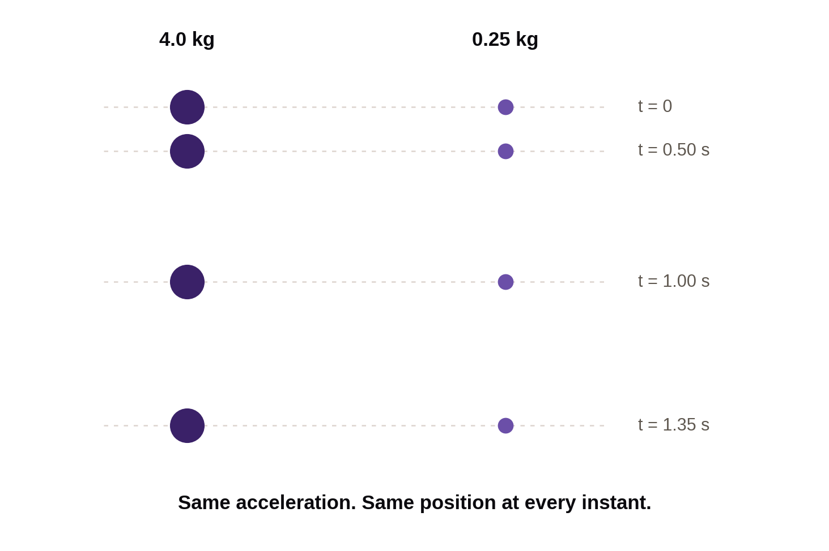  ✎ Mass is not in the kinematic equations, so mass cannot change the answer.
SIGNS & SYMMETRY  At the very top, what is v? What is a?  How does the time up compare with the time down? | UP IS POSITIVE, ALL UNIT  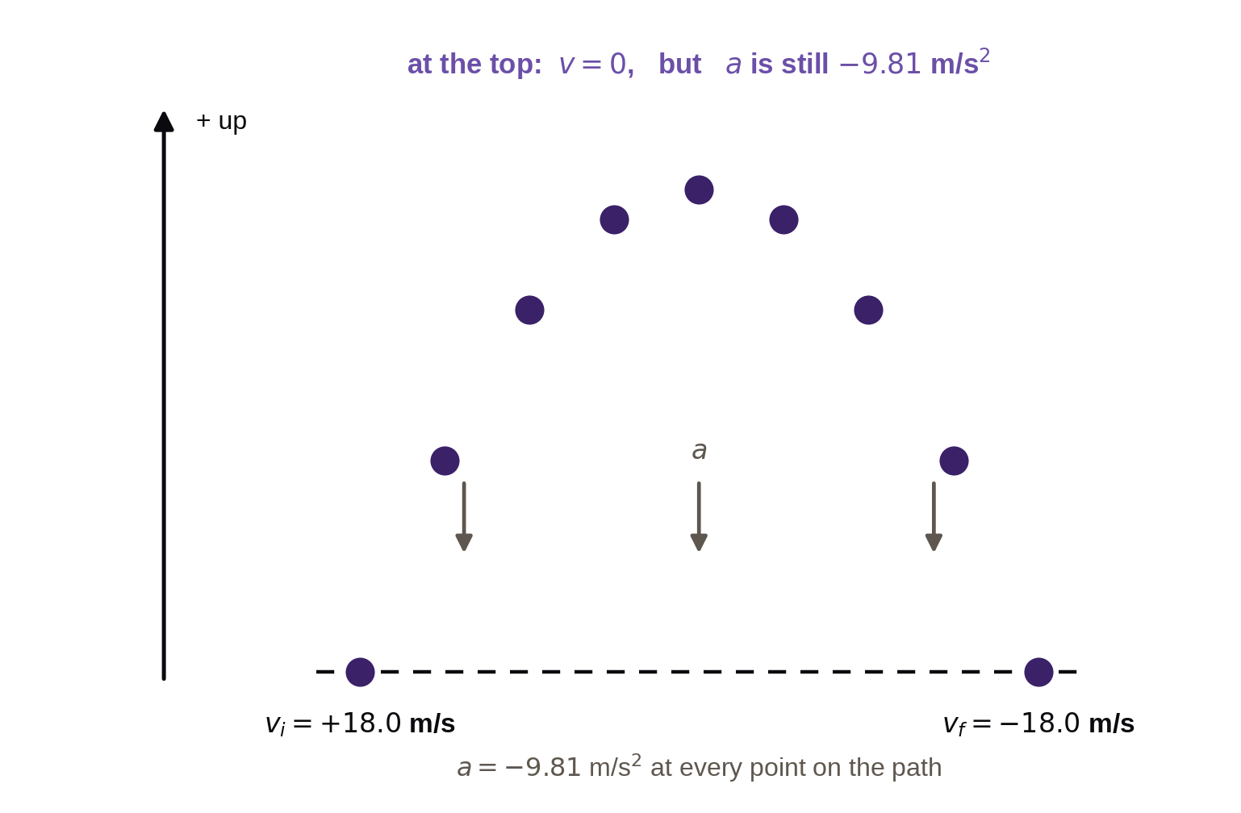  At the top of the flight v = _______ , but a is still _________________ . It never stops accelerating.  Between the same two heights, the time up equals the time _______ .  Thrown up at +18.0 m/s, it returns to that height at _______________ .  ✎ "At the top" is a given, not a question. It tells you v = 0 at that instant.
WORKED EXAMPLE  Which given comes from the phrase "at the top"? | EXAMPLE — THROWN STRAIGHT UP  A ball is thrown straight up from a student's hand at 18.0 m/s. Up is positive.  GIVEN v₀ = +18.0 m/s · a = −9.81 m/s² · at the top, v = 0  NEED (a) time to reach the top (b) height gained above the hand  WORK — WATCH THE SIGNS  Answers: t = __________ and Δx = ____________ .
WORKED EXAMPLE  Why is the displacement negative here? | EXAMPLE — DROPPED FROM A CLIFF  A rock is dropped from the top of a 45.0 m cliff. Up is positive and the cliff top is the origin.  GIVEN v₀ = 0 · a = −9.81 m/s² · Δx = −45.0 m  NEED (a) time to reach the ground (b) velocity on impact  WORK — BOTH NEGATIVES MATTER  Answers: t = __________ and v = _______________ , meaning 29.7 m/s downward.

SECTION SUMMARY — close your notes before you write this
In your own words: a ball is thrown straight up. Explain what happens to its velocity and to its acceleration on the way up, at the top, and on the way down.

SELF-CHECK
☐ I can state a = −9.81 m/s² and say why it is negative.
☐ I can explain why v = 0 at the top but a is not.
☐ I can solve a dropped-object problem with the right sign on Δx.

