Project 1

Title: Specification and Simulation of a Three-Level Inverter for Electric Vehicle Traction

Project Overview:
In an EV traction inverter, the converter fundamental frequency is not fixed; it follows the vehicle operating condition because it is directly tied to motor speed and torque demand, see figure below.
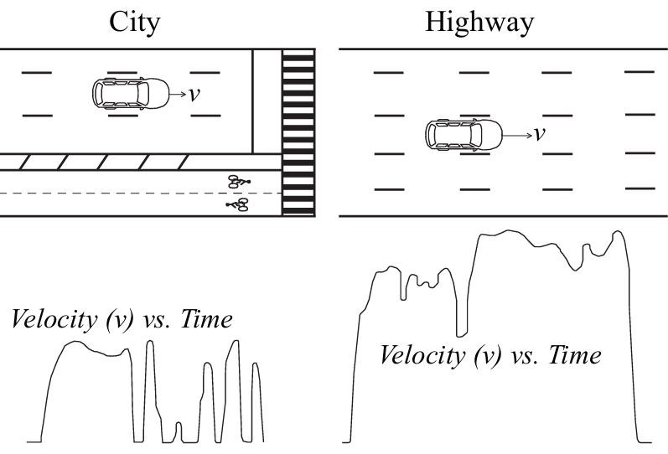

Under city driving, the vehicle experiences frequent acceleration and deceleration, so it spends most of its time at low rotational speeds, which implies lower motor electrical fundamental frequency. Under highway driving, operation shifts predominantly to higher sustained speeds, so the inverter fundamental frequency becomes higher. Since the electrical frequency is related to mechanical speed by $f_{e}=(P/2) n_{mech}/60$, higher vehicle speed leads directly to higher converter fundamental frequency. Also, the switching frequency can also be scheduled according to operating condition rather than kept constant: at lower-speed urban operation, the inverter may use a lower switching frequency to reduce stress on the semiconductor power switch, while as speed increases the switching frequency can be ramped upward up to a limit turn-on and turn-off losses. In this way, city and highway profiles naturally produce different combinations of fundamental frequency and switching frequency, allowing the converter to balance efficiency, torque quality, EMI, and switching stress across the drive cycle.

This project aims to provide students with practical insight through simulation-driven investigation in specifying and simulating a multi-level inverter for electric vehicle traction applications fed from batteries. Students will simulate a three-phase, three-level inverter, implement current control, and simulate its operation under a specific load profile.

Project Objectives:
- Understand Multi-Level Inverter Topologies: Research and select a suitable three-level inverter topology.
- Specify and Simulate the Inverter: Develop a detailed simulation model of the chosen inverter topology using software like MATLAB or PSIM.
- Compare the impact on semiconductor temperature when the inverter switching frequency is varied according to the operating condition versus a baseline case in which the switching frequency is kept constant (e.g., 20 kHz).
- Prepare a comprehensive report documenting your work (follow the IEEE conference-paper template), simulation results, and analysis, and present the findings in a 10-minute video, emulating the format typically used for conference presentations (use PowerPoint describing what is in the report/paper).

Project Requirements:
- Topology Selection:
  - Students must specify the components used in terms of voltage, current, and frequency.
  - Provide a clear figure of the schematic of the chosen topology.
- Simulation and Modeling:
  - Develop a detailed simulation model including:
    - DC voltage source.
    - Switching devices (e.g., IGBTs, MOSFETs).
    - Clamping diodes or capacitors (depending on the topology).
    - RL load (R = 1.3 Ohms, L = 2 mH).
  - The load is three-phase; for simplicity, it may be modeled as an RL load, although in the actual application the inverter would be connected to an electric machine.
- Performance Analysis:
  - Analyze the simulated output current waveform to verify expected behavior.
  - Measure the temperature across the semiconductor devices for different operation conditions of frequency.
- Documentation and Presentation:
  - Prepare a comprehensive project report/paper detailing the specification, simulation results, and analysis. The report must be written in an IEEE paper format, i.e., following the attached template (http://www.ieee.org/publications_standards/publications/authors/author_templates.html). The reports should include: Abstract, Introduction, Modeling, Simulation Results, and Conclusions.
  - Record a video of at least 10 minutes presenting the paper using PowerPoint.

More information:
When preparing a manuscript according to Institute of Electrical and Electronics Engineers (IEEE) guidelines, the introduction should clearly establish the context, motivation, and contribution of the work. The section typically begins by presenting the broader problem area and its relevance to the research community, followed by a concise review of the most relevant prior studies. This literature discussion should naturally lead to the identification of existing gaps or limitations in the current state of the art. The introduction should then state the objective of the present work and clearly summarize the main contributions of the paper. In most IEEE papers, the introduction concludes with a brief outline of the structure of the manuscript.

IEEE uses a numbered citation style in which references are cited in the text using square brackets, such as [1], [2], or [3]–[5]. Citations should appear in the order in which the references are first mentioned in the text. The reference number is placed inside the brackets and typically appears before punctuation marks. When referring to prior work within a sentence, it is recommended to integrate the citation smoothly into the narrative (e.g., “Previous studies in [4] and [5] investigated…”). In the reference list, entries are ordered numerically according to their appearance in the manuscript and must follow the IEEE reference format, including authors, title, publication venue, volume, pages, and year.

The writing style in IEEE manuscripts should be formal, concise, and technically precise. Authors should avoid overly long sentences, informal language, and unnecessary repetition. Passive voice is commonly used in engineering writing when the focus is on the process or results rather than the authors (e.g., “The converter was tested under different operating conditions”). Figures and tables should be clearly referenced in the text, and all technical claims should be supported by analysis, experimental results, or properly cited literature. Overall, clarity, logical organization, and precise technical language are essential characteristics of effective IEEE-style writing.

