Developing an action game

Analysis:

Background and Identification of the problem:

Video games are something my friends and I enjoy playing in our spare time. One of the types of video games we enjoy is the 2d roguelike and platformer genre.

With the rise of powerful game engines which seem to improve nonstop such as unity and unreal engine, 3d games are becoming more and more prevalent as they become easier to make. This is evident from many websites giving opinions on the best games that came out this year e.g. polygon.com shows there opinion on the best games of the current year Only 2 of 20 games were 2d. Hence many people who would say they enjoy 2d games will not have as much content to play This year. I asked many of my friends and online lovers of the genre on what they are currently playing in their spare time all of which stated as a summary: that either they weren’t playing anything due to lack of anything new or they were playing older games that came out years ago.

As I study computer science my friends have asked me to make a 2D roguelike platformer action-adventure game, for all of us to play. This means we can have control on things we want inside the game to keep it fun and be able to add new fresh ideas to it to keep it interesting when it gets repetitive. Furthermore, this will give us more ideas to suggest to game developing companies to incentivise potential new games to come out.

*links to information I used above:*

*polygon.com best games of 2022:* <https://www.polygon.com/what-to-play/22956981/best-games-2022>

# Description of the current system:

For simplicity I have decided to make this a specifically computer-based game. This simplifies the need to add support for other input methods such as controller input for console or touchscreen input for mobile. This also narrows down the current systems available. While there are many different types of applications that explore different mechanics the best example of a current system would be games such as ‘dead cells’, ‘HP sword’ and ‘celeste’. These are very famous games in the target genre. While there are others to due to my lack of artistic skills I’ve decided to choose systems that use simple pixel art type graphics.

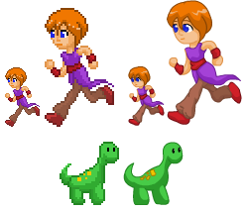

Drawing in pixel art will be simpler as less detail is needed to produce a good result as well as taking less time to do.

Firstly, Dead Cells (the game in the picture below) makes use of a controllable player that can walk, roll, attack and jump. It also makes use of procedural world building to create new worlds to explore. This is something a lot of games that fit into this genre use and would be an interesting thing to add in order to make the game less repetitive and keep it being fun for longer. Enemies are what make the experience interesting. The way Dead cells handles enemies is by checking for when the player comes into a certain range of the enemy. If the player steps into this range, they get the enemies ‘Aggro’. This means they’ve spotted you and will run after you so that they can attack you. Due to complex terrain the ai has to be able to navigate its way around to get to the player. If it can catch up to you then it will try to hit the player. It seems dead cells enemies as well as other enemies in the other above listed systems seem to all go for slow but high range attacks. They deal high amount of damage to the player and incentivise the player to try and dodge there attacks with abilities such as the roll mentioned beforehand. The roll works by making the player immune to all damage for a certain amount of time but unable to attack. This ability can only be used again after a second or so.

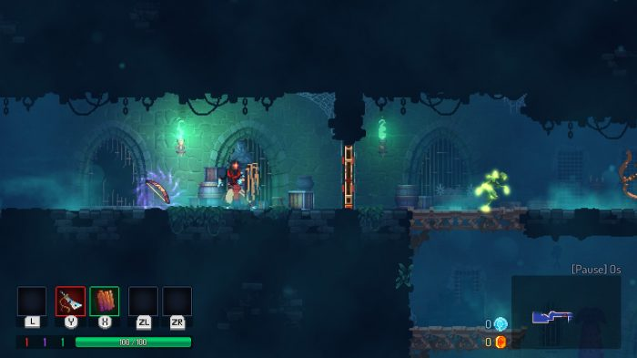

The screen has a:

Powerups , Hp Bar, Inventory , Map , Gold amount , In game time

Despite having quite a lot different things on the screen attention stays on the player this is most likely done through correct use of colour. Despite this the screen could be argued to be rather cluttered and could decrease in the amount of things shown. For example while in game time and a map is useful if a map was truly needed then a button could be allocated to bring up a map. Furthermore, the in-game time isn’t very useful unless you want to try to complete the game as quick as possible.

One of the things that Dead cells makes use of a lot is interesting particles and lighting which could be something to add to make the game more appealing to look at while playing.

Looking at reviews of the game to see what people found interesting were similar things already stated such as the procedurally generated world and the interesting combat and enemy system. One of the aspects of the game reviews thought was rather unlikable about the game is the difficulty. Some friends of mine also agree that the game can be challenging and while sometimes that’s a nice thing but other times for example to de-stress can be a less attractive feature.

*links to information I used above:*

*pixel art vs vector art:* [*https://www.deviantart.com/moosader/art/Pixel-sprites-vs-Vector-sprite-134830250*](https://www.deviantart.com/moosader/art/Pixel-sprites-vs-Vector-sprite-134830250)

*dead cells : https://switchplayer.net/2018/08/07/dead-cells-review/*

# Identification of the prospective user(s):

The game will probably be in the interest in users who have played similar types of games and have access to a computer. Furthermore, the age range of teens so 13 and above. I will attempt to use as many video game conventions as possible e.g. using the ‘w’, ’a’, ’s’ and ’d’ keys for movement as well as the space bar for jumping. This will make the controls easy to get the hang of by users who have used similar systems before which as I said is most likely the type of user who would use this system. As stated, I have many friends who play games in this genre who I’m sure would be eager to give ideas for the project via interviews.

# Identification of users’ needs

### To understand the users’ needs I set up an interview with some of my friends who count as prospective users; All of which claim to enjoy 2d video games. I asked them all the same questions and recorded their answers. Here are the questions and the results I got from them:

## Question 1:

Question:

What is your favourite 2D games do you enjoy playing?

Reason for this question:

To understand and get inspiration on current systems.

Answers:

Many of the answers was dead cells which was too be expected as it is quite famous. The second common answer was ‘Hollow night’ and the third being ‘Hades’ after doing research both games share very similar concepts when abstracting all 3, they can be summarised as the user can control a character (move around and attack using a melee weapon). There is an environment you can explore but there will be enemies along the way you must defeat to get to the end of the game which is usually a boss.

## Question 2:

Question:

What do you like about the game you stated in question 1?

Reason for this question:

It would be good to gauge the main aspects of interest when it comes to the current systems and focus on them.

Answers:

Answers usually commented on either the combat system of the game or the procedural generation. With a couple stray answers such as interesting artwork or story. Many said they liked the speed of the combat in the current systems and how smooth it is. Those who said procedural generation thought when done right can make the game more interesting and less repetitive as well as making the game harder in a fun way.

## Question 3:

Question:

is there anything you dislike in the game you just said?

Reason for this question:

It will be useful to know improvements on the current system. Correcting things that went wrong in the current system will make the game more fun and playable.

Answers:

Most of the answers were unsure but the answers I did get were mainly: for games such as dead cells were disliking the difficulty of the game being to easy at sometimes but too hard in the others. Another dislike about current systems were the ability to save the procedurally generated world so that you can come back to it if you want to.

## Question 4:

Question:

How would you solve this issue (if stated one)

Reason for this question:

It will be useful to see how they user would want a solution to the problem they had with the current system. This will give me ideas on how I will solve the problem.

Answers:

Most of the Answers to the difficulty of the game were creating a difficulty option for each specific world created depending on how the user feels at the time. And being able to save the world in an in-game menu which can be retrieved somewhere in the startup/main menu would work quite well.

## Question 5

Question:

What essential systems are needed in your opinion?

Reason for this question:

While similar to question 2 it would be great to know if there were systems in place which whilst may not be fun might still need in the game to make it harder or more interesting or other ways that the game needs in order to be any good.

Answers:

The majority repeated their answers in question 2 but some also added that good animations and difficulty options were both very essential for the game in their mind. When asked why, good animations draw the user in, and difficulty options are good for the mood of the player.

## Question 6:

Question:

Do you enjoy sword or gun combat more?

Reason for question:

the current systems usually have both melee and ranged combat (swords and guns) but due to time constraints and simplicity I will only be adding one weapon so it’s best I understand which one is the most enjoyable.

Answer:

The results from this were mainly a sword combat system when asked why the reason seemed to come down to gun combat makes the screen to cluttered from all the bullets on the screen. This will make it easier to do fun combat in general as the player has to risk getting close to the enemy to damage the enemy.

## Question 7:

Question

State your opinion on the current systems enemy Ai?

Reason for question:

Understanding what the prospective users thoughts on the current systems enemy Ai is crucial as it will be one of the hardest things to create.

Answers:

All answers either thought the ai is done extremely well or they were done well on the current systems. I got no answers stating they didn’t like the current systems enemies.

## Question 8:

Question:

What makes a good enemy AI?

Reason for questions:

Now I have asked what they thought of it I need to understand the reasoning behind why it’s good or bad the users mind.

Answers:

Firstly, users who thought the ai was done fabulously, in summary, explained that:

* The Ai was smart and new best when to strike.
* The Ai intentionally left openings for the player to attack in.
* The Ai was able to chase after you whilst navigating obstacles.

Those who said the ai was okay stated the same positives above but when asked why it was just okay to them said:

* The Ai in a lot of current systems was too hard.
* “The Ai would just teleport to you if you got to far which is annoying”.

## Question 9:

Question:

Do you understand the limitations of the project?

Reason for this question:

The prospective users must understand that I have a time limit and being a solo developer on this project with only moderately good art skills may not produce a the most preface desirable result.

Answers:

All the people understood but stated that the game does not have to be perfect. One of the users said: “a de-stressing tool for the time being would be great right now as my exams get closer”.

Question 10:

Question:

What is something you’d like to see in the game that isn’t in the current system?

Reasoning:

A final question just to get some ideas to make the game different from the current system.

Answers:

Most were unsure some like the idea of a rich story but due to time constraints I’m unsure I will be able to get it done. An interesting answer was character creation which I think it could be an interesting system to implement which not a lot of current system for this application type do often.

# Acceptable limitations:

As I don’t have a lot of time I need to make sure that certain systems as mandatory and others as optional. Looking over the time I have and the information I collected in my interviews I can say that a good combat system and procedural generation with an interesting enemy Ai will be something I must complete. These set requirements are in place as they seem the most important things to making the application fun for the prospective users. However, the combat system will be reduced from the current systems design to a single close-range sword. The procedural generation will be made to output different worlds that can be navigated but there will only be enemies to find In the world. This means that a good challenging ai to fight will be crucial and something I must spend a lot of time on to make the game fun. Additionally in the last question of the interview I mentioned the interesting idea of a character creation. Due to the time constraints and research, I will have to limit myself into just the addition of naming the users character.

# Objectives

### With the following information in mind my objectives for the project are:

THE MAIN MENU:

1. **Startup menu:**

The program should have a startup menu with the game title at the top and to allow the users to easily select one of the following options.

* 1. Play
  2. Exit
* Play button leads to the character menu.
* Exit button closes the application.

1. **Character Menu**

When the user clicks the ‘Play’ button in the startup menu it should take the user to this screen. It has A title on top: ‘Characters’ and has a list of options:

* 1. Create new character.
  2. Character list
  3. Back
* Create new character option takes the user to the character creation menu.
* Character list takes the user to the character selection menu.
* Back takes the user back to the startup Menu.

1. **Create new character Menu:**

When the user clicks the Create new character option in the Character menu it will take the user to this screen. It has the title ‘Create new character’ on the top of the screen and text prompting the user to enter a chosen name for their character into a bar below it. Underneath all that there are two options next to each other:

* 1. Submit
  2. Back
* The submit button will create the player record and save it to a database then take the user to the world menu.
* Back returns the user back to the character Menu.

1. **Character selection menu:**

**If** the user **selected the character list option in the character menu, then this screen will be returned. It has the title load Character at the top of the screen. Below it there is a box which will display all the characters saved** the user **can scroll through them if they all don’t fit in the box and select one which will then be highlighted. Next to the box is a list of options:**

* 1. **Submit**
  2. **Back**
* **Submit will then take** the user **to the world menu screen.**
* **Back returns** the user **to the character menu.**

1. **The world menu:**

When the user has created/chosen a character the system will take the user to this screen. It has the title “Worlds” on top of the screen and two options below it:

* 1. Create new world.
  2. World list
  3. Back
* Create new world takes the user to the world creation menu.
* World list takes the user to the world selection menu.
* Back takes the user back to the character menu.

1. **World Selection menu**

**If** the user **selected the world list option in the world menu, then this screen will be returned. It has the title ‘load world’ at the top of the screen. Below it there is a box which will display all the worlds saved.** the user **can scroll through them if they don’t all fit inside the box and when select a world that world name will then be highlighted. Next to the box is a list of options:**

* 1. **Submit**
  2. **Back**
* **Submit will then start the game.**
* **Back returns** the user **to the world menu.**

1. **World creation menu**

When the user clicks the Create new world option in the world menu it will take the user to this screen. It has the title ‘Create new world’ on the top of the screen and text prompting the user to enter a chosen name for their world into a bar below it. Underneath all that are too options next to each other:

* 1. Submit
  2. Back
* The submit button will take the user to the difficulty option menu.
* Back returns the user back to the world Menu.

1. **Difficulty menu**

When the user creates a name for a new world and presses submit the system takes the user to the difficulty menu where the title at the top is ‘create new world’ below that is text prompting the user to select a difficulty with 3 options each next to each other (a, b, and c) and one below all of them (d):

* 1. Easy
  2. Normal
  3. Hard
  4. Back
* Easy, normal, hard starts the game in the world created with the corresponding difficulty and saves this world.
* Back returns the user to the world menu.

THE GAME:

1. **After selecting/creating a character and a world the game will start.**
2. **the world will be generated with a random seed if the user created a new world or with a saved seed if the user selected a world.**
3. **When the world is created Enemies are place randomly around the world.**
4. **the screen is constructed in this manner:**
5. **The user should be able to press the ‘a’ key to move left, the ‘b’ key to move right, the spacebar to jump, left shift to dash in a direction and left click to attack with a sword.**
6. **the enemies should follow the player if player gets close.**
7. **the enemy will try to attack the player if they get close enough.**
8. **If the player gets hit by the enemy attack, there hp goes down.**
9. **If the enemy gets hit by the players attack, there hp goes down.**
10. **If the player presses shift then they can no longer take damage for a second.**
11. **If the enemies hp goes to 0 then they will disappear**
12. **If the players hp goes to 0 then they will die**
13. **If the player dies a death screen pops up**
14. **The death screen gives the user the option to exit or respawn.**
15. **Exit closes the game.**
16. **Respawn puts the players health to 100% and puts the player in the spawn location (the start)**
17. **the user can press ‘escape’ to go to the in game menu**
18. **the in-game menu displays as:**
19. **save- saves the players data.**
20. **exit – closes application.**

Design

# Human-Computer-Interface Rationale

1. Menus

All the menus in the game will similar a title a list of options or prompts with the occasional special interaction such as a type bar. The idea is to keep it simple and easy to understand which screen you at and be able to navigate easily with easy-to-understand buttons.

1. Game

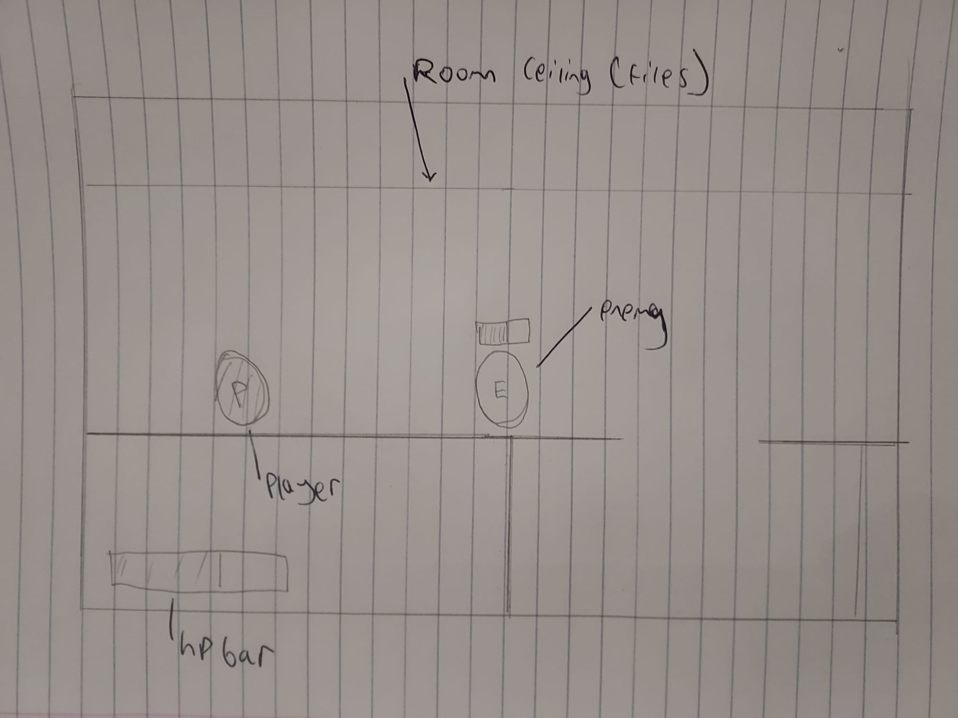

Enemy hp bar

This is the in game Ui where the hp Bar is the only thing that is constantly on the screen for each enemy there will be a hp bar above there head. Hence the screen is very abstracted and easy to understand.

# 

# Potential solution:

Game engines such as unity could make making the game simple due to their expanse in different functionality that can be easily applied. But due the complexity of unity a lot of abstraction is done on a lot of the systems meaning a lot of control with aspects such as the physics is out of my control (for the most part). Through my research I found many different solutions to ways I can go about achieved the desired application. Narrowing it down I decided I’d choose between Pygame and Godot. Pygame is a module you can import in Python and Godot is an engine which makes use of its own language GDScript. These both seemed like good candidates as through my research they seem simple to use, have the ability to make the type of game I would like and use a language I’m quite proficient in python (GDScript being very similar to python). On the one hand Godot is much more powerful in terms of implementing features. Furthermore, performance wise Godot is better then Pygame due to Pygame only using the CPU whereas Godot making use of the CPU and the GPU. On the other hand Pygame simplicity makes it a lot more approachable and as I said before Pygame leaves all the implementation of features such as physics and animations down to the programmer. Through research I found that Pygame is agreed upon as easier to learn then other engines such as Godot because of it’s simplicity. This is why I thought it would be best to go with Pygame. The idea of it is to get the core fundamentals of the game down in Pygame and if the game continues to get updated perhaps I could transpose from Pygame to Godot at some point in the future.

Python will work very well with the structure of the system as python allows for object orientated approaches to problems. It will also be easy to do lots of mathematical operations in general and on arrays. This is useful as I will be doing a lot of array mathematics due to working with a coordinate system.

Other then Pygame Python has a multitude of different modules to work with for example to random module will come in use when I need to generate random numbers for enemy locations and world generation. The math and NumPy module will come in handy too for the mathematical side of the application which was summarised above.

# Identification of validation required

|  |  |  |  |
| --- | --- | --- | --- |
| Form | Data Item | Check type | Check details |
| Main menu | Name of character | Length | Length must be larger than 0 letters |
| Main menu | Name of world | Length | Length must be larger than 0 letters |
| Main menu | Name of character | Length | Length must be shorter than 10 letters |
| Main menu | Name of world | Length | Length must be shorter than 10 letters |
| Main menu | Name of character | Format | Name must be in letters e.g. no numbers or symbols |
| Main menu | Name of world | Format | Name must be in letters e.g. no numbers or symbols |

# Modular system design:

# Object orientated designs:

**Data source(s) and destination(s)**

|  |  |  |  |  |
| --- | --- | --- | --- | --- |
| Data name | Description | Source | Destination and process | Data volume |
| saved progress | After playing the game the user may want to continue playing with the progress, they’ve achieved another time so the user will press the save button | The user (the person playing the game) | the data will have to be stored locally on the user’s computer to be retrieved later |  |
|  |  |  |  |  |
|  |  |  |  |  |
|  |  |  |  |  |
|  |  |  |  |  |
|  |  |  |  |  |
|  |  |  |  |  |

**Data dictionary:**

CHARACTER

|  |  |  |  |
| --- | --- | --- | --- |
| Variable | Data Type | Description | Relationships |
| CharacterID | INT(4) | The key for the character entity | None |
| Name | CHAR(255) | The name of the character | None |
| HP | INT (4) | An integer that holds the amount of hp a specific character has. | none |

WORLD

|  |  |  |  |
| --- | --- | --- | --- |
| Variable | Data Type | Description | Relationships |
| WorldID | INT(4) | World entity key | Foreign key to the settings entity and the saved entity |
| Name | CHAR(255) | Stores the name of the world | None |
| seed | INT(12) | An integer that is used to create the world | None |
| dateOfCreation | DATE | Holds the date of when the world was created | None |

SAVED

|  |  |  |  |
| --- | --- | --- | --- |
| Variable | Data Type | Description | Relationships |
| worldID | INT(4) | World entity key | Links to the world entity |
| CharacterID | INT(4) | The key for the character entity | Links to the character entity |
| Xpos | DOUBLE(6,3) | A float that holds the x position on the map of the character it belongs to | None |
| ypos | DOUBLE(6,3) | A float that holds the y position on the map of the character it belongs to | none |

WORLDSETTINGS

|  |  |  |  |
| --- | --- | --- | --- |
| Variable | Data type | Description | Relationships |
| worldID | INT(4) | World entity key | Links to the world entity |
| difficultyLevel | INT(4) | A number that denotes the difficulty of the game | Links to the difficulty entity |

DIFFICULTY

|  |  |  |  |
| --- | --- | --- | --- |
| Variable | Datatype | Description | Relationships |
| DifficultyLevel | INT(4) | Difficulty level of the game | Relates as a foreign key to CHARACTER entity |
| EnemyHPMultiplier | INT(4) | A multiplier for the base enemy hp for a specific difficulty | None |
| EnemyAttackMultiplier | INT(5) | A multiplier to the base damage of an enemy’s attack for a specific difficulty | none |
| Name | ENUM | The name of the difficulty e.g. “easy” | none |

APPLICATIONSETTINGS

|  |  |  |  |
| --- | --- | --- | --- |
| Variable | Datatype | Description | Relationships |
| Fullscreen | Bool | A if true the application will be in Fullscreen (take up the entire space of the monitor)  If the application will be the size of a specific resolution | None |
| Resolution | ENUM | The resolution of the application window | None |
| Volume | INT(2) | Percentage for the volume of the game | None |

**Entity relationship diagram:**

**Data Flow diagrams:**

Proposed menu system: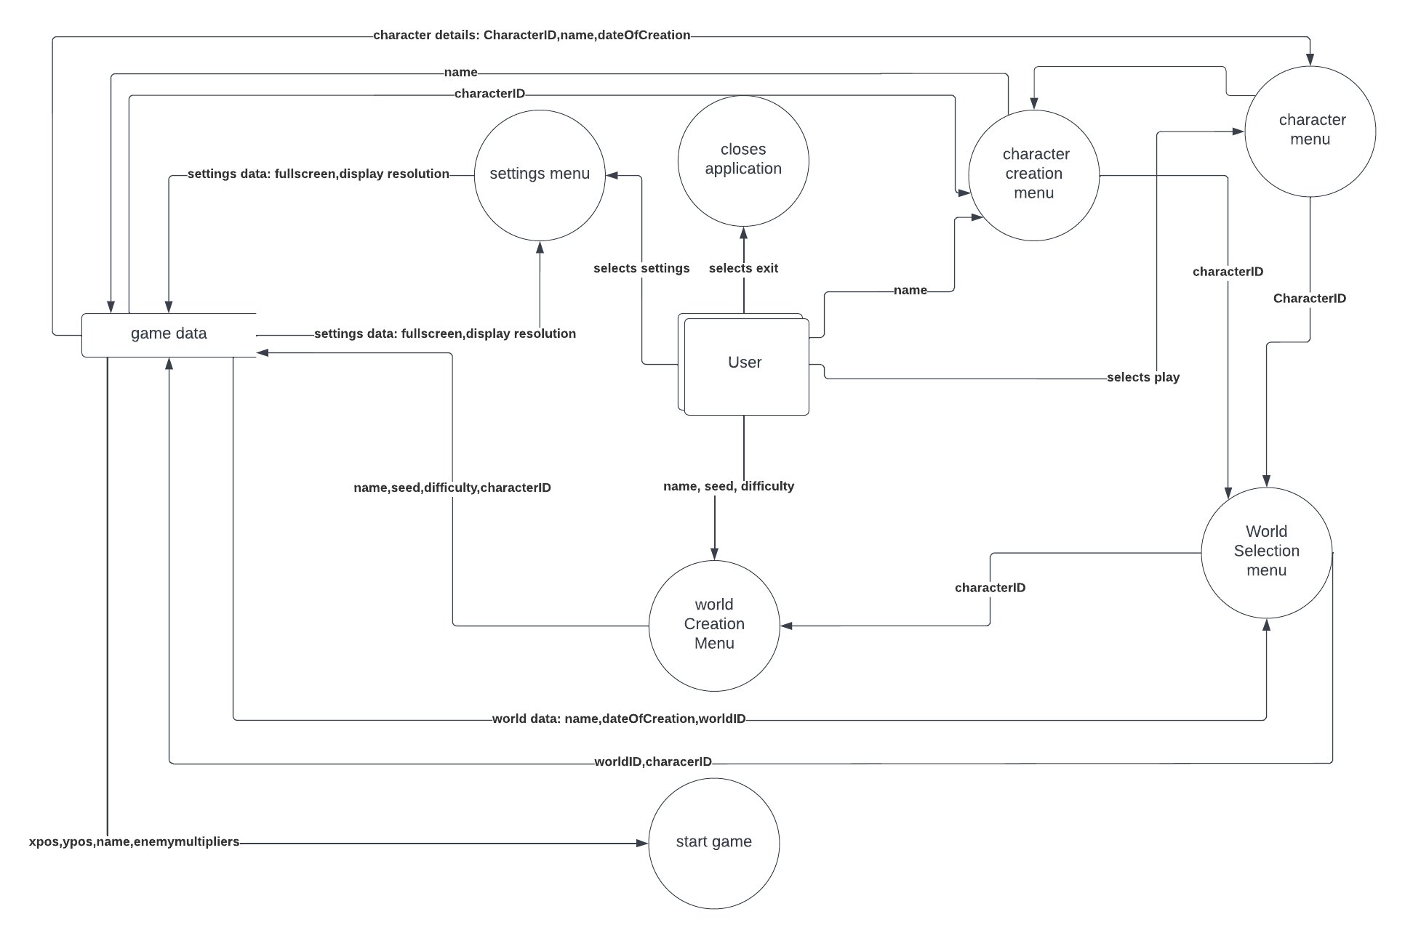

Proposed system for game



