Lab 9 - Profiling in Python
Hayam Itani

Before optimisation

cProfile
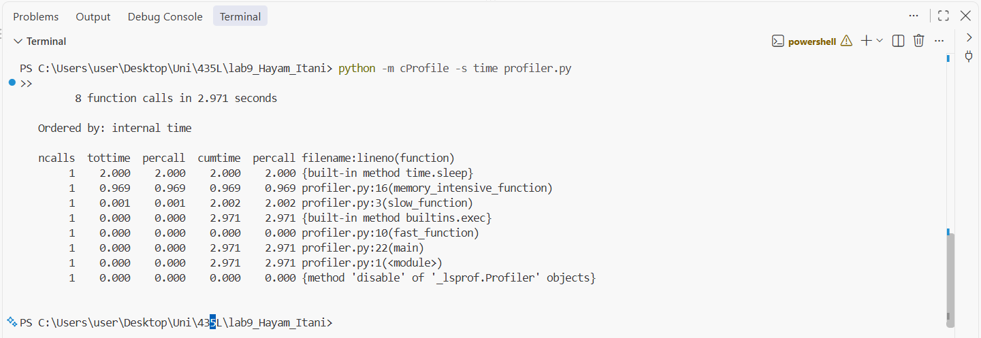
The program took 2.971 seconds in total. Most of this time is time.sleep, which takes 2 seconds inside slow_function. The second slowest part is memory_intensive_function with 0.969 seconds, because it loops 10 million times. fast_function took almost no time (0.000 s).

line_profiler
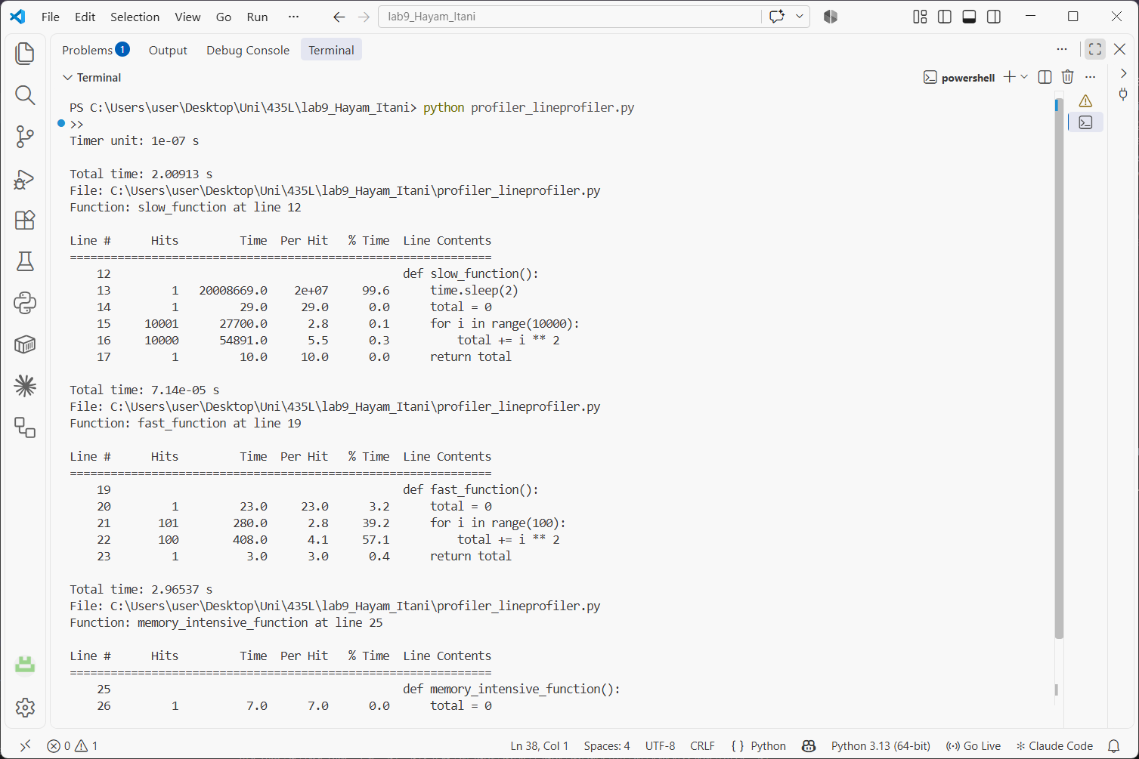
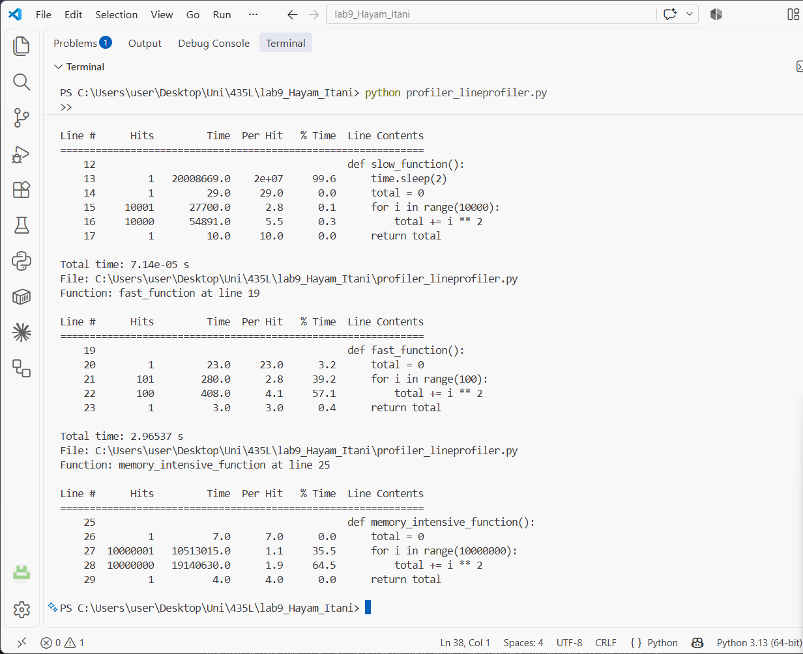
In slow_function, the time.sleep(2) line takes 99.6% of the time and the loop is only a very small part. fast_function took about 71 microseconds in total, mostly on the for line (39.2%) and the total += i ** 2 line (57.1%). In memory_intensive_function, the for line takes 35.5% and total += i ** 2 takes 64.5%, since each one runs 10 million times. This function took 2.97 seconds here, compared to 0.97 seconds with cProfile, because line_profiler slows the code down by timing every line.

memory_profiler
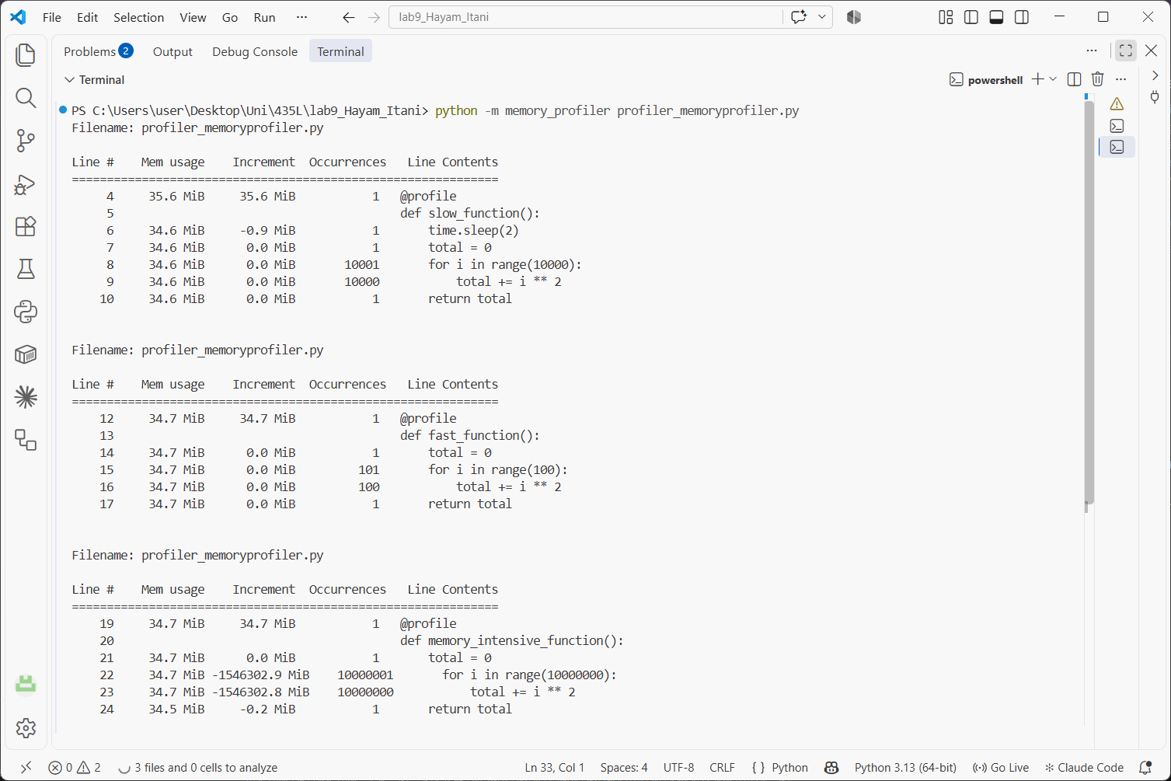
Memory usage stays around 34.6 to 34.7 MiB in all three functions, so none of them really increases memory. memory_intensive_function only stores one number (total), and range does not create a list, so it uses a lot of CPU but not memory. The big negative values in the Increment column (‑1546302.9 MiB) are not real. memory_profiler adds up the change on every loop iteration, so for a loop that runs 10 million times this number is meaningless, and the Mem usage column is the one to look at.

test_profiler and coverage
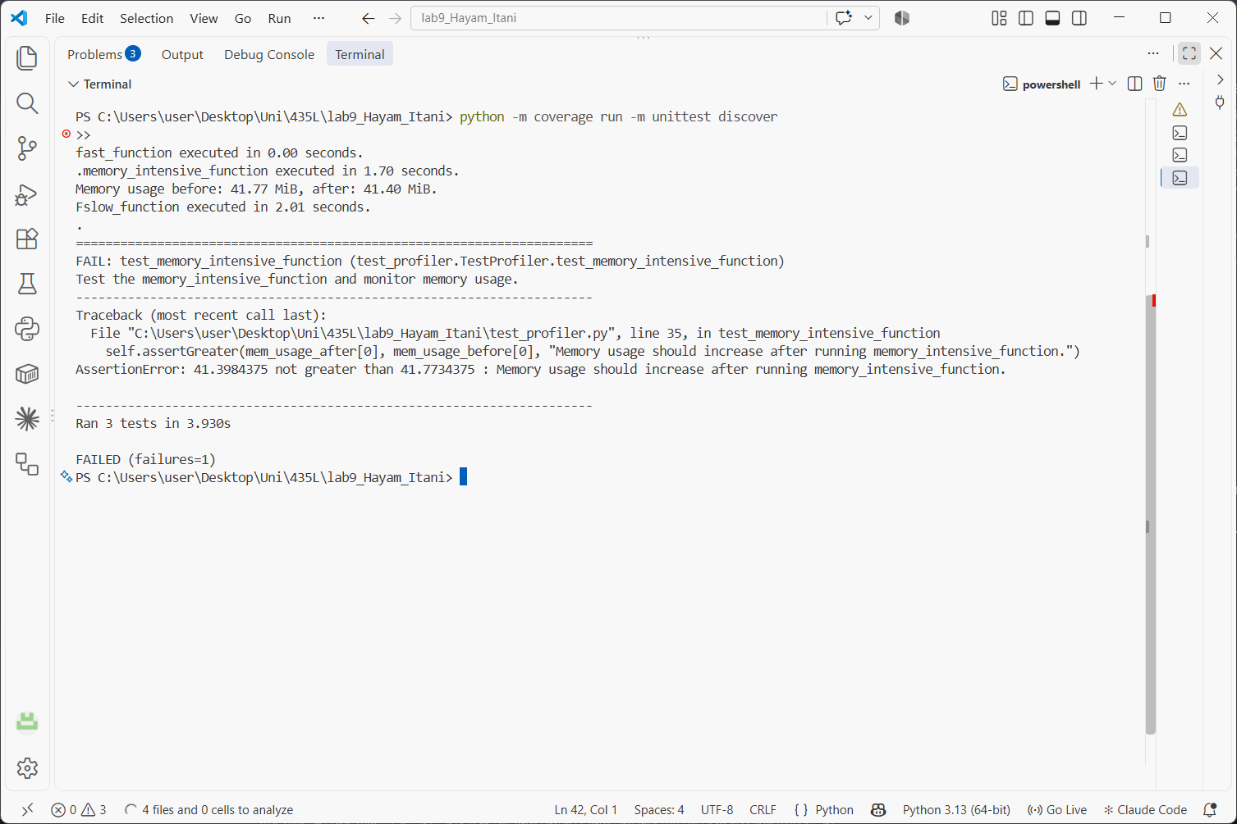
3 tests ran in 3.93 seconds. test_slow_function (2.01 s) and test_fast_function (0.00 s) passed. test_memory_intensive_function failed: the time was fine (1.70 s), but memory went from 41.77 MiB to 41.40 MiB, while the test expects it to increase. This matches the memory_profiler result, since the function does not use extra memory.
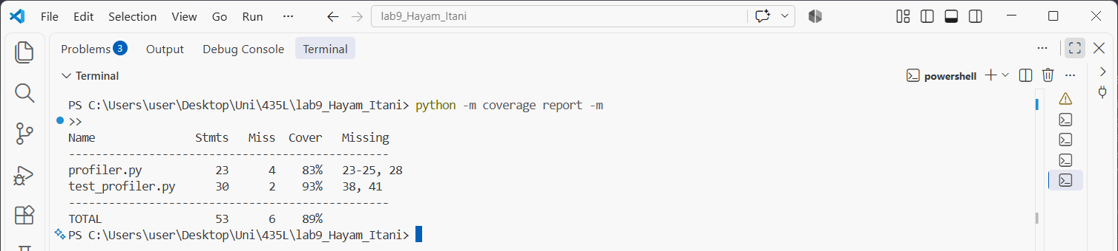
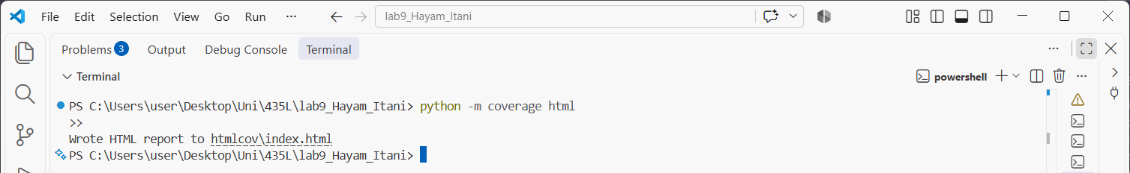
Coverage: profiler.py is 83% (23 statements, 4 missed), test_profiler.py is 93% (2 missed), and the total is 89%.
Lines not executed: in profiler.py, lines 23-25 (the three calls inside main()) and line 28 (main() under if __name__ == "__main__") were not run, because the tests call the functions directly and never call main(). In test_profiler.py, lines 38 and 41 (unittest.main() and main()) were not run because the tests were started with unittest discover.

Optimisation
I replaced fast_function with optimized_fast_function, which uses sum() instead of a for loop, and changed main() to call the new function in all the files.
Before:
def fast_function():
total = 0
for i in range(100):
total += i ** 2
return total
After:
def optimized_fast_function():
return sum(i**2 for i in range(100))

After optimisation

cProfile
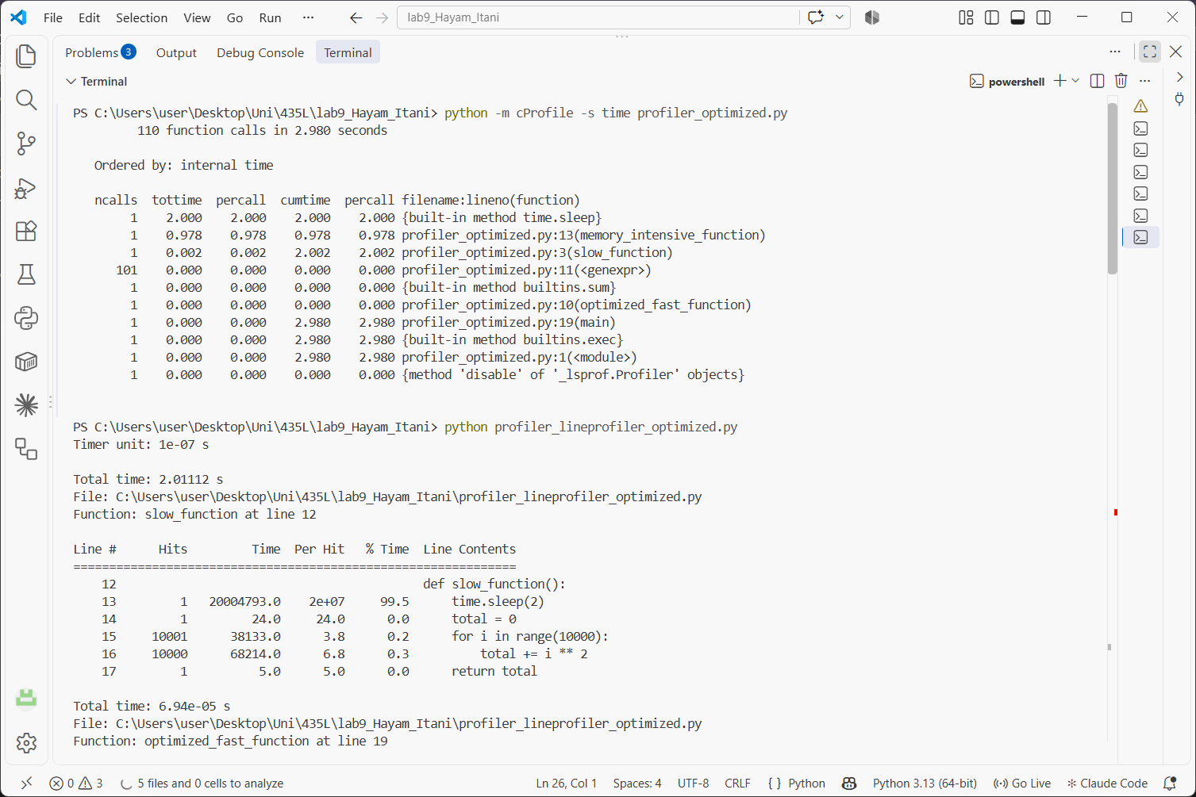
The total time is 2.980 seconds, almost the same as before (2.971 s). The number of function calls went from 8 to 110, because cProfile counts the generator expression once for every value it gives (101 calls) plus one call to sum(). time.sleep (2 s) and memory_intensive_function (0.978 s) are still the slowest parts.

line_profiler
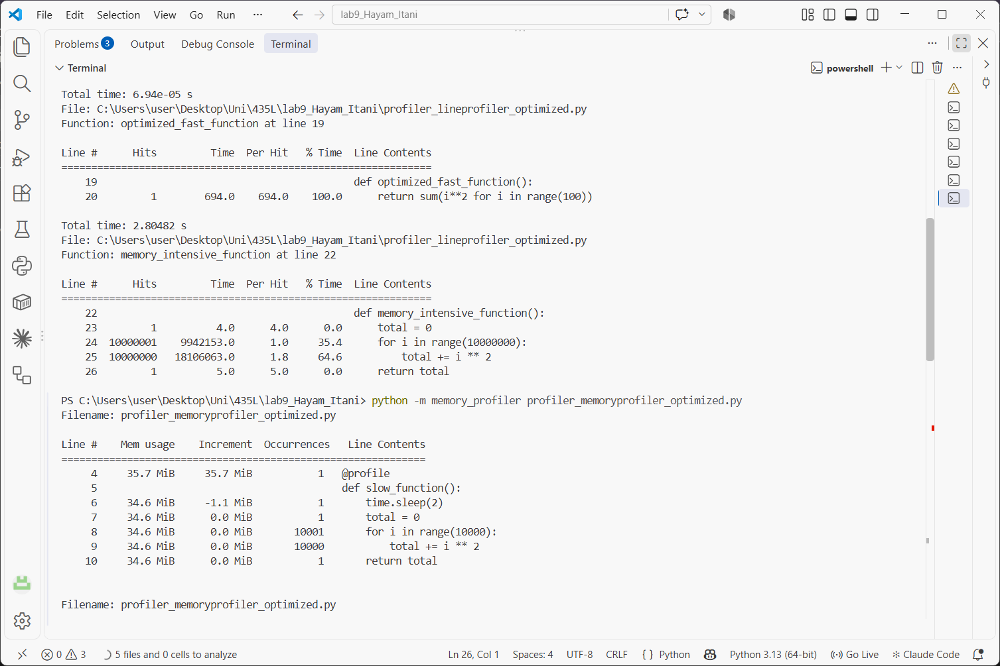
optimized_fast_function took 69.4 microseconds, compared to 71.4 before, which is basically the same. slow_function (2.01 s, 99.5% on sleep) and memory_intensive_function (35.4% on the for line and 64.6% on total += i ** 2) look the same as before. memory_intensive_function took 2.80 s this time instead of 2.97 s even though I did not change it, which shows how much the timings vary between runs.

memory_profiler
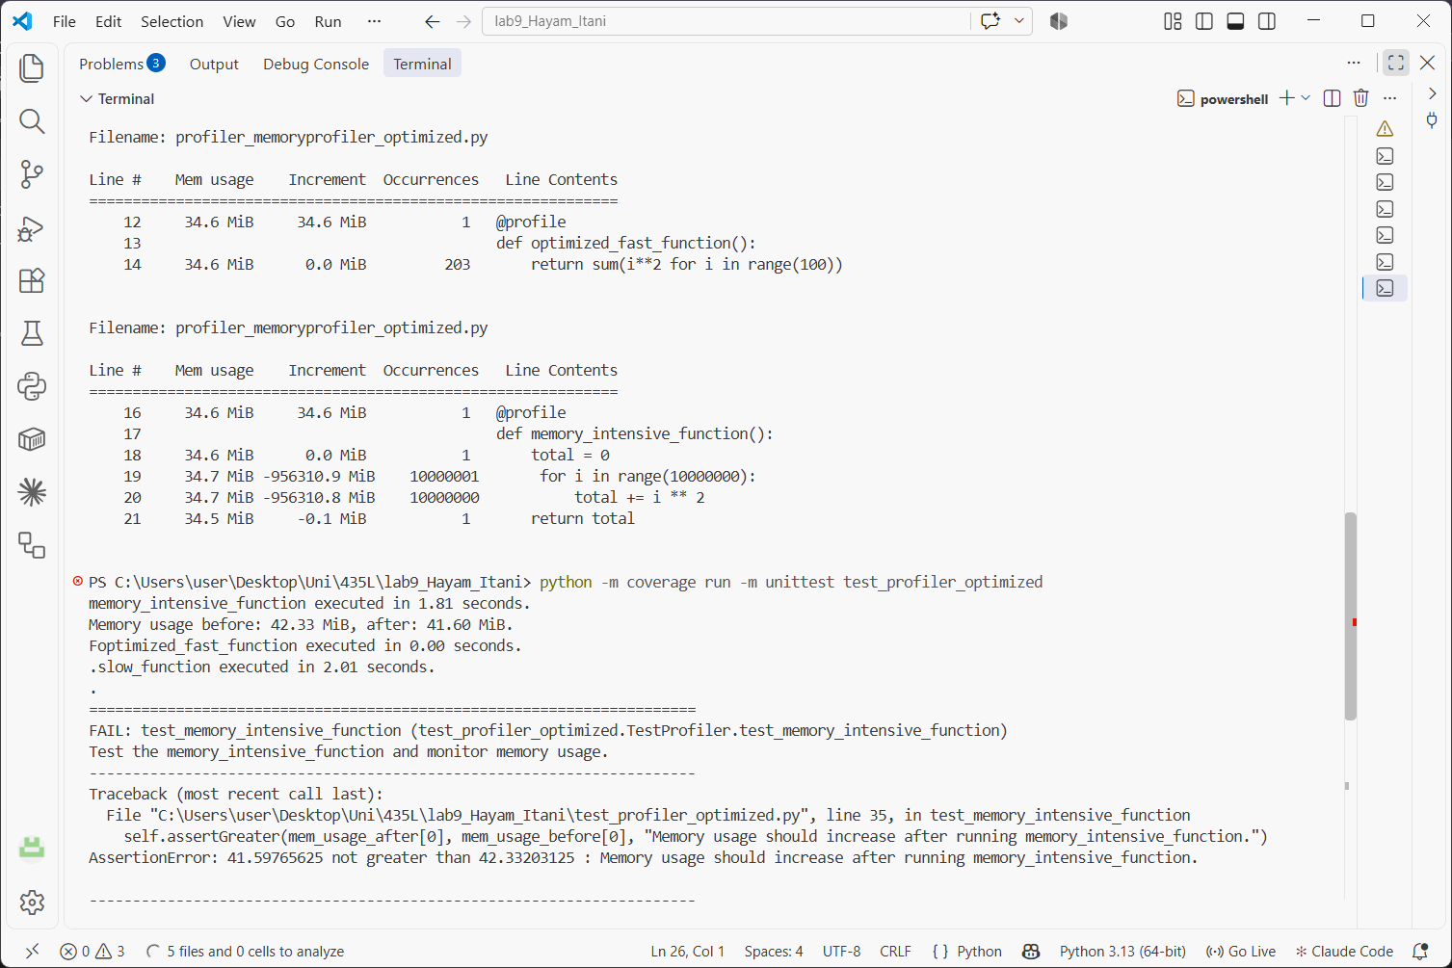
Memory is still around 34.6 to 34.7 MiB. optimized_fast_function has a 0.0 MiB increment, same as fast_function before. The negative increment in memory_intensive_function is now ‑956310.9 MiB, different from before even though the function is the same, which shows again that this number is not meaningful.

test_profiler and coverage
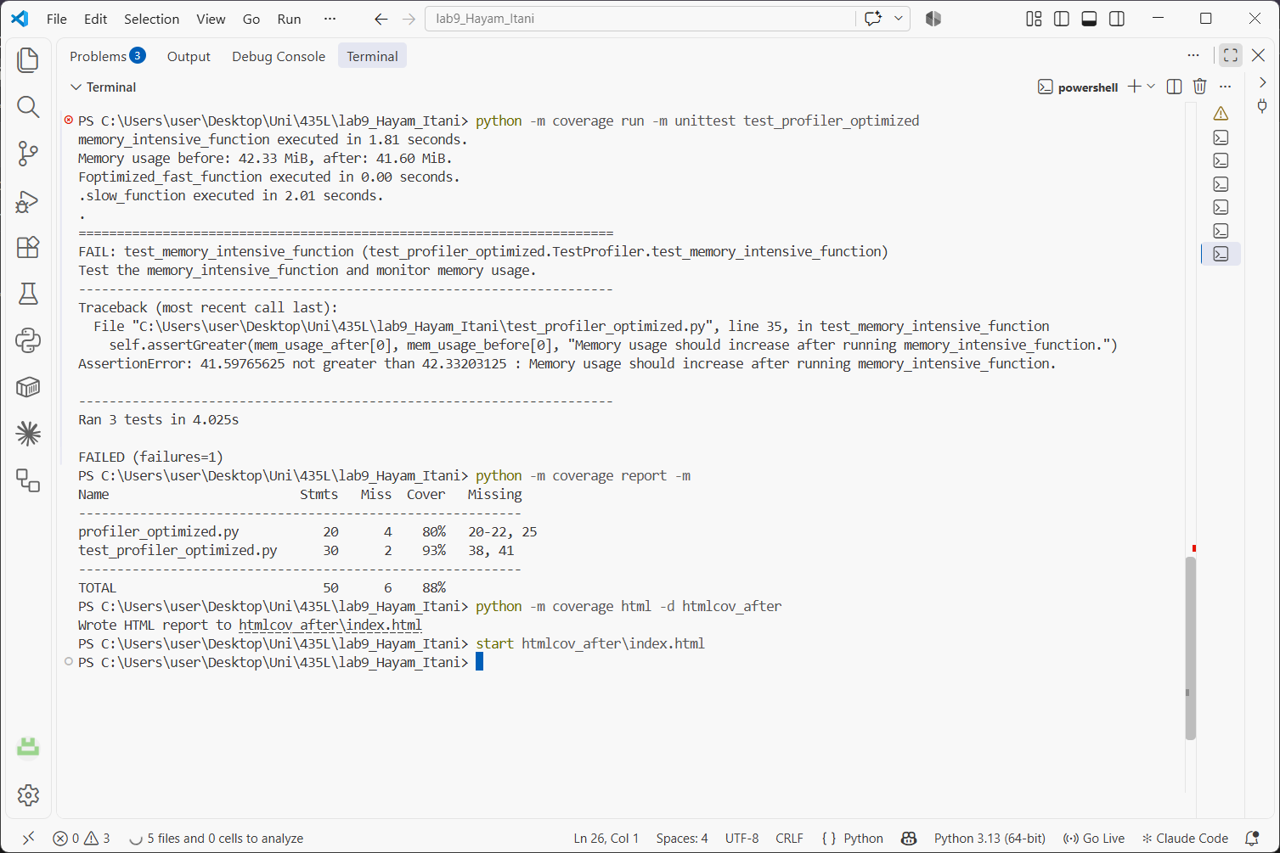
3 tests ran in 4.03 seconds with the same results as before: test_slow_function and test_optimized_fast_function passed, and test_memory_intensive_function failed again because memory went down (42.33 MiB to 41.60 MiB). Coverage of profiler_optimized.py is 80% (20 statements, 4 missed: lines 20-22 and 25), and the total is 88%. The lines not executed are the same ones as before, the calls inside main() and the main() call.

Comparison
 | Before | After
Total time (cProfile) | 2.971 s | 2.980 s
memory_intensive_function (cProfile) | 0.969 s | 0.978 s
fast function time (line_profiler) | 71.4 µs | 69.4 µs
fast function memory increment | 0.0 MiB | 0.0 MiB
Memory usage (memory_profiler) | 34.6 - 34.7 MiB | 34.6 - 34.7 MiB
Tests passed | 2 of 3 | 2 of 3
Coverage of profiler file | 83% | 80%
Total coverage | 89% | 88%

Analysis
The optimisation made fast_function shorter, but it did not make a noticeable difference to the program. fast_function was already very fast and was never the bottleneck, so changing it could not really improve the total time. The small differences between before and after (for example 2.971 s and 2.980 s) are just normal variation between runs.
Memory usage did not change either, because none of the functions store much data. The memory test fails in both versions because it expects memory to go up, which does not happen.
Coverage went down from 83% to 80% only because the new file has fewer statements, while the same 4 lines in main() are still not executed by the tests. So the tests did not get worse.
From the profiling results, the parts that really take time are time.sleep(2) in slow_function and the 10 million iteration loop in memory_intensive_function. To get a real improvement, those are the parts that would need to be optimised.

