This is the long title

Author A

Author B

December 2018

# Motivation

Here some text about diamonds.

# Analysis

Here some text to explain the analysis, in which we apply ggplot2 (Wickham 2009).

# Result

We have data about 53940 diamonds. Only 126 are larger than 2.5 carats. The distribution of the remainder is shown in Figure 1.

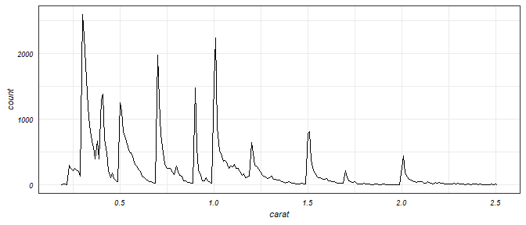

Figure 1 A plot on diamonds.

# References

Wickham, Hadley. 2009. *Ggplot2: Elegant Graphics for Data Analysis*. Springer-Verlag New York. <http://ggplot2.org>.