Hayat Dahraj
Computer Science, University of North Texas
1155 Union Circle, Denton, TX 76203

HayatDahraj@my.unt.edu

April 12, 2026

Dr. Susannah Holbert O’Bara
Superintendent of Schools
Denton Independent School District
1307 N. Locust Street
Denton, TX 76201

Dear Dr. O’Bara,
I am writing to present the enclosed formal report on Project Clara, a proposed mobile application designed to consolidate school communication into a single platform for Denton K-12 public schools. This report was prepared as part of my coursework in TECM 4180, Advanced Technical Communication, at the University of North Texas, under the guidance of Dr. Cynthia Pope.
Project Clara addresses a documented problem: families in the Denton area currently navigate multiple disconnected platforms to stay informed about their children’s education, and teachers bear the administrative burden of managing these fragmented tools. The enclosed report synthesizes findings from an expert interview, five scholarly and industry secondary sources, and a Qualtrics eSurvey of 33 Denton-area respondents. The research consistently demonstrates both a community need for a unified communication platform and the technical feasibility of building one using React Native and AWS.
The report includes detailed sections on research methodology, results, discussion of findings, and a recommended implementation timeline. I believe the findings will be of interest to your office as well as to Mr. Robert Pierce, Chief Technology Officer, and Ms. Julie Zwahr, Chief Communications Officer, given the intersection of technology infrastructure and family communication that Project Clara addresses.
I welcome the opportunity to discuss this proposal further at your convenience. Please feel free to contact me at HayatDahraj@my.unt.edu with any questions or requests for additional information.
Respectfully,

Hayat Dahraj
Computer Science, University of North Texas
HayatDahraj@my.unt.edu

Project Clara: A Unified School Communication Platform
A Formal Report on the Feasibility and Implementation of a Consolidated Mobile Application for Denton K-12 Public Schools
Prepared by
Hayat Dahraj
Computer Science, University of North Texas

Prepared for
Dr. Cynthia Pope, TECM 4180
Dr. Susannah Holbert O’Bara, Superintendent, Denton ISD

April 12, 2026

ABSTRACT
This report examines the feasibility and community need for Project Clara, a proposed mobile application that would consolidate school communication into a single platform for Denton K-12 public schools. The research draws on three primary methods: an expert interview with a UNT Ph.D. candidate specializing in mobile systems architecture, a review of five scholarly and industry secondary sources, and a Qualtrics eSurvey of 33 Denton-area respondents.
Findings reveal that current school communication is fragmented across an average of three to four platforms per school, creating documented dissatisfaction among parents and administrative burden for teachers. Over 60% of survey respondents indicated willingness to adopt a single consolidated app, with emergency notifications, teacher messaging, and student records access ranked as the most valued features. Nearly two-thirds of respondents expressed concern about data security.
The report concludes that Project Clara is technically feasible using a React Native and AWS architecture, addresses a demonstrated community need, and can be implemented through a phased approach beginning with a pilot deployment at one Denton ISD elementary school.

TABLE OF CONTENTS
ABSTRACT 4
TABLE OF CONTENTS 5
INTRODUCTION 6
METHODOLOGY 6
Expert Interview 6
Secondary Research 7
Qualtrics eSurvey 7
RESULTS 7
Current Communication Is Fragmented and Inadequate 7
Strong Community Interest in a Unified Platform 8
Data Security Is a Top Concern 9
Technical Feasibility Is Confirmed 9
DISCUSSION 10
CONCLUSION AND RECOMMENDATIONS 10
Works Cited 12
APPENDIX A: INTERVIEW QUESTIONS 13
APPENDIX B: eSURVEY QUESTIONS 14

INTRODUCTION
Elementary school parents today face a significant communication gap that leaves them disconnected from their children’s daily school experience. Current communication methods rely on outdated approaches including paper notes, sporadic emails, and infrequent parent-teacher conferences that fail to provide the real-time visibility that modern families need and expect. Working parents, in particular, struggle with anxiety about their child’s whereabouts during the school day, miss important updates about academic progress or behavioral incidents, and lack efficient channels to communicate directly with teachers.
This report investigates the feasibility of Project Clara, a proposed mobile application built with React Native and AWS that would consolidate school communication into a single platform for Denton K-12 public schools. The central research question guiding this study is: can a unified, mobile-first communication platform address the documented fragmentation in school communication tools while meeting federal privacy requirements and the practical constraints of a student-led development team?
To answer this question, the report draws on three research methods: an expert interview assessing technical architecture, five secondary scholarly and industry sources examining communication fragmentation, cross-platform development, digital equity, and FERPA compliance, and a Qualtrics eSurvey capturing community attitudes toward school communication. The findings consistently support the conclusion that Project Clara addresses a genuine community need and is technically achievable. The remainder of this report details the methodology, results, discussion, and recommendations for implementation.

METHODOLOGY
This study employed three complementary research methods to assess both the community need for and the technical feasibility of Project Clara. Each method was selected to address a distinct aspect of the research question.

Expert Interview
An email interview was conducted on February 15, 2026, with Indira Devi Siripurapu, a Ph.D. Candidate in UNT’s Smart Electronic Systems Lab and the technical advisor for the capstone team developing Project Clara. Ms. Siripurapu responded to ten open-ended questions covering architecture decisions, security requirements, scalability planning, and realistic scope for a student development team. This empirical qualitative source provided expert assessment of the proposed technology stack and implementation strategy. One limitation is that this interview represents a single technical perspective; additional interviews with school district IT staff or parents could offer complementary viewpoints.

Secondary Research
Five scholarly and industry sources were gathered through UNT library databases and industry publications to address different dimensions of the proposal: communication fragmentation and its impact on stakeholders (Skinner), the relationship between parent-teacher communication and student outcomes (Kraft and Rogers), digital equity and smartphone dependency among lower-income populations (Pew Research Center), cross-platform mobile development feasibility (Biorn-Hansen et al.), and federal compliance requirements for handling student data (Amazon Web Services). Sources include two peer-reviewed academic studies, one technical whitepaper, one statistical report, and one industry news article. One limitation is that most sources address general K-12 contexts rather than Denton ISD specifically, though the patterns identified are broadly applicable.

Qualtrics eSurvey
A nine-question anonymous Qualtrics eSurvey was distributed via social media, text messages, and direct outreach to UNT classmates and Denton-area contacts between February 28 and March 5, 2026. The survey collected 34 total responses, of which 33 were complete and usable. Respondents included UNT students with K-12 siblings (14), community members (11), parents or guardians (3), teachers or school staff (2), and others (3). This empirical quantitative source captured community attitudes toward current communication tools, desired features, likelihood of app adoption, and data security concerns. One limitation is that the sample skews toward college-aged respondents rather than parents who navigate school communication daily, though many reported firsthand family experience with these challenges.

RESULTS

Current Communication Is Fragmented and Inadequate
Both the secondary research and the eSurvey data converged on a consistent finding: school communication is scattered across too many platforms. A 2025 study by Cornerstone Communications and Edsby found that 42% of parents rated their satisfaction with managing multiple school apps at 5 out of 10 or lower, and that most schools currently use between 10 and 15 separate educational applications (Skinner). The eSurvey confirmed this locally: email was cited by 29 of 33 respondents, phone calls by 23, social media by 20, and text messages by 13, yet only 10 reported using a dedicated school app like ClassDojo or Remind (Dahraj). Only 10 of 33 respondents expressed any level of satisfaction with current methods. See Figure 1.
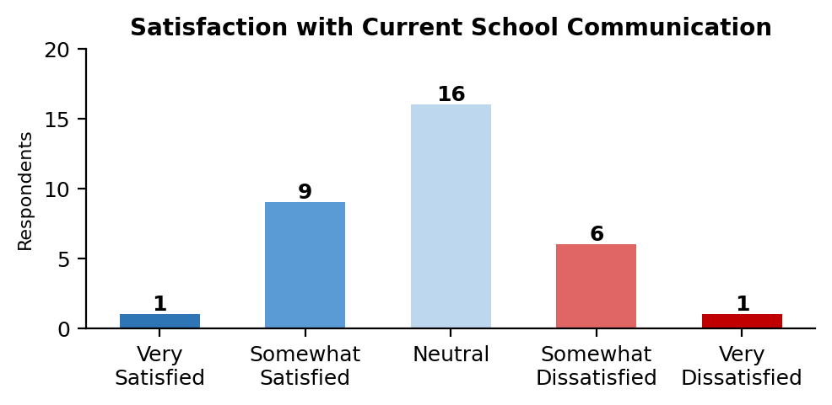
Figure 1: Respondent satisfaction with current school communication methods (n=33).
Open-ended responses reinforced this theme. One respondent explained that their family "sometimes struggle[s] with the multiple communication modes" because information appears on a district Facebook page before being distributed by email or phone (Dahraj). Another noted "confusion from different system operation platform[s]" and called for the "same info" to appear on all systems (Dahraj).

Strong Community Interest in a Unified Platform
When asked how likely they would be to use a single app that combines all school communication, 12 respondents selected "Very Likely" and 8 selected "Somewhat Likely," meaning over 60% indicated willingness to adopt. Eleven were neutral and only 2 were somewhat unlikely, with no respondent selecting "Very Unlikely" (Dahraj). See Figure 2.
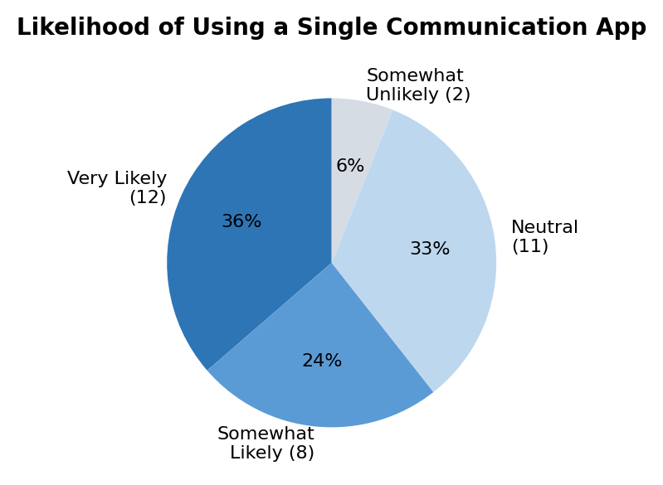
Figure 2: Likelihood of adopting a single school communication app (n=33).
Emergency notifications, absence reporting, and student records access all received majority support in the "Very Important" or "Extremely Important" categories, while teacher messaging and homework reminders also drew strong interest (Dahraj). See Figure 3. One respondent wrote that a single app allowing parents to "see their children’s assignment, grades, and progress" while communicating with teachers "would be very helpful" (Dahraj). Another stated that "one streamlined app that houses everything would likely eliminate communication issues" (Dahraj).
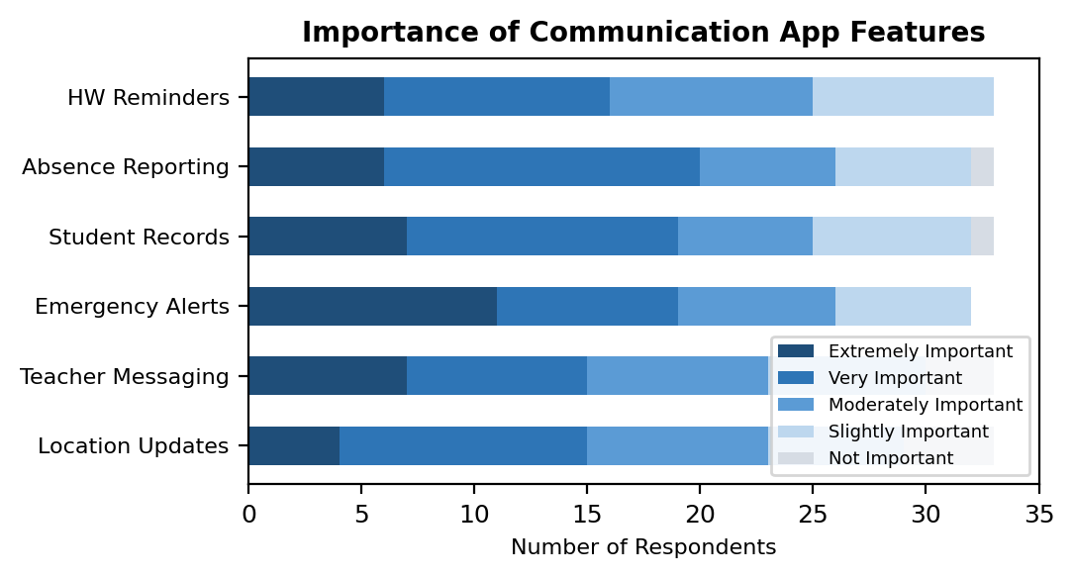
Figure 3: Importance ratings for proposed communication app features (n=33).

Data Security Is a Top Concern
Of the 32 respondents who answered, 11 selected "Very Concerned" and 9 selected "Somewhat Concerned" about the security of their child’s data in school apps, meaning nearly two-thirds hold some level of concern. The remaining 12 were neutral, and no respondent indicated they were unconcerned (Dahraj). See Figure 4.
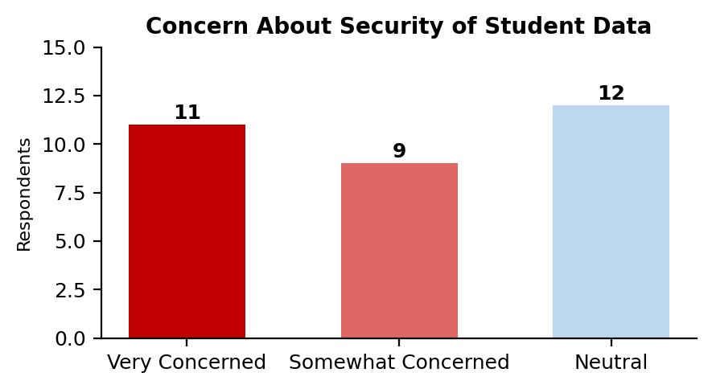
Figure 4: Concern about security of student data in school apps (n=32).

Technical Feasibility Is Confirmed
The expert interview and secondary sources confirmed that the proposed React Native and AWS architecture is viable for a student-led team. Peer-reviewed research demonstrates that React Native "offers near-native performance while allowing small teams to deploy to both iOS and Android simultaneously" (Biorn-Hansen et al. 15). Ms. Siripurapu confirmed this stack is a "smart choice for a student team" (Siripurapu). AWS documentation details full FERPA compliance through its Shared Responsibility Model (Amazon Web Services 8). Ms. Siripurapu recommended a phased MVP approach, advising: "I’d rather you build a smaller version that works really well than a big version that’s unreliable" (Siripurapu).
Research by Kraft and Rogers demonstrated that consistent parent-teacher messaging directly improves student homework completion rates (52), establishing that communication consolidation has direct academic benefits beyond administrative convenience. Pew Research Center data showed that a significant percentage of lower-income families are smartphone-dependent for internet access, making a mobile-first architecture an equity requirement.

DISCUSSION
The results from all three research methods converge on a consistent conclusion: Denton-area school communication is fragmented, the community wants a unified solution, and the technology to build one is both accessible and compliant with federal regulations.
The fragmentation documented by Skinner at a national level was confirmed locally through the eSurvey. The fact that respondents reported schools using an average of three to four different communication platforms, yet fewer than one-third noted a dedicated school app, suggests that existing solutions have failed to consolidate the communication landscape. This aligns with Ms. Siripurapu’s observation that the project operates in a "high responsibility" area requiring careful, phased development rather than another hastily deployed standalone tool.
The strong adoption interest (over 60% willing to use a single app) is particularly meaningful when paired with the feature priorities respondents identified. Emergency notifications, student records access, and teacher messaging ranked highest, all core features of Project Clara’s design. This suggests the proposed feature set is not hypothetical but directly responsive to community demand.
The security concern finding is both a challenge and an opportunity. Nearly two-thirds of respondents expressed worry about data security, which means any proposed platform must earn trust through visible security practices. Project Clara’s architecture addresses this through AWS-based encryption, role-based access control, audit logging, and FERPA compliance, all measures specifically recommended by Ms. Siripurapu during the interview.
One limitation of this study is the demographic skew of the eSurvey toward college-aged respondents. However, many of these respondents reported direct family experience with K-12 school communication, and their responses aligned with patterns documented in the national secondary sources, lending credibility to the findings. A follow-up study with a larger parent sample would strengthen these conclusions.

CONCLUSION AND RECOMMENDATIONS
This report investigated whether a unified, mobile-first communication platform could address the documented fragmentation in Denton-area school communication. The evidence gathered through an expert interview, five secondary sources, and a primary eSurvey of 33 respondents consistently supports the conclusion that Project Clara is both needed and feasible.
The research revealed three key findings. First, school communication is fragmented across too many platforms, creating measurable dissatisfaction for families and administrative burden for teachers. Second, the Denton-area community shows strong willingness to adopt a consolidated platform with features that directly align with Project Clara’s design. Third, data security is a top concern that Project Clara’s FERPA-compliant AWS architecture is specifically designed to address.
Based on these findings, this report recommends the following:
- Approve a pilot deployment of Project Clara at one Denton ISD elementary school, to be developed in partnership with the UNT Computer Science department.
- Assign a district liaison from the Technology Division (under Mr. Robert Pierce, CTO) to collaborate with the development team on integration requirements and data security standards.
- Conduct a follow-up survey of parents at the pilot school to validate the eSurvey findings with a more targeted demographic sample.
- Adopt a phased implementation timeline, beginning with core features (login, roles, roster, attendance, messaging) before adding advanced capabilities like GPS tracking and third-party integrations.

The following table outlines the recommended implementation timeline:
# | Task | Date
1 | Stakeholder meetings with Denton ISD leadership | May 2026
2 | Finalize system requirements and data architecture | June 2026
3 | Secure AWS educational credits and configure cloud infrastructure | June 2026
4 | Design UI/UX wireframes and conduct usability testing | July 2026
5 | Develop MVP: login, roles, roster, and attendance tracking | Aug–Sep 2026
6 | Implement two-way parent-teacher messaging | Oct 2026
7 | Build incident reporting and push notification systems | Nov 2026
8 | Integrate student records module (medical, emergency contacts) | Dec 2026
9 | Security audit, penetration testing, and FERPA compliance review | Jan 2027
10 | Pilot deployment at one Denton ISD elementary school | Feb 2027
11 | Collect pilot feedback and iterate on usability issues | Mar 2027
12 | District-wide rollout to remaining Denton ISD schools | May 2027
Project Clara represents an opportunity for Denton ISD to lead in family communication technology while directly supporting student academic outcomes. The research demonstrates that the need is real, the solution is feasible, and the community is ready.

Works Cited
Amazon Web Services. “FERPA Compliance on AWS Resource Guide.” AWS Whitepapers, Aug. 2024, d1.awsstatic.com/whitepapers/compliance/FERPA_Compliance_on_AWS.pdf.
Biorn-Hansen, Andreas, et al. “A Survey and Taxonomy of Core Concepts and Research Challenges in Cross-Platform Mobile Development.” ACM Computing Surveys, vol. 51, no. 5, 2018, pp. 1-34.
Dahraj, Hayat. “Project Clara Communication Survey” [Unpublished raw data survey]. University of North Texas. unt.az1.qualtrics.com/jfe/form/SV_5w1ajjuIPZPclCu. 8 Mar. 2026.
Kraft, Matthew A., and Todd Rogers. “The Underutilized Potential of Teacher-to-Parent Communication: Evidence from a Field Experiment.” Economics of Education Review, vol. 47, 2015, pp. 49-63.
Pew Research Center. “Mobile Technology and Home Broadband 2021.” 3 June 2021, www.pewresearch.org/internet/2021/06/03/mobile-technology-and-home-broadband-2021/.
Siripurapu, Indira Devi. Personal interview via email. 15 Feb. 2026.
Skinner, Katrina. “Using Too Many School Apps May Burden Parents, Teachers.” Government Technology, 17 Mar. 2025, www.govtech.com/education/k-12/using-too-many-school-apps-may-burden-parents-teachers.

APPENDIX A: INTERVIEW QUESTIONS
The following questions were posed to Indira Devi Siripurapu, Ph.D. Candidate, UNT Smart Electronic Systems Lab, via email on February 15, 2026.
- What has been your experience working with React Native and AWS in school or work projects?
- As someone guiding our team, what parts of Project Clara’s design worry you the most?
- What challenges do you expect with building real-time location tracking and notifications for both iPhone and Android?
- We are relying heavily on AWS managed services to simplify our development. In your professional opinion, does this create a vendor lock-in risk that would make it difficult to port our backend to a different infrastructure if the District requires it in the future?
- How should we handle data security for sensitive student information like medical records and emergency contacts?
- What would a realistic first version of Project Clara look like given our team’s time and resources?
- How hard would it be to connect our app with communication tools that schools already use?
- If more schools in Denton wanted to use the app later, what should we plan for now to handle that growth?
- Based on your experience, what mistakes should we avoid when building an app for both iPhone and Android?
- Looking at our project requirements, which features do you think are too difficult for a student team to finish?

APPENDIX B: eSURVEY QUESTIONS
The following questions were distributed via Qualtrics between February 28 and March 5, 2026.
Q1. What is your relationship to K-12 education in the Denton area?
Options: Parent or guardian of a K-12 student / Teacher or school staff member / Community member with no direct connection / UNT student with siblings in K-12 / Other
Q2. How satisfied are you with the way schools currently communicate with families?
Options: Very satisfied / Somewhat satisfied / Neutral / Somewhat dissatisfied / Very dissatisfied
Q3. Which methods does your school currently use to communicate with families? (Select all that apply.)
Options: Paper notes sent home / Email / Phone calls or robocalls / A school-specific app (e.g., ClassDojo, Remind) / Social Media / Text Messages / School Website / Other
Q4. How important are the following features in a school communication app? (Matrix: Not Important to Extremely Important)
Features: Real-time updates on my child’s location and activities / Direct messaging with teachers / Instant notifications about incidents or emergencies / Access to student records (medications, emergency contacts) / Absence reporting / Homework and deadline reminders
Q5. How likely would you be to use a single app that combines all school communication into one platform?
Options: Very Likely / Somewhat likely / Neutral / Somewhat unlikely / Very Unlikely
Q6. Do you currently use more than one app or tool to communicate with your child’s school?
Options: Yes / No
Q7. What challenges have you experienced from using multiple communication tools for school updates? (Open-ended, displayed if Q6 = Yes)
Q8. How concerned are you about the security of your child’s personal information in school apps?
Options: Very concerned / Somewhat concerned / Neutral / Not very concerned / Not concerned at all
Q9. Is there anything else you would like to share about how schools could improve communication with families? (Open-ended)

