REAL ESTATE HOUSING MARKET
ANALYSIS
An End-to-End Data Analytics Project

100,000  Total Transactions | DKK 193Bn  Total Market Value | DKK 1.93M  Avg Property Price | 1992 – 2024  Analysis Period | 50+  Cities Covered

Tools Used:
Python (Pandas, Matplotlib, Seaborn) • MySQL (SQL Analysis) • Power BI (Dashboard)

Data Analytics Portfolio Project | 2026

1. Business Problem Statement
A real estate consulting and investment firm seeks to gain deeper insights into housing market dynamics to support data-driven investment, pricing, and market expansion decisions. The firm has observed significant variations in property prices, sales activity, and buyer negotiation behavior across different cities and regions. Changing economic conditions — particularly inflation and interest rates — are also suspected to influence property demand and valuation.

The overarching business question driving this project is:

“How can real estate transaction and economic data be leveraged to identify market trends, evaluate investment opportunities, optimize pricing strategies, and support data-driven decision-making in the housing market?”

1.1 Key Objectives
- Identify cities and regions with the highest property values and strongest market performance.
- Understand the impact of property characteristics (house type, size, rooms, build era) on purchase prices.
- Analyze how inflation and interest rates influence housing prices and market activity.
- Evaluate buyer negotiation behavior across different regions and property segments.
- Discover emerging markets and investment opportunities through geographic and trend analysis.
- Develop an interactive analytics dashboard to support strategic business and investment decisions.

2. Dataset Overview
The dataset contains 100,000 residential property transactions from Denmark, spanning 1992 to 2024. It includes property-level details, geographic identifiers, macroeconomic indicators, and engineered buyer behavior metrics. The data was sourced for academic and portfolio purposes.

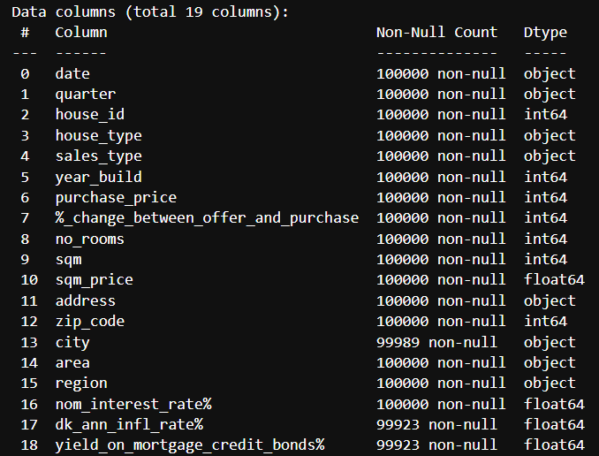
Figure 1: Dataset schema from df.info() — 19 original columns, 100,000 rows with some missing values in city, inflation rate, and mortgage yield fields

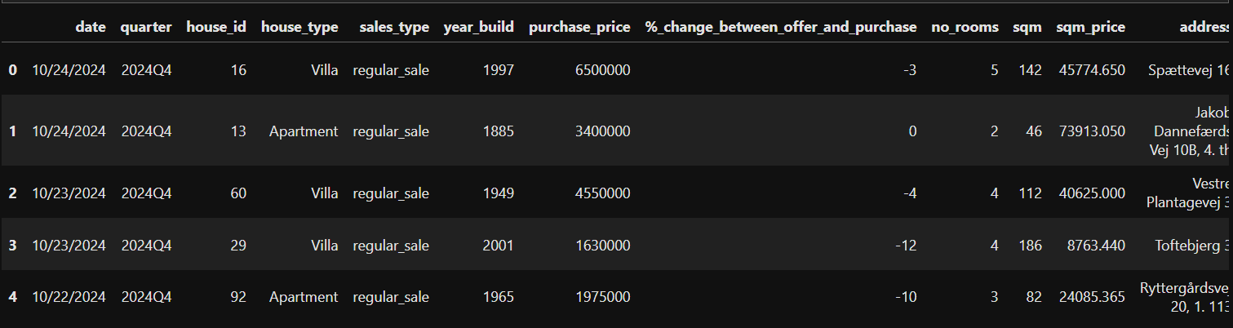
Figure 2: Sample rows from the raw dataset showing property transactions with all key columns

2.1 Column Description
Column | Type | Description
date | Date | Transaction date
quarter | String | Quarter label (e.g., 2024Q1)
house_id | Integer | Unique property identifier
house_type | String | Villa, Apartment, Townhouse, Summerhouse, Farm
sales_type | String | Regular sale, family sale, auction, other
year_build | Integer | Year the property was constructed
purchase_price | Integer | Final transaction price (DKK)
%_change_between_offer_and_purchase | Integer | Percentage change from offer to final purchase price
no_rooms | Integer | Number of rooms in the property
sqm | Integer | Property size in square meters
sqm_price | Float | Price per square meter (DKK)
address / zip_code / city / area / region | String | Geographic identifiers at multiple levels
nom_interest_rate% | Float | Nominal interest rate at time of sale
dk_ann_infl_rate% | Float | Danish annual inflation rate
yield_on_mortgage_credit_bonds% | Float | Mortgage bond yield — proxy for borrowing cost

2.2 Engineered Features
The following columns were derived during feature engineering to enrich the analytical depth of the dataset:
Feature | Logic / Purpose
price_segment | Classifies properties into Budget, Mid, Premium, Luxury, Ultra-Luxury based on purchase price thresholds
build_era | Categorizes year_build into: Pre-1900, 1900s, Mid-century, 70s, 80-90s, 2000s, Modern
sales_season | Derives Winter, Spring, Summer, Autumn from transaction date
offer_price | Back-calculated from purchase_price and %_change column to reveal initial listing price
negotiation_gap | Absolute DKK difference between offer price and purchase price
real_interest_rate | nom_interest_rate% minus dk_ann_infl_rate% — measures true cost of borrowing
distressed_sale | Flag where %_change_between_offer_and_purchase < -15% (severe price cut)

3. Data Cleaning & Preparation (Python)
All data cleaning and preprocessing was performed using Python (Pandas library). The following steps were executed to ensure data quality before analysis.

3.1 Initial Assessment
- Loaded dataset using pd.read_csv() and reviewed structure with df.head(), df.info(), and df.describe().
- Identified date format inconsistency: dates existed in both 'MM/DD/YY' and 'MM-DD-YY' formats.
- Found missing values in three columns: city (11 nulls), dk_ann_infl_rate% (77 nulls), and yield_on_mortgage_credit_bonds% (77 nulls).

3.2 Cleaning Steps
- Date normalization: Standardized all date entries to DD/MM/YY format using regex-based parsing and pd.to_datetime().
- City nulls: Rows with missing city values were dropped as city is a critical geographic dimension and represents less than 0.02% of total data.
- Inflation & yield nulls: Missing values in dk_ann_infl_rate% and yield_on_mortgage_credit_bonds% were imputed with the median of the same quarter within the same year — preserving seasonal economic patterns.

3.3 Export to MySQL
After cleaning and feature engineering, the final dataset was exported to a MySQL server using SQLAlchemy for structured SQL analysis. This allowed seamless transition from Python-based EDA to SQL-driven business querying.

4. Exploratory Data Analysis (Python)
EDA was conducted using Pandas, Matplotlib, and Seaborn to uncover distributions, outliers, patterns, and relationships across property and economic dimensions.

4.1 Property Price Distribution
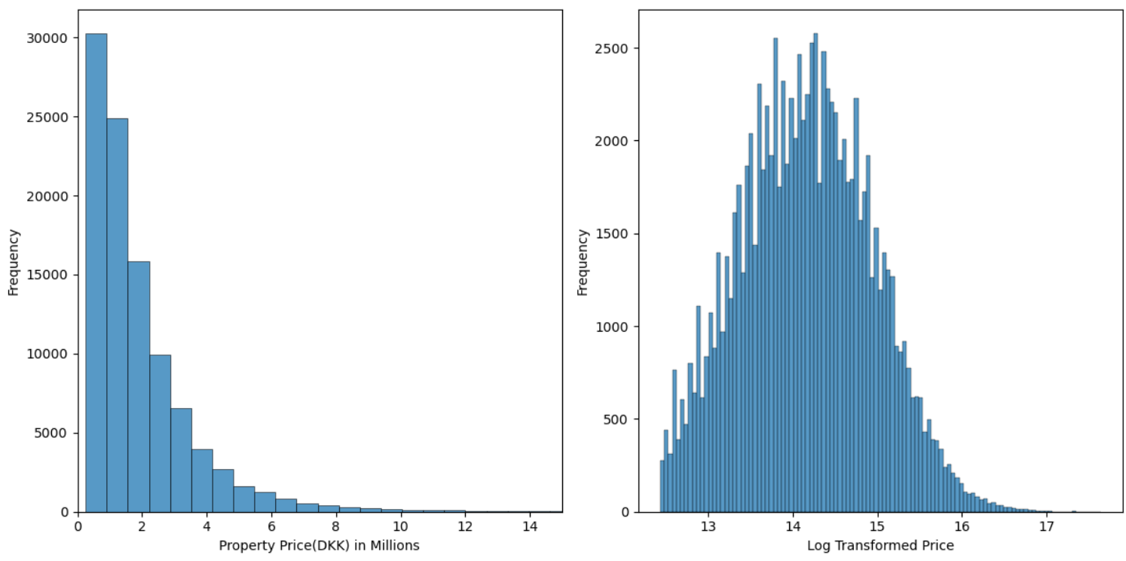
Figure 3: Property price distribution (left: raw DKK, right: log-transformed) — strong right skew indicates most properties are modestly priced with a small segment of luxury outliers

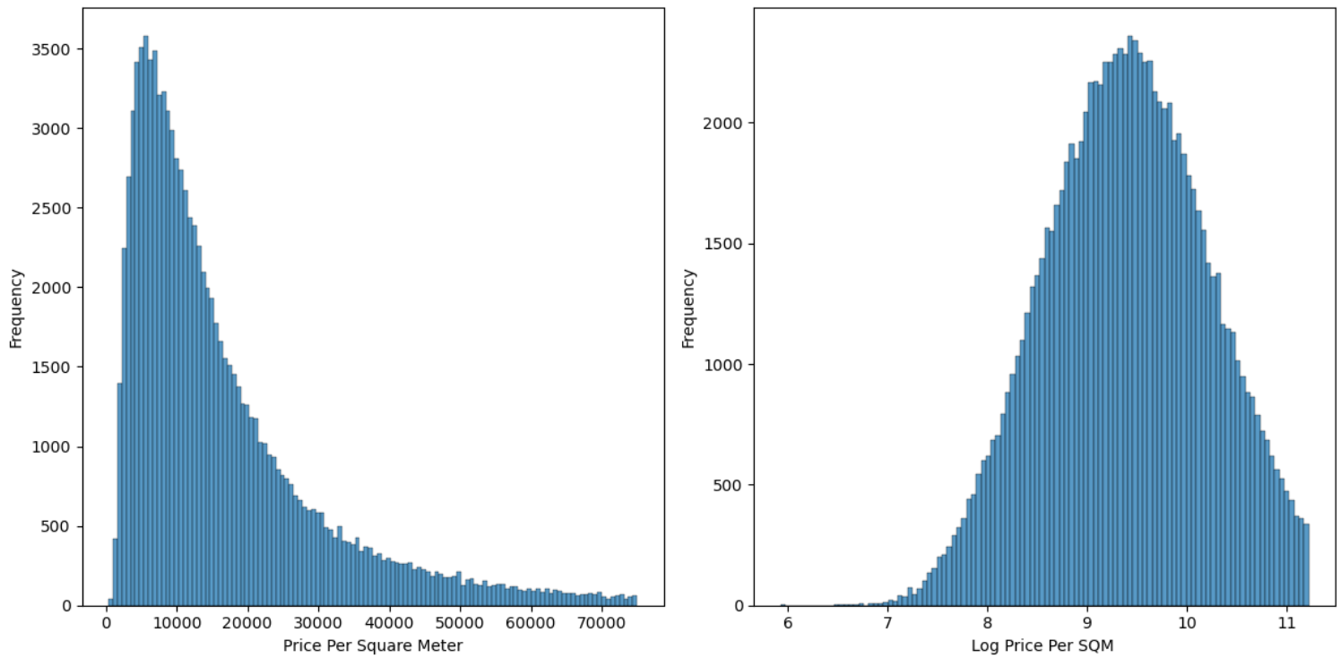
Figure 4: Price per square meter distribution (left: raw, right: log-transformed) — log-normal distribution confirms SQM pricing follows a multiplicative structure

🔍 Price Distribution Findings
- Most properties are modestly priced; a small luxury segment pulls average prices significantly above medians.
- The log-normal distribution of both purchase price and SQM price validates the use of median (not mean) as the representative price metric.
- Price per SQM shows less extreme variation than total price, making it a more reliable cross-property comparison metric.

4.2 House Type Analysis
House Type | Count | Share | Mean Price | Median Price | M/Md Ratio
Villa | 54,210 | 54.2% | 1,785,136 | 1,300,000 | 1.37
Apartment | 19,354 | 19.4% | 2,433,244 | 1,950,000 | 1.25
Summerhouse | 11,339 | 11.3% | 1,219,568 | 977,500 | 1.25
Townhouse | 10,184 | 10.2% | 2,107,443 | 1,720,000 | 1.23
Farm | 4,902 | 4.9% | 2,740,145 | 1,700,000 | 1.61

House Type | Median SQM (m²) | Median SQM Price | Max Price | Min Price
Apartment | 79 | 25,437 | 34,402,208 | 250,750
Farm | 186 | 9,415 | 37,250,000 | 250,536
Summerhouse | 76 | 12,944 | 45,955,000 | 250,750
Townhouse | 107 | 16,526 | 18,750,000 | 252,000
Villa | 147 | 9,109 | 34,000,000 | 250,200

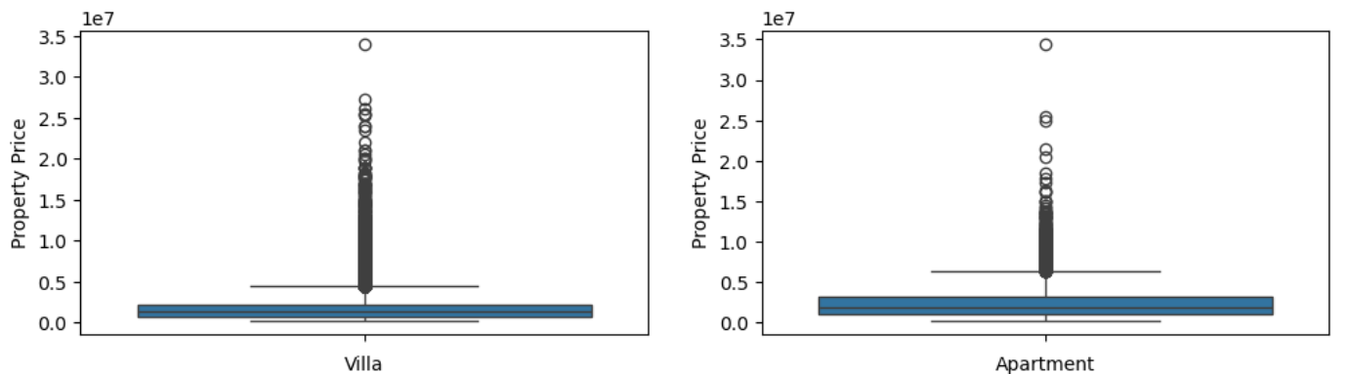
Figure 5: Boxplots — Villa and Apartment price distributions, showing presence of high-value outliers in both segments
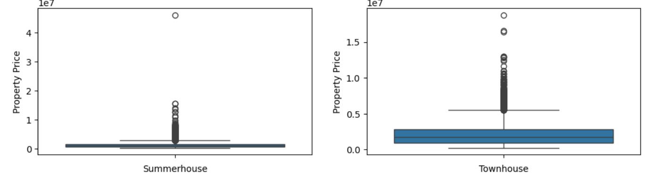
Figure 6: Boxplots — Summerhouse and Townhouse, with Summerhouse showing an extreme outlier at ~DKK 46M (likely coastal premium property)

🔍 House Type Key Insights
- Villas dominate the market (54.2% of all transactions), making them the benchmark property type.
- Apartments command the highest SQM price (DKK 25,437/m²) despite being the smallest — reflecting prime urban location premiums.
- Farms have the widest Mean/Median ratio (1.61), indicating a highly skewed market with a few extremely expensive agricultural estates.
- Townhouses show the most consistent pricing (lowest M/Md ratio at 1.23) — suitable for stable investment.
- Summerhouses have the highest recorded transaction (DKK 45.9M), likely coastal luxury vacation properties.

4.3 Regional Analysis
Region | Apartments | Farms | Summerhouses | Townhouses | Villas | Distress%
Zealand | 10,139 | 1,089 | 4,910 | 4,926 | 18,676 | 2.10%
Jutland | 7,864 | 3,224 | 5,554 | 3,876 | 29,408 | 2.90%
Fyn & Islands | 1,300 | 529 | 660 | 1,192 | 5,583 | 3.65%
Bornholm | 51 | 60 | 215 | 190 | 543 | 3.97%

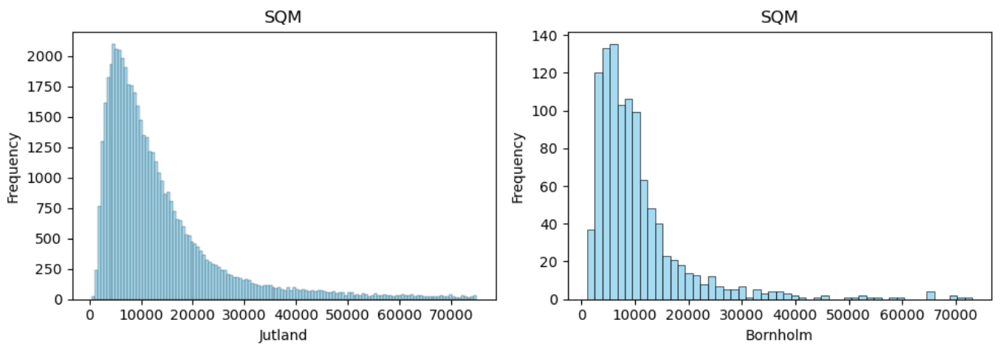
Figure 7: SQM price distribution for Jutland (left) and Bornholm (right) — both right-skewed, Bornholm shows higher SQM concentration at lower values
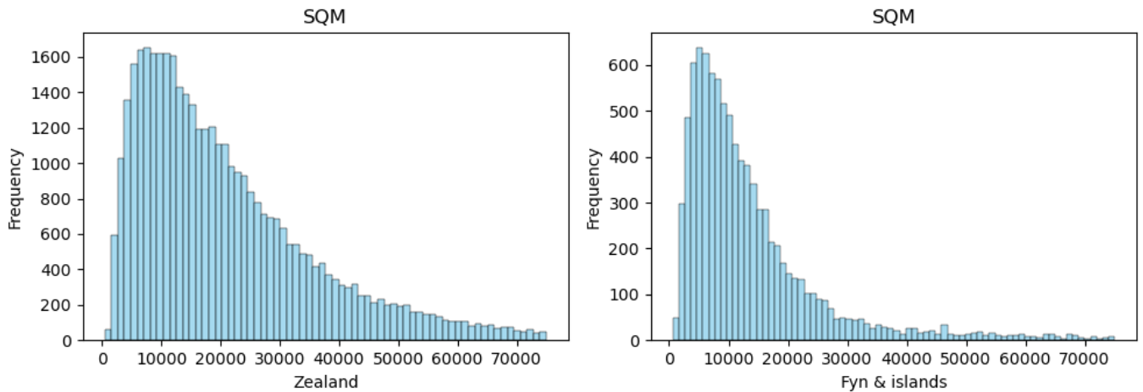
Figure 8: SQM price distribution for Zealand (left) and Fyn & Islands (right) — Zealand shows a broader, higher-value distribution indicating premium pricing

🔍 Regional Performance Insights
- Zealand is the largest and most premium market (40K transactions, IQR spread DKK 2.1M) with the lowest distressed sale rate (2.10%) — indicating strong demand and market health.
- Jutland is the most active region overall (50K transactions) but shows more price variability with a moderate distress rate of 2.90%.
- Bornholm has the smallest market but the highest distress rate (3.97%), suggesting weaker demand and lower liquidity — higher-risk investment territory.
- Fyn & Islands is a mid-tier market with solid volume but higher distress than the top two regions.

4.4 Build Era Analysis
Build Era | Median SQM Price (DKK) | Count
Pre-1900 | 10,154 | 11,535
1900s | 13,014 | 20,444
Mid-century (1940–60s) | 11,261 | 26,707
70s | 10,986 | 22,950
80-90s | 13,987 | 3,393
2000s | 15,950 | 7,335
Modern (Post-2010) | 17,348 | 7,625

🔍 Build Era Insights
- Modern properties (post-2010) command the highest premium at DKK 17,348/m² — reflecting energy efficiency, modern amenities, and current building standards.
- The 2000s and Modern eras together represent a premium segment despite lower absolute transaction counts.
- Mid-century (1940–60s) and 70s builds have lower SQM prices, likely requiring renovation investment.
- Surprisingly, 1900s properties have higher SQM values than pre-1900 — possibly due to historical/character value in prime city locations.

4.5 Negotiation Behavior Analysis
House Type | Zero Neg. % | Mean Gap (DKK) |  | Interpretation
Farm | 80.7% | -237,182 |  | Rare but deep discounts
Apartment | 69.1% | -104,608 |  | Urban demand keeps sellers firm
Townhouse | 66.4% | -100,377 |  | Moderate negotiation activity
Villa | 61.1% | -125,792 |  | Active negotiation, large gaps
Summerhouse | 59.6% | -94,530 |  | Most negotiated, smallest gaps

🔍 Negotiation Behavior Insights
- 63.96% of all transactions (63,957 out of 99,989) have zero negotiation gap — sellers and buyers agree on the offer price outright.
- Farms have the lowest negotiation frequency (80.7% zero-gap) but the largest average discount when negotiation occurs (DKK -237,182).
- Summerhouse buyers are the most active negotiators (40.4% of transactions have a gap), though discount amounts are the smallest.
- The extreme left skew (skewness = -16.1) confirms rare but massive discounts drag the mean far below zero.
- Villas, despite dominating the market, see meaningful negotiation in ~39% of cases with substantial discounts averaging DKK -125,792.

5. Data Analysis Using SQL (MySQL)
Eighteen targeted business questions were answered using structured SQL queries on the cleaned property sales dataset loaded into MySQL. Queries covered pricing trends, regional comparisons, interest rate impact, negotiation behavior, and investment screening.

5.1 Geographic & Pricing Analysis

Q1 — Top 10 Cities by Average Purchase Price
The query retrieved the 10 highest-valued cities by mean purchase price. The Power BI dashboard confirms Rungsted Kyst leads at DKK 6.1M average, followed by Nordhavn (6.0M), Klampenborg (6.0M), and Vedbæk (5.8M). All top cities are concentrated in the affluent North Zealand coastal area near Copenhagen.

Q2 — Average SQM Price by Region
Zealand commands the highest average SQM price among all regions, consistent with its role as the premium market. Jutland leads in raw volume but trails in per-square-meter valuation. The query confirms geographic price hierarchy across Denmark's four regions.

5.2 Temporal Trend Analysis

Q3 — Average Purchase Price by Quarter & Year
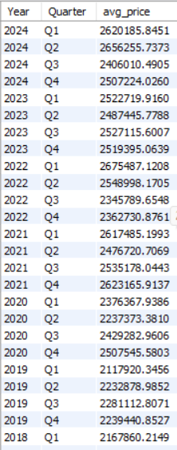
Figure 9: Quarterly average purchase price trend (partial view) — prices in recent years (2019–2024) range DKK 2.1M to 2.7M with consistent seasonal patterns

The data shows consistent upward price movement over the analysis period. Recent years (2020–2024) show average prices between DKK 2.1M and DKK 2.7M. Q1 2022 stands as one of the highest averages at DKK 2.68M, before moderating in 2023–24 as interest rates rose sharply.

Q4 — Highest Sales Volume by Quarter
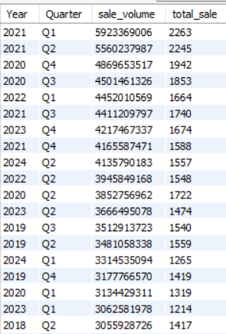
Figure 10: Sale volume by quarter — 2021 Q1 and Q2 show peak volumes, coinciding with the post-pandemic property boom in Denmark

🔍 Temporal Trend Insights
- 2021 Q1 recorded the highest single-quarter sale volume (2,263 transactions, DKK 5.9Bn) — driven by post-pandemic demand surge and historically low interest rates.
- Prices showed steady growth from 1992 through 2022, with the most aggressive appreciation between 2010 and 2022.
- 2023 and 2024 saw moderation in both price growth and volume, consistent with rising real interest rates in this period.

5.3 Property Characteristics Analysis

Q5 — House Type with Highest Average Purchase Price
Farms rank as the highest-priced property type by average purchase price (DKK 2.74M), despite having the lowest SQM price. This reflects large land parcels and the overall size of farm estates. However, the mean is skewed by a small number of exceptionally expensive agricultural properties.

Q6 — Number of Rooms vs. Average Price
A near-linear positive relationship exists between room count and average purchase price, as confirmed by the Power BI chart. Properties with 15+ rooms reach average prices above DKK 6M, while 1-2 room properties average around DKK 1.5–1.8M. This validates room count as a reliable price predictor.

Q7 & Q9 — Build Era and SQM Price
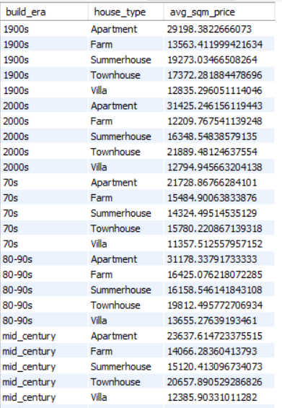
Figure 11: Average SQM price by build era and house type — Apartments consistently command higher SQM prices across all eras; 2000s and Modern eras show premiums

🔍 Build Era & Type Cross-Analysis Insights
- Across every build era, Apartments consistently hold the highest SQM price — peaking at DKK 31,425/m² for 2000s-built apartments.
- Modern-era Villas (DKK ~15,000/m²) and Townhouses (DKK ~20,000/m²) are the best-performing non-apartment segments.
- Farm SQM prices remain low across all eras (DKK 9,000–16,000/m²), reinforcing that farm value lies in land area, not SQM price.
- 80-90s builds show a value dip across types — suggesting structural or maintenance issues that buyers discount for.

Q8 — City with Largest Villas
SQL analysis identifies the city with the highest average SQM for villas, highlighting which markets have the largest villa properties — useful for investors targeting premium-size villa segments.

5.4 Economic & Macro Analysis

Q10 — Nominal Interest Rate vs. Average Purchase Price
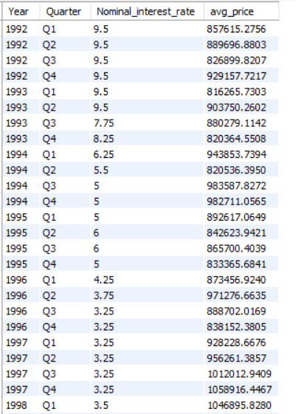
Figure 12: Nominal interest rate vs. average purchase price (1992–1998 shown) — early 1990s show high interest rates (9.5%) with relatively low property prices, confirming inverse relationship

The data clearly shows that as nominal interest rates fell from 9.5% in 1992 toward 3.25% by the late 1990s, average purchase prices rose from around DKK 820K to DKK 1.05M. This inverse relationship holds throughout the full dataset, with the lowest rates in 2020–21 coinciding with price peaks.

Q11 — Real Interest Rate vs. SQM Price
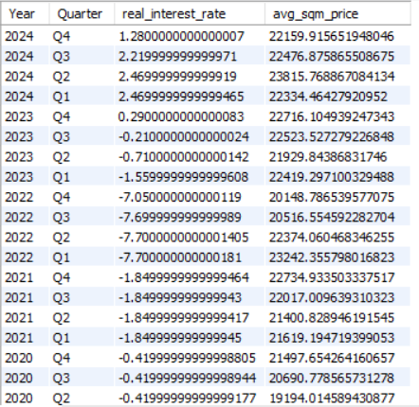
Figure 13: Real interest rate vs. average SQM price by quarter (2020–2024) — negative real rates in 2022 coincide with peak SQM prices; as real rates turned positive in 2023, SQM growth moderated

🔍 Interest Rate Impact Insights
- A clear inverse relationship exists between interest rates and property prices — lower rates accelerate price growth, higher rates compress it.
- The 2022 period of sharply negative real interest rates (nominal rate < inflation) was a major driver of the 2021-22 price surge.
- As real interest rates turned positive in 2023-24 (reaching 1.28% by Q4 2024), SQM price growth plateaued at DKK ~22,000–22,500/m².
- This relationship is critical for investment timing: periods of low-to-negative real rates are historically associated with price acceleration.

Q12 — Inflation Regimes vs. Property Prices
The SQL analysis categorized transactions into three inflation regimes. High inflation periods (above 3%) are associated with strong purchase price levels as property is used as an inflation hedge. However, analysis is partial as the output covers a subset of data — full conclusions require the complete dataset view.

5.5 Negotiation & Pricing Gap Analysis

Q13 — Offer-to-Purchase Discount by Region
Average offer-to-purchase discount percentages vary by region. The Power BI dashboard shows Zealand buyers negotiate the largest absolute gap (avg -DKK 55K), followed by Fyn & Islands (-DKK 39K), Jutland (-DKK 34K), and Bornholm (-DKK 19K). Higher-value markets see larger absolute negotiation gaps.

Q14 — Cities with Highest Negotiation Gap
The top 5 cities with the most extreme negotiation gaps represent high-value markets where the spread between asking and final price is largest. These cities likely have longer days-on-market and more motivated sellers, creating opportunities for buyers.

Q15 — Negotiation Gap by Price Segment
Premium and Ultra-Luxury segments exhibit larger average negotiation gaps, consistent with the general principle that higher-priced assets have more pricing flexibility. Budget segment buyers face near-zero negotiation gaps, indicating tight competition in entry-level markets.

5.6 Advanced Analysis: Growth & Value Screening

Q16 — Year-over-Year City Price Growth
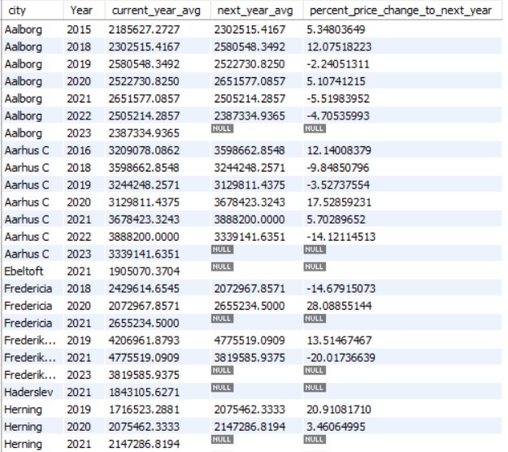
Figure 14: Year-over-year price growth by city (partial view) — Aarhus C shows 12.1% growth in 2016 and 17.5% in 2020; Aalborg shows 12.1% growth in 2018; some years show negative growth indicating market corrections

🔍 YOY Growth Insights
- Aarhus C shows strong YOY growth (12–17%) in multiple years, positioning it as a high-growth secondary market worth monitoring.
- Aalborg shows consistent positive growth with occasional dips, typical of a healthy but cyclical market.
- Frederiksberg shows a sharp reversal in 2021 (-20%) after a peak, highlighting the importance of entry timing in high-value markets.
- NULL next-year values represent the most recent year per city where forward comparison is unavailable — not data errors.

Q17 — Properties Sold Above 20% Premium vs. City Average
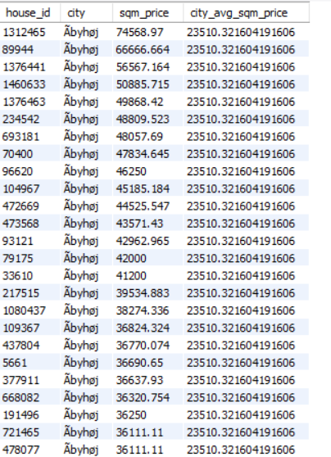
Figure 15: Properties with SQM price at least 20% above city average (partial view, Åbyhøj city shown) — individual house_ids with SQM prices ranging DKK 36K–74K vs city average of DKK 23,510/m²

This window function query identifies premium-performing properties — those commanding at least a 20% SQM price premium over their city's average. These represent either genuinely superior properties (location, condition, size) or outliers that merit investigation. In Åbyhøj, the city average SQM price is DKK 23,510 while flagged properties range from DKK 36,111 to DKK 74,569 — showing the extent of premium pricing within the same city.

Q18 — Best Value House Type
This composite query evaluates all house types by average price, SQM price, room count, and price-per-room. Summerhouses offer the lowest entry price (DKK 1.22M avg) with the lowest SQM price, making them accessible. Villas dominate by volume and offer the best price-per-room value relative to their total size, while Apartments offer premium location access at a higher SQM cost.

6. Power BI Dashboard
An interactive 3-page Power BI dashboard was developed to present the full analysis visually. The dashboard includes cross-filtering capabilities with slicers for Year, City, Region, and House Type across all pages.

6.1 Page 1: Market Overview
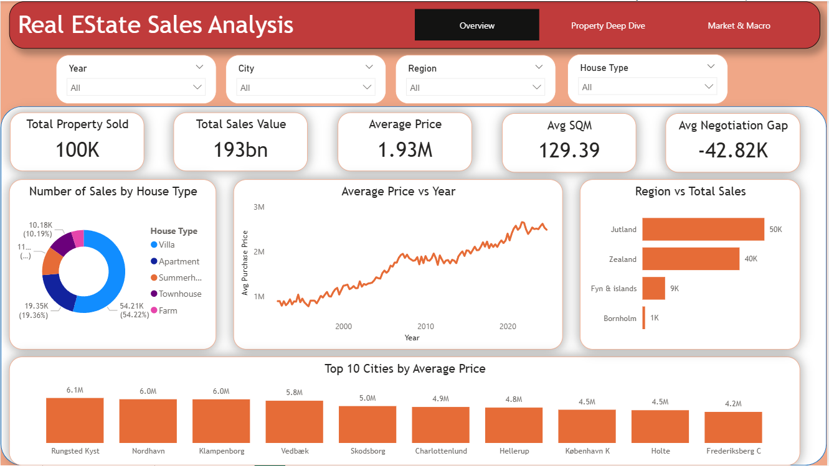
Figure 16: Dashboard Page 1 — Market Overview showing KPIs, house type mix, price trend (1992–2024), regional volume, and Top 10 cities by average price

🔍 Dashboard Page 1 — Key Findings
- Total market: 100K transactions worth DKK 193Bn at an average price of DKK 1.93M with average area of 129 m².
- Villas dominate at 54.22% of all transactions; Apartments are second at 19.36%.
- Average price trend shows consistent growth from ~DKK 800K in 1992 to ~DKK 2.8M in 2024, with a visible plateau in 2022–23.
- Jutland leads in transaction volume (50K) but Zealand is the premium market by price.
- Rungsted Kyst, Nordhavn, and Klampenborg are the top 3 most expensive cities — all in the Copenhagen metropolitan North Shore area.
- Average negotiation gap stands at -DKK 42.82K — sellers accept offers below list in the aggregate, confirming active buyer negotiation.

6.2 Page 2: Property Deep Dive
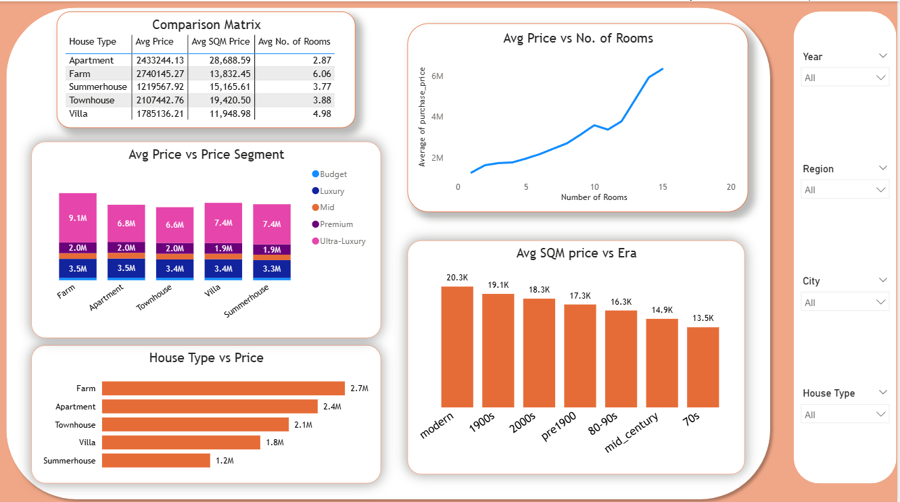
Figure 17: Dashboard Page 2 — Property Deep Dive showing comparison matrix, price by segment, rooms-to-price relationship, and SQM price by build era

🔍 Dashboard Page 2 — Key Findings
- Farm has the highest average purchase price (DKK 2.74M) and the most rooms (6.06 avg), but the lowest SQM price (DKK 13,832) — size-driven, not location-driven.
- Apartment leads in SQM price (DKK 28,689) with fewest rooms (2.87 avg) — compact urban premium assets.
- Modern-era properties command DKK 20.3K/m² while 70s-era properties fetch only DKK 13.5K/m² — a 50% premium for contemporary construction.
- Ultra-Luxury segment exists across all house types with the highest concentration in Farms (DKK 9.1M avg in Ultra-Luxury tier).
- A positive near-linear relationship exists between number of rooms and average price, peaking above DKK 6M for 15+ room properties.

6.3 Page 3: Market & Macro
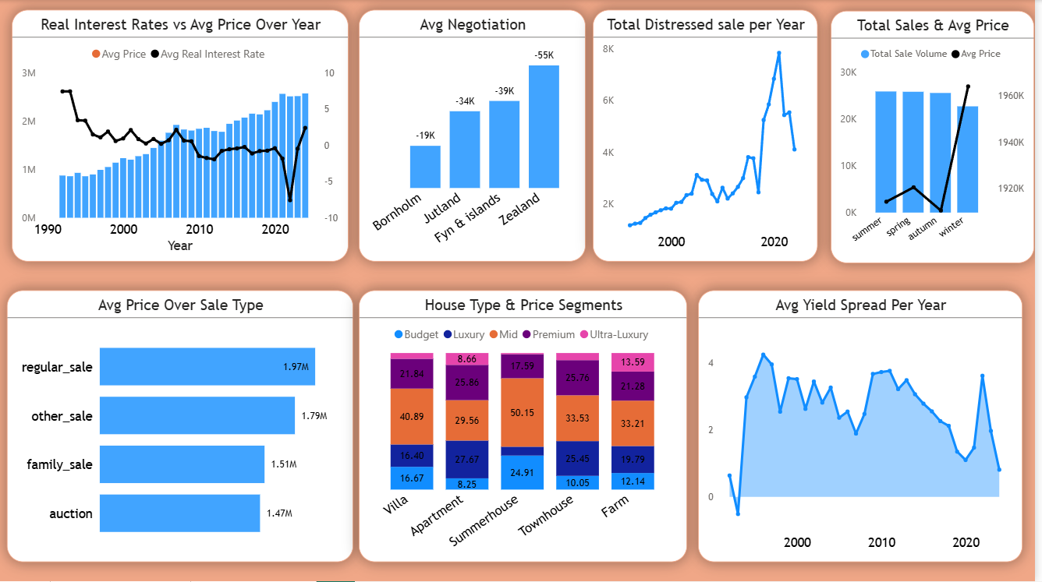
Figure 18: Dashboard Page 3 — Market & Macro showing real interest rates vs price, negotiation by region, distressed sales, seasonal patterns, sale type analysis, and mortgage yield trend

🔍 Dashboard Page 3 — Key Findings
- Real interest rate and property price show a clear inverse relationship over 30+ years — as real rates fell from ~8% in the early 1990s toward negative territory in 2021, prices more than tripled.
- The sharp negative real interest rate spike in 2022 (approx. -8%) coincided with peak property prices before rate normalization.
- Zealand buyers negotiate the largest absolute gap (-DKK 55K avg), while Bornholm has the smallest (-DKK 19K) — reflecting market competitiveness.
- Total distressed sales peaked sharply around 2007–2009 (financial crisis) and again showed a smaller uptick post-2020. Overall distress rates remain low (2–4%).
- Winter sales have the highest average price (DKK ~1,960K) while Summer has the lowest volume — buyers in winter may be more motivated and purchase higher-value properties.
- Regular sales average DKK 1.97M vs. Auction sales at DKK 1.47M — auctions present a 25% discount opportunity.
- Mortgage bond yield (Avg Yield Spread) peaked ~4% in the mid-2000s and trended toward near-zero in 2020, before rising again post-2022 — tracking the broader interest rate cycle.

7. Summary of Key Findings

# | Key Finding
1 | Denmark's residential market grew from DKK ~820K average (1992) to DKK ~2.8M (2024) — a ~240% increase over 32 years.
2 | Villas account for 54% of all transactions, making them the core product of the Danish housing market.
3 | Apartments command the highest SQM price (DKK 25,437–28,689/m²), driven by urban location premiums in Copenhagen-area cities.
4 | North Zealand coastal cities (Rungsted Kyst, Klampenborg, Nordhavn) are the highest-value markets averaging DKK 5.8M–6.1M.
5 | Modern properties (post-2010) sell at a 50%+ SQM premium over 70s-era builds, reflecting energy efficiency and modern standards.
6 | Real interest rates have the strongest macro influence on prices — negative real rates (2020–22) corresponded to peak price appreciation.
7 | 2021 Q1 was the peak activity quarter with 2,263 transactions and DKK 5.9Bn in total sales value.
8 | 64% of all transactions have zero negotiation gap — when negotiation occurs, Farms see the deepest discounts (avg -DKK 237K).
9 | Zealand has the lowest distress rate (2.10%) confirming it as the most liquid and stable market; Bornholm has the highest (3.97%).
10 | Auction properties trade at a ~25% discount to regular sales, representing a systematic value entry point for investors.
11 | Cities like Aarhus C show consistent 12–17% YOY price growth in multiple years, qualifying as a high-growth secondary market.
12 | Summerhouses are the most negotiated segment (40.4% see a price drop), but average discount (-DKK 94K) is the smallest.

8. Business Recommendations
Based on the full analysis across Python EDA, SQL business queries, and Power BI dashboard insights, the following strategic recommendations are made for a real estate consulting and investment firm operating in the Danish market.

8.1 Investment Strategy Recommendations

Recommendation 1: Prioritize Zealand for Core Investment
Zealand — particularly the North Shore corridor (Rungsted Kyst, Klampenborg, Vedbæk) — offers the highest property values, the lowest distressed sale rate (2.10%), and the broadest price IQR spread (DKK 2.1M). This market exhibits the strongest demand fundamentals and should be the primary focus for premium portfolio allocation.

Recommendation 2: Target Aarhus C and Aalborg as Growth Markets
Aarhus C shows 12–17% YOY price growth in multiple years, making it the strongest secondary growth market identified. Aalborg shows consistent positive growth. Both offer entry price points significantly below Copenhagen-area premiums while delivering superior capital appreciation rates. A buy-and-hold strategy in Aarhus C Apartments or modern-era Townhouses is well-supported by the data.

Recommendation 3: Use Auctions as a Value Entry Strategy
Auction properties sell at an average 25% discount versus regular sales (DKK 1.47M vs DKK 1.97M). Investors with capacity to assess and renovate distressed properties should actively monitor auction pipelines — particularly in Bornholm and Fyn where distress rates are higher — to capture forced-sale discounts.

Recommendation 4: Modern and 2000s Build Era Properties for Premium Returns
Modern-era (post-2010) properties command a 50%+ SQM premium over 70s and 80-90s builds. Investors should avoid 70s-80s era properties unless the acquisition price reflects the renovation discount. New-build acquisition or conversion investment in the Modern tier offers the best price-per-m² growth trajectory.

8.2 Pricing & Product Strategy

Recommendation 5: Use SQM Price as the Core Valuation Metric
Total purchase price varies enormously by property size, making comparisons misleading. SQM price provides a standardized, like-for-like valuation basis. The firm's pricing models and client advisory tools should default to SQM price as the primary comparator, especially for cross-city and cross-type analysis.

Recommendation 6: Exploit the Room Count Premium
There is a near-linear positive relationship between room count and average purchase price. For development or acquisition decisions, properties with 8+ rooms are systematically underrepresented in supply but show strong average prices. Larger family-oriented villas and townhouses in mid-market cities represent an under-served segment.

Recommendation 7: Differentiate Negotiation Strategies by Property Type
Farm and Villa buyers should expect to negotiate (39–40% of transactions see a gap) and can target meaningful discounts (DKK 125K–237K on average). Apartment buyers face stiffer pricing — urban demand keeps sellers firm (only 31% see negotiation). Summerhouse buyers should negotiate consistently but expect modest gains. Pricing advisory to clients should be calibrated accordingly.

8.3 Macro-Timing & Risk Management

Recommendation 8: Monitor Real Interest Rate as the Primary Market Timing Signal
The analysis confirms that real interest rate (nominal rate minus inflation) is the most predictive macro variable for Danish property price direction. When real rates are negative or near-zero, the market is in an expansion phase — accelerate acquisitions. When real rates rise above 2–3%, expect price moderation or correction — reduce exposure or target value plays.

Recommendation 9: Avoid Over-Exposure to Bornholm
Bornholm's 3.97% distressed sale rate and small market size signal weaker demand and lower liquidity. While entry prices may appear attractive, exit risk is elevated. The firm should limit Bornholm exposure to opportunistic, short-hold strategies rather than core portfolio allocation.

Recommendation 10: Leverage the Winter Buying Window
Winter sees the highest average purchase prices (DKK 1,960K+) but also the lowest volume — suggesting that winter buyers are motivated, well-qualified purchasers of higher-value properties. Sellers listing in winter may transact faster. The firm should time premium property launches for autumn and track winter closing volumes as a demand health indicator.

9. Technology Stack & Tools

Tool | Purpose | Key Libraries / Features Used
Python 3.x | Data Cleaning & EDA | Pandas, NumPy, Matplotlib, Seaborn, SQLAlchemy
Jupyter Notebook | Interactive Analysis | Cell-based exploration, inline visualizations
MySQL | SQL Business Analysis | Window functions (LEAD, OVER PARTITION BY), GROUP BY aggregations, subqueries, CASE statements, CTEs
Power BI Desktop | Dashboard & Visualization | Custom DAX measures, cross-page filtering, slicers, interactive charts
GitHub | Version Control | Project repository with ipynb, SQL, and documentation

Project Pipeline
Business Problem  Definition | Data Cleaning  & EDA (Python) | SQL Analysis  18 Queries (MySQL) | Power BI  3-Page Dashboard | Project Report  Insights & Recs | GitHub Repo  Code & Portfolio

About This Project
This is an end-to-end data analytics portfolio project covering the full analytical pipeline from business problem definition to dashboard delivery. The analysis covers 100,000 Danish residential property transactions spanning 32 years, combining Python-based data science, SQL-driven business querying, Power BI visualization, and structured strategic reporting. All code and queries are available in the accompanying GitHub repository.

