TCS iON invites your students to participate in a 4-Day Hands-on Challenge – AI Tools to Create Your YouTube Channel from 27th April to 30th April 2026, from 4:00 PM – 4:30 PM IST.

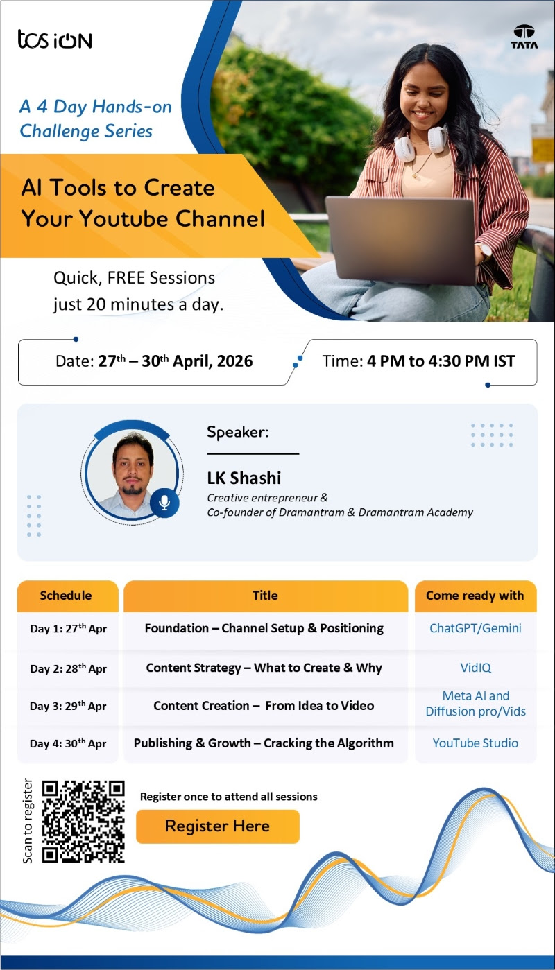
One-time registration gives access to all sessions: https://iur.ls/HandsOnChallengeSeries
To participate smoothly, please ensure all prerequisites are completed before the sessions to avoid any setup issues.
Program Structure & Prerequisites:
Day 1: Foundation – Channel Setup & Positioning | ChatGPT or Gemini (Sign in with Gmail )
Day 2: Content Strategy – What to Create & Why |VidIQ (Free account signup using Gmail)
Day 3: Content Creation – From Idea to Video |Meta AI / Diffusion Pro / Vids (Access using Gmail )
Day 4: Publishing & Growth – Cracking the Algorithm | YouTube Studio (Access using Gmail)
Note: Ensure you have access to a Gmail account.
Warm Regards,
TCS iON

