VOICE-TO-TASK BOT
Module: The Master Architecture & Blueprint
Welcome everyone.
Today, we aren't just building a basic script. We are going to build an AI-Powered Serverless Application. Our objective today is to develop a zero-cost, voice-to-text task manager using the exact architecture that modern developers use to integrate Cloud APIs without leaking private credentials.
1. WHAT are we building? (The Project Architecture)
We are building a Python-Driven UI Application “Voice-to-Task Bot”.
- Serverless AI Architecture: The core principle of this project is to rely completely on Free Cloud APIs (Hugging Face) instead of downloading heavy, computer-crashing AI models locally.
- Decoupled Logic: We will separate the User Interface (Streamlit) from the AI Brain (Hugging Face Llama-3 & Whisper) and our Secrets (API Keys).
- Result: The final output will be a lightweight, lightning-fast web app where you speak into your microphone, and it instantly prints out a structured To-Do list, entirely for free.
2. WHY are we doing it this way? (The Business & Tech Logic)
Why are we avoiding the traditional approach (Paid APIs or Heavy Local Models)?
Feature | ❌ Traditional Way | ✅ Our "Zero-Cost" Architecture
Cost | Paying $0.02 per query to OpenAI. | $0.00 using Hugging Face Free Serverless API.
Hardware | Requires 16GB+ RAM to run Ollama locally. | Runs smoothly even on a basic 4GB RAM non-IT laptop.
Security | Hardcoding API keys (risking theft). | Using a hidden .env file to act as a secure vault for tokens.
- Ultimate Privacy (Environment Variables): We use a .env file so that if this code is ever shared or uploaded to GitHub, your private Hugging Face token remains safe on your local machine.
- User-Friendly Interface: We are using Streamlit so that instead of looking at a scary black terminal, the user gets a clean webpage with a simple "Record" button.
3. HOW are we executing this? (The Tech Stack & Workflow)
We will use an ecosystem of 5 tools to build this system:
- Python & Streamlit (The Engine & UI): Python will handle the logic, and Streamlit will instantly convert our Python code into a beautiful Web UI.
- Hugging Face Whisper API (The Ear): This free API will take your voice audio and transcribe it into raw text.
- Hugging Face Llama-3 API (The Brain): This API will read the raw text and logically extract actionable tasks into a bulleted list.
- Cursor IDE (AI Pair-Programming): Instead of writing code from scratch, we will use Cursor. Through our precise "God Prompt", the AI will generate the entire application.
- Python-Dotenv (The Vault): A security library to safely read your API token from the hidden .env file.
4. WHERE are we doing this? (The Project Blueprint)
To implement this logic into code, we will initialize our base project named voice-to-task-bot.
Once we set up this project folder, our architectural layout (Folder Structure) will look like this. Understand this carefully, as this will be our workspace:
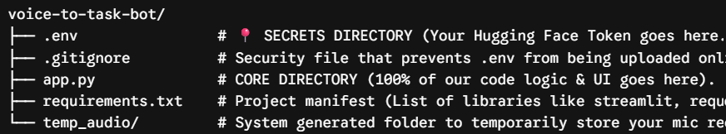
The 3 Pillars of our Architecture:
- /.env (Source of Secrets): Only the API Token resides here. No application logic.
- /app.py (Presentation & Logic Layer): The Streamlit frontend and API-calling backend live here. It is completely 'dumb'—it only sends data to the cloud and prints the response.
- Hugging Face Cloud (The Processing Layer): All the heavy lifting (Voice to Text, Text to To-Do) happens on the cloud, saving our local computer's memory.
CORE FEATURES (The Dynamic Capabilities) What makes this bot powerful and easy to maintain?
- One-Click Recording (audio_capture): Speak directly into your browser. The app temporarily saves the audio, sends it to the AI, and deletes the local file to save space.
- Instant Transcription (whisper_sync): Converts any spoken English or Hinglish into highly accurate text automatically.
- Smart Formatting (llama_extraction): It doesn't just repeat what you said. If you say, "I need to call mom and also buy milk," it generates a clean, actionable checklist automatically.
Step 1: Workspace Initialization (Creating & Opening the Folder)
- Creating the Root Directory
  - Navigate to your Desktop.
  - Right-click, select New, and then Folder.
  - Name the directory exactly: voice-to-task-bot.
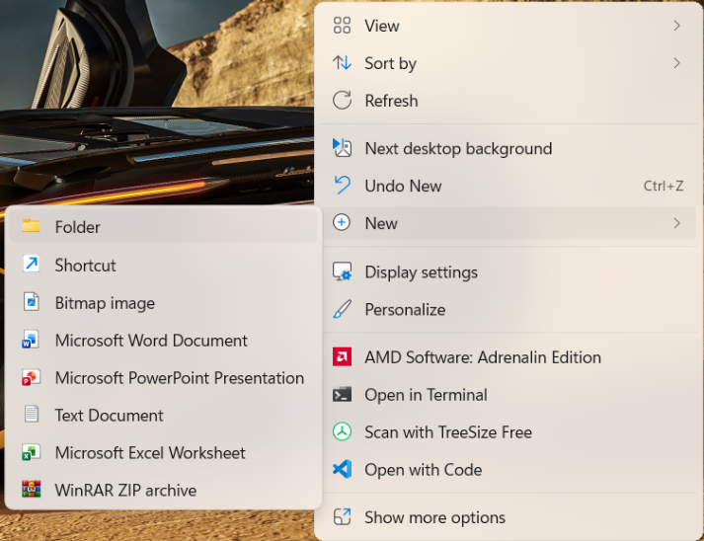
  - Open this folder inside Cursor IDE.
  - 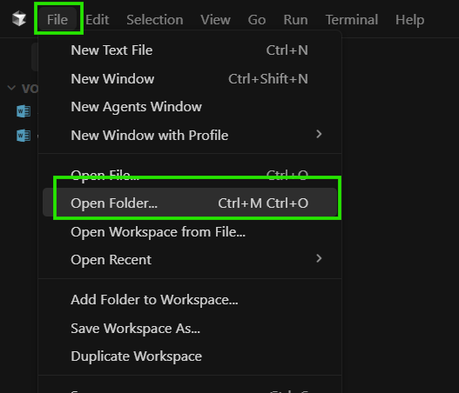
  - 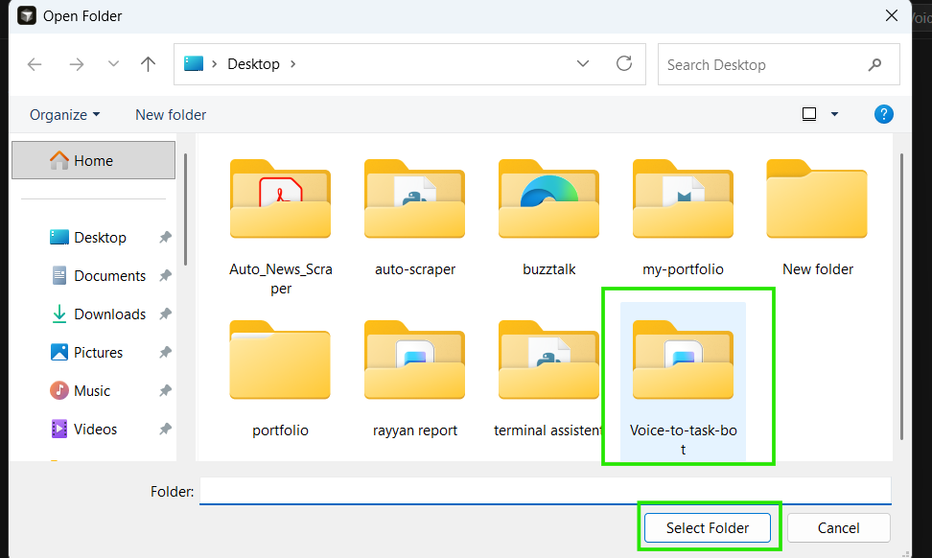
Step 2: The Security Vault (Setting up your FREE API Key)
Before we write any code, we need a "Key" to access the AI models for free. We will use Hugging Face, which provides free access to powerful AI models.
How to get your Free Token:
- Go to huggingface.co and create a free account.
- 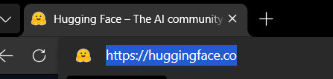
- 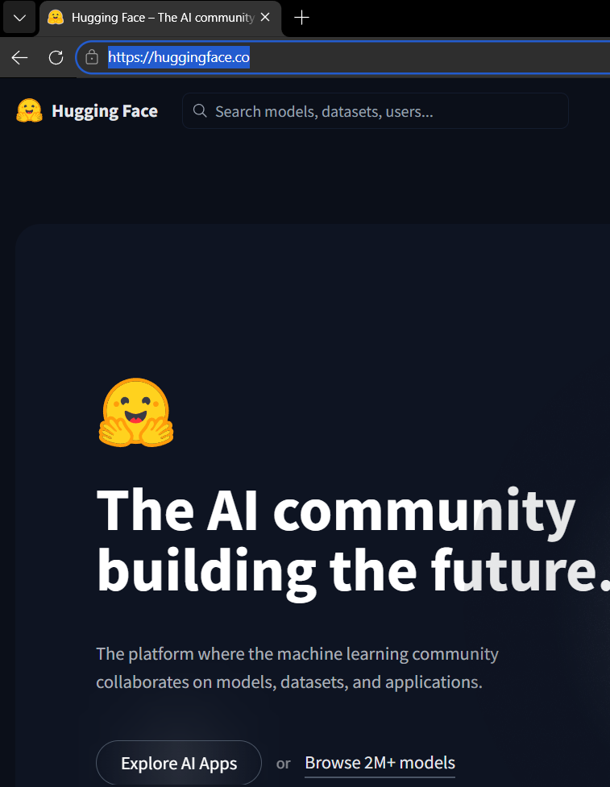
- Go to your Profile Settings -> Access Tokens.
- 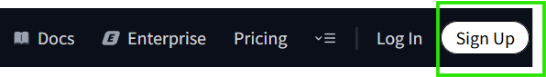
- 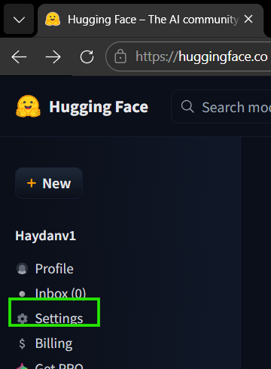
- 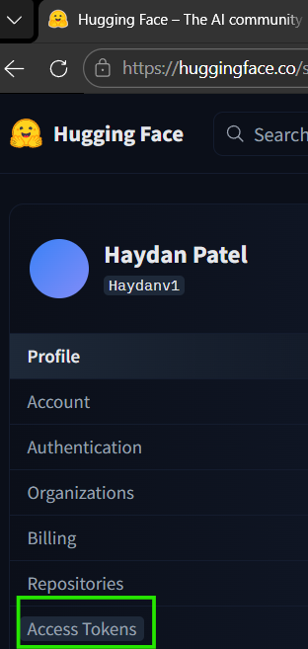
- Click "Create new token" (Choose the 'Read' role) and copy the generated key.
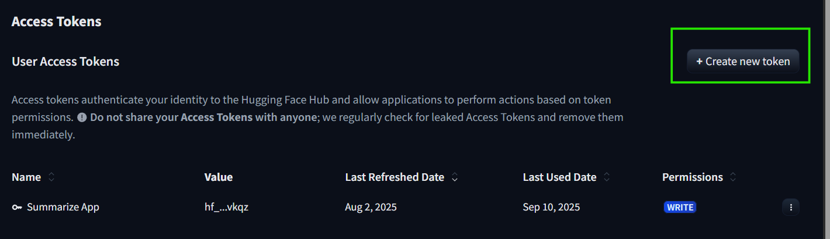
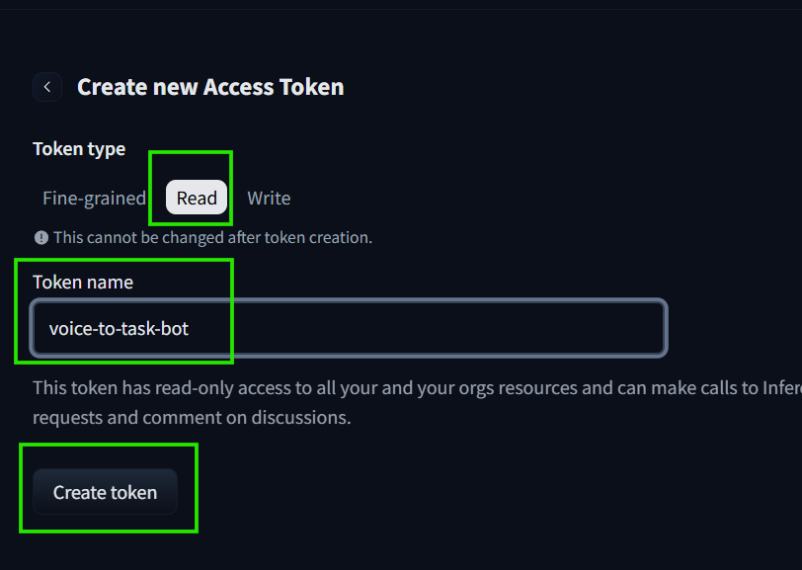
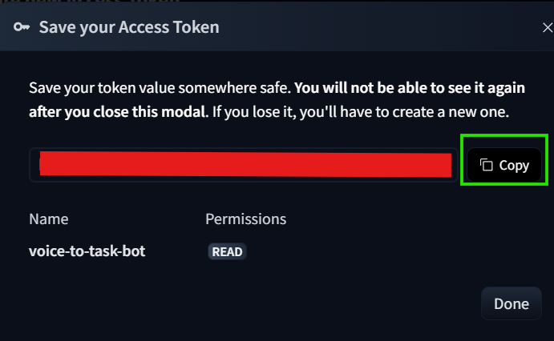
How to secure it (The .env file):
- Inside your voice-to-task-bot folder in Cursor IDE, create a new file and name it exactly .env (don't forget the dot!).
- 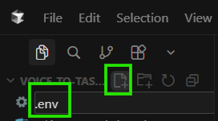
- Open the .env file and type the following:
HUGGINGFACE_API_KEY=paste_your_copied_token_here
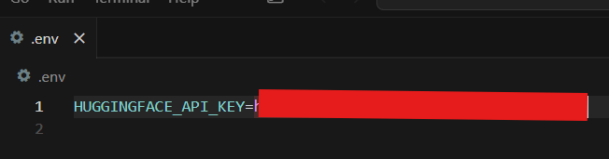
- Save the file. Your secret key is now safely locked inside the vault.
⚖️ Technical Note: Cursor Core Tools (For Non-IT Users)
How do we talk to the AI inside Cursor IDE?
Tool | Shortcut | What it does | When to use it?
Inline Chat | Ctrl + K | Edits a specific line or small block of code. | Fixing a small error in one file.
Composer | Ctrl + I | The Architect. It can read multiple files, create new files, and build the entire app. | Right Now! For generating whole projects from scratch.

Step 3: The "God Prompt" (Executing AI Magic)
Now, we will command the AI to build the entire application. We don't need to write the Python logic ourselves; we just need to provide a flawless, structured instruction.
- In Cursor IDE, press Ctrl + I (or Cmd + I on Mac) to open the Composer.
- Copy the entire prompt below and paste it into the Composer box.
- Hit Enter and watch the AI write all the code, link the APIs, and build the UI for you!
📋 THE MASTER PROMPT (Copy everything below this line):
Act as an Expert Python Backend Developer. I want to build a "Voice-to-Task Bot" using Streamlit for the UI. We must strictly use FREE Hugging Face Serverless Inference APIs. No local LLM installations.
Technical Requirements:
- Libraries: Use streamlit, requests, python-dotenv, and audio-recorder-streamlit (for mic input in the browser).
- Security: Use dotenv to load the HUGGINGFACE_API_KEY from my .env file. Do NOT hardcode the API key in the script.
- Audio Processing: Use the Hugging Face Inference API for the openai/whisper-tiny.en model to transcribe the recorded audio into text.
- Task Extraction (LLM): Send the transcribed text to the Hugging Face Inference API for meta-llama/Meta-Llama-3-8B-Instruct. Give the LLM a strict system prompt to act as an assistant that ONLY outputs a formatted bulleted To-Do list based on the spoken text.
App Flow:
- Display a clean Streamlit title and description.
- Provide a mic button to record audio.
- Once recorded, show a "Transcribing..." spinner while calling the Whisper API.
- Display the extracted text.
- Show an "Extracting Tasks..." spinner while calling the Llama-3 API.
- Display the final To-Do list in a clean markdown format.
Please generate the full app.py code and also provide the contents for a requirements.txt file so I can install the dependencies. Make the UI professional and error-proof.
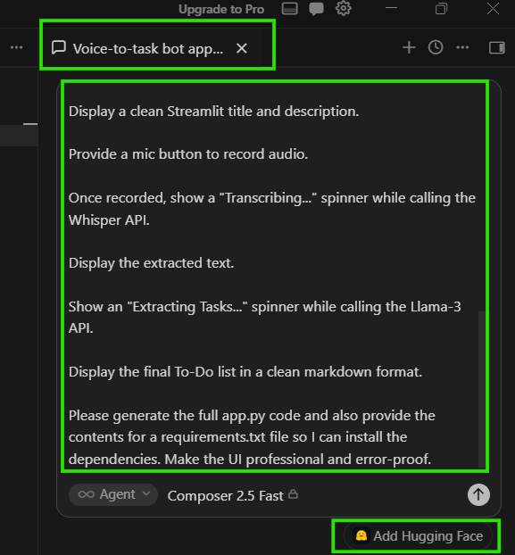
Now press enter
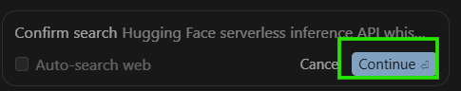
Click on continue
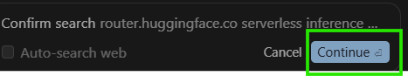
Again click continue
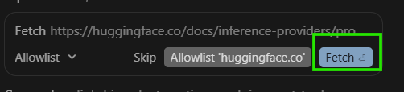
Then click on fetch
Again click on fetch 5 times , if asked
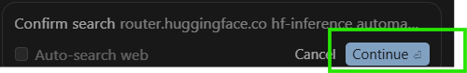
Now click on continue , 2 times one by one , if asked
Then again click on fetch
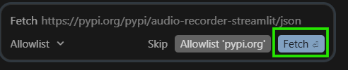
At last but not least you should see this output , then click on run
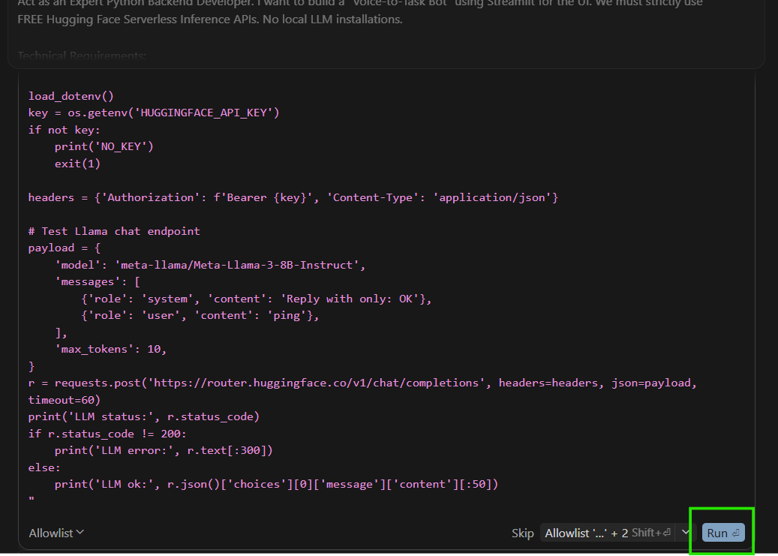
Click on run again
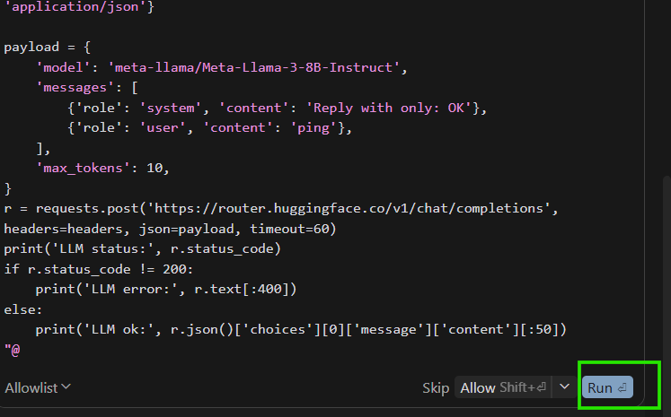
Again click on run
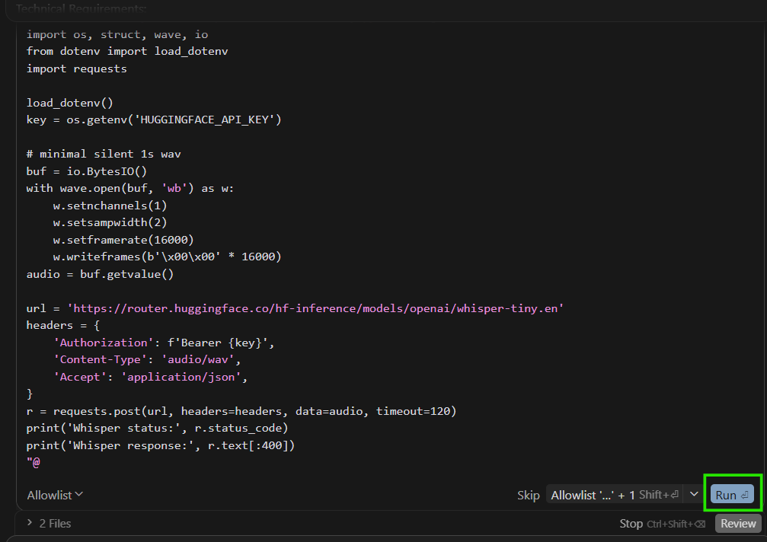
CLICK ON RUN AGAIN
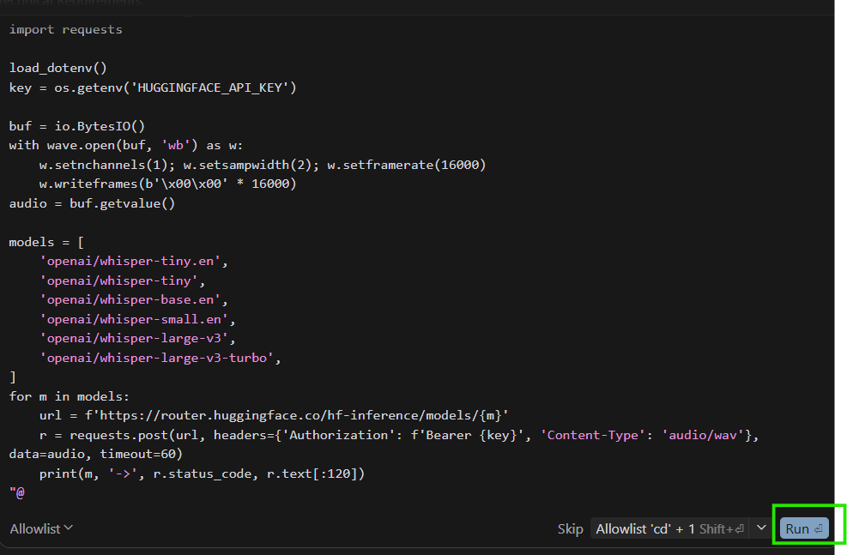
CLICK ON CONTINUE
NOW CLICK ON RUN 2 or click on continue and run and fetch until and unless you should be seen this output
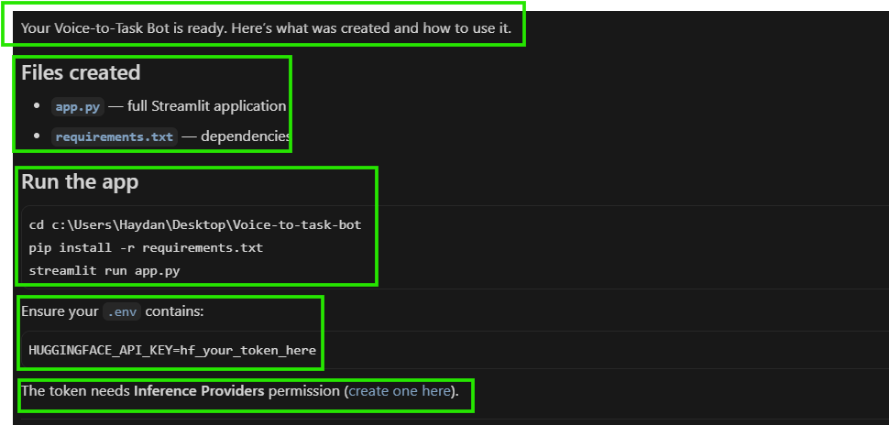
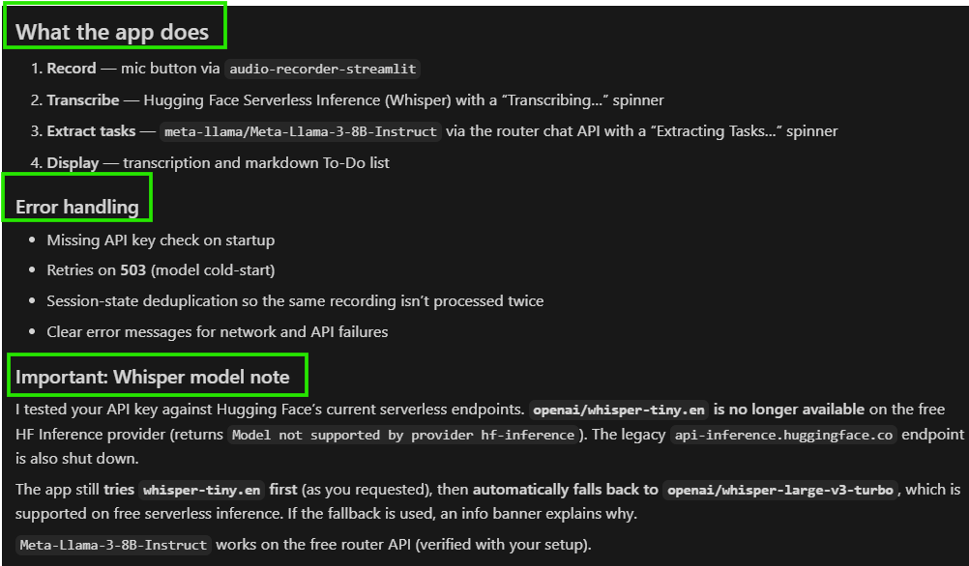
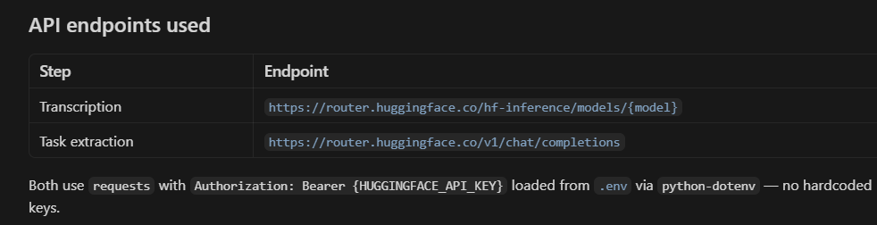
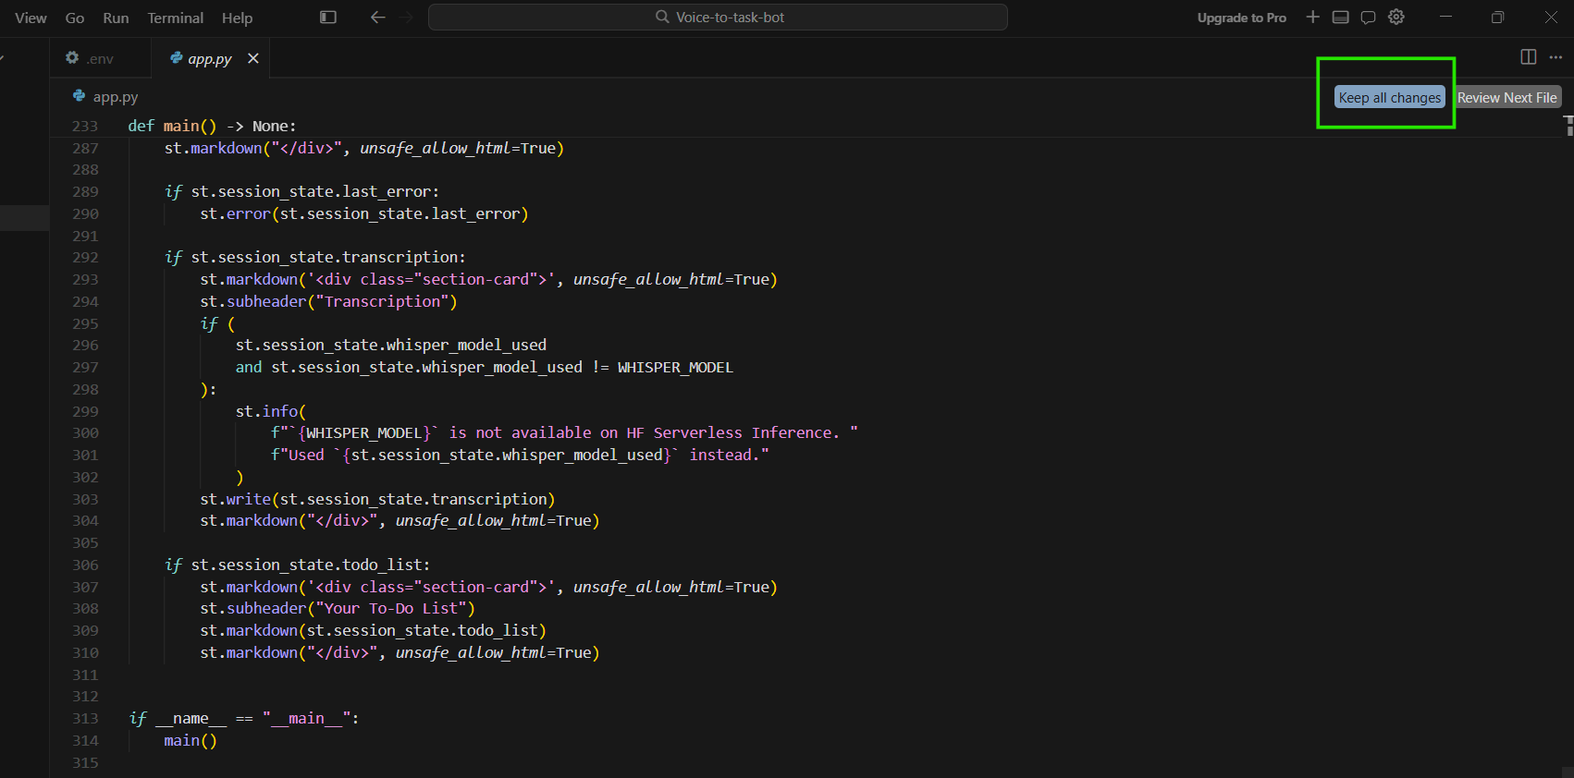

Now do this steps to final settlement and finishing
Dependency Installation: pip install -r requirements.txt run this command in terminal
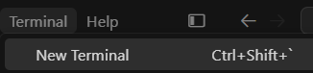
Copy this command and press enter
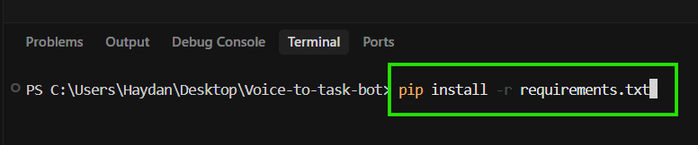
Run this command in terminal: python -m streamlit run app.py
Launch the Beast: streamlit run app.py
Copy this command in terminal and press enter
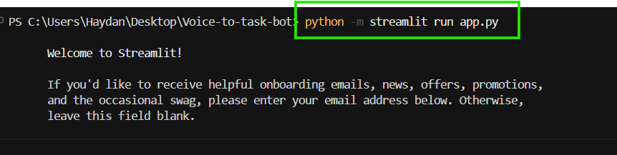
If you see the below message just press enter
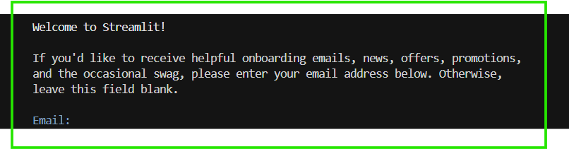
And you will see this output in your browser

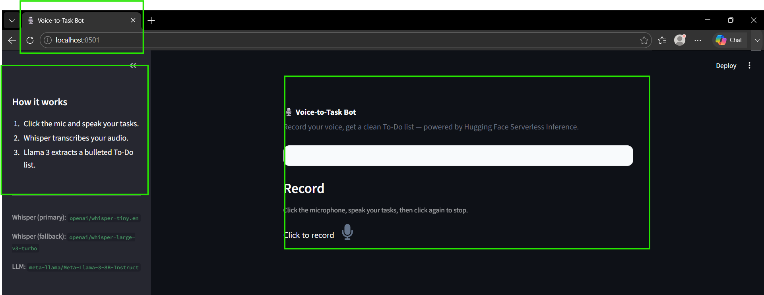

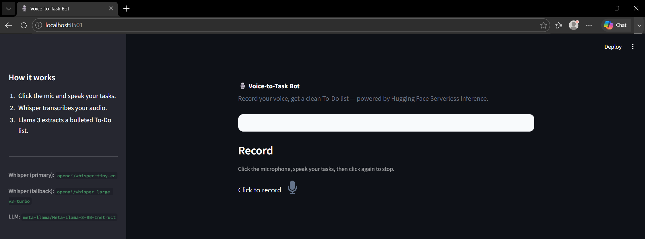
Here is your project is complete

