|  |
| --- |
| CRAZY GAME CREATION Crazy-PNG-File-420x272.png  **Crazy Game Creation** |
| Zombie Rush |
| The return of the last Zombies |
| Version #0.1  All work Copyright © 2012 by XX Games.  All rights reserved. |
| **Haydar shariff - 300828076**  **Adalberto Cuevas de Paula - 300917462**  **Ostap Hamarnyk - 300 836 326** |
|  |

|  |
| --- |
| August 04th 2017 |

# 1 Table of Contents

**CRAZY GAME CREATION** **1**

**1 Table of Contents** **3**

**2 Version History** **4**

**3 Game Overview** **6**

3.1 Game Play Mechanics 6

3.2 Camera 6

3.3 Controls 7

3.4 Interface Sketch 8

3.5 Menu and Screen Descriptions 9

3.6 Game World 9

3.7 Levels 10

3.8 Game Progression 10

3.9 Enemies 10

3.10 Weapons 11

3.11 Items 12

3.12 Abilities 12

3.13 Vehicles 12

3.14 Art / Multimedia Index 13

3.15 Design Notes 14

3.16 Future Features 14

# 2 Version History

0.1 Setup of the graphic and game architecture.

0.2 Create the game first screen menu.

#### 

# 3 Game Overview

*The last Zombies are invading your city, it is time for you and your troops to take action and with your arsenal set Zombies killer at a strategic location, and get those invaders kill so the peace can come back to your city.*

## 3.1 Game Play Mechanics

*It is a tower game, player need to set his troops in way that Zombies don’t get into the city. Troop are going to block and eliminates Zombies with their guns. Onces the Zombies start entering in to your city, you will start losing points for every of them that have access to it, onces you get into 0 points you will lose the game.*

## 3.2 Camera

*It is a Tower game with a fit camera.*

## 3.3 Controls

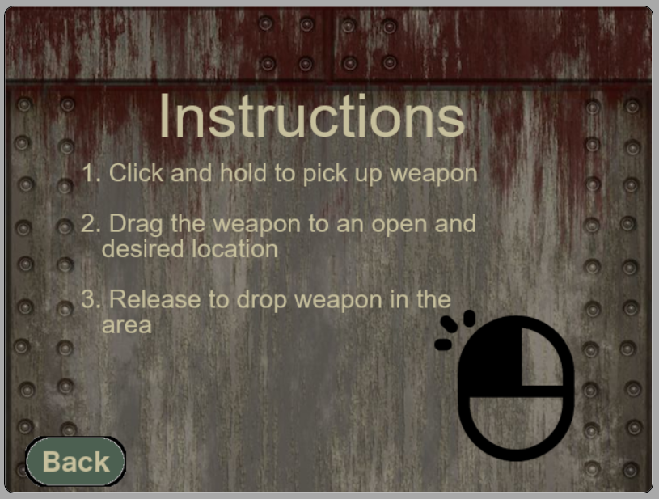

## 3.4 Interface Sketch

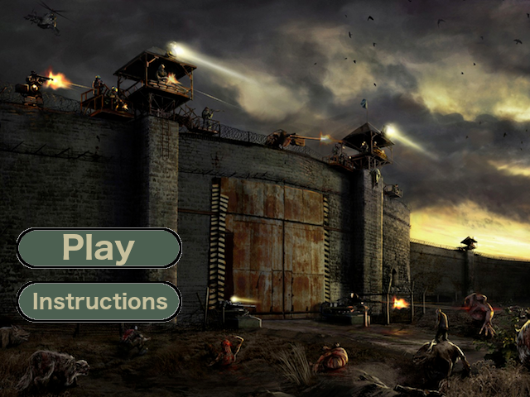

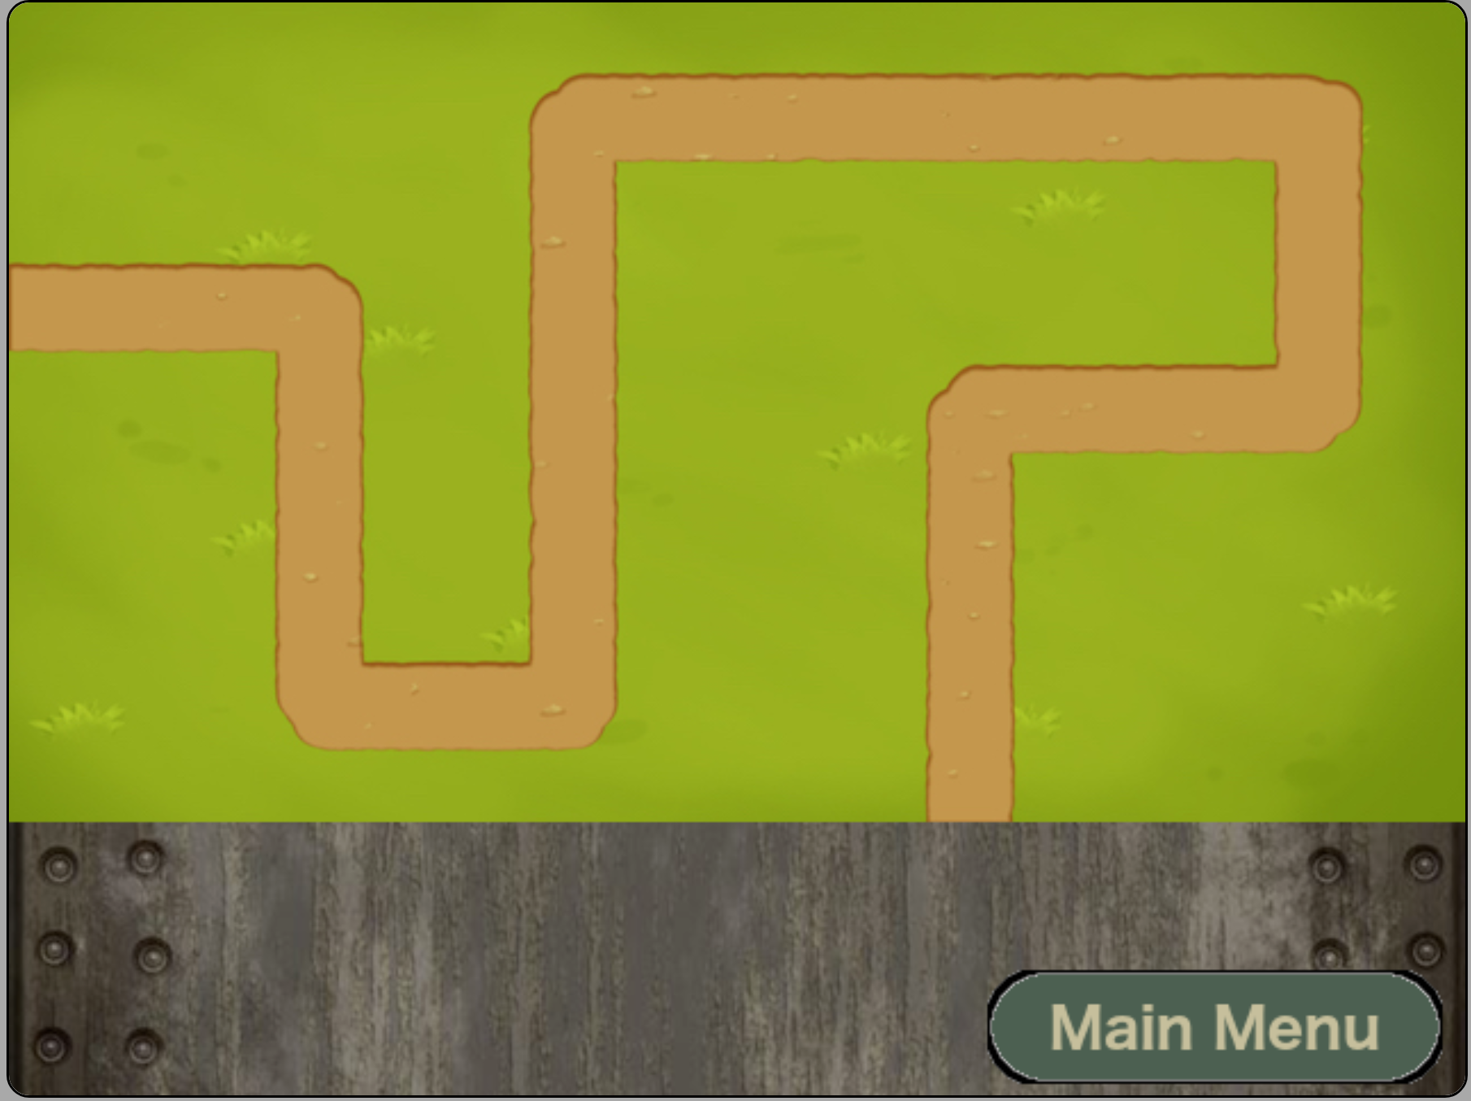

## 3.5 Menu and Screen Descriptions

*(Include additional screen shots and accompanying descriptions for any menus and additional screen)*

## 3.6 Game World

*(Describe Your Game Environment)*

## 3.7 Levels

*(Describe Each of your game levels)*

## 3.8 Game Progression

1. **Characters**

*(Describe Your game avatar if applicable)*

1. **Non-player Characters**

(Describe Any Computer controlled Allies and how they work)

## 

## 3.9 Enemies

*Zombies that try to get in the city and infect it population.*

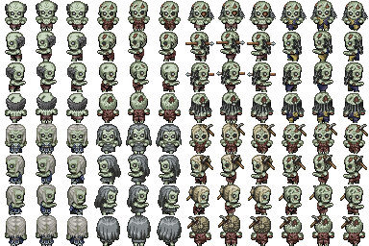

## 3.10 Weapons

*(Describe any weapons available to the user)*

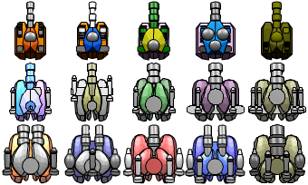

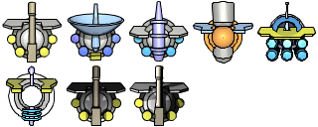

## 3.11 Items

*(Describe any in-game items that can help or hinder the user)*

## 

## 3.12 Abilities

## 3.13 Vehicles

1. **Script**
2. **Scoring**
3. **Puzzles/Mini-games**
4. **Bonuses**
5. **Cheat Codes**
6. **Sound Index**

*(Include an index of all your sound clips)*

1. **Story Index**

*(Outline your game story here)*

## 3.14 Art / Multimedia Index

*\*Buttons*

*FbackBtn.png*

*instructionsBtn.png   
mainMenuBtn.png  
playBtn.png*

*\*Images*

*bullets.png  
gameBackground.png  
instructionsBackground.png  
mouseIconLeft.png  
turrents_sprite.png  
turrets_lazer.png   
zombies.png*

*\*Maps*

*1.jpg   
10.jpg   
11.jpg   
12.jpg   
2.jpg   
3.jpeg   
4.jpg   
5.jpg   
6.jpg   
7.jpg   
8.jpg   
9.jpg*

## 3.15 Design Notes

*(Include additional design notes here)*

## 3.16 Future Features

*(Include any future features that are planned to be implemented)*