

**MARMARA UNIVERSITY**

**FACULTY OF ENGINEERING**

CSE3055

Database Systems

Project Step #4

Date:08.01.2023

|  |  |  |
| --- | --- | --- |
|  | Student Id | Name Surname |
| 1 | 150119745 | Haydar Taha TUNÇ |
| 2 | 150119739 | Emir Ege EREN |
| 3 | 150119743 | Burak DURSUN |

**Installation**

We used python to do interface development. For this, we first installed the 3.11.1 version of Python on our computer. We then used the Pycharm idea to write the code. We installed the packages required to run the project from the Project menu in the settings menu.

Required packages = “pyodbc, PyQt6”

Then we need to install the Driver in order to run the pyodbc package we installed. In order to do this setup, it is necessary to add a new user to SQL. For this, we first go to the Security menu from the properties menu of the database installed locally from the Microsoft SQL Server Management Studio program. Then we change the Server authentication at the top to SQL Server and Windows Authentication mode.

metin içeren bir resim

Açıklama otomatik olarak oluşturuldu

Then we double-click on the database from the Object Explorer and then click on Security. Then right click on Login and press New Login. Then we make the settings as shown in the picture and press the OK button.

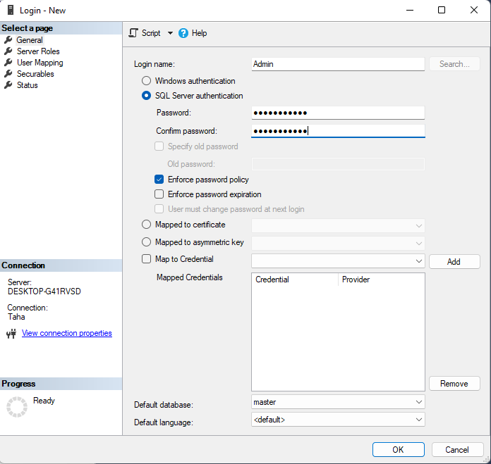

metin içeren bir resim

Açıklama otomatik olarak oluşturuldu

metin içeren bir resim

Açıklama otomatik olarak oluşturuldu

Afterwards, the drivers in the links I have given need to be installed.

<https://go.microsoft.com/fwlink/?linkid=2214634>

<https://go.microsoft.com/fwlink/?linkid=2217421>



After doing all this, we update the connect string in the 7th line of the program in accordance with the user we created.

After doing all this, the program is ready to run.

Example screenshots:

