Table S1. Number of microbial metabolic pathways showing the highest abundances in honey metagenomes from different geographical origins (Granada PDO, Tenerife PDO, Villuercas-Ibores PDO, Non-PDO controls). These metabolic pathways are summarised by bacterial species and metabolic function.
A) Microbial metabolic pathways showing
the highest abundances in specific honey PDOs (summarised by taxa)
Higher in: | Taxa displaying the metabolic functions presented in Table B) | n
Granada | Lactobacillus apinorum | 5
Tenerife | Parasaccharibacter apium | 53
Tenerife | Lactobacillus kunkeei | 26
Tenerife | Acinetobacter nectaris | 15
Tenerife | Lactobacillus apinorum | 10
No DPO | Lactobacillus apinorum | 1
Total |  | 110
B) Microbial metabolic pathways showing
the highest abundances in specific honey PDOs (summarised by metabolic function)
Higher in: | Metabolic functions corresponding to taxa presented in Table A) | n
Granada | Vitamins | 2
Granada | Amino acids | 1
Granada | Cell wall | 1
Granada | Nucleotides | 1
Tenerife | Nucleotides | 42
Tenerife | Amino acids | 28
Tenerife | Other | 20
Tenerife | Vitamins | 7
Tenerife | Carbohydrates | 3
Tenerife | Cell wall | 3
Tenerife | Lipids | 1
No DPO | Vitamins | 1
Total |  | 110

Table S2. Sensitivity, specificity and balanced accuracy of partial least squares (PLS), random forest (RF), boosted logistic regression (LOGITBOOST) and artificial neural networks (NNET) models computed to classify honey metagenomes according to their geographical origin (Granada PDO, Tenerife PDO, Villuercas-Ibores PDO, Non-PDO controls).
 | Sensitivity (%) | Specificity (%) | Balanced Accuracy (%)
PLS - Train phase: Granada | 95.24 | 100.00 | 97.62
PLS - Test phase: Granada | 85.71 | 95.74 | 90.73
PLS - Train phase: Non-PDO | 100.00 | 100.00 | 100.00
PLS - Test phase: Non-PDO | 100.00 | 100.00 | 100.00
PLS - Train phase: Tenerife | 100.00 | 96.81 | 98.40
PLS - Test phase: Tenerife | 100.00 | 92.86 | 96.43
PLS - Train phase: Villuercas | 91.30 | 100.00 | 95.65
PLS - Test phase: Villuercas | 69.23 | 100.00 | 84.62
RF - Train phase: Granada | 100.00 | 100.00 | 100.00
RF - Test phase: Granada | 100.00 | 100.00 | 100.00
RF - Train phase: Non-PDO | 100.00 | 100.00 | 100.00
RF - Test phase: Non-PDO | 100.00 | 100.00 | 100.00
RF - Train phase: Tenerife | 100.00 | 100.00 | 100.00
RF - Test phase: Tenerife | 100.00 | 100.00 | 100.00
RF - Train phase: Villuercas | 100.00 | 100.00 | 100.00
RF - Test phase: Villuercas | 100.00 | 100.00 | 100.00
LOGITBOOST - Train phase: Granada | 100.00 | 100.00 | 100.00
LOGITBOOST - Test phase: Granada | 80.00 | 100.00 | 90.00
LOGITBOOST - Train phase: Non-PDO | 100.00 | 100.00 | 100.00
LOGITBOOST - Test phase: Non-PDO | 100.00 | 100.00 | 100.00
LOGITBOOST - Train phase: Tenerife | 100.00 | 100.00 | 100.00
LOGITBOOST - Test phase: Tenerife | 100.00 | 95.12 | 97.56
LOGITBOOST - Train phase: Villuercas | 100.00 | 100.00 | 100.00
LOGITBOOST - Test phase: Villuercas | 100.00 | 100.00 | 100.00
NNET - Train phase: Granada | 100.00 | 100.00 | 100.00
NNET - Test phase: Granada | 100.00 | 100.00 | 100.00
NNET - Train phase: Non-PDO | 100.00 | 100.00 | 100.00
NNET - Test phase: Non-PDO | 100.00 | 100.00 | 100.00
NNET - Train phase: Tenerife | 100.00 | 100.00 | 100.00
NNET - Test phase: Tenerife | 100.00 | 100.00 | 100.00
NNET - Train phase: Villuercas | 100.00 | 100.00 | 100.00
NNET - Test phase: Villuercas | 100.00 | 100.00 | 100.00

Table S3. Sensitivity, specificity and balanced accuracy of partial least squares (PLS), random forest (RF), boosted logistic regression (LOGITBOOST) and artificial neural networks (NNET) models computed to classify honey metagenomes according to their product variety (Albaida, Avocado, Chestnut, Heather, Multifloral, Retama del Teide, Rosemary and Tajinaste).
 | Sensitivity (%) | Specificity (%) | Balanced Accuracy (%)
PLS - Train phase: Albaida | 84.62 | 100.00 | 92.31
PLS - Test phase: Albaida | 100.00 | 100.00 | 100.00
PLS - Train phase: Avocado | 100.00 | 98.90 | 99.45
PLS - Test phase: Avocado | 100.00 | 97.44 | 98.72
PLS - Train phase: Chestnut | 82.35 | 100.00 | 91.18
PLS - Test phase: Chestnut | 66.67 | 100.00 | 83.33
PLS - Train phase: Heather | 100.00 | 96.77 | 98.39
PLS - Test phase: Heather | 33.33 | 97.30 | 65.32
PLS - Train phase: Multifloral | 69.23 | 87.72 | 78.48
PLS - Test phase: Multifloral | 53.85 | 74.07 | 63.96
PLS - Train phase: Retama del Teide | 55.56 | 93.10 | 74.33
PLS - Test phase: Retama del Teide | 60.00 | 94.29 | 77.14
PLS - Train phase: Rosemary | 100.00 | 100.00 | 100.00
PLS - Test phase: Rosemary | 100.00 | 100.00 | 100.00
PLS - Train phase: Tajinaste | 83.33 | 94.44 | 88.89
PLS - Test phase: Tajinaste | 50.00 | 92.11 | 71.05
RF - Train phase: Albaida | 100.00 | 100.00 | 100.00
RF - Test phase: Albaida | 100.00 | 100.00 | 100.00
RF - Train phase: Avocado | 100.00 | 100.00 | 100.00
RF - Test phase: Avocado | 100.00 | 100.00 | 100.00
RF - Train phase: Chestnut | 100.00 | 100.00 | 100.00
RF - Test phase: Chestnut | 100.00 | 100.00 | 100.00
RF - Train phase: Heather | 100.00 | 100.00 | 100.00
RF - Test phase: Heather | 100.00 | 100.00 | 100.00
RF - Train phase: Multifloral | 100.00 | 100.00 | 100.00
RF - Test phase: Multifloral | 100.00 | 100.00 | 100.00
RF - Train phase: Retama del Teide | 100.00 | 100.00 | 100.00
RF - Test phase: Retama del Teide | 100.00 | 100.00 | 100.00
RF - Train phase: Rosemary | 100.00 | 100.00 | 100.00
RF - Test phase: Rosemary | 100.00 | 100.00 | 100.00
RF - Train phase: Tajinaste | 100.00 | 100.00 | 100.00
RF - Test phase: Tajinaste | 100.00 | 100.00 | 100.00
LOGITBOOST - Train phase: Albaida | 100.00 | 100.00 | 100.00
LOGITBOOST - Test phase: Albaida | 100.00 | 100.00 | 100.00
LOGITBOOST - Train phase: Avocado | 100.00 | 100.00 | 100.00
LOGITBOOST - Test phase: Avocado | 100.00 | 100.00 | 100.00
LOGITBOOST - Train phase: Chestnut | 100.00 | 100.00 | 100.00
LOGITBOOST - Test phase: Chestnut | 100.00 | 100.00 | 100.00
LOGITBOOST - Train phase: Heather | 100.00 | 100.00 | 100.00
LOGITBOOST - Test phase: Heather | 50.00 | 100.00 | 75.00
LOGITBOOST - Train phase: Multifloral | 100.00 | 100.00 | 100.00
LOGITBOOST - Test phase: Multifloral | 100.00 | 86.67 | 93.33
LOGITBOOST - Train phase: Retama del Teide | 100.00 | 100.00 | 100.00
LOGITBOOST - Test phase: Retama del Teide | 100.00 | 100.00 | 100.00
LOGITBOOST - Train phase: Rosemary | 100.00 | 100.00 | 100.00
LOGITBOOST - Test phase: Rosemary | 50.00 | 100.00 | 75.00
LOGITBOOST - Train phase: Tajinaste | 100.00 | 100.00 | 100.00
LOGITBOOST - Test phase: Tajinaste | 100.00 | 100.00 | 100.00
NNET - Train phase: Albaida | 100.00 | 100.00 | 100.00
NNET - Test phase: Albaida | 100.00 | 100.00 | 100.00
NNET - Train phase: Avocado | 100.00 | 100.00 | 100.00
NNET - Test phase: Avocado | 100.00 | 100.00 | 100.00
NNET - Train phase: Chestnut | 100.00 | 100.00 | 100.00
NNET - Test phase: Chestnut | 100.00 | 100.00 | 100.00
NNET - Train phase: Heather | 100.00 | 100.00 | 100.00
NNET - Test phase: Heather | 50.00 | 100.00 | 75.00
NNET - Train phase: Multifloral | 100.00 | 100.00 | 100.00
NNET - Test phase: Multifloral | 100.00 | 86.67 | 93.33
NNET - Train phase: Retama del Teide | 100.00 | 100.00 | 100.00
NNET - Test phase: Retama del Teide | 100.00 | 100.00 | 100.00
NNET - Train phase: Rosemary | 100.00 | 100.00 | 100.00
NNET - Test phase: Rosemary | 50.00 | 100.00 | 75.00
NNET - Train phase: Tajinaste | 100.00 | 100.00 | 100.00
NNET - Test phase: Tajinaste | 100.00 | 100.00 | 100.00

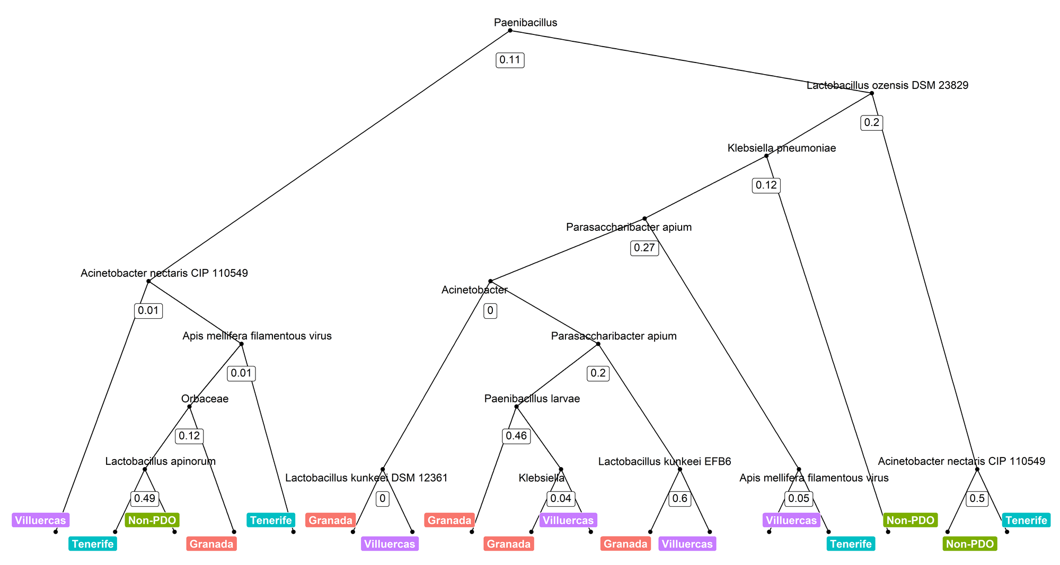
Fig. S1. Example of a random forest (RF) tree where a set of classification rules are learnt directly from the input data (honey metagenomes), considering the abundances of different taxa. RF model illustrated was built to classify honey metagenomes according to their geographical origin: i) Granada PDO, ii) Tenerife PDO, iii) Villuercas-Ibores PDO, iv) Non-PDO controls.
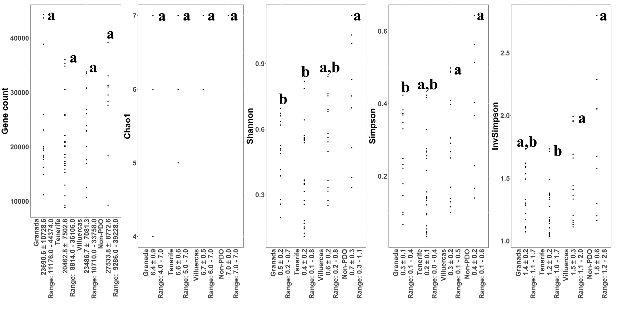
Fig. S2. Comparison of the gene count (based on functional profiles) and different alpha-diversity indicators (Chao1, Shannon, Simpson and Inverse Simpson, based on taxonomic profiles) determined in honey metagenomes according to their geographical origin: i) Granada PDO, ii) Tenerife PDO, iii) Villuercas-Ibores PDO, iv) Non-PDO controls. These indicators measure the variability of microbial taxa within a sample. ^{a,b} Statistically significant differences (p < 0.05) between groups calculated using non-parametric methods (Kruskal-Wallis test).

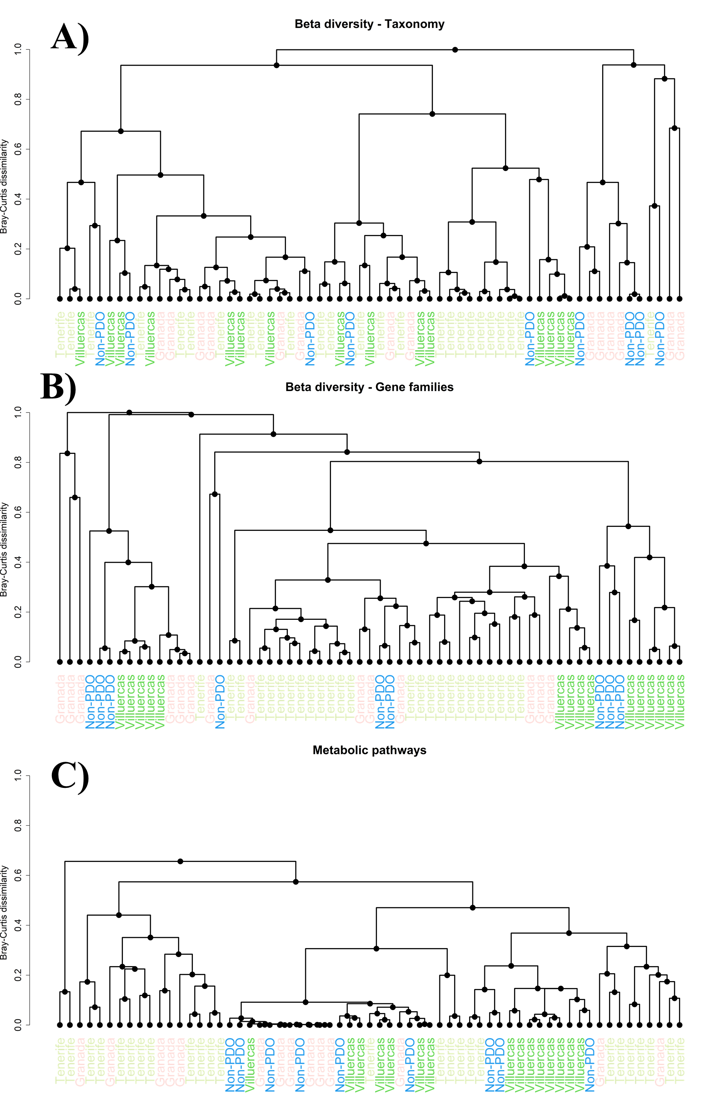
Fig. S3. Cluster analysis of honey metagenomes according to their geographical origin: i) Granada PDO, ii) Tenerife PDO, iii) Villuercas-Ibores PDO, iv) Non-PDO controls. Bray-Curtis dissimilarity distances were calculated considering taxonomic composition (A), microbial gene families (B) and metabolic pathways (C).
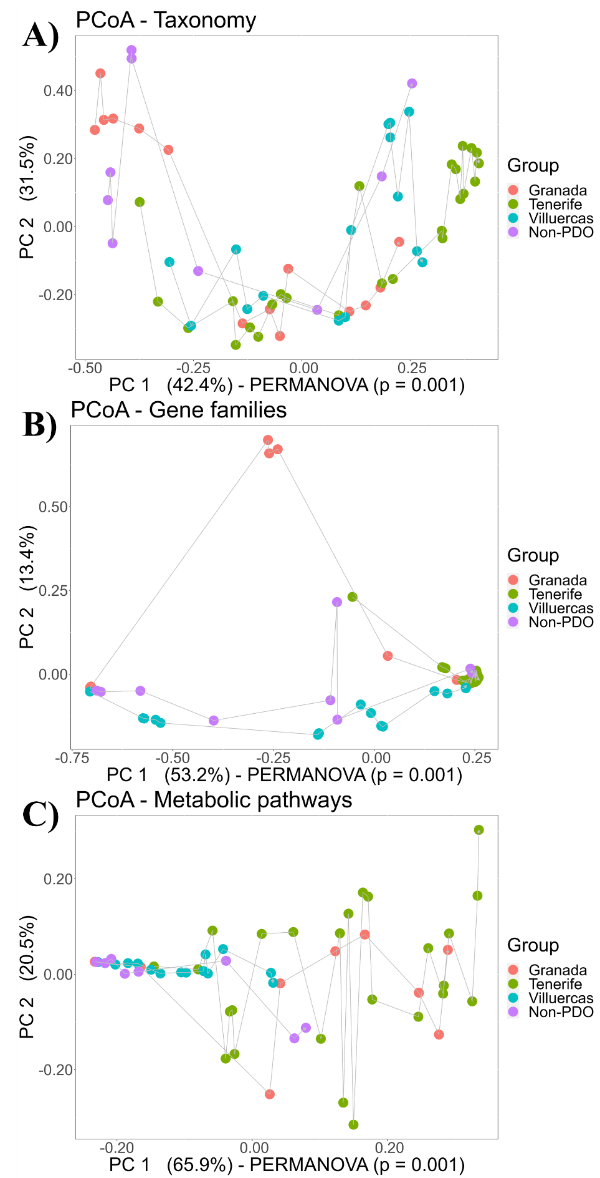
Fig. S4. Principal coordinates analysis (PCoA) of taxonomic profiles (A), gene families (B) and metabolic pathways (C) found in the microbiota of honey samples according to their geographical origin: i) Granada PDO, ii) Tenerife PDO, iii) Villuercas-Ibores PDO, iv) Non-PDO controls. PC: principal coordinate. The percentage (%) of variance explained by each PC is indicated in the axis.
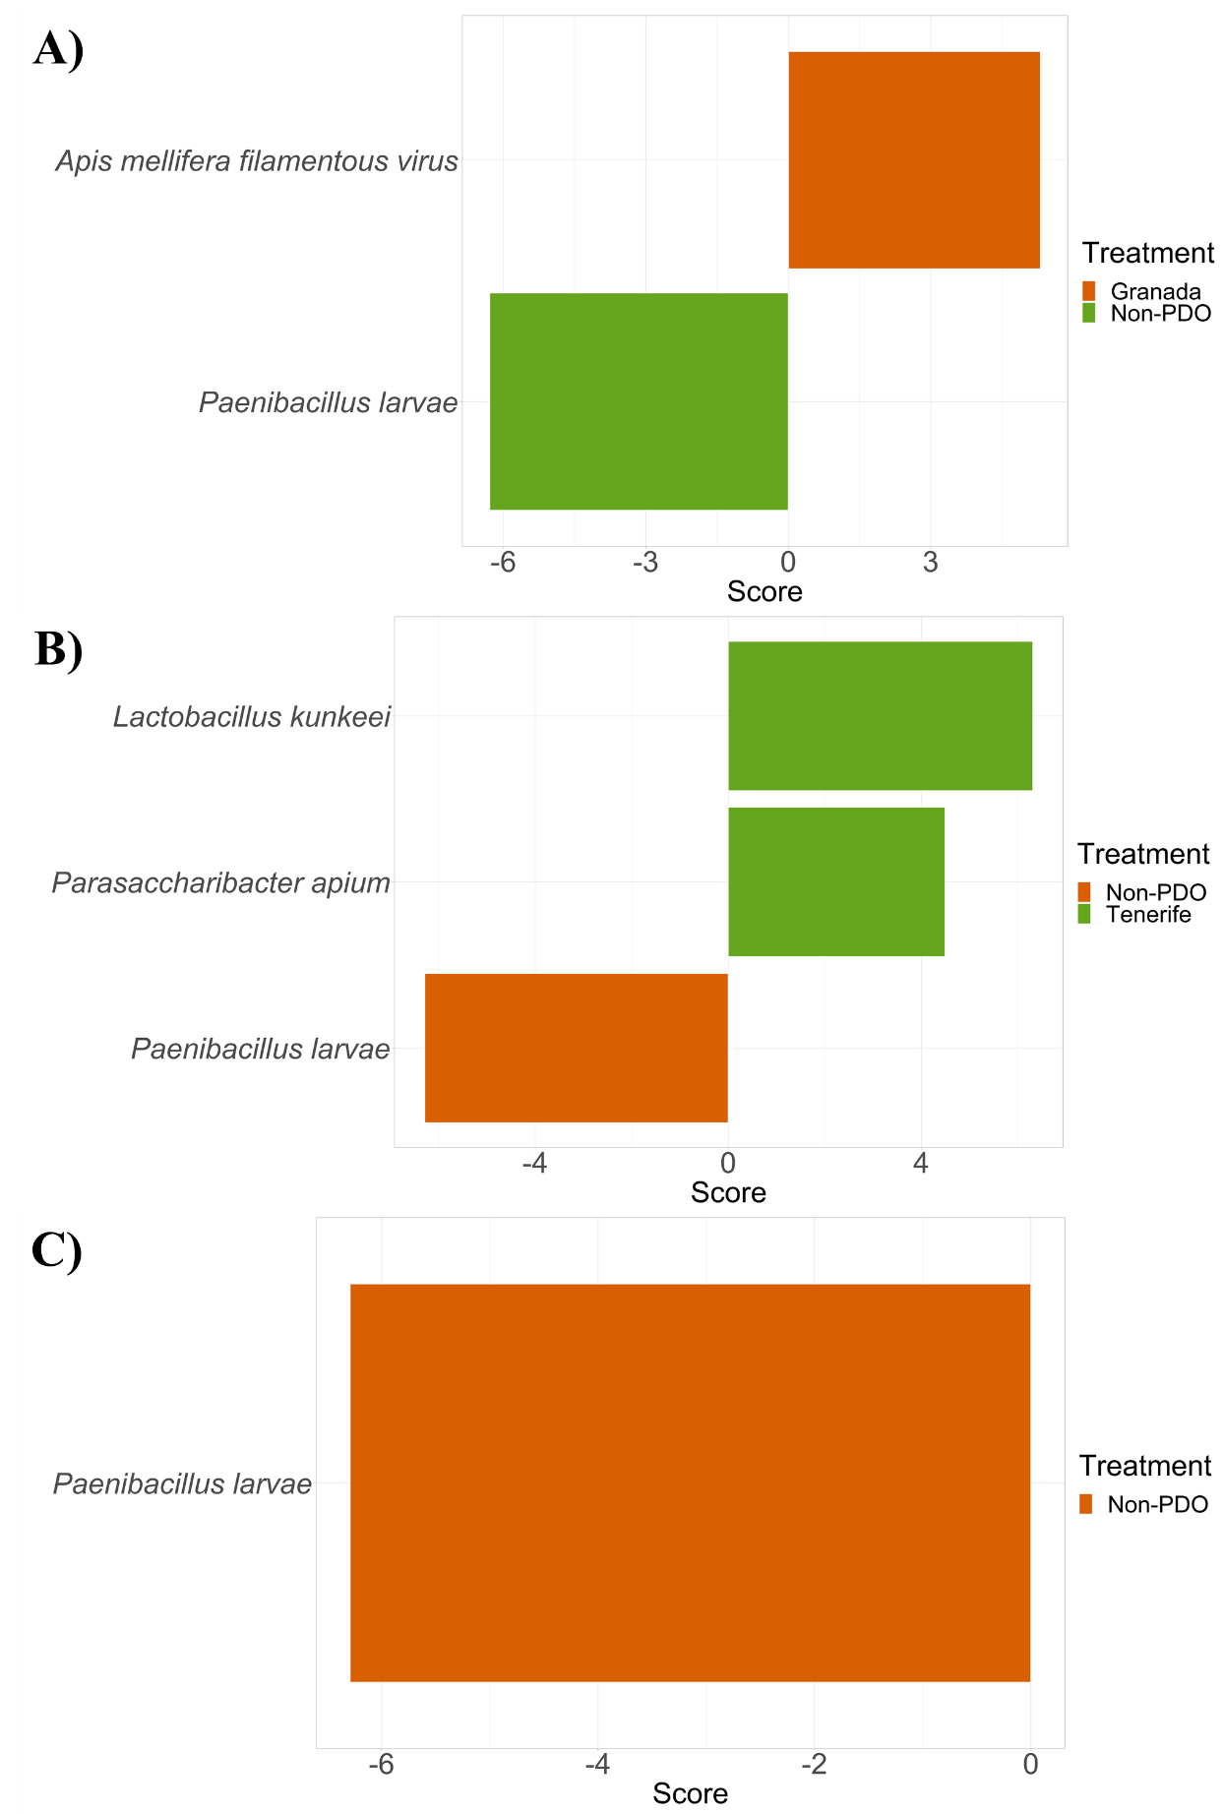
Fig. S5. Scores plots obtained for Linear discriminant analysis Effect Size (LEfSe) of honey metagenomic composition profiles. This plot illustrates potential biomarkers for different honey PDOs compared to non-PDO controls: A) Granada PDO (Apis mellifera filamentous virus) vs Non-PDO controls (Paenibacillus larvae), B) Tenerife PDO (Lactobacillus kunkeei, Parasaccharibacter apium) vs Non-PDO controls (P. larvae), C) Villuercas-Ibores PDO vs Non-PDO controls (P. larvae).

Fig. S6. Network plot obtained for CoNet algorithm from Cytoscape implemented in R. This network illustrates positive (green) and negative (red) associations between microbial species identified in the metagenomic profiles different honey PDOs and non-PDO controls. Positive associations were found between Lactobacillus kunkeei and Parasaccharibacter apium (two species showing the highest and lowest abundances in Tenerife PDO and non-PDO controls, respectively). In contrast, these two taxa showed negative associations with Lactobacillus apinorum, Paenibacillus larvae and Klebsiella pneumoniae showing the highest abundances in non-PDO controls.

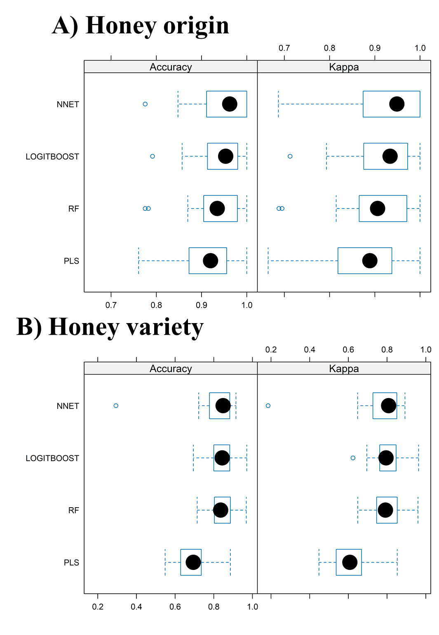
Fig. S7. Comparison of four different algorithms used for classification of honey metagenomes according to their geographical origin (Granada PDO, Tenerife PDO, Villuercas-Ibores PDO, Non-PDO controls) (A) and product variety (Albaida, Avocado, Chestnut, Heather, Multifloral, Retama del Teide, Rosemary and Tajinaste) (B): partial least squares (PLS), random forest (RF), boosted logistic regression (LOGITBOOST) and artificial neural networks (NNET). Differences between models were calculated via their resampling distributions (number of resamples = 10).

