GOV.UK Challenge

The program implements a login system, a search bar and a feedback system to the GOV.UK website that improves navigation and overall usage of the website.

**Installation (No current way to use without Visual Studio)**

1. Open a web browser on a device with access to the internet
2. Seach for the GOV.UK website
3. Enter the website
4. Enable the extension

**Features and Usage.**

When you run the program, you are presented with a prompt to log into the GOV.UK website by using a unique ID and Password. The IF statement will check if the combination of the ID and Password are correct before allowing the user to access the website, this is because it allows the government to have data about the user which reduces the repetitiveness of constantly entering their data into each service.

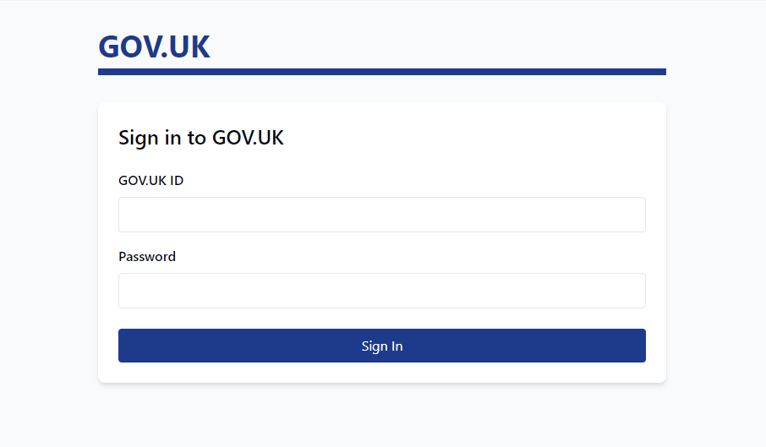

Once logged in, the user can select whether they want to search for a certain place to get relevant information from the website, or give feedback based on their experience using the GOV.UK website and what could be improved. To avoid simple errors, the program makes all inputs from this prompt to be in all capital letters. This format means that no errors could be created by entering the wrong combination (e.g. SeArCh becomes SEARCH)

The search is coded within a function which allows it to return the result to the main code so it can be reused at any time unless the user was to search for another prompt then the variable that stores the results will be overwritten by the function with the new search results.

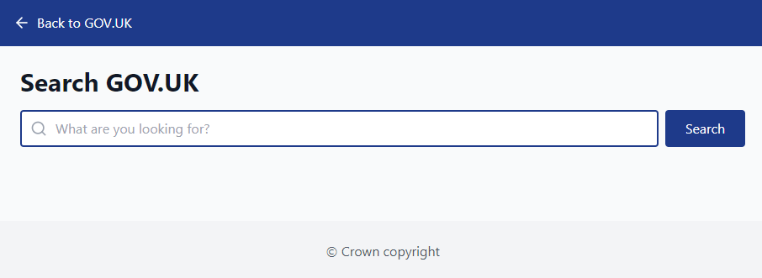

Also, the feedback system is coded within a function. When the user says that they would like to give feedback to the development team, they can specify which service that they would like to give feedback for. Then the code outputs a line to show the user what service that they are submitting a rating and a reason for it. Once the user has entered the rating and the reason, it is saved to a variable called feedback. This variable then gets returned to the main code. Then the string is outputted to the user as a confirmation of the report they have just submitted.

**Known Issues/Bugs**

I wanted to add a simple way to scroll through all headings of the government website for easy navigation, but I didn’t have enough time to spare to implement this feature. Also, it would take a lot of time but will only help a small number of people who have a problem with navigating.

I also wanted to implement an AI assisted assistant that would help with the Navigation and search of information. I do not have the time scope or the ability to add this, so it won’t be included in the solution.

**Credits**

* Claude AI helped with the visualisation of the code
* ChatGPT helped with bug fixing the first function in the C# code.