Week 1 Progress Report: Scalable Smart Home Lighting System

Days 1-2: AWS Infrastructure Setup
What we did:
- Set up AWS account with IAM user and CLI configuration (Picture 1 & 2)
- Established project structure and documentation
Why this matters:
The AWS infrastructure is the backbone of our entire system. Without proper account setup and security configurations, none of the IoT components could function. The IAM setup ensures we have the right permissions for device management, database operations, and cloud services while following security best practices.
How it enables scalability:
- Secure device authentication that works with thousands of devices
- Cost tracking and optimization for large-scale deployments
- Automated management capabilities through AWS CLI

Day 3: System Architecture Design
What we did:
- Created detailed block diagram showing all system components
- Designed MQTT topic structure (iot/sensors/{location}/{deviceType}/{deviceId}/data)
- Planned data schemas for sensor data and device states
Why this design works:
The block diagram serves as our blueprint, ensuring everyone understands how components interact. The hierarchical MQTT topic structure enables efficient message routing and device organization. This makes it easy to add new sensors or rooms without changing the overall architecture.
How it enables scalability:
- Modular design allows independent scaling of components
- Standardized communication supports thousands of devices
- Clear data organization enables efficient analytics and monitoring

Day 4: Device Simulation Implementation
What we did:
- Created IoT "Thing" and device certificates for secure communication
- Built comprehensive Node.js sensor simulator with realistic data generation
- Established secure MQTT connection to AWS IoT Core (Picture 3 & 4)
Why we chose simulation over hardware:
Physical sensors are expensive and unreliable for testing. Our simulator generates realistic data including time-of-day cycles, weather effects, and battery simulation. This allows us to test with hundreds of devices without hardware costs or setup complexity.
Technical features:
- Realistic light patterns based on time and weather
- Battery drain simulation for authentic device behavior
- Error handling and retry logic for network issues
- Rich metadata including device status and data quality

Day 5: Data Communication & Verification
What we did:
- Successfully connected sensor simulator to AWS IoT Core via MQTT (Picture 5)
- Verified data transmission using AWS IoT Test Client (Picture 6)
- Fixed IoT Policy permissions for proper device authentication
Why MQTT is ideal for IoT:
MQTT is lightweight, reliable, and designed for IoT communication. It uses minimal bandwidth (important for battery devices) and has built-in quality of service levels. AWS IoT Core handles the complex scaling automatically.
Troubleshooting process:
Initial connection failures were resolved by updating IoT policies to include:
- iot:Connect - Allow device connection
- iot:Publish - Allow data transmission
- iot:Subscribe - Allow receiving commands

Day 6: Automated Data Processing
What we did:
- Created DynamoDB table with optimized schema (deviceId + timestamp) (Picture 7)
- Implemented AWS IoT Rule for automatic data routing
- Set up CloudWatch Logs for real-time monitoring and tested with simulated light sensor created in Day 4 (Picture 8)
Database design rationale:
- Partition Key (deviceId): Enables efficient queries by device
- Sort Key (timestamp): Supports chronological data retrieval and time-range queries
- On-demand billing: Scales automatically with data volume
IoT Rule implementation:
The SensorDataLogger rule automatically captures all sensor data and routes it to CloudWatch Logs. This provides immediate visibility into system operation and enables rapid troubleshooting.

Screenshots
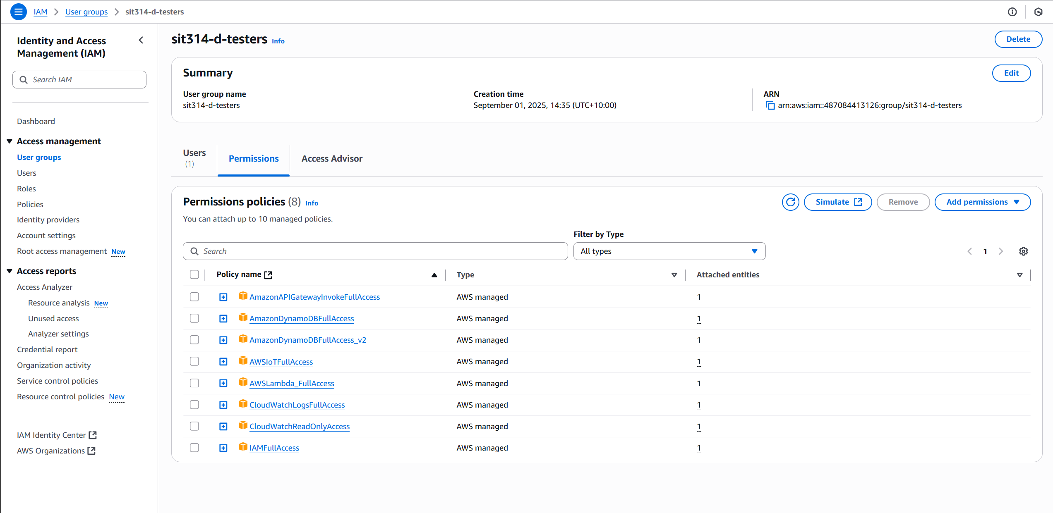
Picture 1 – IAM user account with limited permission policies

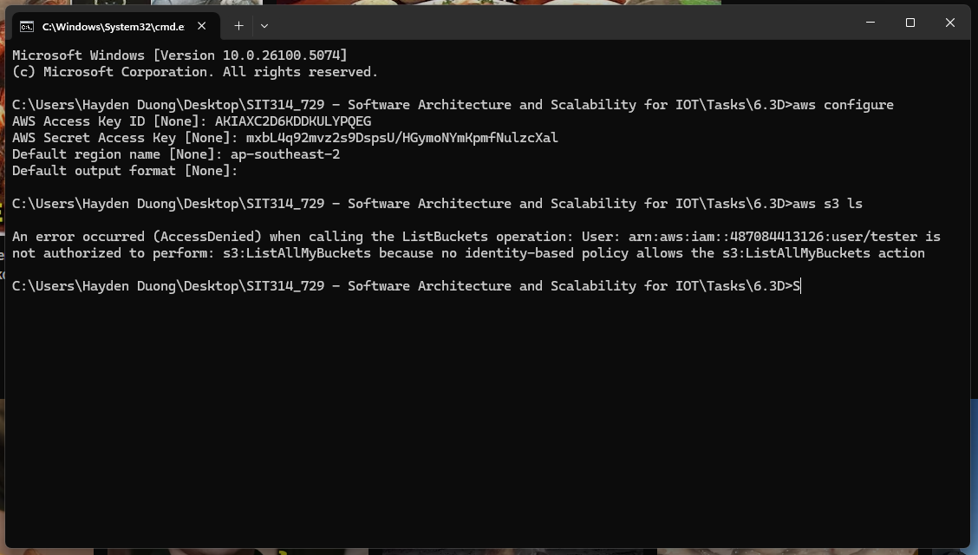
Picture 2 – Logged in as IAM user instead of root account & test its authorization.
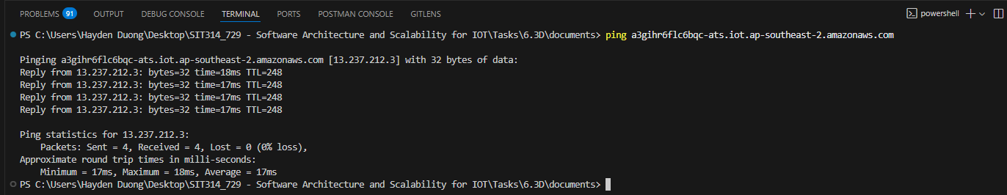
Picture 3 – Successfully ping to AWS
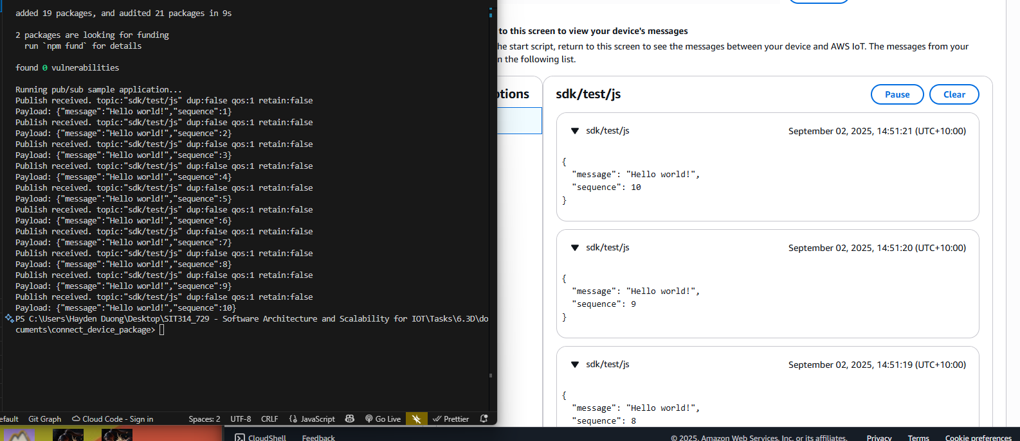
Picture 4 – Successfully generated payload and sent to AWS using the provided package.
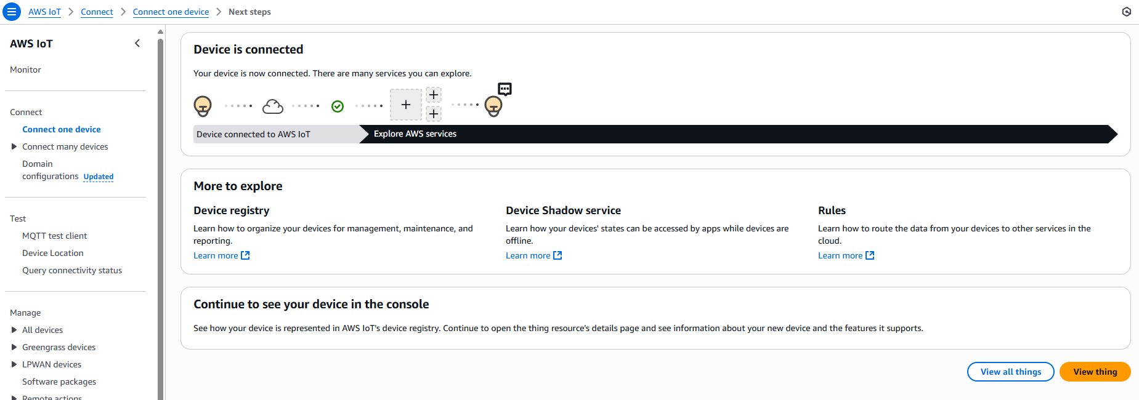
Picture 5 – Successfully connected to AWS IoT
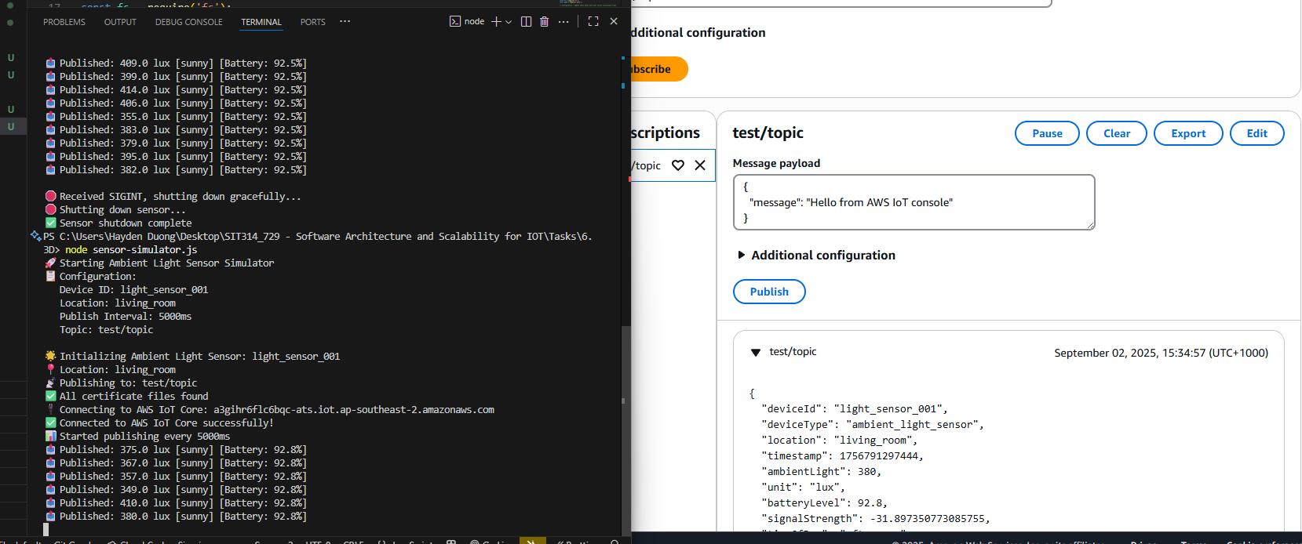
Picture 6 – Successfully run a simulated ambient light sensor and sent the payload to AWS MQTT test client.
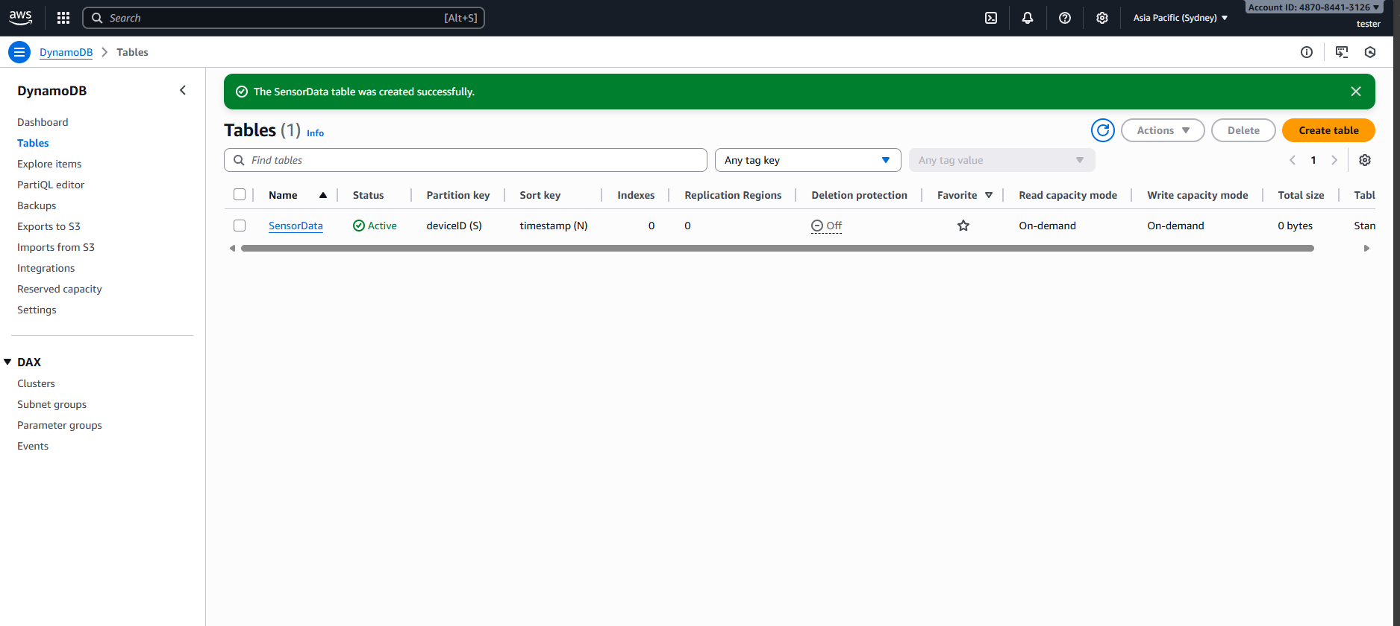
Picture 7 – Create SensorData Table on DynamoDB
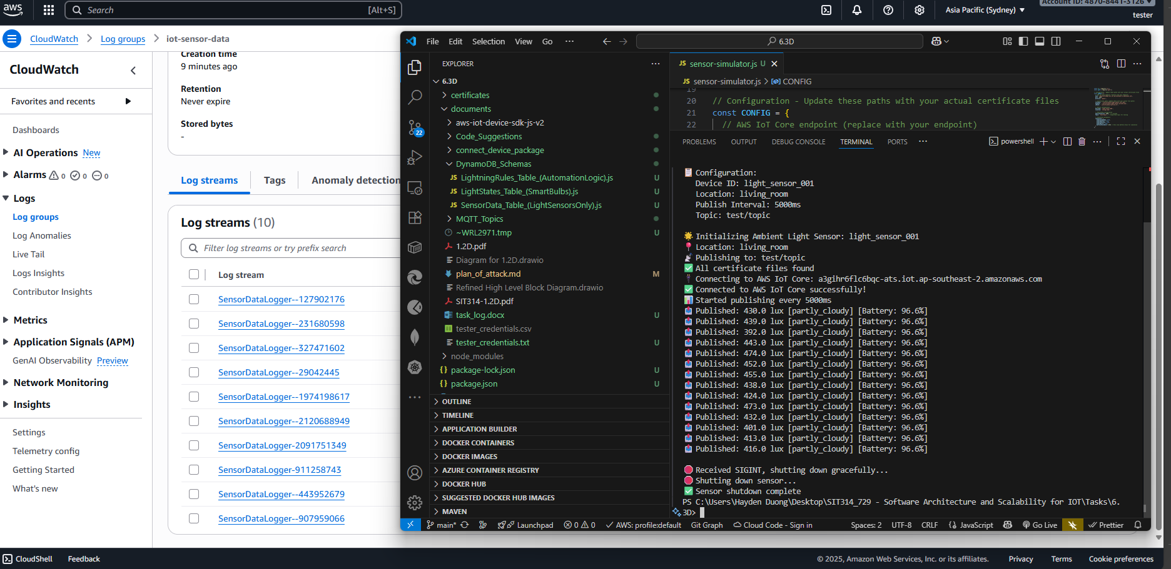
Picture 8 – Successfully displayed the sent payload on CloudWatch Logs.

