A – Class Discussion

Security in Scalable IoT

What are the security requirements for IoT?
Security requirements for IoT are critical due to the vast attack surface and sensitive data involved. Key requirements include:
- Confidentiality: Protecting sensitive data (personal, operational) from unauthorized access.
- Integrity: Ensuring data remains accurate and unaltered during transmission and storage.
- Availability: Guaranteeing that IoT devices and services are accessible and operational when needed.
- Authentication: Verifying the identity of devices, users, and services before granting access.
- Authorization: Defining and enforcing what authenticated entities are permitted to do.
- Non-repudiation: Providing proof of an action, preventing denial of involvement.
- Resilience/Robustness: The ability of devices and systems to withstand, adapt to, and recover from attacks or failures.
- Privacy: Protecting personal and sensitive information gathered by IoT devices.
- Physical Security: Protecting devices from tampering, theft, or physical damage.

How do we categorize security issues in IoT, i.e. low level, intermediate level and high level?
Security issues in IoT can be categorized based on their proximity to the hardware, the communication layer, and the application/cloud layer.
- Low-Level (Device/Hardware Level): Concerns the physical devices, embedded systems, and their immediate operating environment.
  - Focus: Device firmware, hardware components, physical access, boot processes, cryptographic modules.
- Intermediate Level (Network/Communication Level): Involves the communication channels and protocols used by IoT devices to connect to gateways, other devices, and the cloud.
  - Focus: Network protocols (e.g., Wi-Fi, Zigbee, Bluetooth, cellular, LoRaWAN), gateways, edge computing, data in transit.
- High-Level (Cloud/Application Level): Relates to the cloud infrastructure, backend services, user interfaces, and the data stored and processed by the IoT system.
  - Focus: Cloud platforms, data storage, API security, user authentication/authorization, application logic, data analytics.

What are some examples of attacks and security vulnerabilities that might be present in each of these layers?

Low-Level (Device/Hardware Level):
- Vulnerability: Weak default credentials (e.g., default passwords like "admin/admin"), unpatched firmware, physical tampering ports (JTAG, UART), lack of hardware root of trust, insecure bootloaders.
- Attack Examples:
  - Physical Tampering: An attacker gains physical access to a smart meter and extracts cryptographic keys or manipulates readings.
  - Firmware Exploitation: A vulnerability in a device's firmware allows an attacker to inject malicious code, taking control of the device.
  - Side-Channel Attacks: Analyzing power consumption or electromagnetic emissions to deduce cryptographic keys from a device.

Intermediate Level (Network/Communication Level):
- Vulnerability: Unencrypted communication, weak or absent authentication protocols, replay attacks, denial-of-service (DoS) vulnerabilities in protocols (e.g., jamming wireless signals), insecure gateways/routers.
- Attack Examples:
  - Man-in-the-Middle (MITM) Attacks: An attacker intercepts communication between an IoT device and a cloud server, altering data or stealing credentials (e.g., intercepting traffic from a smart thermostat).
  - DDoS Attacks (Botnets): Malicious actors compromise numerous IoT devices (like security cameras or routers) with weak security to form a botnet, then use this botnet to launch large-scale distributed denial-of-service attacks against other targets (e.g., Mirai botnet).
  - Jamming/Spoofing: Disrupting wireless communication signals (jamming a smart lock) or impersonating a legitimate device to send false data.

High-Level (Cloud/Application Level):
- Vulnerability: Insecure APIs, weak server-side authentication and authorization, insecure data storage (unencrypted databases), misconfigured cloud services, insufficient input validation in web applications, insider threats.
- Attack Examples:
  - API Exploitation: An attacker finds a vulnerability in the cloud API controlling smart home devices, allowing them to remotely unlock doors or disarm alarms.
  - Data Breach: Sensitive user data (e.g., health metrics from a wearable device, location data from a smart car) stored in an insecure cloud database is compromised.
  - Account Takeover: Weak authentication or credential stuffing allows an attacker to gain control of a user's IoT account, giving them access to all connected devices.

Interoperability in Scalable IoT

What is interoperability?
- Interoperability in IoT refers to the ability of diverse IoT devices, systems, and applications from different vendors or using different technologies to understand, communicate, and exchange information meaningfully without requiring special efforts from the end-user.
- It's about seamless interaction and data exchange across heterogeneous environments.

Why are interoperability and standardization important and how does it impact IoT?
Interoperability and standardization are fundamentally important for IoT due to its fragmented nature, and they significantly impact IoT in several ways:
- Market Adoption & Growth: Without interoperability, consumers and businesses are hesitant to invest in IoT ecosystems locked into single vendors. Standards foster trust and enable broader adoption.
- Reduced Complexity & Cost: Standards simplify development, integration, and maintenance. Developers don't need to write custom code for every device combination, reducing complexity, time-to-market, and development costs.
- Enhanced User Experience: Seamless interaction between devices from different brands creates a more cohesive and convenient user experience (e.g., a smart light from one brand working with a motion sensor from another).
- Innovation: A standardized foundation encourages innovation by allowing developers to build new applications and services without having to reinvent basic connectivity or data formats.
- Scalability: Standard protocols and data models are crucial for scaling IoT deployments from a few devices to millions, ensuring that new devices can be easily integrated.
- Security & Reliability: Standards can define common security practices, making it easier to secure diverse systems and reducing the likelihood of unique vulnerabilities in every bespoke integration.

What are some key considerations and challenges in IoT interoperability and standardization?
Key considerations and challenges in IoT interoperability and standardization include:
- Heterogeneity of Devices & Technologies: IoT encompasses an enormous range of devices (from simple sensors to complex industrial machines) using diverse hardware, operating systems, and communication protocols (Wi-Fi, Bluetooth, Zigbee, LoRaWAN, NB-IoT, cellular).
- Fragmented Ecosystems: Numerous vendors, industry alliances, and open-source communities are pushing their own proprietary or semi-proprietary solutions, leading to "walled gardens."
- Data Semantics: Devices may collect the same type of data (e.g., temperature) but represent it differently (Celsius vs. Fahrenheit, integer vs. float, different units of measurement). Standardizing data models and ontologies (semantic interoperability) is crucial.
- Security & Privacy Trade-offs: Integrating diverse systems with varying security capabilities can introduce vulnerabilities. Standards need to balance interoperability with strong security and privacy by design.
- Scalability of Standards: Standards must be robust enough to handle the sheer volume and diversity of data and devices in large-scale IoT deployments without becoming bottlenecks.
- Legacy Systems Integration: Many IoT deployments involve integrating new smart devices with existing legacy industrial control systems or building automation systems that were not designed for modern connectivity.
- Governance & Collaboration: Achieving widespread adoption requires consensus among competing companies and diverse stakeholders (governments, academia, industry).
- Evolution vs. Stability: IoT technology evolves rapidly. Standards need to be adaptable to new technologies while maintaining backward compatibility.
- Resource Constraints: Many IoT devices are low-power and low-compute, meaning standards need to be lightweight enough to run on these constrained devices.

Legal, Regulatory, and Rights in Scalable IoT

What are the legal, regulatory, and rights challenges in IoT?
The rapid proliferation and pervasive nature of IoT devices introduce significant legal, regulatory, and rights challenges:
- Data Privacy & Protection: IoT devices collect vast amounts of personal and sensitive data (location, health, habits, biometric). Regulations like GDPR, CCPA, and similar privacy laws are challenged by the scale and diversity of IoT data collection.
- Security & Liability: Who is liable when an IoT device fails, is hacked, or causes harm? Manufacturers, service providers, or users? Regulations often struggle to define clear lines of responsibility.
- Cross-Border Data Flows: IoT data often crosses national borders, leading to conflicts between different national data protection laws.
- Jurisdiction: Determining which country's laws apply when devices, users, and data servers are in different jurisdictions is complex.
- Intellectual Property (IP) & Ownership: Who owns the data generated by an IoT device (device owner, manufacturer, service provider)? What about algorithms derived from that data?
- Ethical Considerations & Bias: Algorithmic bias in AI-driven IoT, discriminatory outcomes, and the erosion of privacy through constant surveillance raise ethical and legal questions.
- Consumer Protection: Ensuring devices are fit for purpose, have clear terms of service, and are not misleading in their capabilities or data practices.
- Regulatory Gaps & Overlaps: Existing laws may not adequately address IoT, leading to gaps, or multiple regulations may apply, creating confusion.
- Interception of Communications: Legal frameworks for lawful interception designed for traditional telecom may not fit the diverse communication methods of IoT.

Why is it important to consider these challenges in IoT?
It is critically important to consider these challenges because they directly impact on the viability, adoption, trustworthiness, and ethical operation of IoT systems:
- Building Trust: Addressing privacy and security concerns is fundamental to building public trust. Without trust, widespread adoption will be hampered.
- Avoiding Legal Penalties: Non-compliance with data protection, security, and consumer protection laws can lead to severe fines, lawsuits, and reputational damage.
- Ensuring Ethical Use: Considering rights and ethical implications helps to design IoT systems responsibly, preventing misuse of data, discrimination, and privacy infringement.
- Market Access & Innovation: Clear legal frameworks provide certainty for businesses, fostering investment and innovation. Conversely, ambiguity can stifle growth.
- Defining Liability: Clear liability models are essential for rapid incident response, compensation for damages, and motivating manufacturers to build secure products.
- Protecting Human Rights: IoT has the potential for pervasive surveillance and data exploitation. Addressing these challenges ensures that fundamental human rights, particularly privacy, are upheld.
- Sustainable Growth: A robust legal and ethical foundation ensures that the IoT market can grow sustainably, minimizing negative societal impacts.

What are some key considerations and challenges in IoT legal, regulatory, and rights? And how can these be illustrated with some examples and use cases?
Data Privacy (Consent, Transparency, Anonymization):
- Consideration: Obtaining meaningful consent for data collection and processing from users, especially for continuous monitoring. How much information should be disclosed? Can data be effectively anonymized?
- Challenge: The sheer volume and variety of data make granular consent difficult. Re-identification risks exist even with anonymized data.
- Example/Use Case: A smart home assistant constantly records voice commands. Legally, the user needs to understand what data is collected, how it's used, and for how long. The challenge is explaining this transparently to a non-technical user, and how to prevent recordings from being misused or accessed by third parties without explicit permission.

Security & Product Liability:
- Consideration: Manufacturers have a responsibility to design secure devices. What happens if a device is hacked and causes damage?
- Challenge: Attribution of fault in a complex IoT ecosystem (device vendor, software developer, cloud provider, user configuration). Long-term security updates are often neglected by manufacturers.
- Example/Use Case: A smart lock has a critical firmware vulnerability. An attacker exploits it to gain unauthorized entry to a home, leading to theft. Who is liable for damage? The lock manufacturer for vulnerability, the user for not updating, or the network provider if their connection was compromised?

Cross-Border Data Transfer & Jurisdiction:
- Consideration: Data from a device in one country might be processed by a server in another. Which country's privacy laws apply?
- Challenge: Harmonizing disparate national data protection laws (e.g., GDPR in Europe, CCPA in California) when data flows globally.
- Example/Use Case: A fleet of connected cars operates across Europe and sends telematics data to a cloud server in the US. Each country in Europe has specific GDPR interpretations, and US laws differ. Ensuring compliance across all jurisdictions for data storage, access, and processing is a massive legal hurdle.

Right to Repair & Obsolescence:
- Consideration: Can users repair their own devices or are they locked into vendor services? What happens when a vendor stops supporting an IoT device, rendering it unusable (planned obsolescence)?
- Challenge: Manufacturers often use proprietary parts or software, making self-repair difficult or impossible, sometimes even voiding warranties.
- Example/Use Case: A smart refrigerator's display panel breaks after 5 years, but the manufacturer no longer produces replacement parts or software updates. Does the consumer have a right to repair, or is it forced to buy a new device, creating e-waste and additional cost?

Algorithmic Bias & Discrimination:
- Consideration: AI-driven IoT applications might make decisions based on biased data, leading to unfair or discriminatory outcomes.
- Challenge: Identifying and mitigating bias in complex algorithms and large datasets, especially when systems are opaque ("black box").
- Example/Use Case: A smart city surveillance system uses facial recognition and predictive policing algorithms. If the training data was biased, the system might disproportionately target certain demographics, leading to legal challenges regarding civil liberties and discrimination.

B – Group Activity

Tasks

Consider a new Australian Banking service which allows the use of retina eye-identification to withdraw money from any ATM at any bank. Answer the following:

1 - What potential security issues do that application have?

This type of application, which relies on sensitive biometric data, has several potential security vulnerabilities.
- Data Breaches: If the retina eye-identification data is stored in a central database, it becomes a high-value target for hackers. Unlike a password, biometric data cannot be changed if it's stolen, making a breach particularly damaging.
- Authentication Spoofing: Attackers could try to create a fake retina scan or use high-resolution photos of a person's eye to bypass the identification system.
- Malicious Insiders: Employees with access to the system could potentially steal or misuse customer data.
- System Vulnerabilities: The software and hardware used for the retina scans could have exploitable bugs or weaknesses that an attacker could leverage

2 - What potential interoperability issues do the application have?

For the service to work across different banks and ATM networks, there would need to be a high level of cooperation and standardization.
- Hardware Compatibility: Not all ATMs have the necessary hardware for retina scanning. The service would require every participating bank to upgrade their ATMs with a compatible retina scanner.
- Software and API Integration: The system would need to integrate with the software of every different bank's ATM network and backend systems. This would require standardized APIs and protocols.
- Data Format and Storage: The format in which the retina data is collected, stored, and shared would need to be uniform across all banks to ensure the system can accurately identify users regardless of which bank's ATM they use.

3 - What legal, regularity and rights issues do the application have?

The use of biometric data for a financial service raises significant legal and ethical questions.
- Data Privacy Laws: The collection and storage of retina scans are subject to strict privacy laws in Australia, such as the Privacy Act 1988. Banks would need to ensure they have robust policies for data handling, consent, and a clear purpose for collecting the data.
- Regulatory Compliance: The banking service would need to comply with financial regulations set by bodies like the Australian Prudential Regulation Authority (APRA) and the Australian Securities and Investments Commission (ASIC).
- User Consent and Rights: Customers must be fully informed about what data is being collected, how it will be used, and their rights to access or request the deletion of their biometric data.
- Liability and Fraud: It would be important to establish who is liable in the event of a security breach or fraudulent transaction, especially if the fraud is a result of a system vulnerability.

C – Technical Task
Screenshots

Picture 1 – Successfully accessed to http://localhost:3050.

Used WSL – Ubuntu method for Window 11 to generate the SSL Certificate
- PEM pass phrase: vietnam
- Country Name: AU
- State or Providence Name: Victoria
- Locality Name: Burwood East
- Organization Name: Deakin University
- Organization Unit: SEBE
- Common Name: Hayes
- Email Address: none
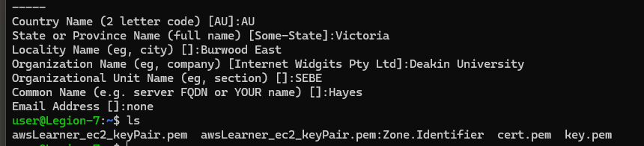
Picture 2 – Generated cert.pem & key.pem.

Picture 3 – Able to access the URL, however, “connection isn’t private” error occurred.

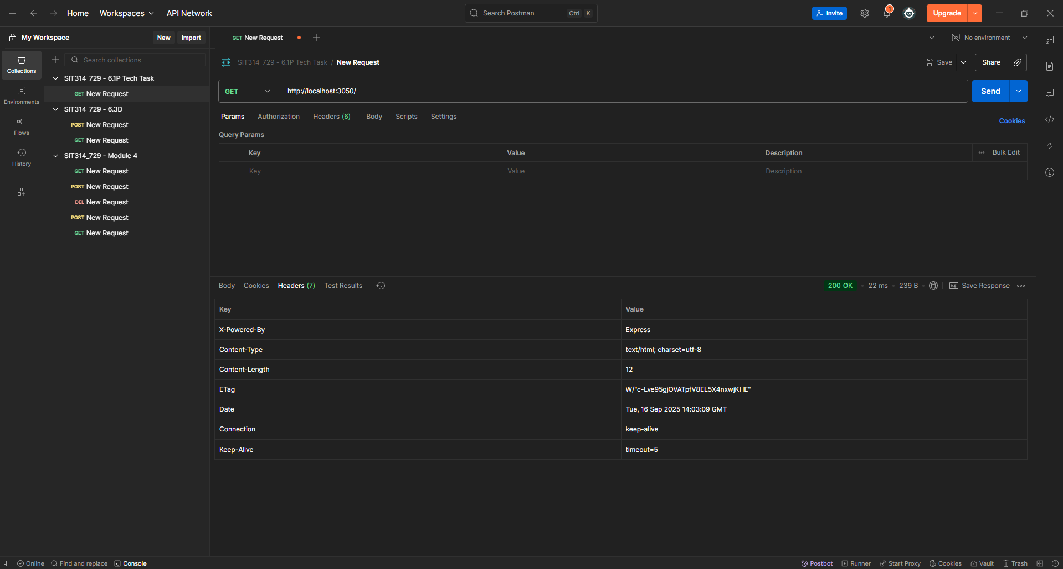
Picture 4 – Tested server.js with Postman.

Picture 5 – Able to run the “helmetserver.js”

- It was found that the suggested code-lines related to “helmet” middleware is a deprecated version and no longer supported.
- “app.use(helmet());” is sufficient.

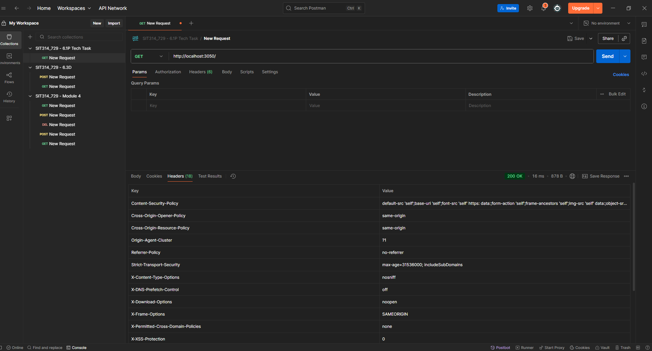
Picture 6 – Results obtained from testing “helmetserver.js” via Postman.

Explanation from the results obtained from both “server.js” and "helmetserver.js”:
Understanding the Role of Helmet.js in Web Security
The two API network screenshots demonstrate a clear difference in the HTTP headers returned by a standard Express server versus one using the Helmet.js middleware. This difference highlights Helmet's primary function: to enhance web application security by setting a variety of HTTP headers.
By default, a basic Express server only provides a minimal set of headers, such as X-Powered-By, Content-Type, and Content-Length. These headers provide very little protection against common web vulnerabilities.
When the helmet() middleware is added to the server, it automatically adds or modifies a range of security-focused headers. Each of these headers serves a specific purpose in defending the application and its users. For example:
- Content-Security-Policy: Prevents Cross-Site Scripting (XSS) and other injection attacks by specifying which sources of content (scripts, stylesheets, etc.) the browser is allowed to load.
- X-Frame-Options: Mitigates clickjacking attacks by preventing the website from being embedded within an <iframe> on another site.
- Strict-Transport-Security (HSTS): Forces the browser to connect to the server using HTTPS, which helps prevent Man-in-the-Middle (MITM) attacks by ensuring all communication is encrypted.
- X-Content-Type-Options: Protects against MIME-sniffing attacks by ensuring browsers adhere to the declared content type.
In summary, the presence of numerous security headers in the helmetserver.js response, and their absence in the server.js response, serves as direct evidence that Helmet.js successfully provides an essential layer of defense against several key web security threats. It is a best practice for modern web development to employ such security-focused headers to protect both the server and its users.

D – Module Summary
This module on scalable IoT security covers key security requirements like confidentiality, integrity, and availability. It categorizes security issues into low-level (device), intermediate level (network), and high-level (cloud).
- Examples of attacks include physical tampering, man-in-the-middle attacks, and API exploitation.
- The material also emphasizes the importance of interoperability for market adoption and scalability, defining it as the ability of devices from different vendors to communicate.
- Finally, it addresses legal and ethical challenges such as data privacy, product liability, and algorithmic bias, which are crucial for building trust and ensuring ethical operation of IoT systems.
For a software engineer or fullstack developer, this knowledge is critical for building robust, scalable, and legally compliant applications. Understanding these layers and challenges ensures that I can design secure systems and create trustworthy solutions

