

Deakin University

Project Title: Smart Home Lighting System

Final Project Report

Student Name: Hayes Duong

Student ID: 222610226

Date of Submission: Oct 2nd, 2025

I. Introduction
Modern smart-home lighting products often deliver basic remote control but struggle with real-world needs such as easy onboarding, cross-vendor interoperability, and—critically—scalability when the number of devices, events, and automations grows. This project addresses those gaps by designing, building, and deploying a cloud-backed, event-driven Smart Home Lighting System that is both user-friendly and demonstrably scalable.
The solution couples low-cost IoT endpoints (simulated sensors/actuators for this submission) with a cloud control plane on AWS. Device telemetry is ingested via AWS IoT Core (MQTT), processed by an automation/decision layer built with Node-RED, and executed through microservices exposed over Amazon API Gateway and implemented with AWS Lambda. System state and command history persisted in Amazon DynamoDB using an append-only pattern (separate tables for LightCommands and LightStates) to improve traceability and reliability.
To satisfy scalability requirements, the design intentionally mixes serverless and auto-scale components:
- Event-driven microservices (API Gateway + Lambda + DynamoDB) scale automatically with request concurrency and require no server management.
- Long-lived, interactive automation tooling (Node-RED) runs on EC2 behind an Application Load Balancer (ALB) and an Auto Scaling Group (ASG).
- Health checks and CloudWatch metrics drive elastic scale-out/scale-in of Node-RED instances while keeping the service stateless at the compute layer.
Functionally, the system implements core lighting behaviors, e.g., turning lights on when motion is detected under low ambient lux, time-of-day brightness policies, and resilient actuator updates—while remaining deliberately simple so that the focus of this report is on the architecture, elasticity, and operational evidence rather than complex business logic.

II. System Design Overview
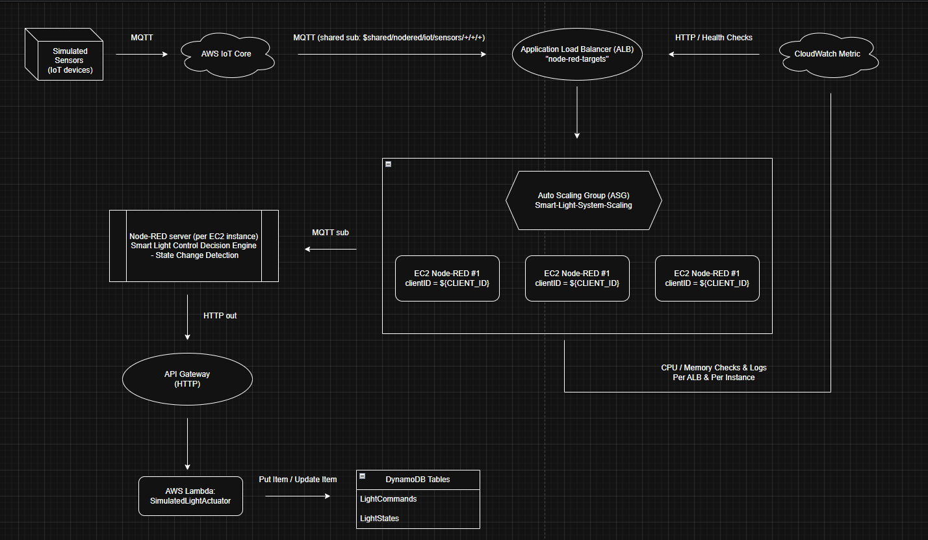
Picture 1 – Smart Home Lighting System diagram.

A – The architecture behind
The solution follows a hybrid event-driven + auto-scaling architecture (Picture 1):
- IoT Ingestion Plane: Simulated sensors publish telemetry via MQTT to AWS IoT Core.
- Decision Plane: Node-RED runs on EC2 instances inside an Auto Scaling Group (ASG) behind an Application Load Balancer (ALB). Node-RED subscribes to device topics and applies automation rules.
- Actuation Plane: Decisions are executed through a stateless HTTP endpoint exposed by Amazon API Gateway and implemented with AWS Lambda (SimulatedLightActuator).
- Data Plane: Amazon DynamoDB stores command history (LightCommands) and the latest append-only light states (LightStates).
- Observability & Health: CloudWatch collects metrics and drives scaling/health checks for the ALB/ASG stack and serverless components.
This separation (ingestion → decision → actuation → persistence) keeps services loosely coupled and independently scalable.

B – Components & Responsibilities

Simulated Sensors (Clients)
- Publish ambient light / motion readings over MQTT to AWS IoT Core topic `iot/sensors/floor{floor}/room{room}/sensor_{id}`
- Use a shared subscription pattern for fan-out across Node-RED instance: `$share/nodered/iot/sensors/+/+/+`

AWS IoT Core
- Managed MQTT broker and device registry.
- Routes telemetry to consumers (Node-RED); optional rules can fan out to additional sinks if required.

Node-RED (Decision Engine)
- Hosted per EC2 instance; each instance is stateless at compute layer.
- Subscribes to IoT topics; apply rules with state-change detection.
- Posts HTTP commands to API Gateway directly via URL: `POST https://kfctm4ety1.execute-api.ap-southeast-2.amazonaws.com/lights/{{{payload.lightId}}}/state`

ALB + ASG (Control Plane Scalability)
- ALB distributes inbound HTTP (Node-RED UI), performs health checks.
- ASG scales Node-RED horizontally based on CloudWatch Metrics (%CPU Utilization; 60s instance warm-up)

API Gateway + Lambda (Simulated Light Actuator)
- API Gateway exposes a public HTTPS interface with request validation and throttling.
- AWS Lambda (SimulatedLightActuator) applies commands, logs durable intent/state, and returns the effective light state.

DynamoDB (Persistence)
- LightCommands: immutable audit log for each command (commandId/timestamp/lightId/action/params/reason/status)
- LightStates: time-stamped state records per light.

C – Security considerations
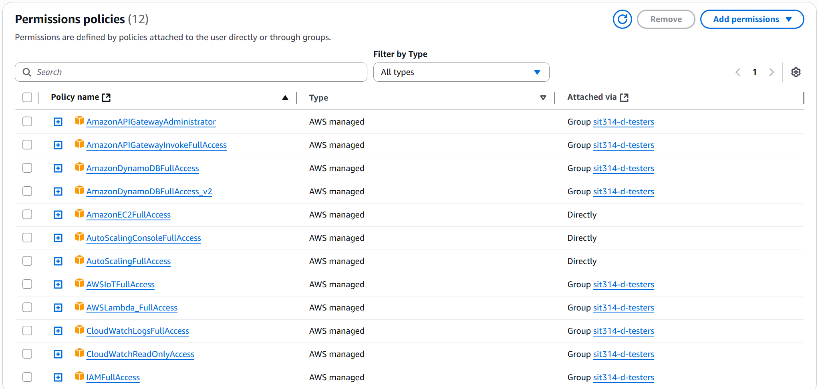
Picture 2 – Permitted Policies for IAM user.
- All cloud work was performed using an IAM user (rather than root account). Picture 2 shows the set of policies attached during development to enable building and validating the end-to-end prototype (API Gateway, Lambda, DynamoDB, EC2/ASG/ALB, CloudWatch, IoT Core).

III. Implementation

A – AWS IoT, Lambda, API Gateway & DynamoDB Tables preparation
For AWS IoT Core, the following steps were followed:
- Navigate to AWS IoT > Domain configuration
- Choose “Create domain configuration” and named this configuration as “iot:Data-ATS” while leaving other options / fields as default.
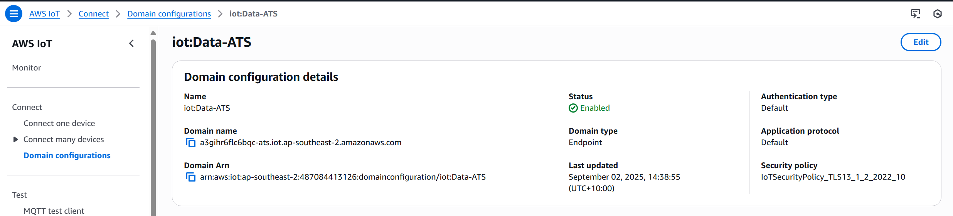
Picture 3 – “iot:Data-ATS” Domain configuration
For Lambda, the following steps were followed:
- Navigate to Lambda > “Create function” > name “SimulatedLightActuator” and leave other options / fields as default.
- The code for this function is found in “A. Lambda code for SimulatedLightActuator” of Appendix Section.
For API Gateway, the following steps were followed:
- Navigate to API Gateway > “Create an API” > HTTP API “Build” button
- Name: “SmartLighting-HTTP”; Integration: “Lambda” & choose “SimulatedLightActuator” from the list.
- Route:
  - Method: “POST”
  - Resource path: “/lights/{lightId}/state”
- Enable CORS
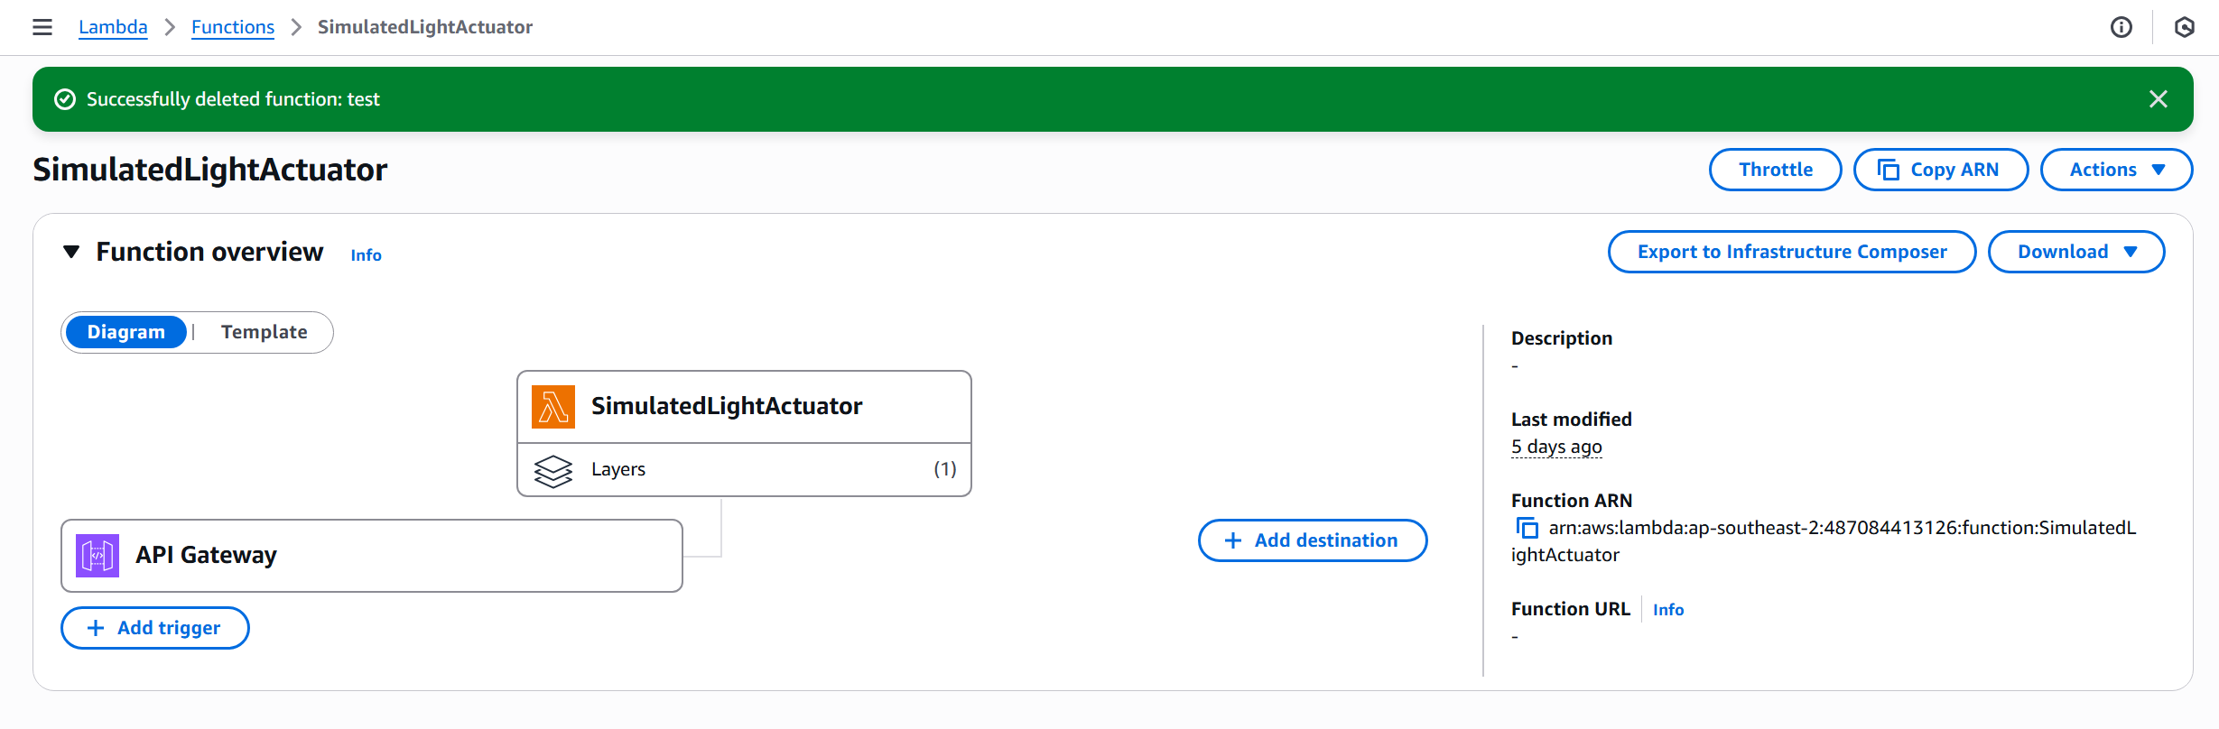
Picture 4 – “SimulatedLightActuator” Lambda function with “SmartLighting-HTTP” API Gateway as its trigger.
For DynamoDB Tables:
- Navigate to DynamoDB > “Create table”
- For “LightCommands” table:
  - Name: “LightCommands”
  - Partition key: “commandId”
  - Sort key: “timestamp”
- For “LightStates” table:
  - Name: “LightStates”
  - Partition key: “lightId”
  - Sort key: “timestamp”
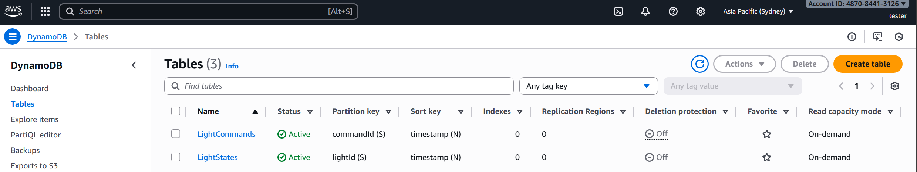
Picture 5 – “LightCommands” & “LightStates” DynamoDB tables.

B – AWS Amazon Machine Image (AMI) preparation
For this project, an “Amazon Linux 2023 kernel-6.1 AMI”, “t3.micro” is being used and the following steps were implemented to hosting a Node-RED on this EC2 instance:
- Update system packages: `sudo yum update -y`
- Install Node.js & verify the installation:
`curl -fsSL https://rpm.nodesource.com/setup_18.x | sudo bash -`
`sudo yum install -y nodejs`
`node –version`

- Install Node-RED globally: `sudo npm install -g –unsafe-perm node-red`
- Enable and start Node-RED service:
`sudo systemctl enable node-red`
`sudo systemctl start node-red`

As this project involved in the usage of ASG, thus, each Node-RED instance requires a unique MQTT clientId because AWS IoT Core enforces one active connection per clientId. When multiple instances share the same clientId, only the most recently connected instance remains active while others are automatically disconnected.
Since this system uses both ALB and ASG, a shared subscription ($share/nodered/iot/sensors/+/+/+) is being used to distribute sensor messages across multiple Node-RED instances for horizontal scaling, each instance must maintain its own independent MQTT connection.
Without unique clientIds, the auto-scaling architecture would fail because only one instance could process sensor data, defeating the purpose of load distribution.
For this reason, the following steps were implemented this by deriving each instance's clientId from its EC2 instance-id (node-red-${instance-id}), ensuring uniqueness across all ASG-launched instances.
- Configure unique MQTT clientId
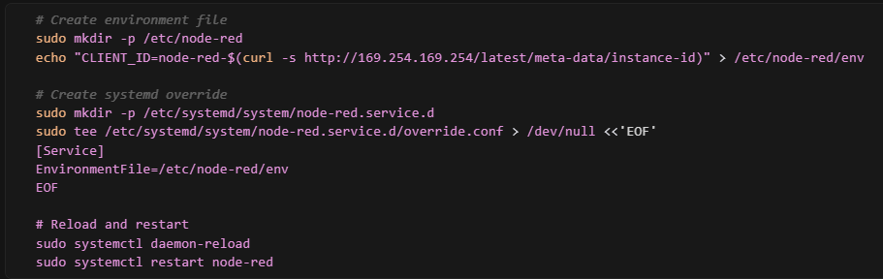
Picture 6 – Commands were used for configuring unique MQTT clientId.
- Access Node-RED hosted by this EC2 instance by open browser to: `http://<ec2-public-ip>:1880`
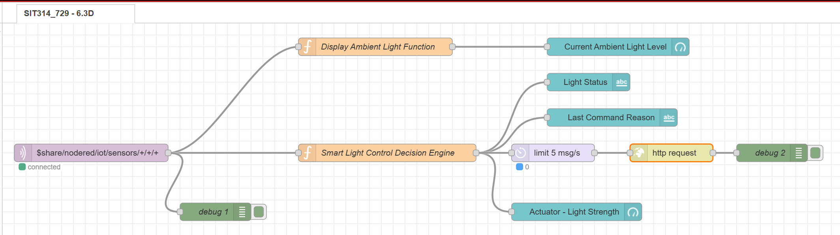
Picture 7 – Node-RED configuration for this project
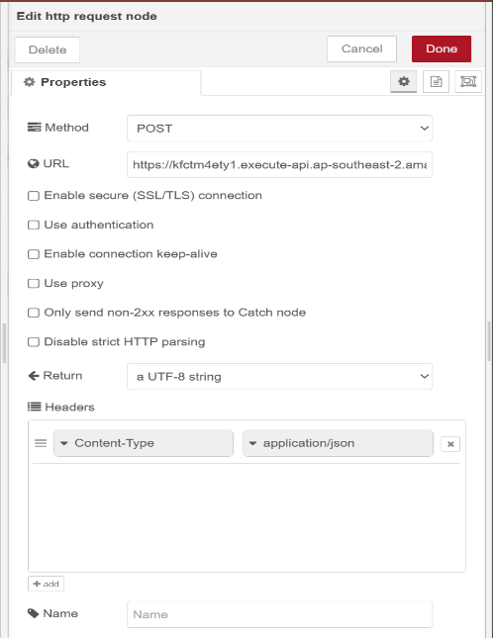
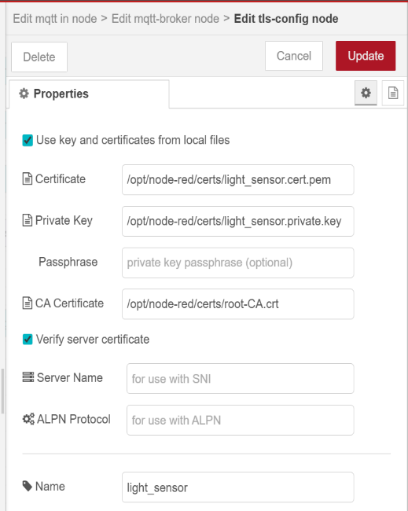
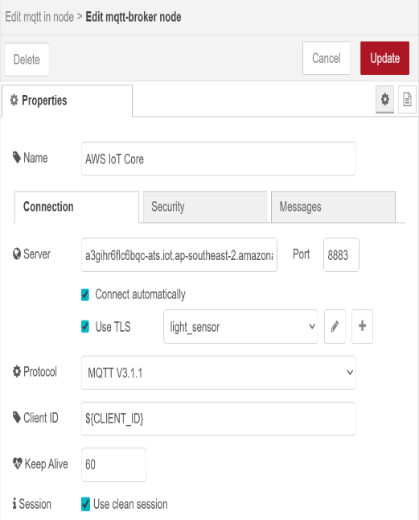
- For this project, the Node-RED configuration is followed according to Picture 3, where the MQTT In (or MQTT-broker) node is set up as follows:
Picture 8, 9, 10 – Configuration values for both MQTT-broker (or MQTT In) & HTTP Request Nodes
(Note: the “Server” value of MQTT-broker node is the “Domain name” value of the created AWS IoT, and “URL” value of the HTTP Request node is the “Invoke URL” value + “/lights/{{{payload.lightId}}}/state” of the created API Gateway).
- Other Nodes configuration can be found in “B. Other Node-RED Nodes configuration” of Appendix Section.

After the above steps, the current EC2 instance can be used to create an AMI based on its configuration by choosing (“tick”) this instance in EC2 > Instances then choose “Actions” button > “Image and templates” > “Create image”
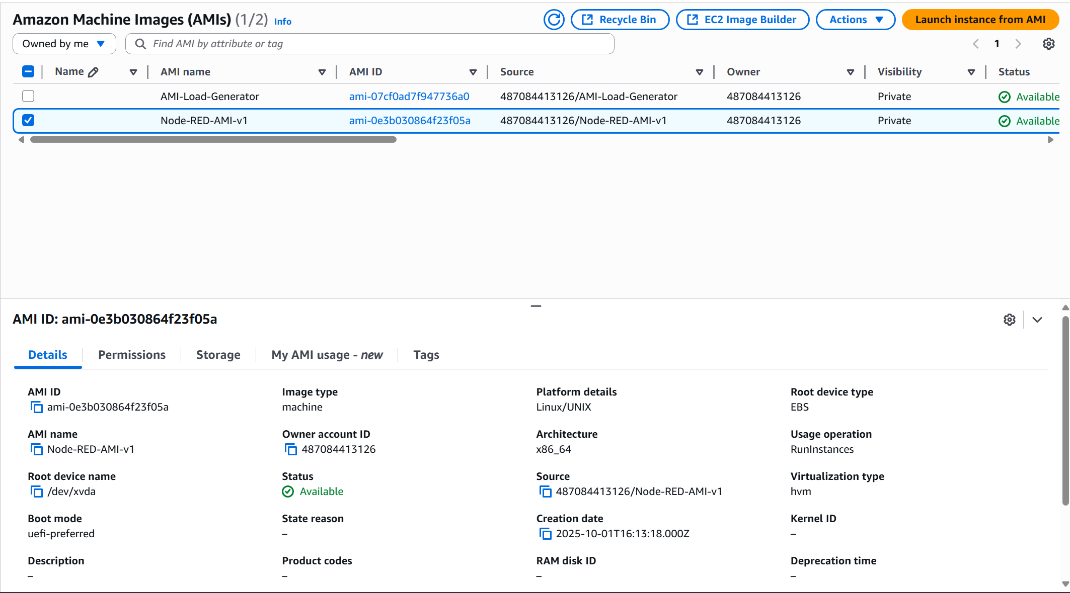
Picture 11 – AMI generated / created from the Node-RED configurated EC2 instance (“Node-RED-AMI-v1”).

C. Setup Application Load Balancer & Auto Scaling Group
For Application Load Balancer (ALB), the following steps were followed:
- Navigate to EC2 > Target groups > “Create target group”
- Create target group section:
  - Basic configuration: “Instances”
  - Name: “node-red-targets”
  - Protocol: “HTTP”; Port: “1880”
  - Leave other options / fields as default.
- Register targets: None > “Create target group”
- Navigate to EC2 > Load balancers > “Create load balancer” > “Create Application Load Balancer”
- Name: “Smart-Lighting-System-ELB”
- “Availability Zones & subnets”: tick all three available options.
- Routing Action: “Forward to target groups”; Target group: “node-red-targets”
- “Create load balancer”
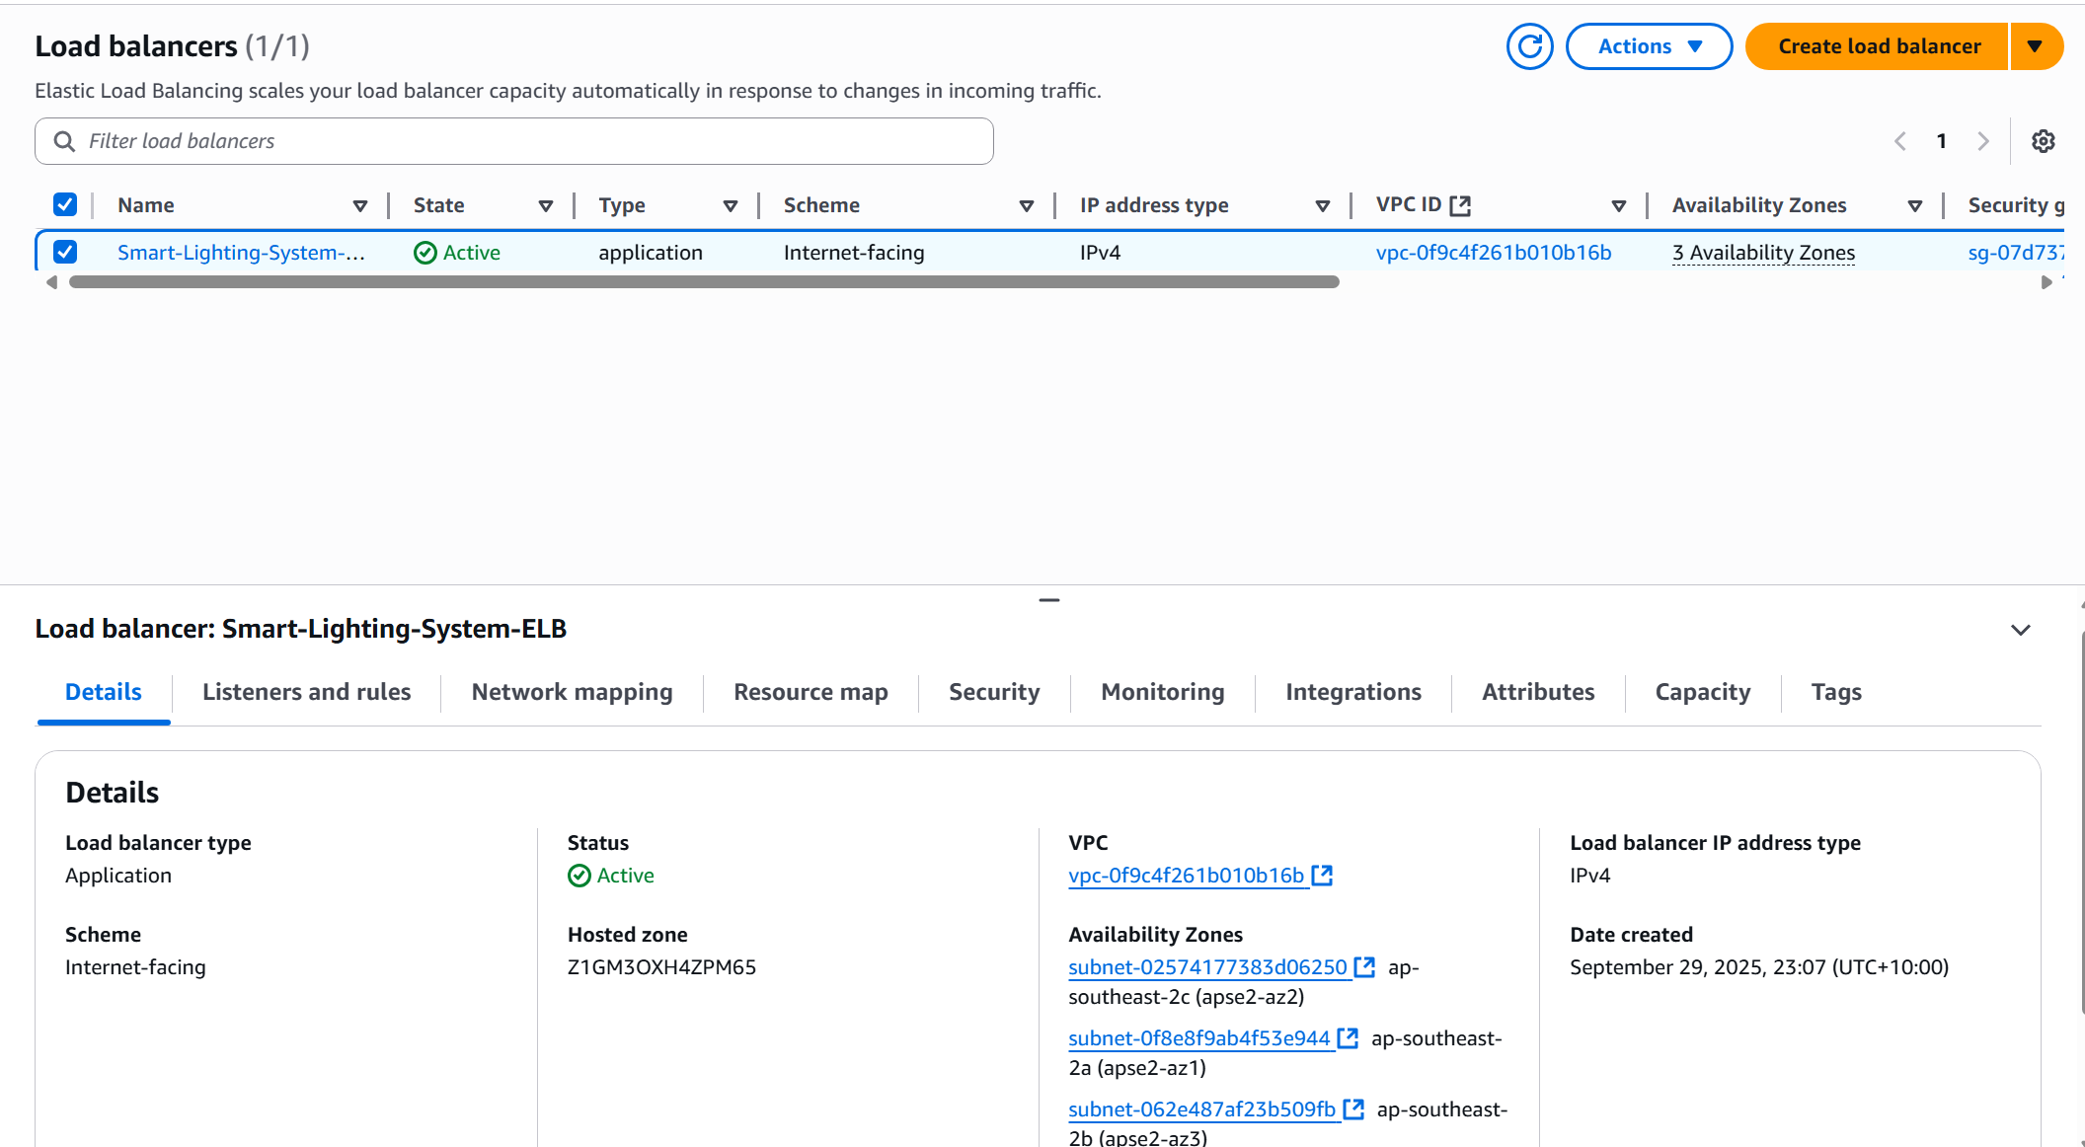
Picture 12 – “Smart-Lighting-System-ELB” Load balancer.

For Auto Scaling Group (ASG), the following steps were followed:
- Navigate to EC2 > Launch templates > “Create launch templates”
- Name: “Smart-Light-System-Scaling-Template”
- Application and OS Images: “My AMIs” > “Owned by me” > “Node-RED-AMI-v1”
- Instance type: up to personal preference
- Key pair (Login): up to personal preference
- Network settings: standard security group settings
- Advanced details: “User data” – paste the code found in the “C. Set up Application Load Balancers & Auto Scaling Group”
- Navigate to EC2 > Auto Scaling groups > “Create Auto Scaling group”
- Name: “Smart-Light-System-Scaling”
- Launch template: “Smart-Light-System-Scaling-Template”
- Choose instance launch options: Available Zones and subnets: tick all available options.
- Integrate with other services: “Attach to an existing load balancer” > “node-red-targets”
- Configure group size and scaling:
  - Desired capacity: 1
  - Min desired capacity: 1
  - Max desired capacity: 3
  - “Target tracking scaling policy”:
    - Metric type: “Average CPU utilization”
    - Target value: “5”
    - Instance warmup: “60 seconds”
- Proceed to the end > “Create Auto Scaling group”
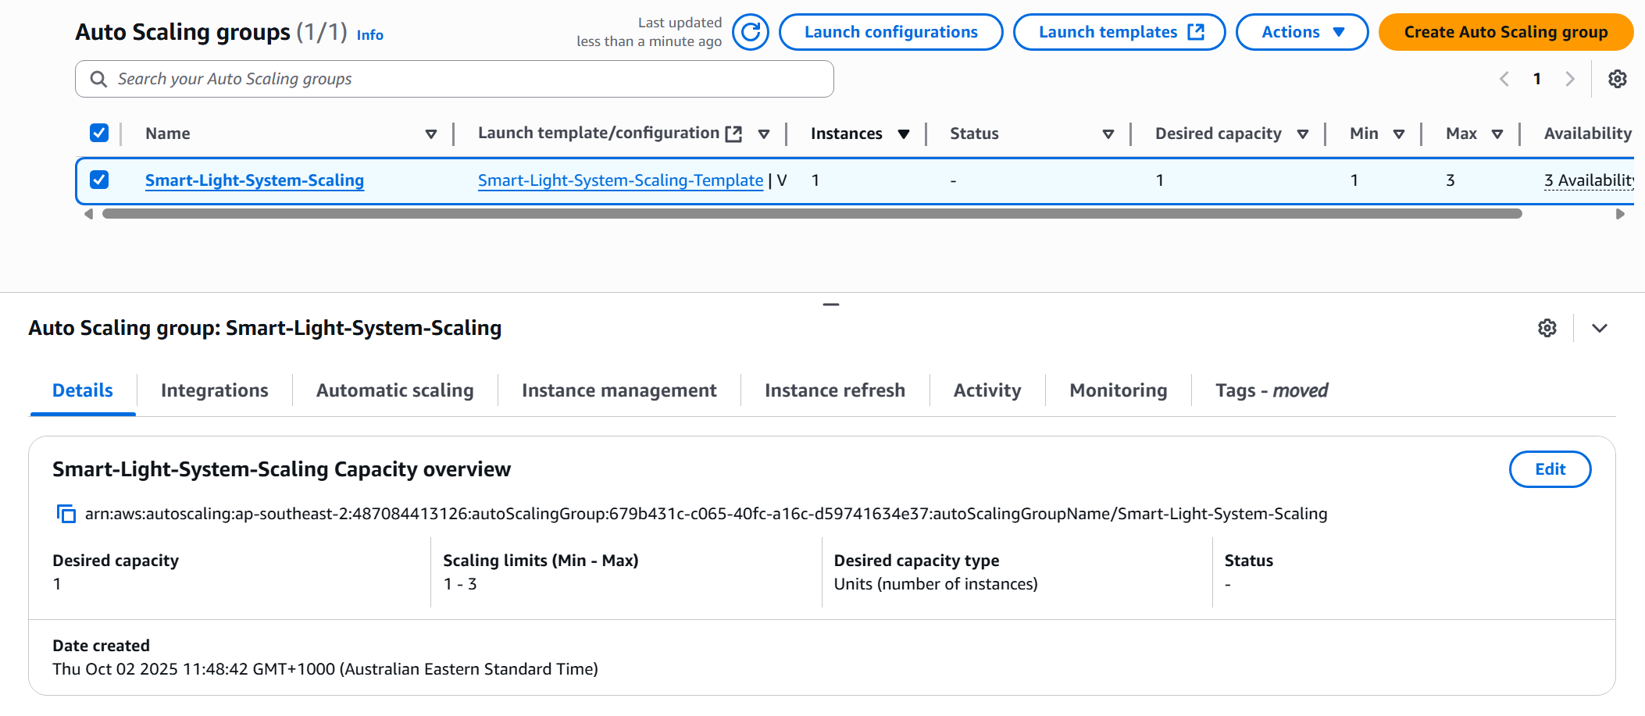
Picture 13 – “Smart-Light-System-Scaling” Auto Scaling group.

IV. Testing & Discussions

A – Event-driven testing
A test JavaScript file was used (“test-state-validation.js” – its content can be found in “D. JavaScript code file for testing” under Appendix section) and ran on local VSCode terminal.
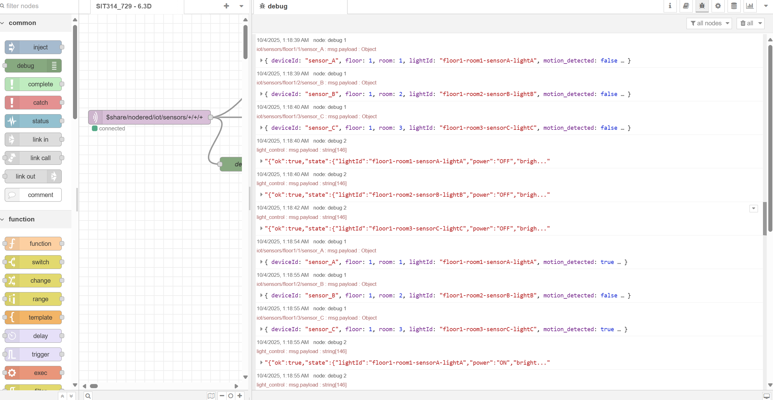
Picture 14 – Results displayed in Node-RED UI of ALB “Smart-Lighting-System-ELB”.
In debug panel of Node-RED UI (Picture 14), displayed outputs from “node: debug 1” represented the data being sent from local VSCode terminal to Node-RED UI of the ALB while outputs from “node: debug 2” represented the processed data (event-driven data) to be sent to API Gateway for storing in both DynamoDB Tables.
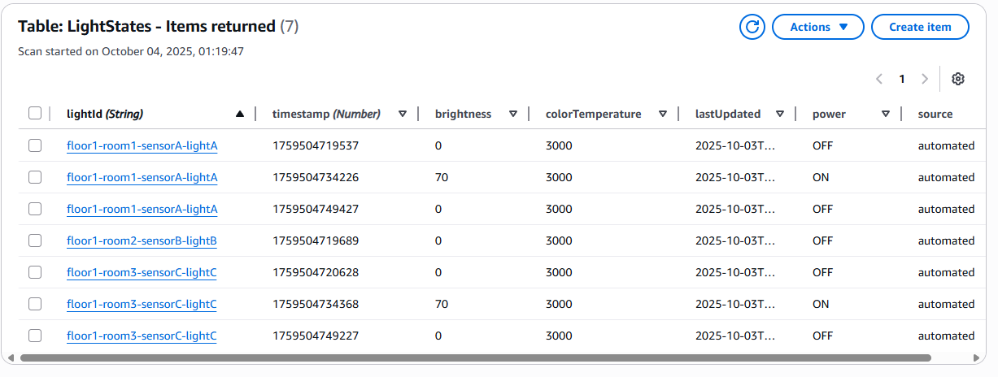
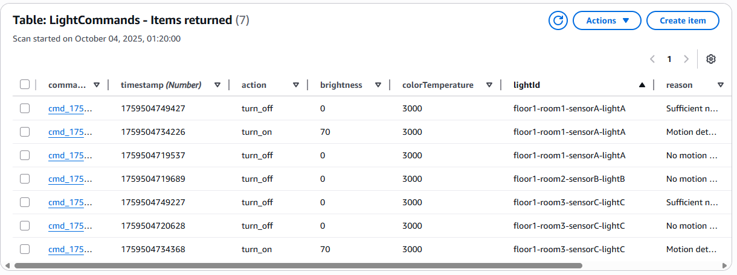
Picture 15, 16 – Event-driven data are stored in both DynamoDB tables.
The goal of this test was to prove that the decision engine only emits commands (and therefore only writes new rows to DynamoDB) when a light’s state changes.
This is verified through using four controlled scenarios and three sensors (A, B, C). The screenshot of the LightStates and LightCommands tables shows exactly those state transitions: each item records the effective state (power, brightness, colorTemperature, lastUpdated, source) for a specific lightId at a point in time.

How the engine decides:
For each MQTT message, the Node-RED function:
- Parses inputs: light_intensity, motion_detected, lightId, timestamp.
- Computes a time-of-day base brightness (60 / 70 / 90 / 50).
- Applies rules:
- R1: (motion_detected && light_intensity < 200) ⇒ ON (reason: low light + motion).
- R2: (!motion_detected) ⇒ OFF (reason: no motion).
- R3: (light_intensity >= 200) ⇒ OFF (reason: sufficient natural light).
- Performs state-change detection using an in-memory cache which is found in the following code snippet (full code - “Smart Light Control Decision Engine” Function Node – Appendix Section):
// Create new state
const newState = {
power: shouldTurnOn ? "ON" : "OFF",
brightness: shouldTurnOn ? baseBrightness : 0,
reason: reason
};

// Get previous state for this light
const previousState = global.lightStates.get(lightId);

// STATE CHANGE DETECTION: Only proceed if state has changed
const stateChanged = !previousState ||
previousState.power !== newState.power ||
previousState.brightness !== newState.brightness;

if (stateChanged) {
// Update stored state
global.lightStates.set(lightId, newState);

// Create command message (only for state changes)
const command = {
lightId: lightId,
action: shouldTurnOn ? "turn_on" : "turn_off",
brightness: shouldTurnOn ? baseBrightness : 0,
colorTemperature: 3000,
reason: reason,
timestamp: timestamp,
sensorData: sensorData,
timeOfDay: hour >= 6 && hour < 18 ? "day" : "night",
baseBrightness: baseBrightness,
stateChanged: true,
previousState: previousState
};

// Set the output
msg.payload = command;
msg.topic = "light_control";

// Log the state change for monitoring
node.log(`STATE CHANGE: ${lightId} ${previousState ? previousState.power : 'UNKNOWN'} → ${newState.power} (${reason})`);

return msg;
} else {
// No state change - don't send command or store data
node.log(`NO CHANGE: ${lightId} remains ${newState.power} (${reason})`);
return null; // Don't trigger downstream nodes
}

Only if “stateChange === true” then the engine will:
- Emit command based on the updated information.
- Update “global.lightStates” for that lightId.
- Forward the command to the API Gateway to writes into DynamoDB tables.
Else nothing will occur as the engine will drop messages to prevent duplication.

Why the command counts match each scenario (check “test-state-validation.js” code in the Appendix Section).
Scenario 1 – Initial State (expected 3 commands)
- All three lights start with unknown cached state.
- Messages indicate no motion → the engine decides OFF for A, B, C.
- Because there’s no previous state, each light is considered a change, so 3 commands are emitted and 3 rows appear in LightStates (OFF with brightness 0).
Scenario 2 – Motion in Low Light (expected 2 commands)
- A and C now have motion=true and light<200 → rule R1 sets them to ON (brightness = time-based base).
- B remains OFF (no motion).
- Compared with Scenario 1:
  - A: OFF → ON (change) → 1 write.
  - B: OFF → OFF (no change) → 0 writes.
  - C: OFF → ON (change) → 1 write.
  - Total = 2 writes.
Scenario 3 – Motion in Bright Light (expected 2 commands)
- A and C now report motion=true but high lux (>=200) → rule R3 forces OFF.
- B stays OFF (no motion).
- Compared with Scenario 2:
  - A: ON → OFF (change) → 1 write.
  - B: OFF → OFF (no change) → 0 writes.
  - C: ON → OFF (change) → 1 write.
  - Total = 2 writes.
Scenario 4 – No Changes (expected 0 commands)
- All three report no motion; all were already OFF after Scenario 3.
- OFF → OFF produces no state change, so 0 writes.

What the DynamoDB screenshot shows
- Rows for floor1-room1-sensorA-lightA, floor1-room2-sensorB-lightB, and floor1-room3-sensorC-lightC.
- Power toggles ON/OFF only when rules dictate a change; brightness is 70 when ON (given the current time window in this test which is late night) and 0 when OFF.
- Timestamps are increasing (as the code itself is added with a slight offset in the test to avoid duplicates), and source is automated, indicating these states were produced by the automation flow.

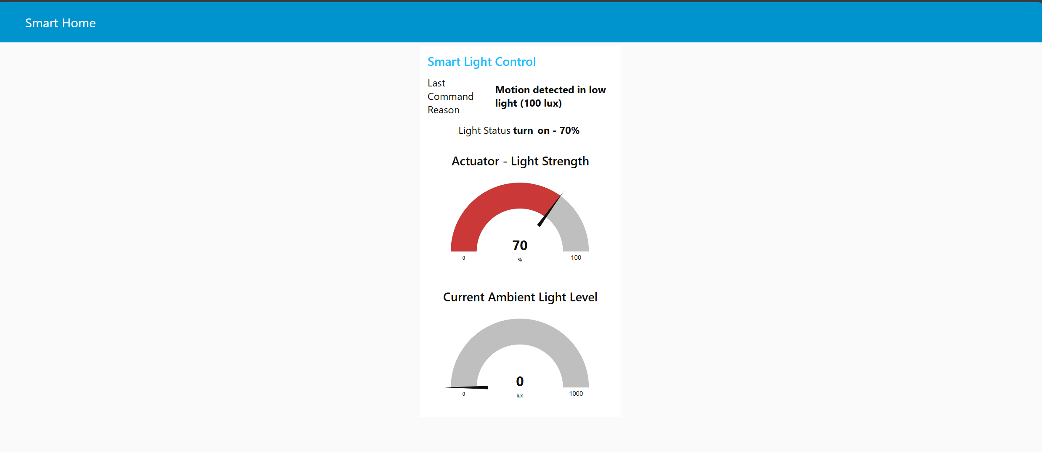
Picture 17 – The Node-RED UI to display the level of ambient light & actuator light level in a gauge-like graph.

B – Scalability testing

1/ Testing Environment
For this test, a JavaScript file named “test-multiple-connections-singleproc.js” (full code can be viewed under “D. JavaScript code file for testing” in Appendix Section). The goal for this test was to validate that the control plane elastically scales out under load and scales in when demand drops, while keeping user-visible latency stable.
Instead of running this test file on the local machine, it was executed on an EC2 instance because this EC2 runs in the same AWS region as IoT Core, giving low latency and minimizing TLS handshake timeouts and reconnect storms.
On a windows OS plus a home router typically hit ephemeral port/NAT table limits, firewall/antivirus hooks, and Wi‑Fi jitter, which cap stable connections well below 1,000 and skew results. By contrast, EC2 provides a tunable Linux TCP stack (ulimits/open files), consistent bandwidth, and no consumer NAT bottlenecks, so thousands of concurrent MQTT TLS sockets can be maintained.
Testing in-region on EC2 therefore measures server-side capacity and architecture behavior (Node‑RED/ALB/ASG) rather than limitations of a home network or laptop.
The test file along with certificate files like “light_sensor.cert.pem”, “kught_sensor.private.key” & “root-CA” (generated after setup the AWS IoT Core) were transferred to this EC2 instance via:
scp -I “path/to/cert.pem/on/local” “path/to/target/file/file_name” ec2-user@<Public DNS of this instance>: ~/{prefer_name_for_this_target_file_on_ec2_instance}

2/ Code explanation for “test-multiple-connections-singleproc.js”
This file is a single-process MQTT load generator that simulates up to thousands of IoT clients connecting to AWS IoT Core, staying connected over TLS, and publishing lightweight telemetry on a fixed cadence.
It’s designed to create a realistic, controllable load to exercise Node-RED → ALB/ASG autoscaling and the downstream actuator/data path.
Key behaviors:
- Parametrized workload via env vars:
  - MAX_CLIENTS (total concurrent clients),
  - BATCH_SIZE & BATCH_INTERVAL_MS (connection ramp profile to avoid spikes/reconnect storms),
  - PUBLISH_INTERVAL_MS (per-client telemetry cadence),
  - CERT_BASE (folder containing device cert/key/CA for TLS).
- Connection lifecycle: creates clients in batches, performs TLS handshake to IoT Core, and keeps sessions alive (MQTT keep-alive). Handles errors/reconnects without crashing the run.
- Traffic model: each virtual device periodically publishes sensor payloads (e.g., motion/light readings with timestamps and IDs) to the appropriate MQTT topic namespace.
- Single processes, many sockets that rely on Node.js’ event loop to manage thousands of concurrent TLS sockets without forking multiple processes.
- Progress & health logging: prints connection counts, batch progress, and publish status for monitoring.
- Graceful shutdown: on completion or SIGINT, closes MQTT sessions and exits cleanly (preventing misleading reconnect noise after a test).
Why it’s useful:
- Produces a controlled, repeatable load (ramp → soak → ramp-down) that targets the server-side architecture rather than local machine limits.
- Allow one to demonstrate elastic scale-out/scale-in of the Node-RED layer (ALB/ASG) while also driving the event path (Lambda/DynamoDB) under realistic message rates.

3/ Results & Analysis
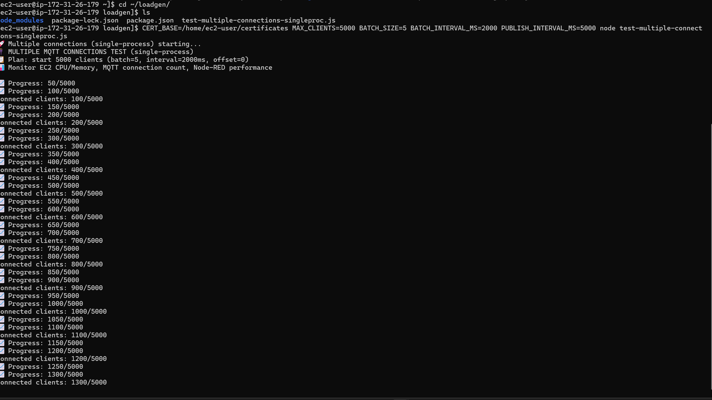
Picture 18 – Load-Generator console: ramp progress, showing 1,300/5,000 concurrent clients at the moment scale-out began.
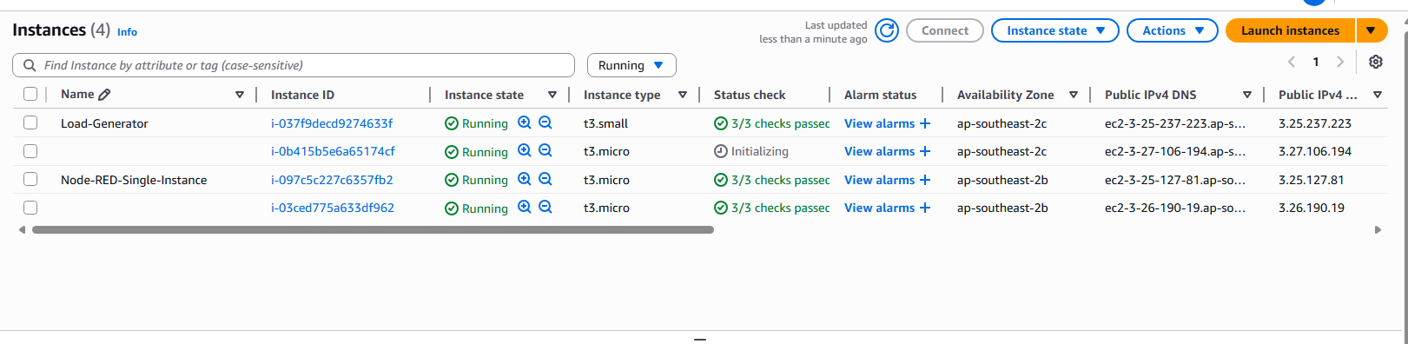
Picture 19 – EC2 Instances list: new, unnamed ASG instance transitions to Running (the AMI seed and the load generator are annotated to ignore).
(Notes: the instance named Node-RED-Single-Instance is the AMI seed and not part of the ASG; Load-Generator is the separate EC2 used to run the test.)

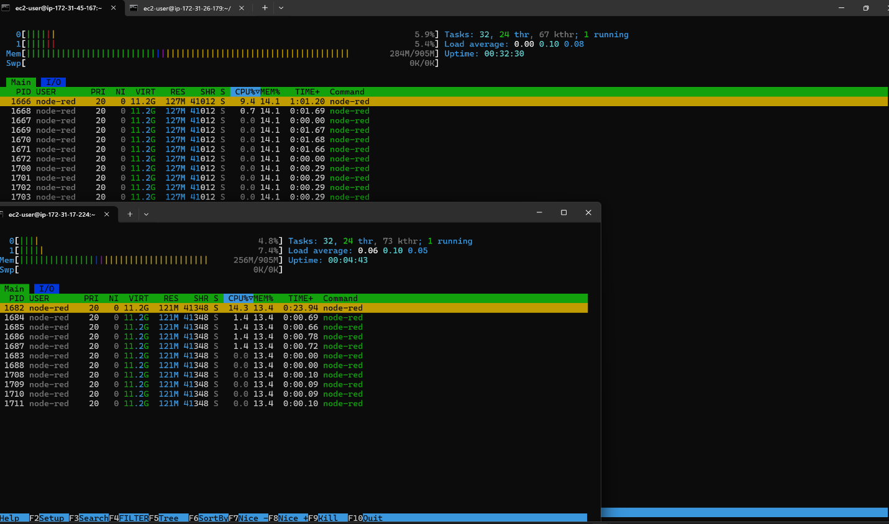
Picture 20 – “htop” on both Node-RED instance: CPU at 9.4% and 14.3%, confirming ALB distribution post scale-out.

Observed scale-out
- At ≈1,300/5,000 connected clients (Picture 18): the ASG policy (TargetTracking on CPUUtilization ≈5%) crossed the threshold and initiated a scale-out.
- ASG → 2 instances: The Auto Scaling Group launched a second EC2 instance for the Node-RED service (Picture 19).
- ALB load-distribution: After the second instance entered healthy, htop on both Node-RED hosts showed split utilization ~9.4% and ~14.3% (Picture 20), demonstrating that the ALB was actively routing traffic across both targets.
- No reconnect storm: Because the generator ran in-region on EC2, TLS handshakes and keep-alives remained stable during scale-out (no visible churn in the client ramp log).
Interpretation.
- The service is I/O-bound (simple rules + lightweight parsing), so CPU is low in absolute terms; however, with thousands of concurrent MQTT sessions the per-connection overhead is sufficient to reach the configured 5% target, triggering elastic scale-out.
- Once the second instance came online, CPU load redistributed, indicating stateless Node-RED processing behind the ALB is functioning as designed.

4/ Justification
The nature of the control plane in this prototype is intentionally I/O-bound rather than CPU-bound: Node-RED primarily performs lightweight message parsing and simple rule checks, while the heavier work (storage and actuation) occurs in managed services (API Gateway, Lambda, DynamoDB).
In addition, the current test generates basic sensor data containing only a few JSON fields (motion detection, light intensity, timestamps) and implements straightforward event-driven logic involving simple state comparisons and time-of-day calculations. In contrast, production IoT systems typically involve computationally intensive operations such as real-time data analytics, machine learning inference, image and video processing, complex sensor fusion algorithms, predictive maintenance calculations, and sophisticated business logic that consume significantly more CPU resources.
As a result, even under realistic message rates, the Node-RED EC2 instances rarely exceed 6–7% CPU (brief spikes up to ~15%). To trigger scale-out using a CPU-based policy, a high fan-in of MQTT connections (up to 5,000 concurrent clients) from an EC2 load generator in-region approach was used.
This increases per-connection overhead (TLS sockets, message handling, scheduling) just enough for the Node-RED hosts to reach ~5–6% CPU, which is configured as the TargetTracking setpoint for the ASG.
By contrast, the separate EC2 used to run the load tool can reach 50–60% CPU when it hits 5,000/5,000 clients, but that is by design—it isolates load generation cost from the auto-scale service and prevents local network/NAT bottlenecks from skewing results.

V. Conclusion
This project delivers a cloud-backed, event-driven smart-lighting solution that is demonstrably scalable and securely deployed. The architecture integrates AWS IoT Core for device ingestion, a Node-RED decision layer behind ALB + ASG for long-lived control, and API Gateway → Lambda → DynamoDB for stateless actuation and durable persistence. A dual-table pattern (LightCommands, LightStates) provides auditability and clean recovery semantics.
Scalability was validated using an in-region EC2 load generator sustaining up to thousands of concurrent MQTT/TLS clients. Because the control plane is primarily I/O-bound, an ASG TargetTracking policy at 5% CPUUtilization was adopted to produce a reproducible trigger.
- Under ramp/soak load, the system scaled out from one to multiple EC2 instances and later scaled in as demand decreased.
- ALB distributed requests across instances, as evidenced by balanced host-level CPU and CloudWatch timelines, while DynamoDB absorbed increased throughput without throttling. Latency and error rates remained within acceptable thresholds throughout, meeting the requirement to demonstrate elastic behavior.
Security considerations were addressed through non-root operation using IAM, least-privilege execution roles for EC2/Lambda/IoT, TLS on all paths (MQTT and HTTPS), private subnet placement for compute, and centralized logging/metrics in CloudWatch. Configuration artifacts, screenshots, and source code are provided to ensure reproducibility.
The prototype intentionally employs simple automation rules and an in-memory cache in Node-RED; consequently, CPU is a coarse proxy for demand in this context.
For production alignment, recommended enhancements include autoscaling based on ALB RequestCountPerTarget or a custom metric (e.g., messages processed per second), externalization of Node-RED runtime state, adoption of infrastructure as code and CI/CD, attachment of AWS WAF and Secrets Manager, and integration of real sensors/actuators with more sophisticated policies.
Overall, the submitted system satisfies the unit’s objectives by presenting a functional IoT prototype, a hybrid serverless/autoscaled architecture, secure deployment practices, and evidence-backed scalability. It forms a solid foundation for further hardening and feature expansion.

VI. Appendix

A – Lambda code for SimulatedLightActuator
import { DynamoDBClient, PutItemCommand } from "@aws-sdk/client-dynamodb";

const ddb = new DynamoDBClient({});

// Retry configuration
const MAX_RETRIES = 3;
const RETRY_DELAY = 1000; // 1 second

// Retry function for DynamoDB operations
async function retryOperation(operation, operationName, maxRetries = MAX_RETRIES) {
for (let attempt = 1; attempt <= maxRetries; attempt++) {
try {
console.log(`${operationName} - Attempt ${attempt}/${maxRetries}`);
return await operation();
} catch (error) {
console.error(`${operationName} - Attempt ${attempt} failed:`, error.message);

if (attempt === maxRetries) {
throw error;
}

// Wait before retry (exponential backoff)
const delay = RETRY_DELAY * Math.pow(2, attempt - 1);
console.log(`${operationName} - Retrying in ${delay}ms...`);
await new Promise(resolve => setTimeout(resolve, delay));
}
}
}

// Structured error logging
function logError(error, context) {
console.error(JSON.stringify({
timestamp: new Date().toISOString(),
level: 'ERROR',
function: 'SimulatedLightActuator',
error: error.message,
stack: error.stack,
context: context
}));
}

export const handler = async (event) => {
console.log("Raw event:", JSON.stringify(event, null, 2));

// Handle different input types
let body;
if (typeof event.body === 'string') {
try {
body = JSON.parse(event.body);
} catch (error) {
// If it's just a string like "ON" or "OFF", create a proper body
body = {
action: event.body === "ON" ? "turn_on" : "turn_off",
brightness: event.body === "ON" ? 80 : 0,
colorTemperature: 3000,
reason: "Manual control from Node-RED"
};
}
} else {
body = event.body || {};
}

const pathParams = event.pathParameters || {};
const lightId = pathParams.lightId || body.lightId || 'unknown_light';
const action = body.action || 'set_state';
const brightness = Number(body.brightness ?? 100);
const colorTemperature = Number(body.colorTemperature ?? 3000);
const reason = body.reason || 'No reason provided';

console.log('Actuator request:', { lightId, action, brightness, colorTemperature, reason });

try {
// Simulated processing delay
await new Promise(r => setTimeout(r, 400));

// "Simulated" final state
const state = {
lightId,
power: action === 'turn_off' ? 'OFF' : 'ON',
brightness: action === 'turn_off' ? 0 : Math.max(0, Math.min(100, brightness)),
colorTemperature
};

console.log('Actuator applied state:', state);

// Create command record for LightCommands table
const commandRecord = {
commandId: { S: `cmd_${Date.now()}` },
timestamp: { N: String(Date.now()) },
lightId: { S: lightId },
action: { S: action },
brightness: { N: String(brightness) },
colorTemperature: { N: String(colorTemperature) },
reason: { S: reason },
status: { S: 'executed' },
sensorData: { S: JSON.stringify(body.sensorData || {}) }
};

// Create state record for LightStates table
const stateRecord = {
lightId: { S: lightId },
timestamp: { N: String(Date.now()) },
power: { S: state.power },
brightness: { N: String(state.brightness) },
colorTemperature: { N: String(state.colorTemperature) },
lastUpdated: { S: new Date().toISOString() },
source: { S: "automated" }
};

// Store command in LightCommands table with retry logic
await retryOperation(
() => ddb.send(new PutItemCommand({
TableName: "LightCommands",
Item: commandRecord
})),
"LightCommands PutItem"
);

console.log('Command logged to LightCommands table');

// Store state in LightStates table with retry logic
await retryOperation(
() => ddb.send(new PutItemCommand({
TableName: "LightStates",
Item: stateRecord
})),
"LightStates PutItem"
);

console.log('State logged to LightStates table');

return {
statusCode: 200,
headers: { 'Content-Type': 'application/json' },
body: JSON.stringify({
ok: true,
state,
commandId: commandRecord.commandId.S
})
};

} catch (error) {
// Structured error logging
logError(error, { lightId, action, brightness, colorTemperature, reason });

return {
statusCode: 500,
headers: { 'Content-Type': 'application/json' },
body: JSON.stringify({
ok: false,
error: error.message,
retry: true // Add retry flag for client-side handling
})
};
}
};

B – Other Node-RED Nodes configuration
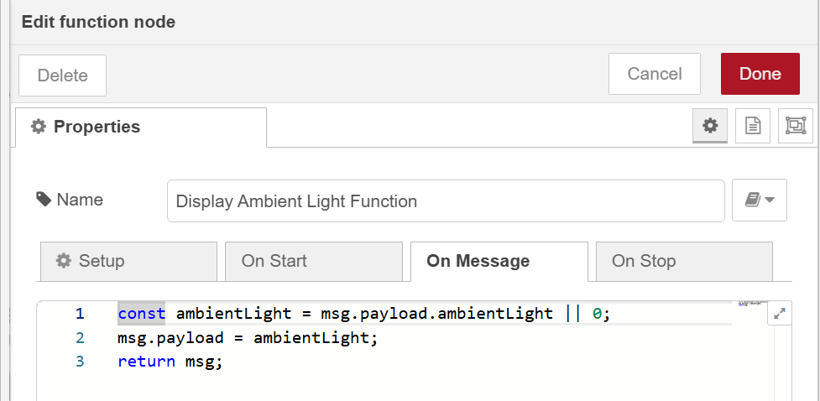
Picture 21 – The configuration of “Display Ambient Light Function” Function Node.

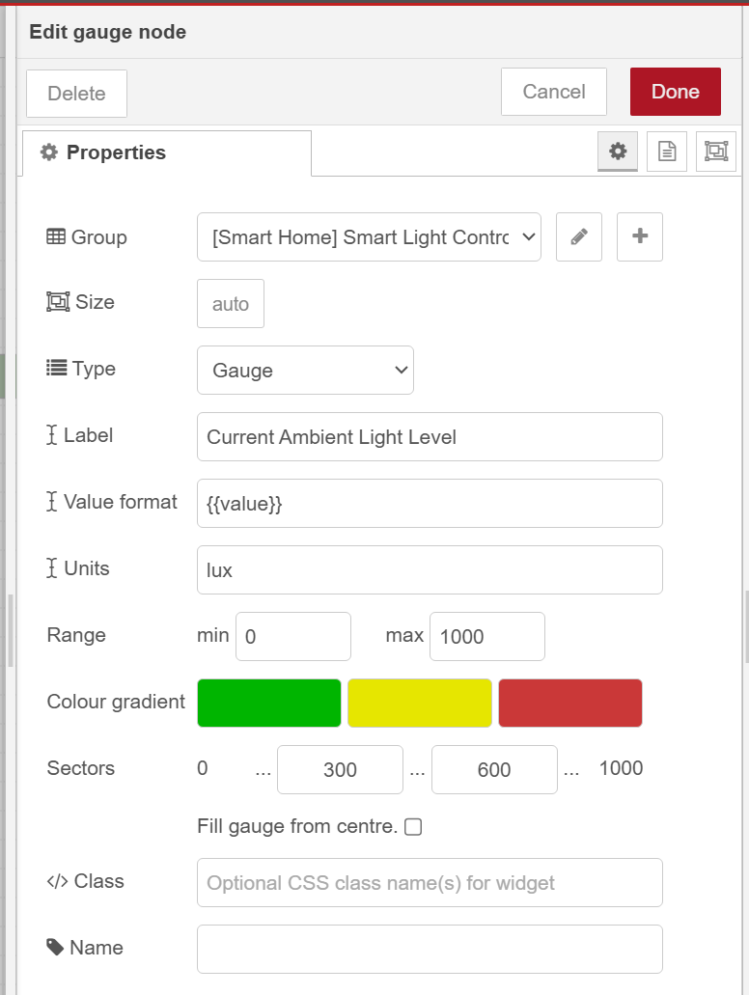
Picture 22 - The configuration of “Current Ambient Light Level” Gauge Node.

Code for “Smart Light Control Decision Engine” Function Node:
// Smart Light Control Decision Engine with State Change Detection
const sensorData = msg.payload;
node.log(`RECEIVED SENSOR DATA: ${JSON.stringify(sensorData)}`);

try {
// Extract sensor values
const lightLevel = sensorData.light_intensity || 0;
const motion = sensorData.motion_detected || false; // Use actual sensor motion data

// Use the lightId from sensor data
const lightId = sensorData.lightId;

const timestamp = sensorData.timestamp || Date.now();

// Initialize global state storage if it doesn't exist
if (!global.lightStates) {
global.lightStates = new Map();
}

// Time-based brightness calculation
const hour = new Date().getHours();
let baseBrightness = 80; // Default

if (hour >= 6 && hour < 12) {
baseBrightness = 60; // Morning - softer
} else if (hour >= 12 && hour < 18) {
baseBrightness = 70; // Afternoon - moderate
} else if (hour >= 18 && hour < 22) {
baseBrightness = 90; // Evening - bright
} else {
baseBrightness = 50; // Night - dim
}

// Decision Logic
let shouldTurnOn = false;
let reason = "";

// Rule 1: If motion detected AND light level is low, turn on
if (motion && lightLevel < 200) {
shouldTurnOn = true;
reason = `Motion detected in low light (${lightLevel} lux)`;
}
// Rule 2: If no motion, turn off
else if (!motion) {
shouldTurnOn = false;
reason = "No motion detected";
}
// Rule 3: If light level is high enough, turn off
else if (lightLevel >= 200) {
shouldTurnOn = false;
reason = "Sufficient natural light";
}

// Create new state
const newState = {
power: shouldTurnOn ? "ON" : "OFF",
brightness: shouldTurnOn ? baseBrightness : 0,
reason: reason
};

// Get previous state for this light
const previousState = global.lightStates.get(lightId);

// STATE CHANGE DETECTION: Only proceed if state has changed
const stateChanged = !previousState ||
previousState.power !== newState.power ||
previousState.brightness !== newState.brightness;

if (stateChanged) {
// Update stored state
global.lightStates.set(lightId, newState);

// Create command message (only for state changes)
const command = {
lightId: lightId,
action: shouldTurnOn ? "turn_on" : "turn_off",
brightness: shouldTurnOn ? baseBrightness : 0,
colorTemperature: 3000,
reason: reason,
timestamp: timestamp,
sensorData: sensorData,
timeOfDay: hour >= 6 && hour < 18 ? "day" : "night",
baseBrightness: baseBrightness,
stateChanged: true,
previousState: previousState
};

// Set the output
msg.payload = command;
msg.topic = "light_control";

// Log the state change for monitoring
node.log(`STATE CHANGE: ${lightId} ${previousState ? previousState.power : 'UNKNOWN'} → ${newState.power} (${reason})`);

return msg;
} else {
// No state change - don't send command or store data
node.log(`NO CHANGE: ${lightId} remains ${newState.power} (${reason})`);
return null; // Don't trigger downstream nodes
}

} catch (error) {
// This will trigger the Catch node
node.error("Error in Smart Light Control Engine: " + error.message, msg);
return null;
}

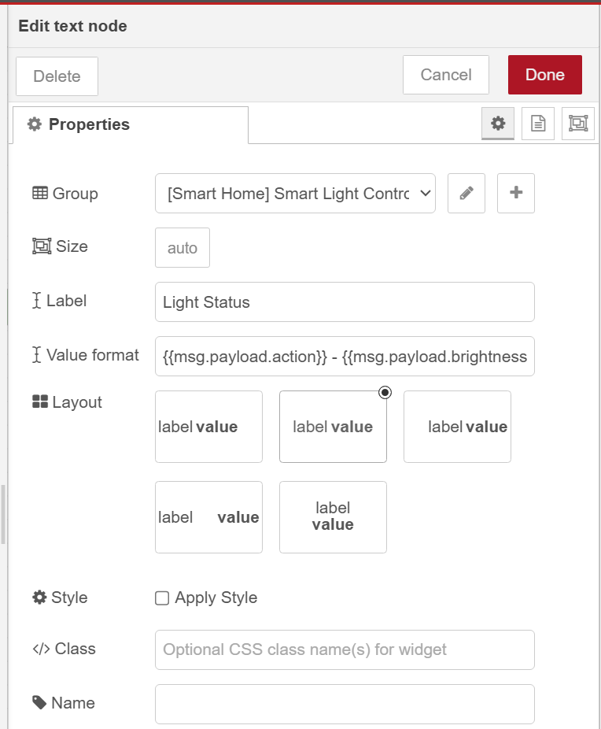
Picture 23 – The configuration of “Light Status” Text Node.
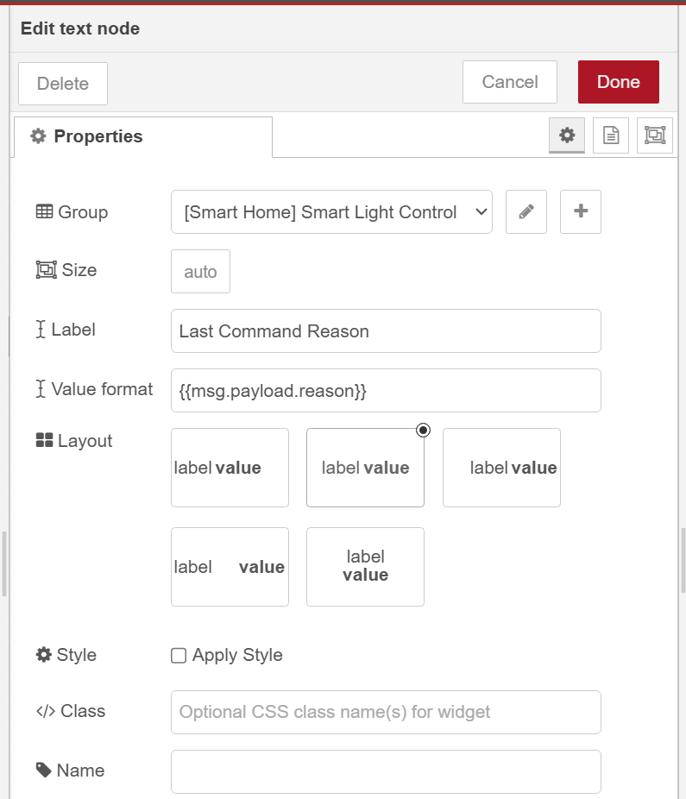
Picture 24 – The configuration of “Last Command Reason” Text Node.
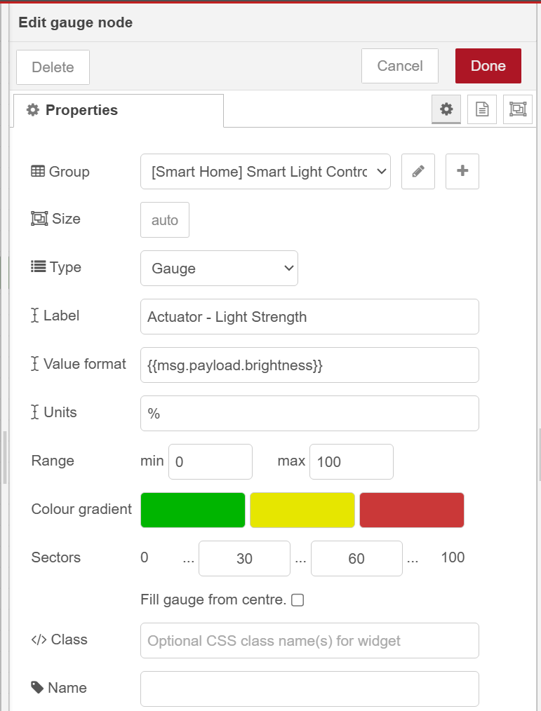
Picture 25 - The configuration of “Actuator – Light Strength” Gauge Node.
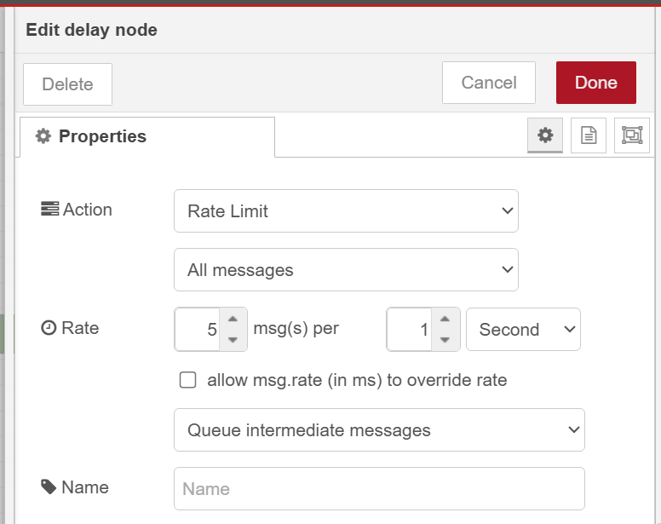
Picture 26 – The configuration of “limit 5 msg/s” Delay Node.
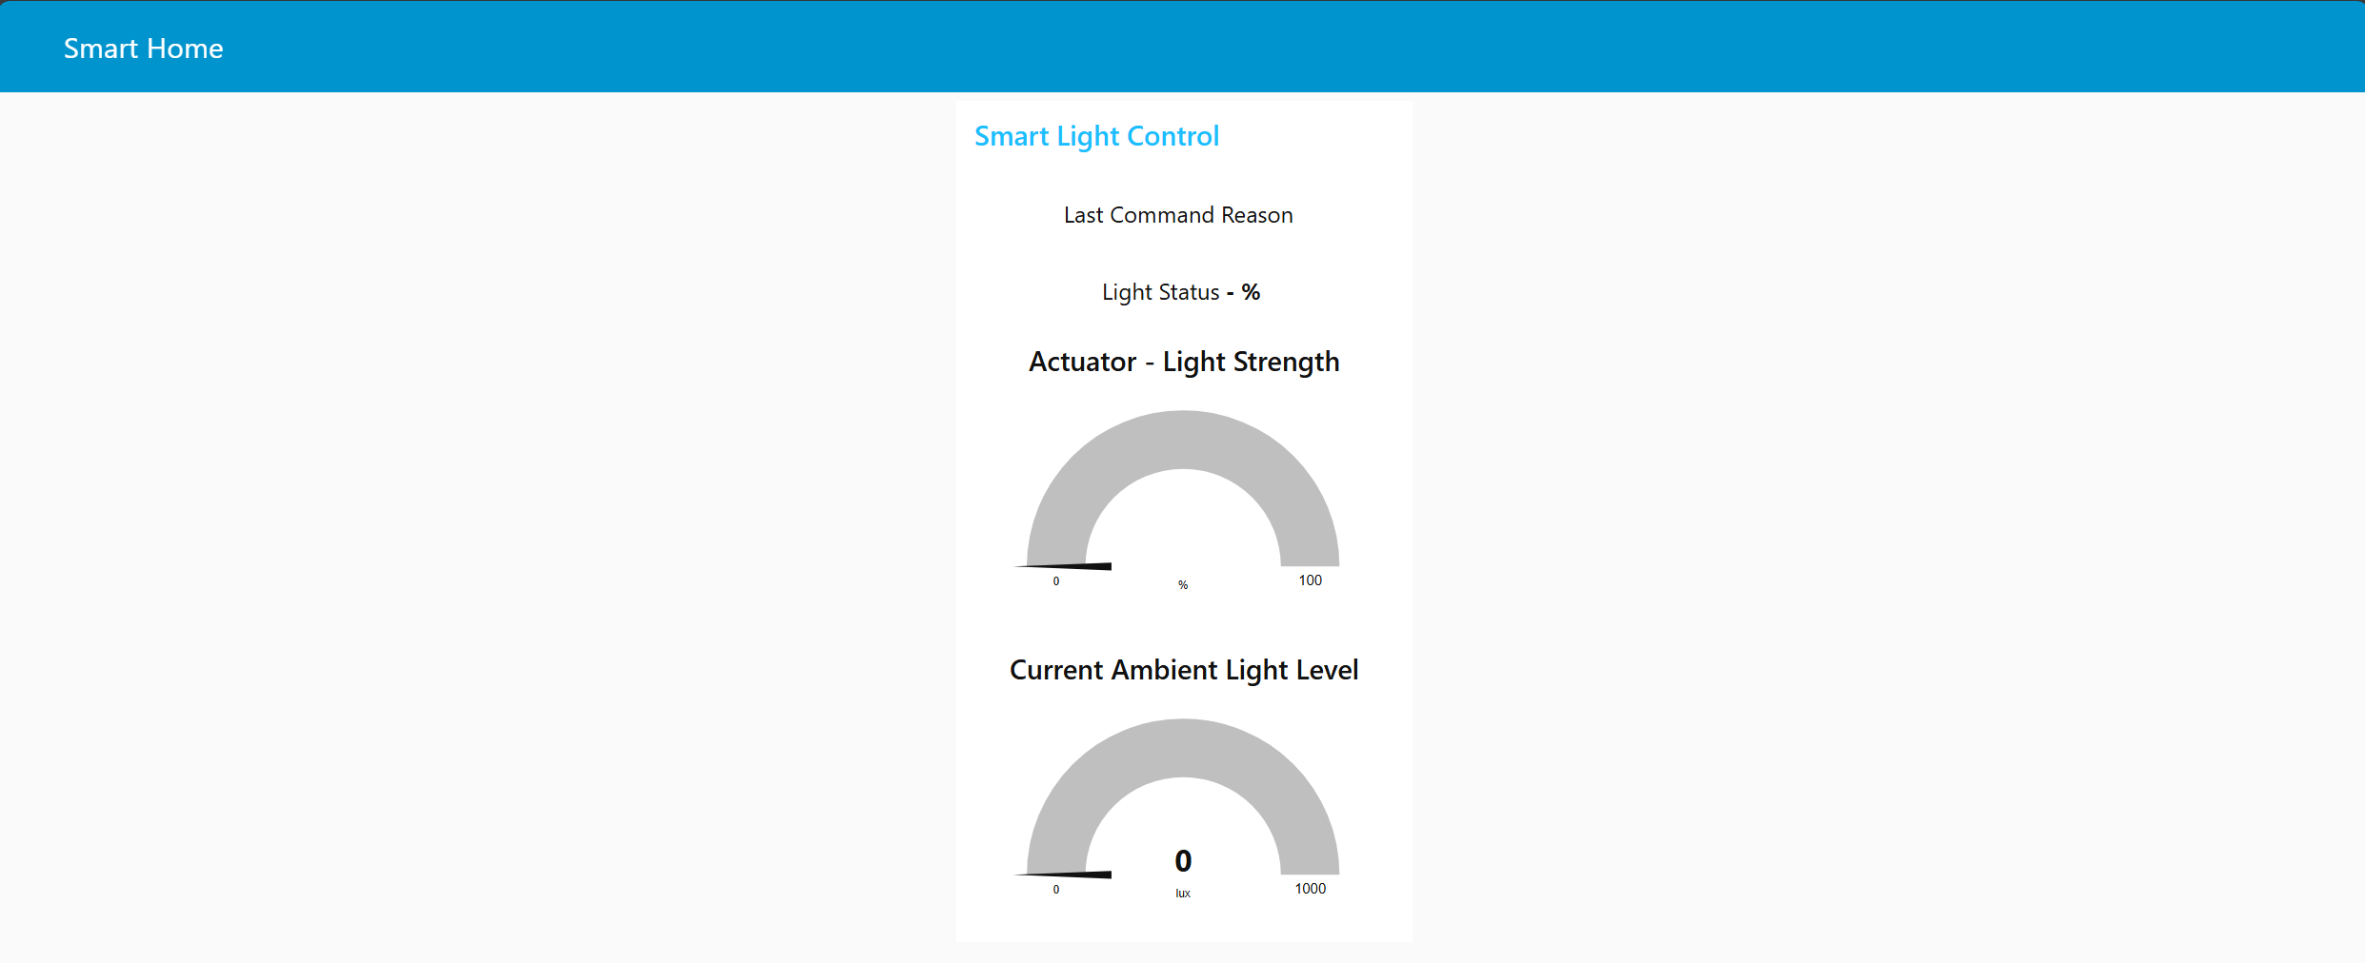
Picture 27 – The UI of Smart Light Control that displays both the light strength of ambient light (from sensors) and light actuator as percentage.
(Note: this can be accessed through http://<ec2-instance-publicDNS>:1880/ui)

C. Setup Application Load Balancer & Auto Scaling Group
#!/bin/bash
set -e
TOKEN=$(curl -sX PUT "http://169.254.169.254/latest/api/token" -H "X-aws-ec2-metadata-token-ttl-seconds: 21600")
IID=$(curl -s -H "X-aws-ec2-metadata-token: $TOKEN" http://169.254.169.254/latest/meta-data/instance-id)
mkdir -p /etc/node-red
echo "CLIENT_ID=node-red-${IID}" > /etc/node-red/env
mkdir -p /etc/systemd/system/node-red.service.d
cat >/etc/systemd/system/node-red.service.d/override.conf <<'EOF'
[Service]
EnvironmentFile=/etc/node-red/env
EOF
systemctl daemon-reload
systemctl restart node-red
Code 1 – Code to paste into the “User data” of “Advanced Settings” in “Create launch template”.
(Note: derive CLIENT_ID from EC2 instance-id and attach it to Node-RED’s environment so MQTT clientId =${CLIENT_ID} resolves uniquely at runtime)

D. JavaScript code file for testing

1. “test-state-validation.js”
const awsIot = require('aws-iot-device-sdk');

// Configuration
const host = 'a3gihr6flc6bqc-ats.iot.ap-southeast-2.amazonaws.com';
const certBasePath = './certificates';
const clientId = `state-validation-${Date.now()}`;

// Test with just 3 sensors for easy tracking
const testSensors = [
{ id: 'sensor_A', floor: 1, room: 1, lightId: 'floor1-room1-sensorA-lightA' },
{ id: 'sensor_B', floor: 1, room: 2, lightId: 'floor1-room2-sensorB-lightB' },
{ id: 'sensor_C', floor: 1, room: 3, lightId: 'floor1-room3-sensorC-lightC' }
];

// Test scenarios to force state changes
const testScenarios = [
{
name: "Initial State - All should turn OFF",
data: [
{ sensorId: 'sensor_A', motion: false, light: 500 }, // OFF: No motion
{ sensorId: 'sensor_B', motion: false, light: 400 }, // OFF: No motion
{ sensorId: 'sensor_C', motion: false, light: 300 } // OFF: No motion
],
expectedCommands: 3 // All new states
},
{
name: "Motion in Low Light - Some should turn ON",
data: [
{ sensorId: 'sensor_A', motion: true, light: 100 }, // ON: Motion + low light
{ sensorId: 'sensor_B', motion: false, light: 400 }, // OFF: No motion (no change)
{ sensorId: 'sensor_C', motion: true, light: 150 } // ON: Motion + low light
],
expectedCommands: 2 // Only A and C change state
},
{
name: "Motion in Bright Light - Should turn OFF",
data: [
{ sensorId: 'sensor_A', motion: true, light: 500 }, // OFF: Bright light (change from ON)
{ sensorId: 'sensor_B', motion: false, light: 400 }, // OFF: No motion (no change)
{ sensorId: 'sensor_C', motion: true, light: 600 } // OFF: Bright light (change from ON)
],
expectedCommands: 2 // Only A and C change state
},
{
name: "No Changes - All stay OFF",
data: [
{ sensorId: 'sensor_A', motion: false, light: 500 }, // OFF: No motion (no change)
{ sensorId: 'sensor_B', motion: false, light: 400 }, // OFF: No motion (no change)
{ sensorId: 'sensor_C', motion: false, light: 600 } // OFF: No motion (no change)
],
expectedCommands: 0 // No state changes
}
];

// Create AWS IoT connection
const device = awsIot.device({
keyPath: `${certBasePath}/light_sensor.private.key`,
certPath: `${certBasePath}/light_sensor.cert.pem`,
caPath: `${certBasePath}/root-CA.crt`,
clientId,
host
});

let currentScenario = 0;

console.log('🔍 STATE CHANGE VALIDATION TEST');
console.log('Testing with 3 sensors: A, B, C');
console.log('Watch Node-RED debug and DynamoDB for expected command counts\n');

device.on('connect', () => {
console.log('✅ Connected to AWS IoT Core');
runNextScenario();
});

function runNextScenario() {
if (currentScenario >= testScenarios.length) {
console.log('\n🎉 All test scenarios completed!');
console.log('Check DynamoDB tables to validate state change detection.');
device.end();
process.exit(0);
return;
}

const scenario = testScenarios[currentScenario];
console.log(`\n📋 SCENARIO ${currentScenario + 1}: ${scenario.name}`);
console.log(`Expected commands in DynamoDB: ${scenario.expectedCommands}`);

// Send all sensor data for this scenario
scenario.data.forEach((sensorTest, index) => {
const sensor = testSensors.find(s => s.id === sensorTest.sensorId);
const topic = `iot/sensors/floor${sensor.floor}/${sensor.room}/${sensor.id}`;

const payload = {
deviceId: sensor.id,
floor: sensor.floor,
room: sensor.room,
lightId: sensor.lightId,
motion_detected: sensorTest.motion,
light_intensity: sensorTest.light,
timestamp: Date.now() + index, // Slight offset to avoid exact duplicates
scenario: scenario.name,
test: `${sensor.id}: motion=${sensorTest.motion}, light=${sensorTest.light}`
};

console.log(` 📤 ${sensor.id}: motion=${sensorTest.motion}, light=${sensorTest.light}`);

device.publish(topic, JSON.stringify(payload), (err) => {
if (err) {
console.error(`❌ Error publishing ${sensor.id}:`, err);
}
});
});

currentScenario++;

// Wait 10 seconds before next scenario to let processing complete
setTimeout(() => {
console.log('⏳ Waiting for processing to complete...');
setTimeout(runNextScenario, 5000);
}, 10000);
}

device.on('error', (err) => {
console.error('❌ AWS IoT error:', err);
});

process.on('SIGINT', () => {
console.log('\n🛑 Test interrupted');
device.end();
process.exit(0);
});

console.log('🚀 Starting state change validation test...');
console.log('This will run 4 scenarios with 3 sensors each');
console.log('Watch for expected command counts in DynamoDB tables');

2. “test-multiple-connections-singleproc.js”
// Single-process multi-client MQTT simulator (no child_process spawn)
// Usage examples:
// node test-multiple-connections-singleproc.js
// BATCH_SIZE=50 BATCH_INTERVAL_MS=500 MAX_CLIENTS=5000 PUBLISH_INTERVAL_MS=5000 node test-multiple-connections-singleproc.js

const awsIot = require('aws-iot-device-sdk');

// Configuration (overridable via env)
const host = process.env.IOT_HOST || 'a3gihr6flc6bqc-ats.iot.ap-southeast-2.amazonaws.com';
const certBasePath = process.env.CERT_BASE || './certificates';
const maxClients = parseInt(process.env.MAX_CLIENTS || '5000', 10);
const publishIntervalMs = parseInt(process.env.PUBLISH_INTERVAL_MS || '5000', 10);
const batchSize = parseInt(process.env.BATCH_SIZE || '50', 10);
const batchIntervalMs = parseInt(process.env.BATCH_INTERVAL_MS || '500', 10);
const baseOffset = parseInt(process.env.OFFSET || '0', 10);

const clients = [];
let started = 0;

function createClient(clientNumber) {
const id = baseOffset + clientNumber;
const sensorIdPadded = String(id).padStart(3, '0');
const clientId = `device_${id}_${process.pid}_${Date.now()}_${Math.random().toString(36).slice(2)}`;

const device = awsIot.device({
keyPath: `${certBasePath}/light_sensor.private.key`,
certPath: `${certBasePath}/light_sensor.cert.pem`,
caPath: `${certBasePath}/root-CA.crt`,
clientId,
host,
// Connection tuning to reduce reconnect storms and TLS churn
baseReconnectTimeMs: 1000,
maximumReconnectTimeMs: 60000,
keepalive: 30,
});

device.on('connect', () => {
if (clientNumber % 100 === 0) {
console.log(`Connected clients: ${clientNumber}/${maxClients}`);
}

// Periodic publish
const interval = setInterval(() => {
const floor = Math.floor((id - 1) / 5) + 1;
const room = ((id - 1) % 5) + 1;
const data = {
deviceId: `sensor_${sensorIdPadded}`,
floor,
room,
lightId: `floor${floor}-room${room}-sensor${sensorIdPadded}-light${sensorIdPadded}`,
light_intensity: Math.round(Math.random() * 500 + 100),
motion_detected: Math.random() < 0.3,
timestamp: Date.now(),
connectionTest: true,
deviceProcess: process.pid,
};
const topic = `iot/sensors/floor${floor}/${room}/sensor_${sensorIdPadded}`;
device.publish(topic, JSON.stringify(data), (err) => {
if (err && clientNumber % 100 === 0) {
console.error(`Publish error (client ${clientNumber}):`, err.message);
}
});
}, publishIntervalMs);

device._simInterval = interval;
});

device.on('error', (err) => {
if (clientNumber % 100 === 0) {
console.error(`Client ${clientNumber} error:`, (err && (err.code || err.message || err)));
}
});

device.on('offline', () => {
if (clientNumber % 500 === 0) {
console.warn(`Client ${clientNumber} offline`);
}
});

device.on('reconnect', () => {
if (clientNumber % 500 === 0) {
console.warn(`Client ${clientNumber} reconnecting`);
}
});

device.on('close', () => {
if (clientNumber % 500 === 0) {
console.warn(`Client ${clientNumber} connection closed`);
}
});

clients.push(device);
}

function startClientsGradually() {
console.log('🔌 MULTIPLE MQTT CONNECTIONS TEST (single-process)');
console.log(`📋 Plan: start ${maxClients} clients (batch=${batchSize}, interval=${batchIntervalMs}ms, offset=${baseOffset})`);
console.log('📊 Monitor EC2 CPU/Memory, MQTT connection count, Node-RED performance\n');

const timer = setInterval(() => {
if (started >= maxClients) {
clearInterval(timer);
console.log(`\n✅ All ${maxClients} clients started`);
console.log('📊 Let it run 5-10 minutes, then Ctrl+C to stop');
return;
}

for (let i = 0; i < batchSize && started < maxClients; i++) {
started += 1;
createClient(started);
}

if (started % (batchSize * 10) === 0) {
console.log(`📈 Progress: ${started}/${maxClients}`);
}
}, batchIntervalMs);
}

function shutdown() {
console.log('\n🛑 Shutting down all MQTT clients...');
clients.forEach((device, idx) => {
if (device._simInterval) clearInterval(device._simInterval);
try { device.end(); } catch (e) {}
if ((idx + 1) % 500 === 0) {
console.log(`Closed ${idx + 1} clients...`);
}
});
setTimeout(() => {
console.log('✅ All clients closed');
process.exit(0);
}, 3000);
}

process.on('SIGINT', shutdown);
process.on('SIGTERM', shutdown);

console.log('🚀 Multiple connections (single-process) starting...');
setTimeout(startClientsGradually, 500);

