Github Link:

Because 6.2C is a continuous task from 6.1P, thus, all the coding resources can be tracked back in folder “6.1P”

1/ Verifying the status of application through kubectl command

* Check all current-running pods by “kubectl get pods” (Image 1):



Image 1

* Check all current-running services by “kubectl get services” (Image 2):

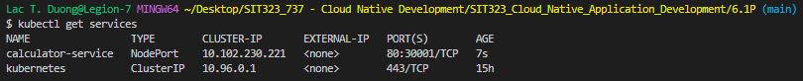

Image 2

2/ Forward traffic from a local port to the Kubernetes service

* Type in command: “kubectl port-forward svc/calculator-service 8080:80” (Image 3):



Image 3

3/ Test the application

* Can be tested by type in “/http:localhost:8080/add?a=20&b=30” (Image 4):

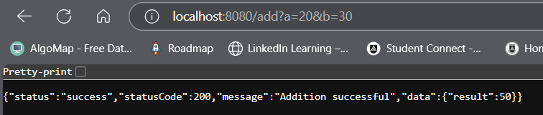

Image 4

* Or open a new terminal within vs code and type “curl localhost:8080”, it will display the html structure of the application (Image 5):

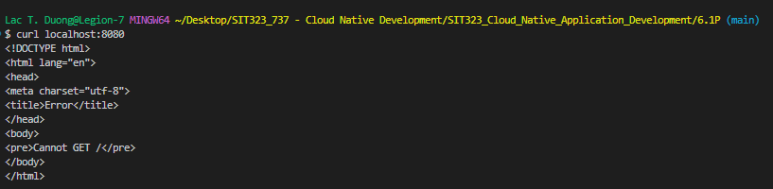

Image 5