Hayden Gough CreateClassesObjs

Submit your work on the coding activities for Modules One, Two, Three, Four, and Six in this document. In addition to this document, you should submit a ZIP file containing all your Visual Studio project files and source code that can be run in Visual Studio on a different computer.

For each coding activity, complete the following steps:

- Download and rename this document to meet the file naming conventions requested in the assignment instructions.
- Fill in the required information below by replacing the bracketed text with the relevant information.
- Submit this document and your ZIP file for grading and feedback. Your ZIP file should follow the same naming conventions.

Document your work in the coding activity by completing each of the following items:

- Provide a screenshot of the output that resulted from running your program successfully in Visual Studio. See the coding assignment instructions for an example of what should be included in the screenshot. Your screenshot must include the following elements:
  - Your last name as the first printed text on the screen
  - Verification that the program is fully functioning and data results are accurate for the given problem

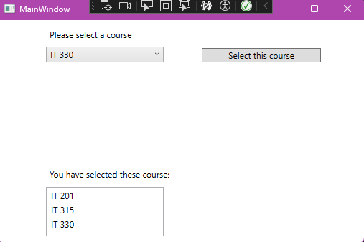
- Copy and paste the source code text you wrote for this assignment from the *.cs file into the space below. Only providing the *.cs files or a screenshot does not meet the requirements for this part of the assignment. Code should be logically organized. It should also follow proper syntax and conventions noted in the Coding Activity Guidelines and Rubric.

using System;
using System.Collections.Generic;
using System.Linq;
using System.Text;
using System.Threading.Tasks;

namespace CreateClassesObjs
{
public class Course
{
private string _name;

public void SetName(string name)
{
_name = name;
}

public string GetName()
{
return _name;
}

public override string ToString()
{
return _name;
}
}
}
- Show that you understand the task by explaining the design of your program in the space below. Include the process and steps you took to write your code. Explain how you arrived at the solution to the problem and completed the activity.

Since classes are defined by namespace rather than the file they are in I made a different ‘.cs’ file to write separate code for the original code to read. Inside of this separate file I made a private string field named ‘_name’. This allows the name of the course to be stored. Then I added a ‘SetName’ method so that other parts of the program could assign values to the ‘_name’ field. I also added a ‘GetName’ method so the whole programs could retrieve the value stored in ‘_name’. Finally, I added an ‘override’ so that the ‘ToString’ is overridden to return the course name.

- Reflect on your learning experience and what you learned from completing the activity.

I learned how separate ‘.cs’ files can communicate in a program. I also learned how to override a ‘ToString’ method to change object represention. And I also learned the interaction between backend code and frontend UI. As well as how to write for a WPF application.

