Console Register Student
Hayden Gough
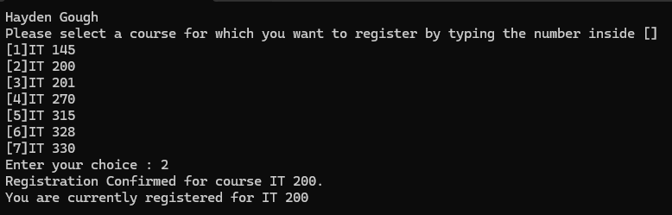
The program first opens with a list of courses to select, and I type in “2” and press “enter”.
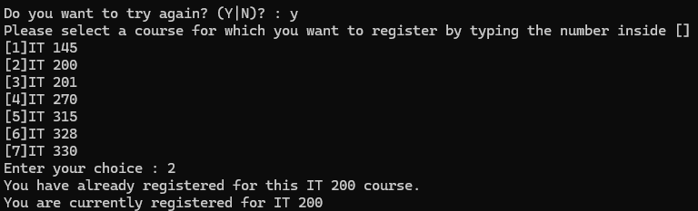
The program then asks me if I want to sign up for another course if I type “Y” then press “enter” the program repeats, and if I type “2” again and press “enter” it prints a line telling me that I’ve already signed up for this course.
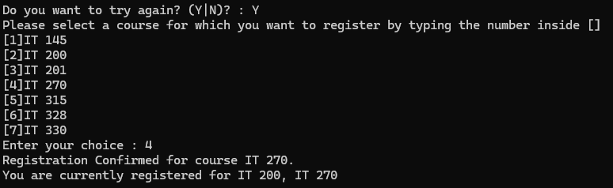
If I type “Y” to run the program again and then select a different course (in this case “4”) the program then tells me that I signed up for the IT 270 course.
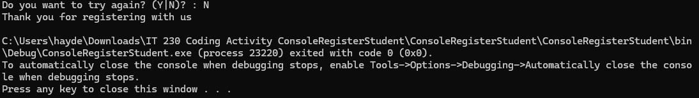
Then if I press “N” and “enter” then the program prints one final line before terminating.

Source Code
using System;
using System.Collections.Generic;
using System.Linq;
using System.Text;
using System.Threading.Tasks;

namespace ConsoleRegisterStudent
{
class Program
{
static void Main(string[] args)
{
(new Program()).run();
}

void run()
{
int choice;
int firstChoice = 0, secondChoice = 0, thirdChoice = 0;
int totalCredit = 0;
string yesOrNo = "";

Console.WriteLine("Hayden Gough");

do
{
WritePrompt();
choice = Convert.ToInt32(Console.ReadLine());

int validationResult = ValidateChoice(choice, firstChoice, secondChoice, thirdChoice, totalCredit);

switch (validationResult)
{
case -1:
Console.WriteLine("Your entered selection {0} is not a recognized course.", choice);
break;
case -2:
Console.WriteLine("You have already registered for this {0} course.", ChoiceToCourse(choice));
break;
case -3:
Console.WriteLine("You cannot register for more than 9 credit hours.");
break;
case 0:
Console.WriteLine("Registration Confirmed for course {0}.", ChoiceToCourse(choice));
totalCredit += 3;
if (firstChoice == 0)
firstChoice = choice;
else if (secondChoice == 0)
secondChoice = choice;
else if (thirdChoice == 0)
thirdChoice = choice;
break;
}

WriteCurrentRegistration(firstChoice, secondChoice, thirdChoice);
Console.Write("\nDo you want to try again? (Y|N)? : ");
yesOrNo = Console.ReadLine().ToUpper();
} while (yesOrNo == "Y");

Console.WriteLine("Thank you for registering with us");
}

void WritePrompt()
{
Console.WriteLine("Please select a course for which you want to register by typing the number inside []");
Console.WriteLine("[1]IT 145\n[2]IT 200\n[3]IT 201\n[4]IT 270\n[5]IT 315\n[6]IT 328\n[7]IT 330");
Console.Write("Enter your choice : ");
}

int ValidateChoice(int choice, int firstChoice, int secondChoice, int thirdChoice, int totalCredit)
{
if (choice < 1 || choice > 7)
return -1;

if (choice == firstChoice || choice == secondChoice || choice == thirdChoice)
return -2;

if (totalCredit + 3 > 9)
return -3;

return 0;
}

void WriteCurrentRegistration(int firstChoice, int secondChoice, int thirdChoice)
{
if (firstChoice == 0)
{
Console.WriteLine("You are currently not registered for any courses.");
return;
}

if (secondChoice == 0)
Console.WriteLine("You are currently registered for {0}", ChoiceToCourse(firstChoice));
else if (thirdChoice == 0)
Console.WriteLine("You are currently registered for {0}, {1}", ChoiceToCourse(firstChoice), ChoiceToCourse(secondChoice));
else
Console.WriteLine("You are currently registered for {0}, {1}, {2}", ChoiceToCourse(firstChoice), ChoiceToCourse(secondChoice), ChoiceToCourse(thirdChoice));
}

string ChoiceToCourse(int choice)
{
string course = "";
switch (choice)
{
case 1:
course = "IT 145";
break;
case 2:
course = "IT 200";
break;
case 3:
course = "IT 201";
break;
case 4:
course = "IT 270";
break;
case 5:
course = "IT 315";
break;
case 6:
course = "IT 328";
break;
case 7:
course = "IT 330";
break;
default:
break;
}
return course;
}
}
}

