Hayden Gough DebugFixIFStmt

Submit your work on the coding activities for Modules One, Two, Three, Four, and Six in this document. In addition to this document, you should submit a ZIP file containing all your Visual Studio project files and source code that can be run in Visual Studio on a different computer.

For each coding activity, complete the following steps:

- Download and rename this document to meet the file naming conventions requested in the assignment instructions.
- Fill in the required information below by replacing the bracketed text with the relevant information.
- Submit this document and your ZIP file for grading and feedback. Your ZIP file should follow the same naming conventions.

Document your work in the coding activity by completing each of the following items:

- Provide a screenshot of the output that resulted from running your program successfully in Visual Studio. See the coding assignment instructions for an example of what should be included in the screenshot. Your screenshot must include the following elements:
  - Your last name as the first printed text on the screen
  - Verification that the program is fully functioning and data results are accurate for the given problem

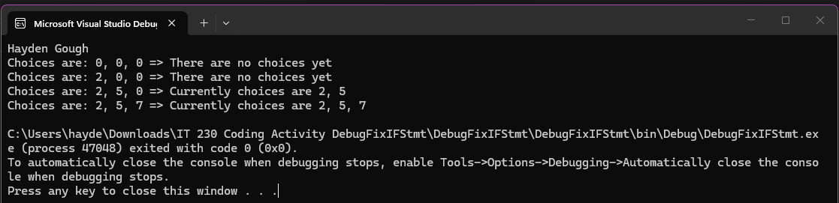

- Copy and paste the source code text you wrote for this assignment from the *.cs file into the space below. Only providing the *.cs files or a screenshot does not meet the requirements for this part of the assignment. Code should be logically organized. It should also follow proper syntax and conventions noted in the Coding Activity Guidelines and Rubric.

using System;
using System.Collections.Generic;
using System.Linq;
using System.Text;
using System.Threading.Tasks;

namespace DebugFixIFStmt
{
class Program
{
static void Main(string[] args)
{
(new Program()).run();
}

void run()
{
int firstChoice = 0, secondChoice = 0, thirdChoice = 0;

System.Console.WriteLine("Hayden Gough");

firstChoice = 0; secondChoice = 0; thirdChoice = 0;
WriteCurrentChoices(firstChoice, secondChoice, thirdChoice);

firstChoice = 2; secondChoice = 0; thirdChoice = 0;
WriteCurrentChoices(firstChoice, secondChoice, thirdChoice);

firstChoice = 2; secondChoice = 5; thirdChoice = 0;
WriteCurrentChoices(firstChoice, secondChoice, thirdChoice);

firstChoice = 2; secondChoice = 5; thirdChoice = 7;
WriteCurrentChoices(firstChoice, secondChoice, thirdChoice);
}

void WriteCurrentChoices(int firstChoice, int secondChoice, int thirdChoice)
{
if (secondChoice == 0)
{
Console.WriteLine("Choices are: {0}, {1}, {2} => There are no choices yet", firstChoice, secondChoice, thirdChoice);
}
else if (thirdChoice == 0)
{
Console.WriteLine("Choices are: {0}, {1}, {2} => Currently choices are {0}, {1}", firstChoice, secondChoice, thirdChoice);
}
else
{
Console.WriteLine("Choices are: {0}, {1}, {2} => Currently choices are {0}, {1}, {2}", firstChoice, secondChoice, thirdChoice);
}
}
}
}

- Show that you understand the task by explaining the design of your program in the space below. Include the process and steps you took to write your code. Explain how you arrived at the solution to the problem and completed the activity.

Most of the errors in the code were errors in the logic, in two lines in the original code instead of comparing one of the ‘else if’ statements actually assigns, so I added a second ‘=’ to fix it. In another line there were actually three ‘===’ in a single line, I just removed one to fix that. Then there were errors in the branches, there was a redundant statement that I just removed, and it shortened the code overall.

- Reflect on your learning experience and what you learned from completing the activity.

Overall, the errors were pretty easy to fix, the one I had the most difficulty with were the redundancy errors.

