7-2 Final Project Part II
Hayden Gough
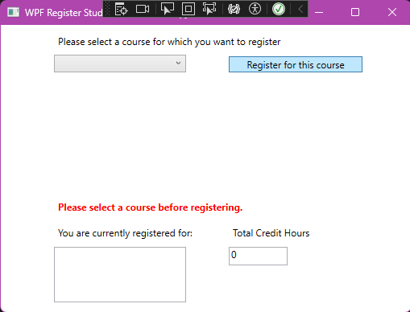
When selecting ‘Register for this course’ without picking a course the message ‘Please select a course before registering.’ appears.
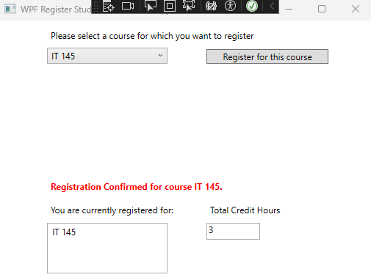
When registering for the first course the message ‘Registration Confirmed for course IT 145.,’ the ‘You are currently registered for:,’ updates with the string ‘IT 145,’ now being displayed. The ‘Total Credit Hours’ box also updates from 0 to now display 3.
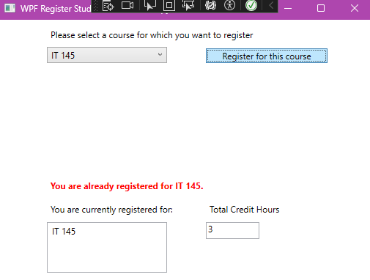
If you try to register for the same course a second time an error message is displayed stating ‘You are already registered for IT 145.,’ and no other values are updated.
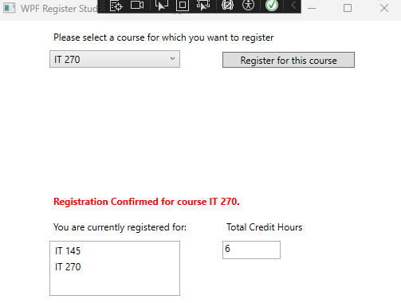
When registering for a second course a new value is added to the currently registered box, ‘IT 270’ with the ‘Total Credit Hours’ being updated to 6.
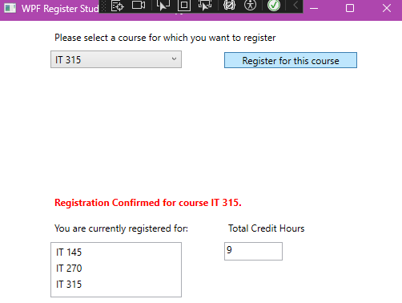
Then after registering for a third class a new value is once again added to the “currently registered” box and ‘Total Credit Hours’ is updated to 9.
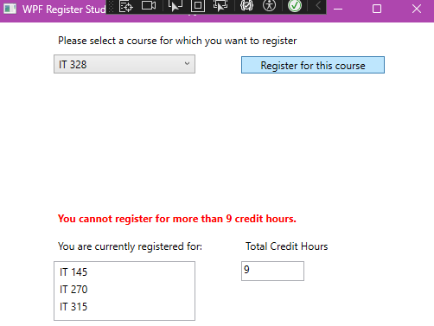
If you try to register for one more an error message will be displayed stating ‘You cannot register for more than 9 credit hours.’

MainWindow.xaml.cs:
using System;
using System.Collections.Generic;
using System.Linq;
using System.Windows;
using System.Windows.Controls;

namespace WPFRegisterStudent
{
/// <summary>
/// Interaction logic for MainWindow.xaml
/// </summary>
public partial class MainWindow : Window
{
private List<Course> registeredCourses = new List<Course>();

Course choice;

public MainWindow()
{
InitializeComponent();
}

private void Window_Loaded(object sender, RoutedEventArgs e)
{
Course course1 = new Course("IT 145");
Course course2 = new Course("IT 200");
Course course3 = new Course("IT 201");
Course course4 = new Course("IT 270");
Course course5 = new Course("IT 315");
Course course6 = new Course("IT 328");
Course course7 = new Course("IT 330");

this.comboBox.Items.Add(course1);
this.comboBox.Items.Add(course2);
this.comboBox.Items.Add(course3);
this.comboBox.Items.Add(course4);
this.comboBox.Items.Add(course5);
this.comboBox.Items.Add(course6);
this.comboBox.Items.Add(course7);

// Initialize UI elements
this.messageLabel.Content = "";
this.listBox.Items.Clear();
this.textBox.Text = "0";
}

private void button_Click(object sender, RoutedEventArgs e)
{
choice = (Course)(this.comboBox.SelectedItem);

if (choice == null)
{
messageLabel.Content = "Please select a course before registering.";
return;
}

int totalCreditHours = registeredCourses.Count * 3;

bool isAlreadyRegistered = registeredCourses.Any(c => c.getName() == choice.getName());
bool hasReachedMaxCredits = (totalCreditHours + 3) > 9;

if (isAlreadyRegistered)
{
messageLabel.Content = $"You are already registered for {choice.getName()}.";
}
else if (hasReachedMaxCredits)
{
messageLabel.Content = "You cannot register for more than 9 credit hours.";
}
else
{
choice.SetToRegistered();
registeredCourses.Add(choice);
totalCreditHours += 3;

messageLabel.Content = $"Registration Confirmed for course {choice.getName()}.";

// Update registered courses list display (ListBox)
listBox.Items.Clear();
foreach (Course c in registeredCourses)
{
listBox.Items.Add(c.getName());
}

// Update total credit hours display (TextBox)
textBox.Text = totalCreditHours.ToString();
}
}
}
}
MainWindow.xaml:
<Window x:Class="WPFRegisterStudent.MainWindow"
xmlns="http://schemas.microsoft.com/winfx/2006/xaml/presentation"
xmlns:x="http://schemas.microsoft.com/winfx/2006/xaml"
Title="WPF Register Student - Teacher's Copy" Height="395.902" Width="525" Loaded="Window_Loaded">
<Grid>
<!-- Course selection ComboBox -->
<ComboBox x:Name="comboBox" HorizontalAlignment="Left" Margin="66,37,0,0" VerticalAlignment="Top" Width="164" IsDropDownOpen="True"/>

<!-- Register button -->
<Button x:Name="button" Content="Register for this course" HorizontalAlignment="Left" Margin="283,39,0,0" VerticalAlignment="Top" Width="166" Click="button_Click"/>

<!-- Registered courses ListBox -->
<ListBox x:Name="listBox" HorizontalAlignment="Left" Height="69" Margin="66,276,0,0" VerticalAlignment="Top" Width="164"/>

<!-- Total credit hours TextBox -->
<TextBox x:Name="textBox" HorizontalAlignment="Left" Height="23" Margin="283,276,0,0" TextWrapping="Wrap" Text="0" VerticalAlignment="Top" Width="73" IsReadOnly="True"/>

<!-- Instruction label -->
<Label x:Name="label" Content="Please select a course for which you want to register" HorizontalAlignment="Left" Margin="66,7,0,0" VerticalAlignment="Top" Width="383"/>

<!-- Registered courses label -->
<Label x:Name="label1" Content="You are currently registered for:" HorizontalAlignment="Left" Margin="66,245,0,0" VerticalAlignment="Top" Width="176"/>

<!-- Total credit hours label -->
<Label x:Name="label2" Content="Total Credit Hours" HorizontalAlignment="Left" Margin="283,245,0,0" VerticalAlignment="Top" Width="106"/>

<!-- Message label for errors and confirmations (red text) -->
<Label x:Name="messageLabel" Content="" HorizontalAlignment="Left" Margin="66,213,0,0" VerticalAlignment="Top" Width="383" Foreground="Red" FontWeight="Bold"/>
</Grid>
</Window>

