Strategies = 1000, 252 da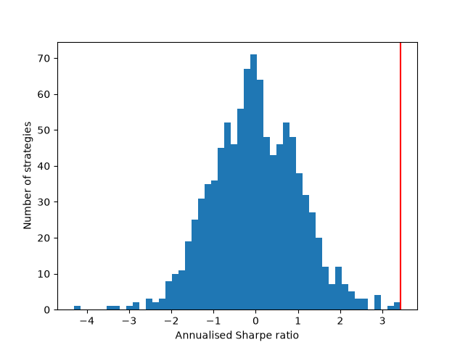

Strategies 100,000
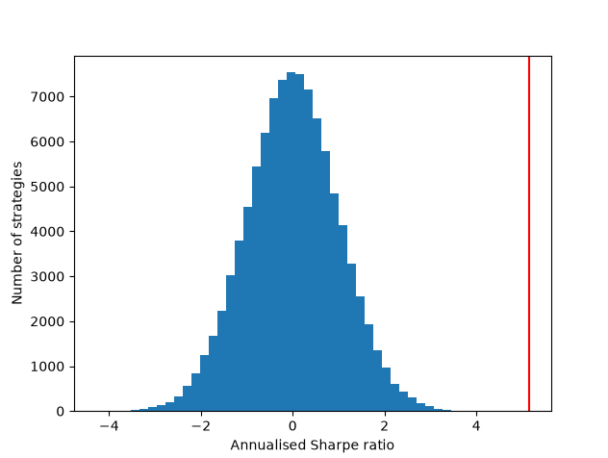

Strats 1000 days 2510. Spread should shrink about Sqrt(10) as its 10 times bigger data


