|  |
| --- |
| Michael & Marlow Systems |
| Meeting Planner System |
| To coordinate all events your company needs |
| Bailey Marlow & Hayden Michael  5-7-2020 |

# Introduction

Hello and welcome to your meeting planning system, designed by yours truly at Michael and Marlow Systems. This application is made with capabilities to schedule meetings among you and your coworkers as well as give you an overview of meetings for the workday. This manual will show you how to navigate and utilize the Meeting Planning system.

# Functionality

1. To begin using the application, first boot the software by selecting to run the meeting planner. This will bring you to the login screen.

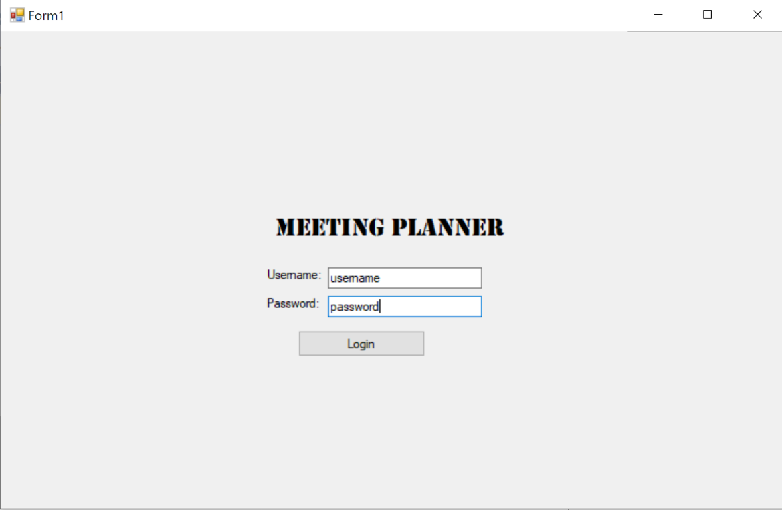

Enter your username and password to login and begin using the application. If the username and/or password you entered is incorrect, you will receive an error message looking like this:

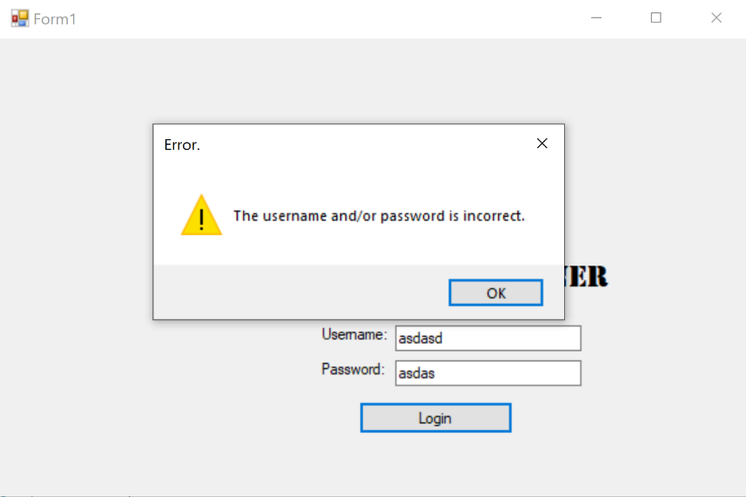

But do not worry, simply press “OK” and re-enter your credentials, ensuring they are correct. Once you are successfully logged in, it will bring you to the main page:

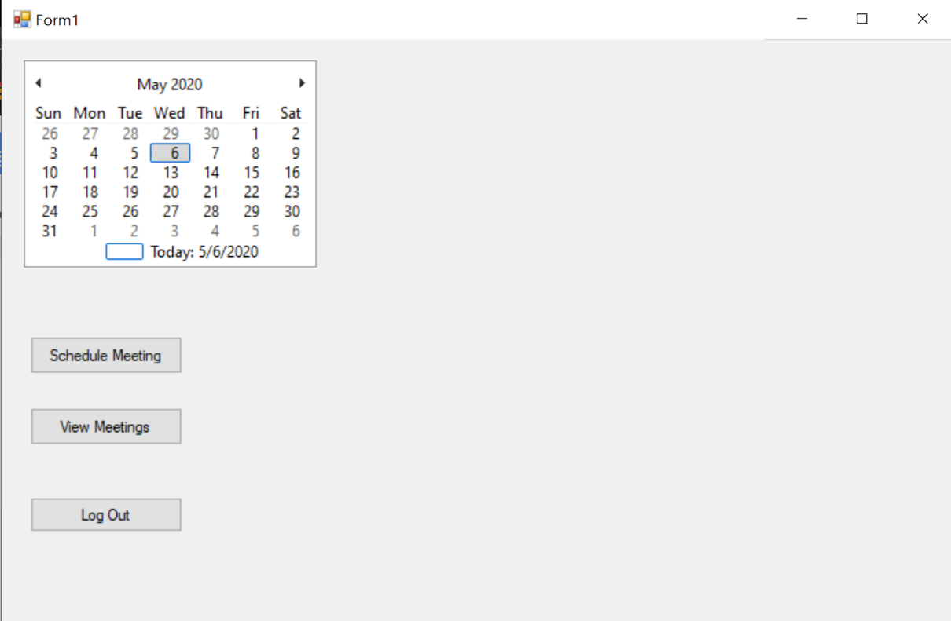

From here you can access the two main functions of the program: scheduling a meeting and viewing your meetings for the day. Let us take a look at how to schedule a meeting.

1. To schedule a meeting, begin by selecting a date on the calendar and pressing the “Schedule Meeting” button. It will display a field to enter the length of your meeting and a box with a list of your coworkers.

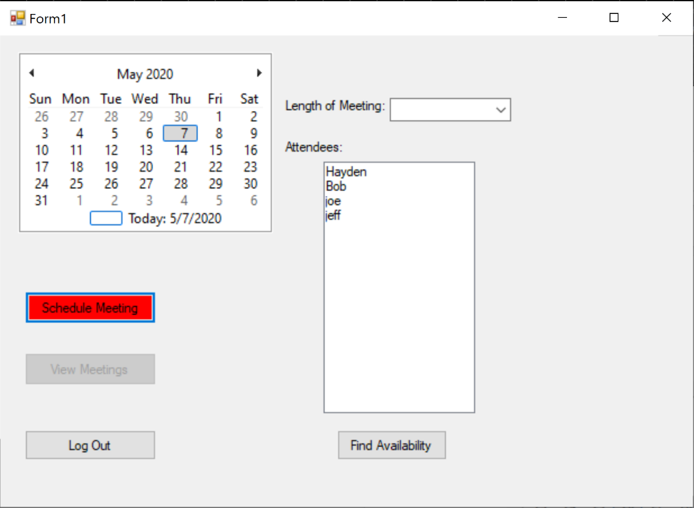

From here, select the length of your meeting from the drop-down box labelled “Length of Meeting” and select the coworkers you would like to attend it from the “Attendees” field. Once you have done that, select the “Find Availability” button. The system will then display the available meeting rooms and available time windows to hold your meeting, as well as a form to fill out containing the meeting’s information.

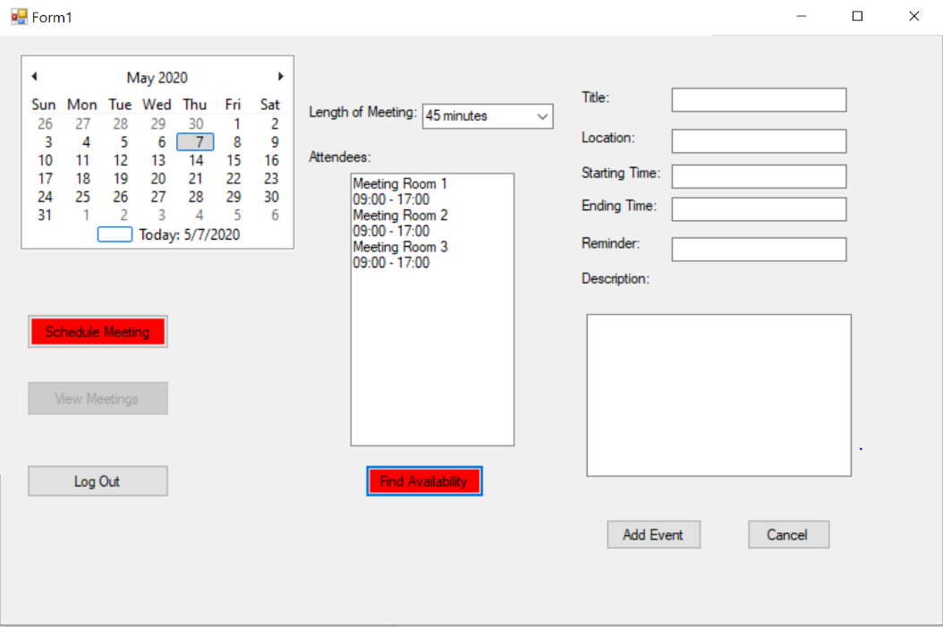

Next, select the meeting room corresponding to the time you would like to use from the list of meeting rooms and times. Then, enter the Title, Starting Time, Ending Time, Reminder Time, and description for your event. **Please be sure that the times entered in the Start Time and End Time fields are formatted as shown in the search box and are within the range of times displayed for the selected room’s availability**. If there is an error in the times entered, you will receive an error message that looks like this:

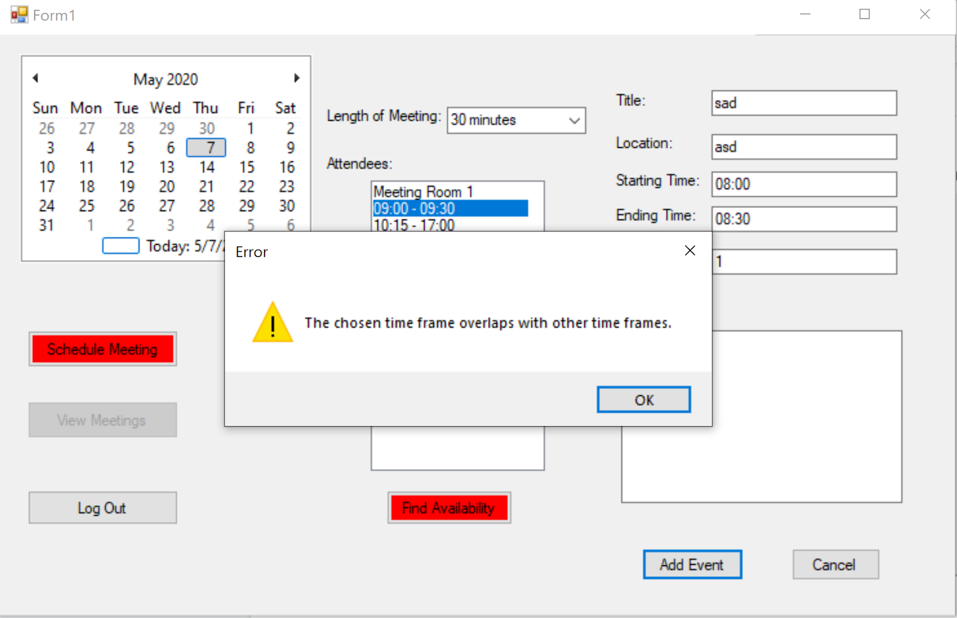

If you receive this message, do not fret as you can simply press “OK” and edit your times to be within the correct time frame. If your times are correct, the event will be added to the calendar and you will receive a confirmation:

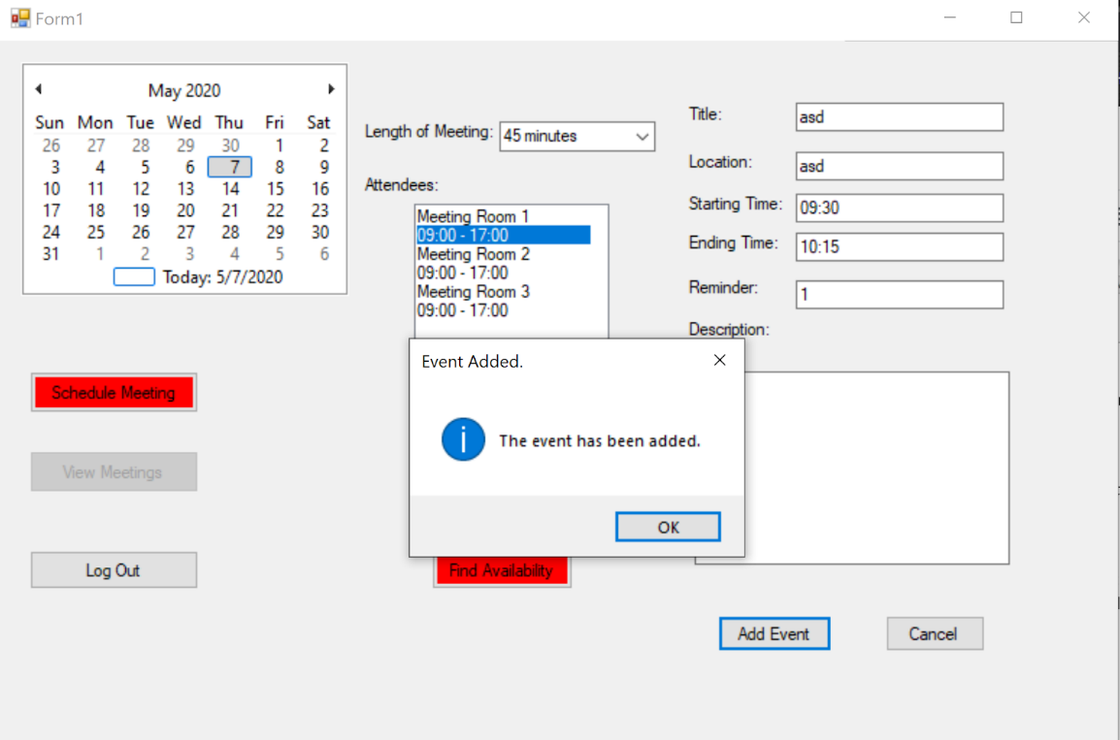

1. The other option is to view your meetings for the day. To begin this process, press the “View Meetings” button. This will open a field titled “Events” where the meetings for the day will be listed, as seen here:

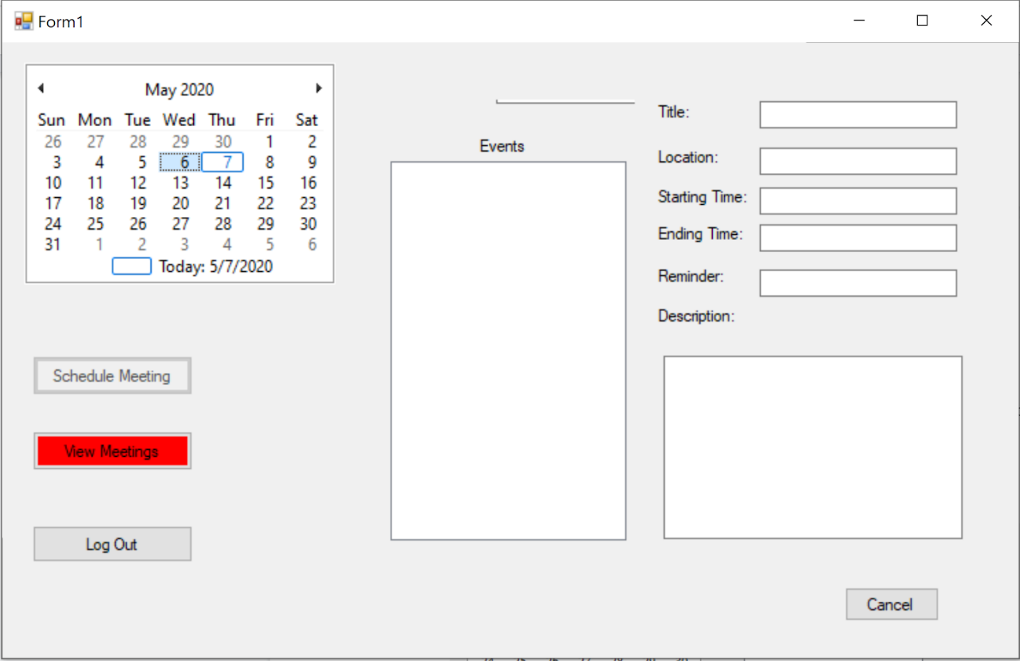

Finally, just select any date in the calendar to have the events listed in the box, placed perfectly for you to be able to see what the day entails:

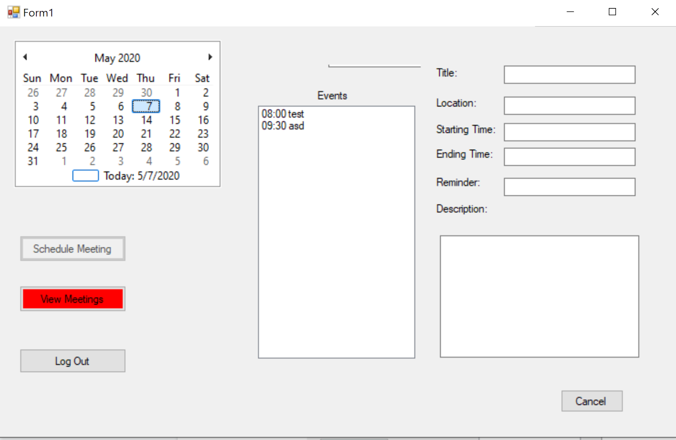

Additionally, you can select an event from the list and view the details for the event, as seen here:

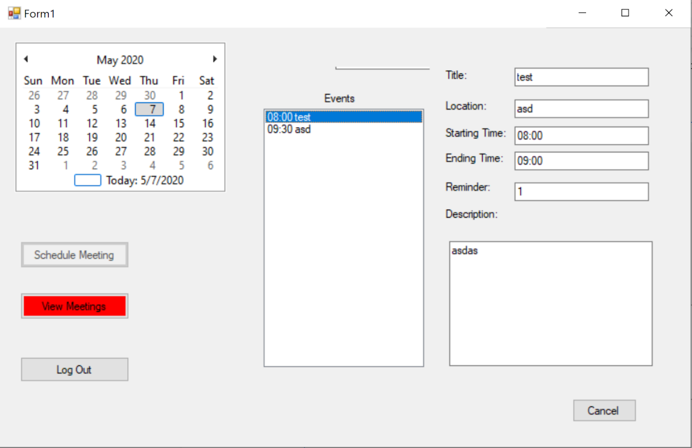

1. When you are finished with the planner, you can log out by pressing the “Log out” button.

To log out, press the “Log Out” button and a confirmation message will pop up like this:

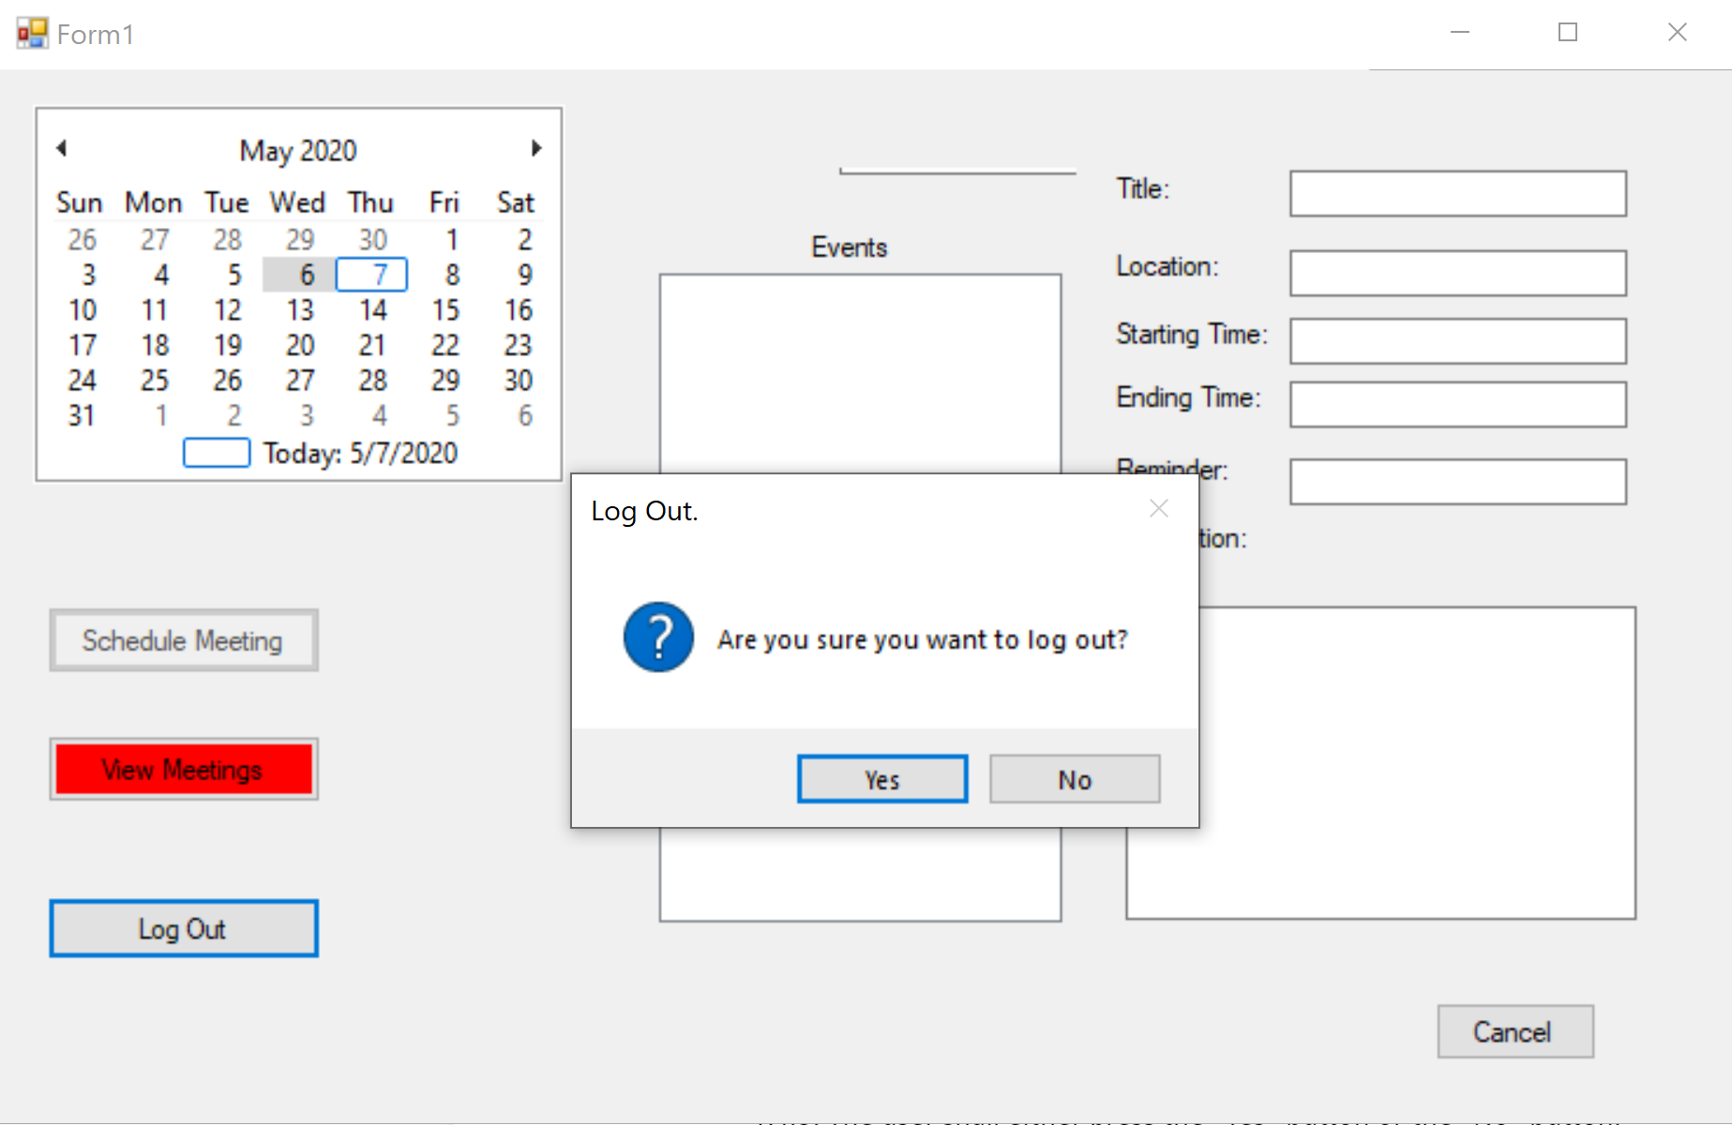

If you select “No”, the message will go away. If you select “Yes”, the system will take you back to the login screen and look like this:

