Topic: Sculpture Thematic Analysis – Rock Cut Sculptures of Mahabalipuram
Hayden Varughese Cheriyan
RA2311030010238
Introduction
Mahabalipuram (Mamallapuram), on the Coromandel coast of Tamil Nadu, is a UNESCO World Heritage Site renowned for its rock-cut monuments, monolithic temples, and narrative bas-reliefs created primarily during the Pallava dynasty (7th–8th century CE). Under the patronage of Narasimhavarman I (Mamalla) and later Rajasimha (Narasimhavarman II), the site became a laboratory for artistic and architectural innovation. The monuments reveal a pivotal transition: from cave-cut sanctuaries (mandapas) into free-standing structural temples, anchoring the emergence of the Dravidian style. Their purposes were manifold—acts of royal devotion and political legitimation, a didactic visual scripture for the public, and bold experimentation in form, iconography, and spatial narrative.
Overview of the Rock-Cut Sculptures
Mahabalipuram’s monuments can be grouped into three broad types:
- Cave Temples (Mandapas): Excavated sanctuaries with sculpted pillars and narrative reliefs on the interior walls. Exemplars include the Varaha Mandapa, Mahishasuramardini Cave, and Krishna Mandapa. They present mythic episodes in high and low relief, integrated with the architectural rhythm of columns and sanctum space.
- Monolithic Rathas (Pancha Rathas): Carved from single granite outcrops, these “chariot-temples” are complete architectural forms sculpted out of living rock. They are not functional temples but prototypes and exercises in formal vocabulary—vimana tiers, kapota cornices, aedicules, and lion or elephant balustrades—demonstrating diverse plans and superstructures.
- Open-Air Bas-Reliefs: Monumental narrative sculptures carved on exposed rock faces, the most spectacular being the Descent of the Ganges/Arjuna’s Penance. These compositions employ the natural cleft and contour of the rock, creating an immersive theatricality.
Materials and Techniques: The medium is local granite—hard, coarse, and unforgiving—worked with hammer and chisel. Artisans mastered shallow and deep relief to model bodies, drapery, and motion; they leveraged the rock’s natural fissures and planes, and minimized applied materials, relying on the stone’s mass and luminosity.

Themes and Iconography
A. Religious Themes
Mahabalipuram articulates a robust Hindu pantheon, with Shaivism and Vaishnavism in energetic dialogue.
- Shaivism Dominance: Shiva appears as Gangadhara (receiver of the Ganga’s descent), as the boon-giver to the ascetic Arjuna, and in familial Somaskanda panels (Shiva-Parvati with Skanda). Dvarapalas flank sanctums with leonine vigor; linga cult imagery anchors royal piety and cosmic authority.
- Vaishnavism Representations: Vishnu’s avatars, especially Varaha (boar) and Vamana/Trivikrama, dramatize the divine restoration of order. Gajalakshmi panels express prosperity and auspiciousness, linking temple, kingship, and wellbeing.
- Mythological Narratives: Arjuna’s severe tapas to obtain the Pashupatastra from Shiva and Bhagiratha’s penance for the Ganga’s descent are paired narratives of ascetic devotion, divine grace, and the world-ordering descent of sacred waters.
B. Cultural Themes
The monuments encode royal authority, ascetic virtue, and communal life.
- Royal and Ascetic Ideals: Kingship is cast as dharmic stewardship under divine sanction; asceticism (tapas) is exalted as a transformative path, symbolically aligning the ruler with sage-like restraint and duty.
- Lived Culture and Nature: Panels teem with domestic and pastoral scenes—cowherds, women with water pots, musicians, playful children—and vivid animal life: elephants, lions, deer, makaras, and nagas. The divine-human-natural continuum asserts a harmonious cosmic ecology.
- Tamil-Dravidian Ethos: The sculptural language integrates early Tamil cultural sensibilities—valor, devotion (bhakti), fertility symbols, and kinship—with pan-Indian mythic frameworks.
C. Artistic Themes
- Sculptural-Natural Harmony: Compositions adapt to and dramatize the rock’s clefts, slopes, and planes, turning geology into iconography.
- Relief Mastery: Alternation of low and high relief creates spatial depth, kinetic rhythms, and expressive silhouettes in hard granite.
- Realism and Dynamism: Anatomical vitality (notably in elephants), balanced stances, and flowing lines communicate motion and psychological nuance.
- Prototyping the Dravidian Temple: The rathas articulate superstructure tiers, shrine plans, porches, and iconographic programs that later blossom in structural temples.

Iconographic Details: Key Examples
Descent of the Ganges / Arjuna’s Penance
This immense open-air bas-relief, carved on twin boulders divided by a natural cleft, stages a multi-register spectacle of gods, sages, animals, and humans around a central ascetic figure. Two interpretive axes operate simultaneously:
- Arjuna’s Penance: The ascetic performs one-legged tapas to win Shiva’s Pashupatastra—an emblem of heroic self-mastery and divine-bestowed agency.
- Descent of the Ganga: The cleft becomes the celestial river’s channel, with nagas swimming through; Shiva receives her torrent, diffusing cosmic energy into earthly life.
Symbolism crystallizes around purification (sacred waters), devotion (tapas as path to grace), and cosmic integration (gods, people, animals sharing one sacred field). The famed cat mimicking penance while mice “worship”—a moral fable inset—adds satirical commentary on hypocrisy and gullibility within the grandeur of dharmic instruction.
Varaha Cave Temple
Inside the Varaha Mandapa, Vishnu as Varaha hoists the Earth goddess (Bhu Devi) from the cosmic waters. The boar’s massive, upward-driving diagonals and the tender, protective gesture constitute a theology of rescue and restoration. Other panels (Vamana/Trivikrama, Gajalakshmi) complete a cycle of abundance, cosmic strides, and salvific intervention—binding royal prosperity and divine guardianship. 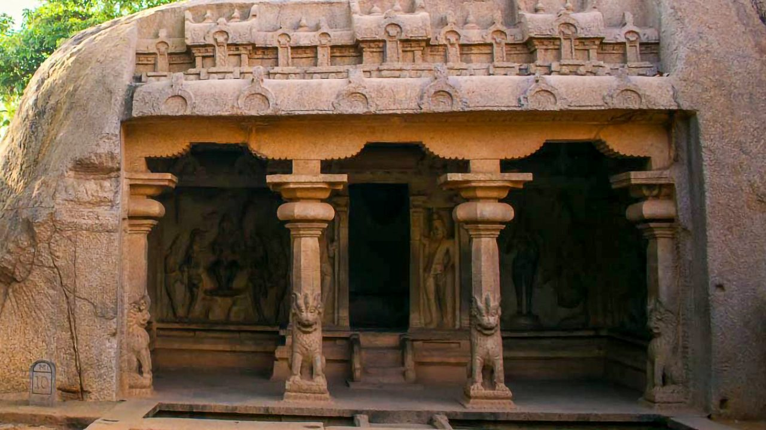Mahishasuramardini Cave
Durga, eight-armed and lion-mounted, charges the buffalo demon Mahisha. The composition is tensile and balanced: advancing diagonals countered by the demon’s mass, weapons radiating from the goddess’s core, soldiers and attendants amplifying momentum. It is a visual hymn to shakti—the feminine divine—triumphing over chaos. A companion panel often shows Vishnu reclining, framing the cave in a polarity of dynamic action and cosmic repose. 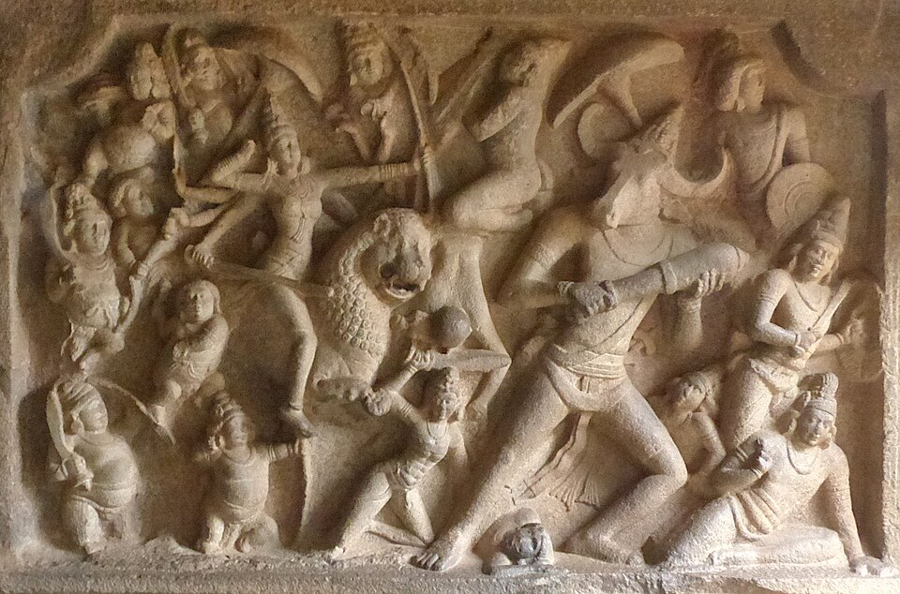
Pancha Rathas
The five monoliths (attributed by later tradition to the Pandavas and Draupadi) each explore distinct formal solutions—plans, superstructure tiers, sculptural niches, animal balustrades—articulating a repertoire that later Dravidian temples refine in structural stone. While not consecrated shrines, they function as a didactic portfolio of temple typologies and a manifesto of Pallava architectural ambition.
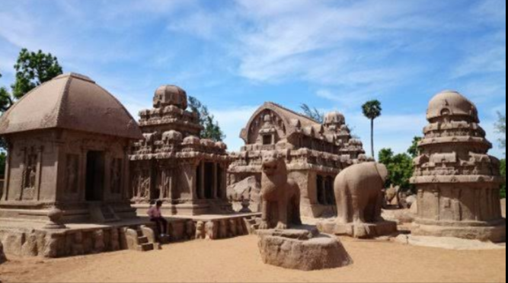
Symbolism and Interpretation
- Dharma, Bhakti, and Kingship: Ascetic devotion wins divine favor; rulers mirror cosmic order through righteous governance, temple patronage, and ritual sponsorship. Imagery binds personal piety with public kingship.
- Sacred Elements in Unity: Earth (Varaha and Bhu Devi), Water (Ganga’s descent, oceanside setting), and Divinity (Shiva-Vishnu-Durga triad) are composed into a single sacred ecology. The landscape itself—rock mass, sea breeze, monsoon wash—is absorbed into ritual meaning.
- Site as Sacred Geography: The coastline, granite outcrops, and natural clefts are not neutral backdrops; they are scripted as Vedic-puranic terrains where myth perpetually reenacts itself.
Artistic and Cultural Significance
Artistic
Mahabalipuram provides the seedbed of South Indian temple form: tiered vimanas, porch-pillared mandapas, narrative relief cycles, guardian figures, and integrated iconographic programs. Its narrative sculpture achieves a rare synthesis—grand scale, clarity of storytelling, psychological immediacy, and compositional daring in unforgiving granite.
Cultural
The ensemble proclaims Pallava power, piety, and cosmopolitanism. As a thriving port, Mahabalipuram radiated artistic influence across the Bay of Bengal, while absorbing and localizing broader Indic currents. The sculptural language—heroism, fertility, devotion—resonates with Tamil poetic and ethical ideals.
Religious
For largely non-literate publics, these works operated as visual scripture. They gave tangible form to complex theology—avatars, shakti, linga worship—and framed devotion as both personal ascent (tapas) and communal welfare (rain, harvest, order).
Global
Long before “land art,” Mahabalipuram fuses environment and art: the sea-salt air, granite outcrops, and monsoon-washed reliefs become co-authors of meaning. This site stands as an early and influential model of environmental integration in sacred art.
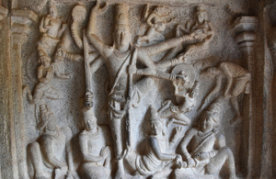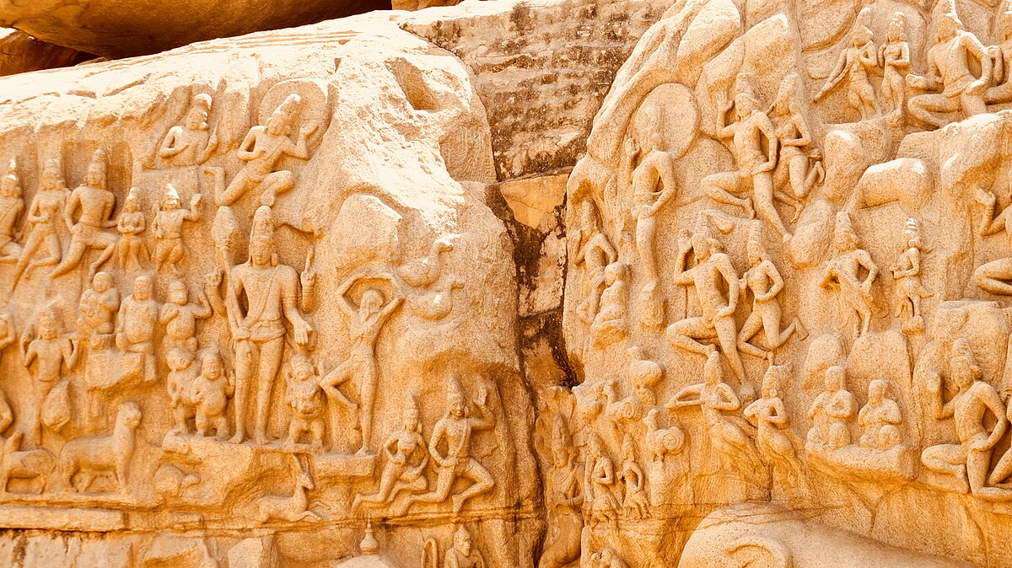

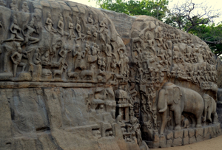
Comparative Context
- Ajanta and Ellora: Like Ajanta’s murals and Ellora’s rock-cut reliefs, Mahabalipuram uses narrative to teach and inspire. Unlike Ajanta’s painted interiors or Ellora’s deep excavations, Mahabalipuram dramatizes myth in open-air reliefs and monoliths, intensifying dialogue with landscape and light.
- Influence on Chola and Pandya: Later Cholas monumentalized the Pallava grammar—raising soaring vimanas (e.g., Thanjavur), elaborating Somaskanda programs, and enhancing bronze sculpture undergirded by Pallava narrative ethos. Pandya and later Vijayanagara traditions continued this iconographic and architectural lineage.
- Continuity of Iconography: The Varaha, Mahishasuramardini, Gajalakshmi, and Somaskanda schemes recur across South India, refined in scale, ornament, and ritual setting, yet retaining their Pallava-era clarity and moral resonance.
Conclusion
Mahabalipuram’s rock-cut corpus marks the apex of Pallava creativity and the hinge between excavated sanctuaries and structural stone temples. Its integrated program—mythic narratives of salvation and justice, royal iconographies of legitimacy, and experimental temple prototypes—establishes the foundations of Dravidian temple architecture and South Indian sacred aesthetics. The site’s enduring power lies in its union of ascetic devotion, regal ambition, and environmental poetics: granite shaped into theology, coastline into cosmology, sculpture into living scripture. For art history, Mahabalipuram is not only a chapter of early medieval experimentation; it is the prologue to a millennium of South Indian temple art.

