Indian Art Form
Assignment - 7

Hayden Varughese Cheriyan
RA2311030010238

The Shore Temple – Main Highlight of Visit
Photo Captured
- Monument Name: Shore Temple
- Location: Mahabalipuram, Tamil Nadu, India

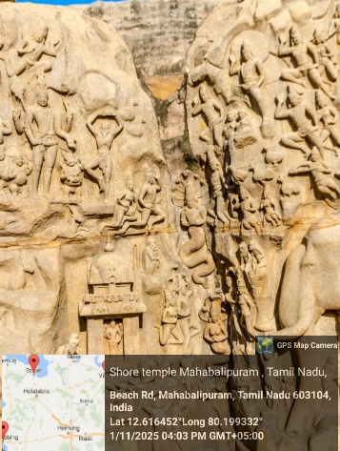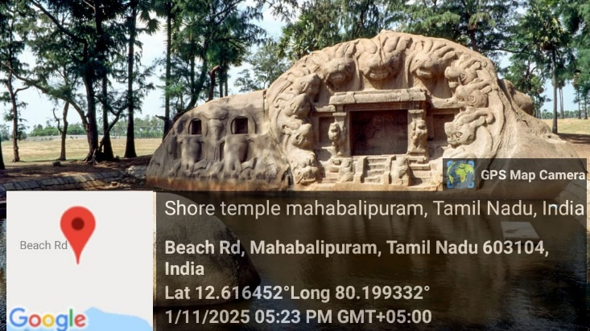
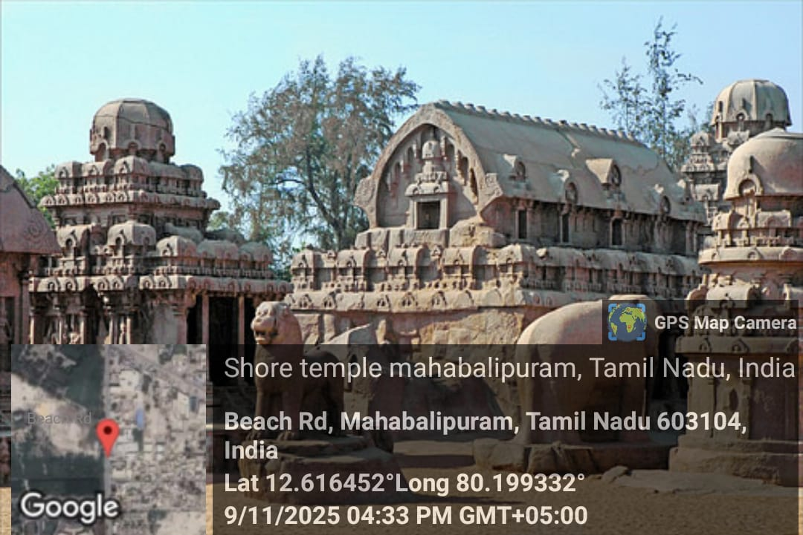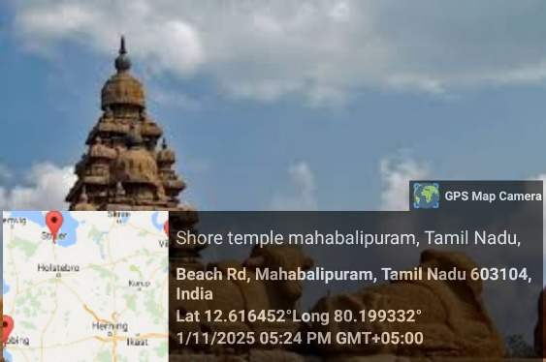
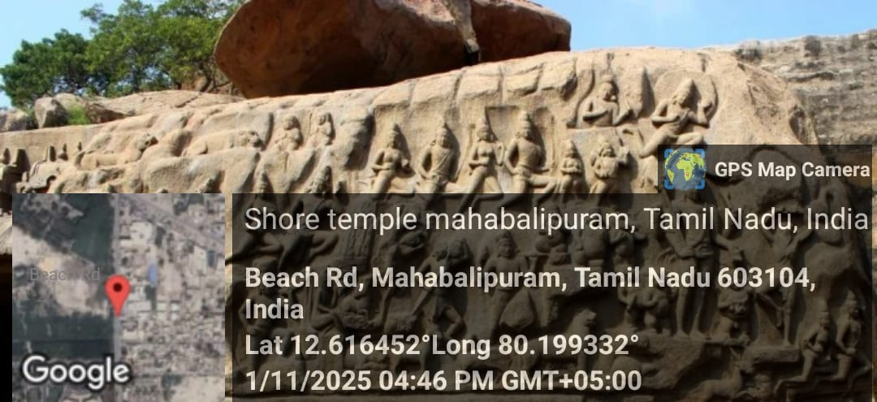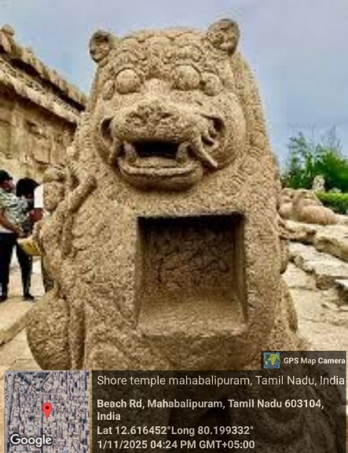

Historical Background
The Shore Temple is one of the oldest and most iconic structural stone temples in South India. Built during the reign of the Pallava king Narasimhavarman II (Rajasimha) in the early 8th century, the temple stands majestically on the Coromandel Coast overlooking the Bay of Bengal.
It was named the Shore Temple due to its proximity to the sea and served not just as a place of worship but also as a landmark for ancient maritime traders.

Architectural Features
- Temple Type: Structural (built using blocks of granite, unlike monolithic rock-cut shrines seen elsewhere in Mahabalipuram)
- Architecture Style: Dravidian
- Layout: Consists of three ornate sanctuaries — the two larger ones are dedicated to Lord Shiva, and the smaller one is dedicated to Lord Vishnu
- Material Used: Locally sourced granite
- Highlights:
  - Two-tiered pyramidal towers with intricate carvings
  - Bas-reliefs depicting mythological scenes
  - Nandi (bull) sculptures surrounding the temple courtyard
  - View of sunrise behind the temple gives it an ethereal backdrop

Artistic and Cultural Significance
- One of the few surviving temples built under the Pallava dynasty, who were pioneers in rock-cut architecture.
- Represents an important transition from rock-cut to structural temple architecture in India.
- Simultaneously exhibits religious symbolism and technical stone masonry excellence.
- Designated as a UNESCO World Heritage Site in 1984 due to its historical and artistic importance.

Reflections from the Visit
Standing in front of the Shore Temple was a deeply immersive experience. Its ancient carvings and ocean-backed scenery gave a glimpse into India’s rich cultural and spiritual heritage. The temple’s ability to withstand centuries of weathering from salty sea air is a testament to the mastery of Pallava architects.
From this visit, I learned about:
- The evolution of temple architecture in India
- How mythology, history, and art are beautifully intertwined
- The importance of preserving such historic monuments

