ASSIGNMENT 8 - Indian Art Form

Hayden Varughese Cheriyan
RA2311030010238

Introduction
Festivals in India hold deep cultural and spiritual significance, and art has always been an essential part of celebration. Community-based festival art projects, such as Rangoli and floor paintings, promote unity, creativity, and shared identity. For this project, I collaborated with local community members to create a vibrant Rangoli installation for a regional festival.
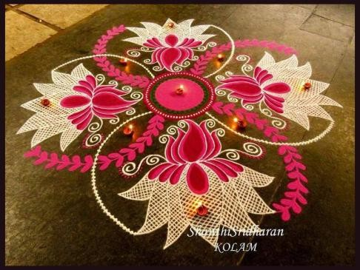
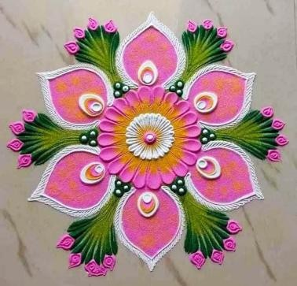

Project Process
- Planning: The team decided on a floral geometric design representing harmony and prosperity.
- Collaboration: Each member contributed ideas, colour combinations, and designs inspired by traditional patterns.
- Execution: Using coloured powders and natural dyes, we created a 10-foot floor Rangoli in the center of the community space.
- Documentation: The process was recorded using photographs and short video clips to capture teamwork and artistic flow.

Community Involvement
The participation of elders and children brought emotional warmth to the project. Elders guided us with traditional techniques, while children added enthusiasm and creativity. This intergenerational exchange made the artwork more meaningful and inclusive.

Final Artwork Description
The final Rangoli displayed a blend of modern symmetry and traditional motifs using vibrant hues of red, yellow, blue, and green. At the center was a lotus symbolizing purity and growth. The artwork became a focal point of the festival, admired by many visitors.

Conclusion
The Community Festival Art Project not only enhanced artistic understanding but also strengthened social bonds. Through this collaboration, I realized how collective creativity can transform simple art into a shared celebration of culture and emotion.

References
- Wikipedia: Rangoli Art of India
- Cultural India: Festival Art and Community Traditions
- India Today: The Revival of Community Arts During Festivals

