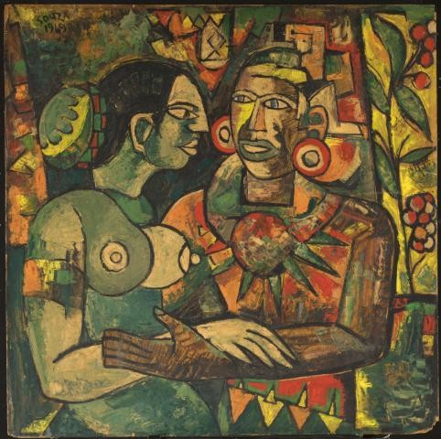
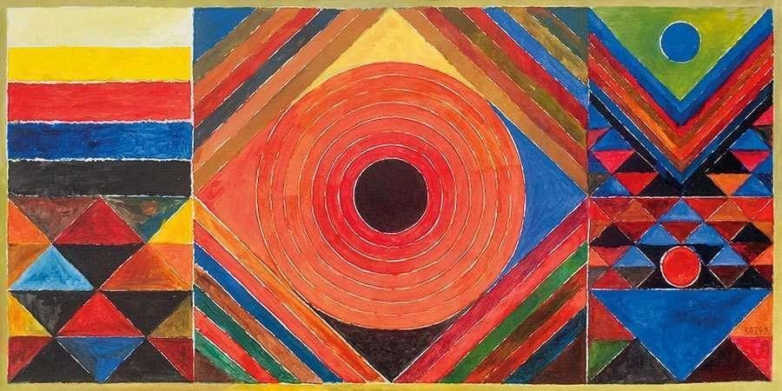
Experiment - 9 Artistic Recreation – CO5

Hayden Varughese Cheriyan
RA2311003010294

Assignment Title: Recreation of a Famous Artwork by a PAG Artist
- Introduction
The Progressive Artists’ Group (PAG) was formed in 1947 in Bombay (now Mumbai) by artists who sought to break free of colonial‑academic styles and express modern India through bold new visual languages. Key founding members include F. N. Souza,
M. F. Husain, S. H. Raza, K. H. Ara, H. A. Gade and S. K. Bakre. Their works mix Indian themes and motifs with influence from European modernism (cubism, expressionism, etc.).

Selected Original Artwork
I have chosen the artwork ‘Bindu’ by S. H. Raza as my inspiration.

Why this piece:
  - It represents PAG’s fusion of Indian spirituality with modernist abstraction.
  - The geometric composition and vibrant palette appealed to me.
  - The spiritual symbolism of the ‘Bindu’ aligns with my interest in calmness and
focus.

My Recreation – Medium & Process
Medium used: Digital Art Process summary:
  - Studied the symmetry and balance of Raza’s original composition.
  - Recreated geometric forms digitally, experimenting with gradients and textures.
  - Modified the palette to cooler tones to reflect my personal interpretation of peace.
  - Final touches focused on subtle glow effects to enhance meditative depth.

Comparison Essay
Technique & Style:
Raza’s ‘Bindu’ emphasizes geometric abstraction and strong colour symbolism. My
recreation retains the circular motif but simplifies linework for minimalism.

Emotional & Conceptual Aspects:
Raza’s original expresses spiritual energy; mine channels a calmer, digital-era tranquility. Both explore focus and inner balance.

Reflections & Learning:
- Gained insight into symbolic abstraction.
- Learned how small shifts in hue affect emotional tone.
- Appreciated PAG’s ability to merge modern forms with Indian philosophy.

Conclusion
Recreating Raza’s ‘Bindu’ deepened my understanding of abstraction and emotional minimalism. It showed how art can blend modern technique with deep philosophical meaning, and how reinterpretation can reflect personal identity while respecting legacy.

References
  - Wikipedia: Progressive Artists’ Group (PAG)
  - Artisera Blog: The Progressive Artists’ Group and Its Impact on Indian Modern Art
  - Asia Society: The Progressive Revolution – Modern Art for a New India

