**Great Job! 100/100**

**Terms to review:**

identifier

variable

constant

data type

value data type

reference data type

class

object/instance

constructor

field (aka. member variable or instance variable)

method

encapsulation

composition

aggregation

**polymorphism**

**inheritance**

**base class**

**subclass**

**overloaded method**

**overridden method**

**virtual method**

**abstract method**

**abstract class**

**interface**

**strategy pattern**

**IComparable**

**Homework & Labs**

*// Please name your projects LB1, LB2, LB3, etc*

~~LBI. Complete Naming Conventions Handout~~

~~LBII. Complete Data Types Handout~~

**LB1 Letters**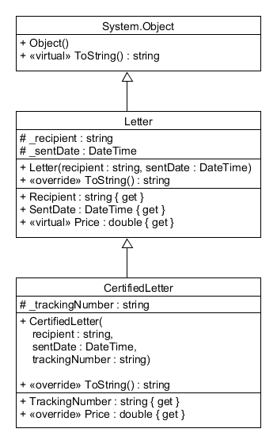

Create a C# Winforms GUI application for a letter delivery service.

* Letters cost 50 cents to send.
* Certified letter cost an **additional** 15 cents to send, but include a tracking number.
* The user can send up to 20 letters.
* Every time a letter is sent it will be added to the **top** of the transaction log.
* Store the list of sent letters in a single array or List.
* **If the letter does not include a tracking number then instantiate a Letter object.**
* **If the letter includes a tracking number then instantiate a CertifiedLetter object.**

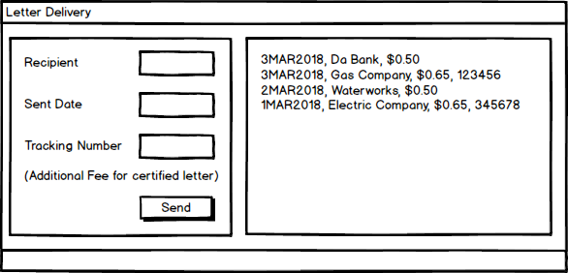

**LB2 Photos**

Write a GUI application for a photography business.

* 8" by 10" photos are $3.99
* 10" by 12" photos are $5.99
* All other sizes are $9.99
* Customers can add either a Matte or a Frame.
* Matted photos are an additional $10.
* Framed photos are an additional $25.
* Override the ToString() methods on the Photo, MattedPhoto, and FramedPhoto classes so that they display all of the information in the fields.

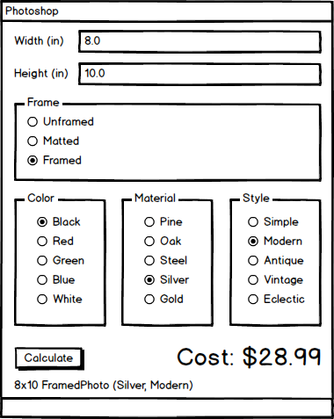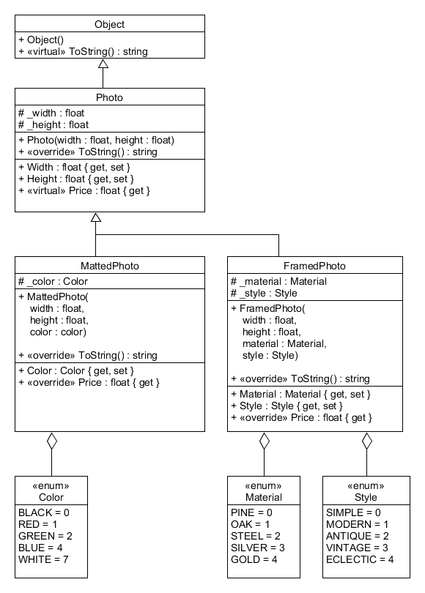

**LB3 BoosterPack**

[**How to work with Images in Windows Forms**](https://youtu.be/MS-aAjR_7JM)

Write a GUI application to randomly generate a pack of pokemon cards.

* Each pack has 10 cards
* There is a 20% chance of getting a shiny pokemon
* Shiny pokemon cards must be displayed with different font styles, foreground colors, and background colors (from the regular version)
* Sort the cards in the booster pack by value (using IComparable).

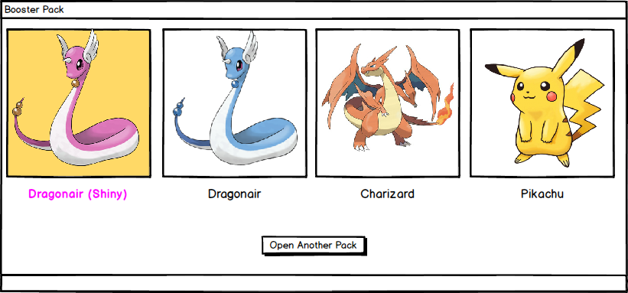

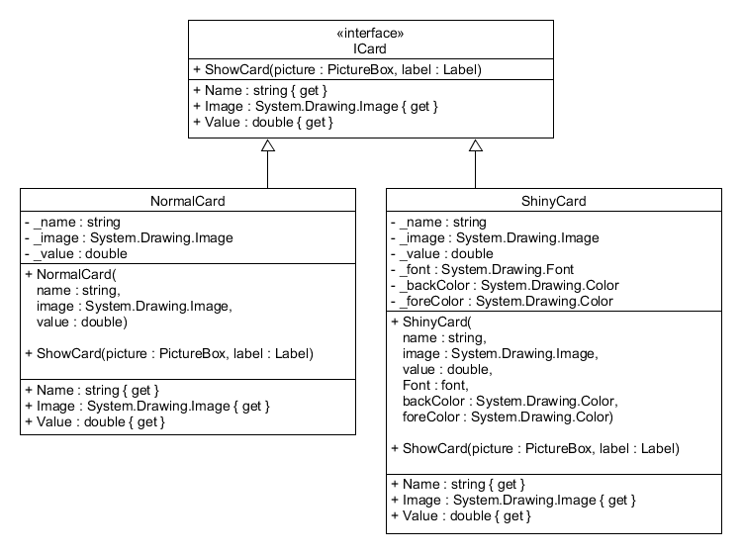

**LB4 BankLoginEnhanced**

Write a GUI application for a bank.

* Users must enter their username and pin number to login.
* The program should have at least 5 accounts.
* There can only be one user logged in at a time.
* Once logged in, the user can deposit money, withdraw money, or print their last 10 transactions.
* When the user is done, they can log out of the system.
* Deposits do not have an associated transaction fee.
* Withdrawals have a 1% transaction fee.
* Users cannot make a withdrawal that would leave them with less than their minimum balance.
* There are three different account types, each has different perks.
* **Bronze** accounts have a minimum balance of $0 and can only make view their current balance,deposit money and withdraw money.
* **Silver** accounts have a minimum balance of $1000 and can also print out their past 10 transactions (show them in a separate window).
* **Gold** accounts have a minimum balance of $5000, can print a **fancy statement** (show them in a separate window)**,** and do not pay any transaction fees.

