PERTH TRAVEL WEBSITe

Daily Journal – Year 12 – Applied Information Technology

Hayden Woods

22 MARCH 2018  Ms. Vettler

# 22nd March 2018

Created all

# 22nd of March 2018

Created all files and folders for the start of the project and completed the

* Statement of Intent
* Target Audience
* Target Audience Issues and Requirements

Although I will need to go back through this later and see if it has all been done correctly according to the finished product and when I have a better understanding of the project.

23rd of March 2018

Started on the webpage design ideas and began to think about some design criteria that will be necessary for the development of my project.   
  
28th of March 2018

Continued creating the sketches once I had finished the Design Criteria. My sketches are almost complete and should be finished during the next lesson.

# 29th of March 2018

Finished the sketches in class and are now moving onto the creation of my Gantt Chart and Flow Chart. I decided to do these after school on this day. To create my Gantt Chart I used a template in Excel which greatly increased the quality and accuracy of the work that I could produce, it also took far less time to complete as compared to drawing it out or using a online diagram tool and making it from scratch.

### First Half of Flow Chart

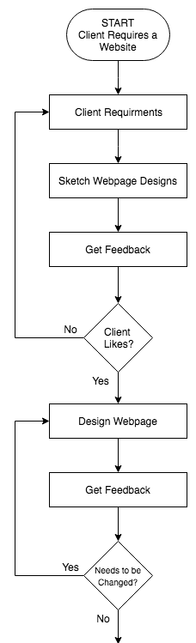To create the flow chat I used Draw.io and I used the marking key/general layout of the assignment to pickup on the stages of the flow chart. Firstly, I did the designing/sketching section for it and I knew that this would require client feedback on both the needs and the final design. Then I did the final design section that would also require the clients sign off on it. Finally, the creation of the website which would also require the client to be happy with the final product given, if so the project would be completed.

# 4th of April to 9th of 2018

### Design/Sketching

I firstly created a rough idea of what I wanted to do on paper through the sketches and storyboarding and on Photoshop and Illustrator.

### Dependencies, Structure and Design

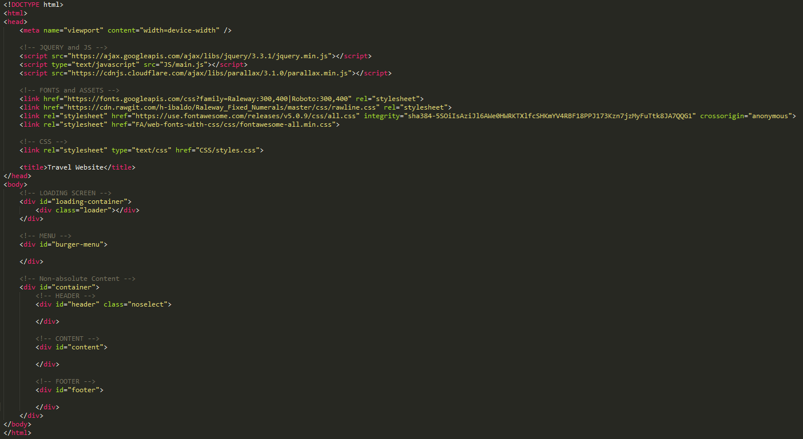Set out all the base HTML and CSS and gather all the dependencies needed. For example, started my website in the format of a singular container around three main sections, header, content, footer. I also found CSS Reset 2.0 online which resets all the base CSS properties that web browsers put onto web pages.

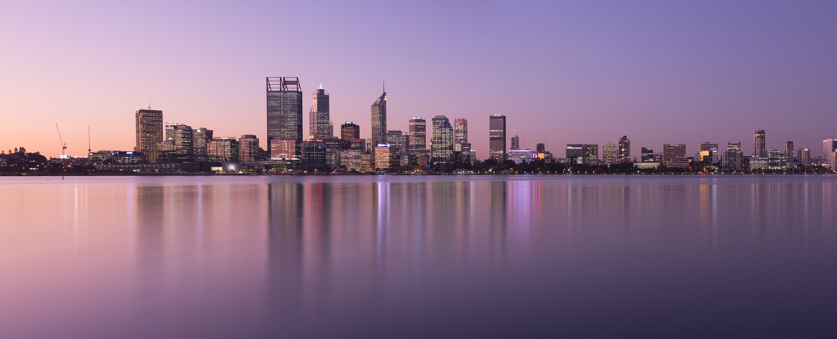I also set out the colour scheme that I would be using in the website. I normally do this by creating the logo first and basing the colour scheme around one colour that works for that. But in this case, I selected a photograph of Perth I liked first and based my websites colour scheme around that.

### Header Creation

The first piece I created was the header. This took multiple iterations of the design and eventually settled on a design that had no background and no borders. The two elements the header had in it are the logo and the burger menu button. These elements are slightly opaque (60%). This makes the header not too obstructive and makes it blend in nicely with the background behind. Some of the other ideas I had for the header where a plain white header with a 4px line across the top with a gradient on it spanning across the entire page. This would go from a darker orange to a lighter orange and would fit in well with the colouring of the full colour logo.

### Concept 1



### Concept 2

### ../../../../Desktop/Screen%20Shot%202018-04-07%20at%208.39.11%20Concept 3 – Early Top Section and Header

### Parallax Content

The next piece I would create would be the top section that covers the entire top of the page, full height and width. In this section I experimented with a static image, gradient, text and a full-size photograph of Perth. In the end, I decided to go with a parallax effect on the top so that when you move your mouse around it would affect the movement of the background. This was accomplished by using a library called parallax.js. I also had to use Photoshop to split the image into multiple sections. Firstly, the City which took about 20 minutes to cut out by hand using the polygon selection tool, then I removed that, pasted it back in on a separate layer and extended the sky that was behind it as to not look transparent when the city moves away at a different speed to the sky. To create the parallax, effect on the web page I used a JavaScript library called parallax.js. This allows you to create a “scene” for the parallax elements and assign values to each of the elements to allow them to move at different speeds.

### Perth Logo Design

In the next step, I had to create the logo that would go on the very front of the parallax section. I did this by selecting a font that I thought would fit into the theme of Perth and the overall design of the website. I chose the colour of the text based of the dark colours in the background image and gave it a white border on the right and bottom sides to make it more visible on top of the image.

### Content

The next section that I built for the webpage was the content and body structure. I had decided that I needed a place to give the customer detailed information about Perth, benefits of the package, pictures and the amount it will cost.

### Burger Menu

After this I would create the burger menu. This would be created using a JavaScript library called jQuery which adds a lot of helpful functions to JavaScript to make the process easier. In the creation of this I had to decide whether I wanted the navigation to push the rest of the content across or if I wanted It to be layered over the top of the page. In the end I decided to create a menu that would go over the top. This is because I didn’t want the user to feel disrupted when reading content and trying to navigate, due to the text changing positions on the screen. I also feel that one moving element is enough, and you don’t need to move the whole page across as well.

# 11th of April 2018

On the last day I had for the assignment I put the final touches on bits and pieces of the website and the overall documentation. I also completed the daily journal and did the analysis of my project (Part Four).