Web Authoring Assignment 1

Introduction

The specification of the website was to create a functional supermarket style webpage for a pseudo company. This website has been based on the niche market of pre-owned and discontinued Lego sets. The webpage includes an Index file which the landing page when first loaded, then an about, cart, store and videos pages which make up the rest of the content.

The author has used comments inside the script, style and html files which when reading though makes it easier to follow what the author is creating and trying to do especially if there is a fault.

Strengths and Weaknesses of the Web Standards Used

Cascading Style Sheet or commonly known as CSS contains the different styles, layouts, fonts and colours of the design in the webpage. The webpage uses a separate file which contains the code for the design. (W3schools, 2016)

The website uses CSS3 which offers great effects like box shadows, gradients and rounded corners which have been implanted in the site. The webpage has used the CSS3 gradient style on hover of the li in the main navigation bar to create a sliding up and down animation feature. The home page includes images which have had box shadows and rounded corners applied using CSS3 which has the advantage of using a single line of code to create this effect. When using these styling effects different versions of the effect need to be declared like: “webkit-transition” and “moz-transition” which need to be applied to each effect to ensure to keep the cross platform capability. Before the availability of CSS3 this effect would have been harder to create there would have been the need to use either a pre made image or the use of JavaScript. (Anon, 2011)

The downfall of using CSS3 is the browser support as it’s mostly only modern versions of browsers that support it. CSS3 is also still under development and there are different modules being developed separately.

Another web standard which has been used is HTML5 which brings semantic markup, and multimedia elements like <canvas> and <video>. This allows richer media elements. In the webpage there is an embedded video and the use of geolocation, on the Video and Store pages respectively.

The webpage has a shopping cart like feature which utilises HTML5 Local Storage. This allows for storage of data within the user’s current browser. The previous method of storing data locally was the use of a browser’s Cookies which when you compare to HTML5 it is not as secure and HTML5 can store large amounts of data without affecting the webpage’s performance. The storage is far larger at least 5MB, the information is also not transferred to the server. (Sharma, 2016)

The main problem with HTML5 is that only modern browsers support it. Another problem includes that the language itself is considered a work in progress which means that any of the elements could change at any time. (W3schools, 2016)

To test the use of the web standards used on the webpage it has been opened and operated across three different common browsers they were Mozilla Firefox, Chrome and Safari as well Safari mobile. Full functionality and compatibility was shown on all browsers when testing was carried out and no faults were found. Internet Explorer showed functionality but did not show the original design layout.

In the webpage, clear separation of structure, style and functionality was used. There are different folders used for the structure, style and functionality the HTML is the structure, the CSS is the style, and the JS is the functionality.

Flex box or Flexible Box Layout Module has been implemented in the site within the new and featured products area. Flex box is a new feature included in CSS3 that allows better control when dealing with layout elements on a page. This capability removes the need to use “float” and “margin” fiddles to align your content which when testing across different screen resolutions can cause many anomalies. Using Flex box makes it simple to arrange your content with vertical, top and bottom alignment. Again the main disadvantage of flex box is support like IE9 but it is possible without too much difficulty to make a site useable when flex box isn’t supported. (McFee, 2016)

The Challenges

In the development process of the webpage there were challenging concepts to overcome an example of this was the implementation of the shopping cart using the local host storage method. The author first heard of this method during lectures and then built on the knowledge gained with a lot of research on the internet. A user of the page can add items to their shopping cart and then remove them as well, as this is happening an updated amount total is calculated and displayed. Improvements to this could include a picture of each item next to its description and a remove all from basket button option.

Another challenge the author was faced with was the overall design of the webpage and took time to settle on a suitable colour and layout to standardise across the different web pages. The first part of the design to be finalised was the navigation bar with the rest falling in from there. As the navigation is possible the most important part of a website it should make it quick and easy to travel throughout the website.

The W 3 Validation Screen Shot

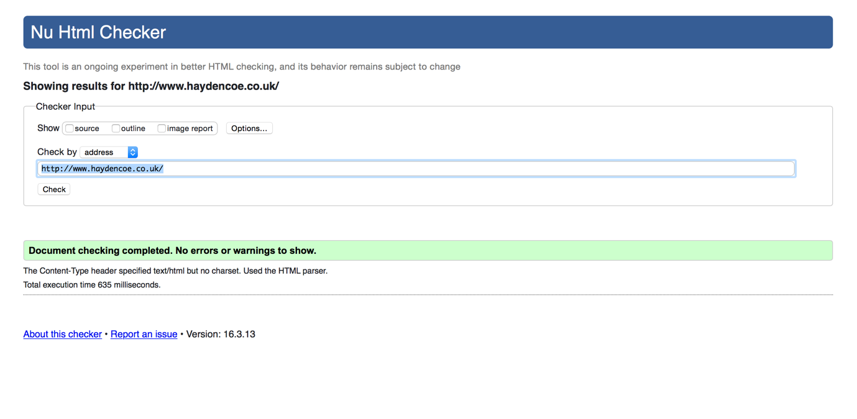

# References

Anon, 2011. *pros and cons of CSS3*. [Online] Available at: <http://a-developer-life.blogspot.co.uk/2011/07/pros-and-cons-of-css3.html> [Accessed 17 March 2016].

McFee, A., 2016. *flexbox so hot right now*. [Online] Available at: <https://medium.com/@andymcfee/flexbox-so-hot-right-now-flexbox-64260da9541#.82xa24a7a> [Accessed 17 March 2016].

Sharma, S., 2016. *html 5 its advantages and disadvantages*. [Online] Available at: <https://voyagegroupin.wordpress.com/2014/02/10/html-5-its-advantages-and-disadvantages/> [Accessed 16 April 2016].

W3schools, 2016. *css intro*. [Online] Available at: <http://www.w3schools.com/css/css_intro.asp> [Accessed 17 March 2016].

W3schools, 2016. *html5 webstorage*. [Online] Available at: <http://www.w3schools.com/html/html5_webstorage.asp> [Accessed 16 March 2016].

Video

The functional video is available to view at <https://youtu.be/sSnKdAawSsg>

Website

The URL of the completed website is <http://www.haydencoe.co.uk/>