* Photos
  + Play to your strengths
  + Dogs
  + Kids
  + Professional
    - Have a suit picture
  + Travel
  + Friends – 1 group pic MAX
  + No hats
  + Run pics through here: <https://www.photofeeler.com/?utm_source=blog&utm_medium=std&utm_campaign=how-many-likes-do-you-get-on-tinder&v=d3>
* General
  + Create a profile that is polarizing, and clearly labels you as belonging to a certain “tribe”
  + Don’t include height
* Profile
  + Add insta
  + Add other info
  + Don’t add spotify – it’s a disqualifier
  + Bio
    - I promise not to use emojis
    - just want my grandma to stop bullying me about not having a gf tbh
* Messages
  + Name in caps
  + Your profile intrigues me…
  + Where is the second picture taken??
  + If you had to choose a favourite berry, which berry would you choose?
  + Weak chat, gif, or cutting the bs and being asked out?
  + You're actually kinda cute, I'd hold your hand in public
  + Oh shit you’re nearly as cute as I am
* Stats
  + <https://towardsdatascience.com/i-analyzed-hundreds-of-users-tinder-data-including-messages-so-you-dont-have-to-14c6dc4a5fdd>
    - How to get tinder data
    - Loads of possibilities!
  + You can request your own data 🡪 try this!
  + Men in general were more likely than women to “swipe right” or the equivalent expression of interest: women received between 540% and 780% more indicators of interest than men
  + 62% male users and 38% female users
  + 80% men 20% women
  + 89% of Tinder users in the UK are male
  + The match rate for women is at 10%, while for men it’s a measly 0.6%
  + 95% of Tinder users meet their matches within a week
  + Mondays, 6-9 pm is the time you can get most matches on Tinder
  + 46% of the time men swipe right, meanwhile women swipe right 14% of the time
    - Nowadays those numbers have diverged massively. Men swipe right on almost everything, and women [swipe on 2%-3% of profiles per day](https://highvaluedaygame.com/2019/10/21/how-often-do-women-swipe-right-on-tinder/).
  + 61% of Tinder conversations are 3 messages or less
  + 39% of conversations contain just one, unreciprocated message.
  + **1.4% of Tinder conversations contain any sort of phone number exchanges**
  + 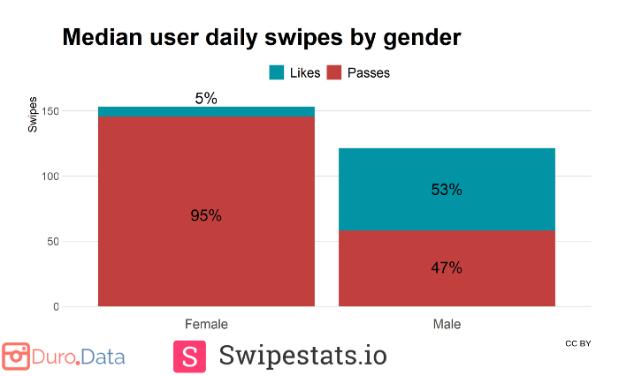
  + 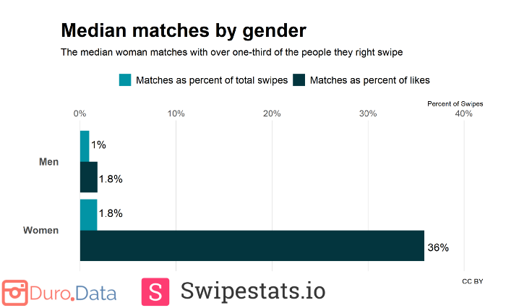
  + 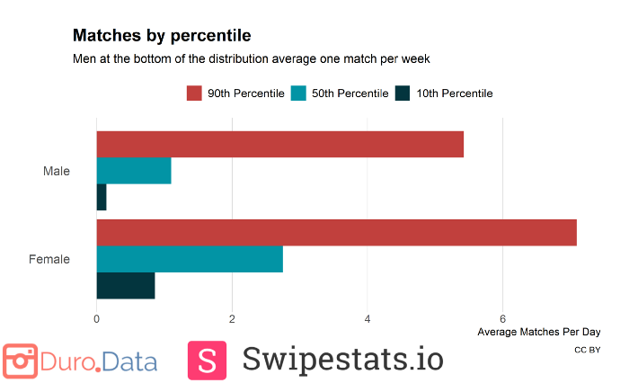
  + Timeline

    Description automatically generated
  + 