Hall B Drift Chamber Operating Procedures

Mac Mestayer

Morgan Cook IV

October 20, 2021

Table of Contents

1. Introduction 3

2. High Voltage System 3

• Introduction and Description of System 3

• HV Control Screen 4

• Turning All Channels On/Off 4

• HV Trips 5

Detecting and Responding to Tripped Channels 5

Responding to Beam Related Trips 5

Resetting an Individual Channel 5

If the Channel Can Not be Reset 5

• High Voltage Expert Operations 5

Going to Expert Mode 5

Changing Operating Voltage 5

Changing Operating Voltage Set Point for Many Channels 6

Table of HV Settings 6

Nominal HV Values 7

Diagnosing the Cause of a HV Trip 7

Recovering a Tripping Channel 7

Disabling a HV Channel Which Continuously Trips 8

Detecting Broken Wires (searching for shorts) 8

Doing a “Minimal Disconnect” 8

Monitoring Long-Term Operation 8

3. Low Voltage System 8

• Introduction and Description of System 8

• Turning On/Off 9

Turning All Channels On/Off 9

Disabling LV to One Group of 32 Wires (two groups of 16 SIPs) 10

• LV Monitoring Status 10

Detecting and Resetting an Individual Supply 10

Detecting a Possible Blown Fuse 10

• Low Voltage Expert Operations 10

Changing Current Trip Thresholds 10

Trouble-shooting a Blown Fuse 10

4. Drift Chamber Gas System 11

• Monitoring DC Gas System Status 11

5. Drift Chamber Readout Boards 12

• Introduction and Description of System 12

• Monitoring Status of Crates and Boards 12

• DCRB Expert Operations 12

Changing Discriminator Thresholds 12

Changing Output Pulse Length 12

Disabling a Channel from Readout 12

6. Monitoring Drift Chamber Performance 13

• Online Monitoring Plots 13

Wire Hit Level 13

Time Hit Level 13

Cluster, Segment, Cross Level 13

Track Level 13

Particle Level 13

7. Calling the Expert 14

8. Expert: Remote Monitoring & Control 14

• Remote Access to Logbook 14

• Remote Login for EPICS Control & Monitoring 14

• Remote Monitoring of the DCRB Scaler Output View of DC Occupancy 14

• Log of calls/pages to on-call expert 15

9. Frequently Asked Questions * 15

10. Glossary: 16

# Introduction

This document describes the procedures to be followed in order to operate the CLAS12 drift chambers. There are four systems involved in DC operation:

* **DC gas**
* low voltage **(LV)**
* high voltage **(HV)**
* drift chamber readout board **(DCRB )**

The CLAS12 drift chamber system is comprised of 18 separate chambers. There are **three types of chambers**: “region 1”, “region 2” and “region 3” depending on location upstream, within or downstream of the CLAS torus magnet. Each chamber has wires arranged in two superlayers of 6 layers by 112wires.

The **gas system** supplies mixed, clean, flow and pressure-controlled Argon/CO2 gas (in a ratio of 90:10) to each of the 18 drift chambers.

The on-chamber amplifier and readout boards are called “signal translator boards” (STB). There are 7 such boards per superlayer. They distribute **low voltage** (LV) power to pre-amplifiers located on the board, one for each sense wire. The pre-amps are placed in groups of 16, with six such groups per board. There is an **individual fuse** for every two groups of sixteen wires (32 total).

There are six **signal connector cables** for each on chamber board, with each cable carrying 16 signals. These signal cables connect each STB group of 16 pre-amps with one connector on the **drift chamber readout board** (DCRB).

**High voltage** is supplied to the wires by on-chamber high-voltage translator boards (HVTB), located on the other endplate from the STB. The high voltage is supplied to the HVTB’s by HV cables connecting the HV crates (HVCRATE) to the high voltage distribution boards (HVDB) and from there by cables to the HVTB’s.

# High Voltage System

## Introduction and Description of System

The chambers' high voltage is supplied by a CAEN System 527 setup with four crates, a maximum of ten boards each, 24 channels per board. The region 2 and 3 crates are fully-loaded, while the two region 1 crates are half-loaded with only 5 boards installed. These crates and the associated distribution panels are located on the floor of Hall B, underneath or near the subway.

## HV Control Screen

The drift chamber HV control screen has a representation of all of the controllable HV channels as small rectangles within a larger rectangular shape. The six largest shapes represent the six sectors with the individual channels for Regions 1, 2 and 3 for that sector contained as rectangular areas within the larger rectangles. In the example figure, channels which are on at full voltage are displayed in green, while channels which have *‘tripped’* due to an over-current condition are shown in red.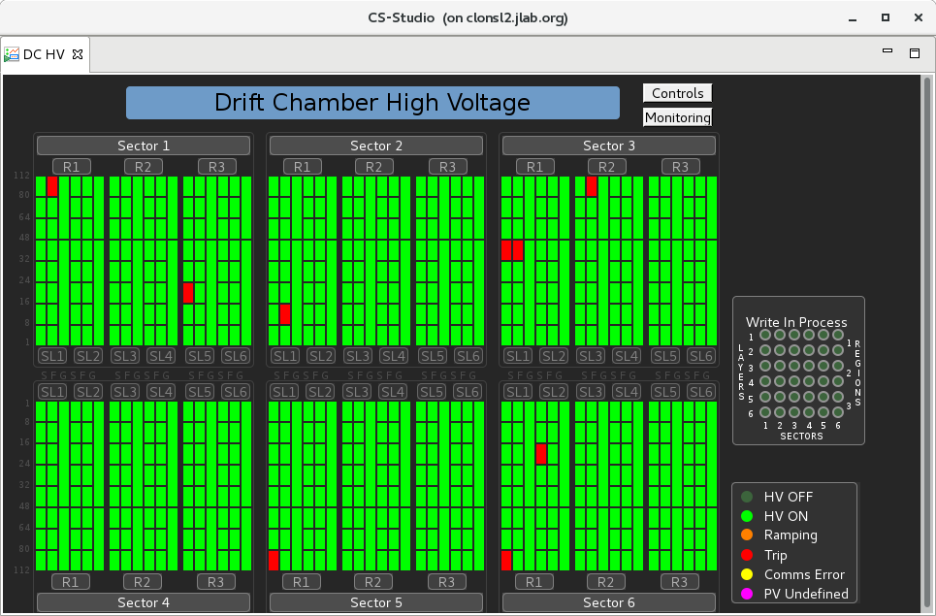

## Turning All Channels On/Off

If one or more channels trip, the normal response is to click ***CONTROLS***, then ***TURN ALL ON***. All tripped channels should come back to normal voltage and the whole screen turn bright green. Similarly, you may turn off all channels by clicking ***CONTROLS***, then ***TURN ALL OFF.***

## Restoring HV Settings

Occasionally, but rarely, the control system can lose its settings. For example, some of the set voltages may have a value of zero. To restore the nominal settings,click ***CONTROLS*** and then ***RESTORE SETTINGS*** and choose the file ***DC_HV_PRODUCTION_SETTINGS.snp***.

## Operations on Individual Channels or Sub-Groups of Channels

Click on the grouping you wish, for example, “Sector 2”, then click ***TURN ON*** or ***TURN OFF***. This also works for smaller sub-groupings down to the individual channel level. You can also turn **ALL** chambers on or off by clicking on “controls” in the upper right-hand corner. In the example above you can see 8 regions which are red, indicating a HV trip, usually due to an overcurrent alarm. In this case, you would use the white ‘controls’ box and select ‘Turn ALL On’.

## HV Trips

### Detecting and Responding **to Tripped Channels**

If one or more HV channels trip (typically by the current going higher than a software limit), the status message says TRIP and is bright red. There will also be an audible and visual alarm. Respond by selecting the smallest sub-group (e.g. ‘Sector 6, R1’) if only a few were tripped. If many channels tripped, respond by using the white ‘Controls’ selection in the upper right to ‘Turn ALL On’.

### Responding to Beam Related Trips

* These are usually caused by excessive beam-induced radiation on the chambers. If it was an intermittent beam problem, simply select ***TURN ON*** to restore operation.
* If the channel cannot be brought back, first determine if it is beam-related by turning the beam OFF and turning the chambers to ***ON***.
* If the chambers’ HV resets, then ask the MCC operators to re-tune the beam.

### Resetting an Individual Channel

You can click on an individual channel to turn it on or off. Cycle power for that channel with its ***on/off*** button.

### If the Channel Can Not be Reset

* If the channel cannot be brought back on, even if the beam has been off for 5 minutes or more, then **leave the channel tripped off** and note the problem in the logbook. At the end of the run (and before the start of the next) try to **reset the channel** again.

## High Voltage Expert Operations

### Going to Expert Mode

First click on the grouping you wish, whether that is all channels in one sector or a single sector. There will then be an ***EXPERT*** button which puts you into ***EXPERT*** mode.

### Changing Operating Voltage

Enter the appropriate changed value in the whited-out boxin the GUI. Remember that if you change a sense wire voltage, for example, you should also change its corresponding partner’s field wire voltage.

### Changing Operating Voltage Set Point for Many Channels

Using CSS, under DC click on HV . Now click on “Controls” in upper right, then “Restore Settings”, then double-click on “Vscan” then “R1” or “R2” or “R3” then “settings”. Now select the setting you want and then “Open”. The voltage gets higher with setting number.

### Table of HV Settings

|  |  |  |  |  |  |
| --- | --- | --- | --- | --- | --- |
| Region | setting # | Total | Sense | Field | Guard |
| 1 | 1 | 900 | 600 | 300 | 214 |
| 2 | 1200 | 800 | 400 | 286 |
| 3 | 1500 | 1000 | 500 | 357 |
| 4 | 1650 | 1100 | 550 | 393 |
| 5 | 1800 | 1200 | 600 | 429 |
| 6 | 1875 | 1250 | 625 | 446 |
| 7 | 1950 | 1300 | 650 | 464 |
| 8 | 2025 | 1350 | 675 | 482 |
| 9 | 2100 | 1400 | 700 | 500 |
| 10 | 2175 | 1450 | 725 | 518 |
| 11 | 2250 | 1500 | 750 | 536 |
| 12 | 2325 | 1550 | 775 | 554 |
| 13 | 2400 | 1600 | 800 | 571 |
| 14 | 2475 | 1650 | 825 | 589 |
| 2 | 1 | 1050 | 700 | 350 | 250 |
| 2 | 1350 | 900 | 450 | 321 |
| 3 | 1650 | 1100 | 550 | 393 |
| 4 | 1800 | 1200 | 600 | 429 |
| 5 | 1950 | 1300 | 650 | 464 |
| 6 | 2025 | 1350 | 675 | 482 |
| 7 | 2100 | 1400 | 700 | 500 |
| 8 | 2175 | 1450 | 725 | 518 |
| 9 | 2250 | 1500 | 750 | 536 |
| 10 | 2325 | 1550 | 775 | 554 |
| 11 | 2400 | 1600 | 800 | 571 |
| 12 | 2475 | 1650 | 825 | 589 |
| 13 | 2550 | 1700 | 850 | 607 |
| 14 | 2625 | 1750 | 875 | 625 |
| 3 | 1 | 1200 | 800 | 400 | 286 |
| 2 | 1500 | 1000 | 500 | 357 |
| 3 | 1800 | 1200 | 600 | 429 |
| 4 | 1950 | 1300 | 650 | 464 |
| 5 | 2100 | 1400 | 700 | 500 |
| 6 | 2175 | 1450 | 725 | 518 |
| 7 | 2250 | 1500 | 750 | 536 |
| 8 | 2325 | 1550 | 775 | 554 |
| 9 | 2400 | 1600 | 800 | 571 |
| 10 | 2475 | 1650 | 825 | 589 |
| 11 | 2550 | 1700 | 850 | 607 |
| 12 | 2625 | 1750 | 875 | 625 |
| 13 | 2700 | 1800 | 900 | 643 |
| 14 | 2775 | 1850 | 925 | 661 |

### Nominal HV Values

Previously: starting (11/29/2017) we were running at HV setting #11.

Previously: starting (4/15/2018) we were running: reg.1 –setting#8, reg.2 – setting#10, reg.3 –setting#9

Currently (September, 2021): starting (10/8/2018) we are running: reg.1 – setting#9, reg.2 – setting#10, reg.3 – setting#10

### Diagnosing the Cause of a HV Trip

#### Overcurrent Condition

If a channel trips, it will be because the supply detected an under or over-voltage condition or because it detected an ‘over-current condition’ in which the channels monitored current exceeds a software level for a time greater than or equal to the ‘trip’ time (a settable duration).

#### Both Sense and Field Channel Trip 🡪 Problem is Inside Chamber

If both the sense and field channels are drawing approximately the same current and this current exceeds the over-current (OVC) limit, then this is likely a problem inside the chamber. In this case, no current is going to ground but is going from the field to the sense wires. An indicator that this is the case is that the current increases exponentially with voltage: doubling with a voltage increase of about 80 V.

#### Only Sense or Field Trips

The problem could be a breakdown on the High Voltage Distribution Boards which are mounted on the chamber. Because of tight dimensional tolerance, there can be a HV breakdown on the board. An indicator of this condition is that the current draw is approximately linear with voltage.

A second possibility is a bad CAEN HV channel; replacing the board is the fix.

### Recovering a Tripping Channel

If a channel trips BOTH SENSE & FIELD channels, then this is a problem with the chamber and not with the HV board. Sometimes the channel can be recovered by lowering the voltages until the current is ~ 0 and then gradually bringing the voltages back up to full values.

### Disabling a HV Channel Which Continuously Trips

If one (or two) channels continually trip due to over-current conditions you will need to set their respective voltage(s) to zero. In the expert mode, click on the channel and enter zero (or the desired voltage). Note that you may be able to minimize the resulting dead area (see “minimal disconnect”, below).

### Detecting Broken Wires (searching for shorts)

Isolate the problem to a specific area and set the voltages to 10V using the ***EXPERT*** button. Because all HV current supplied to the wires passes through a 2 Meg-ohm filter resistor, a short caused by a broken wire will cause the affected channel to draw about 5 microAmps. Unaffected channels will draw the normal dark current of less than 1 microAmp.

### Doing a “Minimal Disconnect”

A “minimal disconnect” refers to the operation of disconnecting from HV the smallest group of wires containing the problem area. For example, suppose a sense wire breaks and now touches a field wire inside the chamber. This will cause a short-circuit in the HV system resulting in very high currents which will cause one or more individual HV channels to trip off. Because each HV channel supplies more than one group of wires in parallel, if we can disconnect the individual circuit containing the broken wire then we can in principle, turn on the HV channel again and lose from operation only those wires on the disconnected sub-circuit and not all wires supplied by the HV channel.

Describing the procedures for a “minimal disconnect’ is beyond the scope of this document and will be left to technical experts during weekday day shifts.

### Monitoring Long-Term Operation

Select ***DC HV*** and use the ***stripchart*** button which plots currents vs. time for various groups of channels. When operating normally, the chamber current is proportional beam-induced radiation, so all channels should go up and down as the beam current goes up and down or as beam steering changes. Watch out for channels which behave differently than the average. Current should return to near-zero dark current values when the beam is off. Failure to do this reveals a serious problem.

MyaViewer-Archive is an option to view a stripchart of past data. You can look at a time series of the value of any signal kept in EPICS.

# **Low Voltage System**

## Introduction and Description of System

There are 18 low voltage power supplies; one for each drift chamber.

The low voltage power is distributed to the individual Signal Translator Boards (STB) through fused conductors. The individual pre-amplifiers on the STBs are arranged in groups of 16 Single Inline Package (SIP) amplifiers, servicing 16 signal wires from the drift chamber. Each double group of 32 SIPs is powered by two fused conductors from the Fuse Box panel, one positive and one neutral/ground return. Each positive conductor (nominally at 7 – 7.5 V potential from the supply) is regulated to 6 V by on-STB regulator.

The fuses are located on a fuse-panel in two grids, each with 6 rows and 7 columns corresponding to the 6 connectors (2 connectors per fuse, two fuses (one positive, one negative)) on each of the 7 STB boards per superlayer. Each grid location contains 2 fuses; one positive and one negative. If a positive fuse blows, a group of 32 SIPs (and thus 32 sense wires) will be inoperative. If a negative fuse blows, unregulated (7 V) voltage will still be supplied to the 32 SIPs, so the sense wires’ pre-amplifiers (and thus the wire signals) will still be operative. The return current will flow through the STB ground plane and through the other 5 negative fuses assigned to that STB board.

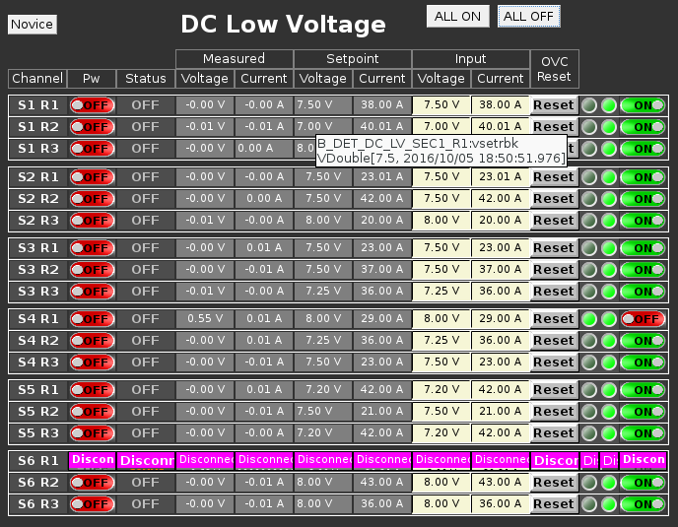

The figure above is the “expert” view of the DC low voltage control panel.

## Turning On/Off

### Turning All Channels On/Off

The only remote control option is to turn one LV supply on or off through the DCLV EPICS screen by clicking on the ***on/off*** button.

### Disabling LV to One Group of 32 Wires (two groups of 16 SIPs)

If for some reason one wants to disable 32 SIPs (and thus 32 sense wires) one can remove the appropriate positive fuse corresponding to that group of SIPs. It is good practice to also remove the corresponding negative fuse.

## LV Monitoring Status

### Detecting and Resetting an Individual Supply

If a DC LV supply trips, the corresponding button on the EPICS screen will be red. Simply click the ***on/off*** button to reset the supply. If it fails to respond notify the shift leader and/or expert.

### Detecting a Possible Blown Fuse

The current drawn by each supply is plotted as an EPICS time-line plot (not shown). A sudden current drop of ~0.3 Amps might indicate that a single positive fuse has blown. Please check the DC Occupancy Plots (see section on Monitoring Drift Chamber performance) for a new dead area (a group of wires six layers high by 5-6 wires wide), paying special attention to the particular chamber (region, sector) as indicated by the name of the LV supply.

## Low Voltage Expert Operations

### Changing Current Trip Thresholds

Go to Expert Mode and change the ***LOLO, LO, HI*** and HIHI levels to be 2 Amps ***(LOLO, HIHI***) or 1 Amps (***LO, HI***) less than or greater than the nominal value.

### Trouble-shooting a Blown Fuse

Turn off the voltage, replace the fuse. If it remains on, good.

# Drift Chamber Gas System

All of the drift chambers use an Argon:CO2 mixture of gas. Currently we are using the gas in a ratio of 90:10 Ar:CO2. We purchase pure Argon and pure CO2 and store them in large pressurized tanks located next to the Hall B gas shed. Within the shed we mix the gas and store it in an intermediate pressure vessel, also located adjacent to the gas shed. From there the gas is pumped into the hall and distributed to the individual chambers via manifolds. Note that we pump the gas into the chambers with positive pressure (relative to atmospheric). Both over-pressure and under-pressure protection is provided via pre-set oil-filled bubblers connected to the exhaust manifolds. Note that CLAS shift takers have responsibility to monitor the gas system performance through EPICS. Any changes to operational parameters (pressures, flow rates, alarm levels, etc.) can only be made by on-call engineering experts using control systems located in the gas shed.

## Monitoring DC Gas System Status

We monitor the DC gas system using an EPICS screen as shown below. Any deviations from Normal conditions should be reported to the shift leader and possibly, the Gas System on-call personnel. Here is a snapshot of the EPICS screen.

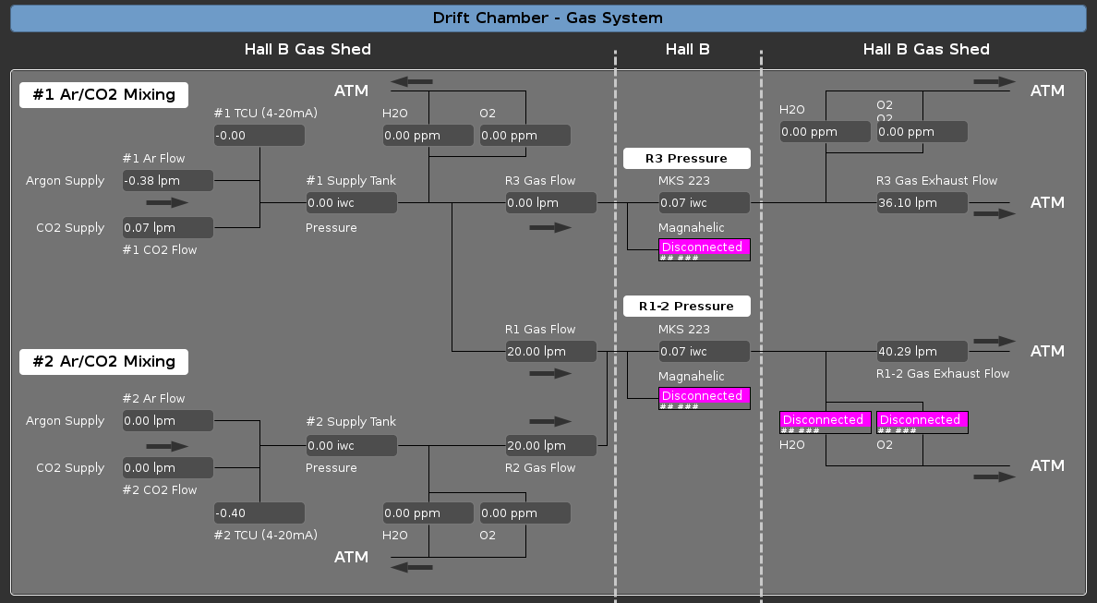

# Drift Chamber Readout Boards

## Introduction and Description of System

Each of the 18 drift chambers is read out by a single Drift Chamber Readout Board (***DCRB***) crate filled by 14 boards; 7 for one superlayer and 7 for the other. Each board handles 96 channels coming in on six 16-conductor cables. Using FPGA technology, the boards amplify, discriminate and digitize the signal; producing a digital time signal output from an analog drift chamber signal input.

## Monitoring Status of Crates and Boards

Look for green or red lights on the ***DCRB Operations GUI***

## DCRB Expert Operations

For now the actions below can only be performed by members of the DAQ team: Sergei Boiarinov and Ben Raydo.

### Changing Discriminator Thresholds

### Changing Output Pulse Length

### Disabling a Channel from Readout

# Monitoring Drift Chamber Performance

It is very important to monitor the drift chamber performance in order to detect any problems at an early stage. Some problems will be automatically detected by our EPICS hardware control and monitoring system and will be announced by an audible and/or visual alarm. Other problems may be more subtle and will only be detected by a change in performance; e.g. a change in the average number of hits on a track or a ‘hole’ developing in the on-line occupancy plot of the DC hits.

In general, we have tried to detect common problems using pattern recognition software, but it is very important for our physicists to remain alert to small changes will may indicate an incipient problem.

## Online Monitoring Plots

### Wire Hit Level

1. 1D histogram of number of wires hit per event
2. accumulated hits/event/sector-layer-wire ("2-D occupancy plot")

(for "all hits", "used in a segment", "used in a cross", "used in a track")

1. hits/event/wire# for each sector-superlayer (36 1-D histograms)

(for "all hits", "used in a segment", "used in a cross", "used in a track")

### Time Hit Level

1. raw time (minus trigger time)

- summed over all wires for each region

- summed over all wires for each signal cable

- summed over all wires for field HV conductor

2) “ ti – tj “ plot, all I,j combinations for some group of neighboring wires; e.g. the 96 wires on one STB 🡪 will show spikes at zero for coherent noise

### Cluster, Segment, Cross Level

1. histogram of x location, y location, angles for each s.l.
2. # hits/cross used for sl(i) and for sl(i+1)

### Track Level

1. # per event (for each sector, also vs. theta, phi)

### Particle Level

1. beta vs. momentum

# Calling the Expert

For online problems, please call or text Engineering On-Call.

# Expert: Remote Monitoring & Control

As the expert, you will be communicating with the shift personnel by phone (voice and/or text), but it is also very helpful to have direct control and direct monitoring from an off-site computer.

## Remote Access to Logbook

From your browser, go to **logbooks.jlab.org**. Follow the tabs from “logbooks” to “Hall B Logbooks” to either “HBLOG” for the main Hall B logbook (used by shift personnel, etc.) or to “HBDC” used by the CLAS12 Drift Chamber group. You can read, edit and/or write new entries.

## Remote Login for EPICS Control & Monitoring

On your off-site computer set up a secure shell: **ssh –X –Y –A** into **username@login.jlab.org**. You will be asked for your CUE password. Once on this computer, you can “ssh” to the computer of your choice. If you wish to log on to a computer in the counting house, it is behind the firewall and you must use a **two-factor encryption device** to log in to **hallgw** : ssh hallgw. You will then be asked to enter your two-factor password.

Once logged in to hallgw, you can ssh as user **clasrun** to any of the CLAS on-line computers. For example, “ssh clasrun@clonsl2” where the “sl” indicates “slow control”. You must give the clasrun password.

Once at this site, you can bring up the EPICS control GUI by typing, for example, **hv**. You will then be able to monitor and control the HV and lv drift chamber systems. On any of the CLONSL computer (CLONSL1, CLONSL2, etc.), type “hv” and a control panel will appear. Clicking “DC” and then “HV”, for example, will give you control and monitoring of the drift chamber high voltage system. Likewise for “DC” “LV” for low voltage, and also the gas system.

## Remote Monitoring of the DCRB Scaler Output View of DC Occupancy

The Drift Chamber Readout Board (DCRB) has a scaler output (accumulated hits per wire on a color 2-D plot), as well as the normal data acquisition (DAQ) output. Here one can quickly see large problems: dead areas and hot areas in particular.

**Note:** do **NOT** do these procedures **during data-taking**. You may inadvertently change the threshold value.

You will need to log in to one of the DAQ machines: for example, **clondaq6**.

There are two utilities to view the DCRB scalers:

1. **diaggui** can view the scaler output from a **single drift chamber** (for example, reg.3, sec.1). To use diaggui, do the following:
   1. cd $CODA/src/diaggui/config; here you will see 18 .txt files (one for each chamber)
   2. then type: diaggui dc62.txt (for example, to see the scaler output of reg.2, sec.6
2. **dc_scalers** can view the scaler output from all 18 drift chambers at once
   1. Once logged into clondaq6, simply type **dc_scalers**.

## Log of calls/pages to on-call expert

1. 2/15/2018: HV was reading zero, under-voltage alarm, but currents approx. same as neighboring channels; HV was actually on; our technicians fixed the problem; it was a bad HV mainframe
2. 2/15/2018 Gas pressure alarm: I told counting house to call engineering on-call.

# Frequently Asked Questions *

(* I made these up as a kind of test for users; real questions can be added!!)

1. **What are the CLAS drift chambers?**
   1. They are wire chambers used to find the trajectories of charged particles in the CLAS detector.
2. **How many are there? Where are they located?**
   1. There are 18 chambers. The six "region 1" chambers are located at about 1 m from the target, before the torus. The six "region 2" chambers are located between the six coils of the torus at a radius of about 2 m, while the six "region 3" chambers are located radially outward of the torus at a radius of about 3 m. Thus there are three chambers in each of the six sectors of CLAS. The name "r3s1" thus means "region 3, sector 1".
3. **What are the main operating systems for the chambers?**
   1. The dc systems consist of high voltage (hv), low voltage (lv), gas and signal.
4. **Describe the high voltage system. How many supplies are there? Where are they located? What program controls the dc high voltage? What operations are you expected to perform?**
   1. The high voltage system for the drift chambers is comprised of four CAEN high-voltage crates. Two of the crates have 10 boards with 24 channels each and the other two crates have 5 boards with 24 channels, for a total of 720 high-voltage channels. The crates and distribution boxes are located on the Hall B floor under the subway.
5. **Describe the low voltage system. How many supplies are there and where are they located? Where are the fuse boxes? What program controls the low voltage? What operations are you expected to perform?**
   1. The low voltage is supplied to the on-chamber pre-amplifiers by 18 separate supplies (one for each chamber). These supplies are located under the subway.
6. **What kind of gas is used the drift chambers? Where is the gas supply located? Where are the gas controls? What program monitors the gas flow? What operations are you expected to perform?**
   1. Our gas mixture is 90:10% Argon: CO2. The gas is mixed in the gas shed (outside the counting house, to the left (facing the doors)) and sent down to the hall. Signals from pressure monitors on the space frame are sent back to the gas shed to control the input flow. Also on the space frame are located our over-pressure and under-pressure relief valves. The gas flow is monitored by epics; similar to the monitoring of many other systems in CLAS.
7. **What kind of signals are measured from the chambers? How are these signals generated, and what is their path into the data acquisition system?**
   1. The signals are timing signals and are generated by a series of 2 boards: an on-chamber pre-amplifier (located on the signal translator board (stb)) sends an analog signal pulse to the amplifier discriminator digitizer boards (DCRB) located in the DCRB crates under the subway. The analog signal is amplified and discriminated (at a settable voltage) and digitized in the DCRB board which are read out at event time.
8. **What operations are required of you to monitor the real-time performance of the chambers during a run?**
   1. Not yet decided.

# Glossary:

Layer(1-36) : wires arranged in 6 layers per superlayer, 36 layers per sector

Superlayer(1-6): a grouping of 6 layers, 2 per chamber, 6 per sector

Local superlayer(1-2): one of the 2 superlayers per chamber

Local layer(1-6): layer numbered 1-6 in one superlayer

Wire(1-112): one layer has 112 wires

STB(1-7): “signal translator board”, on-chamber boards which provide lv, amplification and readout; each STB board service 96 signal (6 local layers by 16 local wires)

Local wire(1-16): wire number local to an STB board

Local layer(1-6): layer number local to one superlayer and/or one STB board

Connector(STB): there are six 16-pin connectors on each STB, pushing the signals out on 16 twisted-pair conductors

DCRB: “drift chamber readout board”, in-crate post-amplification and time digitization boards; one-to-one with the on-chamber STB boards; each STB board is connected via six “signal cables” to one 96-channel DCRB board

DCRB slot: of the 20 slots on the DCRB crates, 14 are devoted to reading out the drift chamber signals. On each crate, boards in slots 4,5,6,7,8,9,10 read out the 7 superlayer-1 stb boards, and boards in slots 13,14,15,16,17,18,19 read out the 7 suplayer-2 stb boards.

Connector(DCRB): there are six 16-pin connectors on each DCRB, receiving the signals from the STB’s on six signal (16-twisted-pair-conductor) cables

HVTB(1-7): “high voltage translator board”, on-chamber boards which provide high voltage; each HVTB services 96 wires (6 local layers by 16 local wires); one-to-one with the STB’s

HVDB(1-2): “high voltage distribution boards”, come in two varieties: “forward” or “back” (2 for each sector, superlayer); these are the intermediate boxes which multiplex high voltage from the CAEN HV supplies to the on-chamber HVTB’s; each box has 3 sets of 4 HV connectors (called “quadruplets”); each quadruplet is composed of 2 “doublets” – the left-hand connector of the doublet has positive voltages for sense and guard and the right-hand connector has negative voltages for the field wires

HVCRATE(1-4): “high voltage crate”, these are 10-slot 24 channel per slot high-voltage supplies from CAEN; crates 1&2 are half-loaded (5 slots) and power the six region 1 chambers; crates 3&4 are fully loaded and power the region 2 and region 3 chambers

HVSLOT(0-9): the slots for the HV boards which are dedicated exclusively to either “sense”, “field” or “guard” wire voltages

HVSUBSLOT-SF(1-3): these are groups of 8 channels (0-7,8-15,16-23) in each of the “sense” and “field” slots;

HVSUBSLOT-G(1-6): for the “guard” slots these are groups of 2 channels (0-1,2-3,4-5,6-7,8-9,10-11)