* Micromegas Vertex Tracker: A guide for shift workers

This document provides a brief description of the Micromegas Vertex Tracker (MVT), a detailed description of the slow control GUI, the histograms displayed by the monitoring suite and an overview of potential issues with a procedure to follow for each of them.

# – MVT Overview

## - Principles and geometry

The Micromegas Vertex Tracker (MVT) is made of Micromegas detectors disposed in several layers. A Micromegas (MICROMEsh GAseous Structure) is a gaseous detector based on a parallel plate electrode structure and a set of microstrips for readout as seen on Fig. 1. The presence of a micromesh between the strips and the drift electrode allows for separating the conversion gap, where particles create primary electrons by interacting with the gas, from the amplification gap, where the primary electrons will create an avalanche in the presence of a high electric field. If this field is high enough compared to the field in the conversion gap, the micromesh is transparent for the electrons, but not for the ions coming from the avalanche. This special feature allows a very fast collection of the ions created in the amplification gap (around 100 ns, compared to several microseconds for a drift chamber). For this reason, Micromegas detectors have a very high-rate capability. The detectors used in the case of MVT have a cylindrical shape for the barrel region and a disk shape for the forward region.

**Drift** (HV 2)



**Gaz**

(Ar + 10% isobutane)

**E ~ 1kV/cm**

**e**

**E ~ 50 kV/cm**

Conversion gap

3 mm

**Mesh** (HV 1)

Amplification gap

100 µm

**Strips**

Ionizing particle Strip readout

*Figure 1 - Schematic of a Micromegas detector*

The Barrel (BMT) consists of six layers of cylindrical detectors, three with strips along the beam axis (Z layers) and three with circular strips (C layers) perpendicular to the beam axis. Each layer is made of three curved 120° detectors, forming 3 sectors. A total of 18 curved detectors are assembled on a carbon structure to complete the Barrel.

For the MVT, the Micromegas detectors are “resistive”, a coating of resistive strip material is deposited above of the readout strip thus allowing to operate the detectors without spark at high rate. In this

configuration, the mesh is grounded and the high voltage for amplification is positive on the resistive strips.

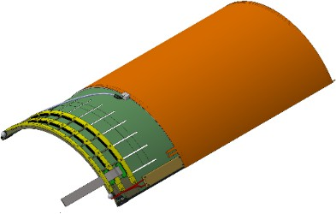 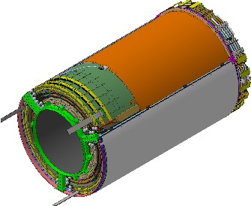

*Figure 2 - Cylindrical Micromegas tile and full barrel*

The Forward part consists of six flat Micromegas disks stacked together. The disks are all identical and assembled with a 60° rotation with respect to one another giving 3 angles of strips (0°, 60° and 120 °). The resulting Micromegas Forward tracker is attached to the Barrel end flange.

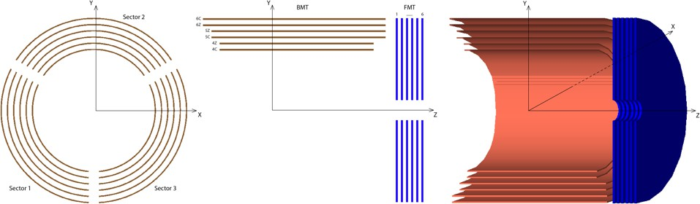

*Figure 3 - Naming convention for sectors and layers*

BMT sectors are numbered from 1 to 3 and layers from 1 to 6. Each BMT tile also have a label that indicates if the tile belongs to a C layer or a Z layer. From interior to exterior, layer 1 is labeled 4C, layer 2 is labeled 4Z, layer 3 is labeled 5Z, layer 4 is labeled 5C, layer 5 is labeled 6Z, layer 6 is labeled 6C.

The six FMT disks are numbered from 1 to 6 from upstream to downstream

In order to hold the MVT in the magnet a stainless steel tube, with the Barrel and Forward at its downstream end, is attached to the flange of the SVT tube structure. This tube also holds the 6 crates containing the readout boards for the Micromegas detectors. The connection between detectors and readout is done using flex cables. Near the downstream end of the tube are the patch panel for the gas and the high voltage cables.

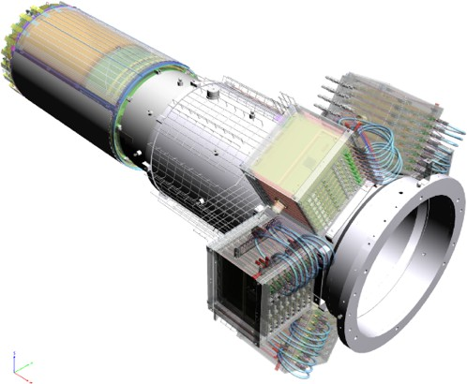

*Figure 4 - Support tube with electronics Rack and MVT detectors*

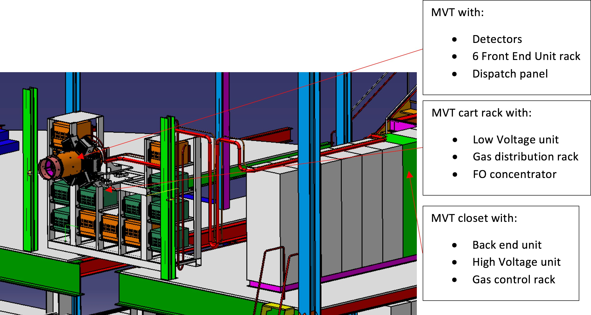

*Figure 5 - General view in hall B*

## - Gas

The Micromegas are continuously flushed with gas in order to keep a good purity and overcome the normal outgassing of the detectors. The gas used for the barrel detector is a flammable mixture, Argon with 10% of isobutane. For the forward detector, it is Argon with 10% of CF4 and 10% of isobutane. The flow rate is 2 l/h (liter per hour) for a set of three detectors in serial. For the barrel 6 lines (one for each layer) and 3 for the forward (on for two forward), of pipes allows the flushing, thus a total of ~ 20 l/h is used. The gas is rejected outside Hall B.

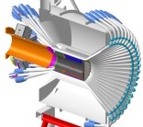

Hall B

Gaz bottle (Isobutane)

Argon tank

Mixing building

MVT Gas rack

Detectors

*Figure 6 - General view of gas lines*

The gas line for the Barrel and the Forward detectors are coming from the gas shack to the MVT gas rack located on the cart of the MVT-SVT in Hall B. In this MVT rack each subsystem (Barrel and Forward) has a mass flow meter at the entrance and two flow meters at the exit (normal gas exhaust and overpressure). The monitoring of the pressure and of the mass flow meter is done through a 1200

series Siemens PLC. If a difference of flow is found (a leak), the system will automatically stop and a leak check can be done using rotameter providing gas for set of 3 detectors.

A MVT gas control panel located in the closet with the MVT back end electronics allows to operate the gas rack in manual (with fixed values for the flow and pressure) or in automatic (by PLC). From the PLC gas data are send trough EPIC.

## - Detectors high voltage

Each Barrel Micromegas detector needs two high voltage potentials to operate (+ground); the resistive strips are at a potential of ~ 500 V and the drift at a potential of ~ -1000 to ~ -2000 V. In addition, the forward detectors are divided in an inner and outer region, which adds yet another potential. These HV values depend on the gas mixture, thus the detectors HV cannot be put ON while the gas mixture is not ok.

The high voltage is provided by a CAEN SY1527 equipped with positives (A1821) and negatives (A1536) cards. The CAEN crate is located in Hall B in the MVT rack. From the crate to the end of the support tube, where the HV patch panel is fixed, standard high voltage cables are used. The Crate is controlled by the EPICS slow control system.

Values of the Drift high voltage are different for each kind of detectors, in order to account for the different Lorentz angle in the 5T magnetic field of the central region.

The effect is more important for the Barrel detectors with Z strips, where the drift voltage is increased in order to lower the Lorentz angle which is perpendicular to the strips

For the forward detector, the drift is at -600V.

|  |  |  |
| --- | --- | --- |
| Detectors | Strip HV (V) | Drift HV (V) |
| Barrel with Z strips | 510 | -1800 |
| Barrel with C strips | 510 | -1500 |
| Forward | 510 | -600 |

## - MVT Readout

*Table 1 – Nominal HV values for MVT*

Extremely tight design of the CLAS12 Central Detector leaves a very narrow space between the MVT and its neighbor detectors. Consequently, a readout architecture based on the off-detector frontend electronics has been adopted. It is shown on Fig. 5. Lightweight micro-coaxial cable assemblies with low linear capacitance carry bare unamplified signals to the frontend units (FEU) housed in crates some 1.5-2 m upstream of the detectors. The frontend electronics are responsible for the pre-amplification and shaping of the detector signals, for holding the latter in a pipeline waiting for trigger process to yield, for the digitization and compression of the selected event data and for their delivery to the backend electronics. The backend is responsible for data concentration event-wise. It provides an interface with the Clas12 event building system. It also ensures a fixed latency path between the Clas12 trigger system and the FEUs. It receives the system clock and trigger from the Clas12 trigger supervisor and synchronously conveys them to the FEUs over bidirectional optical links.

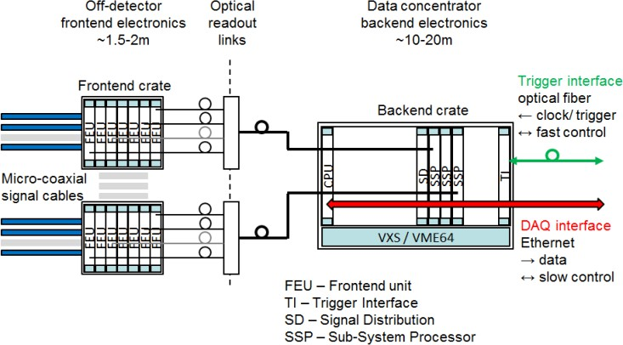

*Figure 7 - Schematic of the Barrel gas rack*

To improve MVT readout noise immunity the readout takes advantage of the continuous sampling of detector signals. Pickup noise usually affects groups of neighboring signal lines. It is possible to determine and remove this coherent noise greatly smoothing the induced fluctuations. For each trigger the signal samples are compared to the channel discriminating threshold after the common mode noise subtraction. For channels with charge deposits above the thresholds, a fixed number of consecutive samples are kept for offline analysis. The retained samples describe the signal development in the channel. Fitting their values with a known function allows accurate estimation of deposited charge and of signal timing.

The system is dimensioned to read out 6K channels of the forward station and almost 16K channels of the barrel station. The expected 10 to 20 MHz physics background results in strip hit rates of 60 kHz in the forward detectors and of 20 kHz in the barrel detectors. The readout system is compliant with the Clas12 requirement of a 20 kHz maximum trigger rate and provides a sufficiently deep data pipeline to cope with a trigger latency as long as 16 µs. The frontend electronics has been designed to withstand the residual 1,5 T magnetic field of the central detector solenoid.

## - Low voltage for the Front-End electronics

The power supply of each crate housing the Front-End units (FEUs) consists in a LV crate, located in the MVT cart rack. It provides six independent channels connected to each crate. The average current and voltage for each channel is about 35A at 4.5V. This power is then shared between the FEUs. The current of a FEU ranges between 4.3 and 5.3A.

## - Cooling the Front-End units

Since the front-end electronics is located close to the detectors on the support tube, it cannot be cooled by fans because of the magnetic field (~1.5T). Also, most of the heat has to be removed in order to keep the PMTs of the CTOF at room temperature.

For two front-end electronics crates, a remote fan is placed 4m away with a pipe bringing fresh air from the hall. An exhaust fan removes the heated air from the six crates in the hall. An interlock system on the fans will shut down the low and high voltages if the fans are not powered.

The average temperature of a FEU is ranging from 40 to 55°C. If the temperature exceeds 70°C, another safety shuts down low and high voltage.

# – Information for Shift Workers

## – Shift workers responsibilities

Shift Workers has the following responsibilities:

1. Start or stop the MVT system (gas, cooling, low voltage, high voltage) and run calibration when needed
2. Respond to alarms following the procedures
3. Monitor the system using the monitoring plots
4. Inform system expert for any problem encountered

## - Turning ON and OFF the MVT

Here follow the general procedures for turning ON and OFF the MVT system: Turning MVT system ON

1. Turn on gas
2. Turn on cooling system
3. Turn on Electronics Low Voltage
4. Turn on Electronics High Voltage
5. Take a Pedestal run, check noise levels, write configuration file
6. Ready for physics Turning MVT system OFF
7. Turn off Electronics High Voltage
8. Turn off Electronics Low Voltage
9. Turn off gas
10. Turn off cooling system

For gas, HV and LV, please refer to the dedicated subsections below, entitled “How to turn on”. Concerning the cooling system and the configuration file, the procedure will be described in a second version of this documentation.

## - Global overview of the slow controls GUI for MVT

Clicking on *CVT (Central Vertex Tracker)*, then *MVT overview* in the CLASCSS menu will make the following panel appear. It summarizes the main information concerning the MVT system. From top to bottom of the panel, we have:

* + - 1. In the red frame of the figure below, the information concerning the high voltage for the barrel (BMT) and forward (FMT) Micromegas tracker. The barrel is represented by behind, the beam going in your back. Twelve layers are displayed because each tile has two HV channels, one for the strips and another one for the drift. The FMT is shown with a side view, the beam going from the right to the left. For each disk, there are three HV channels, one for the drift and two for the strips.
      2. In the purple frame of the figure below, the information concerning the gas, which is the flow entering the MVT and the difference between the flow entering and exiting the MVT system, in order to check there is no major leak (for Barrel, 18 detectors, at total leak > 1 l/h for forward, 6 detectors, leak > 0.5 l/h).
      3. In the blue frame of the figure below, the low voltage information with the delivered voltages and currents to the crate, the status for each channel and the temperature.
      4. In the orange frame of the figure below, the information concerning the Front-End units, i.e. the current going through each FEU and the temperature.
      5. In each sub-panel, there is a gray button allowing to access more information and/or control remotely.

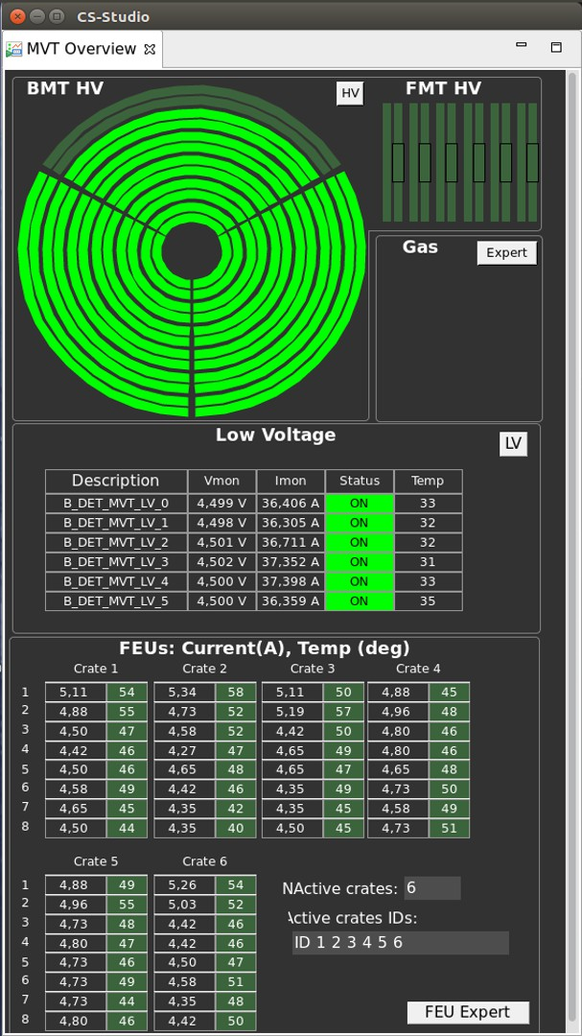

*Figure 8 - MVT Slow control main window*

## - How to start the HV and additional information

To start the HV, click on the HV gray button in the general overview and select “Channel Controls”. The following window will open:

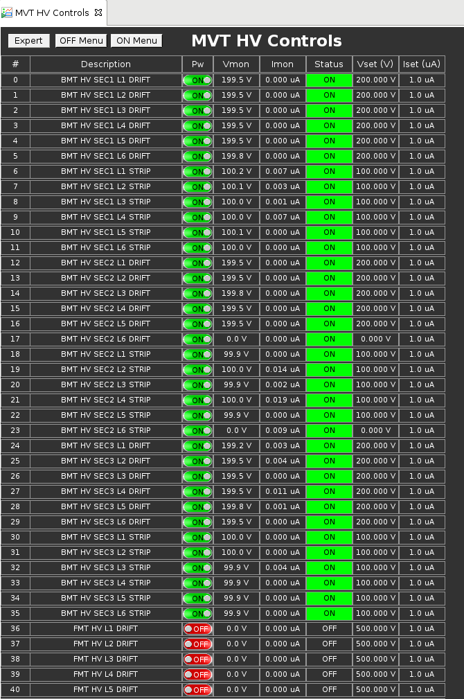

*Figure 9 - MVT High Voltage slow control*

To turn off or on one HV, you just need to click on the button in the third column (Pw). The fourth and fifth column reads the HV and current of the corresponding channel. The two last columns indicates the HV settings and the limit set on the current before turning automatically off the HV channel.

If you want to start or stop all HV for MVT or for BMT only or for FMT only you can use the “ON MENU” or “OFF MENU” button.

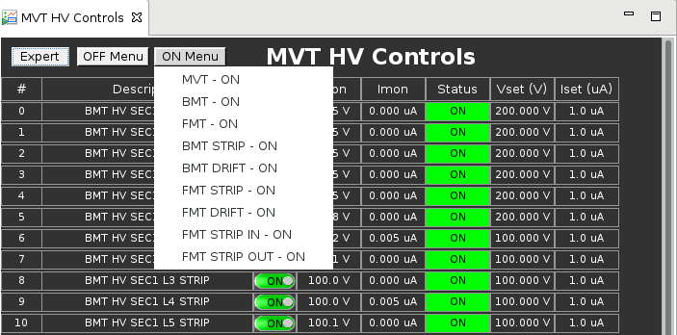

*Figure 10 - MVT High Voltage ON buttons*

## - How to start the gas and additional information

First you need to open the gas window by clicking on the gray button in the gas panel of the general overview. Since the composition of the gas for the BMT and FMT are different, you are asked to choose between the two once you click on the gas button. The following window will then open:

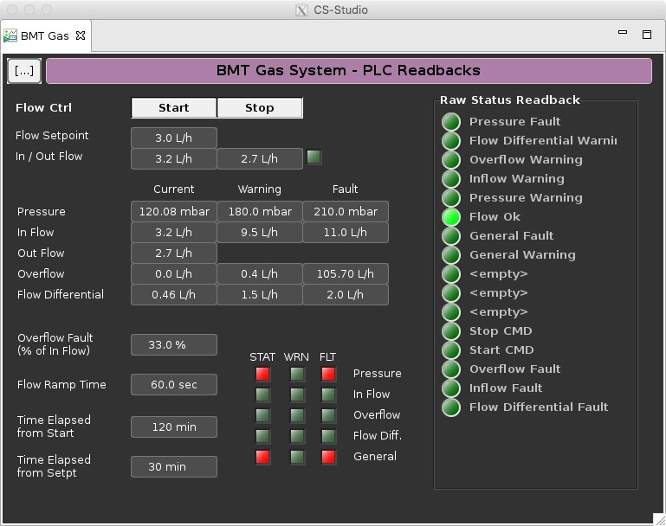

*Figure 11 - MVT Gas slow control*

To start or stop the gas flow, just click on either Start or Stop button. Depending on the flow rate, it takes 2-4 hours to fill the MVT with enough gas to start production data.

## - How to turn on the LV and additional information

To turn on or off the LV, first click on the LV gray button. The following window will open:

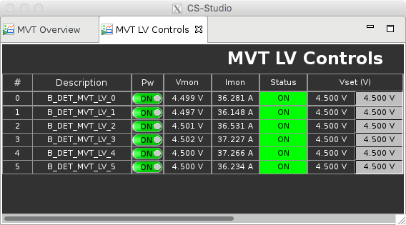

*Figure 12 - MVT Low Voltage slow control*

Then simply click on the button of the third column entitled “Pw” of the corresponding channel you want to turn on or off.

## - Alarms and procedure to follow

In the following section, we describe a few situations that shift workers may encounter and the corresponding procedure to follow.

### - One HV channel dropped to 0

Because of potential sparks, the current on the drift or the strips of a Micromegas detector can exceed the limit. In that case, the corresponding HV channel will trip.

Therefore, you need to turn back on the tripped channel. To do so, please read the section entitled “How to start the HV and additional information”.

In the event that the HV channel trips again when it is ramping up, call the expert.

### - Abnormal readings of current in the FEU

If the current going through a FEU is dropping to 1A-2A, then call the expert. It may happen due to a bad connection of the LV cable to the FEU. In this case, a controlled access will be required to plug back the cable.

### - LV and crates suddenly turned off

The crates are cooled by blowing air inside with fans. An interlock system will automatically turn off the LV channels if the fans stop. Call then the expert.

## - Monitoring of the MVT

Monitoring for shifters is composed of two main tabs, one for MVT and one for FMT. Each one of this main tab is composed of different sub-tabs:

-BMT Occupancies or FMT Occupancies

-BMT Time of Max or FMT Time of Max

-BMT Cluster Size or FMT Cluster Size

## - BMT Occupancies

Occupancy is a view of the number of hits in function of the strip number (=channel number).

Occupancy plot is probably the most important one. In occupancy tab, we have 18 plots, one plot per Micromegas tile. Each column corresponds to a sector and each row to a layer.

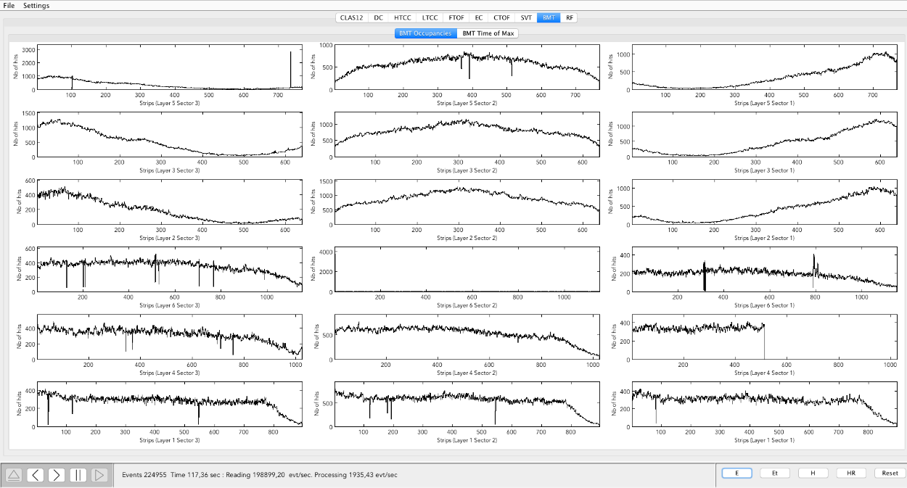

*Figure 13 - MVT Monitoring : occupancies*

The 3 top rows correspond to Z layers, that means that their strips are along the beamline. Occupancy plots for Z tiles are supposed to look the same.

The 3 bottom rows correspond C layers, that means that their strips consist of a circular arc around the beamline. Occupancy plots for C tiles are supposed to look the same.

This plot is normalized so that, for each layer, we can compare tiles from different sectors. It is also important to compare this normalized value to a reference, in order to check if occupancy is changing in time.

## - BMT Time of Max

Time of Max plot is a view of the distribution of the max sample of the pulses for each DREAM ASIC (electronic chip with 64 channels).

Time of Max plot is used to check that our acquisition window is centered on the maximum of the signal. When we take data, we measure signal collected on the channels during some time, the instant when the signal is maximum is called “Time of max”.

On the “Time of max” plot, there are 18 plots (3 sectors in columns and 6 layers in rows). The x axis is time (0 is the beginning of the acquisition window), and the y axis is the number of the dream (electronic chip). The z axis represents the number of time the that the time of max takes some value (normalized for each dream).

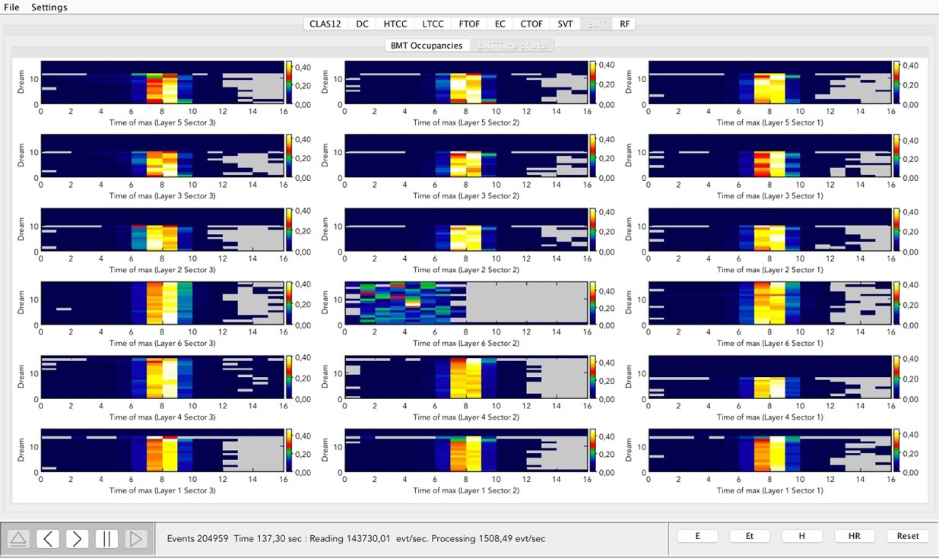

## - BMT Cluster size

*Figure 14 - MVT Monitoring : time of max*

The third tab represents the distribution of the cluster size (number of strips in each reconstructed cluster) over a tile. There are 18 plots (3 sectors in columns and 6 layers in rows). X axis is the number of strips in the cluster (= the cluster size) and y axis is the number of times each cluster size is seen.

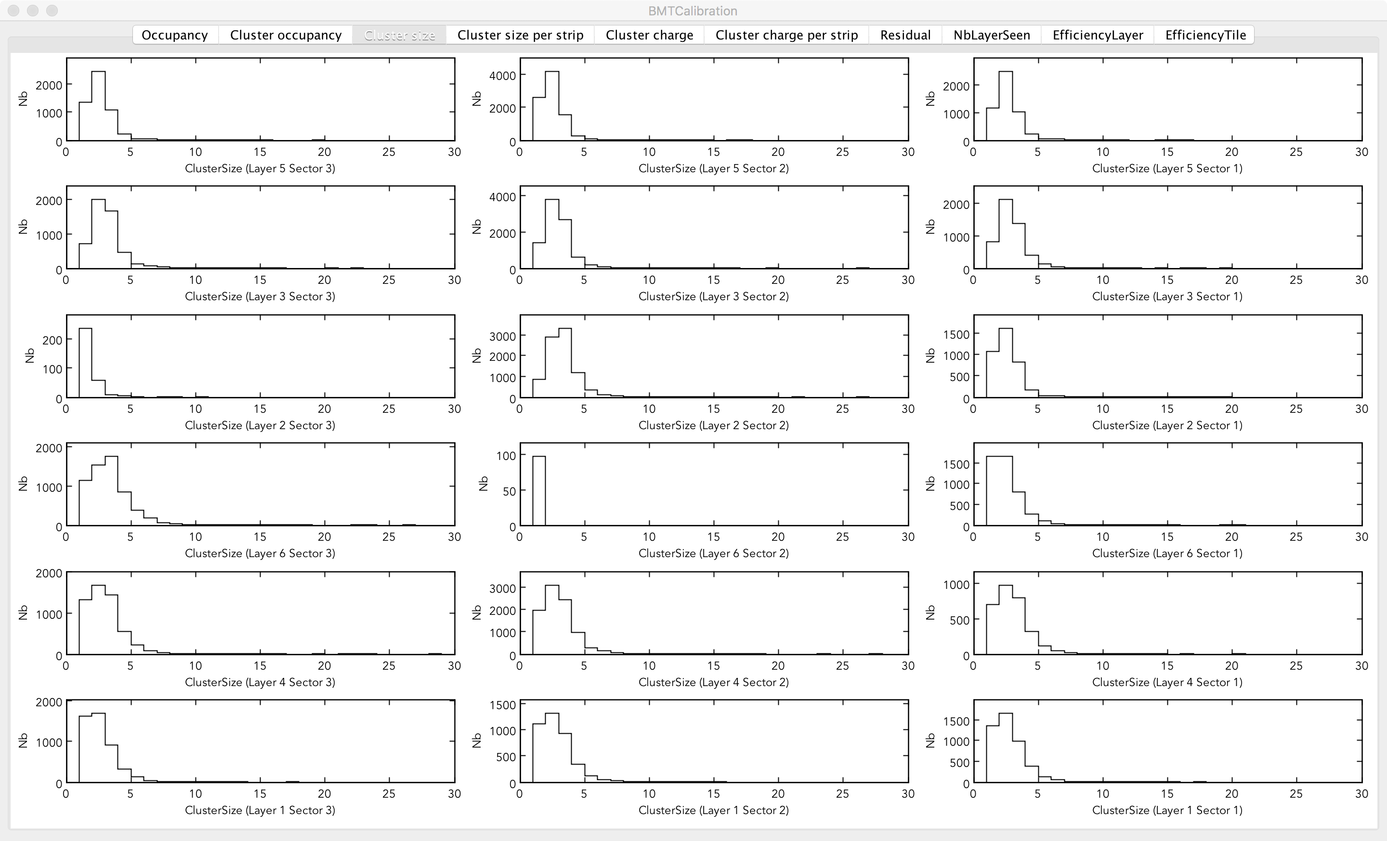

*Figure 15 - BMT Monitoring : cluster size*

## – Problematic situation and procedure to follow

In the following section, we describe a few situations that shift workers may encounter and the corresponding procedure to follow.

### Occupancy: One strip has a strange behavior

If, for some reason, a strip is counting less hits than the expected value then the strip is probably not working fine, but there is nothing to do immediately, don’t call the expert.

If, for some reason, a strip is counting more hits than the expected value, then the strip is probably noisy. There is nothing to do immediately, don’t call the expert. If the strip is very noisy you may not be able to see other strips, in this case rescale the plot (right click on the plot and select Options Panel, then Axes tab, then Y Axis and lower the Axis Max value).

### Occupancy: A group of strips has a strange behavior

If a group of strips has a strange behavior, then one electronical component may be malfunctioning. If a group of 64 strips is not working, an electronic chip probably has a problem, call the expert.

If half of a tile has a problem then a Front-End Unit probably has a problem, call the expert.

In general if a group of more than 4 or 5 neighbor strips are not working as expected call the expert.

### Occupancy: The shape or the number of hits looks different than expected

If an occupancy plot doesn’t look the same as other regions plots and other plots for the same kind of detector (Z detectors for the 3 top detectors and C detectors for the 3 bottom detectors), then call the expert.

If one tile, or the 3 tiles of a layer (or any other configuration) has a number of events that is less than the expected value, call the expert.

### Time of max: The distribution is changing or looks different than expected

If one distribution of “Times of max” is changing or looks different than others or than the distribution we expect, call the expert.

### Cluster size: The distribution is changing or looks different than expected

If the distribution of “cluster size” is changing or looks different than the distribution we expect, check that gas circulation seems normal and call the expert.

Rebooting the MVT LV when observing a drop in BMT strip occupancies. In brief, it requires a reboot of LV as follows:

Stop the run;

Turn LV OFF from MVT Overview->Low Voltage->MVT-All. LV status indicators should change from green to black;

Wait 20 seconds, then turn LV back from the same menu;

In the alarm handler, with a 2-minute alarm delay, there can be alarm NActiveCrates, status also reported on the MVT Overview GUI. This alarm will be cleared 2 min after LV is turned back ON;

At this point, mvt1, mvt2, and mvt3 ROCS can be rebooted;

Start a run (Cancel-->Reset-->Configure-->Download-->Prestart-->Go).

If the beam is ON, and a reboot process takes more than 5 min, please call the DAQ and/or SVT/MVT/MM expert.

1. – MVT Authorized personnel

|  |  |  |  |
| --- | --- | --- | --- |
| Name | Telephone | Email | Area |
| Maxime Defurne | - | [mdefurne@jlab.org](mailto:mdefurne@jlab.org) | MVT Group Leader  Hardware, Software |
| Yuri Gotra | 757-541-7539 | [gotra@jlab.org](mailto:gotra@jlab.org) | Hardware, Software |
| Rafayel Paremuzyan | 757-753-7769 | rafo@jlab.org | Hardware, Software |