The Bored API

Bored API is useful for people who feel bored most of the time. Bored API provides with a bunch of productive activities that will encourage people to be more productive. There are five parameters in this API that can be modified to our needs. Bored API has its own application for people to try out in *Play Store*, you can see how every parameter is used.

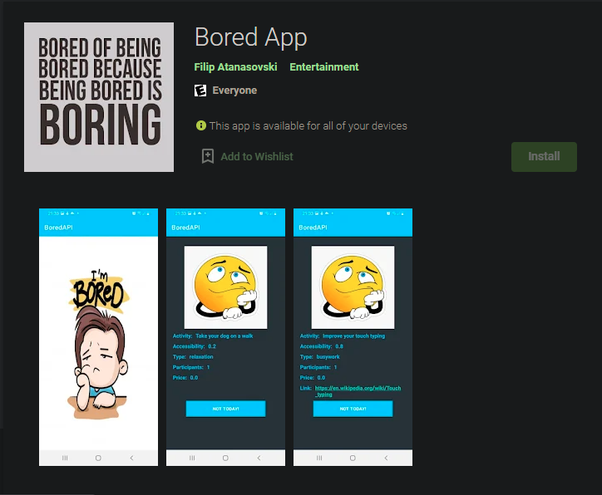

The app itself is developed by *Filip Atanasovski* and the API is developed by *Drew Thoennes*. The full documentation of the API can be seen in the bottom.

* “Activity” This parameter is a description of the queried activity.

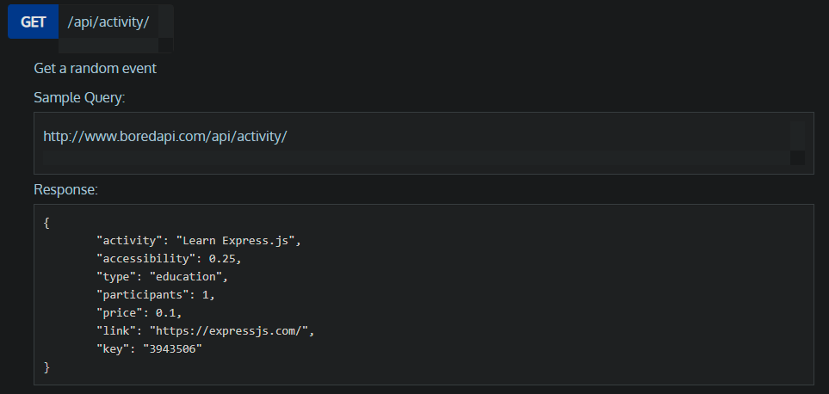

* “Accessibility” This parameter is a description of how possible is it to do.

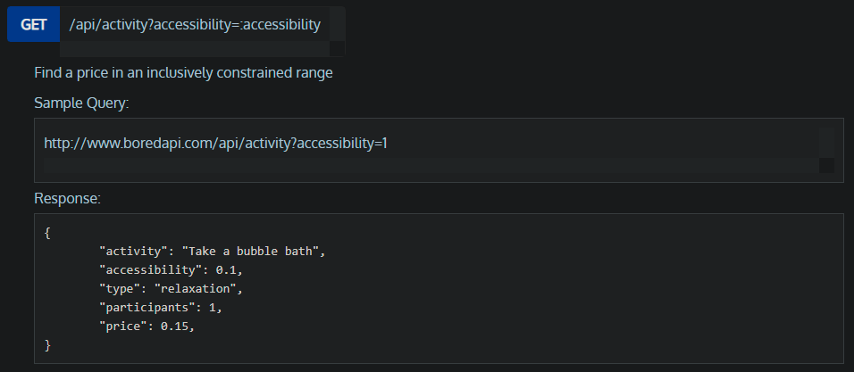

* “Type” This parameter sorts every event into a different category.

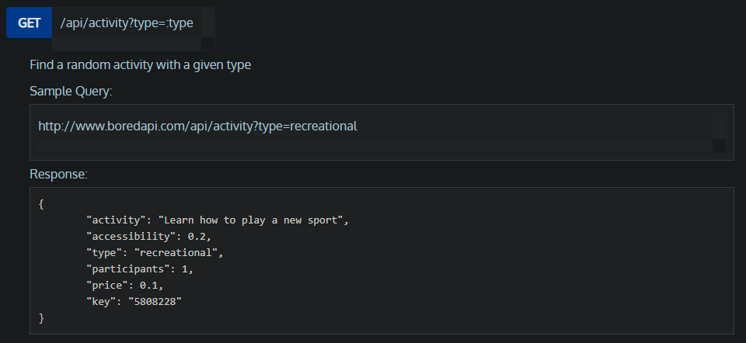

* “Participants” This parameter tells us how many numbers of people is needed or could be involved in a certain event.

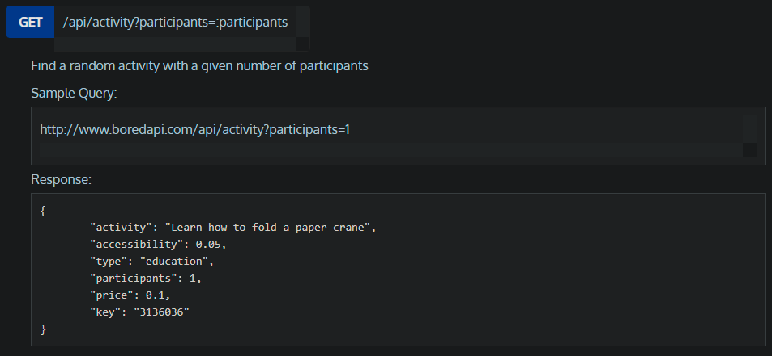

* “Price” This parameter is a description of how much the event cost, where 0 is being free.

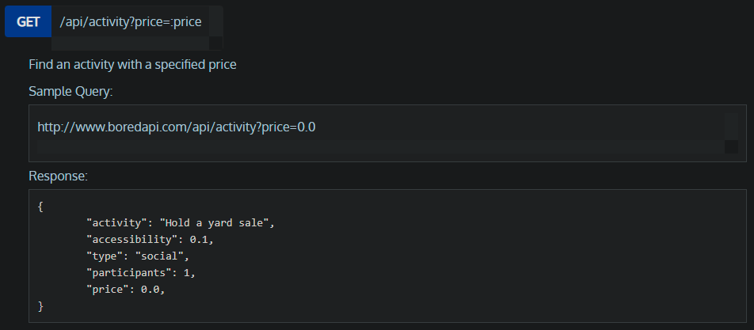

* “Key” This parameter gives an event a unique numeric id.

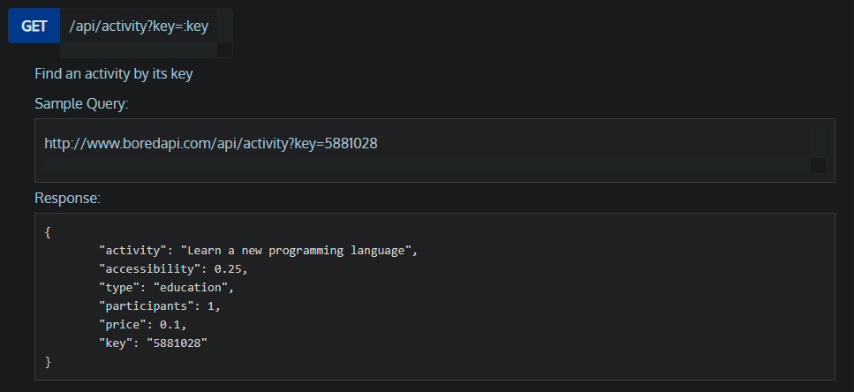

There is couple of two extra parameters that also can be used, they are “Min Price and Max Price” and “Min Accessibility and Max Accessibility”. Those two can be used if you need to get the minimum and maximum price or the accessibility of a certain event. That is useful if the target user is in short of budget or the target user is live far from the event is being given.

References

<https://github.com/drewthoennes/Bored-API>

<https://play.google.com/store/apps/details?id=com.gsixacademy.android.boredapi&hl=en_US&gl=US>

<https://www.boredapi.com/>

<https://www.boredapi.com/documentation>