A company wants to start using a program to store and maintain customer information. Thus far they have been using a spread sheet that references the following information on customers.
- First name
- Last name
- Phone
- Email
- Address
- State
They have asked one of their employees to create the program. The employee however has very basic programming knowledge, the employee tried using generative AI tools to get the program done and ended up with code that throws errors.
The company has reached out to you to fix the program and get it to deliver the results they want. Below is a flowchart showing how they want the program to work.

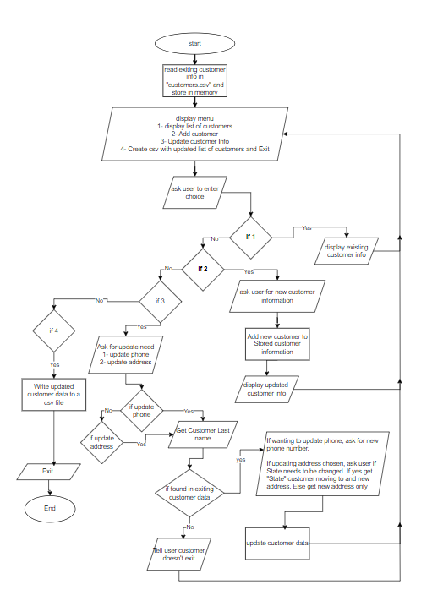

You will notice that the person to tried doing the program used classes, you CAN NOT change that. So continue using the Person and Customer class but do the necessary debugging.
The exiting code files are attached to the assignment post on Bb.

