# UI框架foundation6入门

1. 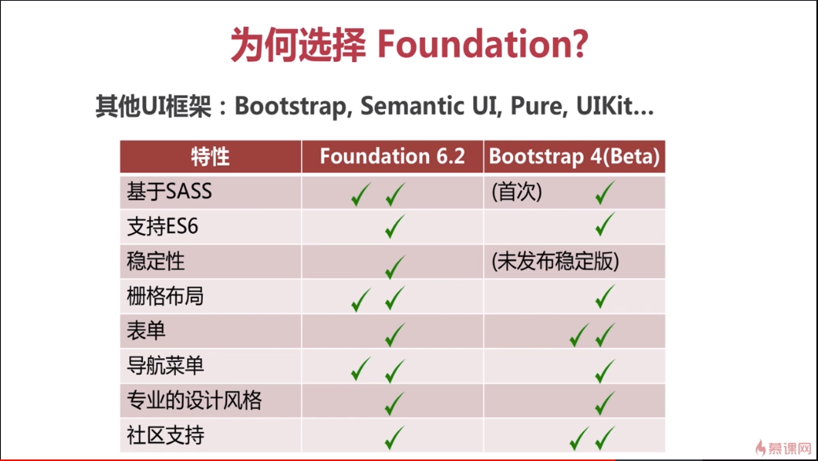 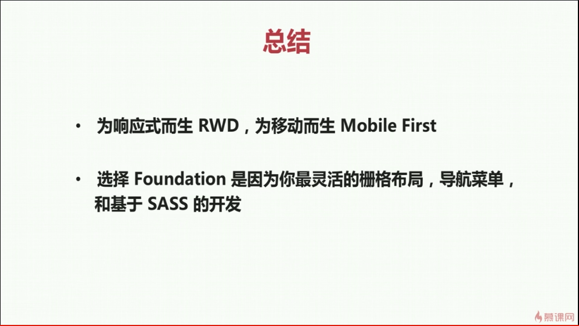 
2. 1
3. 1
4. 1
5. 1
6. 1

# Bootstrap

1. 1
2. 1
3. 1
4. 1
5. 1