Breast Cancer Wisconsin and Wine Classification
Comparative classification and unsupervised clustering report | Fixed test split and three-seed validation | Reproducible Jupyter experiments
Repository URL: ADD YOUR GITHUB REPOSITORY URL HERE (must be completed before submission).

1. Dataset Overview and Class-Label Mapping

Breast Cancer
569 observations and 30 numeric features. Original class counts: {0: 212, 1: 357}. Class names: 0=malignant, 1=benign. X contains features only; y contains original scikit-learn labels.

Wine
178 observations and 13 numeric features. Original class counts: {0: 59, 1: 71, 2: 48}. Class names: 0=class_0, 1=class_1, 2=class_2. X contains features only; y contains original scikit-learn labels.
Interpretation: Breast cancer class 0 denotes malignant and is the positive class for clinical error interpretation; wine retains classes 0, 1 and 2 without relabeling.

2. Missing Values and Duplicate Rows
breast_cancer: Missing values = 0 across all feature columns (none present); duplicate feature rows = 0 (none present).
wine: Missing values = 0 across all feature columns (none present); duplicate feature rows = 0 (none present).
No missing values were created or filled. Any preprocessing was performed after splitting. Interpretation: complete source features allow consistent comparison without imputation.

3. Potential Outliers
Potential outliers were identified by the 1.5×IQR rule in the executed notebooks, without deletion or clipping. Large values can dominate Euclidean distances in KNN and K-Means, while extreme measurements can influence GaussianNB distribution estimates and tree split thresholds. Scaling changes feature units but does not remove outliers.

4. Exploratory Data Analysis: Descriptive Statistics
Feature-level mean, median, minimum, maximum, standard deviation, first quartile and third quartile are provided for every feature in Appendix A and the dataset-specific descriptive CSV files. Interpretation: feature scales vary substantially, motivating comparison of raw and standardized inputs.

5. Class Distribution and Pearson Correlations

Breast Cancer
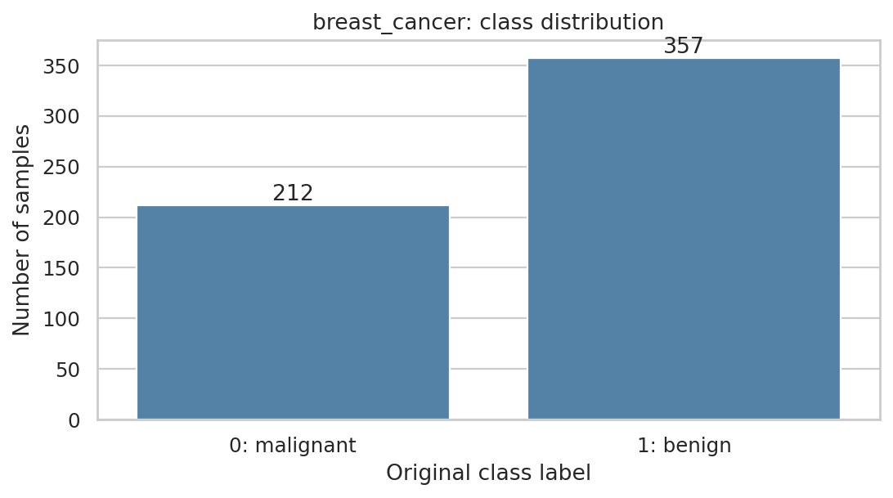
Class distribution: breast_cancer
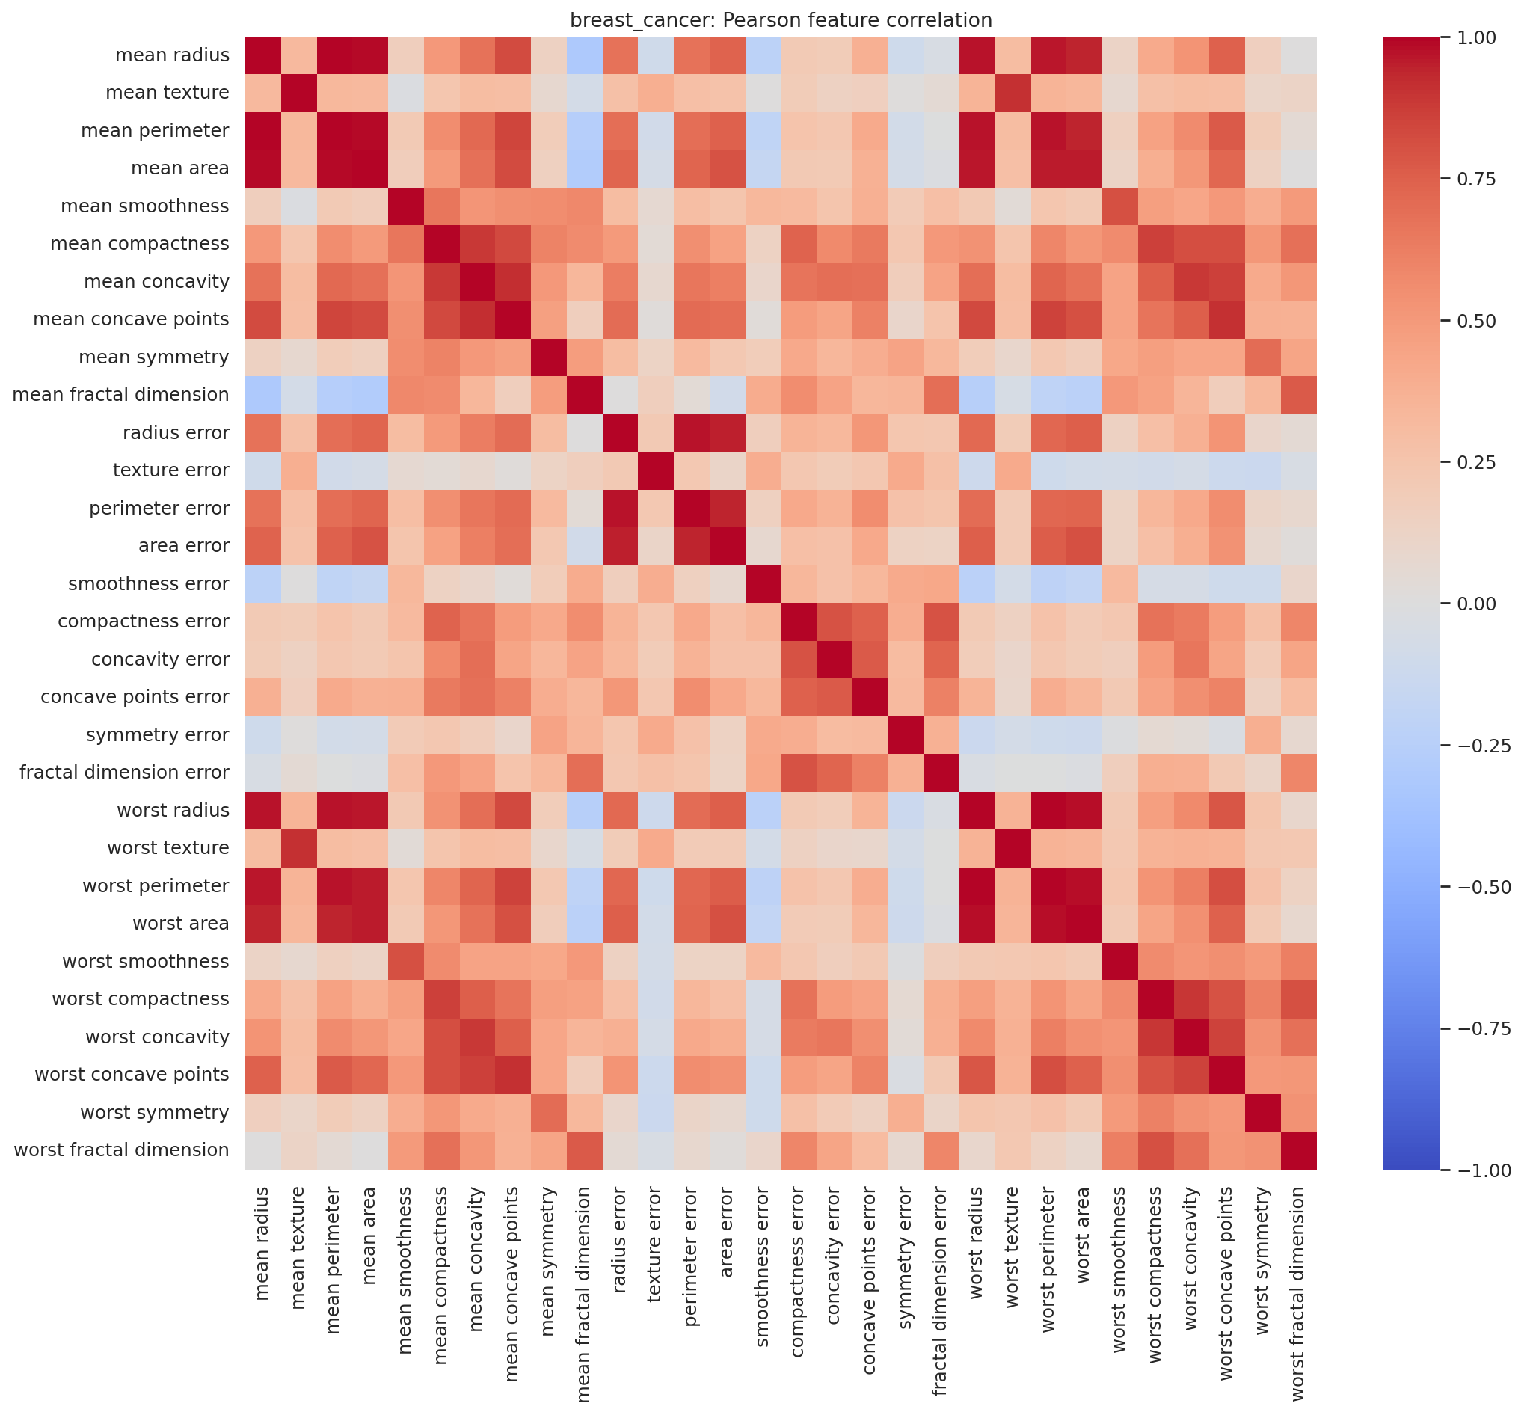
Pearson feature-correlation heatmap: breast_cancer
Three strongest unique feature pairs (diagonal and mirrored pairs excluded): mean radius / mean perimeter (r=0.998); worst radius / worst perimeter (r=0.994); mean radius / mean area (r=0.987).

Wine
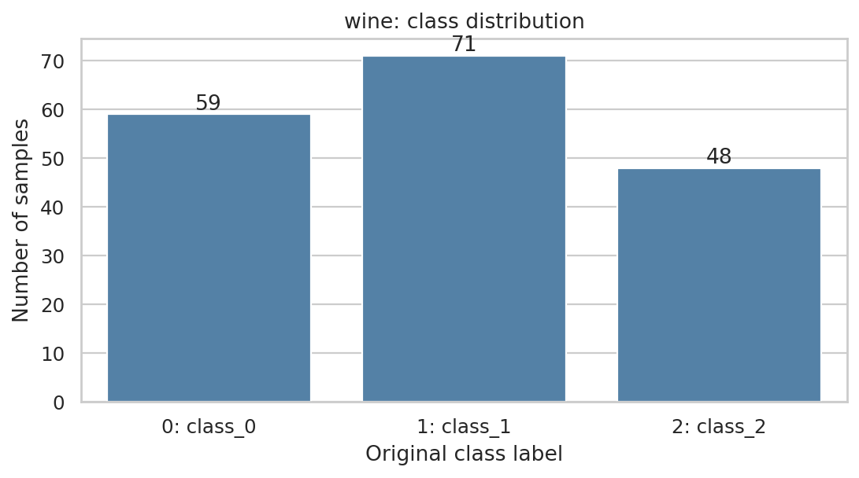
Class distribution: wine
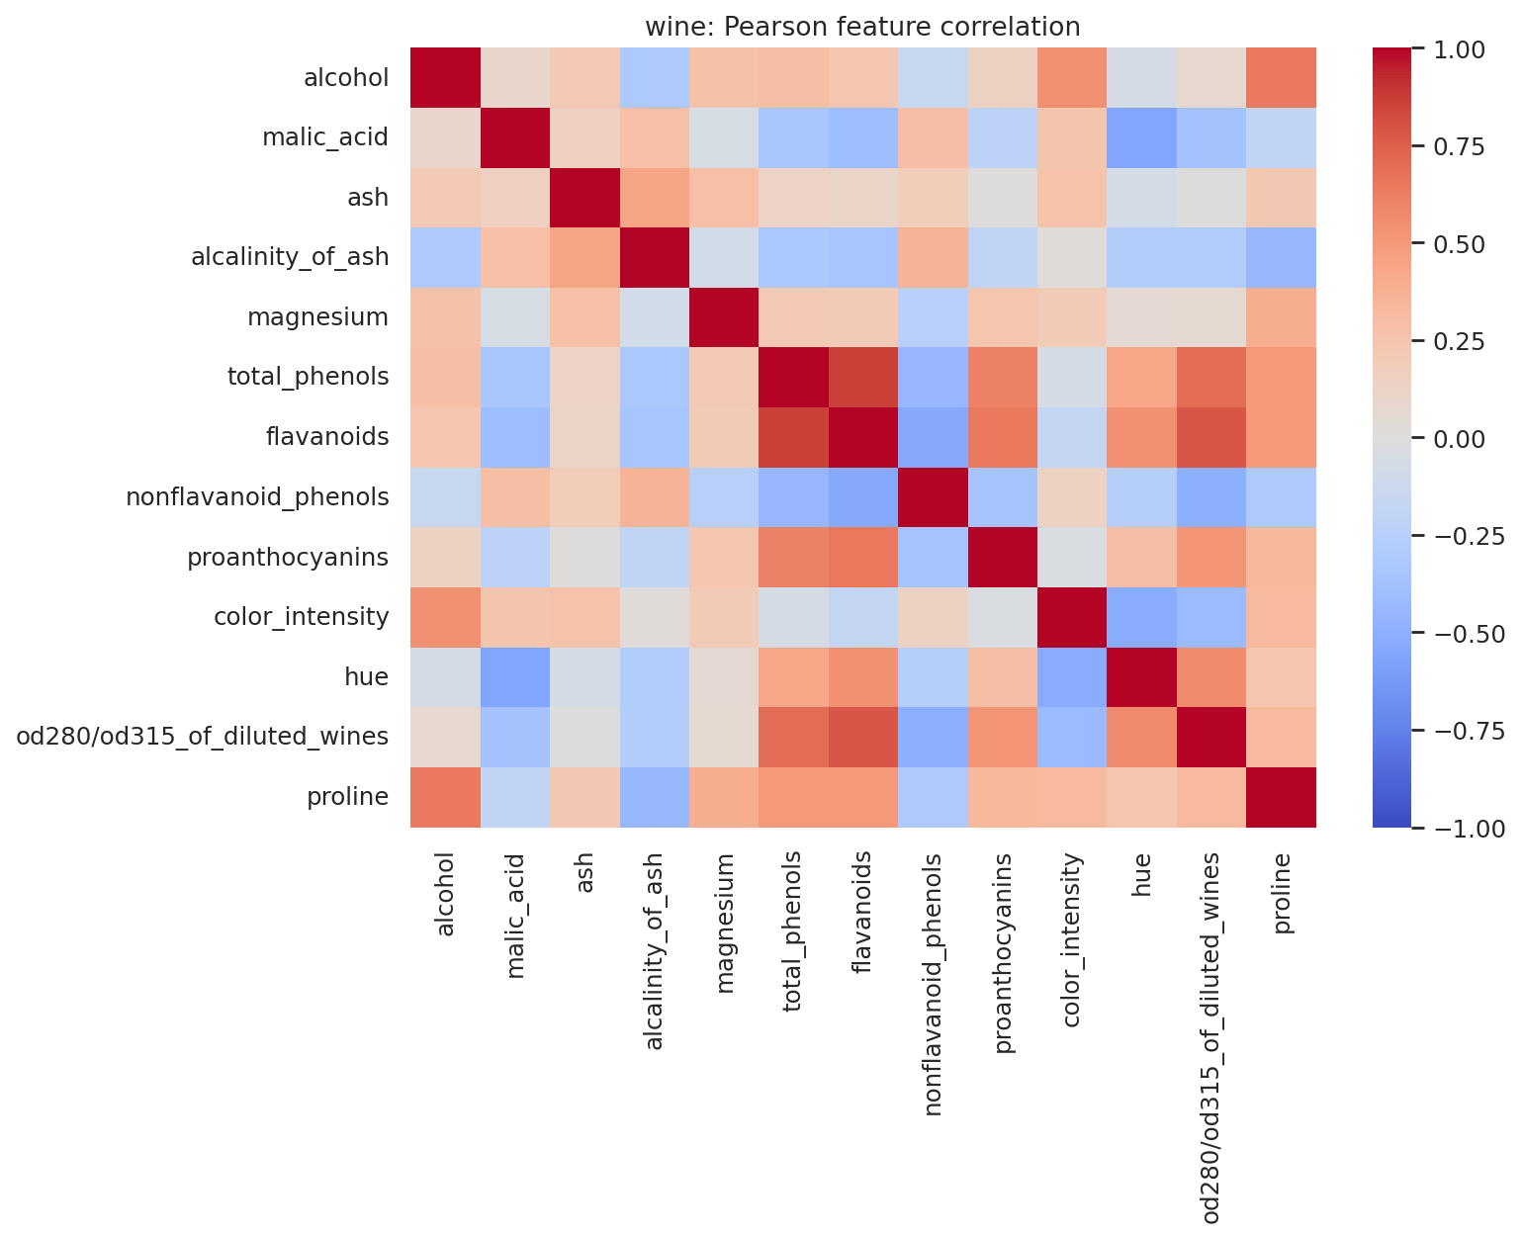
Pearson feature-correlation heatmap: wine
Three strongest unique feature pairs (diagonal and mirrored pairs excluded): total_phenols / flavanoids (r=0.865); flavanoids / od280/od315_of_diluted_wines (r=0.787); total_phenols / od280/od315_of_diluted_wines (r=0.700).
Interpretation: strong correlated pairs contain overlapping information and can affect distance-based methods and feature interpretation.

6. Feature Boxplots
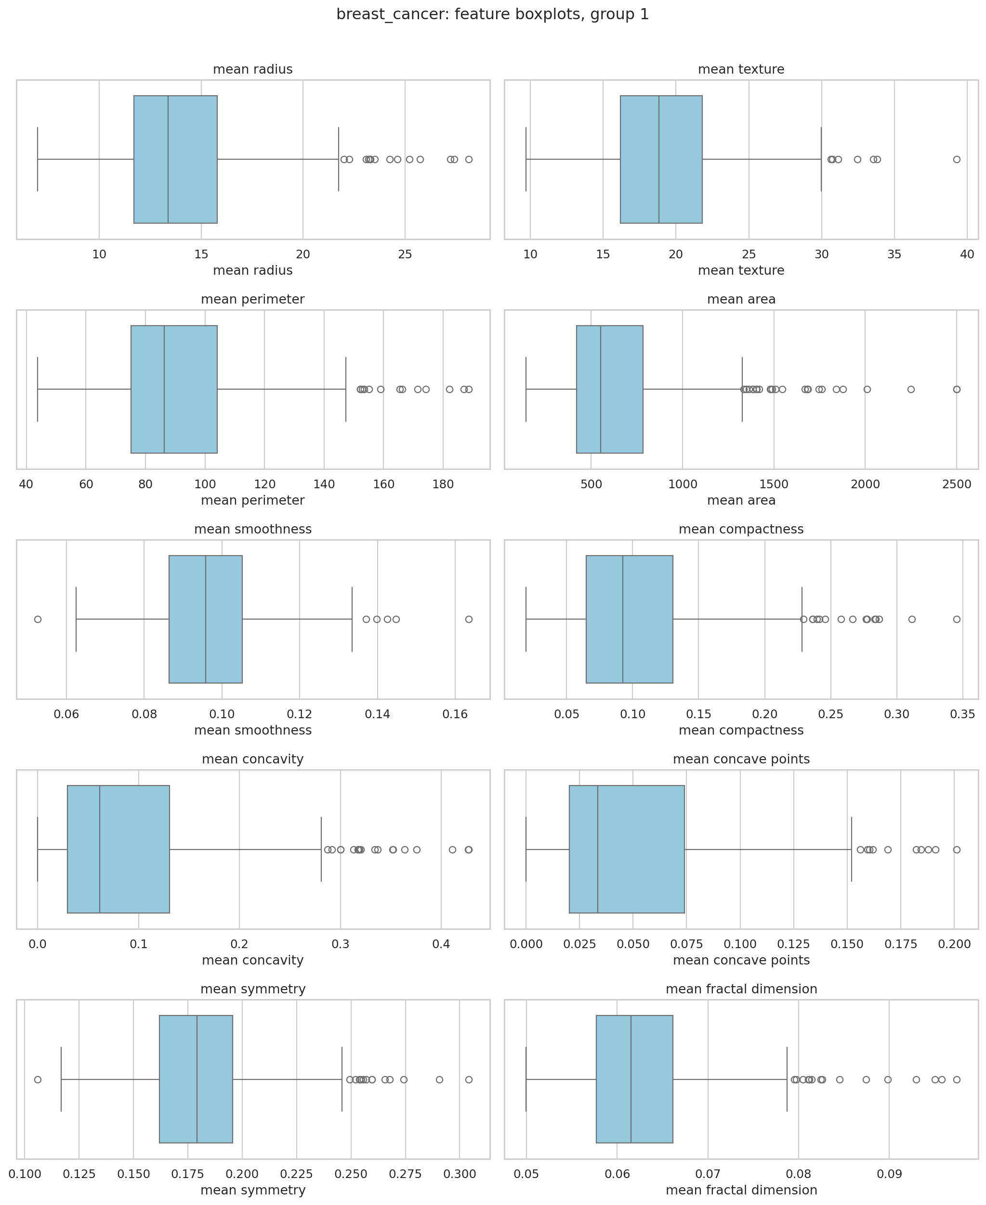
Feature boxplots: breast_cancer_boxplots_1
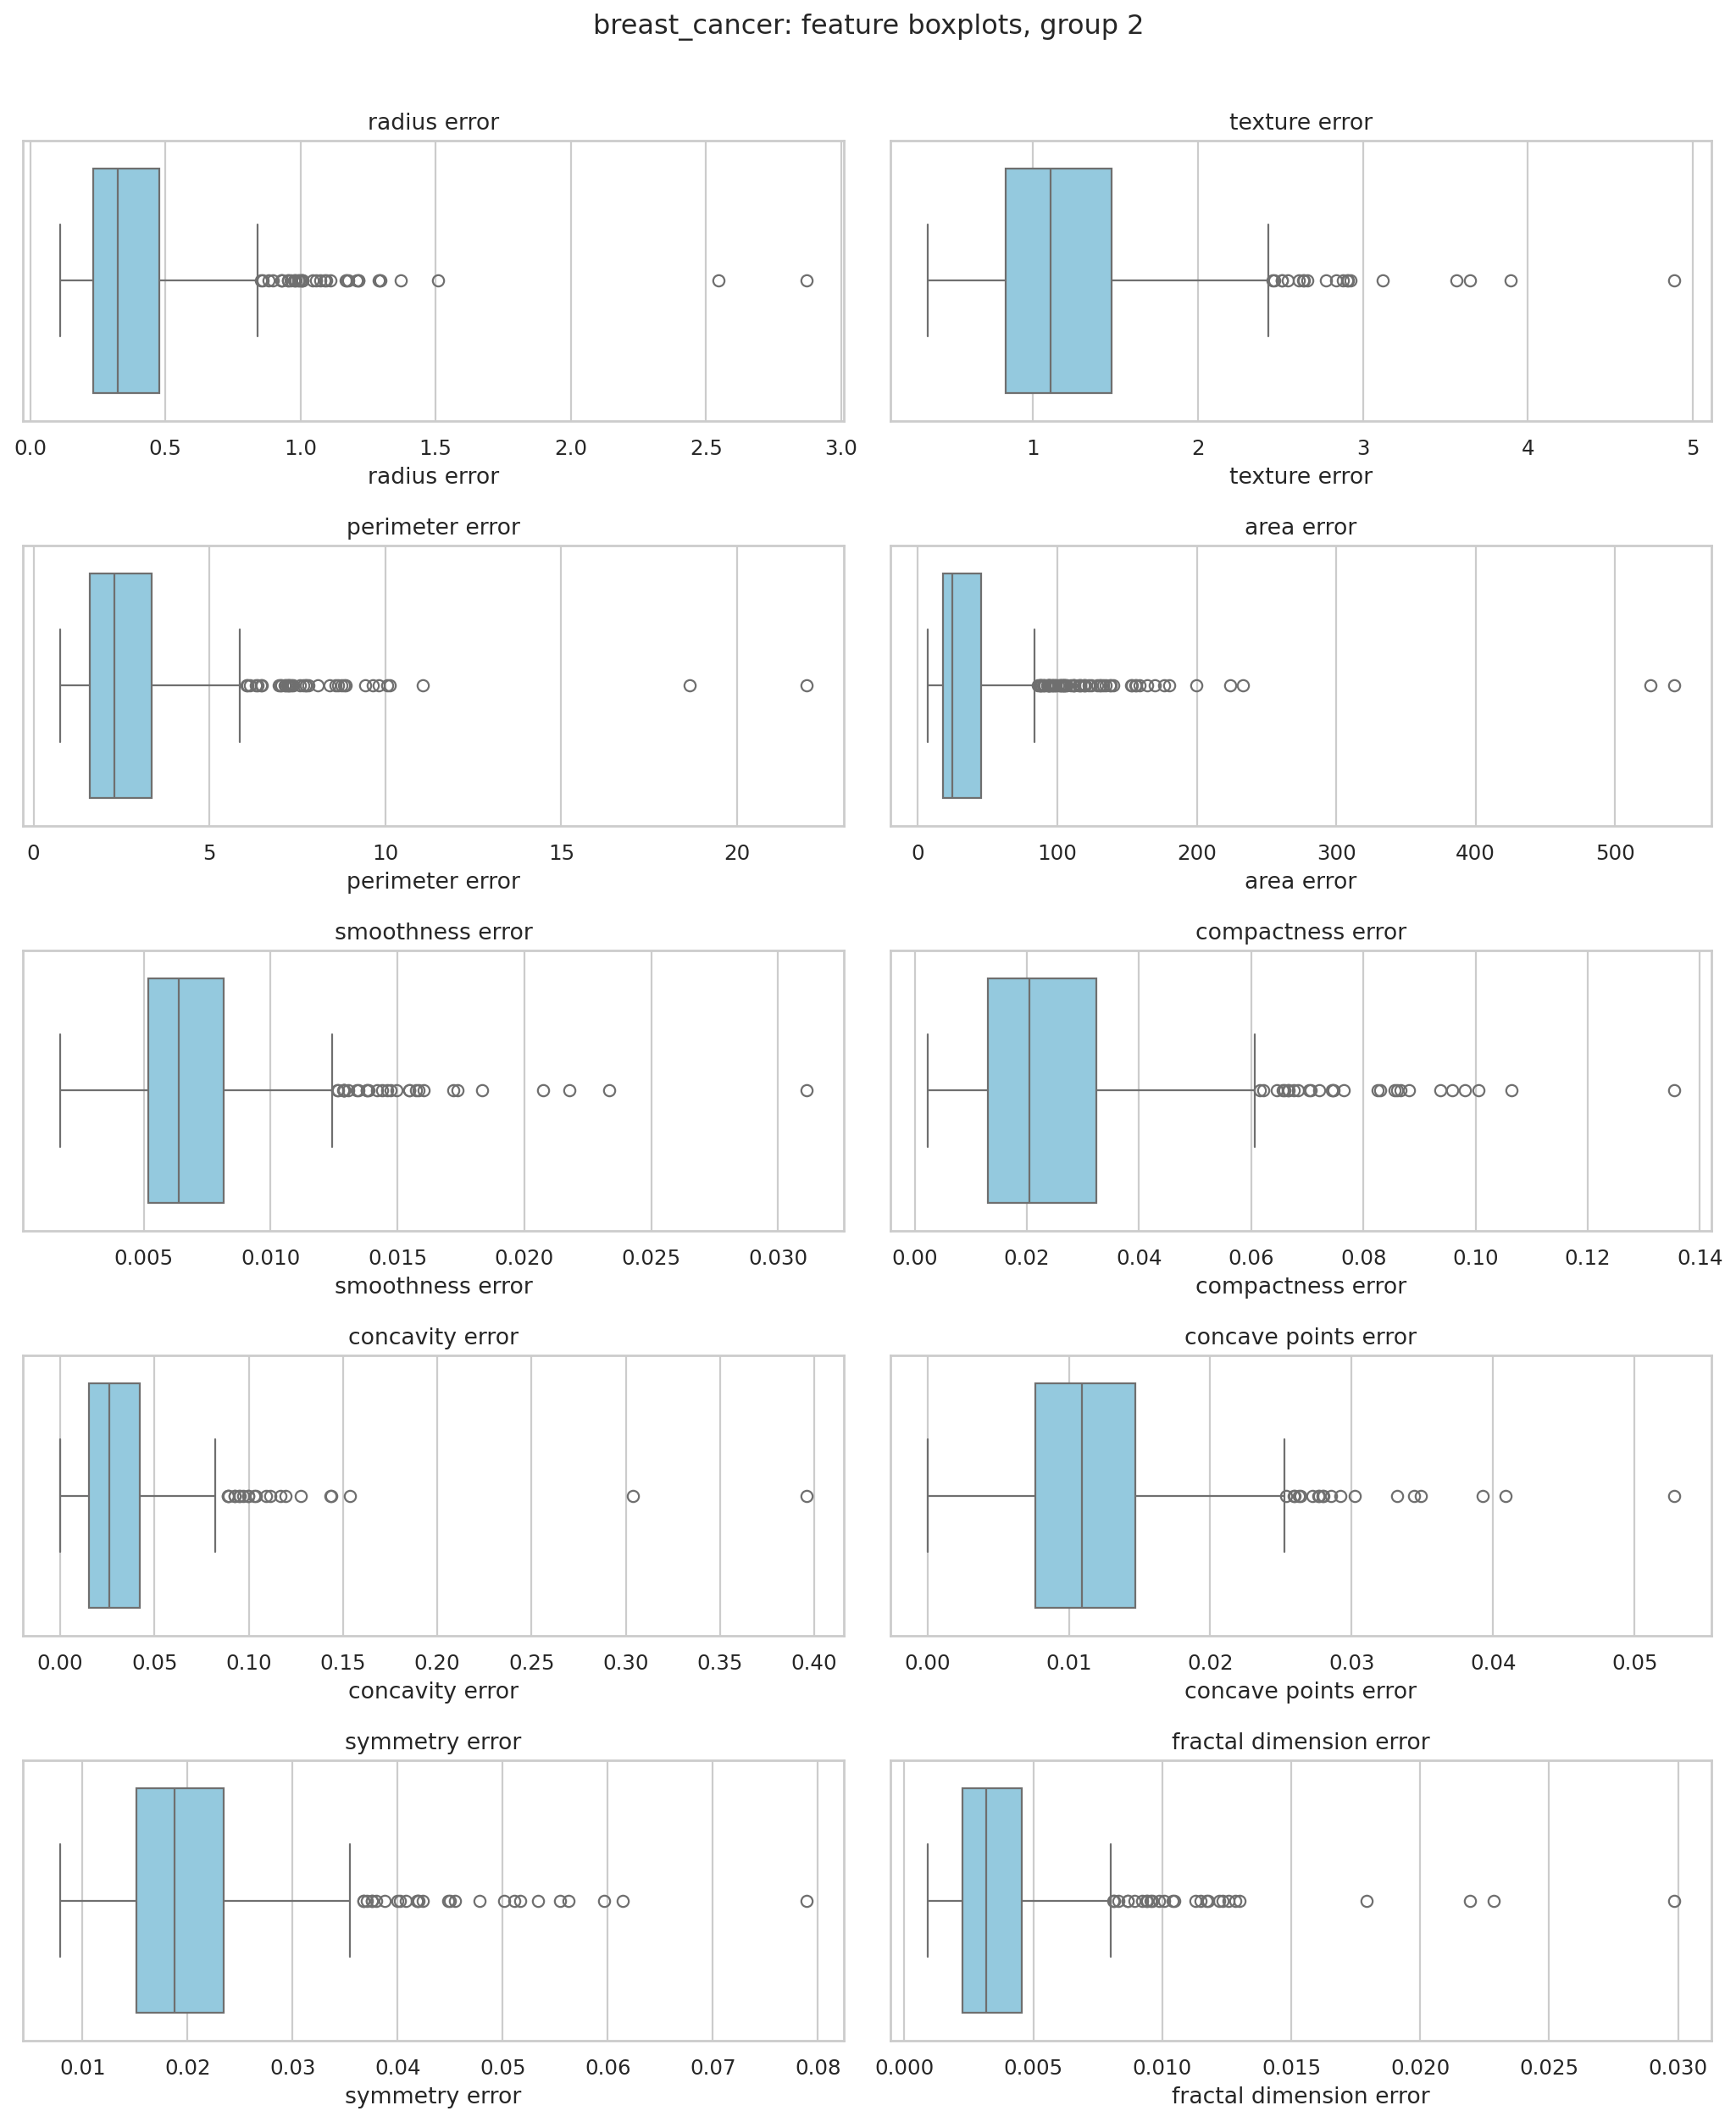
Feature boxplots: breast_cancer_boxplots_2
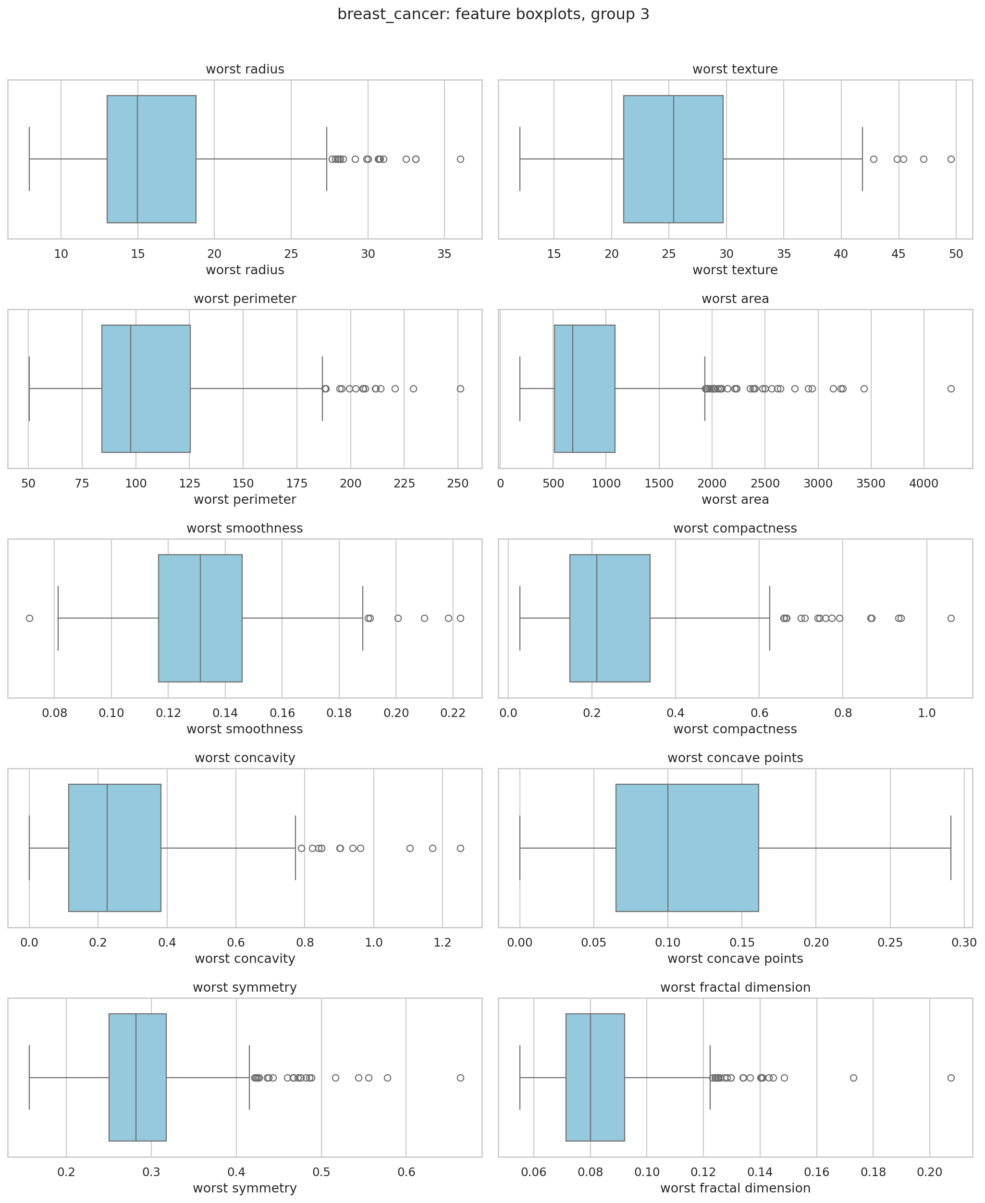
Feature boxplots: breast_cancer_boxplots_3
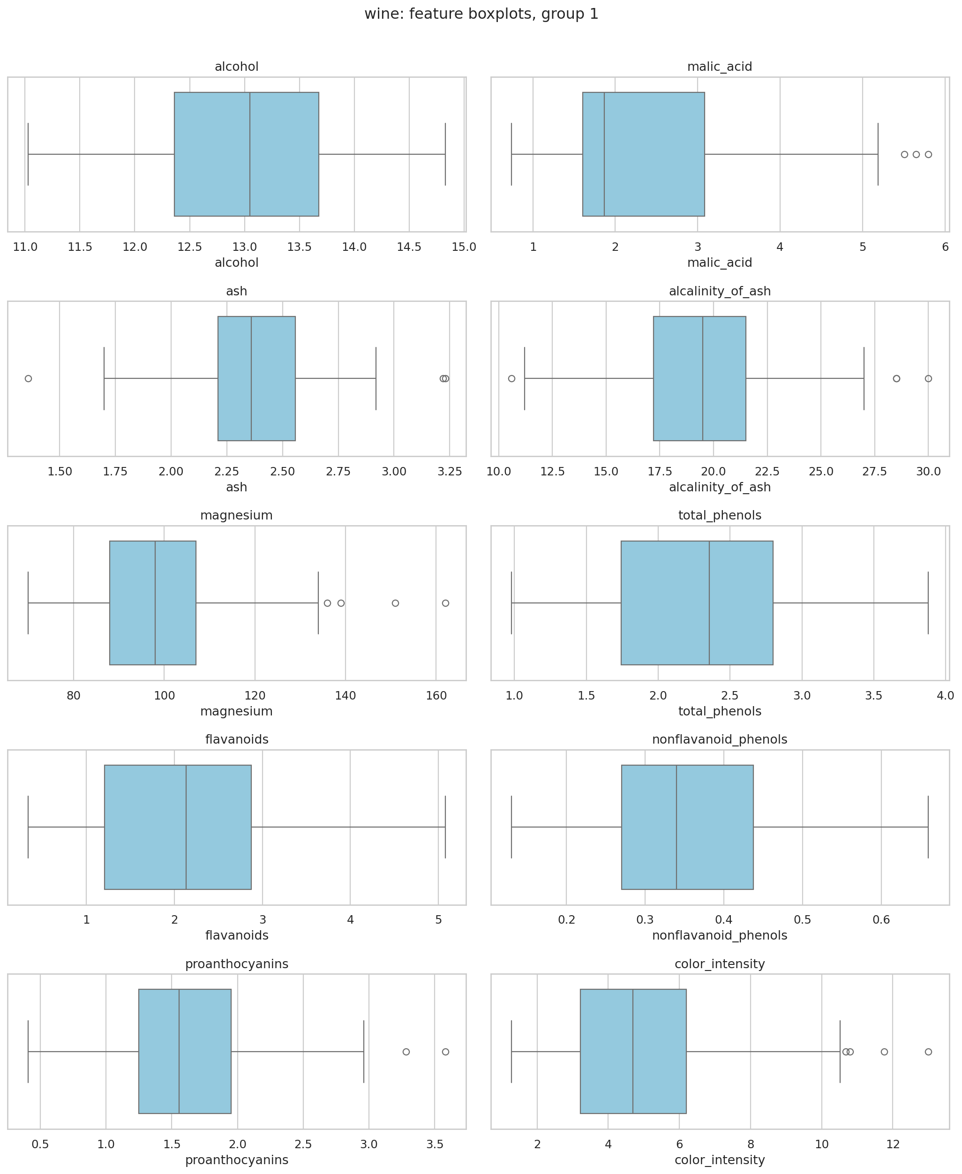
Feature boxplots: wine_boxplots_1
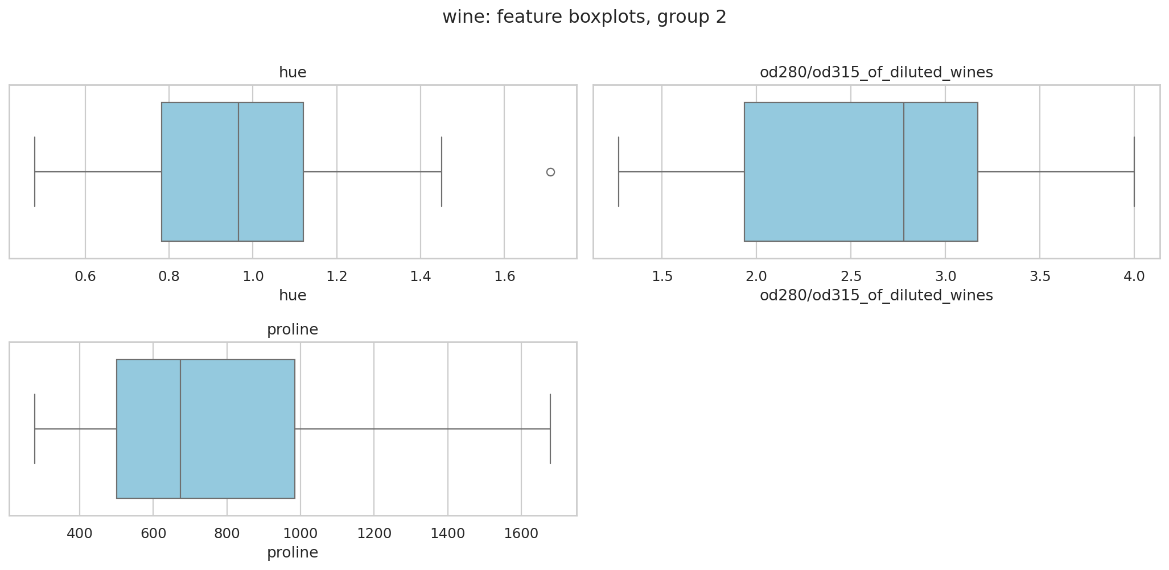
Feature boxplots: wine_boxplots_2
Observations: Breast Cancer features have markedly different measurement ranges, including radius/area-related scales; Wine variables such as proline span larger numeric ranges than features such as hue. Both datasets contain IQR-flagged extremes; none were automatically removed.

7. Fixed Test Split and Three Seed-Based Train/Validation Splits
breast_cancer: seed-42 training 398, validation 57, fixed test 114. The test row indices are unchanged across seeds 42, 52, 62.
wine: seed-42 training 124, validation 18, fixed test 36. The test row indices are unchanged across seeds 42, 52, 62.
Interpretation: a fixed test partition protects against changing test difficulty, and seed-dependent training/validation membership measures sensitivity to sampling.

8. Classification: Validation Experiments and Metrics
For each dataset, 5 Decision Tree depths, 5 KNN neighbor counts, and default GaussianNB were fitted for raw/scaled features under three seeds: 66 runs per dataset. Validation accuracy, macro precision, macro recall, macro F1 and probability-based ROC-AUC were recorded. Precision/recall undefined-class checks precede zero_division=0. Breast Cancer ROC-AUC uses malignant (original class 0) as positive; Wine uses macro one-vs-rest probabilities.

9. Classification: Mean/SD Summaries and Selection

Breast Cancer — 22 configurations
Input | Model | Parameter | F1 mean | F1 SD | AUC mean | AUC SD
raw | Decision Tree | 2 | 0.912 | 0.024 | 0.922 | 0.040
raw | Decision Tree | 3 | 0.918 | 0.030 | 0.941 | 0.021
raw | Decision Tree | 5 | 0.919 | 0.023 | 0.930 | 0.025
raw | Decision Tree | 10 | 0.919 | 0.011 | 0.927 | 0.017
raw | Decision Tree | nan | 0.919 | 0.011 | 0.927 | 0.017
raw | KNN | 1 | 0.879 | 0.057 | 0.876 | 0.063
raw | KNN | 3 | 0.891 | 0.045 | 0.930 | 0.023
raw | KNN | 5 | 0.911 | 0.030 | 0.948 | 0.035
raw | KNN | 7 | 0.904 | 0.001 | 0.958 | 0.029
raw | KNN | 11 | 0.916 | 0.011 | 0.961 | 0.031
raw | GaussianNB | default | 0.937 | 0.023 | 0.980 | 0.013
scaled | Decision Tree | 2 | 0.912 | 0.024 | 0.922 | 0.040
scaled | Decision Tree | 3 | 0.918 | 0.030 | 0.941 | 0.021
scaled | Decision Tree | 5 | 0.919 | 0.023 | 0.930 | 0.025
scaled | Decision Tree | 10 | 0.919 | 0.011 | 0.927 | 0.017
scaled | Decision Tree | nan | 0.919 | 0.011 | 0.927 | 0.017
scaled | KNN | 1 | 0.937 | 0.021 | 0.934 | 0.016
scaled | KNN | 3 | 0.955 | 0.023 | 0.979 | 0.016
scaled | KNN | 5 | 0.955 | 0.023 | 0.979 | 0.017
scaled | KNN | 7 | 0.968 | 0.030 | 0.978 | 0.019
scaled | KNN | 11 | 0.961 | 0.039 | 0.994 | 0.005
scaled | GaussianNB | default | 0.925 | 0.020 | 0.976 | 0.015

Selected: scaled KNN (7); final test macro F1 = 0.9713.

Wine — 22 configurations
Input | Model | Parameter | F1 mean | F1 SD | AUC mean | AUC SD
raw | Decision Tree | 2 | 0.848 | 0.036 | 0.905 | 0.022
raw | Decision Tree | 3 | 0.946 | 0.055 | 0.961 | 0.043
raw | Decision Tree | 5 | 0.946 | 0.055 | 0.955 | 0.046
raw | Decision Tree | 10 | 0.946 | 0.055 | 0.955 | 0.046
raw | Decision Tree | nan | 0.946 | 0.055 | 0.955 | 0.046
raw | KNN | 1 | 0.671 | 0.023 | 0.765 | 0.018
raw | KNN | 3 | 0.646 | 0.043 | 0.833 | 0.031
raw | KNN | 5 | 0.667 | 0.040 | 0.864 | 0.012
raw | KNN | 7 | 0.636 | 0.032 | 0.846 | 0.008
raw | KNN | 11 | 0.600 | 0.001 | 0.822 | 0.025
raw | GaussianNB | default | 0.964 | 0.031 | 1.000 | 0.000
scaled | Decision Tree | 2 | 0.848 | 0.036 | 0.905 | 0.022
scaled | Decision Tree | 3 | 0.946 | 0.055 | 0.961 | 0.043
scaled | Decision Tree | 5 | 0.946 | 0.055 | 0.955 | 0.046
scaled | Decision Tree | 10 | 0.946 | 0.055 | 0.955 | 0.046
scaled | Decision Tree | nan | 0.946 | 0.055 | 0.955 | 0.046
scaled | KNN | 1 | 0.966 | 0.030 | 0.975 | 0.022
scaled | KNN | 3 | 0.946 | 0.056 | 1.000 | 0.000
scaled | KNN | 5 | 0.981 | 0.032 | 1.000 | 0.000
scaled | KNN | 7 | 0.981 | 0.032 | 1.000 | 0.000
scaled | KNN | 11 | 0.981 | 0.032 | 1.000 | 0.000
scaled | GaussianNB | default | 0.964 | 0.031 | 1.000 | 0.000

Selected: scaled KNN (5); final test macro F1 = 0.9718.
Interpretation: selection used the three-seed mean validation macro F1, with mean ROC-AUC as tie-breaker. Standard deviations are sample SD (ddof=1).

10. Training vs Validation Parameter Comparisons
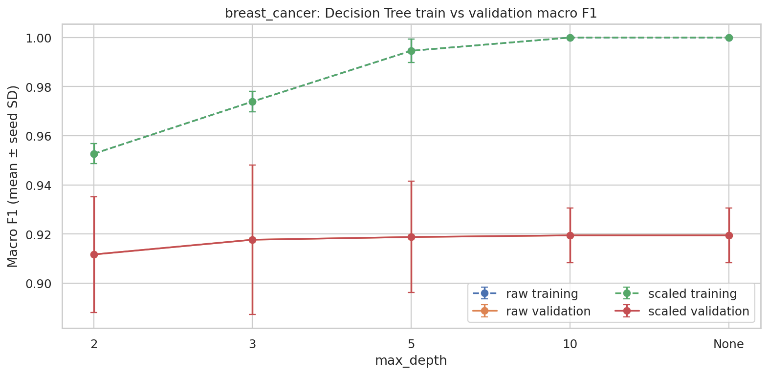
breast_cancer tree-depth mean training/validation macro F1 ± seed SD
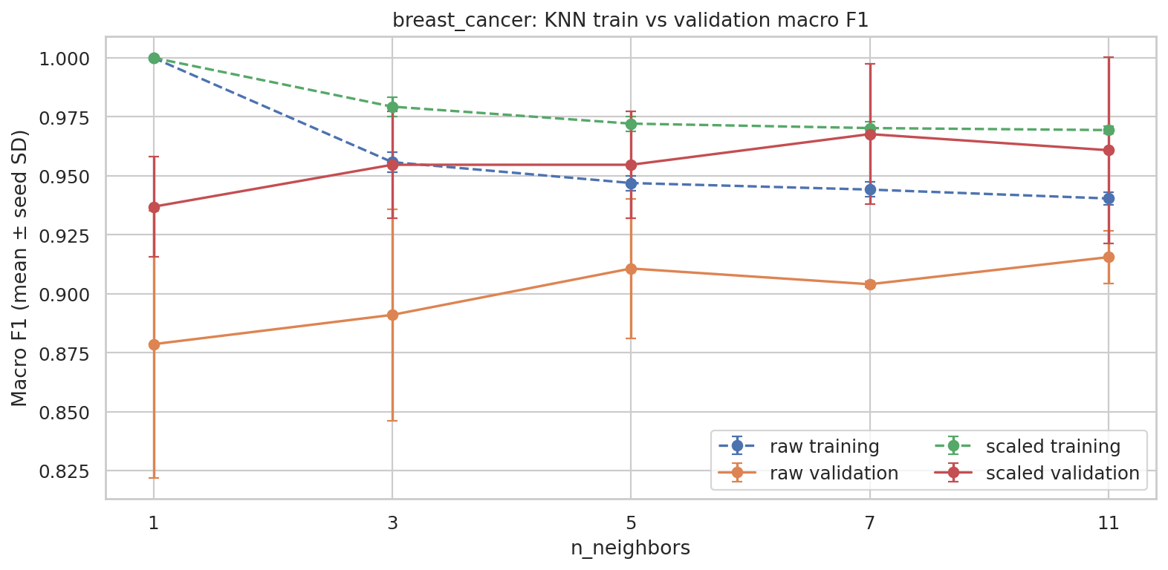
breast_cancer KNN-neighbor mean training/validation macro F1 ± seed SD
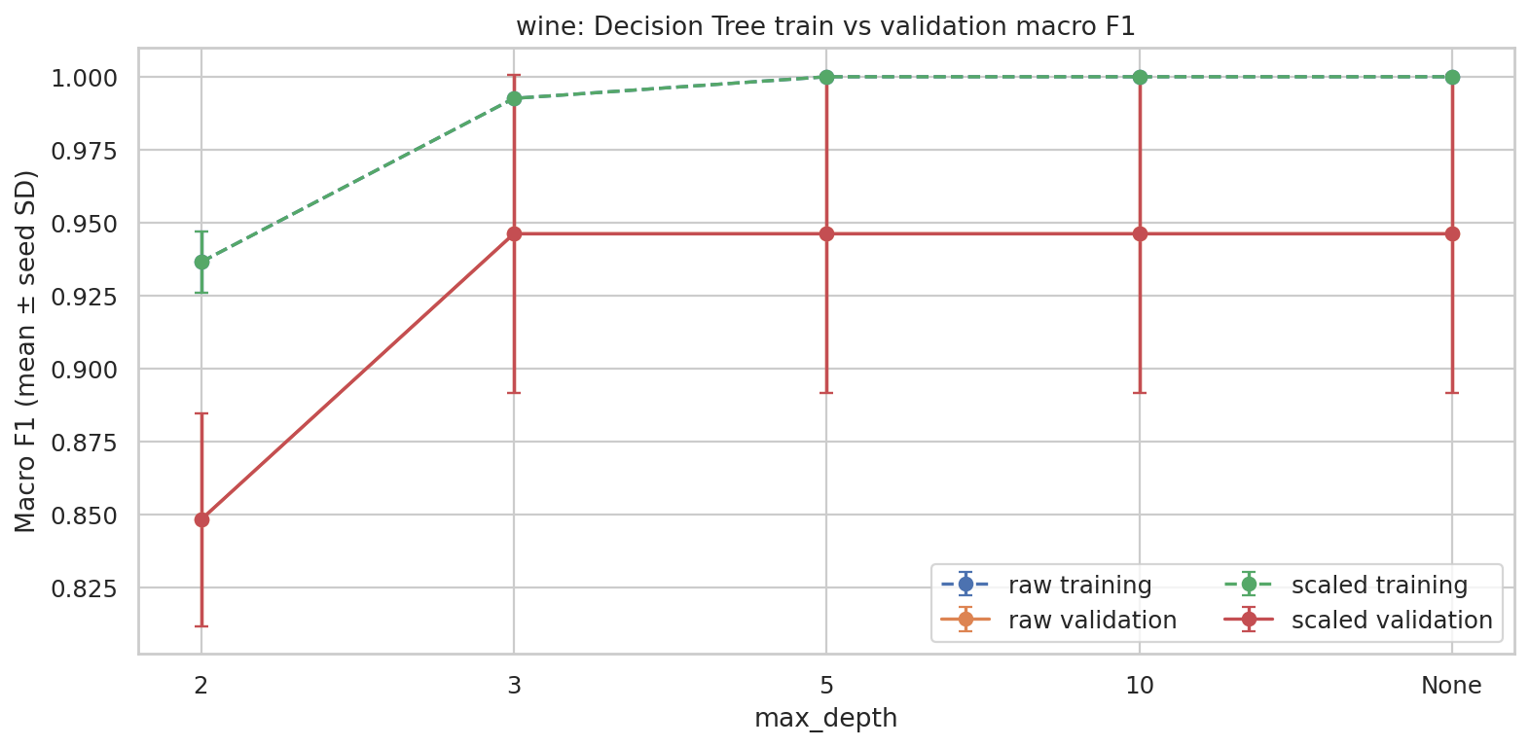
wine tree-depth mean training/validation macro F1 ± seed SD
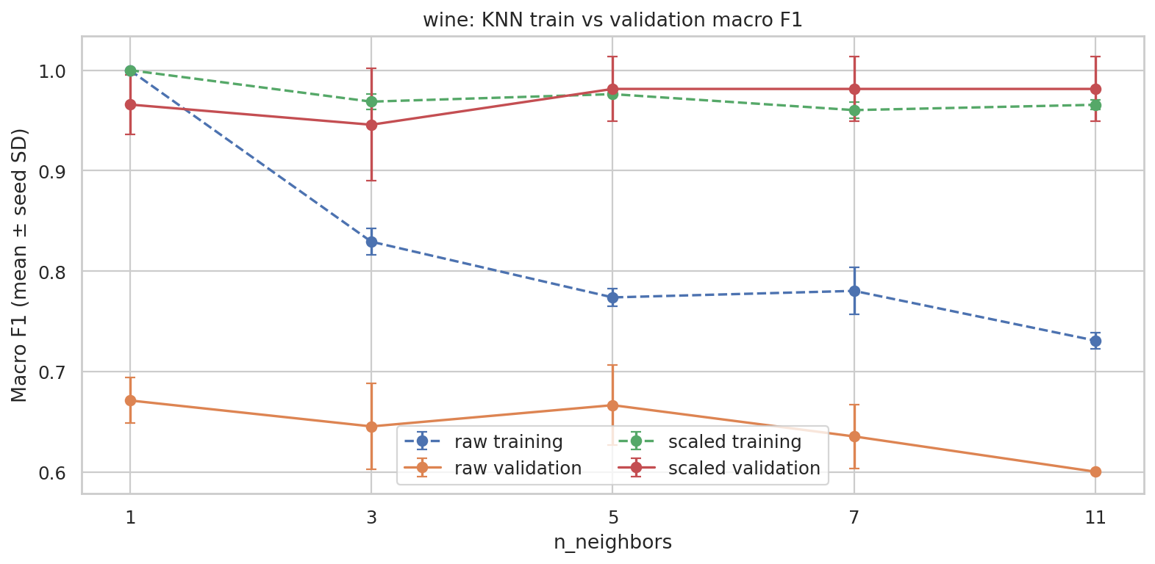
wine KNN-neighbor mean training/validation macro F1 ± seed SD
Interpretation: high training F1 with lower validation F1 suggests overfitting; error bars quantify across-seed variability.

11. Final Fixed-Test Classifier Evaluation
dataset | model | parameter | representation | accuracy | macro_precision | macro_recall | macro_f1 | roc_auc
breast_cancer | KNN | 7 | scaled | 0.974 | 0.980 | 0.964 | 0.971 | 0.989
wine | KNN | 5 | scaled | 0.972 | 0.970 | 0.976 | 0.972 | 0.999

Breast Cancer
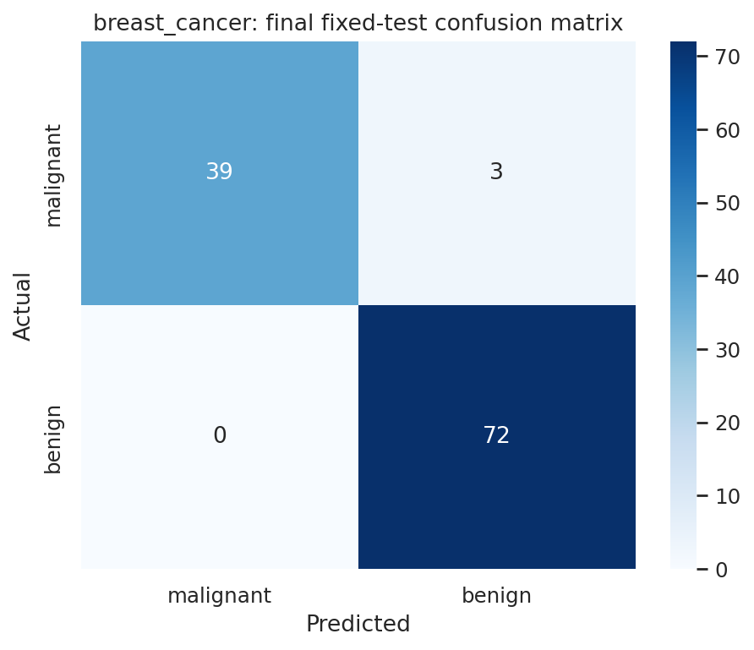
Actual rows / Predicted columns, original class order: breast_cancer
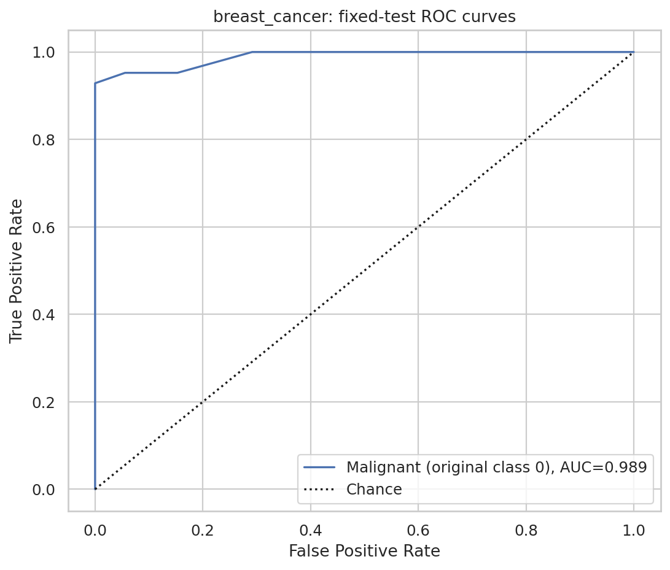
Probability-based ROC on fixed test data: breast_cancer
Manual class-0 one-vs-rest: TP=39, FP=0, FN=3; precision=1.0000, recall=0.9286, F1=0.9630. These equal class-0 precision/recall/F1 in the classification report (not macro averages).
With malignant as positive and class order [0,1], TP=cell(0,0)=39, FN=cell(0,1)=3, FP=cell(1,0)=0, TN=cell(1,1)=72. This is not the usual TN/FP/FN/TP layout.

Wine
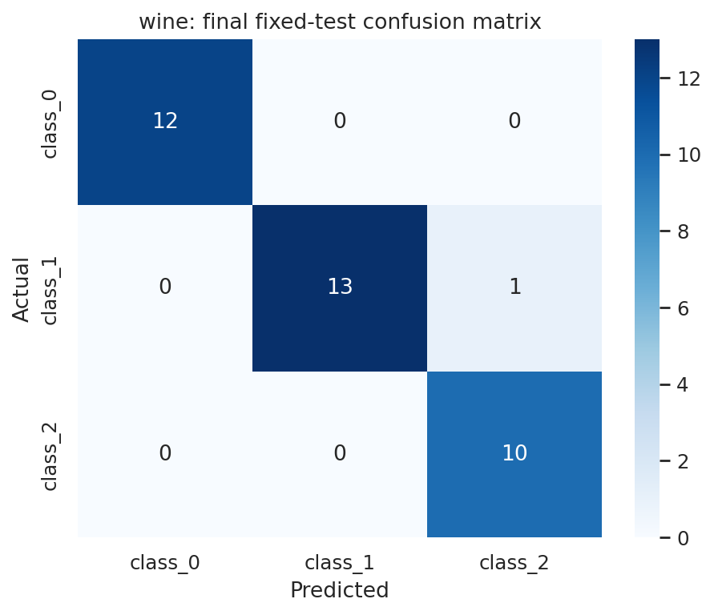
Actual rows / Predicted columns, original class order: wine
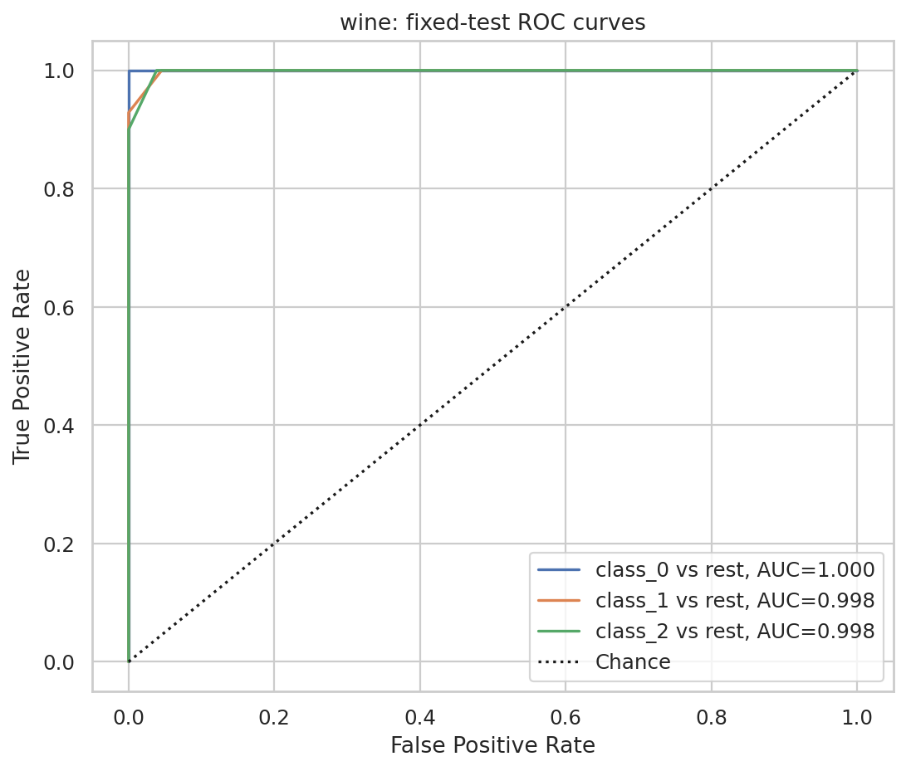
Probability-based ROC on fixed test data: wine
Manual class-0 one-vs-rest: TP=12, FP=0, FN=0; precision=1.0000, recall=1.0000, F1=1.0000. These equal class-0 precision/recall/F1 in the classification report (not macro averages).
Largest off-diagonal confusion: actual Wine class 1 predicted as class 2, 1 samples.

12. K-Means: Training and Validation Results
K-Means was fitted without y_train, with n_clusters=2 for Breast Cancer and n_clusters=3 for Wine, n_init=10, and random_state=seed. Six fits per dataset span both representations and all three seeds. Validation ARI compares predicted cluster partitions to true labels without assuming numeric cluster IDs match classes. Silhouette evaluates validation feature-space cohesion.
dataset | representation | train_inertia_mean | train_inertia_std | validation_ARI_mean | validation_ARI_std | validation_silhouette_mean | validation_silhouette_std | validation_silhouette_valid_n
breast_cancer | raw | 51270883.709 | 1949606.997 | 0.504 | 0.106 | 0.677 | 0.033 | 3
breast_cancer | scaled | 7948.109 | 47.574 | 0.581 | 0.142 | 0.312 | 0.055 | 3
wine | raw | 1348308.499 | 43580.910 | 0.361 | 0.068 | 0.577 | 0.101 | 3
wine | scaled | 879.140 | 9.861 | 1.000 | 0.000 | 0.275 | 0.025 | 3

Interpretation: raw and standardized inertia are measured in different units and must not be directly compared.

13. K-Means Class-versus-Cluster Figures and Fixed-Test Evidence
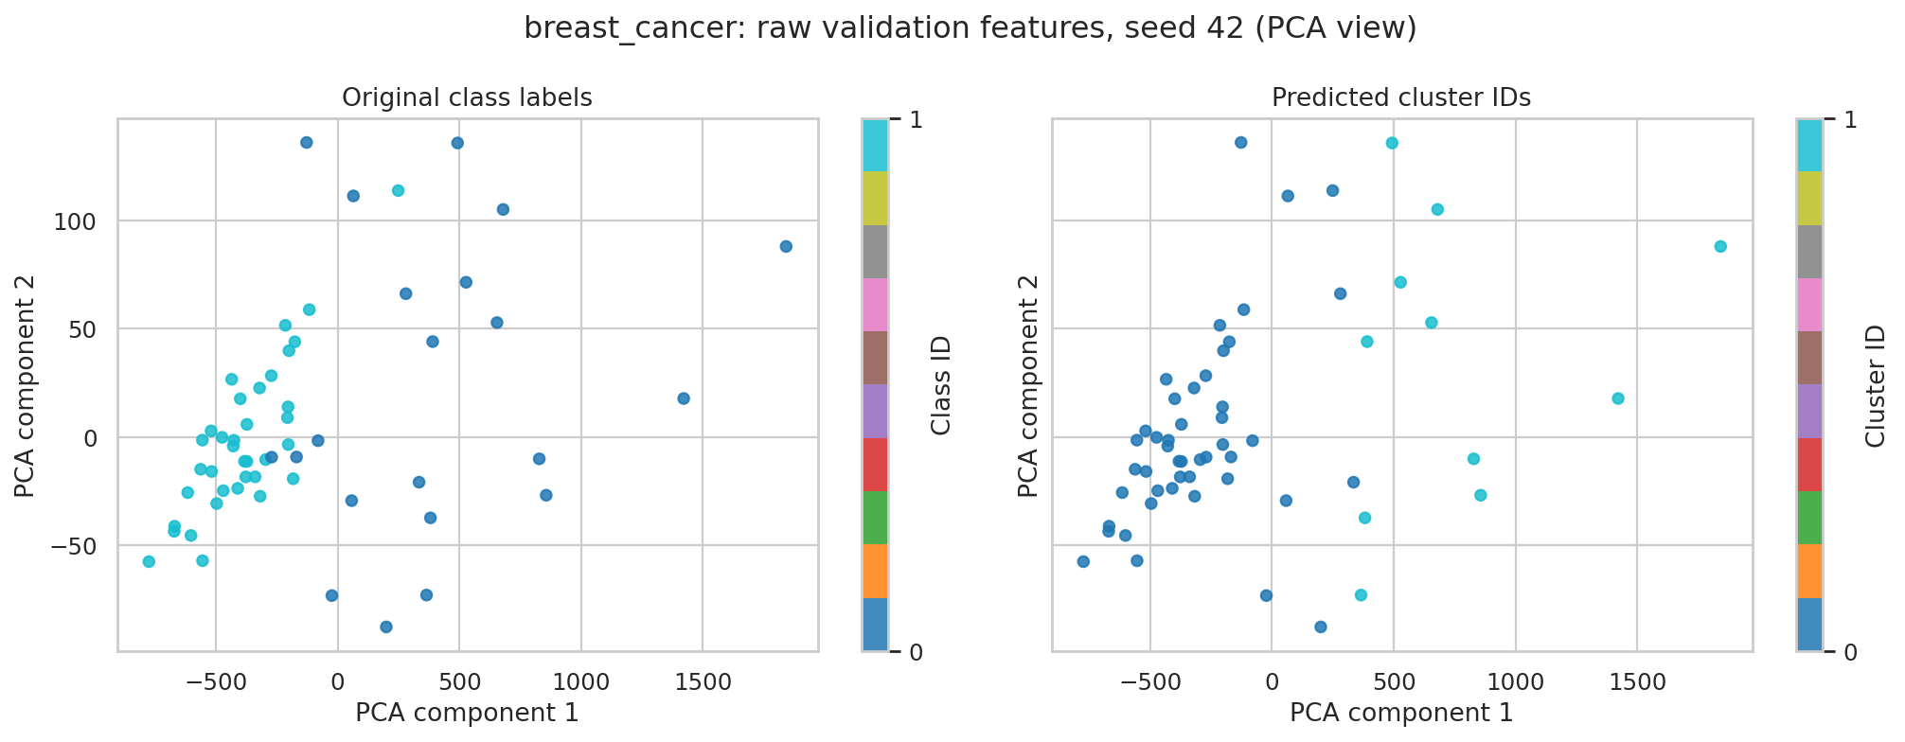
breast_cancer raw: validation true classes vs predicted clusters (PCA view)
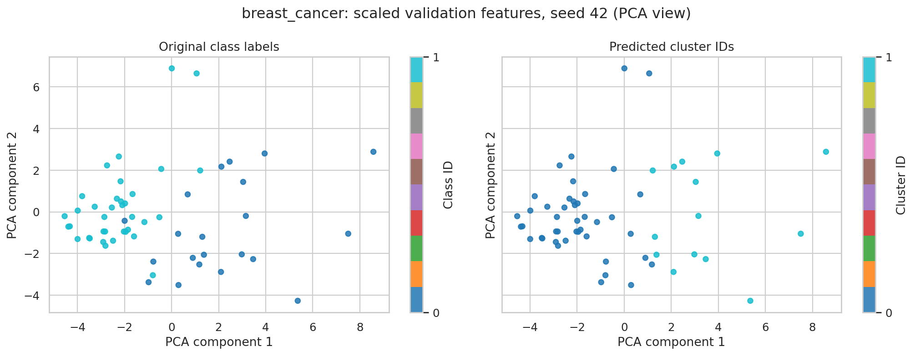
breast_cancer scaled: validation true classes vs predicted clusters (PCA view)
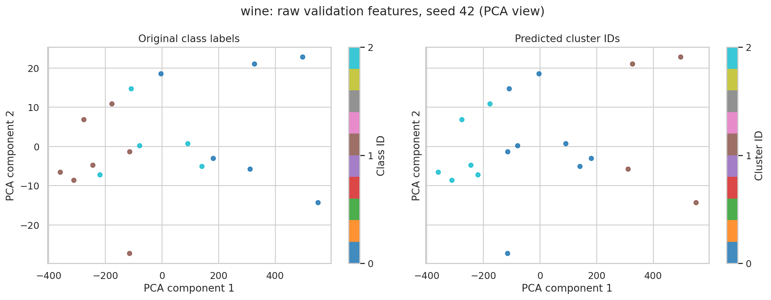
wine raw: validation true classes vs predicted clusters (PCA view)
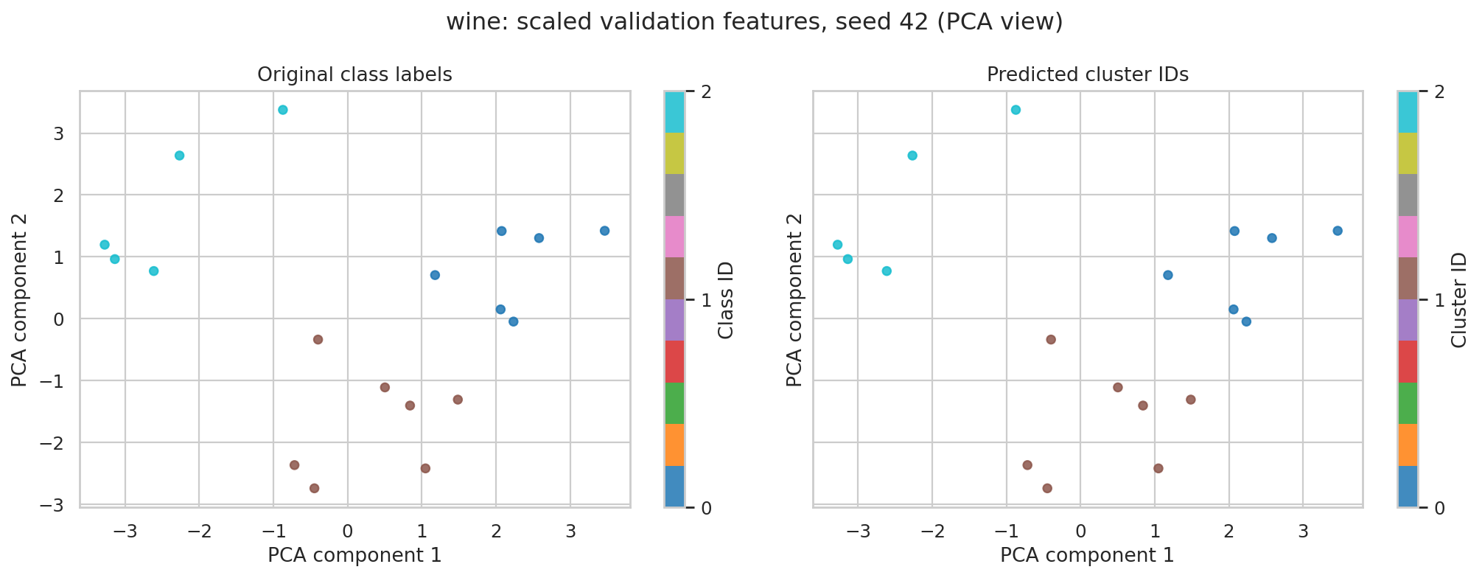
wine scaled: validation true classes vs predicted clusters (PCA view)
dataset | representation | test_cluster_counts | test_ARI | test_silhouette
breast_cancer | raw | 0:86;1:28 | 0.558 | 0.712
breast_cancer | scaled | 0:74;1:40 | 0.735 | 0.325
wine | raw | 0:14;1:10;2:12 | 0.373 | 0.493
wine | scaled | 0:13;1:13;2:10 | 0.909 | 0.271

Interpretation: cluster colors and IDs are arbitrary. Seed-42 test cluster counts, ARI and silhouette are reported separately from validation scores.

14. Cross-Dataset Conclusions and Reproducibility
breast_cancer: selected scaled KNN parameter=7; seed-42 fixed-test accuracy 0.974, macro F1 0.971, AUC 0.989.
wine: selected scaled KNN parameter=5; seed-42 fixed-test accuracy 0.972, macro F1 0.972, AUC 0.999.
The datasets differ in class count, dimensionality, scale and class frequencies, so absolute scores should be interpreted in their own context. Standardization is important to evaluate for distance-based KNN/K-Means; tree classifiers are less sensitive to monotonic feature rescaling. K-Means is an unsupervised comparison rather than a supervised accuracy substitute. Test scores were obtained only after validation-based selection.
Full raw run tables and source code remain in notebooks and six combined CSV files. All figures were generated from Python and saved in figures/. Repository URL must be supplied before GitHub submission. AI use is disclosed in AI_DISCLOSURE.md.

Appendix A. Complete Feature Descriptive Statistics

Breast Cancer
Feature | mean | median | min | max | std | Q1 | Q3
mean radius | 14.127 | 13.370 | 6.981 | 28.110 | 3.524 | 11.700 | 15.780
mean texture | 19.290 | 18.840 | 9.710 | 39.280 | 4.301 | 16.170 | 21.800
mean perimeter | 91.969 | 86.240 | 43.790 | 188.500 | 24.299 | 75.170 | 104.100
mean area | 654.889 | 551.100 | 143.500 | 2501.000 | 351.914 | 420.300 | 782.700
mean smoothness | 0.096 | 0.096 | 0.053 | 0.163 | 0.014 | 0.086 | 0.105
mean compactness | 0.104 | 0.093 | 0.019 | 0.345 | 0.053 | 0.065 | 0.130
mean concavity | 0.089 | 0.062 | 0.000 | 0.427 | 0.080 | 0.030 | 0.131
mean concave points | 0.049 | 0.034 | 0.000 | 0.201 | 0.039 | 0.020 | 0.074
mean symmetry | 0.181 | 0.179 | 0.106 | 0.304 | 0.027 | 0.162 | 0.196
mean fractal dimension | 0.063 | 0.062 | 0.050 | 0.097 | 0.007 | 0.058 | 0.066
radius error | 0.405 | 0.324 | 0.112 | 2.873 | 0.277 | 0.232 | 0.479
texture error | 1.217 | 1.108 | 0.360 | 4.885 | 0.552 | 0.834 | 1.474
perimeter error | 2.866 | 2.287 | 0.757 | 21.980 | 2.022 | 1.606 | 3.357
area error | 40.337 | 24.530 | 6.802 | 542.200 | 45.491 | 17.850 | 45.190
smoothness error | 0.007 | 0.006 | 0.002 | 0.031 | 0.003 | 0.005 | 0.008
compactness error | 0.025 | 0.020 | 0.002 | 0.135 | 0.018 | 0.013 | 0.032
concavity error | 0.032 | 0.026 | 0.000 | 0.396 | 0.030 | 0.015 | 0.042
concave points error | 0.012 | 0.011 | 0.000 | 0.053 | 0.006 | 0.008 | 0.015
symmetry error | 0.021 | 0.019 | 0.008 | 0.079 | 0.008 | 0.015 | 0.023
fractal dimension error | 0.004 | 0.003 | 0.001 | 0.030 | 0.003 | 0.002 | 0.005
worst radius | 16.269 | 14.970 | 7.930 | 36.040 | 4.833 | 13.010 | 18.790
worst texture | 25.677 | 25.410 | 12.020 | 49.540 | 6.146 | 21.080 | 29.720
worst perimeter | 107.261 | 97.660 | 50.410 | 251.200 | 33.603 | 84.110 | 125.400
worst area | 880.583 | 686.500 | 185.200 | 4254.000 | 569.357 | 515.300 | 1084.000
worst smoothness | 0.132 | 0.131 | 0.071 | 0.223 | 0.023 | 0.117 | 0.146
worst compactness | 0.254 | 0.212 | 0.027 | 1.058 | 0.157 | 0.147 | 0.339
worst concavity | 0.272 | 0.227 | 0.000 | 1.252 | 0.209 | 0.115 | 0.383
worst concave points | 0.115 | 0.100 | 0.000 | 0.291 | 0.066 | 0.065 | 0.161
worst symmetry | 0.290 | 0.282 | 0.157 | 0.664 | 0.062 | 0.250 | 0.318
worst fractal dimension | 0.084 | 0.080 | 0.055 | 0.207 | 0.018 | 0.071 | 0.092

Wine
Feature | mean | median | min | max | std | Q1 | Q3
alcohol | 13.001 | 13.050 | 11.030 | 14.830 | 0.812 | 12.363 | 13.678
malic_acid | 2.336 | 1.865 | 0.740 | 5.800 | 1.117 | 1.603 | 3.083
ash | 2.367 | 2.360 | 1.360 | 3.230 | 0.274 | 2.210 | 2.558
alcalinity_of_ash | 19.495 | 19.500 | 10.600 | 30.000 | 3.340 | 17.200 | 21.500
magnesium | 99.742 | 98.000 | 70.000 | 162.000 | 14.282 | 88.000 | 107.000
total_phenols | 2.295 | 2.355 | 0.980 | 3.880 | 0.626 | 1.742 | 2.800
flavanoids | 2.029 | 2.135 | 0.340 | 5.080 | 0.999 | 1.205 | 2.875
nonflavanoid_phenols | 0.362 | 0.340 | 0.130 | 0.660 | 0.124 | 0.270 | 0.438
proanthocyanins | 1.591 | 1.555 | 0.410 | 3.580 | 0.572 | 1.250 | 1.950
color_intensity | 5.058 | 4.690 | 1.280 | 13.000 | 2.318 | 3.220 | 6.200
hue | 0.957 | 0.965 | 0.480 | 1.710 | 0.229 | 0.782 | 1.120
od280/od315_of_diluted_wines | 2.612 | 2.780 | 1.270 | 4.000 | 0.710 | 1.938 | 3.170
proline | 746.893 | 673.500 | 278.000 | 1680.000 | 314.907 | 500.500 | 985.000

Appendix B. References
https://scikit-learn.org/stable/modules/generated/sklearn.datasets.load_breast_cancer.html
https://scikit-learn.org/stable/modules/generated/sklearn.datasets.load_wine.html
https://scikit-learn.org/stable/common_pitfalls.html
https://scikit-learn.org/stable/modules/generated/sklearn.metrics.roc_auc_score.html
https://scikit-learn.org/stable/modules/generated/sklearn.metrics.adjusted_rand_score.html
https://scikit-learn.org/stable/modules/generated/sklearn.metrics.silhouette_score.html
https://scikit-learn.org/stable/modules/generated/sklearn.cluster.KMeans.html

