OUTPUT :

**# This is the main Default page, which will be visible on Opening the web-page….**

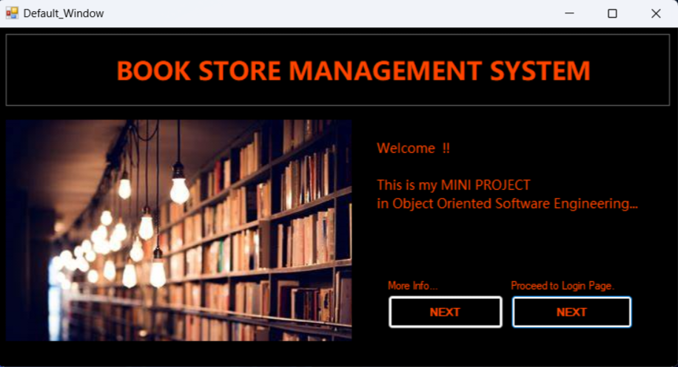



**# On clicking the NEXT Button…**

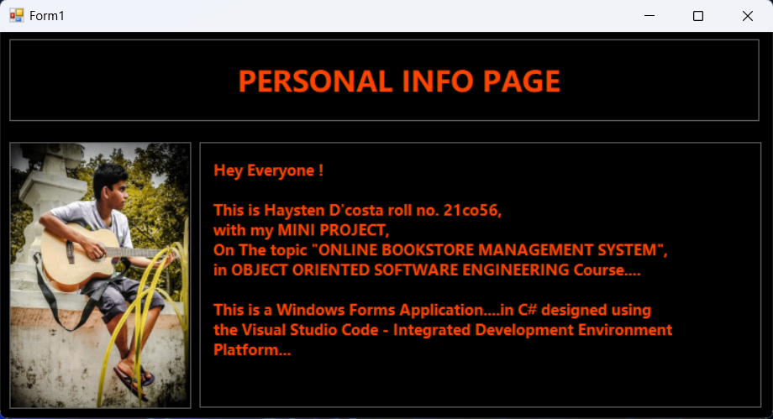

**# On clicking the Proceed to Login Page NEXT button, we will be directed to the page below…**

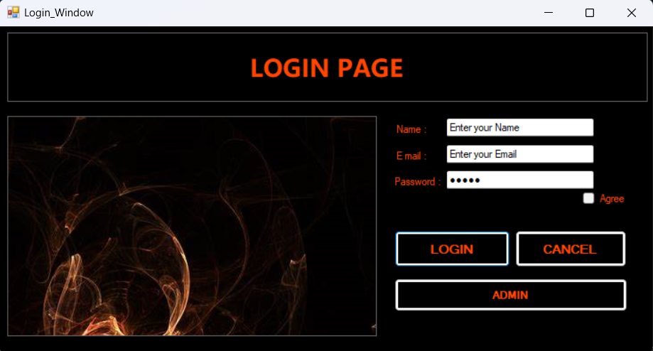

**# Filling the entries…**

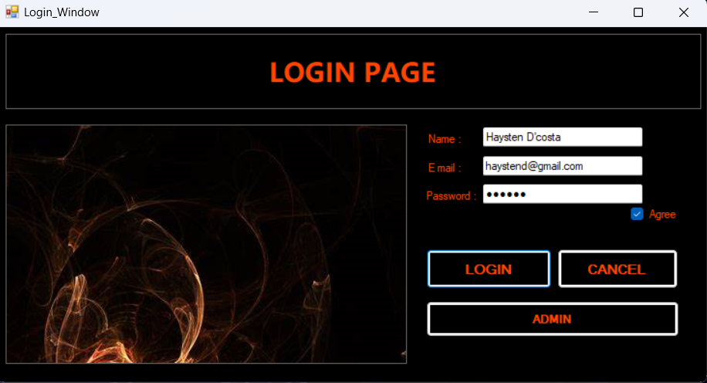

**# After Filling the details and hitting the ‘LOGIN’ button, The details entered are saved to a ‘UserInformation’ table which is contained in a “UserInfo” – DATABASE….**

**(-i.e- Everytime a certain user logs in, the details are saved to this DataBase! )…**

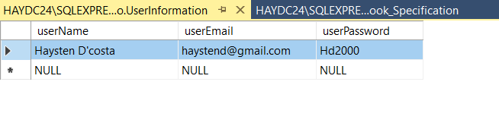

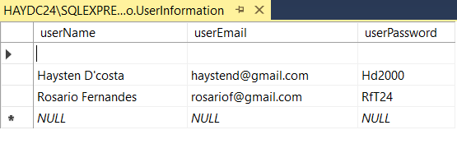

**# This BookStore Management System also uses a DataBase named the “Book_Specifications”, that contains a table –“Books”, to store all the books the Store Contains….**

**Created this Database Manually First…**

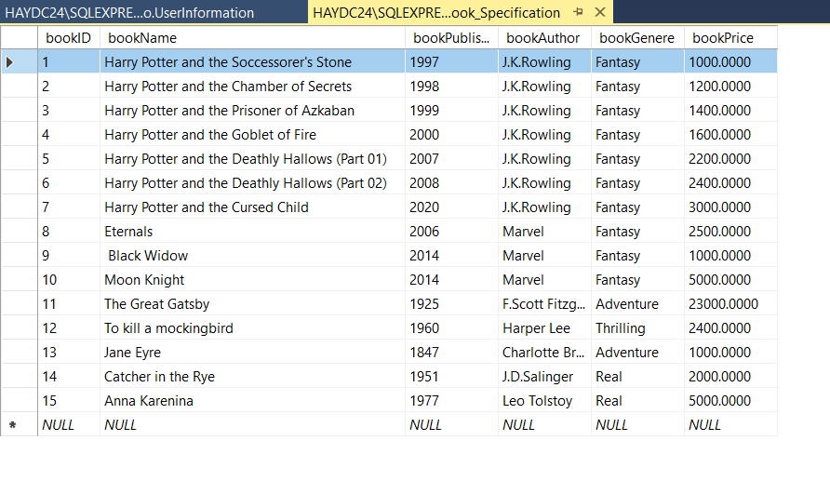

**#** **After successful login, We are taken to the Main page, where we have controls like**

**Books, Category, Cart, Help, and Log Out….**

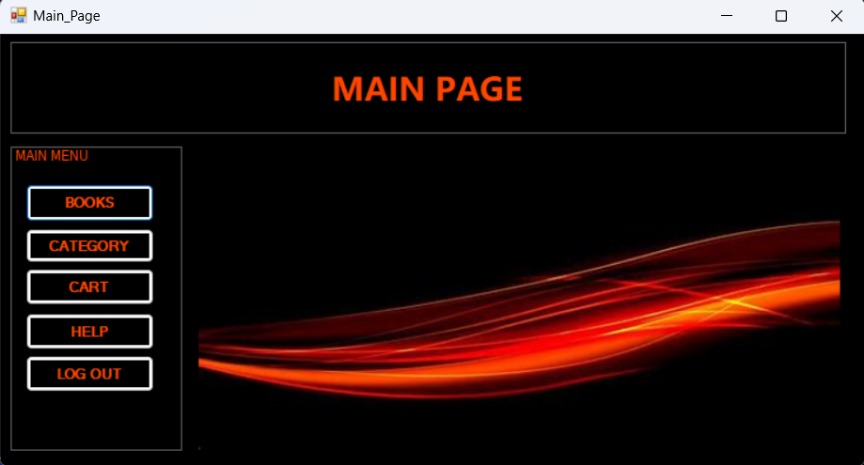

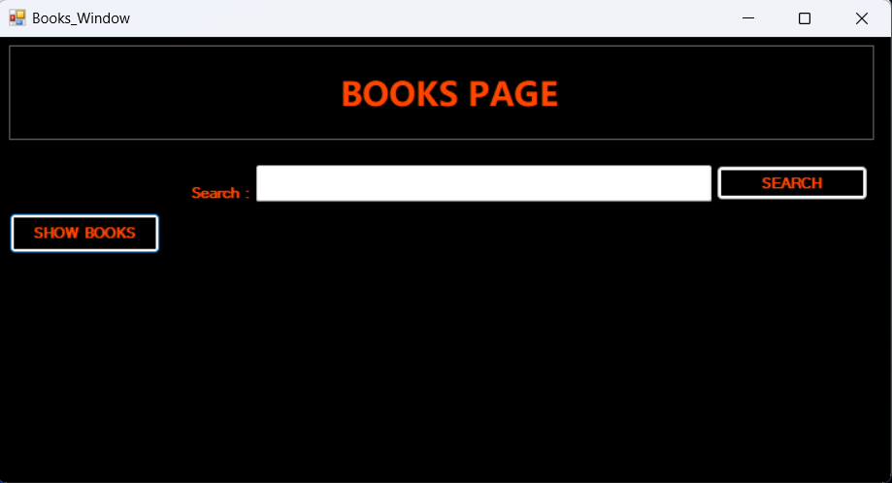

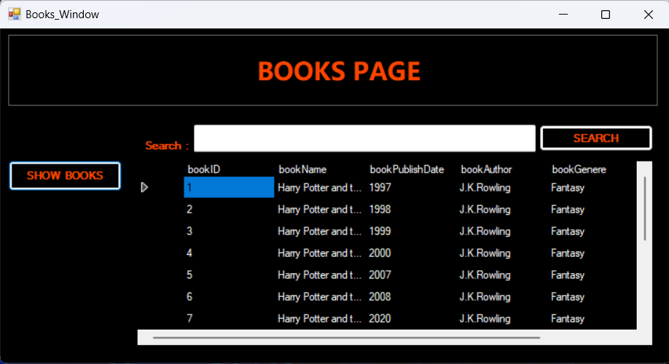

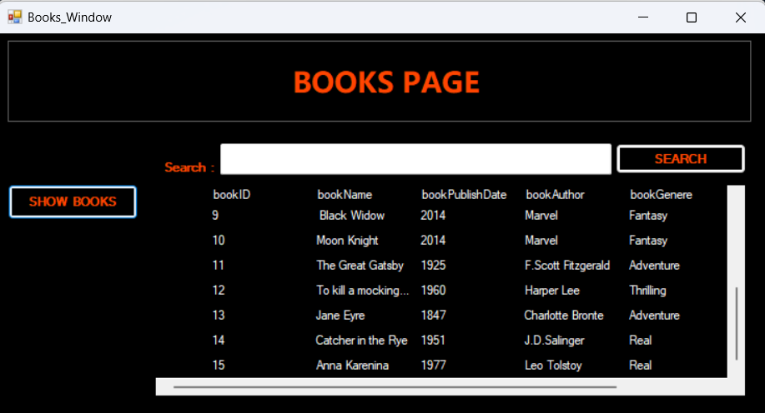

**# Searching for word “Moon”, will show one the entry with ‘moon’ in it…**

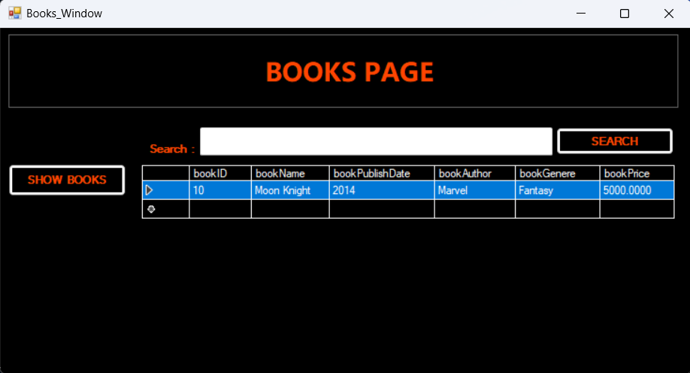

Moon

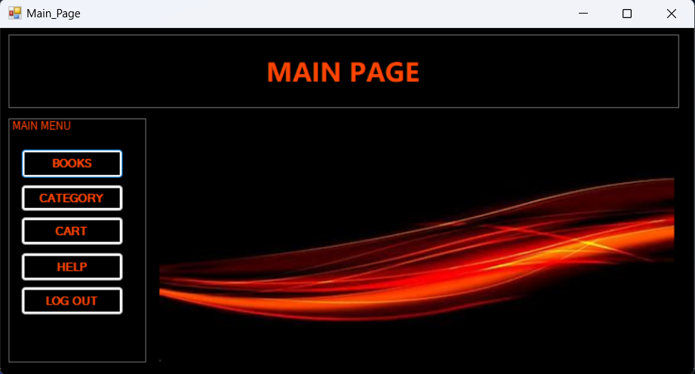

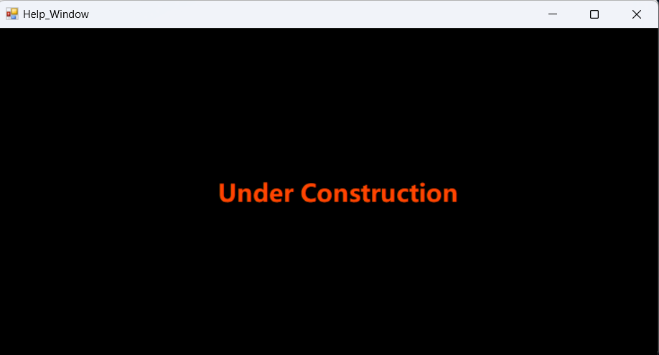**# Some Windows like the Help, Categories, Cart, are under construction (Not developed yet)…**

**# If user is an Admin, then instead of logging in, can go to Admin Page…**

**Books are shown when “SHOW RECORDs” button are clicked…**

**This Admin page enables the admin to Edit -i.e- ‘MODIFY’, the book entries…It has similar ‘Search’ facilities….**

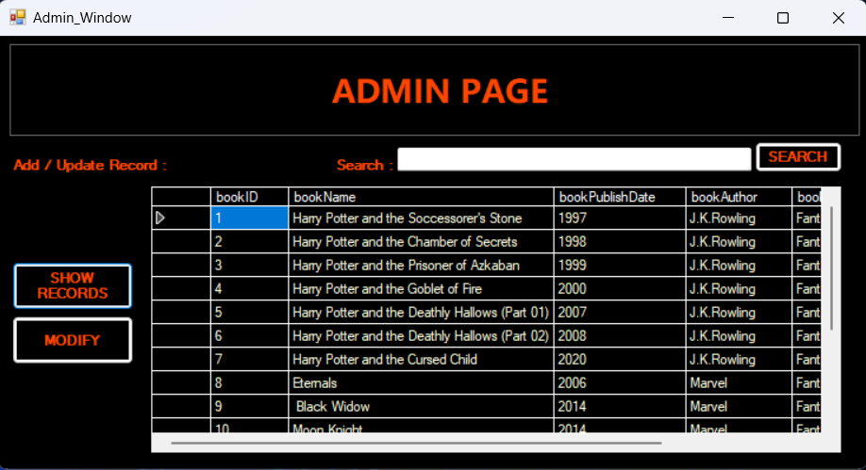

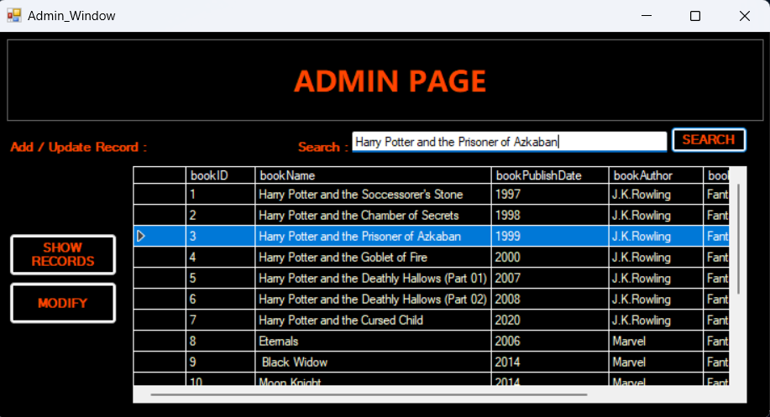

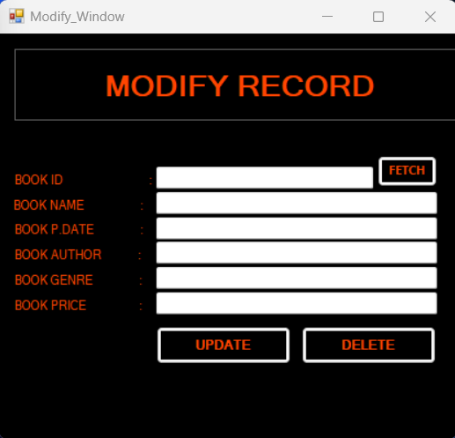

**# If any data is to be modified, the admin hits MODIFY button, which will open a modify pop-up, where modifications can be done like :**

* **Update,**
* **Delete,**
* **Add…**

**For these operations, the “BookID” is an essential Entry !! Operations performed as follows…**

**# UPDATE ENTRY OPERATION :**

* **Done by specifying the Book ID which is to be edited, and new entries are entered….**
* **Only entries to be updated can be entered…**
* **Click UPDATE…and REFRESH…**

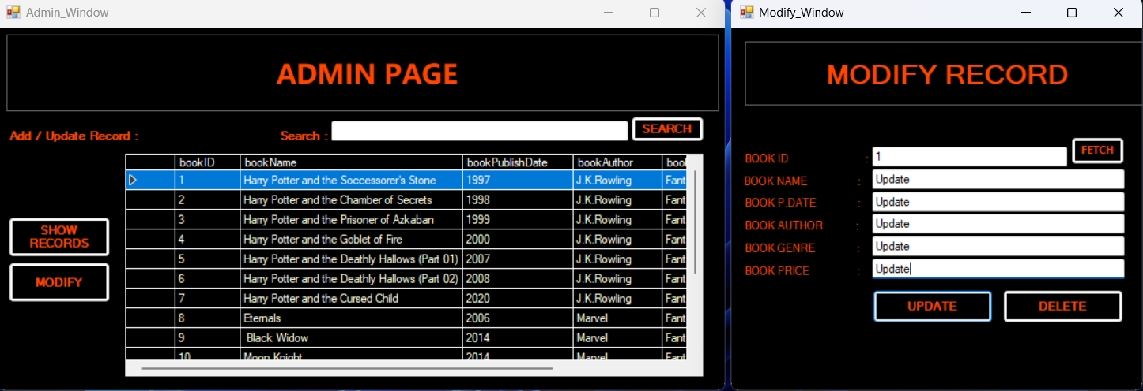

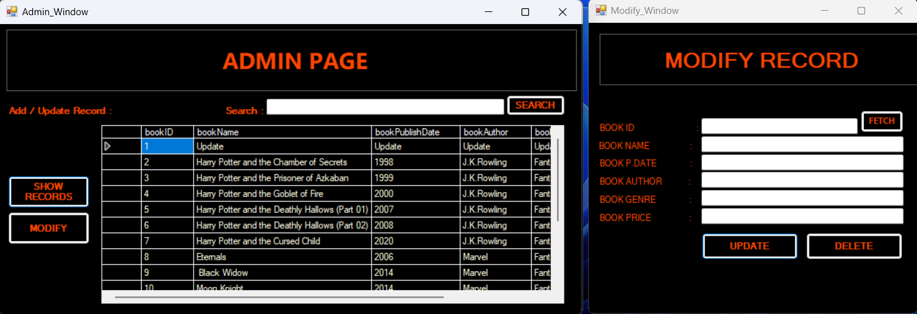

**# Example 2 : Here, the book with ID 8 will be updated to the specified entries…**

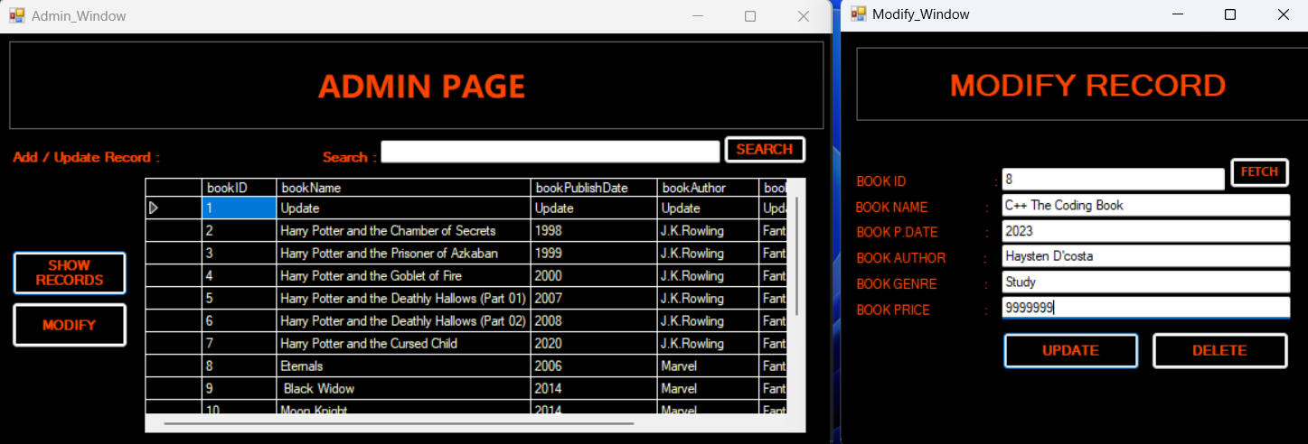

**# SEARCH ENTRY OPERATION :**

* **Done by specifying the BookID/BookName/etc.., which is to be searched ….**
* **Click SEARCH after entering entry in Search Bar, and REFRESH…**

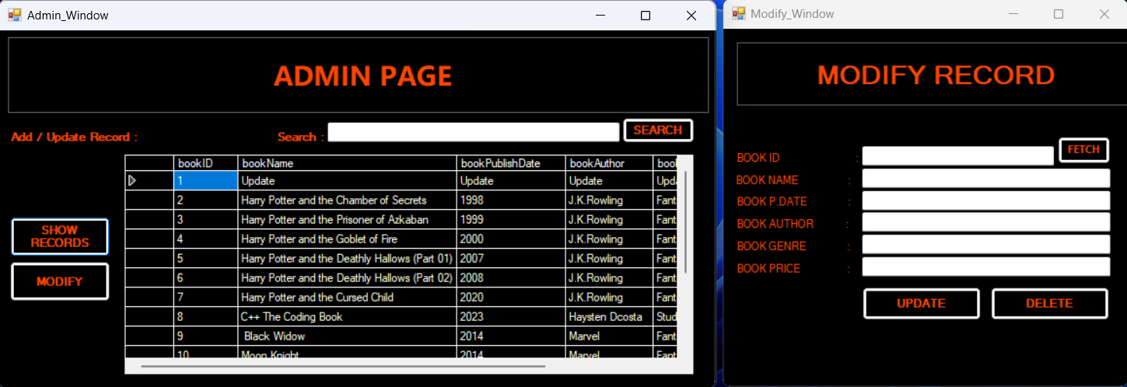

Here, since ‘Harry’ is specified, all Entries with ‘Harry’ are displayed…

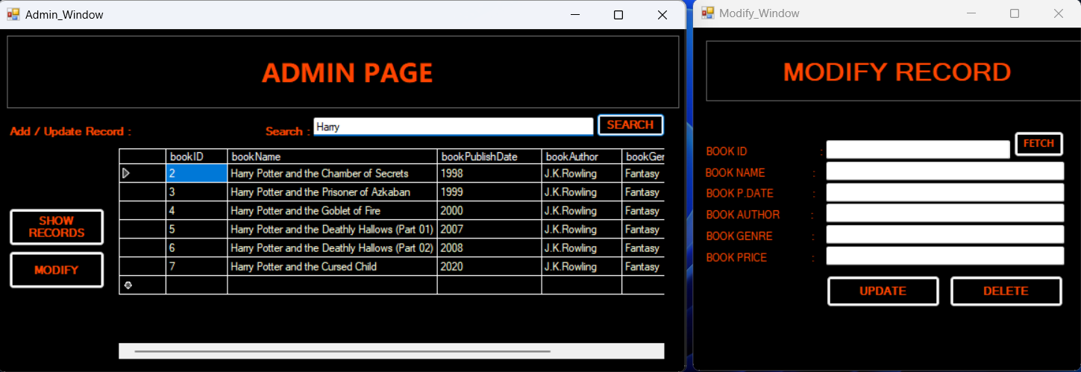

**# DELETE ENTRY OPERATION :**

* **Done by specifying the BookIDof book which is to be deleted ….**
* **Click DELETE after entering entry in bookID bar, and REFRESH…**

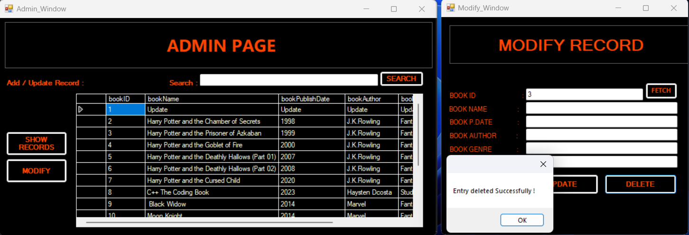

**# After Deletion of entries (Entry 3 is deleted)…**

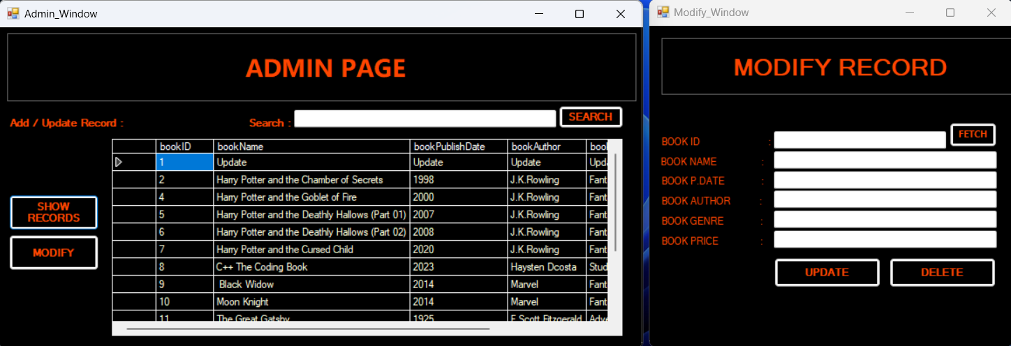

**# INSERT NEW ENTRY OPERATION :**

* **Done by specifying the BookID and other details of book which is to be inserted ….**
* **Click ‘INSERT RECORD’ after entering details, and REFRESH…**

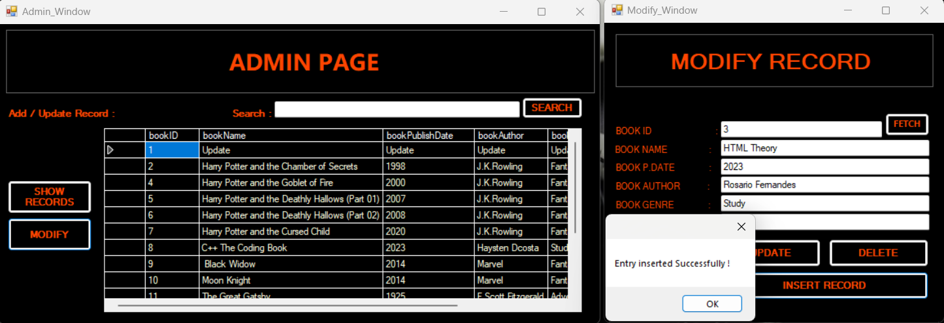

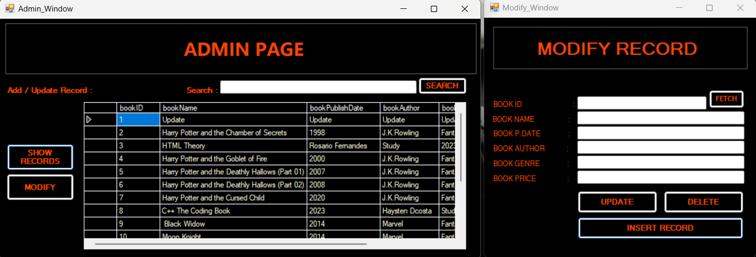

**# On hitting the “LOG-OUT button, The Exit page is displayed….”**

