**HOME PAGE:**

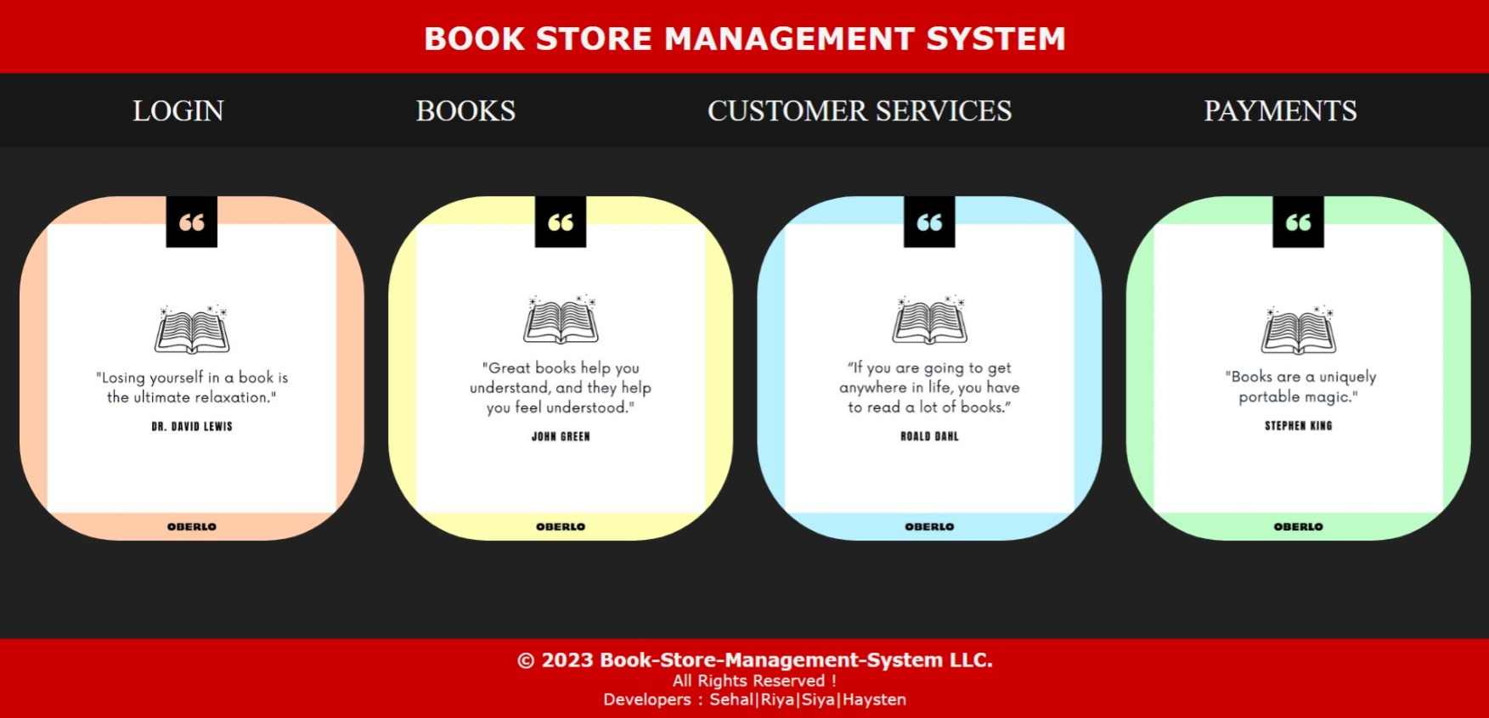

**LOGIN PAGE:** 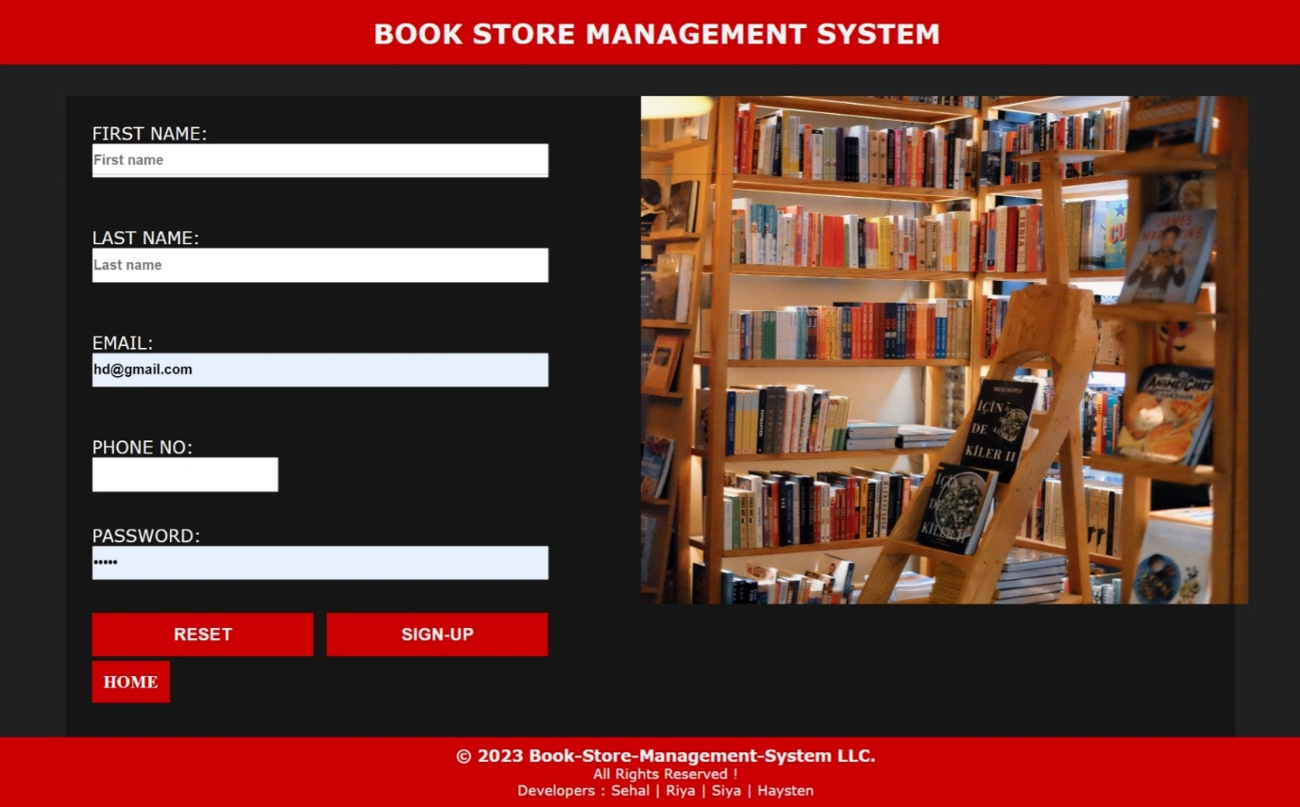

**After logging in successfully….**



**BOOKS PAGE:**

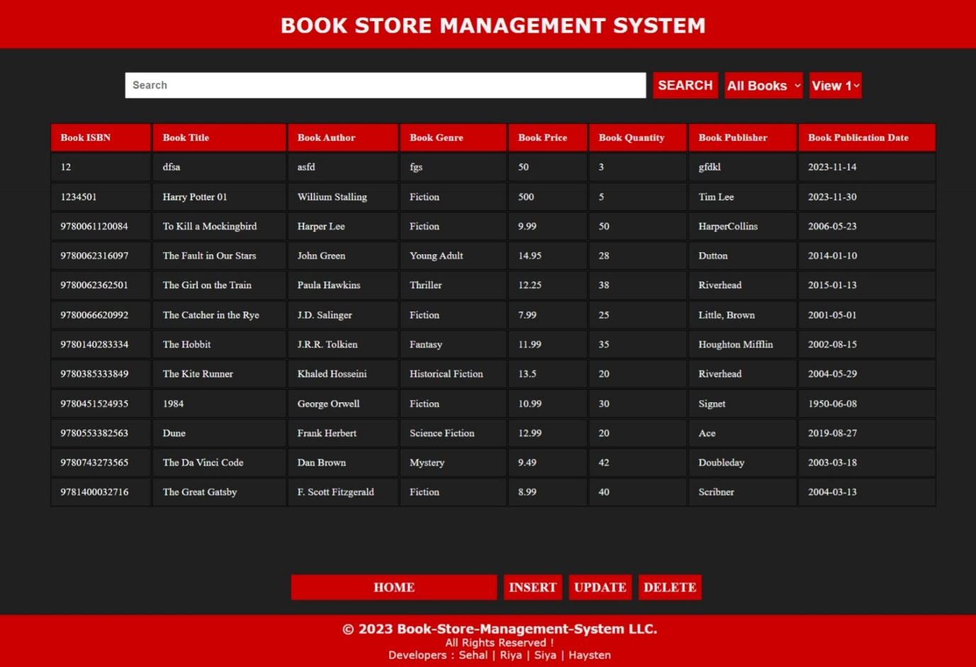

**INSERT BOOK DETAILS :**

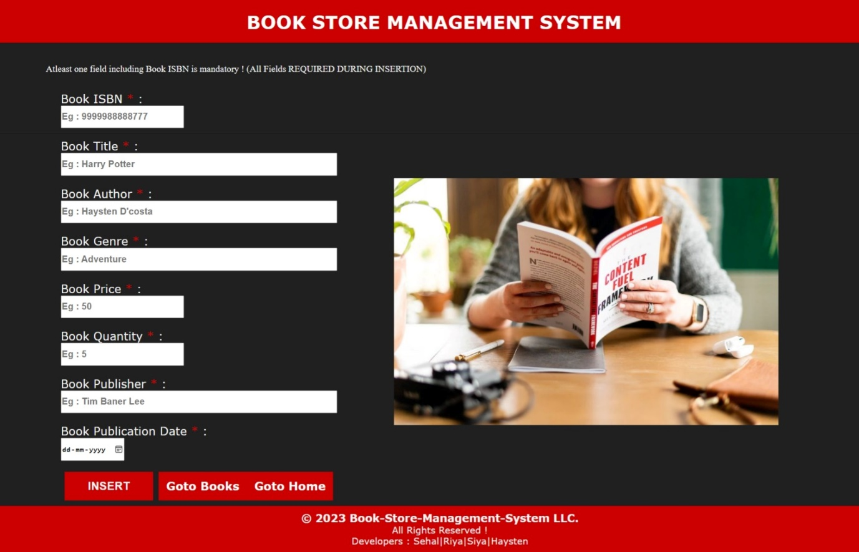

**After inserting book successfully…..**

**UPDATE BOOK DETAILS:**

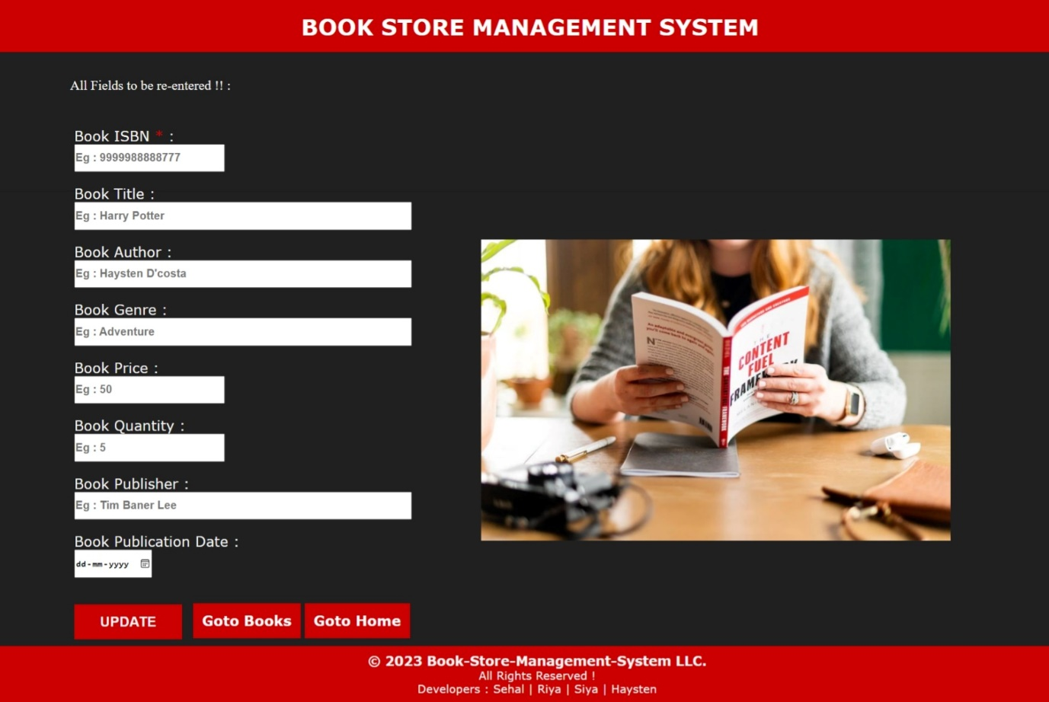

**After updating book details successfully….**



**DELETE BOOK:**

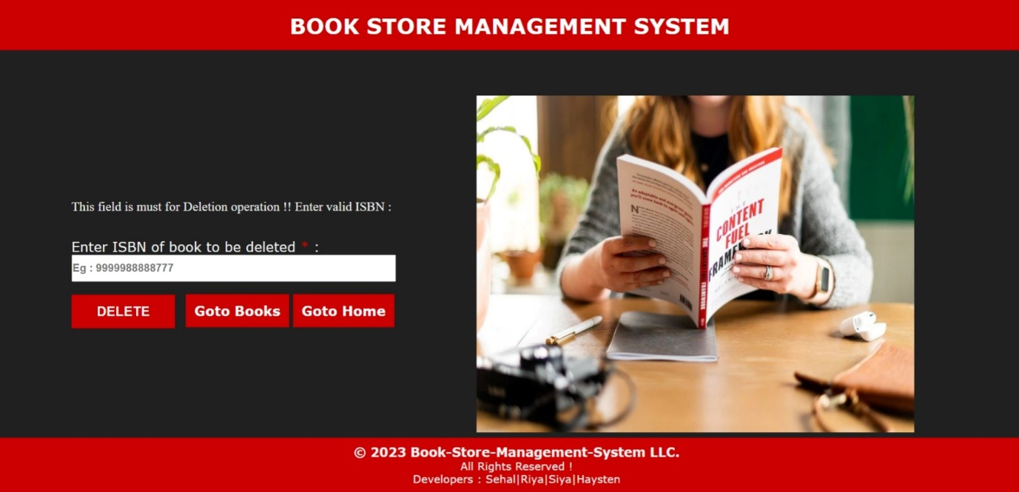

**After Deleting book successfully….**



**CUSTOMER PAGE:**

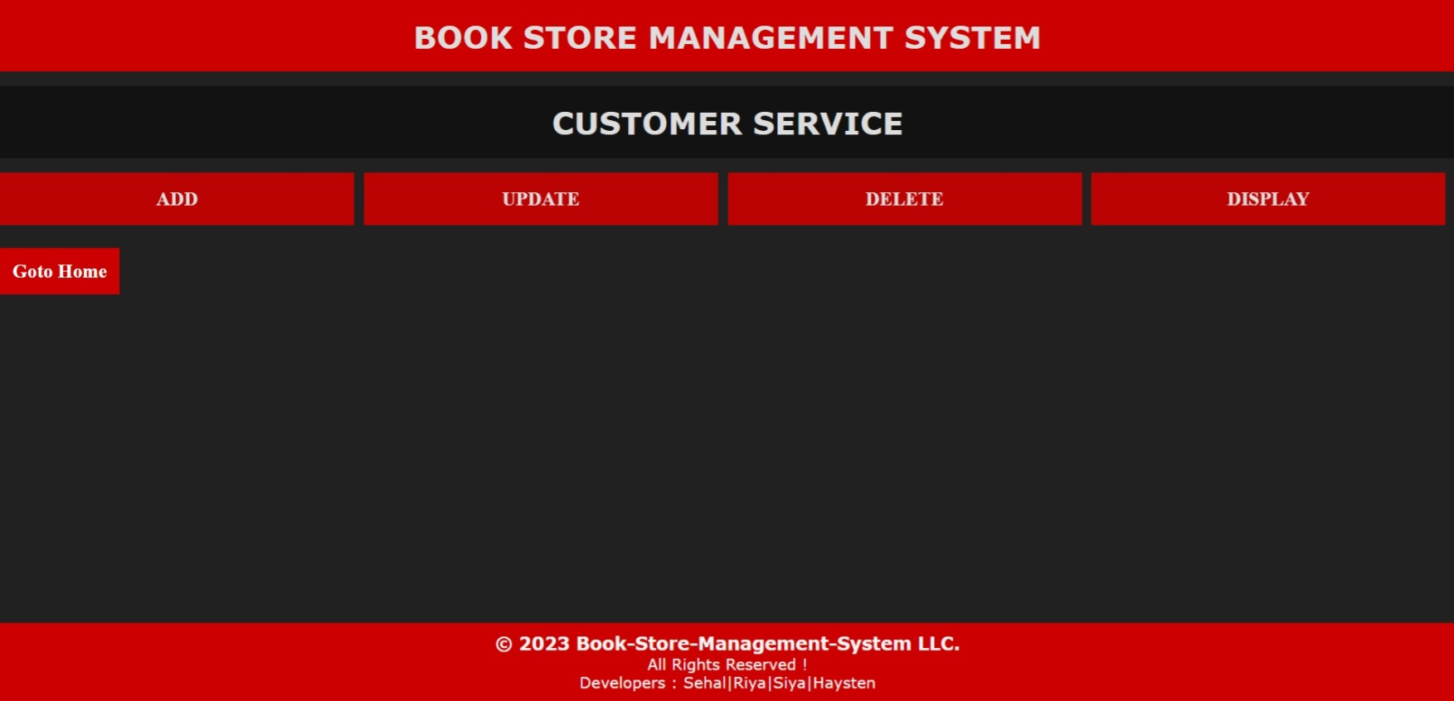

**ADD CUSTOMER:**

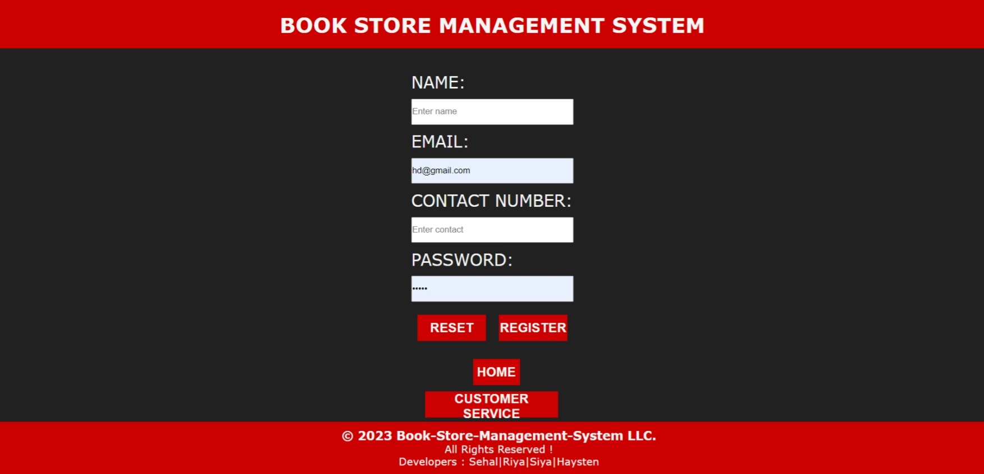

**After successfully adding a customer…**



**UPDATE CUSTOMER DETAILS:**

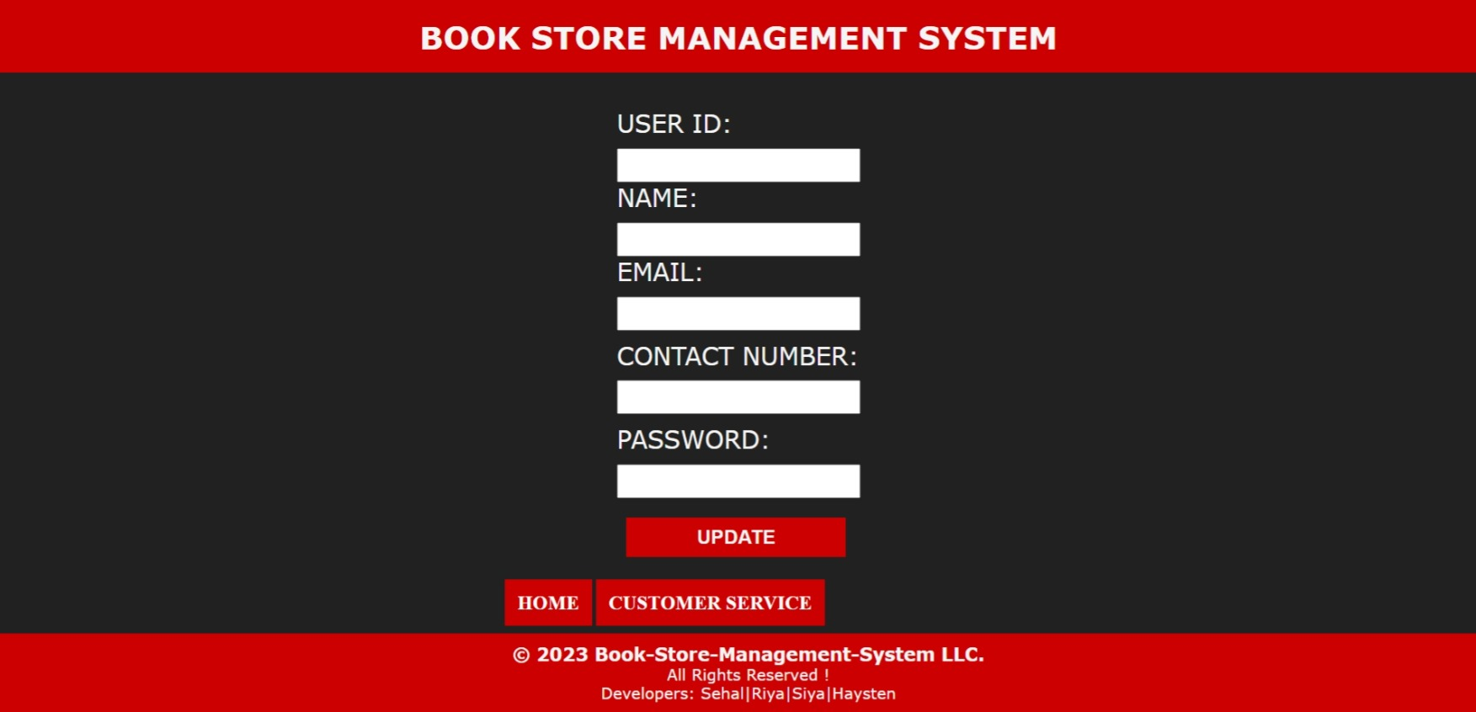

**After successfully updating customer details…..**



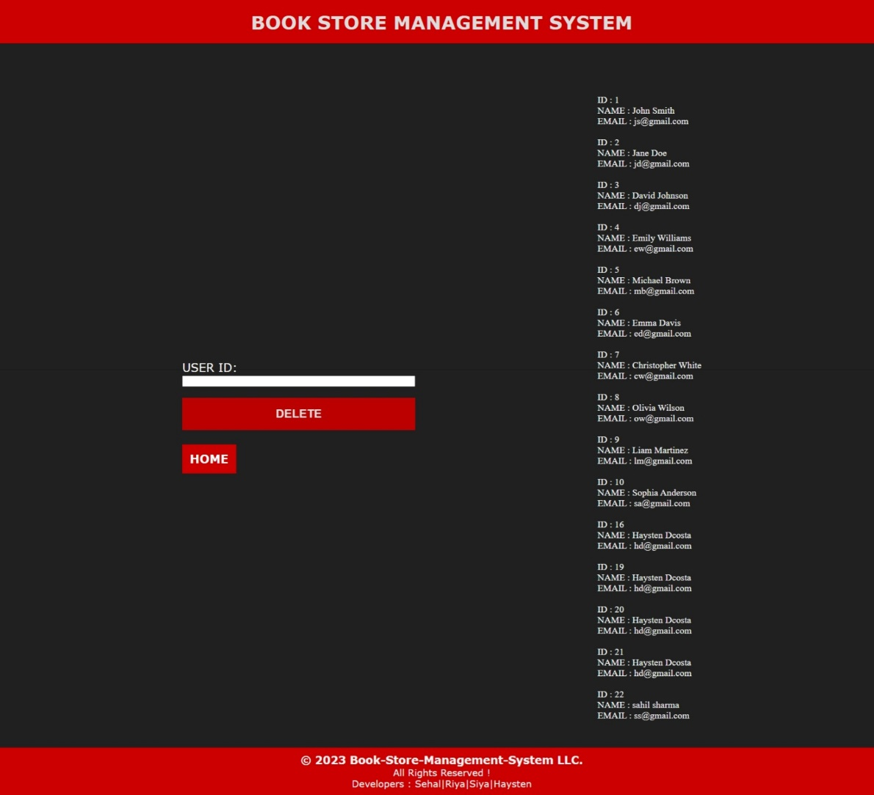**DELETE CUSTOMER:**

**DISPLAY CUSTOMERS:**

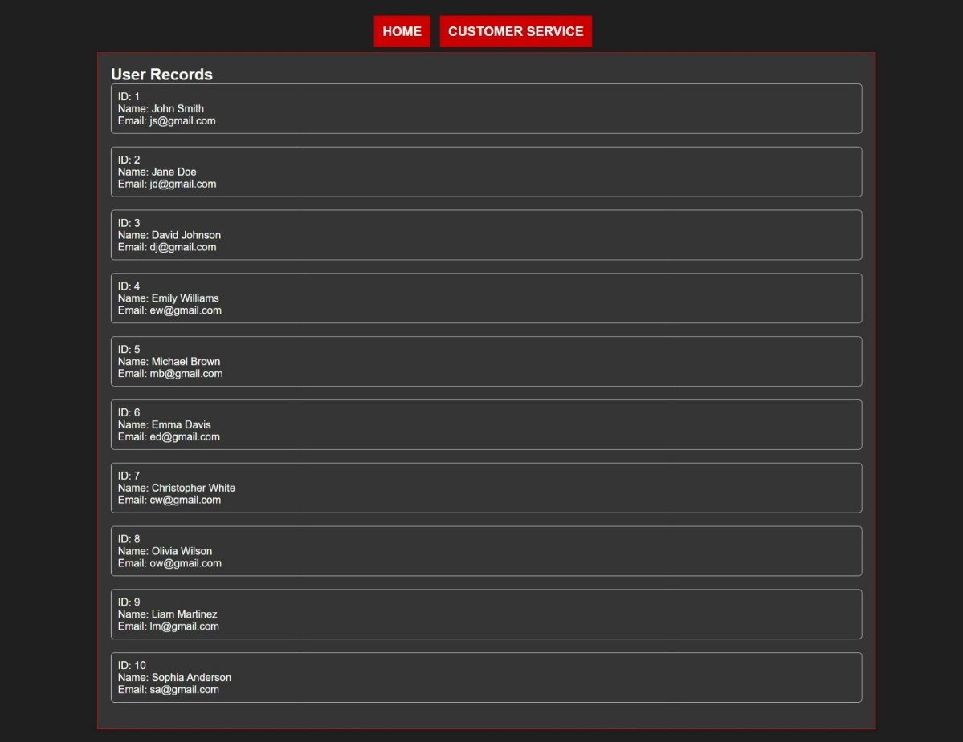

**PAYMENTS PAGE:**

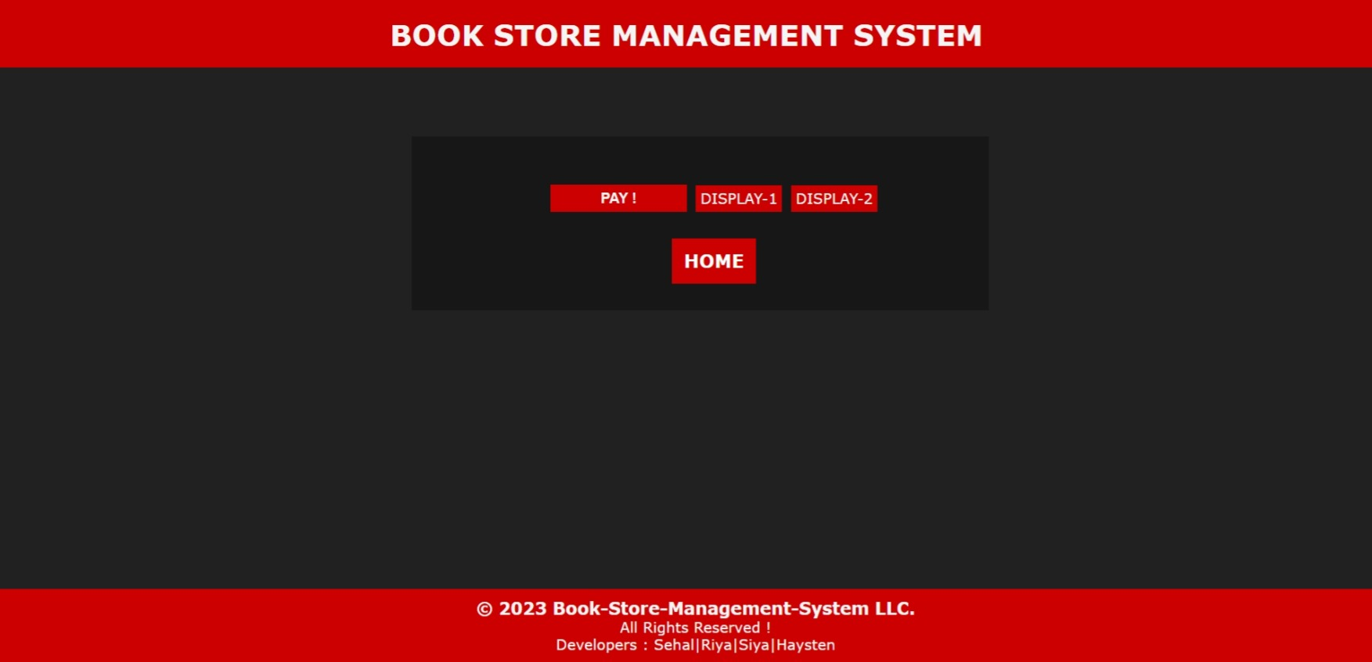

**After successful payment…..**

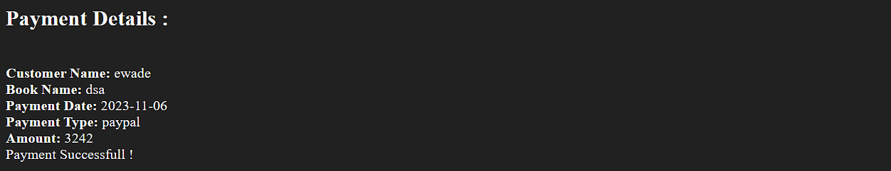

**ADD PAYMENT DETAILS:**

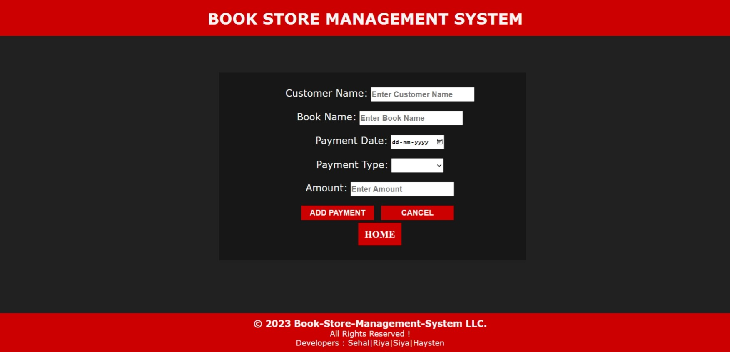

**DISPLAY PAYMENTS DETAILS 1 :**

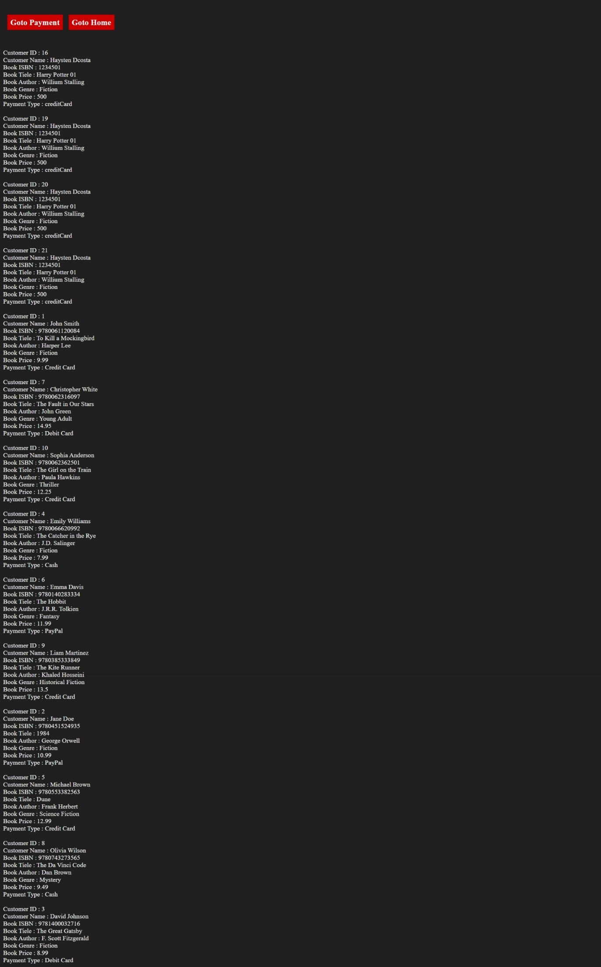

**DISPLAY PAYMENTS DETAILS 2:**

