**LOGINDETAILS TABLE DETAILS :**

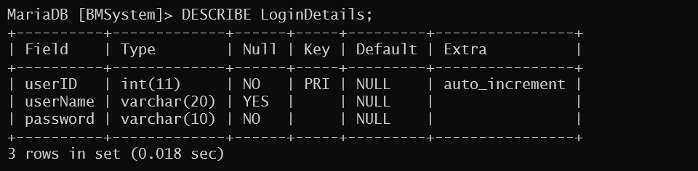

**BOOKS TABLE DETAILS :**

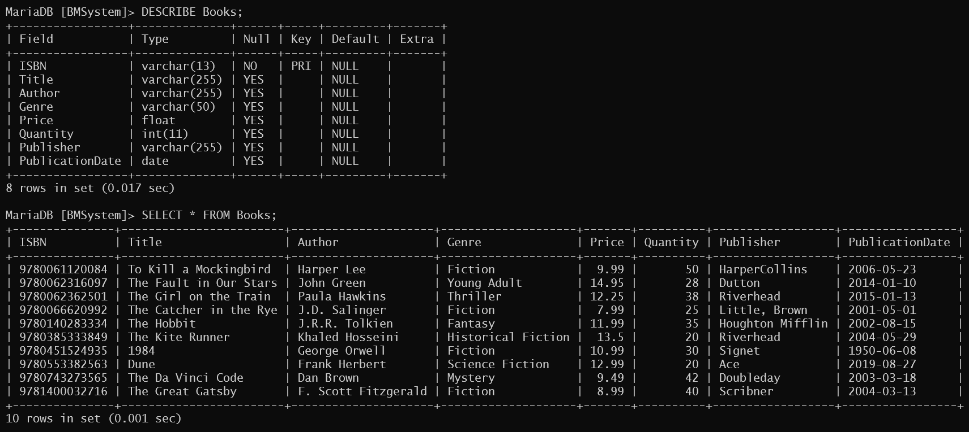

**PAYMENTS TABLE DETAILS :**

