**THE FEDERAL UNIVERSITY OF TECHNOLOGY AKURE.**



**A**

**TECHNICAL REPORT**

**ON**

**STUDENT’S INDUSTRIAL WORK EXPERIENCE (SIWES)**

**UNDERTAKEN AT**

**RADIO NIGERIA AMULUDUN 99.1FM AT MONIYA OLD OYO ROAD ,IBADAN, OYO STATE**

**BY**

**OLOYEDE TAIWO OPEYEMI**

**PHY/17/4828**

**SUBMITTED TO**

**DEPARTMENT OF PHYSICS**

**SCHOOL OF PHYSICAL SCIENCE**

**FEDERAL UNIVERSITY OF TECHNOLOGY, AKURE.**

**IN PARTIAL FULFILLMENT OF THE REQUIREMENT FOR THE AWARD OF BACHELOR OF TECHNOLOGY (B-TECH) DEGREE IN PHYSICS**

**JULY, 2023**

**DECLARATION**

I hereby declare that this report is the account of my six months Student Industrial Work Experience Scheme (SIWES) undertaken at Radio Nigeria Amuludun 99.1FM moniya old oyo road Ibadan, oyo state between “Jan and May2023” and has been prepared in accordance to the regulations guiding the preparation of reports for the award of Bachelor of Technology (B.Tech) in the department of physics, Federal University of Technology, Akure (FUTA).

----------------------------------------- -----------------------------------------

**OLOYEDE TAIWO OPEYEMI Student’s Signature**

Report Reviewed by:

----------------------------------------- -----------------------------------------

**DR. K. ALADENIYI**  **Supervisor’s Signature**

Institution-Based Supervisor

----------------------------------------- -----------------------------------------

**PROF. E.O OGOLO**  **Head of Department’s Signature**

H.O.D

**ACKNOWLEDGEMENT**

My sincere appreciation goes to the Lord Almighty for his mercy, favors and protection during the student industrial work experience scheme (SIWES).

My sincere appreciation goes to my parent for their support and understanding all through the scheme.

I also appreciate my industry based supervisor, Mr Aromose Lawrence Mr. Afonja bukola, Mr. Awe and all staffs of the operations department, Amuludun Moniya, Ibadan, Oyo State. Special thanks to the H.O.D. and other staff of the Department of physics, FUTA.

**TABLE OF CONTENTS**

1.0 INTRODUCTION

1.1 HISTORY AND MEANING OF SIWES

1.2 AIMS AND OBJECTIVES OF SIWES

2.0 HISTORY AND BACKGROUND OF RADIO NIGERIA AMULUDUN

2.1 LOCATION OF THE ORGANIZATION

2.3 OBJECTIVES OF RADIO NIGERIA AMULUDUN

2.4 ORGANIZATIONAL STRUCTURE OF RADIO NIGERIA AMULUDUN2

2.4.1 RADIO NIGERIA AMULUDUN ORGANIZATIONAL CHART

2.4.2 ORGANIZATIONAL CHART AT MANAGEMENT LEVEL

2.5 EXICITER MAINTENANCE

2.6 ELECTRICAL DEPARTMENT

3.0 WORK DONE AND EXPERIENCE GAINED

3.1 EXICITER

3.2 TRANSMITTER

3.3 ICT SECTION

3.4 ELECTRICAL UNIT

3.5 STUDIO TRANSMITTER LINKS

3.6 MAINTENANCE Of TRANSMITTER

3.6.1 POWER CABLE

3.6.2 TYPES OF POWER CABLE

3.6.3 CABLE PART

3.6.4 MICRO PHONE

3.6.5HOW MIXER WORKS

4.-0 CONCLUSION AND SUMMARY

4.1 RECOMMENDATION

**CHAPTER ONE**

# 1.0 INTRODUCTION

## 1.1 HISTORY AND MEANING OF SIWES

The student industrial work experience scheme (SIWES) was established as a result of the realization by the Federal Government of Nigeria in 1973 of the need to introduce a new dimension to the quality and standard of education obtained in the country in order to achieve the much-needed technological advancement. It has been shown that a correlation exists between a country’s level of economic and technological development and its level of investment in manpower development.

The ITF solely funded the scheme during its formative years. But due to the elevated rate of financial involvement, it was withdrawn from the scheme in 1978. In 1979, the Federal Government of Nigeria handed the scheme to the National University Commission (NUC) changed the management and implementation of SIWES fund to ITF. It was effectively taken over by ITF in July 1985 with the funding being solely borne by the Federal Government.

The Federal Government, ITF, the supervising agencies – NUC, NBTE, NCE (National Commission for Colleges of Education), Employers of Labor, and the Institutions contribute its own quota in the management of SIWES. The various responsibilities are as follows:

**FEDERAL GOVERNMENT**

* To provide adequate funds to the ITF through the Federal Ministry of Industries.
* To make it mandatory for all ministries, companies and parastatals to offer places of attachment for students in accordance with the provision of Decree No. 47 of 1971 as amended in 1990.

**INDUSTRIAL TRAINING FUND**

Formulation of policies and guidelines on SIWES for distributions to all the SIWES participating bodies, institutions and companies involved in the scheme on a regular basis, organizing programs for the students prior to their attachment, receive and process master and placement list from the institution and supervising agencies i.e. NUC, NBTE, NCE, supervise industrial attachment, disburse supervisory and students allowance at the shortest possible time, provide insurance during student attachment/training.

**THE SUPERVISING AGENCIES**

* Ensure the establishment and accreditation of SIWES units in institution under their jurisdiction.
* Co-ordinate the appointment of full-time SIWES unit in all the institutions.
* Ensure adequate funding of a SIWES unit in all the institutions of the Federation.
* Vet and approve master and placement list of students from participating institutions and is been forwarded to ITF
* Monitor and review jobs-specification in collaboration with the institutions towards national minimum academic standard for all the programs approved for SIWES.

The Students Industrial Work Experience (SIWES) is a skill training program, designed to expose and prepare students of different tertiary institutions to real life work/situation after graduation. The scheme exposes students to industrial based skills necessary for smooth transition from the classroom to the world of work. It affords students of tertiary institution the opportunity of being exposed to the needed experience in handling machinery and equipment which are not available in the education institute.

## 

## 1.2 AIMS AND OBJECTIVES OF SIWES

* To provide an avenue for students in tertiary institutions to acquire industrial skills and experience in their course of study.
* To expose students to work methods and technique in handling equipment and machineries that may not be available in the institution.
* To prepare students for the work situation that they are likely to meet after graduation
* To provide students with the opportunity to apply their theoretical knowledge in real work situation, thereby bridging the gap between the university work and the actual work practices.
* To expose students to the latest developments and technological innovations in their chosen professions.

CHAPTER TWO

# 2.0 HISTORY AND BACKGROUND OF THE RADIO NIGERIA AMULUDUN 99.1 FM

Amuludun 99.1 FM was established on 10th October 2007 and commenced transmission on the 22nd October ,2007 to bring a core grassroot radio broadcasting to the ordinary masses of the south west geo-political zone of the federal republic of Nigeria

## 

## 2.1 LOCATION OF THE ORGANIZATION

The Radio Nigeria Amuludun 99.1 is located at moniya j&p, bus stop Ibadan and they has head quarter at dugbe opposite CBN and NEPA Ibadan, OYO STATE.

**2.2 HISTORY OF RADIO NIGERIA AMULUDUN 99.1FM**

Before the year 2007,it was conspicuously observed that of the three regions of Nigeria, the Yoruba speaking area do not have a language radio station to tend to the tradition and socio-cultural values of the region .By August 2005 , approval has been granted , in principle for the establishment of such a radio station .Radio house, headquarters of the federal radio corporation of Nigeria (FDCN) quickly rallied support and a transmitter was procured for the new station .The management team of radio Nigeria, Ibadan national station, under whose umbrella the new Yoruba language station was to be established rightly identified then transmitting station at moniya Oyo road Ibadan as the most auspicious settlement for the station .So ,by latter part of 2006, the management team under the indefatigable leader ship of the then executive director of radio Nigeria Ibadan national station, Mr. Atilade Atoyebi swung into action put in place a studio, transmitter house and block of offices for various department ,befitting enough for pure undiluted Yoruba language radio broadcasting to commence operation in earnest.

## 2.3 OBJECTIVES OF RADIO NIGERIA AMULUDUN 99.1FM STATION

The law establishing 99.1 FM, which was enacted by federal radio corporation of Nigeria, gives the organization’s goal as stated in its Vision and Mission statements thus:

* **VISION:** To become one of the best Yoruba language station informative educative and entertainer.
* **MISSION: We will be recognized as creators and distributors of high quality, relevant and vibrant radio programming. Our organization will build a strong financial base with a fully supported staff.**

In addition to these, the radio Nigeria amuludun station also provides services in the following

* **LANDSIDE:** Car parks, shops, offices,
* **TERMINAL BUILDING:** Provision of facilities for arrival, offices, Information desks and other services that ensure maximum comfort for our customers while waiting for their advertisement.
* **TELECOMMUNICATIONS:** Provision for internet connection
* **SECURITY:** Safety

## 2.4. CORPORATE ORGANOGRAM OF FEDERAL RADIO CORPORATION OF NIGERIA

* Board of directors
* Director -General
* Zonal Director.
* Deputy Director
* Secretary to the corporation
* Director of Maintenance & Engineering service
* General Manager FM station

### 2.4.1 ORGANOGRAM OF COMMITTEE OF MANAGEMENT (COM) FRCN ZONAL STATION

* **Zonal director**
* **Deputy director admin & supply**
* **Deputy director finance & account**
* **Deputy director of programmes**
* **Deputy director News**
* **Deputy director engineering service**
* **General manager (specified FRCN) FM station**

### 2.4.2 ORGANOGRAM OF AMULUDUN FM STATION

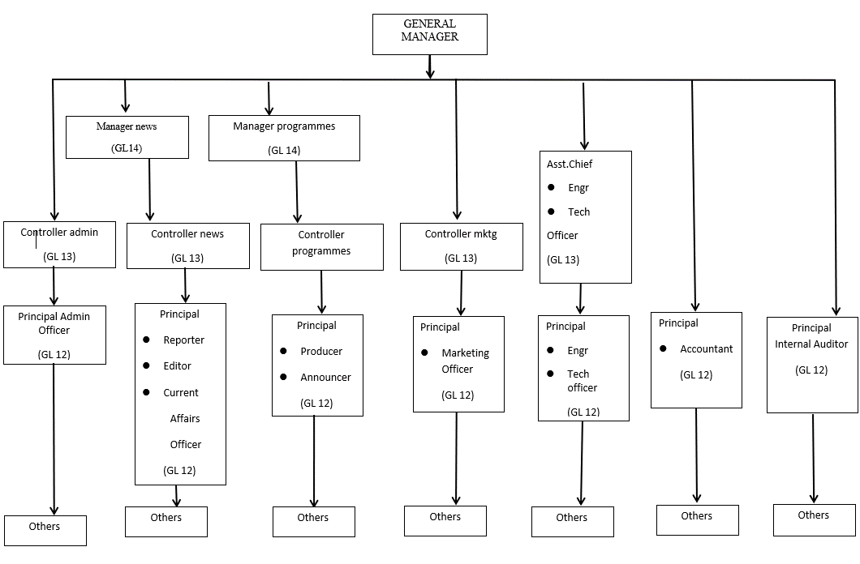

## 2.5 LIVE STUDIO ROOM

During the SIWES program, I was opportune to work at the studio room of the federal Road Amuludun station. To maintain the console in the live studio.

## 

## 2.6 ELECTRICAL DEPARTMENT

The electrical department of the Federal Radio Amuludun is a department under the directorate of Engineering, its main function is to provide different forms of maintenance and electrical services to the organization as a whole.

CHAPTER THREE

# 3.0 WORK DONE AND EXPERIENCE GAINED

**INTRODUCTION**

This chapter gives a quick overview of work done during the period I was posted to the Engineering department of the organization. There are sub sections within this chapter that divides the experience into parts which focus on; transmitter, exciter, power cables and maintenance.

Furthermore, I also gained knowledge on principles guiding the operations of these systems and operation in relations to the physical laws guiding them.

## 

## 3.1 TRANSMITTER

During the course of the SIWES program, I was actively involved in the types, function and the general purpose of a transmitter. A transmitter is an electronic device used in telecommunications to produce radio waves in order transmit or send data with the aid of antenna .it is also called transmitting set and also there are types of transmitters which are; integrated temperature transmitter, pressure temperature transmitter, liquid level, capacitance -level, ultrasonic and so. The general purpose of a transmitter is to transmit signal or to process the information. These signals contain information, which can be audio, video or data. A transmitter launches signal into the air via a transmitter antenna. The main one used in radio station is the FREQUENCY modulation (FM) transmitter. The frequency range of FM is 88 to108MHZ in the higher spectrum.

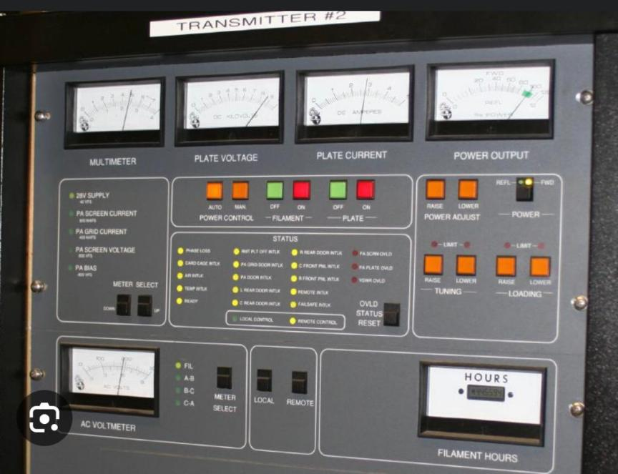

* 1. **EXCITER**

Designed and tuned to operate on fixed frequency with in the FM band (88-108) MHZ and 10KHZ increment. Most exciter are of single phase AC voltage ,exciter are solid state wide band units of FM transmitter which provides a variable RF output from 0watt- the highest RF output level of its power amplifier .Most exciter accept wide band composite input from a stereo generator . Exciter is the heart of transmitter because its signal modulator ,generate signal carrier that is ,Radio frequency and also set a desired radio frequency to be used e.g. 99.1FM

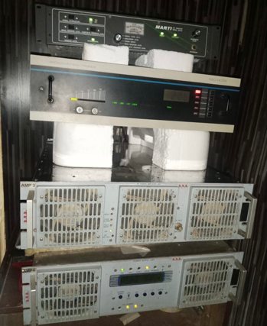

**EXCITER INSTALLATION**

Exciter may be installed in any convenient location in about 19inch (48.3cm) rack within reach of signal and power cable. The exciter should not be installed directly above or below heat generating equipment

**INFORMATION AND COMMUNICATION TECHNOLOGY UNIT**

Information and Communication Technologies (ICT) are electronic machines and devices. Their application has both computing and communication capabilities. They range from physical devices like digital cameras, tape recorders, computers, sensing devices, scanners, mobile phone, etc. to cyber space-the internet, software, teleconferencing, satellite etc. Their application is broad and cuts across all interpersonal and mass communication media, giving more power, robustness and veracity to their operations and performance. . Information and communication technologies into broadcasting especially radio broadcasting is therefore designed to boost and enhance qualities of broadcast programmes. Most importantly has been the digitization of radio signal, innovation programming and live reporting from any corner of the world. E.g. microphone audio signal →audio pre amplifier →Amplified audio signal →modulator carrier →modulated signal →RF amplifier →Antenna

To make a clear version of the sound at anywhere you are.

**ELECTRICAL UNIT**

Introduction of seizes of wires e.g., 15mm,25mm and flexible wire and also where each type can be used like15mm is for light wiring and 25mm for kitchen socket while the flexible is used in lamp holder. Some lamp holder was repaired inside live studio and also, I was taught how to connect a lamp holder to ceiling rose.

**STUDIO TRANSMITTER LINKS**

This transmitter and its companion the receiver are the core of **a high quality, synthesised studio-to-transmitter link (STL)**, to be used for broadcast repeaters in conjunction with any standard FM or AM transmitter.  
They are **an evolution of the previously established STL series**, whose main circuitry is still extensively used here with a new controller, user interface and software, and more advanced oscillators in a compatible 2u 19" case.  
These allow the reception of mono or stereo signals and its retransmission without using any additional stereo-coder on the receiving end; in both cases, the LF output signal from the receiver must be sent to the stereo input (linear or not pre-emphasized) of the local FM rebroadcast transmitter. There are two types of STL: receiving and transmitting STL.

## 3.2 RECEIVER RADIO LINK MODELS

|  |  |
| --- | --- |
| **MODEL** | **DESCRIPTION** |
| TK-STL-R1 | Link Receiver Band 170 - 490MHz (band max ±10MHz) |
| TK-STL-R3 | Link Receiver Band 820 - 960MHz (band max ±10MHz) |
| TK-STL-R5 | Link Receiver Band 1.4 - 2.5 |

## 3.3  TRANSMITTER RADIO LINK MODELS

|  |  |
| --- | --- |
| **MODEL** | **DESCRIPTION** |
| TK-STL-T1-11 | Link Transmitter Band 170 - 490MHz (band max ±10MHz), 10W |
| TK-STL-T3-10 | Link Transmitter Band 820 - 960MHz (band max ±10MHz), 10W |
| TK-STL-T1-20 | Link Transmitter Band 170 - 490MHz (band max ±10MHz), 20W. |
| TK-STL-T3-20 | Link Transmitter Band 820 - 960MHz (band max ±10MHz), 20W |
| TK-STL-T5-5 | Link Transmitter Band 1.4 - 2.5 GHz (bands max ±5MHz), 5W |

The difference between receiver studio transmitter links and transmitter studio links is that the receiver STL detected signals by receiving antennas which convert it into signals. While the transmitter STL use transmission antennas to transmit specific types of signals and propagate it through the air.

## MAINTENANCE OF TRANSMITTER

1. Check critical transmitter values against last logged value
2. Check forward/reflected power on main transmitter
3. Check and reset any overloads
4. Check generator fuel level
5. Check the STL signal strength level against last logged value.
6. General check of building, look in all rooms, inspect for damage from vandalism, Leaking roofs, obvious signs of trouble, take steps to correct. Also, the maintenance is done with methylated spirit, smooth brush and blower.

## 

## 3.6 POWER CABLES

These refers to the collection of one or more electrical conductors, usually held together with an overall sheath which is used for the transmission of electrical power. Cables generally consist of 3 major components: conductors, insulators and protective jackets. The construction of a cable is determined by three factors; which are:

* **Working voltage**; determining the thickness of the insulation.
* **Carrying capacity:** determines the cross-section size of the conductors.
* **Environment conditions** such as temperature, water, chemical or sunlight exposureand mechanical impact determines the form and composition of the outer cable jacket.

Underground cables may also include metal armor in form of wires spiraled around the cable. This armor maybe made of steel or aluminum, and although connected to earth, it is not intended to carry current during normal operation. Some power cables for outdoor overhead use may have no overall sheath.

### 3.6.1 TYPES OF POWER CABLES

This part gives the various types of power cables usedin power system network and also gives some common characteristics in construction of cables. Most cables tend to have a common characteristic, some of the various armored cables used in power system network are:

* XLPE power cable
* Oil-paper insulated led cable
* Aluminum sheathed cable
* Concentric neutral cable***.***

### 3.6.2 CABLE PARTS

* **Conductor:** usually stranded copper(Cu) or aluminum(Al). Copper is desire andheavier, but more conductive than aluminum.
* **Conductor screen:** usually a semi-conductor tape to maintain a uniformelectric field and minimize electrostatic stress.
* **Insulation:** this cable uses a thermosetting type material (XLPE) as a form ofinsulation.
* **Conductive sheath**: This is typically a copper tape and used as a shield to keepelectromagnetic radiation in and also provide path for fault and leakage currents.
* **Filler**: the interstices of the insulated conductor bundle are sometimes filedusually with a soft polymer material.
* **Bedding/inner sheath:** Typically**,** a thermoplastic (usually PVC) is used to keepthe bundle together and to also provide bedding for the cable armor.
* **Armor**: For mechanical protection of the conductor bundle; steel wire is usuallyused and galvanizing is used for rust prevention. steel wire armor (SWA) is used in multi–core cables; aluminum wire armor (AWA) is used in single-core cables.
* **Outer sheath:** Applied over the armor for overall mechanical, weather, chemical,and electrical protection typically a thermosetting material (PVC).

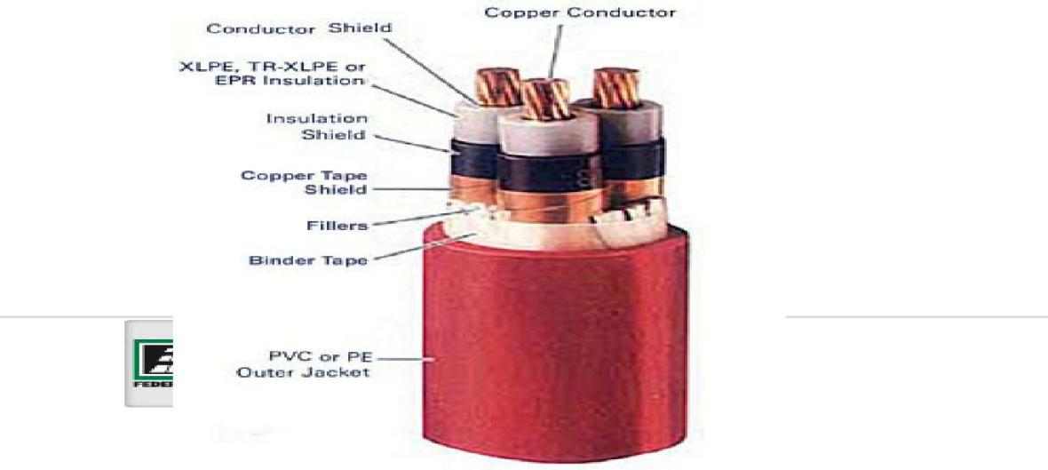

**MICRO PHONE**

#### Understanding Microphone Transducers

A microphone is essentially a transducer, which converts acoustic energy into electrical energy.

#### Directionality or Polar-Pattern

Directionality refers to the sensitivity relative to the direction or angle of sound arriving at the microphone. Directionality is usually plotted on a graph referred to as a polar pattern. A polar pattern graph shows the variation in sensitivity as you move 360 degrees around the microphone.  
  
There are a number of different directional patterns available. The three most common patterns are omnidirectional, unidirectional, and bidirectional.

**Omnidirectional microphones:** They have equal response at all angles. Its coverage or pickup angle is a full 360 degrees, which comes with a number of distinct advantages or disadvantages depending on your application. On the positive side, omnidirectional mics have a very natural and open sound that is perfect for capturing organic sounds, such as an acoustic guitar. On the other hand, Omni mics pick up more room ambience, which can be desirable so long as you have great sounding room acoustics.

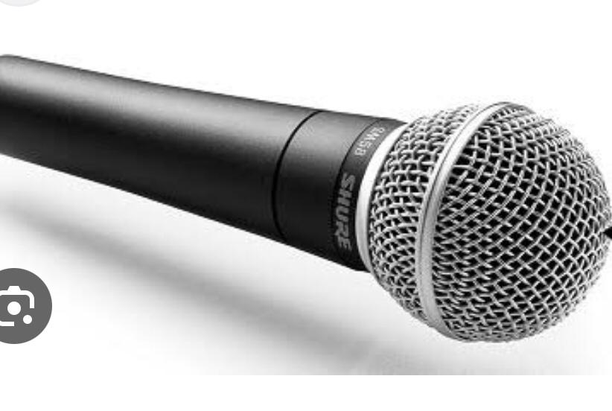

**Unidirectional microphones: are most sensitive to sound arriving from one particular direction. The most common type is cardioid(heart-shaped) response. This polar pattern has full sensitivity at 0 degrees(on-axis) and is least sensitive at 180 degrees (off axis). Unidirectional microphones are used to isolate the desired-on axis sound from unwanted off-axis sound.**

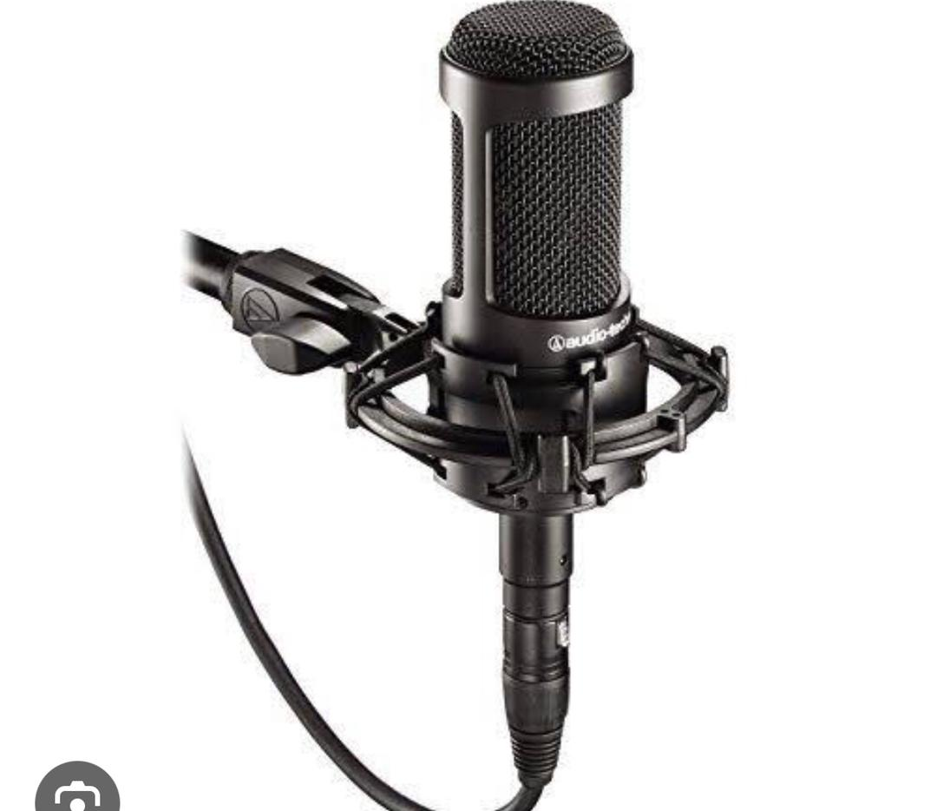

**Bidirectional microphones: They have full response at both 0 degrees (front) and at 180 degrees (back). They are least sensitive at the sides. This mic can be used to your benefit when picking up two sound sources such as two vocalists facing each other, however, in most cases, its typical just to use one side.**



**HOW THE MIXER WORKS**

In basic terms, a mixer is a piece of equipment that takes multiple audio signals and blends them together into one mono or stereo signal. This mixed signal is then sent out via the 'main output' to gear like a PA amplifier or a set of active speakers.

The purpose of the mixer is to provide both the sum and difference frequency at the output port when two input frequencies are provided at the other two ports.



MAINTENANCE OF MIXER

To ensure optimal performance and longevity of a mixer used in sound mixing, regular maintenance is crucial. Here are some key points to consider when it comes to maintaining a mixer:

1. Cleaning: Keep the mixer clean and free from dust and debris. Regularly wipe the surface and control knobs using a soft, lint-free cloth. Be cautious not to use abrasive materials or harsh chemicals that may damage the equipment.

2. Cable Management: Proper cable management is essential to prevent strain on connectors and cables. Avoid excessive bending or twisting of cables and use cable ties or Velcro straps to keep them organized and prevent tripping hazards.

3. Fader and Knob Maintenance: Clean the faders and knobs regularly to prevent dust and dirt buildup that can affect their smooth operation. Use a non-abrasive electronic cleaner or compressed air to remove any debris or residue.

4. Check Connections: Inspect the connections regularly to ensure they are secure and free from corrosion. Loose or faulty connections can lead to signal issues or noise in the audio output.

5. Firmware and Software Updates: If your mixer has firmware or software, stay up to date with the latest updates provided by the manufacturer. These updates may include bug fixes, performance improvements, and new features that can enhance the functionality of the mixer.

6. Preventive Maintenance: Consider periodic maintenance checks by a qualified technician. They can inspect internal components, perform cleaning, and address any potential issues before they become major problems.

7. Transport and Storage: When transporting or storing the mixer, use appropriate cases or covers to protect it from physical damage, moisture, and temperature extremes. Follow manufacturer guidelines for safe transportation and storage.

8. Use in Suitable Environments: Ensure the mixer is used within recommended temperature and humidity ranges specified by the manufacturer. Extreme environmental conditions can affect the performance and lifespan of the equipment.

CHAPTER FOUR

# 4.0 CONCLUSION AND SUMMARY

Student Industrial Work Experience Scheme (SIWES) is very important because it is the only opportunity where undergraduates can apply the knowledge gained in school to various fields and real-life situation. Theories learnt in school most times may appear very abstract, and it is only during SIWES that the student can see the application of such theories. For any student to be exposed to the practical training of his/her profession, there is need to undergo SIWES. The scheme also gives students the opportunity to see, handle and appreciate various equipment and tools used in their profession and related professions. Therefore, the benefit of SIWES to students cannot be overemphasized, it prepares students for challenges that await them in their profession, and after school generally, in whatever profession they find themselves.

My training at the Federal Radio Amuludun station has made me to have more interest in aviation industries. The experiences though challenging was of great benefit, as it educated me practically on the various aspects of the profession and the areas of applications.

# 4.1 RECOMMENDATION

The SIWES program in terms of career development, youth empowerment, and with the aim of improving the economy of the country has proven to be helpful and aiding application of theoretical knowledge of one’s course of study into real life situations. Efforts of the school and the Federal Government must be commended and strengthened. I therefore present my recommendations as follows:

* For the student to excel in the labour market, I would recommend that the program be taken more seriously and student should not be limited in their choice of placement.
* The ITF should develop a good relationship with the students and make available a welfare scheme for the student.
* The ITF should support students by facilitating the payment of monthly stipends to help with transportation and feeding costs.

REFERENCE

Article on electrical substation (2014), Retrieved from htp://www.wikipedia.org

Donald G., Fink H and Wayne Beauty (1978), *Standard Handbook for Electrical Engineers. Eleventh Edition McGraw HilISBN:0-02-020974-X chapter17 substation Federal Radio Amuludun*

Giorgio Bertoti (1998), Hysteresis In Magnetism: *For physicists, materials scientists, and Engineers, San Diego Academic press*.

Information on transformers, http://www.galco.com/prod/trnsfmrs.htm

Israel D.Vagner, Lambrikov B.I., Peter Rudolf Wyder (2003),*Electrodynamics Of Magneto active Media, Springer, ISBN 3540436940.*

NeilS and JohnE. T.(2003), *Hand book of electrical design details. Second Edition McGraw-Hil, ISBN0-07-142579-9*.

Walsh and Ronald A(1990), *Electromechanical Design Handbook, McGraw-Hil, New York.*

SIWES(2008), Retrieved January 2015, from ITF: http://odich.com/itfnig/siwes.php.