IMAT5168
Analytics Programming
Assessment 2

Hayyan Ebrahem
P15244202
MSc BI/Data Mining
De Montfort University
January 19, 2016

Group 2 Lesson 4:

Using "FILENAME" statement :

FILENAME statement is used to associate a file reference with a physical file or device.
The syntax of tor the FILENAME is as follow:

FILENAME fileref <device-type> <'external-file'> <option>;

In this example the FILENAME was used as follow:

filename job "/folders/myfolders/dmu";

- fileref : job
- <'external-file'> :"/folders/myfolders/dmu"

the FILENAME is used to read/write external files stored on disk (can be used to access files with a different access methods like SSH for instance).

Using %INCLUDE :

%INCLUDE source ;

the %INCLUDE statement point to a file stored on the disk and when the statement is executed , the included file in the statement is inserted into the calling program at the location of the call

%include job("SAS-Proc-Reg.txt");

job: storage location "defined in the previous statement".

TESTING FOR NORMALITY

1-Using UNIVARIATE:
(Group2-Les6)

PROC UNIVARITE <option>;

The UNIVARITE procedure provide a descriptive measures and statistical methods which can be used to summarize ,visualize and analyze the model.
general output of the UNIVARITE statement might look like:

N Sum Weights
Mean Sum Observations
Std Deviation Variance
Skewness -Kurtosis
Uncorrected SS Corrected SS
Coeff Variation

When you specify the NORMAL option in the PROC UNIVARIATE statement the procedure computes goodness-of-fit tests.

Below is an example of code used to investigate the distribution of a variable (Normal Distribution). In our example, we will use the expenditures data set and we will investigate the distribution of the continuous variable expenditure:

proc univariate data=expenditures normal;
title ' Normality test for expenditures data';
var expenditure;
histogram / normal;
run;

Interpretation of the output:

According to the SAS documentation(Base SAS(R) 9.2 procedures guide: Statistical procedures, Third edition, 2010), if the sample size is over 2000, the Kolmgorov test should be used. If the sample size is less than 2000, the Shapiro test is better. The null hypothesis of a normality test is that there is no significant departure from normality. When the p is more than .05, it fails to reject the null hypothesis and thus the assumption holds.

2-Using T-Test:

The t test assumes that the data is normally distributed ,to test the normality " Goodness-of-Fit Tests " since n <30 normal distribution = Bell shaped curve and also assumes that the two samples, variables (Continuous) are independent we can see that these variables are independent since there is n effect from one other.

A-two-samples assumptions (independent , normally distributed , equity of variances “f-test”):

proc ttest data=expenditures H0=205 sides=2 alpha=0.05;
var expenditure;
run;

The qq-plot shows the data points fit the regression lines in good fit, moreover we can see that the Anderson-darling test 0.250 which mean our expenditures data is normally distributed "null hypothesis is not rejected "
46
47
48 /* Second way to test normality is
49 by useing histogram of the data and using QQ-plot.
50 in t-test proc
51
52 NULL hypothesis: H0= mu=205
53 Ha= mu != 205 means are fidderent (sides=2)
54 ALPHA 0.05 Accepted possibility of type | error is 5%
55 OR 95% confidence interval */

B:two-paird samples : Dependency(after-before) “repeated measurements are taken about the same subject”

Tests of Equality of Variances
The “Equality of Variances” test results show that the assumption of equal variances is
reasonable for these data (the Folded F statistic with p ) . If the assumption of normality is also reasonable, the appropriate test is the usual pooled ttest, If the assumption of equality of variances is not reasonable, then either the Satterthwaite or the Cochran test should be used.
The assumption of normality can be checked using PROC UNIVARIATE; if the as-
sumption of normality is not reasonable, you should analyze the data with the non-
parametric Wilcoxon Rank Sum test using PROC NPAR1WAY.

Two-Way ANOVA in SAS

Multiple regression with two or
more categorical variables as predictors

Two-way ANOVA is Analysis of Variance when you have two variables to test the equality of mean values.
Significance Tests in Two-Way ANOVA
Ho: Effect=0 vs. Ha: Effect not Zero
There are three hypothesis tests for a TWO-Way ANOVA.
-To Test of Main Effect of A
-To Test of Main Effect of B
-To Test the Interaction of A and B

Example:
proc anova data = dental;
class A B;
model relief = A B A*B;
run;
quit;

“class” tells SAS the two classification variables, which are generally going to be the effect
that you are studying. In this case, the effects are “A” and “B.”
“model” tells SAS the dependent variable. The general format is “model Y = X1 X2 X1*X2” where Y is the dependent variable, X1 and X2 are independent variables. X1*X2 means the interaction of X1 and X2.
The output is shown in this tables:

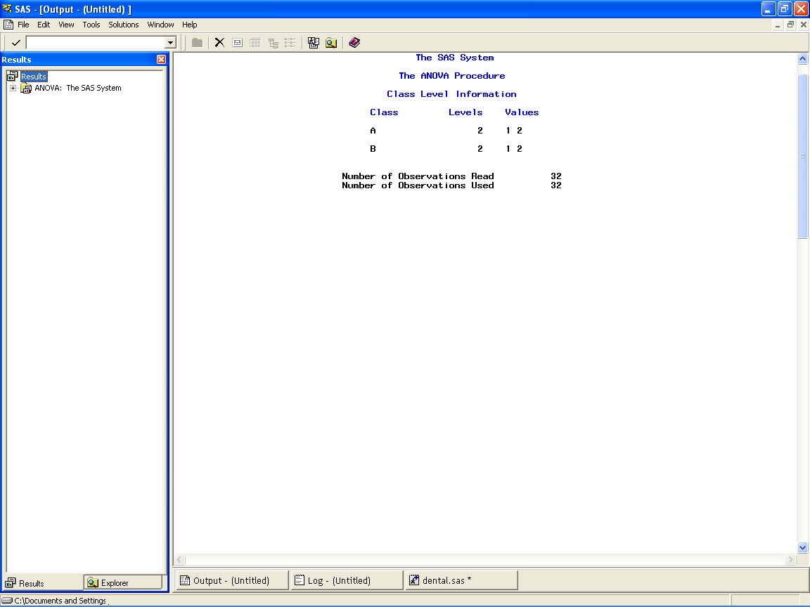

The first page of your output says that there are two values under both of the variables “A” and “B”: 1 or 2.
It also tells you that there are 32 observations.

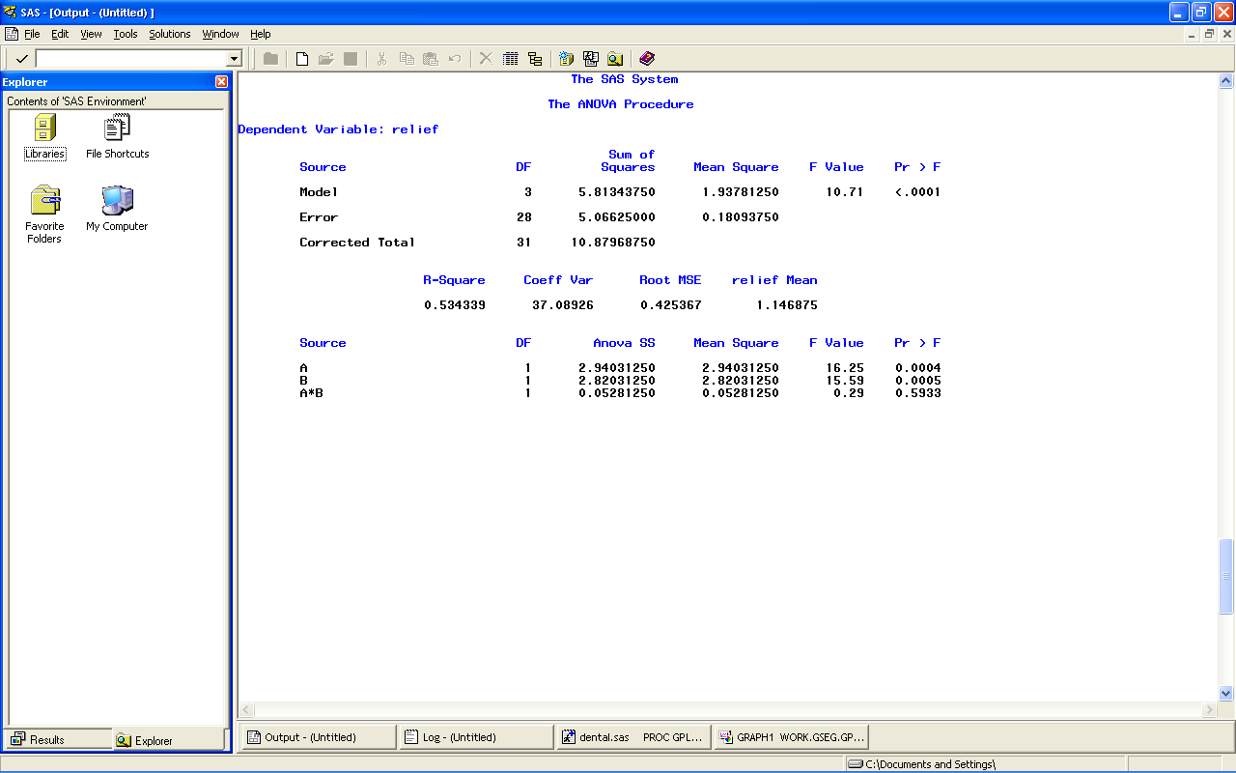

Interpreting the SAS Output

For the main effect of factor A, the F*= 10.96. The p-value of this F* is found under “Pr>F” and p =0.0026.
For the main effect of factor B, the F*= 16.03. The p-value of this F* is p =0.0004.
For the A*B interaction, the F*= 0.21. The p-value of this F* is p =0.6476.

For factor A and B:
Because the p-values for the test statistic (F*) are less than alpha (0.05),
we reject the null hypotheses and conclude that the main effects of both factor A and B are
significant.
For the A*B:
The p-value for F* is greater than 0.05. Hence we accept the null hypothesis and conclude that the interaction of A and B is not significant.

References

. 2016. . [ONLINE] Available at: http://www.lexjansen.com/nesug/nesug06/dm/da05.pdf. [Accessed 18 January 2016].

. 2016. . [ONLINE] Available at: http://www.indiana.edu/~educy520/sec5982/week_2/variable_types.pdf. [Accessed 18 January 2016].

