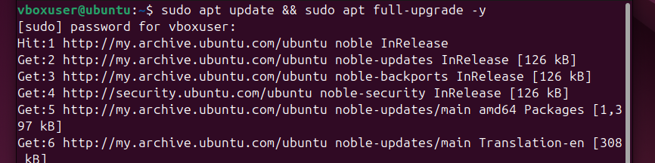
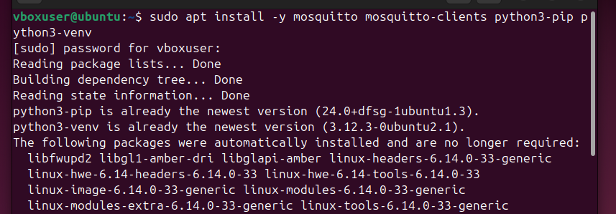
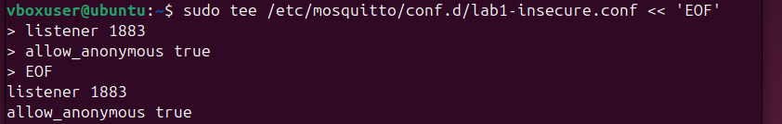
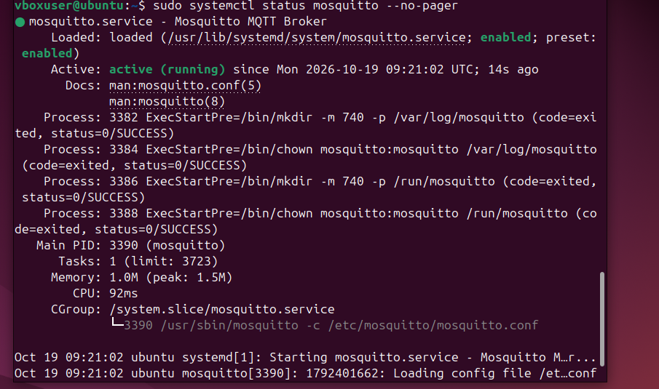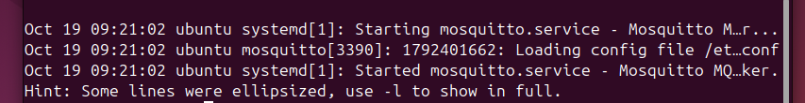
Make gateway
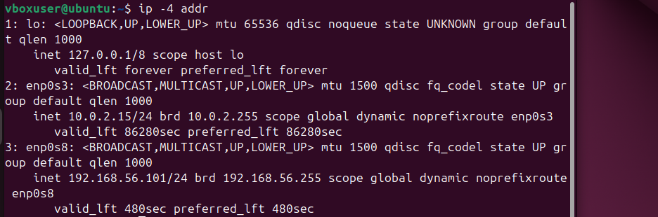
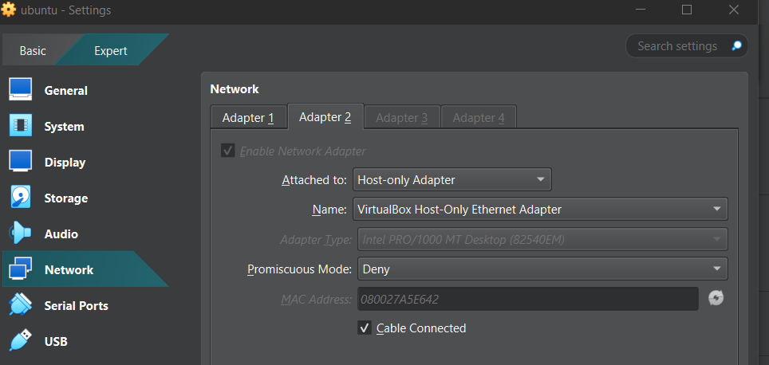
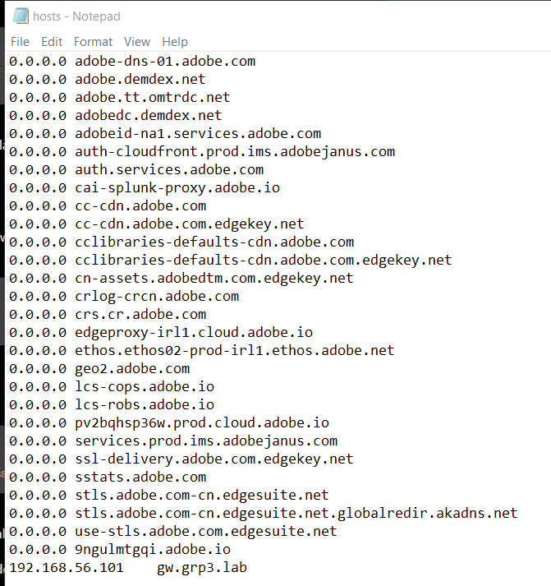

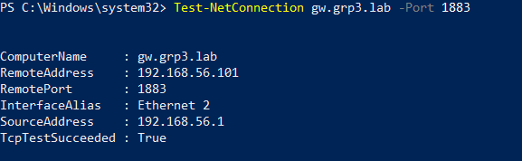
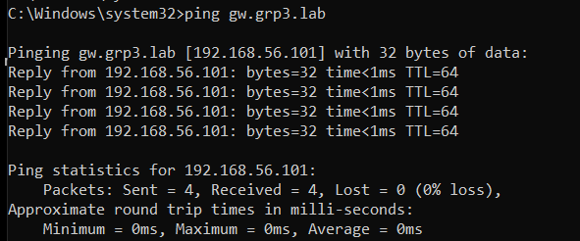
Checkpoint A – Test Hello
PowerShell 1
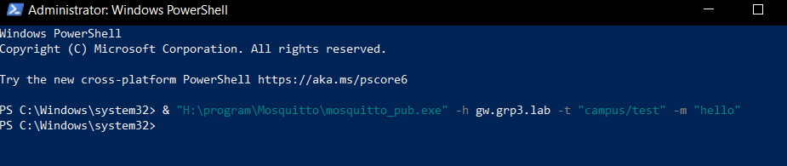
PowerShell 2
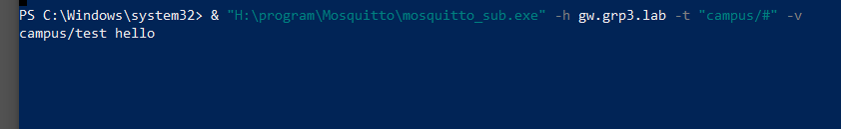

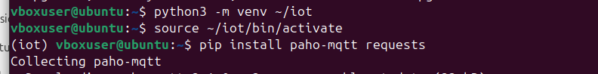
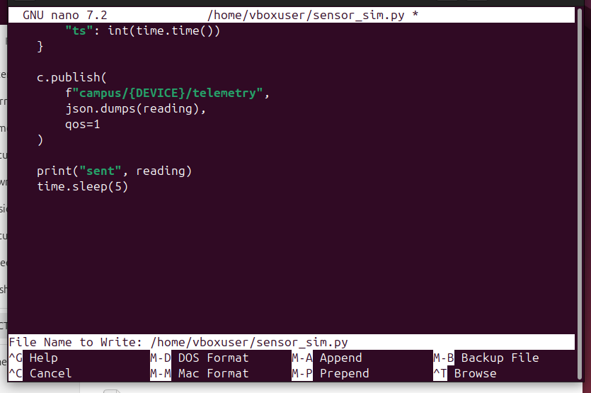
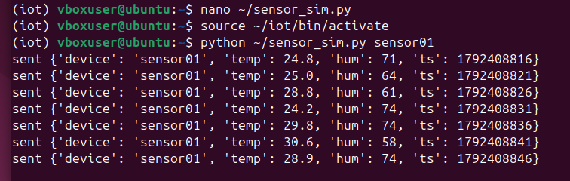
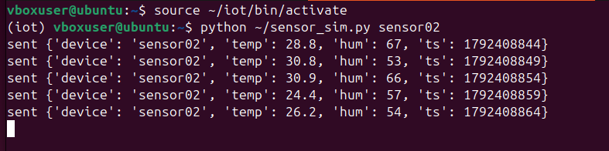
Checkpoint B
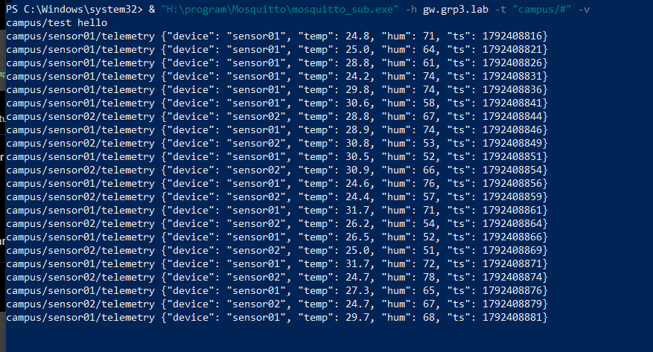

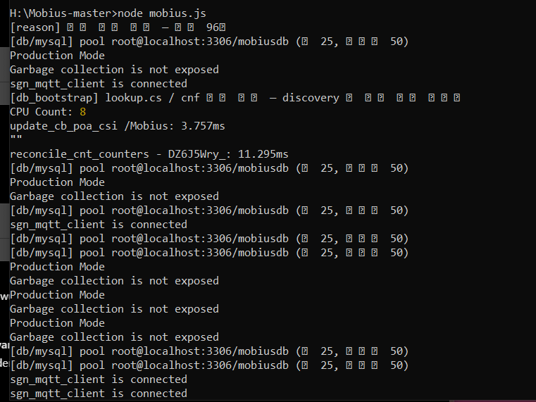
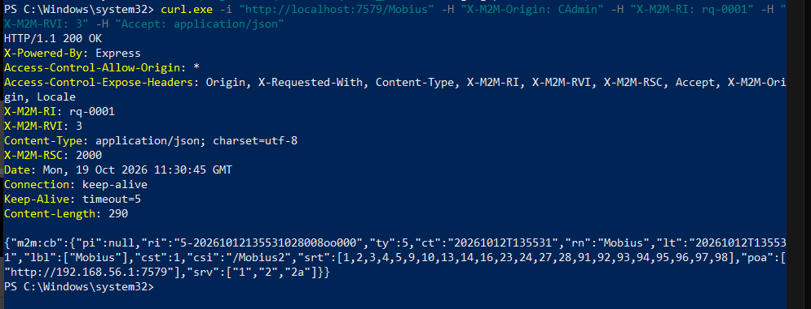
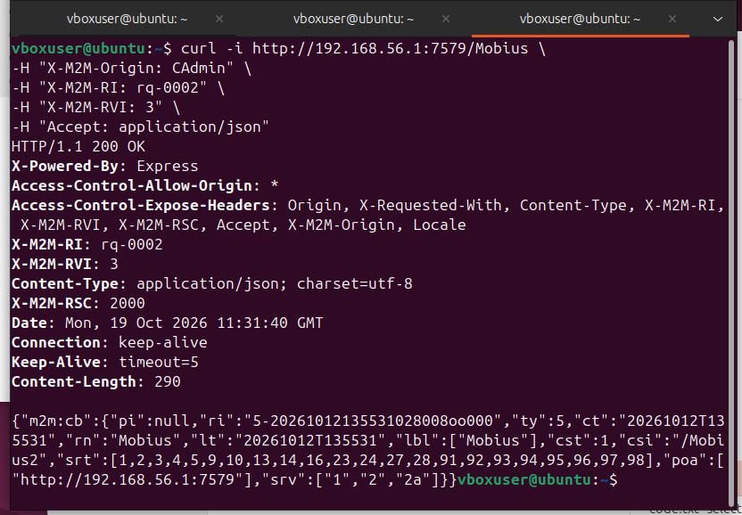
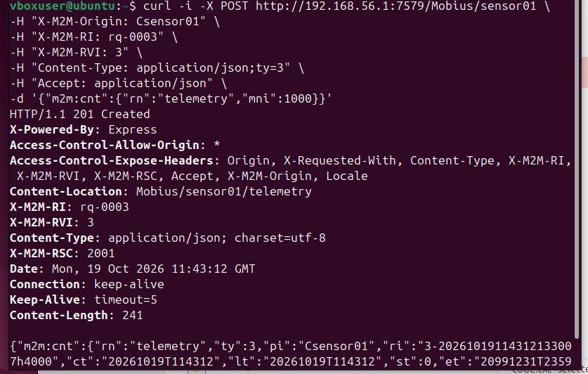
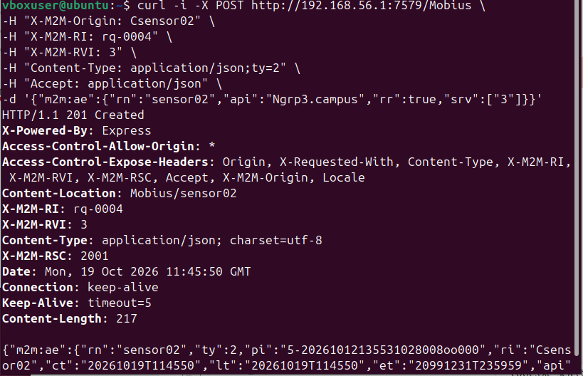
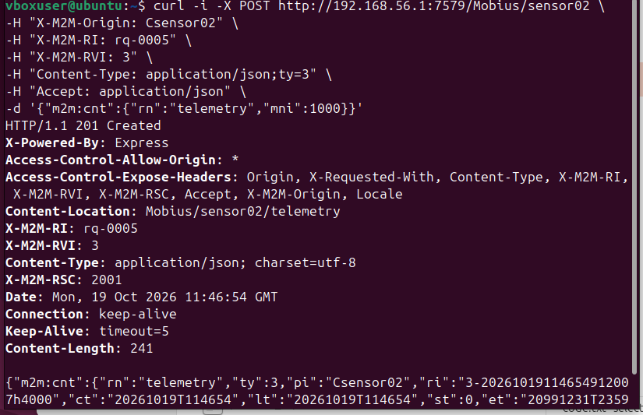
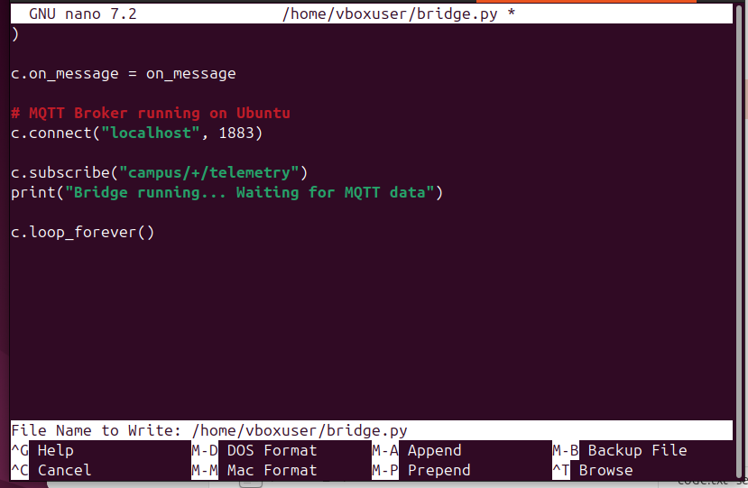
Checkpoint C1
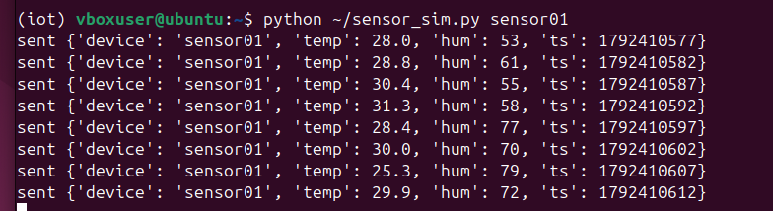
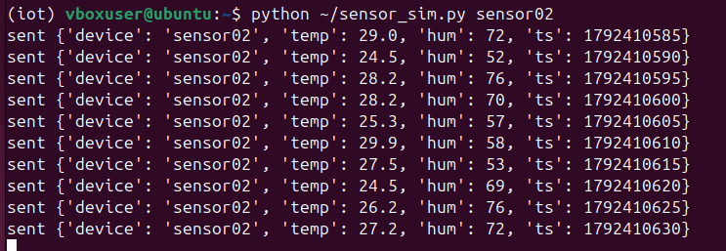
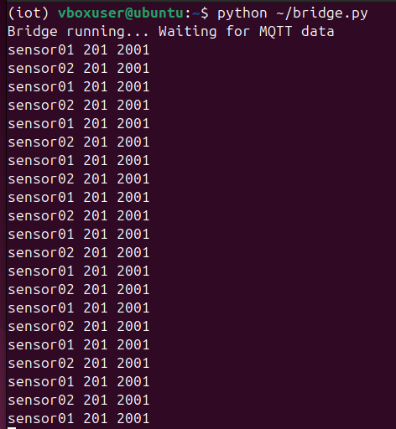

Checkpoint C2
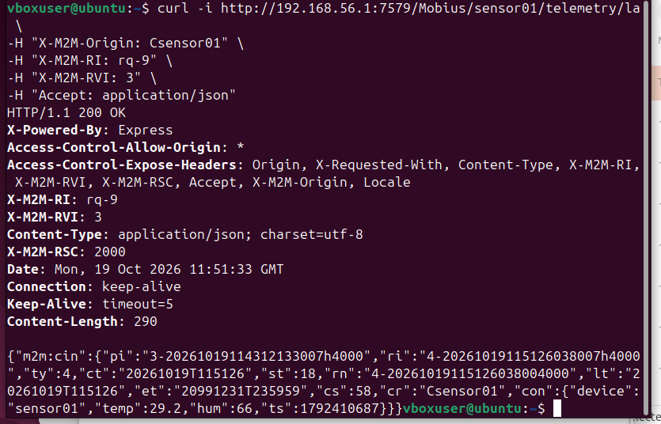
Item | Result
HTTP Status | 200 OK ✅
X-M2M-RSC | 2000 ✅
Resource Type | m2m:cin (Content Instance) ✅
Device | sensor01 ✅
Temperature | 29.2°C
Humidity | 66%
Latest Resource | /telemetry/la ✅

Part D
Eavesdropping
& "H:\program\Mosquitto\mosquitto_sub.exe" -h gw.grp3.lab -t "#" -v
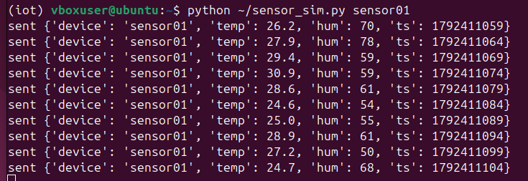
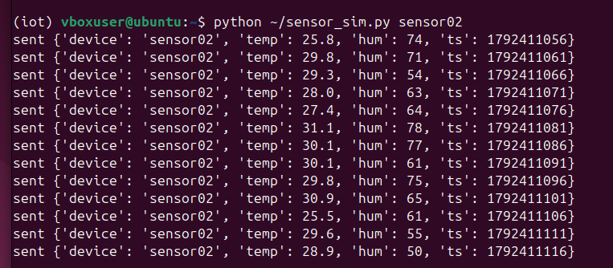

output
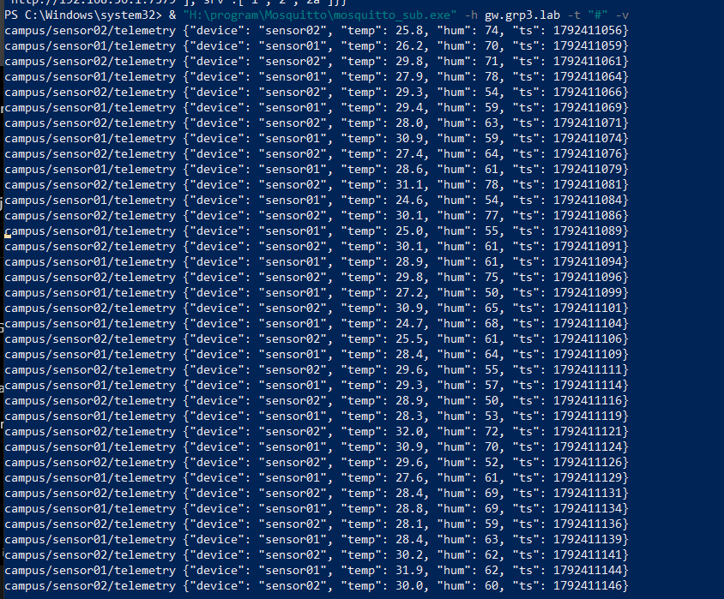
MQTT broker kau membenarkan anonymous clients subscribe kepada telemetry. Jadi, sesiapa yang mempunyai akses rangkaian ke broker dan dibenarkan oleh konfigurasinya boleh membaca data sensor tanpa authentication.
D2 - Sniffing
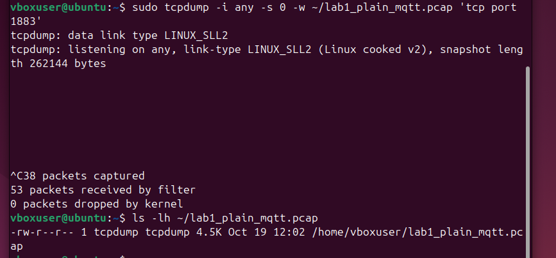
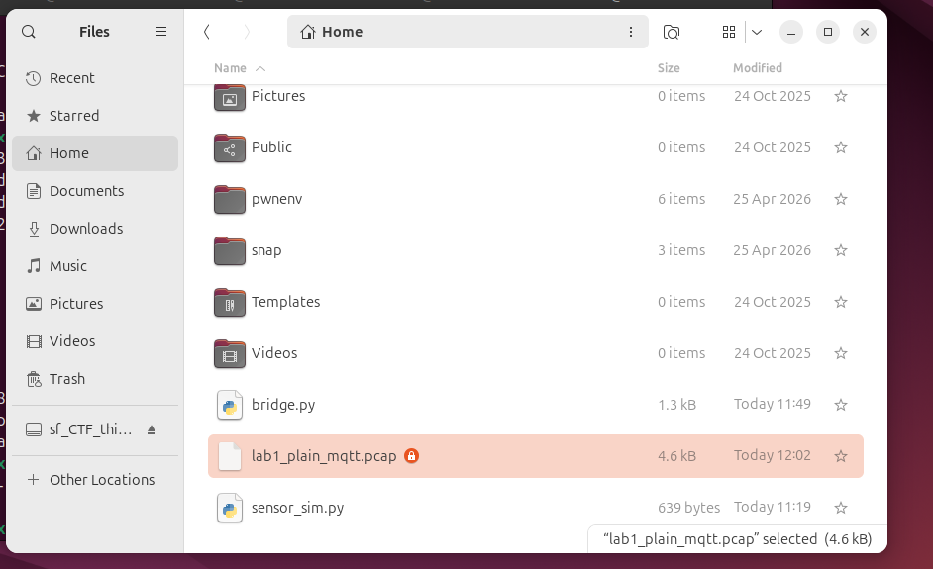
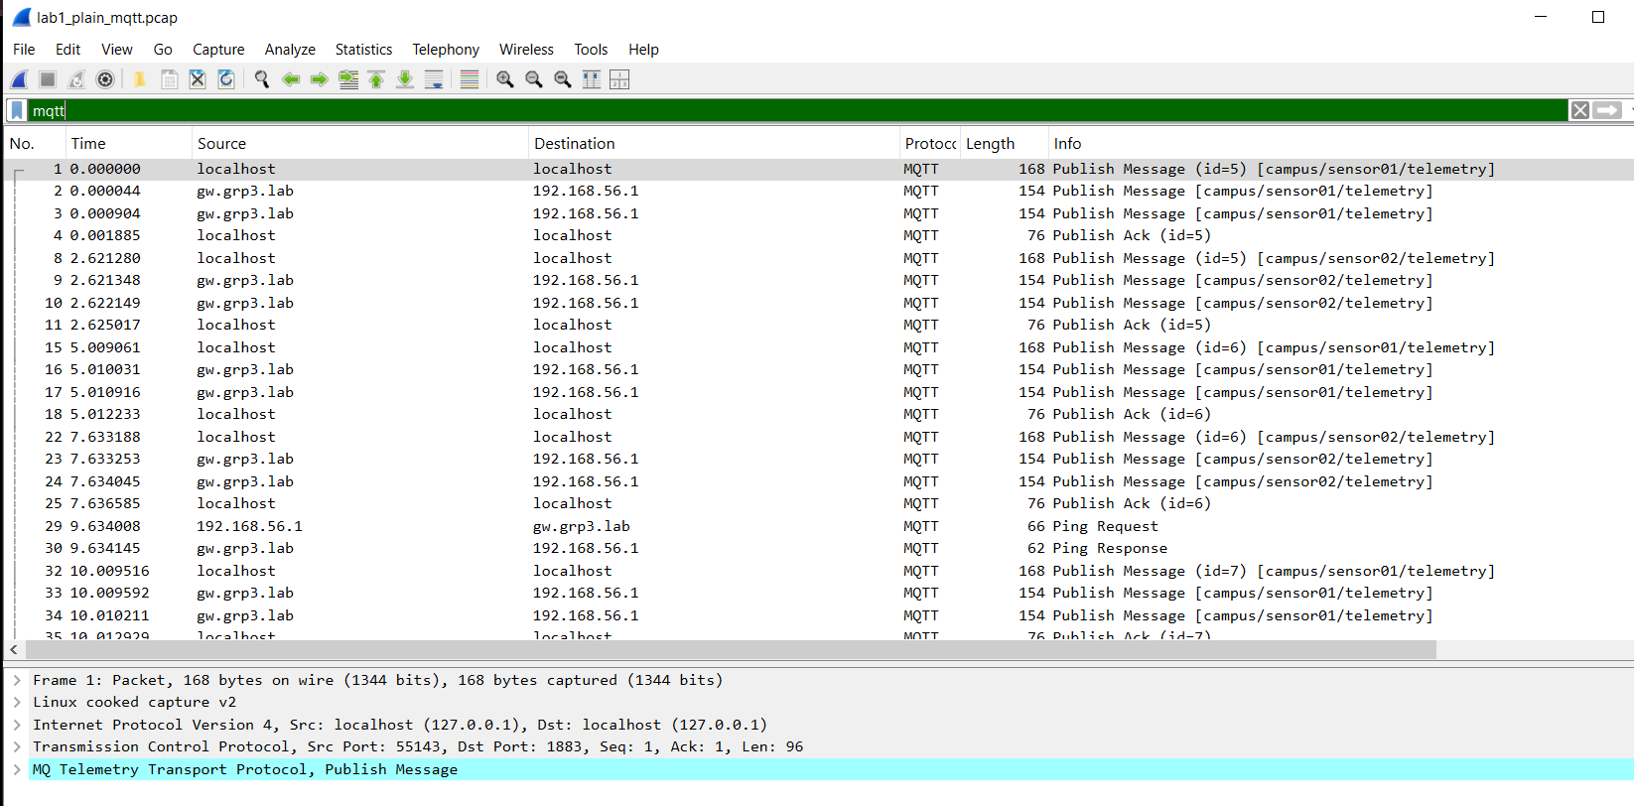
Output D2 Sniffing
Follow > TCP streams
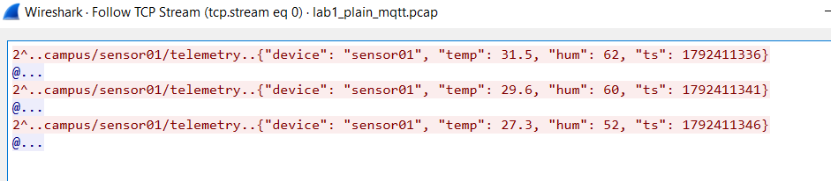
Security finding: MQTT telemetry dihantar dalam plaintext, jadi pihak yang boleh menangkap trafik rangkaian tersebut boleh membaca data sensor tanpa menyahsulitnya.

D3 : Injection Attack
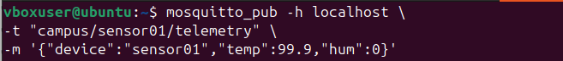
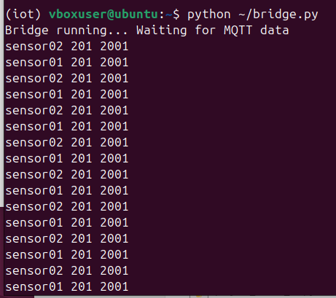
Verify fake reading
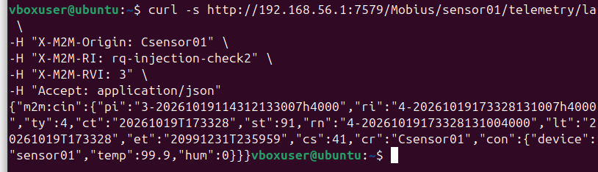
Security finding: Sistem menerima data sensor palsu yang dihantar melalui MQTT tanpa mengesahkan identiti publisher. Bridge kemudian menyimpannya dalam Mobius seolah-olah bacaan sebenar daripada sensor01.
D4 – Spoofed Originator
GET Test successful
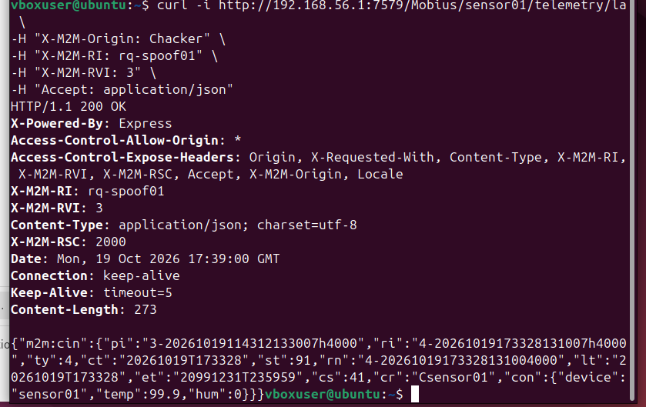
Test POST - Chacker
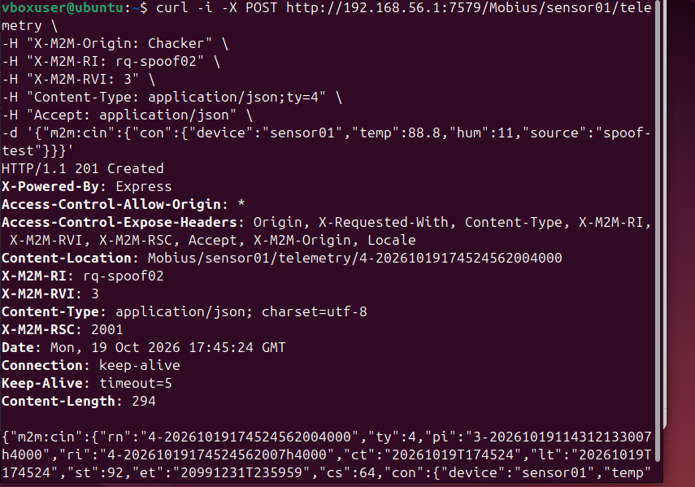
The test shows that the Mobius CSE currently permits the originator "Chacker" to read and create resources within sensor01's telemetry container. This indicates that access control is too permissive for this lab scenario, as an unauthorized originator can access sensor data and insert fake readings. Stronger authentication and appropriate access control policies are needed to prevent unauthorized access.

D5 : Service Discovery
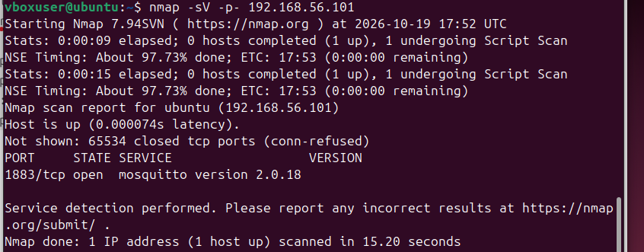
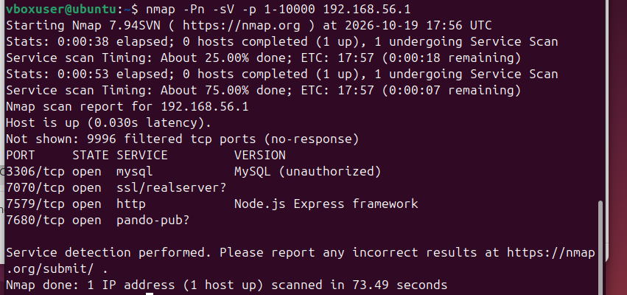
Nmap to txt file
D6 - Credential Hunting
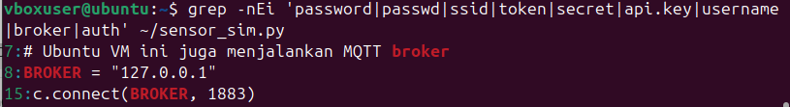
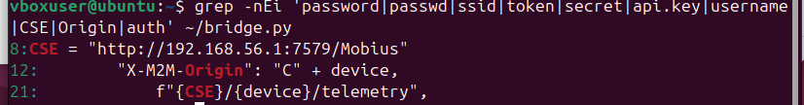
The credential hunting test identified a hardcoded MySQL database password stored in plaintext within the Mobius conf.json configuration file. The file also exposed a privileged superuser identifier and server configuration details. These findings highlight the risk of credential exposure if configuration files are accessed by unauthorized users or accidentally uploaded to public repositories.
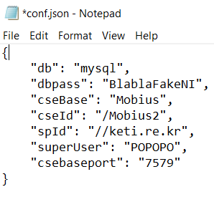

8. Baseline findings table (evidence)
Complete this table. It becomes Section 3 (“Baseline security assessment”) of your Mini Project Report. The last column shows which lab will fix each finding.
# | Finding | Evidence file | MTSFB threat / weakness | Fixed in
F1 | MQTT broker accepts anonymous clients, allowing unauthorized subscription to sensor telemetry. | D1_Eavesdropping.png | T-Sec-3 / R-Sec-5 | Lab 3
F2 | MQTT telemetry is transmitted in plaintext and can be captured and read using Wireshark. | lab1_plain_mqtt.pcapng | T-Sec-4 / R-Sec-3 | Lab 3
F3 | Unauthenticated MQTT publishers can inject fake sensor readings, which are subsequently stored in Mobius. | D3_Injection.png | Data integrity / Message injection | Lab 3, Lab 5
F4 | Mobius CSE permits an unverified originator (Chacker) to retrieve telemetry and create Content Instances. | D4_Spoofed_Originator.png | Identity spoofing / Weak access control | Lab 5
F5 | Network scanning reveals exposed services, including MQTT (1883), MySQL (3306), and Mobius HTTP (7579). | D5_Service_Discovery.png | Service exposure / Information disclosure | Lab 4
F6 | No Wi-Fi password was found in the Python simulator. However, device originator identifiers are predictable and not strongly authenticated. | D6_Source_Code.png | Weak device authentication | Lab 3
F7 | A MySQL database password is stored in plaintext in the Mobius conf.json configuration file. | D6_Conf_Redacted.png | Hardcoded credentials / Credential exposure

10. Reflection Questions
Question 1: Which finding would an attacker exploit first in a real deployment, and why?
An attacker would likely exploit F1 (Anonymous MQTT Access) first because the MQTT broker allows clients to connect and subscribe to sensor data without authentication. This vulnerability is relatively easy to exploit because the attacker only needs network access to the broker. After observing the telemetry, an attacker could attempt to inject fake sensor readings, as demonstrated in F3. This could compromise both the confidentiality and integrity of the IoT system.
Question 2: Map findings F1–F6 to the four security domains (device, communication, gateway, cloud).
Finding | Primary Security Domain | Explanation
F1 — Anonymous MQTT Access | Gateway | The Mosquitto broker accepts unauthenticated MQTT clients.
F2 — Plaintext MQTT Communication | Communication | Sensor telemetry is transmitted without encryption and can be intercepted using Wireshark.
F3 — Fake Sensor Data Injection | Device / Communication | Attackers can impersonate sensor publishers and inject false readings into the data stream.
F4 — Spoofed Originator | Cloud / Platform | Mobius accepts read and create requests from an unverified originator.
F5 — Open Ports and Services | Gateway / Cloud | Nmap reveals accessible network services on the gateway and Mobius server.
F6 — Weak Device Credential Management | Device | The simulator uses predictable device identifiers and communicates without MQTT authentication credentials.
Some findings affect multiple domains because vulnerabilities in one part of the IoT architecture can affect other connected components.
Question 3: Why is "the lab network is private" not a sufficient security control? Relate your answer to zero trust.
A private network does not guarantee that all connected devices and users are trustworthy. An attacker may gain access through a compromised device, an insider account, or an improperly configured network connection. In our testing, MQTT messages could be read without authentication, and fake sensor data could be injected into the system.
The zero-trust security model follows the principle of never trust, always verify. Every device and request should be authenticated and authorized regardless of whether it originates from an internal or external network. Therefore, security measures such as strong authentication, encryption, access control and continuous monitoring are necessary even within a private lab network.
Question 4: For your chosen use case, describe one safety harm and one privacy harm that the baseline weaknesses could cause.
Use Case: IoT-Based Campus Environmental Monitoring
Safety Harm: An attacker could inject false temperature readings into the IoT system. For example, a fake temperature reading of 99.9°C could trigger an unnecessary emergency alert or cause an automated monitoring system to make an incorrect decision. This could disrupt campus operations or divert attention from genuine environmental hazards.
Privacy Harm: Since MQTT telemetry is transmitted without encryption and the broker allows anonymous subscriptions, an attacker could intercept environmental sensor readings. If the monitoring system were associated with particular rooms or buildings, the timing and patterns of these readings could potentially reveal information about room usage or occupancy.
These examples demonstrate how weak authentication, insufficient access control and unencrypted communication can affect both the safety and privacy of IoT deployments.

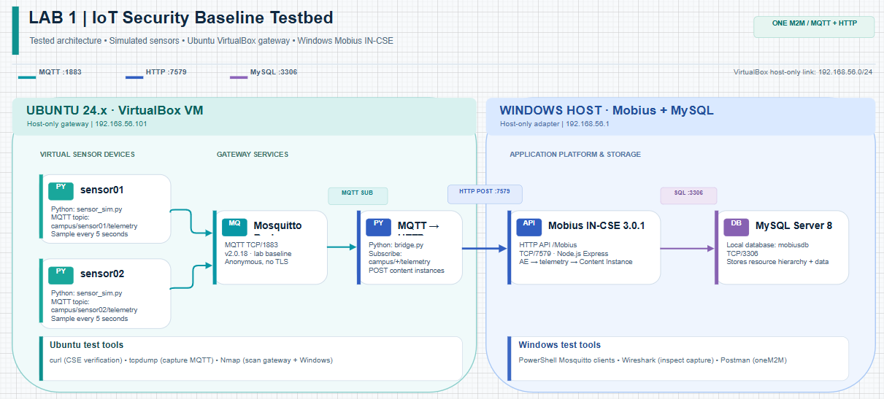
Figure 1: Architecture of the Lab 1 IoT Security Testbed using Ubuntu VirtualBox, MQTT, Python Bridge, Mobius IN-CSE, and MySQL.

