nltk : Natural Language Toolkit, is a Python package that you can use for NLP

from nltk.stem.lancaster import **LancasterStemmer**

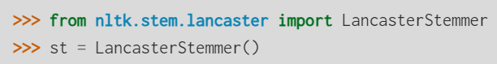

<https://www.nltk.org/api/nltk.stem.lancaster.html>

“Stemming is one of the most widely used techniques for text normalization.”

Stemming, also called suffix stripping, is a technique used to reduce text dimensionality. Stemming is also a type of text normalization that enables you to standardize some words into specific expressions also called stems.

\***gives us the root word. So our model can recognize the word and give appropriate response**

**To get words separately we need to do Tokeniz**

import **tflearn**

