

GROUP ASSIGNMENT
TECHNOLOGY PARK MALAYSIA
CT038-3-2-OODJ-L-8
OBJECT ORIENTED DEVELOPMENT WITH JAVA (OODJ)

HAND OUT DATE: 30th September 2025
HAND IN DATE: 14^{H} December 2025
LECTURER: FATIN IZZATI RAMLIE
INTAKE: APD2F2509IT/APD2F2509(CE)
GROUP:08

No. | Name | TP Number
 | Nazeer Fathima Akla | TP084989
 | Youssef Ahmed Said Ahmed Ghazy | TP084982
 | Hazaa Salem Mubarak Obeid Awadh | TP083920

Table of contents:
Table of contents: 2
1. Introduction 5
2. Design Solution: 6
2.1 Use Case Diagram: 6
2.2 Class Diagram: 8
3. System Implementation Screenshots: 10
3.1 User Management + Email Notification 10
3.1.1 Login + Role Access. 10
3.1.2 Add new user functionality. 15
3.1.3 Edit User Functionality. 18
3.1.4 Activate/Deactivate User Functionality. 21
3.1.5 Reset Password Functionality. 23
3.2 Eligibility Check & Enrolment - 25
3.2.1 Eligibility Checker - Student List Overview: 25
3.2.2 Detailed Eligibility Evaluation (Student At Risk): 27
3.2.3 Sending Eligibility Notification: 28
3.2.4 Notification Sent Confirmation: 29
3.2.5 Email Notification Received by Student: 30
3.3 Course Recovery Plan Module: 31
3.3.1 Student Selection for Course Recovery 31
3.3.2 Failed Components and Recovery Status Listing 31
3.3.3 Recovery Attempts and Eligibility Rules 32
3.3.4 Starting a Recovery Attempt 33
3.3.5 Monitoring Recovery Progress 33
3.3.6 Completing a Recovery Attempt 34
3.3.7 Recovery Completion and Status Update 35
3.3.8 Notifying Student of Recovery Status 35
3.3.9 Recovery Notification Email Sent to Student 36
3.3.10 Generated Recovery Plan PDF (Attached Document) 37
3.4 Acadmeic performance reporting: 38
3.4.1 Academic Performance Report Interface: 38
3.4.2 Student Selection for Academic Report Generation: 39
3.4.3 Loaded Course Performance and GPA Summary: 40
3.4.4 Email Academic Report (PDF) Prompt: 41
3.4.5 Academic Report PDF Sent Confirmation: 42
3.4.6 Academic Performance Report Email Received: 43
3.4.7 Generated Academic Performance Report (PDF View): 44
3.4.8 Console-Based Academic Report Output: 45
4. Object-Oriented Programming Concepts: 46
4.1 Nazeer Fathima Akla- TP084989 46
4.1.1 Packages: 46
4.1.2 Class and Object: 47
4.1.3 Inheritance: 49
4.1.4 Encapsulation: 50
4.1.5 Polymorphism: 51
4.1.6 Abstraction: 52
4.1.7 Modularity: 53
4.2.1 Abstraction: 54
4.2.2 Encapsulation: 57
4.2.3 Inheritance: 60
4.2.4 Polymorphism 62
4.3 Hazaa Salem Mubarak Obeid Awadh- TP083920: 64
4.3.1 Abstraction 64
4.3.2 Encapsulation 65
4.3.3 Inheritance (Object Reuse) 66
4.3.4 Polymorphism 67
4.3.5 Modularity (Packages) 68
5. Additional Features 69
5.1 Modern Colorful Dashboard GUI 69
5.2 Real Time Filter and Search 70
5.3 Visual Status Indicators with Custom Colors 71
5.4 Refresh Button for Data Reload 72
5.5 Professional PDF generation. 73
5.6 Summary Panel in Academic Performance 74
6. Limitations: 75
7. Conclusion: 76
8. Appendix: 77
8.1 GUI Code Snippets 77
8.2 Workload Matrix 94
8.3 References: 95

1. Introduction

The Course Recovery System (CRS) is an organized academic support system that helps institutions to recognize students who are performing poorly and helps them to pass through a recovery process which is uniquely tailored. The system brings together all the necessary academic recovery operations, including monitoring failed elements, creating recovery suggestions, designating milestones, certifying that the students are qualified, tracking advancement, and reporting results. Digitization of these processes means that the CRS will decrease the amount of manual work and enhance consistency of the academic interventions.

The main aim of the system is to make the academic recovery transparent and efficient. It performs automated functions like computing student eligibility, creating performance summary, and recovery plans, and creating detailed progress reports. This lessens the faculty workload, enhances the minimal number of errors, and offers a just and objective recovery route to the students. The system will also make sure that all the recovery decisions are informative and in line with the academic policies.

Academic Officers and Course Administrators are the primary target users of the CRS because of their duty to monitor the performance of students and take recovery plans. The system is used by Academic Officers in assessing the eligibility of the students, in giving them recovery assignments and monitoring of academic improvement. The CRS helps Course Administrators to archive records, monitor milestones, communicate, and have order in the workflow within the academic departments. The CRS tries to help institutions increase the rate of student success and academic standards through these features.

2. Design Solution:

2.1 Use Case Diagram:
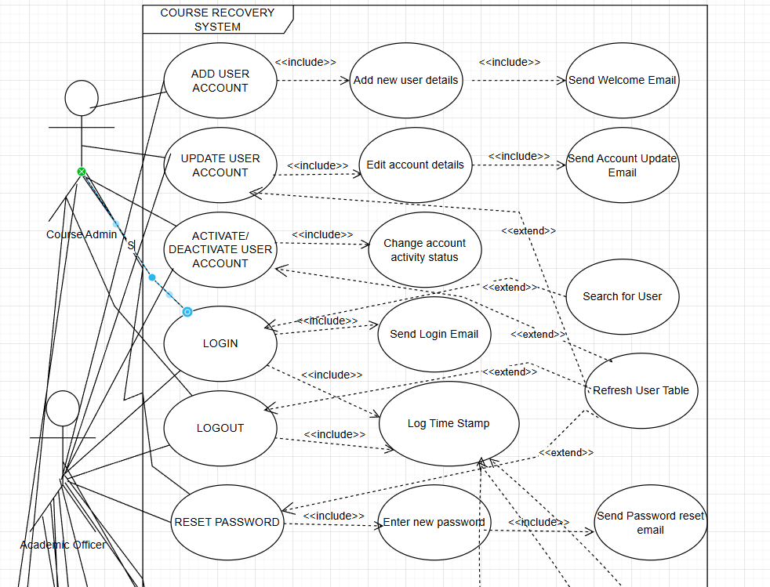
Figure 2.1.1: Use case diagram
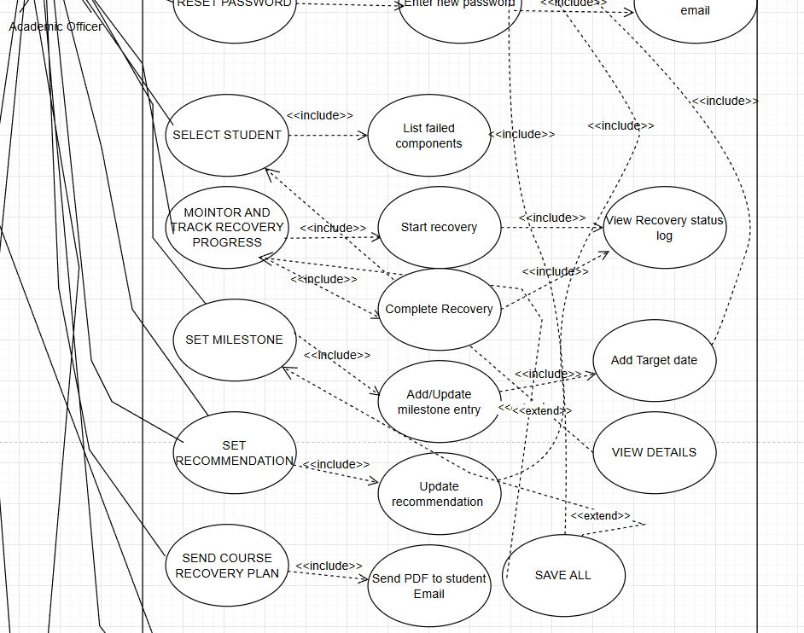
Figure 2.1.2: Use case diagram continued

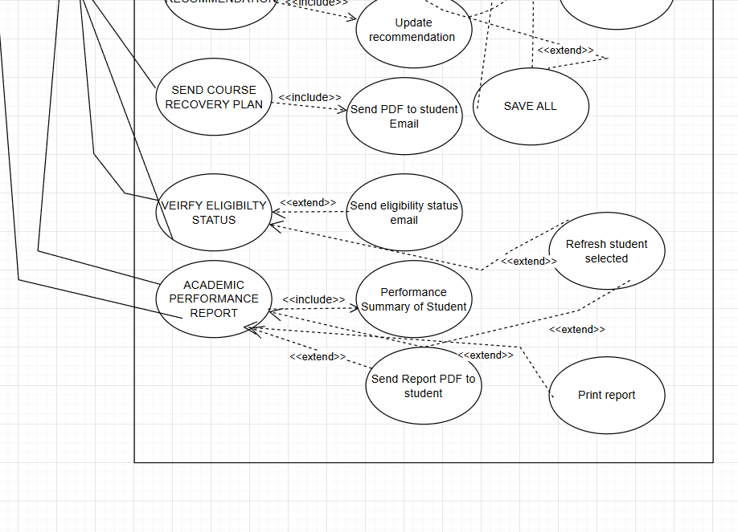
Figure 2.1.3: Use case diagram continued

2.2 Class Diagram:

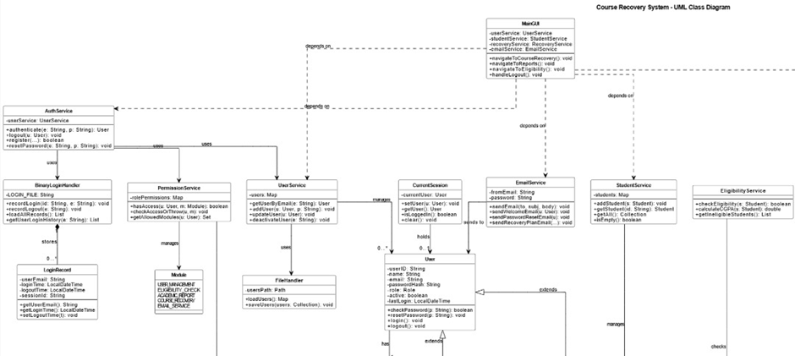Figure 2.2.1: Class Diagram (Upper Left)

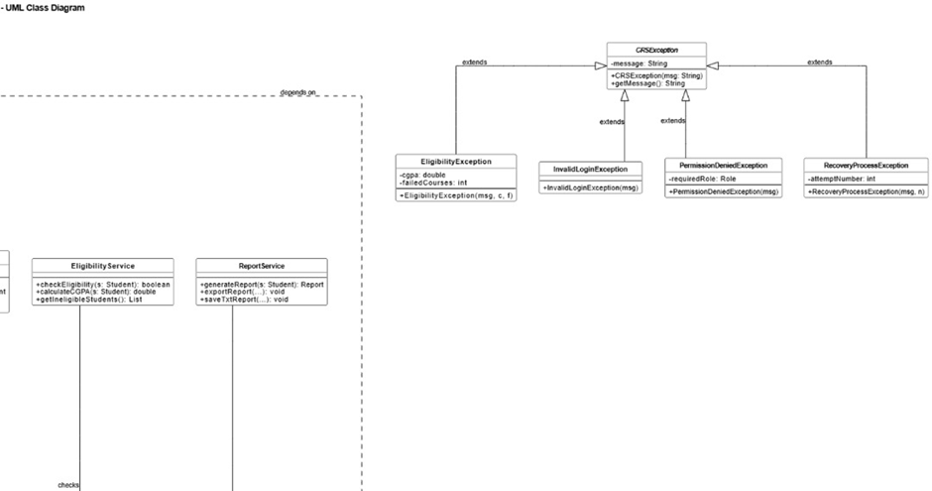Figure 2.2.2: Class Diagram continued (Upper Right)

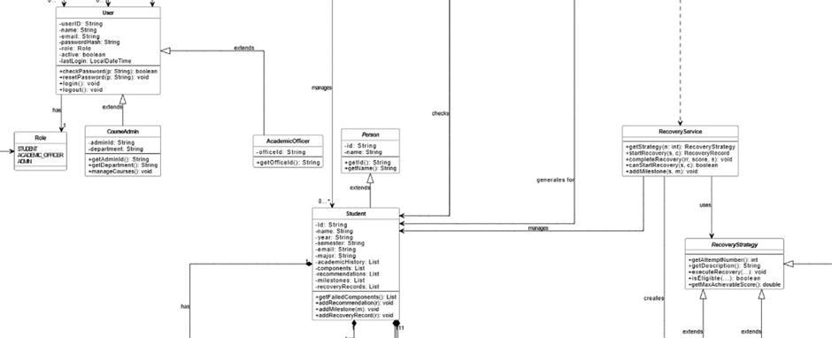Figure 2.2.3: Class Diagram continued (Bottom Left)

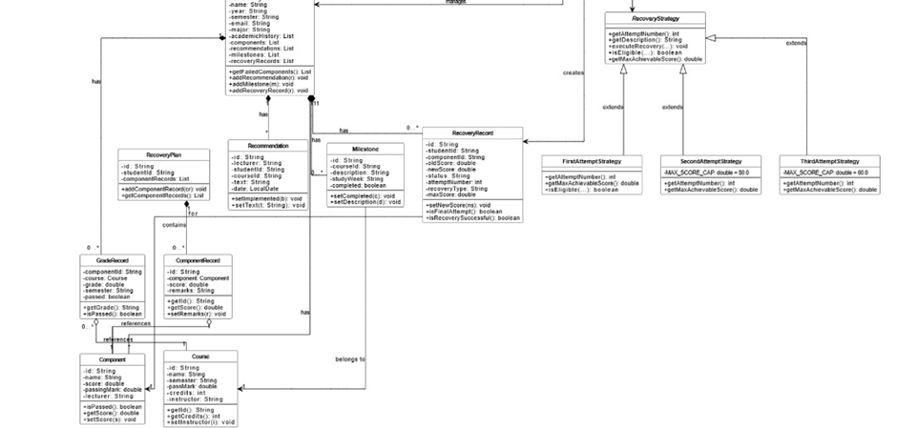Figure 2.2.4: Class Diagram continued (Bottom Right)

3. System Implementation Screenshots:

3.1 User Management + Email Notification

3.1.1 Login + Role Access.
The system allows registered users in file (users.txt) to login into the system based on email and password validation. Role access is implemented here where Academic officer has more privileges than course admin. In addition, for every action involving user, an email notification is sent to the respective email.
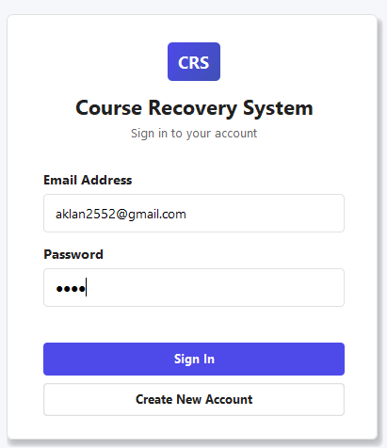
Figure 3.1.1.1: Login panel for CRS portal. Prompting email address and password
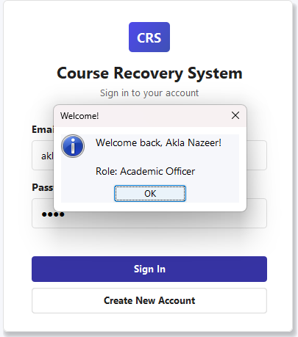
Figure 3.1.1.2: Successful Login as Academic Officer
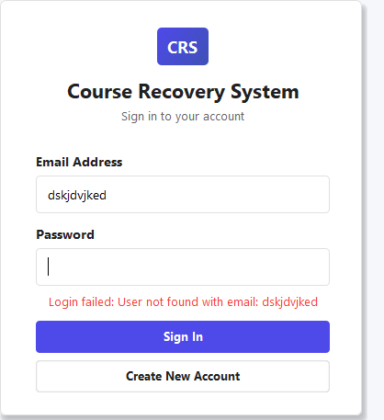
Figure 3.1.1.3: Input validation check

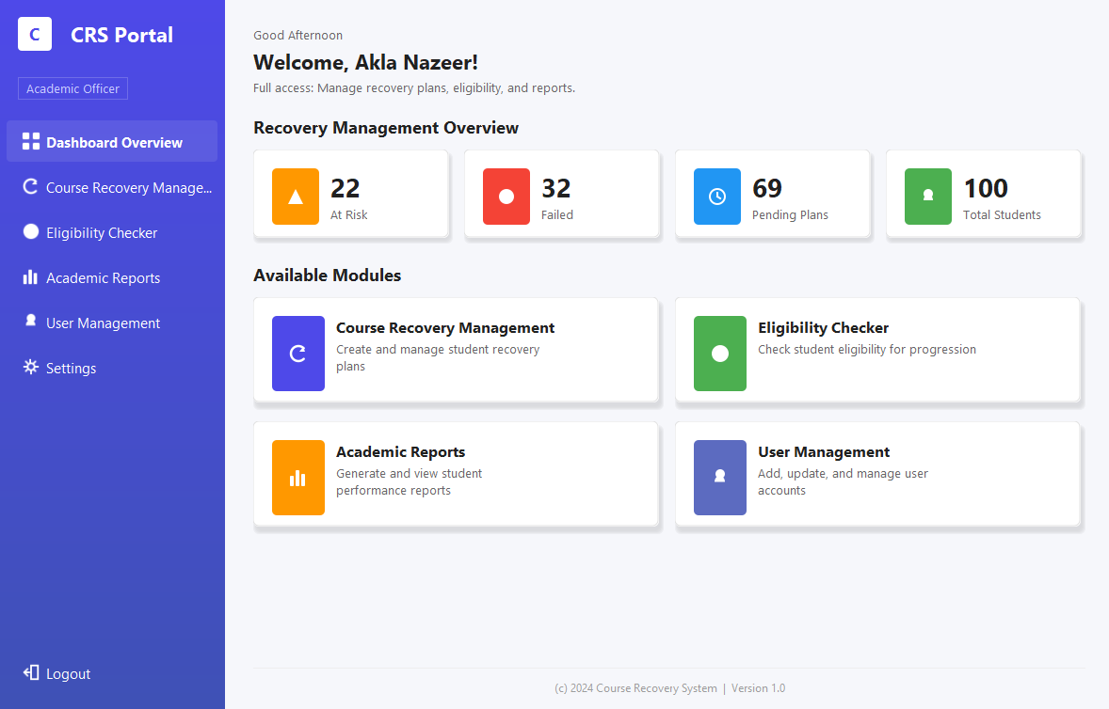
Figure 3.1.1.4: Academic Officer dashboard- has access to all tabs and functions.
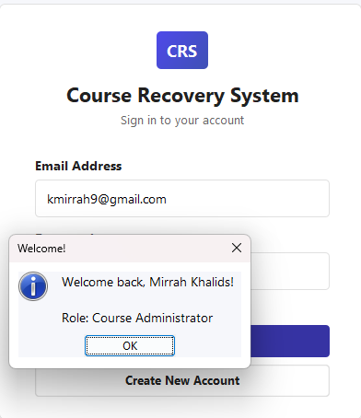
Figure 3.1.1.5: Successful Login as Course Administrator
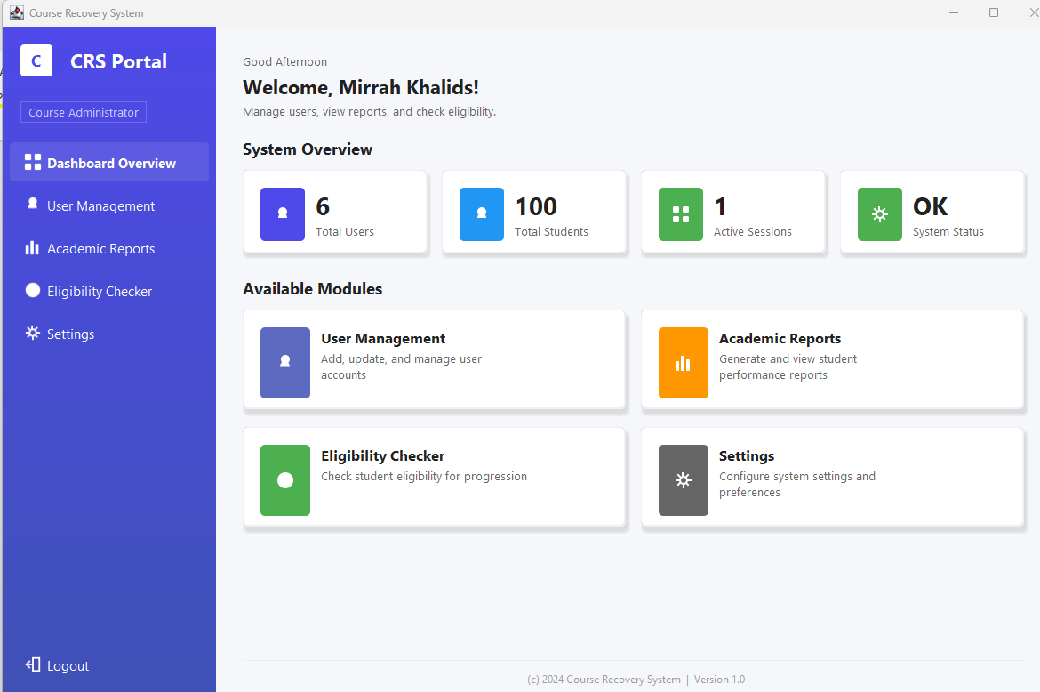
Figure 3.1.1.6: Course Admin dashboard- has access limited tabs (no course recovery plan)

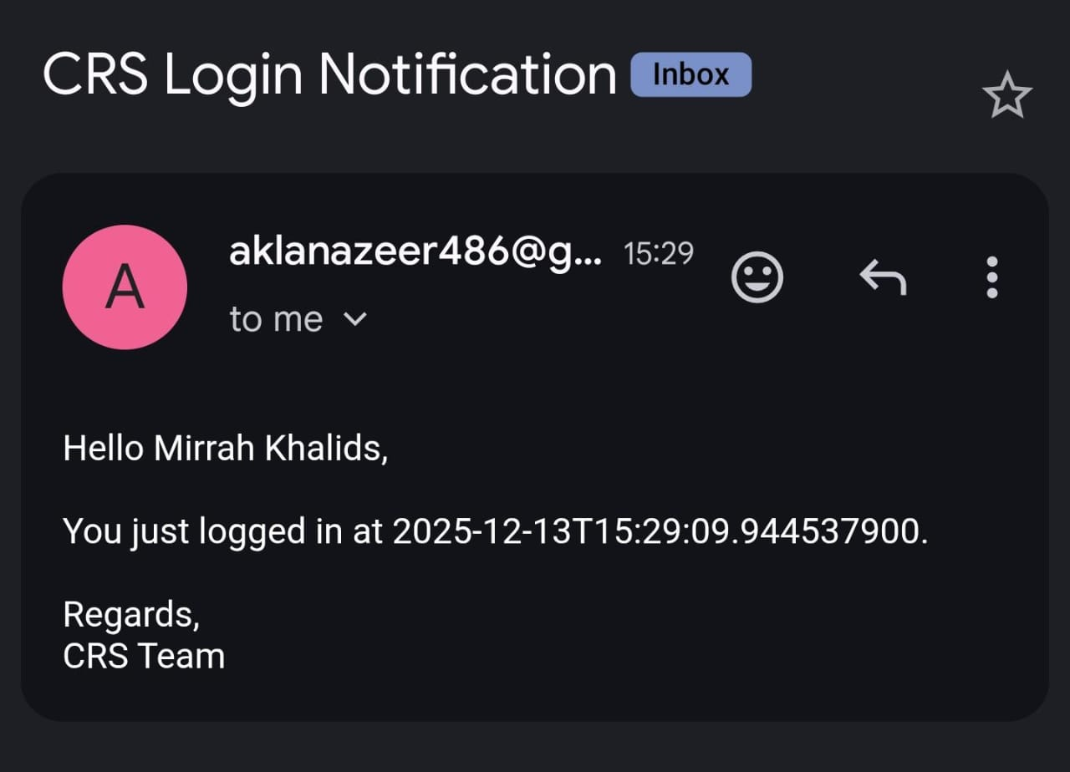
Figure 3.1.1.7: Email notification when logged in with time stamp log.

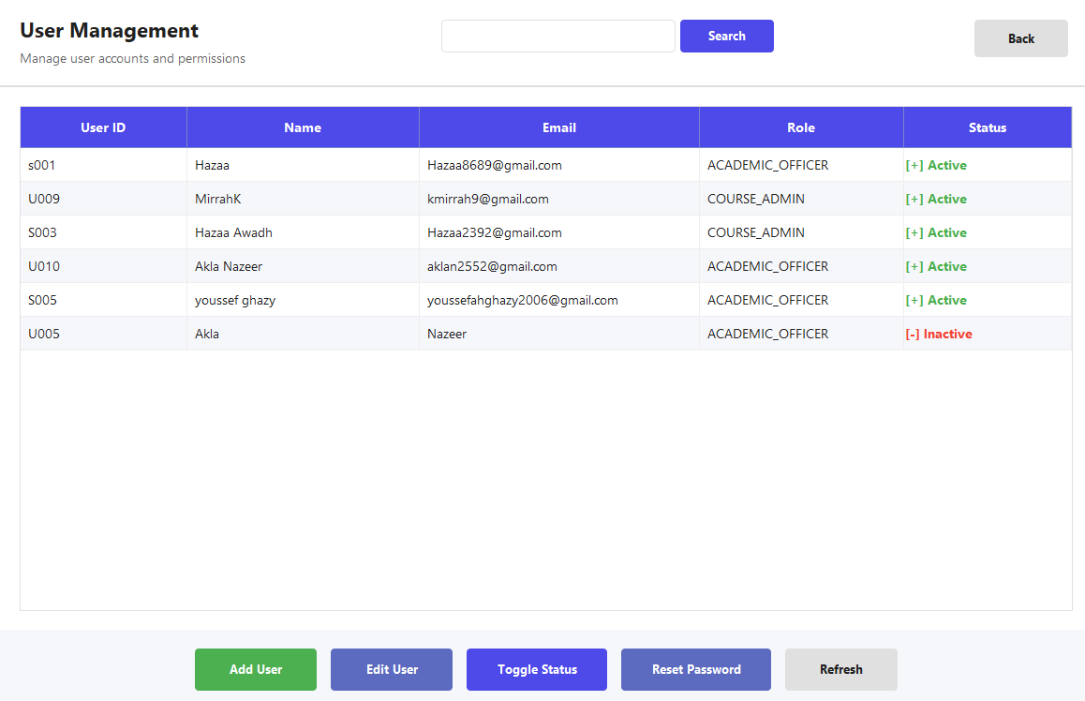
Figure 3.1.1.8: User management panel

3.1.2 Add new user functionality.
The add new user functionality allows the user to create a new account in the Course Recovery System. ID, Name, Email and Role will be prompted to enter with validation checks and the status will be set to active, and email notification will be sent.
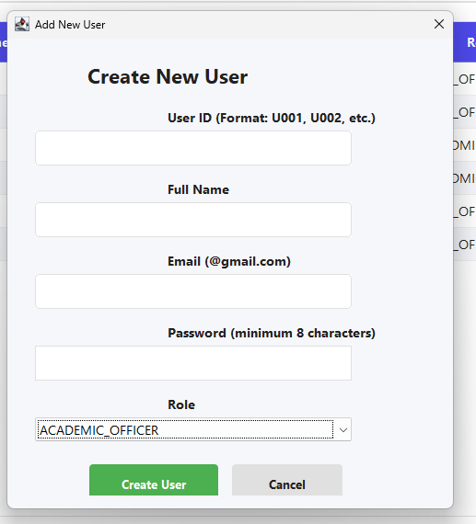
Figure 3.1.2.1: Add user dialog
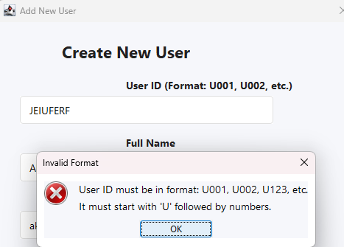
Figure 3.1.2.2: Error handling: ID number 1
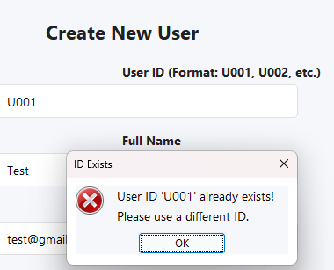
Figure 3.1.2.3: Error handling: Existing data

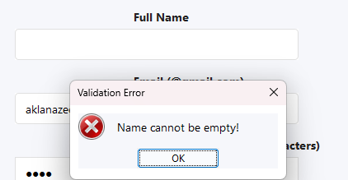
Figure 3.1.2.4: Error handling: Name

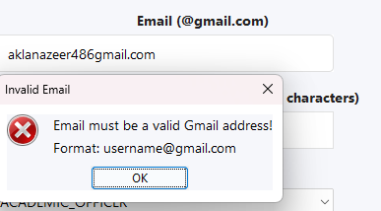
Figure3.1.2.5: Error handling: Email

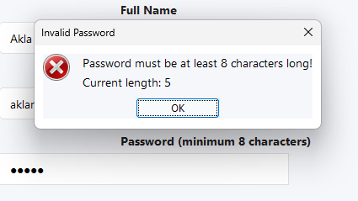
Figure 3.1.2.6: Error handling: Password
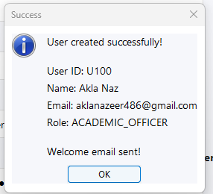
Figure 3.1.2.7: Successfully added user

Figure3.1.2.8: User added to user table

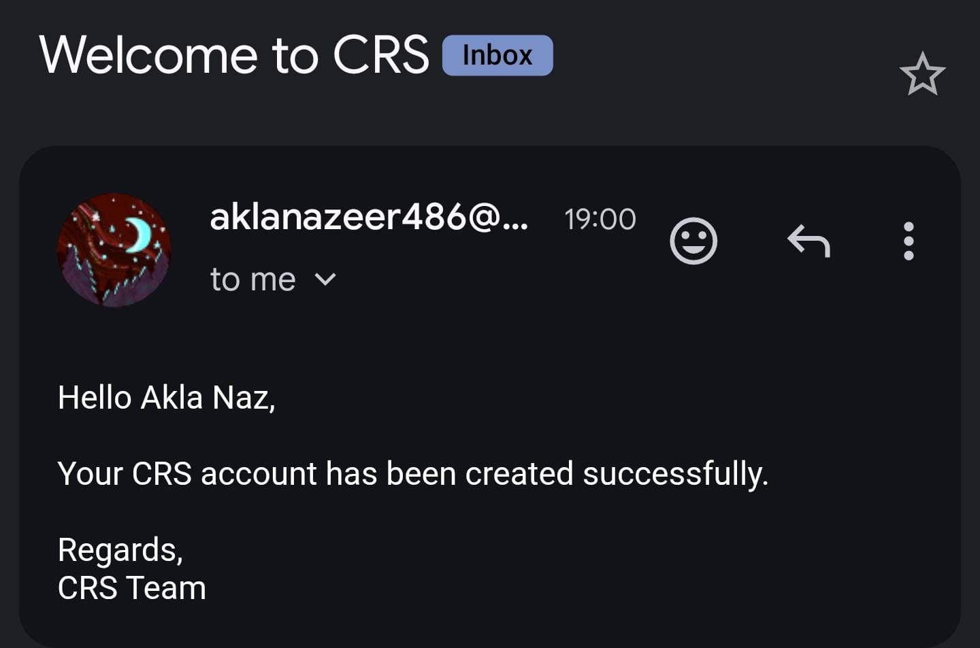
Figure 3.1.2.9: Email Confirmation on account creation

3.1.3 Edit User Functionality.
Over here the user can choose to update account details such as email address or name of existing account and email notification will be sent.
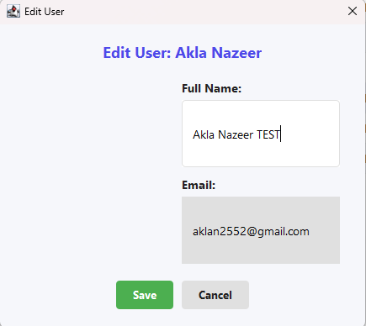
Figure 3.1.3.1: Edit user dialog
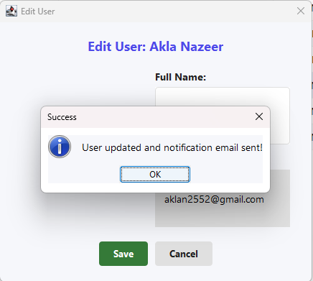
Figure 3.1.3.2: User updated & email confirmation sent message.

Figure 3.1.3.3: Updated in user table

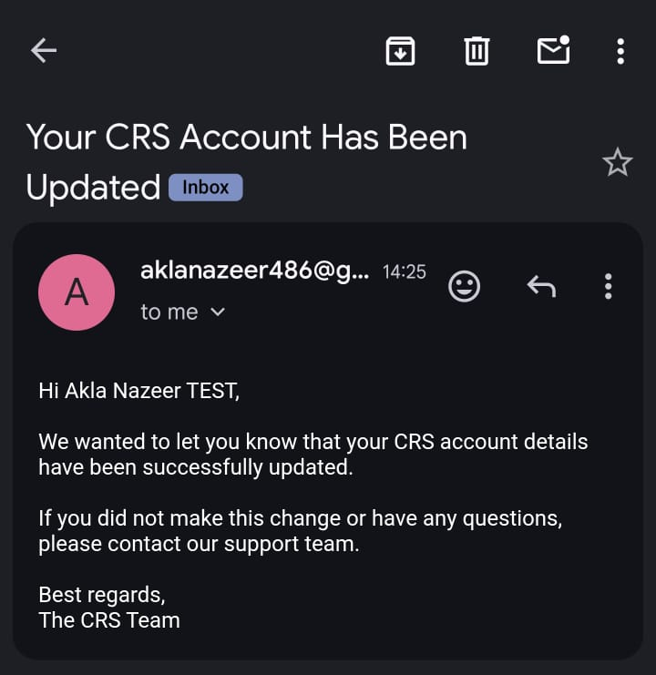
Figure 3.1.3.4: Email confirmation on account update.

3.1.4 Activate/Deactivate User Functionality.
In this functionality, the user can activate or deactivate an existing account. When done so the deactivated user cannot login to the system. Error handling is implemented; user must be selected to change account status.

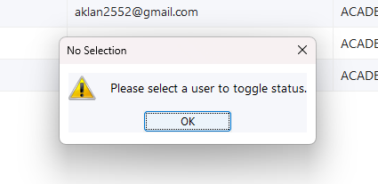
Figure 3.1.4.1: Toggle status error handling
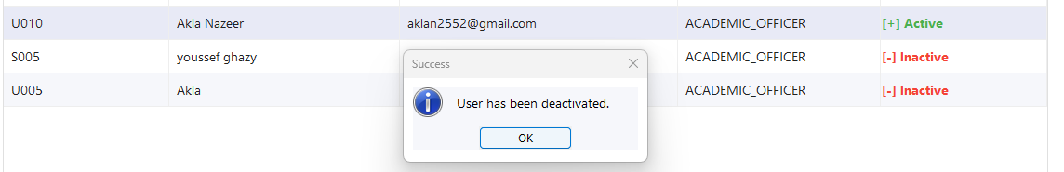
Figur 3.1.4.2: User selected and deactivated

Figure 3.1.4.3: Activity status updated.
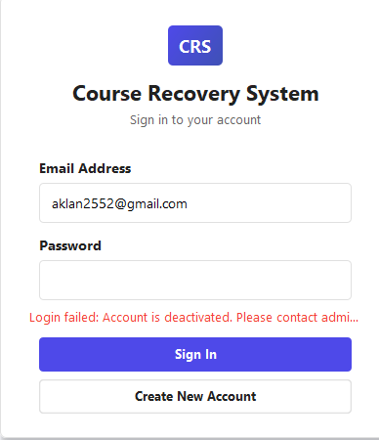
Figure 3.1.4.4: Deactivated User warning message-cannot login

3.1.5 Reset Password Functionality.
This allows the user to choose an account to allow for password reset. Once the new password is entered, email notification will be sent.
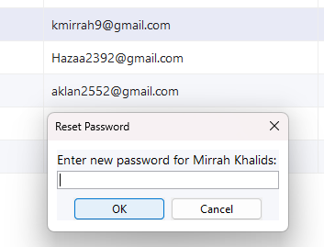
Figure 3.1.5.1: Enter new password

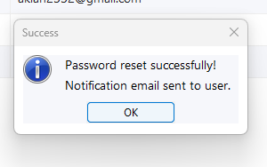
Figure 3.1.5.2: Reset password confirmation
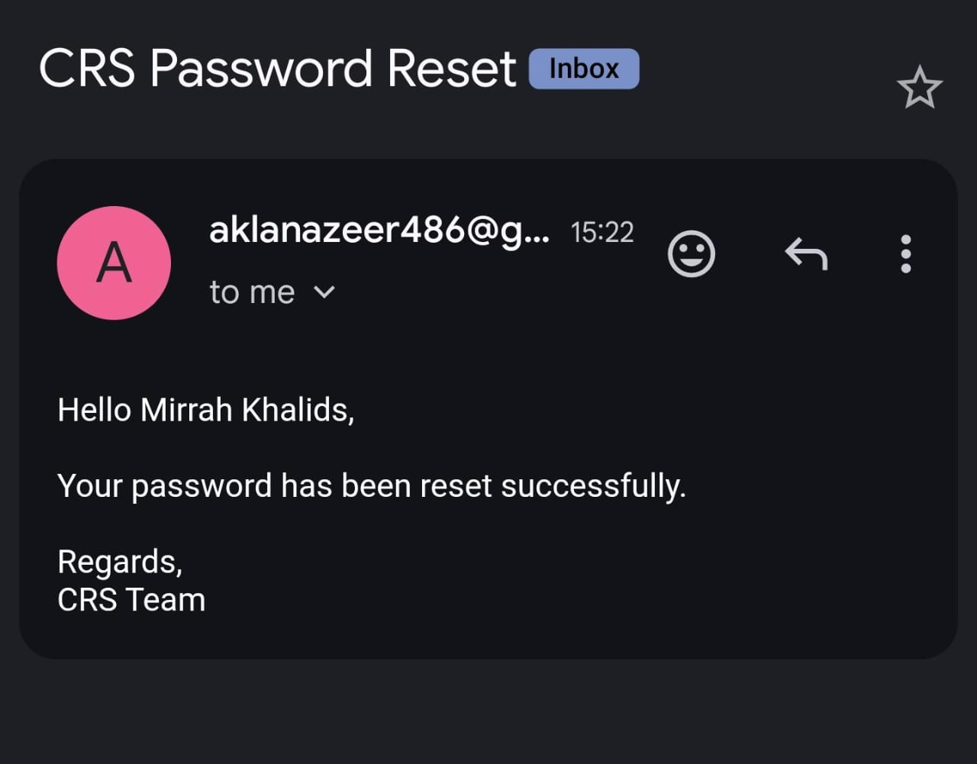
Figure 3.1.5.3: Email confirmation on password reset.
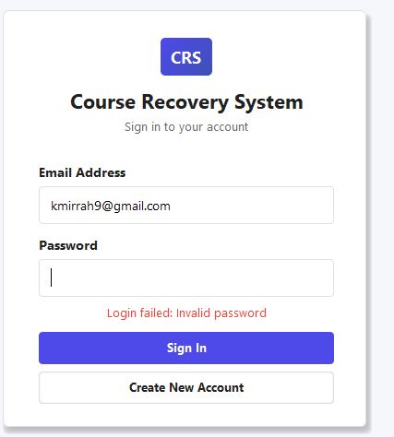
Figure 3.1.5.4: Password validation message.

3.2 Eligibility Check & Enrolment -

3.2.1 Eligibility Checker - Student List Overview:
This dashboard is a high-level view of the Course Recovery System that shows the most important stats relating to eligibility, such as the number of students who are in danger, failed, and pending recovery plans, and the total number of students. These indicators enable academic officers to rapidly determine the general academic status and those students who may need to be checked for eligibility or need to be recovered.

Figure 3.2.1.1: Main dashboard.

This screen gives the list of students that are loaded in the Eligibility Checker module, their CGPA, the number of failed courses and academic status. The system automatically considers eligibility based on predefined eligibility rules such as minimum CGPA must be 2.0 and maximum number of failed courses must be 3.

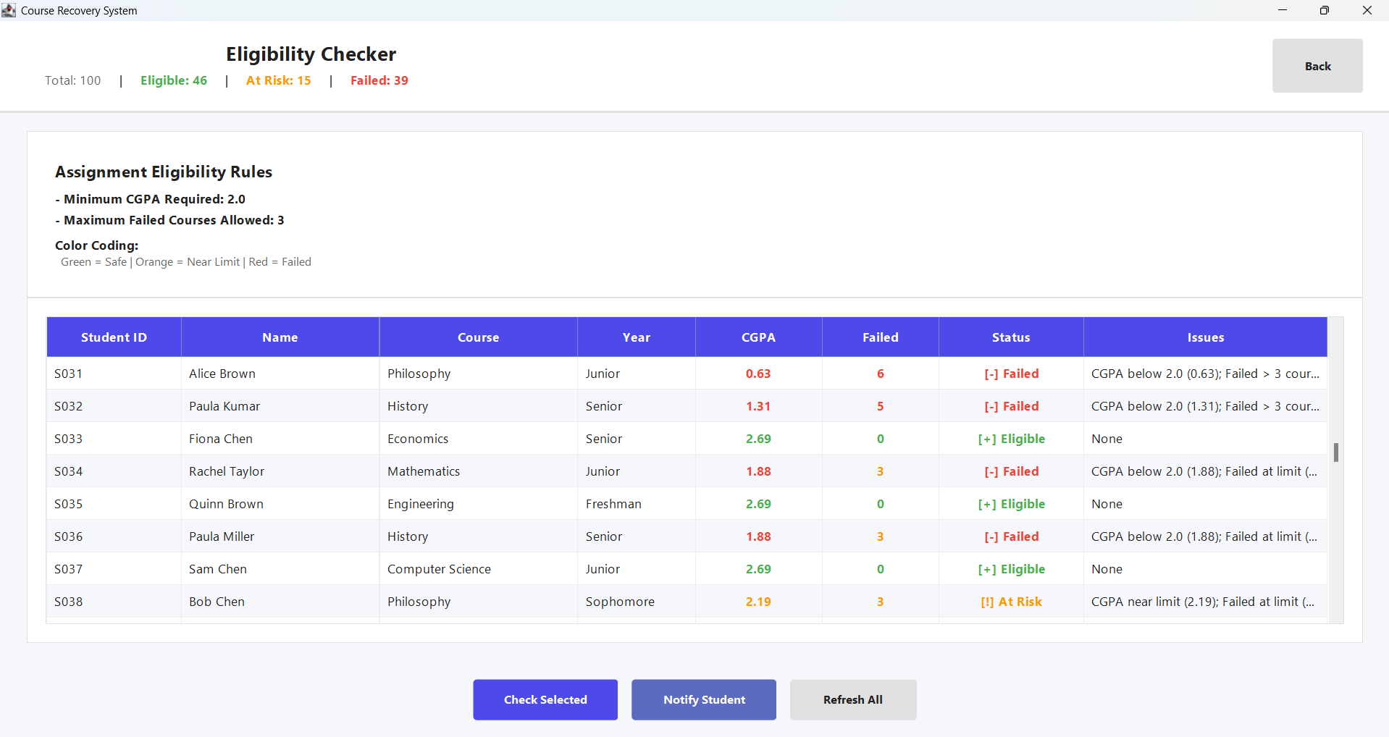
Figure 3.2.1.2: Eligibility Checker dashboard.

3.2.2 Detailed Eligibility Evaluation (Student At Risk):
This dialog box displays a detailed eligibility assessment for a selected student, including CGPA value, failed courses, final status and identified issues. It permits academic officers to have a better understanding of the reason why a student is highlighted as failed or risky.
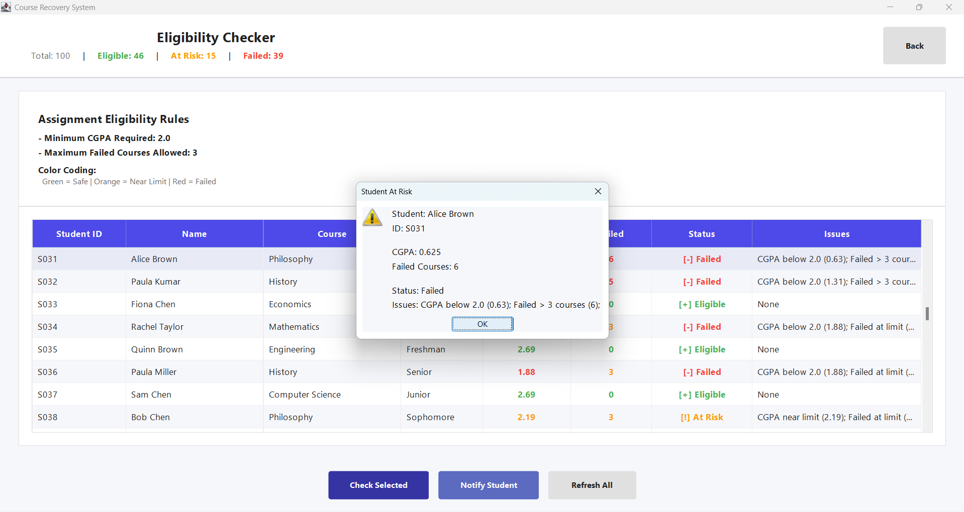
Figure 3.2.2.1: Detailed Eligibility Evaluation.

3.2.3 Sending Eligibility Notification:
This interface asks the academic officer for the student's email address through which an eligibility notification will be sent. The notification process is only triggered once the student has been chosen and their eligibility status is proven to be correct by the system.
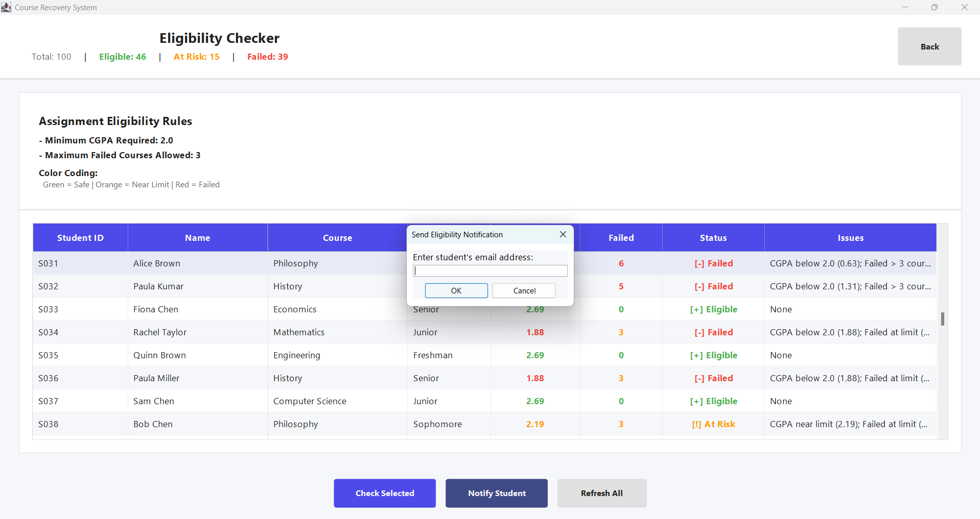
Figure 3.2.3.1: Sending Eligibility Notification.

3.2.4 Notification Sent Confirmation:
This confirmation message is showing that the eligibility notification has been sent successfully to the specified email address. It makes sure that the notification process is done without any errors and provides feedback to the system user.

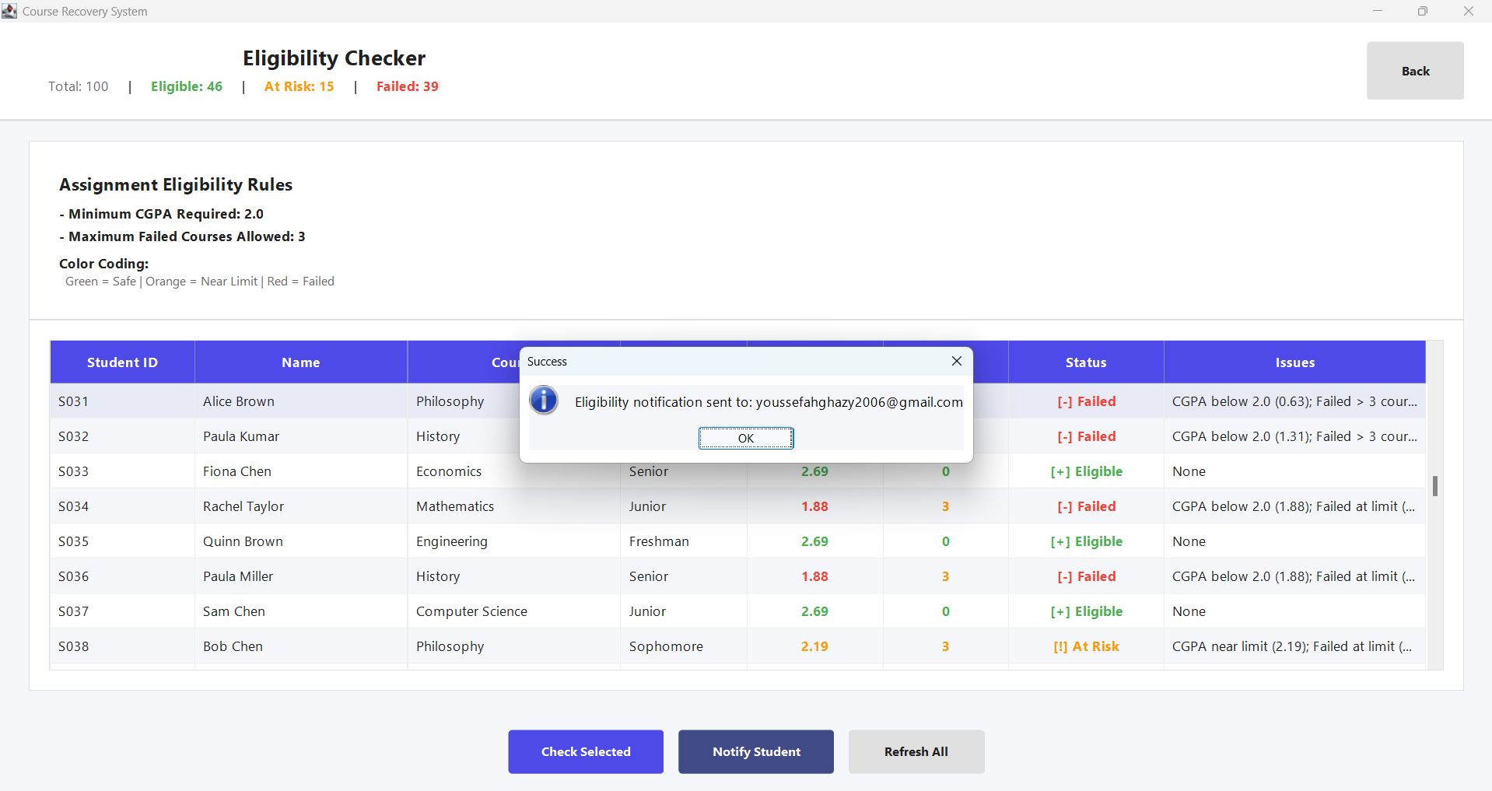
Figure 3.2.4.1: Notification Sent Confirmation.

3.2.5 Email Notification Received by Student:
This is a screenshot of the eligibility notification email sent to this student that summarizes the student's academic status, CGPA, failed courses, and identified problem(s): It gives the student specific indication to pursue more recovery efforts by meeting with their academic advisor.

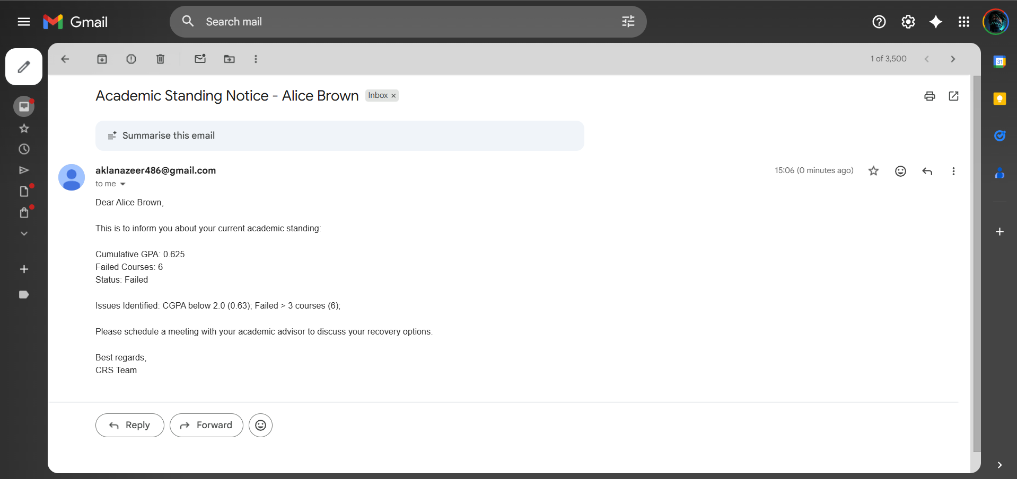
Figure 3.2.5.1: Email inbox.

3.3 Course Recovery Plan Module:

Failed components list in The course recovery plan module allows Academic Officers manage the way to recover students who have failed course units. The module facilitates student selection, display of failed components, recovery attempt, milestones and recommendations, recovery with revised scores and e-mail notification of students.

3.3.1 Student Selection for Course Recovery
In this interface, the Academic Officer is able to choose a student by referring to a dropdown list. After selection, all failed components of the student are loaded into the system and the recovery workflow prepared.

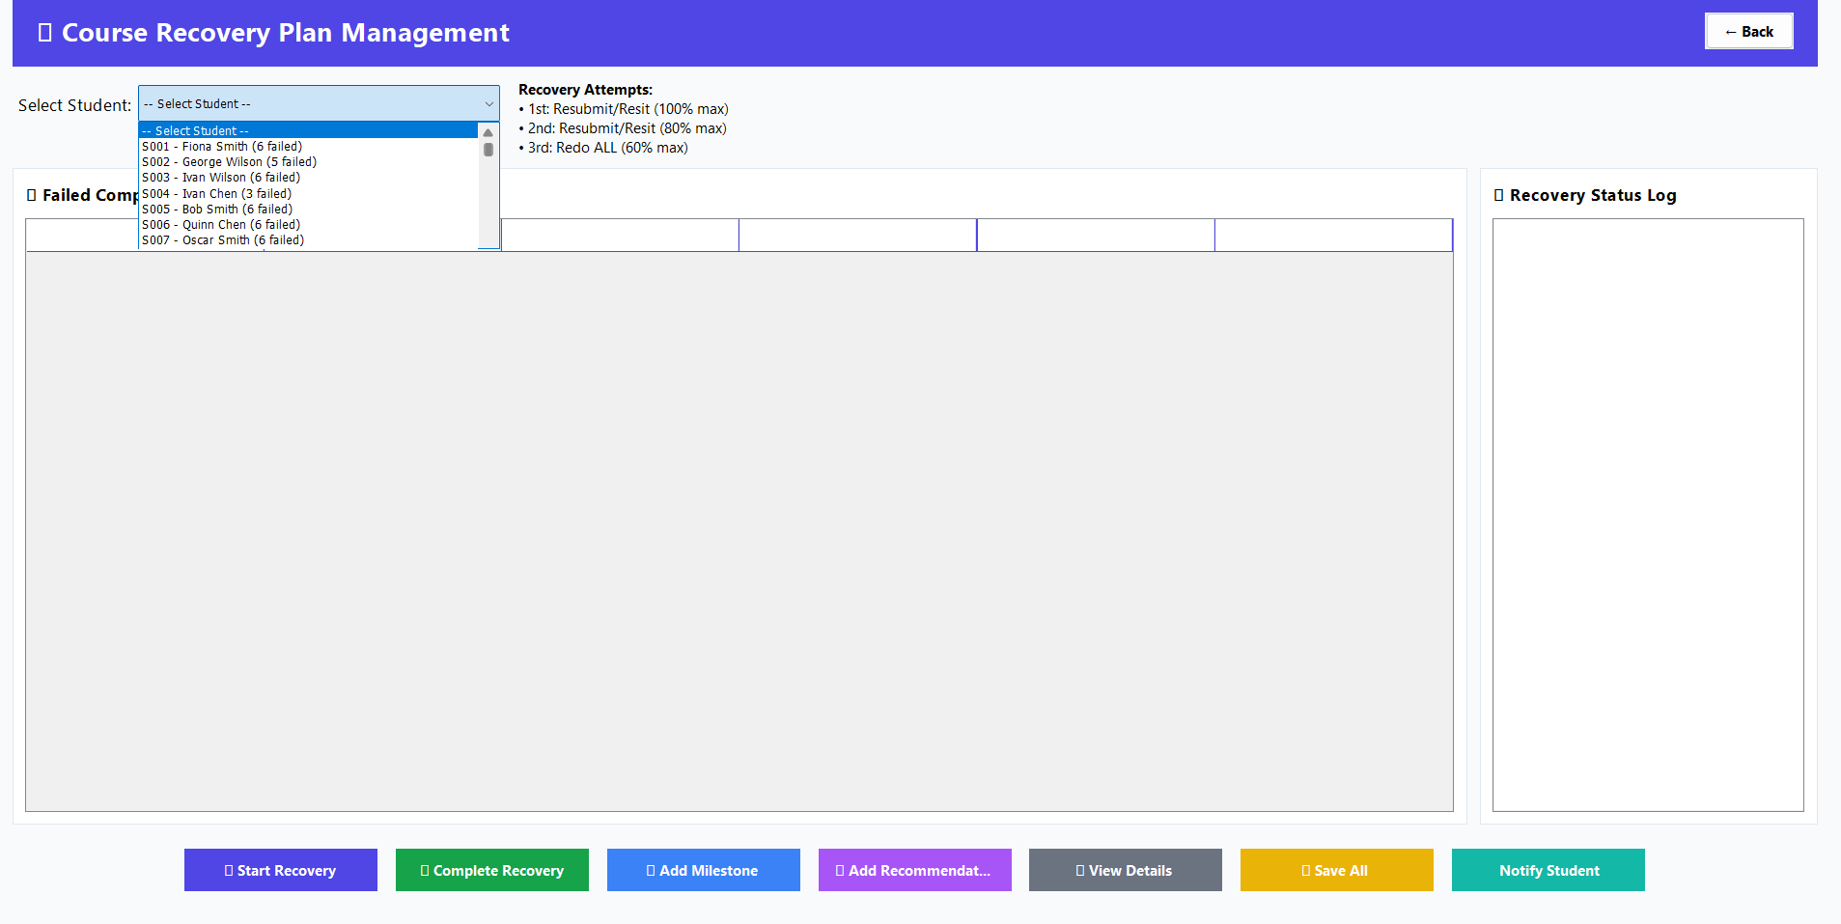Figure 3.3.1.1: Student Selection for Course Recovery Plan

3.3.2 Failed Components and Recovery Status Listing

The table shows all failed elements of the chosen student, his or her current score, the amount of recovery attempts being used, eligibility and the highest score that can be achieved with the current attempt.

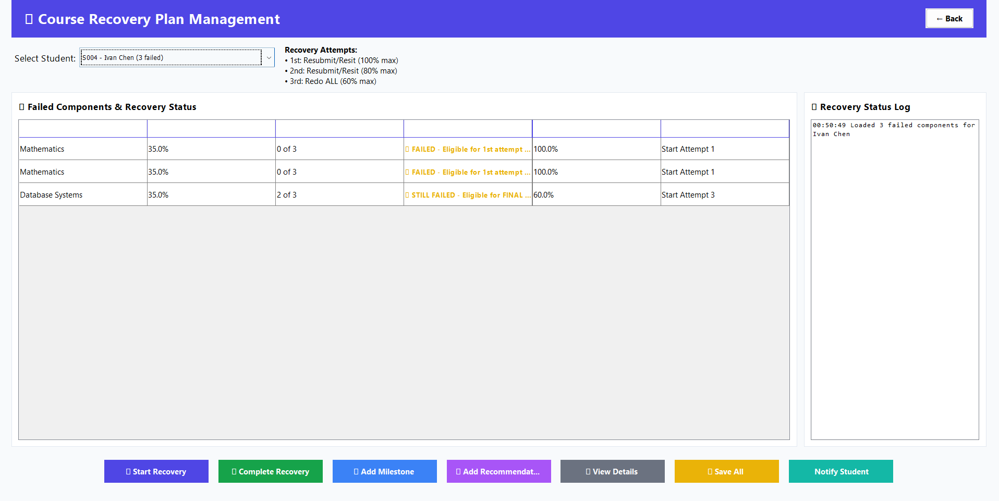Figure 3.3.2.1: Failed Components and Recovery Status Listing

3.3.3 Recovery Attempts and Eligibility Rules

In this section, the system displays the recovery attempt rules. It shows the first, second and third attempts of recovery and their type of recovery and highest score possible.

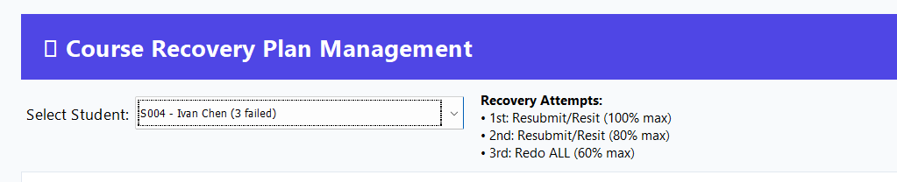Figure 3.3.3.1: Recovery Attempts and Eligibility Rules

3.3.4 Starting a Recovery Attempt

This message supports the fact that a recovery has been initiated successfully on the chosen failed component. It shows the attempt, the type of recovery and the highest possible score.

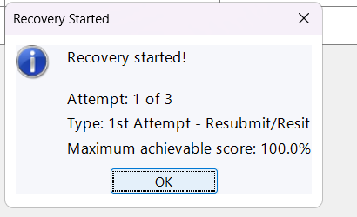
Figure 3.3.4.1: Recovery Attempt Started Confirmation

3.3.5 Monitoring Recovery Progress

Once a recovery attempt has been initiated, the status of the component in terms of recovery is set in the table. The system is dynamic in the reflection of the attempt at hand and the eligibility to the next stage of recovery.

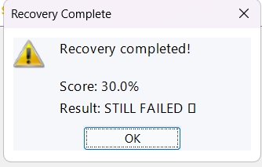
Figure 3.3.5.1: Monitoring Recovery Progress

3.3.6 Completing a Recovery Attempt
The Academic Officer can use this dialog to put in a new score on the recovered component. The system authenticates the score depending on the maximum that can be allowed on the ongoing recovery effort.

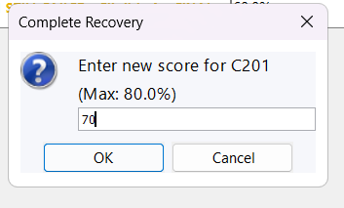
Figure 3.3.6.1: Complete Recovery – Enter Updated Score

3.3.7 Recovery Completion and Status Update
After the new score has been entered, the system completes the process of recovery and changes the status of recovery, respectively. This is confirmation that the recovery effort has been effectively accomplished.

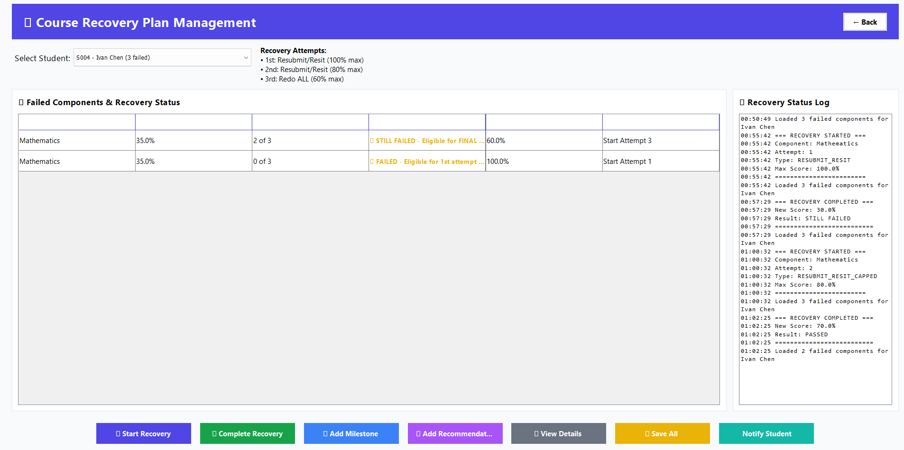Figure 3.3.7.1: Recovery Status Updated

3.3.8 Notifying Student of Recovery Status

This dialogue enables the Academic Officer to send a recovery notification on the email address of the student. The e-mail notifies the student of his/her recovery effort and his/her academic position.

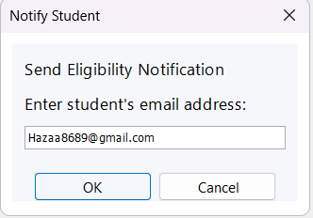
Figure 3.3.8.1: Notify Student Dialog

3.3.9 Recovery Notification Email Sent to Student
This is a screen shot of a recovered notification email that the student obtained. The email establishes the attempt to recover and the current score and the subsequent course of action in academic recovery.

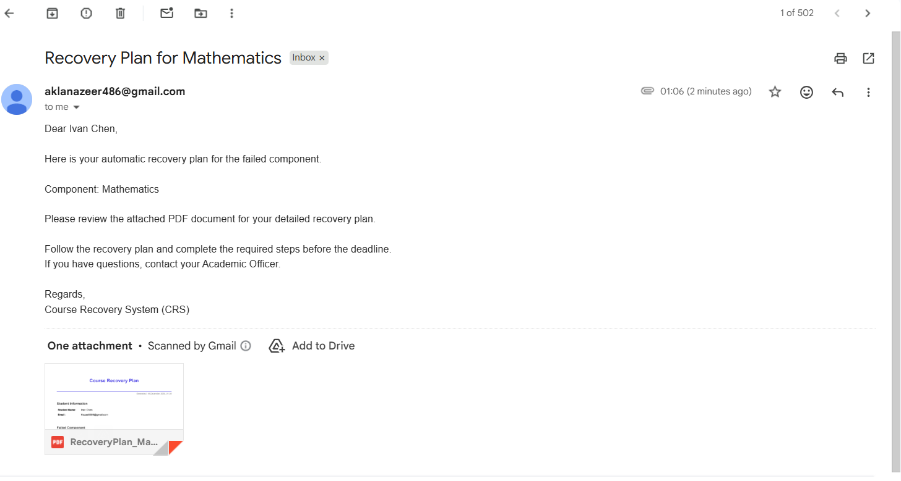Figure 3.3.9.1: Recovery Notification Email Sent to Student

3.3.10 Generated Recovery Plan PDF (Attached Document)

This number depicts the document on recovery plan created in PDF form by the system. The paper will include the details of the student, failed elements, and the formulated recovery plan, which will be a formal academic recovery document.

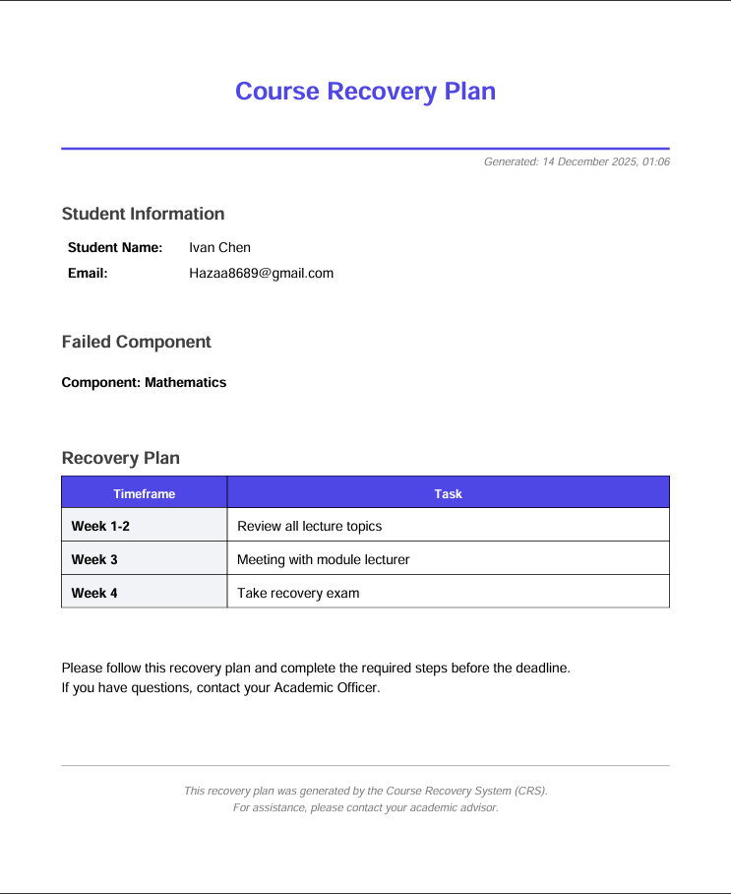
Figure 3.3.11.1: Generated Recovery Plan PDF

3.4 Acadmeic performance reporting:

3.4.1 Academic Performance Report Interface:
This is the Academic Performance Report module screen before a student is selected. It creates an organized interface for producing detailed academic reports, such as course performance, GPA summary and eligibility status.

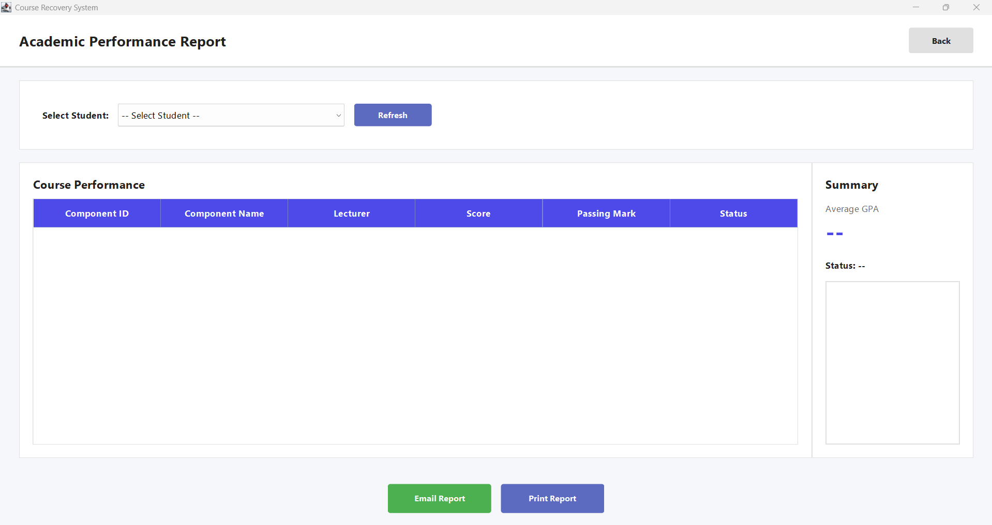

Figure 3.4.1.1: Academic Performance Report Interface (initial view)

3.4.2 Student Selection for Academic Report Generation:
This figure shows the dropdown menu to choose a particular student to be selected from the system. Once a student is selected, the system prepares for retrieving and showing the appropriate academic performance data.

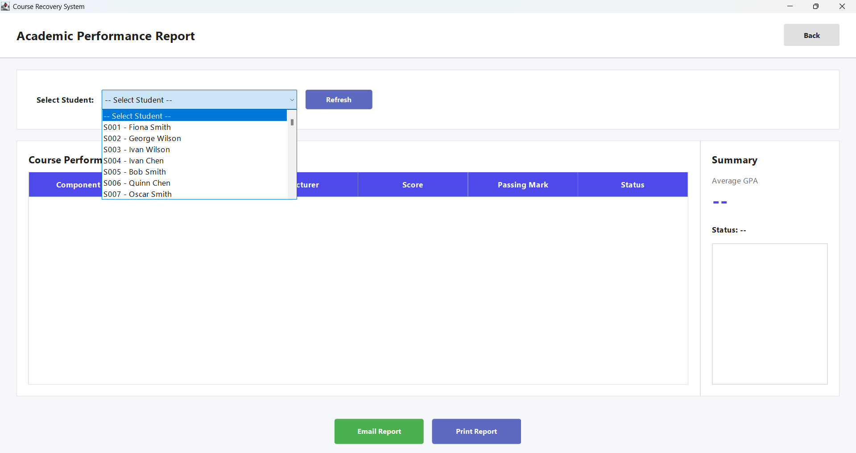

Figure 3.4.2.1: Student Selection for Academic Report Generation

3.4.3 Loaded Course Performance and GPA Summary:
This screen shows the chosen student's performance in the course, i.e., the score obtained in the components, pass/fail status, and lecturer details. The cumulative GPA and overall academic standing is automatically calculated and presented by the summary panel.

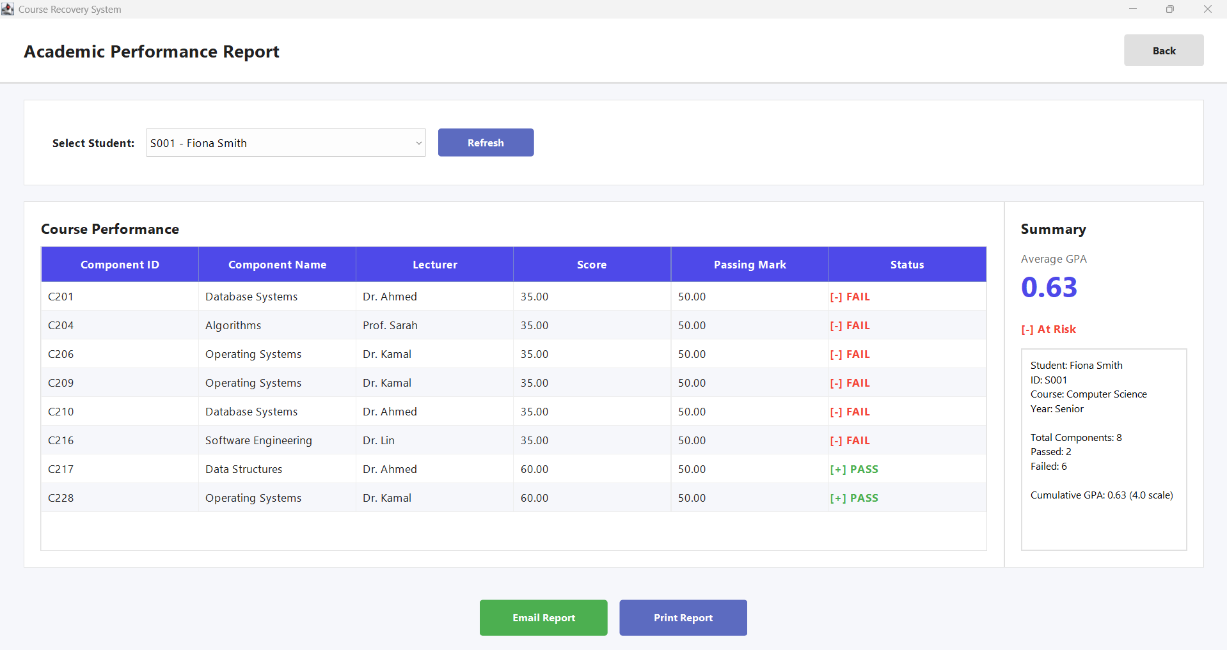

Figure 3.4.3.1: Loaded Course Performance and GPA Summary.

3.4.4 Email Academic Report (PDF) Prompt:
This dialog is used to have the academic officer enter the recipient's email address for sending the academic performance report in PDF format. The report is generated dynamically based upon the data of the selected student.

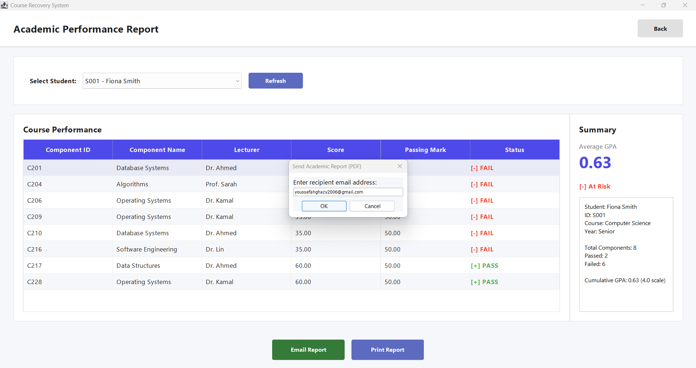

Figure 3.4.4.1: Email Academic Report (PDF).

3.4.5 Academic Report PDF Sent Confirmation:
This message is a confirmation message that the academic performance report was successfully generated and emailed. It also verifies the information contained in the report such as student details and course performance, CGPA calculation and eligibility status.

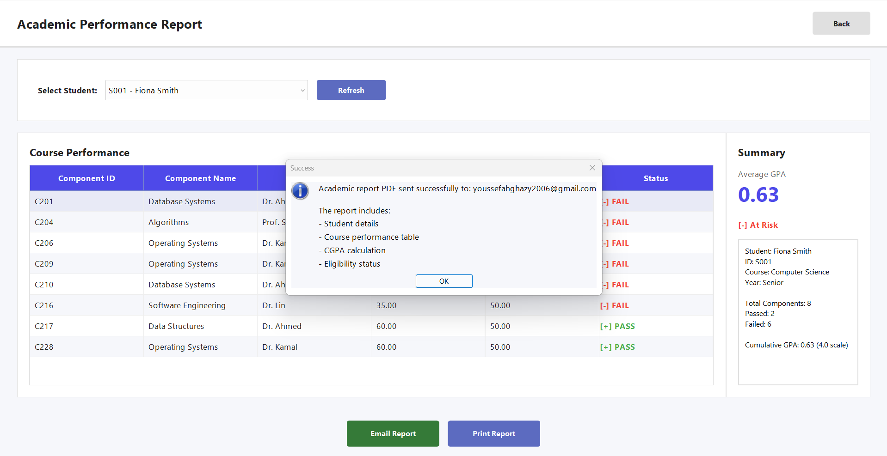

Figure 3.4.5.1: Academic Report PDF sent confirmation.

3.4.6 Academic Performance Report Email Received:
This screenshot is the email from student in which the academic performance report has been attached. It serves the purpose of success in communicating the academic results & suggestions by email notification service.

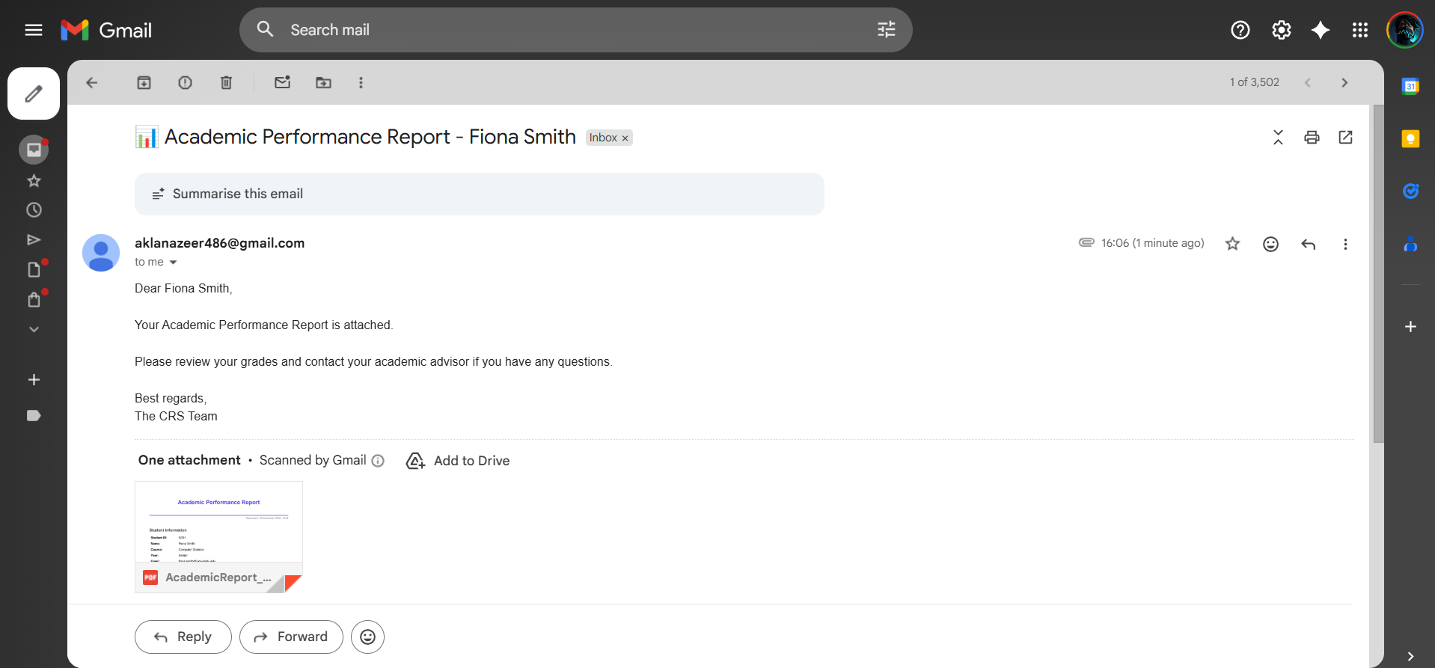

Figure 3.4.6.1: Academic Performance report Email Received

3.4.7 Generated Academic Performance Report (PDF View):
This figure shows the academic performance report in PDF format that is generated which contains student information, table of courses, table of GPAs, and eligibility status. The report is written in such a way as official academic documentation and record keeping.

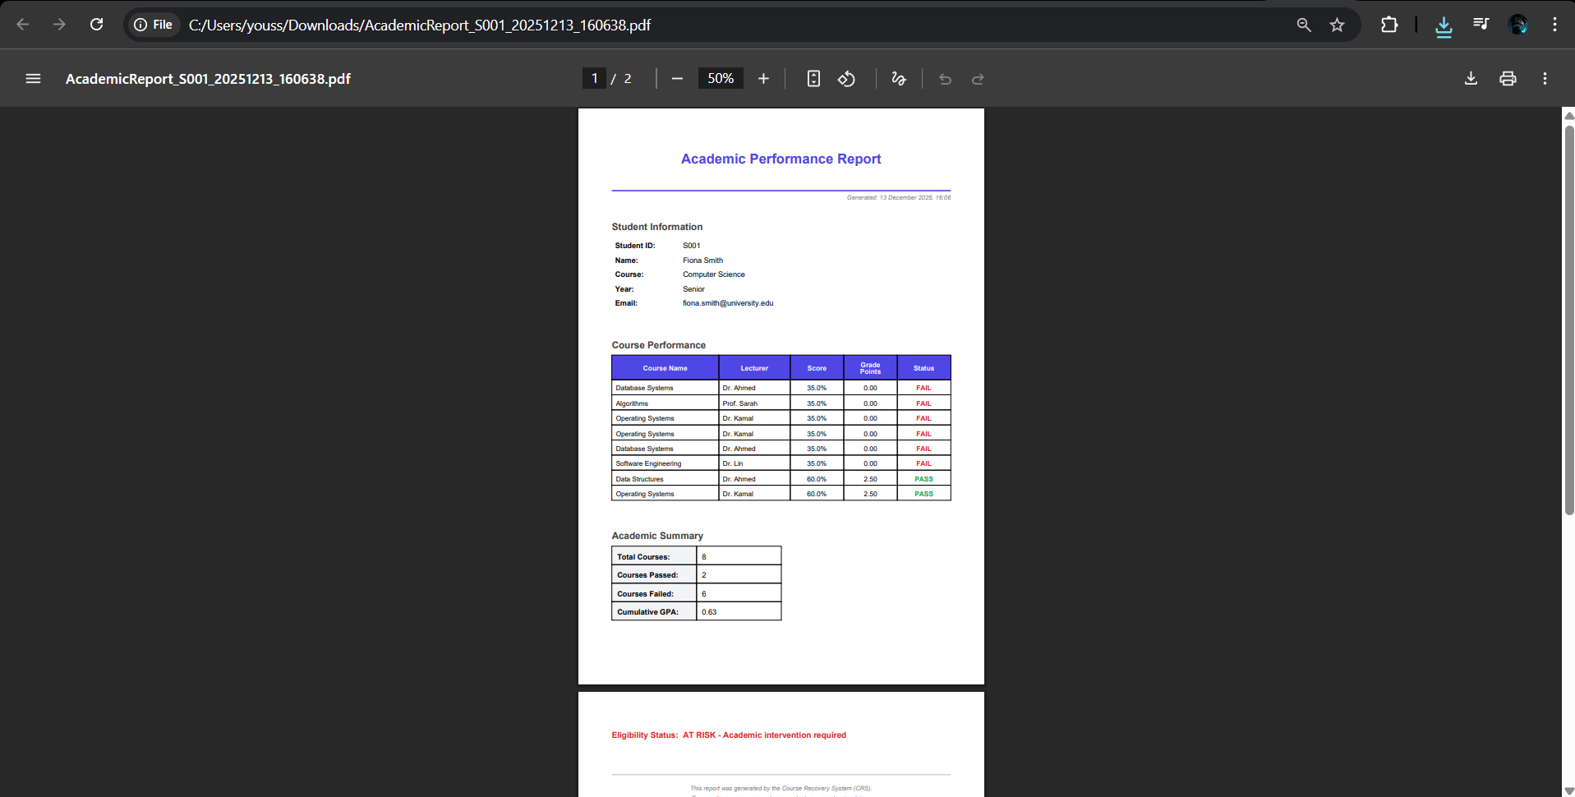

Figure 3.4.7.1: Generated Academic Performance Report (PDF View):

3.4.8 Console-Based Academic Report Output:
This is the screen which displays the text-based academic report which is generated within this system for verification purpose. It has a readable summary of student performance, course results and recovery-related place holders prior to export.

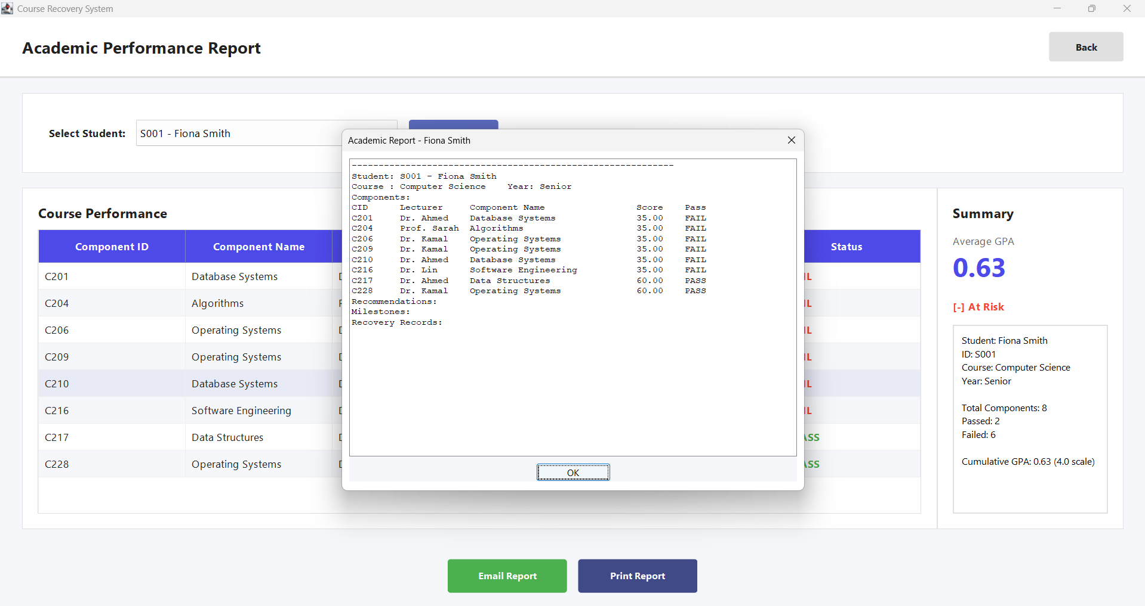

Figure 3.4.8.1: Console-Based Academic Report Output.

4. Object-Oriented Programming Concepts:

4.1 Nazeer Fathima Akla- TP084989

4.1.1 Packages:
In the Course Recovery System, packages organize the codebase into logical layers: crs contains all GUI panels for user interaction, this package structure separates presentation, business logic, and data layers, making the system maintainable and scalable.

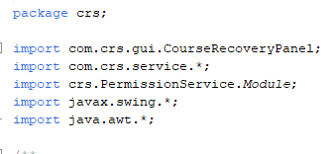
Figure 4.1.1.1: Package imports

In MainGUI.java classes are imported from other packages, demonstrating how packages enable organized code access across the project.

4.1.2 Class and Object:
The CRS uses classes as blueprints to model real-world entities: the User class defines properties (userID, name, email, role) and behaviors (login, logout, checkPassword) for system users, while the EmailService class encapsulates email functionality.
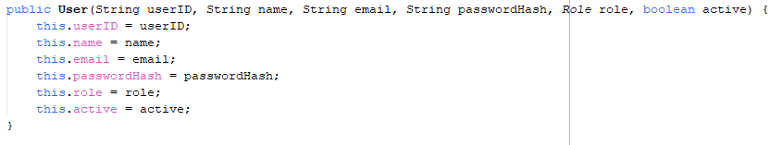
Figure 4.1.2.1: Class declaration Example 1.
The User class is the blueprint defining properties (userID, name, email, etc) and behaviors for user objects in the system, this is used throughout the project for sending emails, filtering, file-handling, etc
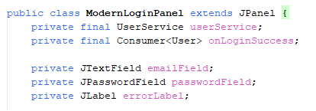
Figure 4.1.2.2: Class declaration Example 2.
Defines the login panel class with its own fields for email input, password input, and user service connection, allowing easy usage through the system.
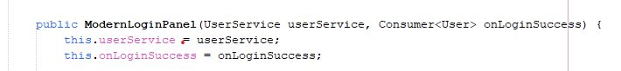
Figure 4.1.2.3: Class declaration Example 3.
Defines HOW to initialize the object when created, this is in the constructor

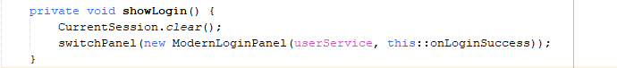
Figure 4.1.2.4: Object creation Example 1.
This CREATES a new ModernLoginPanel object by calling the constructor with specific arguments

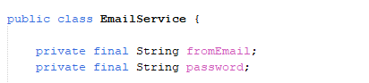
Figure 4.1.2.5: Class declaration Example 4.
EmailService class defines email functionality; email Service object is the actual instance used throughout the application.
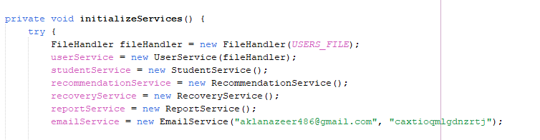
Figure 4.1.2.6: Object creation Example 2.
This is where the EmailService object is created. The new EmailService allocates memory and calls the EmailService constructor, passing email credentials. The created object is then stored in the emailService variable (which was declared as a field at the top of MainGUI class). This object is later passed to other panels like ModernLoginPanel, UserManagementPanel, , this shows code reusability as the object is used multiple times throughout the project.

4.1.3 Inheritance:
The CRS demonstrates inheritance through user types and GUI components. AcademicOfficer, Course Admin classes are all examples of inheritances which promotes object reuse, as it would be duplicating too many codes if inheritance was not applied.
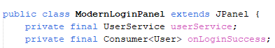
Figure 4.1.3.1: Inheritance Example 1.
ModernLoginPanel inherits all JPanel capabilities (add(), remove(), setBackground()) while adding custom login functionality.
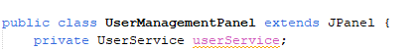
Figure 4.1.3.2: Inheritance Example 2
Inherits JPanel's GUI container features, enabling it to hold buttons, tables, and text fields while adding user management logic.

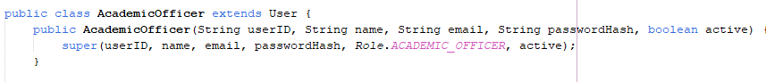
Figure 4.1.3.3: Inheritance Example 3
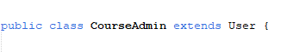
Figure 4.1.3.4: Inheritance Example 4
AcademicOfficer class and CourseAdmin class inherits from User class using the extends keyword. This means AcademicOfficer automatically gets all fields (userID, name, email, password, role, isActive) and methods (getName(), getEmail(), getRole(), etc.) from the User parent class. The constructor uses super() to call the parent User class constructor, passing Role.ACADEMIC_OFFICER to set the specific role. This demonstrates class inheritance where a specialized user type (AcademicOfficer) extends the general User class.

4.1.4 Encapsulation:
Encapsulation protects sensitive data in the CRS by making all User fields (userID, passwordHash, email) private and providing controlled access through public getters and setters.
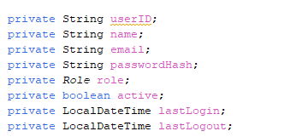
Figure 4.1.4.1: Encapsulation Example 1
All fields in User class are private - hidden from outside access. This is the entire purpose of encapsulation: data hiding
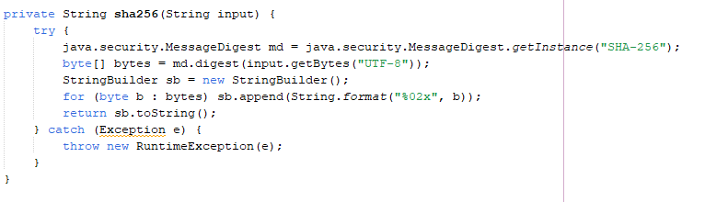
Figure 4.1.4.2: Encapsulation Example 2: Hashing method
This is declared as private method to hide complex SHA-256 hashing implementation. Outside classes don't know HOW passwords are hashed, only that they are hashed.

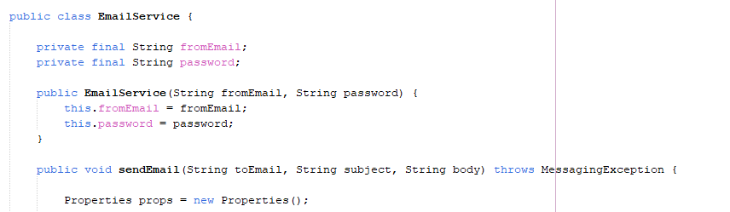
Figure 4.1.4.3: Encapsulation Example 3
Email credentials are private, preventing direct access to sensitive information. Public sendEmail() method safely uses these hidden credentials.

4.1.5 Polymorphism:
The CRS shows polymorphism through method overloading and interface implementations, the below examples effectively demonstrate how one interface supports multiple implementations.
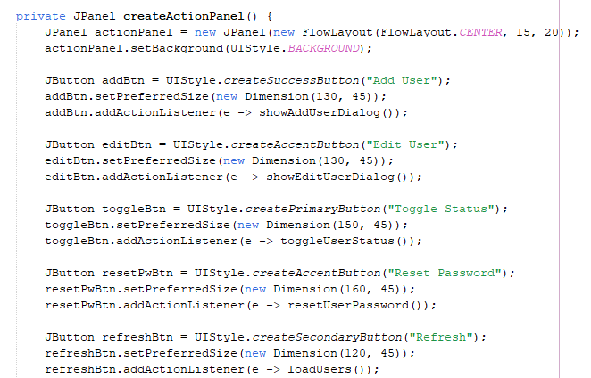
Figure 4.1.5.1: Polymorphism Example 1
All buttons use ActionListener interface (via lambda expressions), but each has different behavior. The lambda e -> showAddUserDialog() implements ActionListener's actionPerformed() method differently for each button. Same interface, multiple implementations - this is runtime polymorphism. It is applied across al the button functionalities.
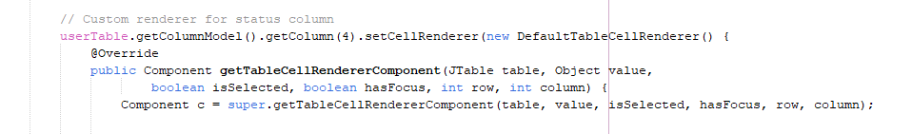
Figure 4.1.5.2: Polymorphism Example 2

Overrides default cell rendering behaviour to display "Active"/"Inactive" with custom colors, demonstrating method overriding polymorphism.

4.1.6 Abstraction:
The CRS uses abstraction to hide complex operations behind simple interfaces.
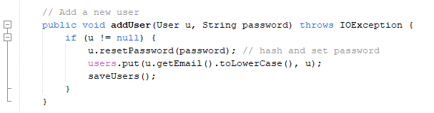
Figure 4.1.6.1: Abstraction Example 1
Hides complex authentication logic (file I/O, SHA-256 hashing, validation). Users call simple “reset password” method without knowing internal complexity of actually hashing the method.
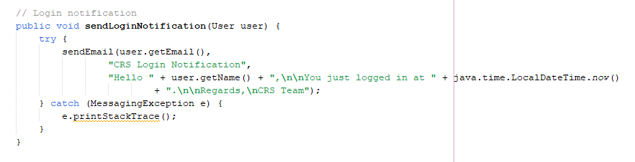
Figure 4.1.6.2: Abstraction Example 2
Abstracts email sending complexity. Users call simple method without dealing with SMTP protocols, authentication, or multiple error handling.

4.1.7 Modularity:
The CRS is built with modular architecture where independent services handle specific responsibilities: UserService manages user data operations, EmailService handles all email communications,
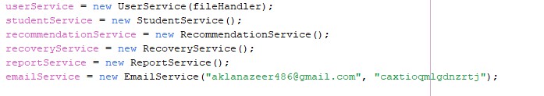
Figure 4.1.7.1: Modularity Example 1
Separate service modules for different responsibilities. Each can be developed, tested, and modified independently, this is used across the project for easy access to these services.
Figure 4.1.7.2: Modularity Example 2
Dependencies injected through constructor, enabling loose coupling. Panels don’t create services, making it reusable and testable. Receives all the services as parameters rather than creating them internally, promoting modularity and reusability. Implemented in login panel and role menu constructors as well.

4.2 Youssef Ahmed Said Ahmed Ghazy - TP084982
The main contribution focuses on the Eligibility Check & Enrolment and Academic Performance Reporting parts of the Course Recovery System (CRS). In these modules, the core object-oriented concepts has been applied: abstraction, encapsulation, inheritance, polymorphism, and modularity (packages).
The examples below are taken specifically from Youssef code implementation.

4.2.1 Abstraction:
Abstraction is used in code to separate what the system should do from how it does it. It has been achieved this mainly through interfaces and an abstract class.
First, the class Person is declared as an abstract class, meaning it cannot be instantiated directly but acts as a generic representation of a person:
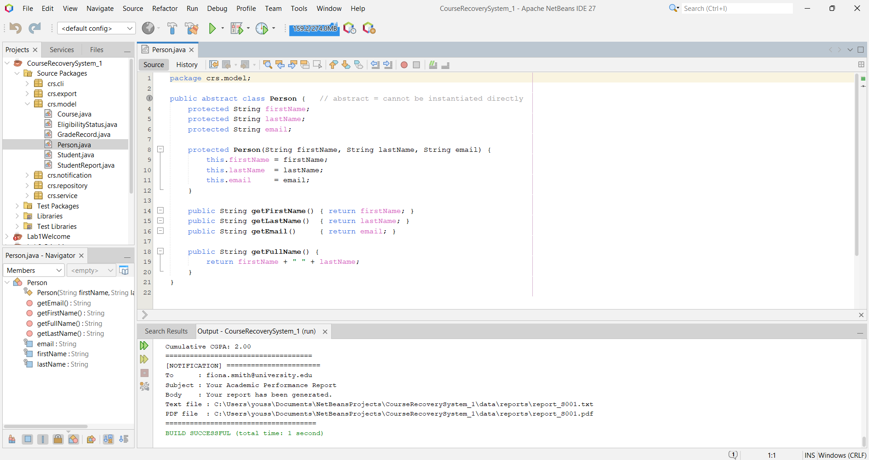
Figure 4.2.1.1 Abstraction

This class hides the implementation details of common person-related data and behaviour. Concrete classes, like Student, inherit from this abstract type and reuse its common logic.
Next, several interfaces define high-level behaviour without exposing implementation details:
- EligibilityChecker:
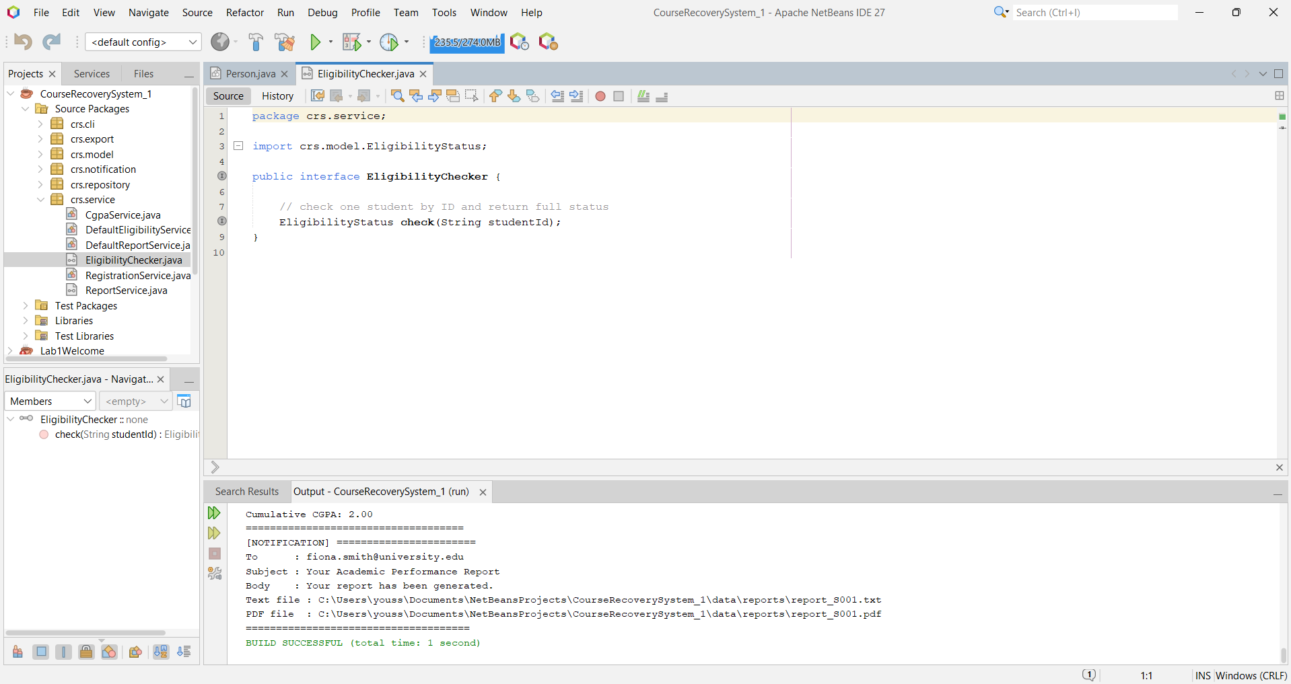Figure 4.2.1.2 Abstraction

- ReportService:
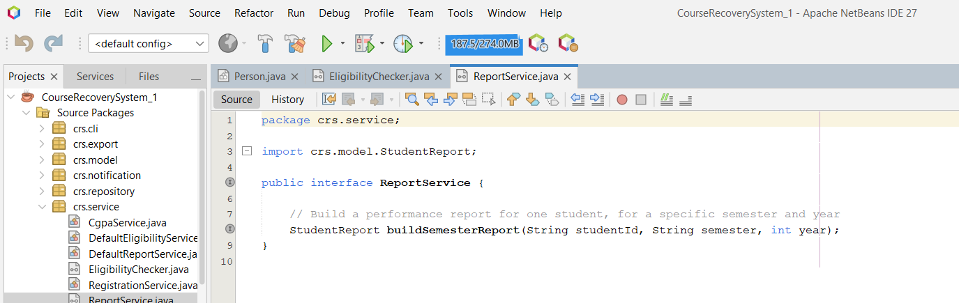Figure 4.2.1.3 Abstraction

- ReportExporter for report exporting strategies:
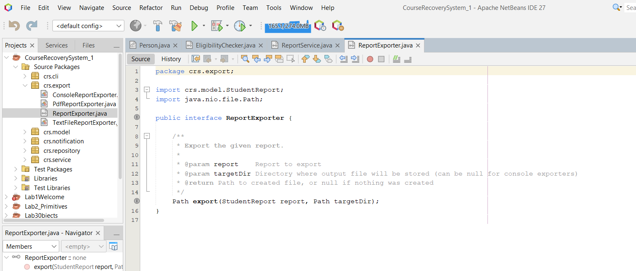Figure 4.2.1.4 Abstraction

- NotificationService for sending notifications:
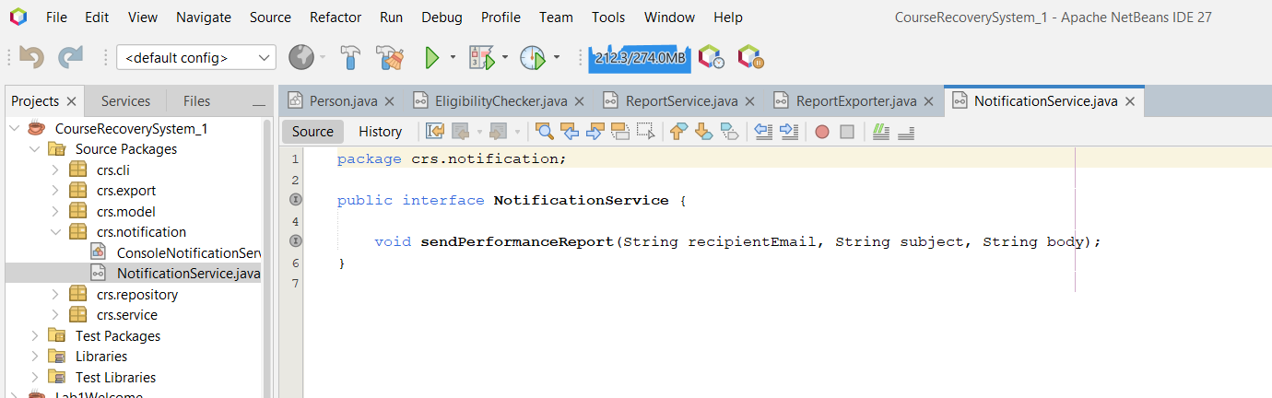Figure 4.2.1.5 Abstraction

These interfaces specify what operations must exist (e.g. “check eligibility”, “build report”, “export report”), but the actual logic is implemented in concrete classes such as DefaultEligibilityService, DefaultReportService, ConsoleReportExporter, TextFileReportExporter, PdfReportExporter, and ConsoleNotificationService.
This makes the system flexible and easier to extend later.

4.2.2 Encapsulation:
Encapsulation in the code is done by declaring fields as private or private final and exposing them through public getter methods. This protects the internal state from being modified directly from outside.
For example, in the Student class:
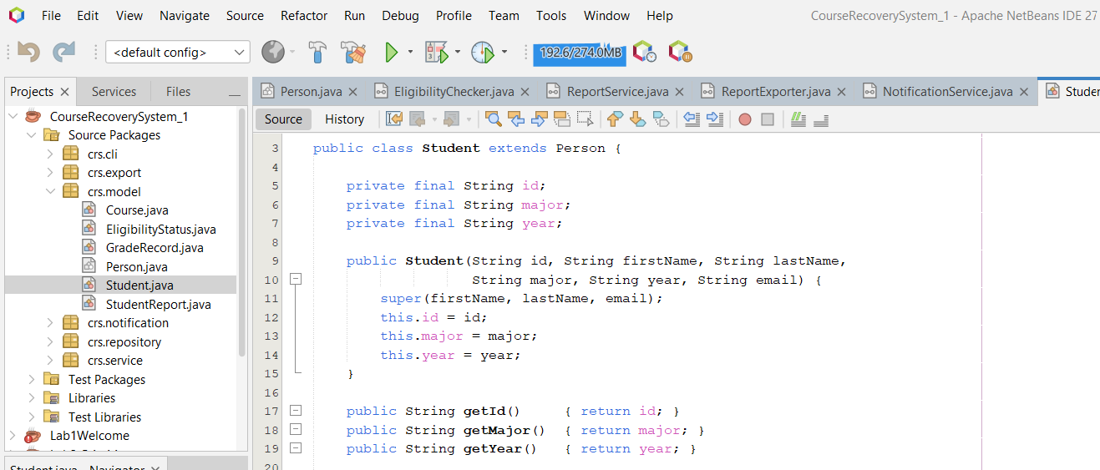Figure 4.2.2.1 Encapsulation

All the data of the student (id, major, year) is hidden and can only be accessed via the getter methods. No external class can directly change these fields.
The same pattern appears in other domain classes:
- Course:
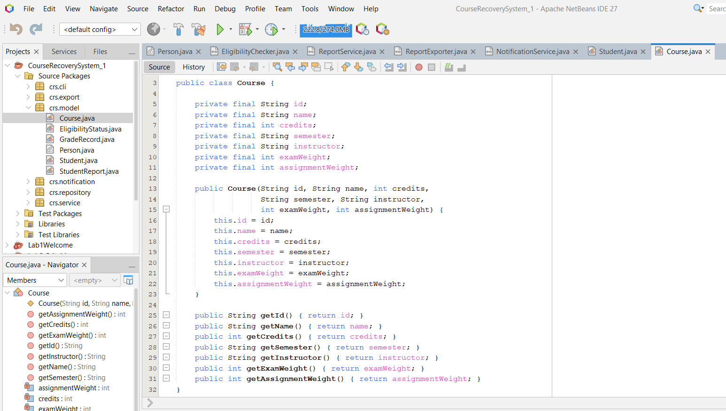Figure 4.2.2.2 Encapsulation

- GradeRecord, EligibilityStatus, and StudentReport also encapsulate their fields and expose information through getters only.

In the repository layer, CsvStudentRepository encapsulates its internal Map that stores student objects:
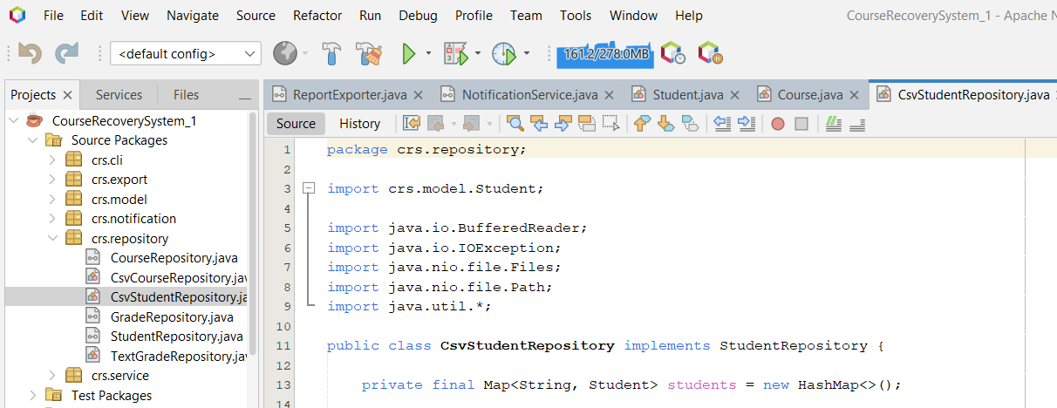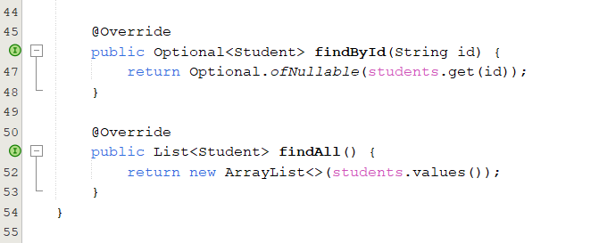Figure 4.2.2.3 Encapsulation
The internal map is never exposed directly. Other parts of the system can only access student data through the public methods findById and findAll, which is a clear example of encapsulation.

4.2.3 Inheritance:
Inheritance is used to reuse common behaviour between related classes and to implement interfaces.
A simple but clear example is Student inheriting from Person:
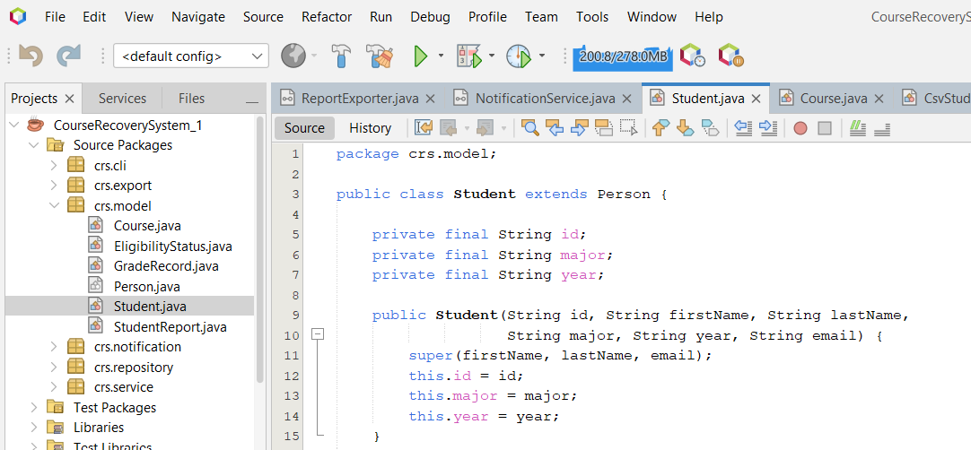
Figure 4.2.3.1 Inheritance

Person (abstract) provides the generic attributes firstName, lastName, and email and a getFullName() method. Student extends Person and adds its own fields for academic data. This reduces duplication and keeps common logic in the superclass.

Inheritance is also used with interfaces:
- DefaultEligibilityService implements EligibilityChecker:
Figure 4.2.3.2 Inheritance

- ConsoleReportExporter, TextFileReportExporter, and PdfReportExporter all implement ReportExporter in the export layer.
This use of inheritance and interface implementation allows different classes to share a contract and reuse structure while providing their own behaviour.

4.2.4 Polymorphism
Polymorphism allows us to treat different implementations through the same interface type. This code uses runtime (dynamic) polymorphism for services, exporters, and notifications.
In Demo.java, we declare variables using interface types and assign them concrete implementations:
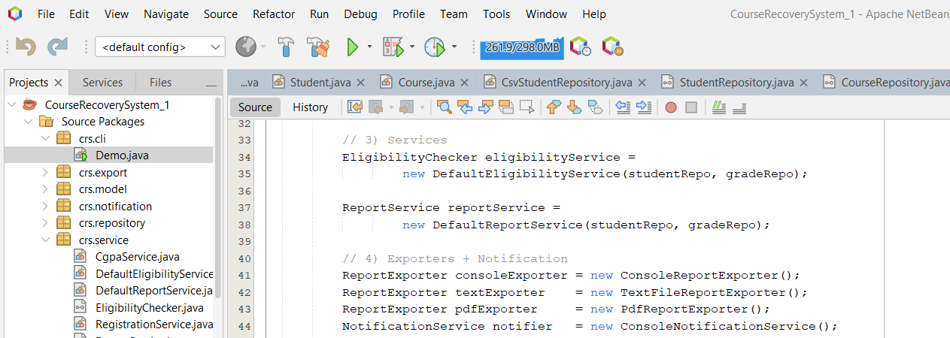
Figure 4.2.4.1 Polymorphism

Here:
- eligibilityService is of type EligibilityChecker but holds a DefaultEligibilityService object.
- reportService is of type ReportService but holds a DefaultReportService.
- consoleExporter, textExporter, and pdfExporter are all of type ReportExporter but point to different export strategies.
- notifier is of type NotificationService but uses ConsoleNotificationService.
When the code later calls export(...) on any ReportExporter, Java resolves at runtime which actual method to execute based on the concrete class (ConsoleReportExporter, TextFileReportExporter, or PdfReportExporter).

Another small example of polymorphism is overriding toString() in Student:
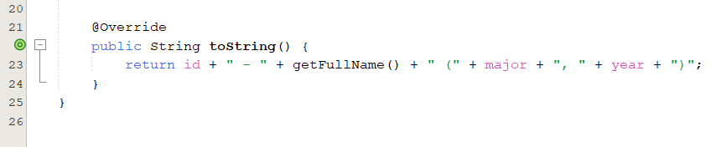
Figure 4.2.4.2 Polymorphism

This overrides toString() from Object, so whenever a Student is printed, the custom version runs.

4.3 Hazaa Salem Mubarak Obeid Awadh- TP083920:

4.3.1 Abstraction
The concept of abstraction is used by dividing recovery operations into their internal implementation. Service classes are used as a means of high-level recovery functionality and allow other system components to communicate with recovery logic without understanding how that data is being processed or stored.

Such service classes as RecoveryService offer abstract methods to control milestones, recover status updates, and progress tracking and obscure file operations and internal implementation.

Screenshot 1 – RecoveryService Class
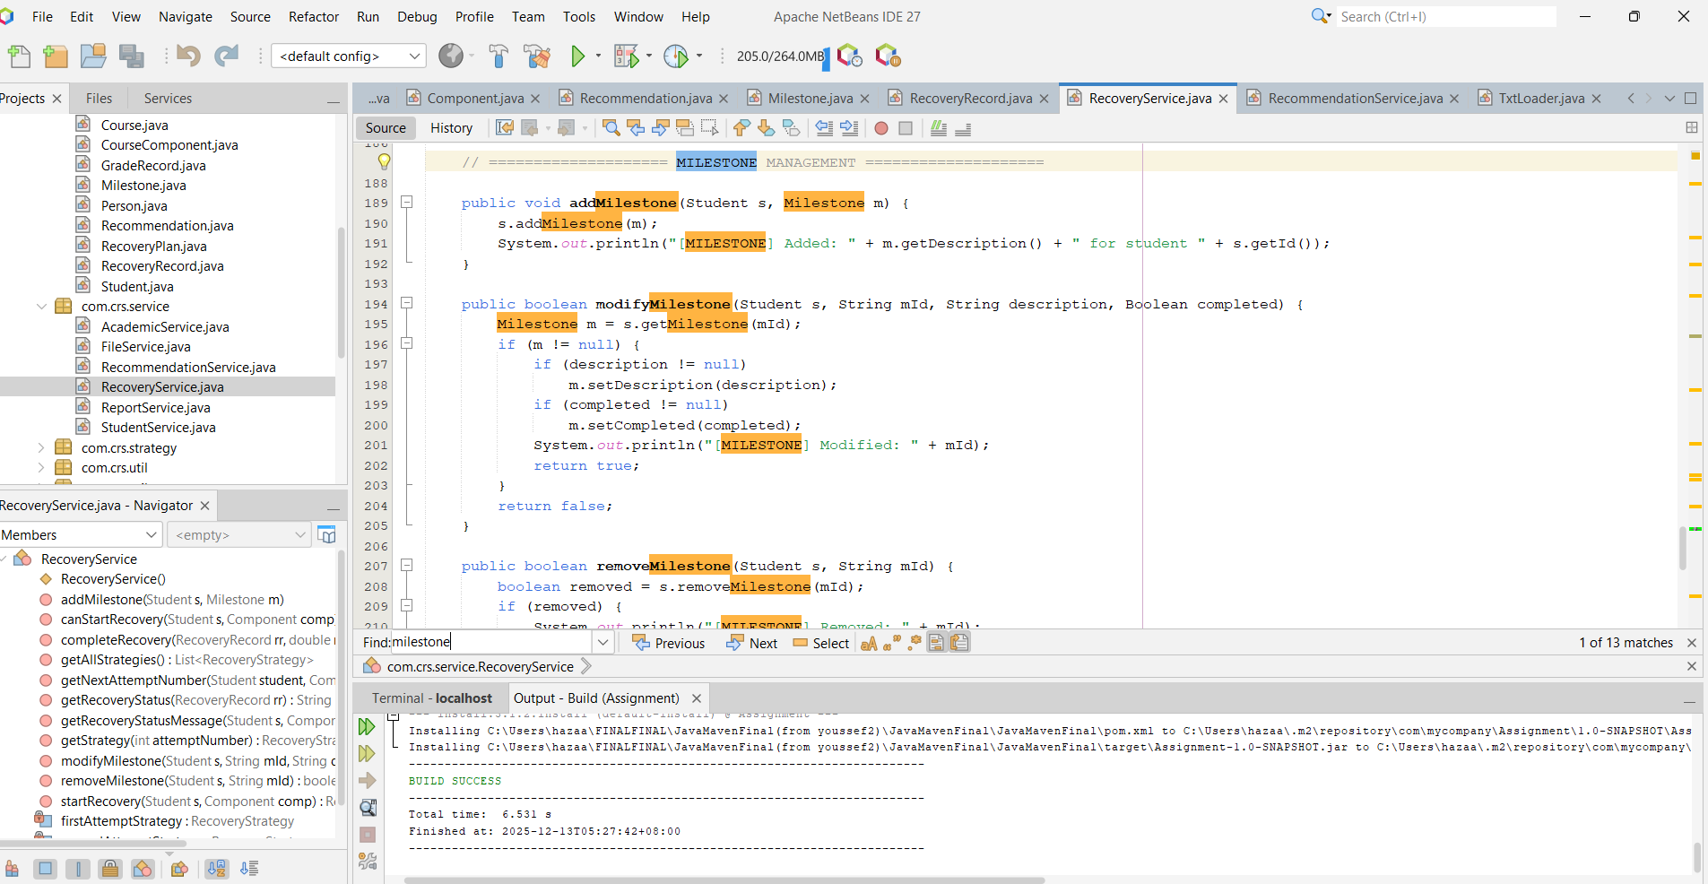Figure 4.3.1.1: Abstraction Example 1

In this screenshot we can see the RecoveryService, abstracting the recovery workflow in the form of high-level methods to manage recovery milestones and monitor the recovery progress without implementation details being revealed.

4.3.2 Encapsulation
The encapsulation is already applied by making all data fields related to recovery to be private and giving accessible access with the help of public getter and setter functions. This makes sure that internal state changes are done in accordance with some business logic and it does not allow unauthorized or invalid updates.

The use of encapsulation is exercised uniformly in model classes which are related to recovery like RecoveryRecord, Milestone, Recommendation and CourseComponent.

Screenshot 1– Milestone Class
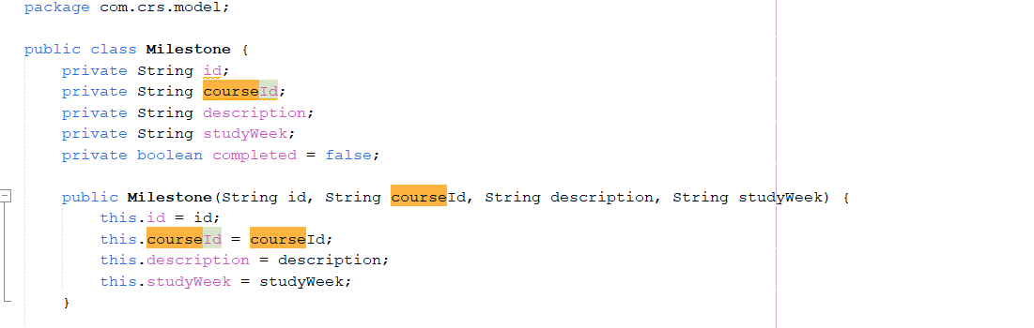Figure 4.3.2.1: Encapsulation Example 1
The screenshot uses encapsulation in the Milestone class, with the attributes like course, study week, task, and status having been declared private and other methods like getter and setter declared public.

Screenshot 2– Recommendation Class
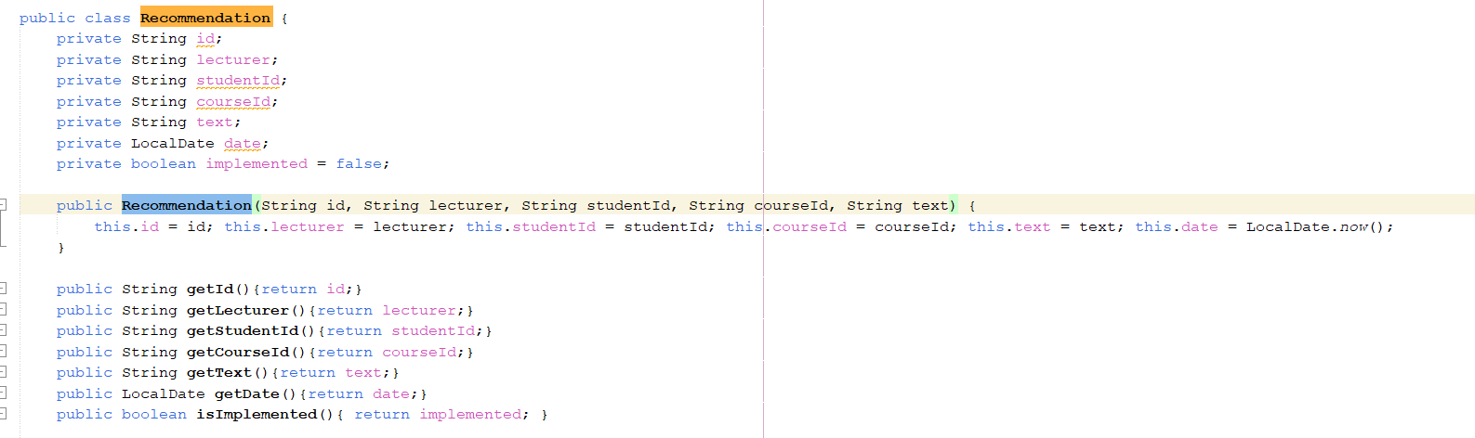Figure 4.3.2.2: Encapsulation Example 2
In this screenshot, the concept of encapsulation is revealed in the Recommendation class whereby the recovery recommendations are secured by private variables and can only be accessed by methods which are controlled.

Screenshot 3– RecoveryRecord Class
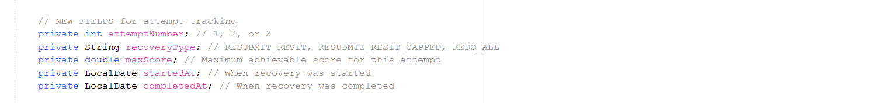Figure 4.3.2.3: Encapsulation Example 3
This screen shot depicts encapsulation with RecoveryRecord class having recovery information as attempt number, recovery type and date information as private fields to keep data integrity.

4.3.3 Inheritance (Object Reuse)

The concept of inheritance in the Course Recovery module is used indirectly via reuse of already existing domain models and not necessarily deep hierarchies of subclass information. Classes that are related to recovery are related to the already established student and course-related classes enabling recovery capabilities to be added to existing classes without duplicating the data.

This will minimize the level of coupling as well as ensure consistency throughout the system.

Screenshot 1– RecoveryRecord Using Existing Domain Models
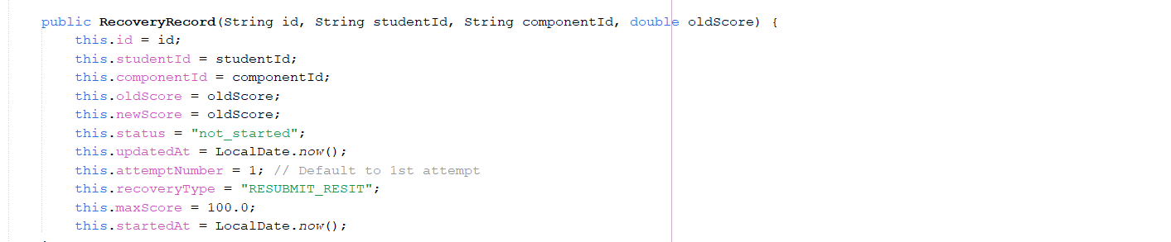Figure 4.3.3.1: Inheritance Example 1
This screen shot shows how the recovery module utilizes the already existing structures of student and course related data in RecoveryRecord class and enables recovery services to create student-related and course-related hierarchies in the RecoveryRecord class.

4.3.4 Polymorphism

Dynamic assessment of recovery states and combined management of recovery operations are used to apply polymorphism. The methods of service are varied concerning recovery status which is not started, in progress, or completed.

This allows the system to respond to various situations of recovery with a single interface and behaviour to vary at runtime.
Screenshot 1– Recovery Status Evaluation Logic
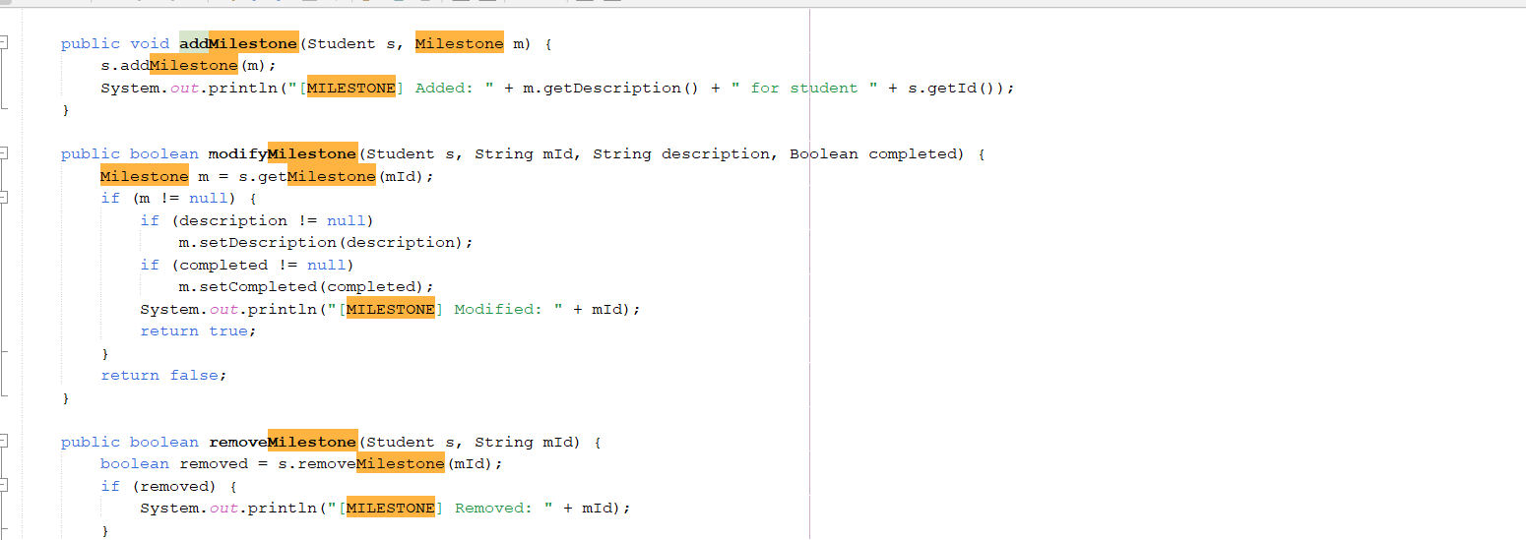Figure 4.3.4.1: Polymorphism Example 1

This screen shot illustrates the dynamic assessment of recovery progress on the fulfillment of milestones, which evidences run time polymorphism in the recovery service logic.
Screenshot2 – RecoveryStatus Enum
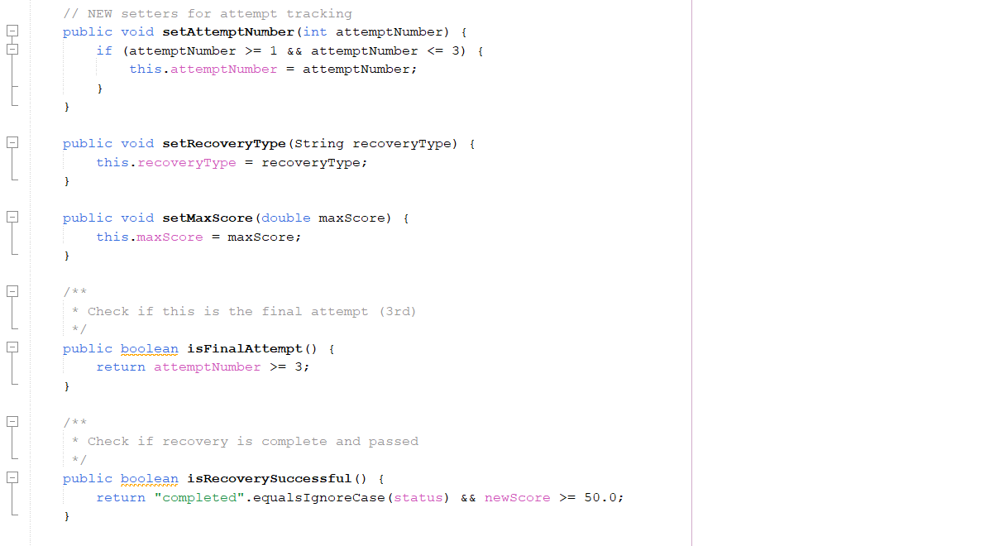Figure 4.3.4.2: Polymorphism Example 2
This is a screen shot of how the status of recovery has been represented in RecoveryRecord class. The recovery condition is registered as a special field and updated on a milestone basis by which recovery completion can be dynamically monitored by the system.

4.3.5 Modularity (Packages)
The Course Recovery module is developed based on the modular package architecture where the concerns are segregated between the models, services, and system logic. Classes that are related to the recovery are pooled into special packages enhancing the readability, maintainability and scalability.

This type of design would enable the recovery module to develop without interference with the rest of the components of the system.

Screenshot 1– Package Structure
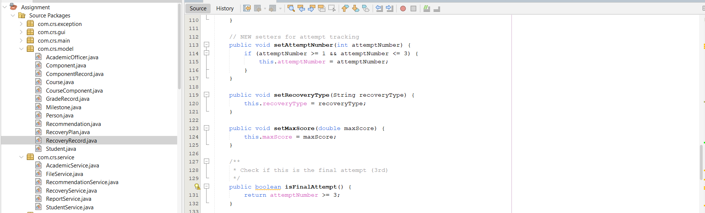Figure 4.3.5.1: Modularity Example 1
In this screenshot, the Course Recovery System is depicted to be modular in package layout. The model classes and service classes dealing with recovery are also separated into distinct packages and this indicates clear separation of concerns and also enhances maintainability and scalability.

5. Additional Features

5.1 Modern Colorful Dashboard GUI
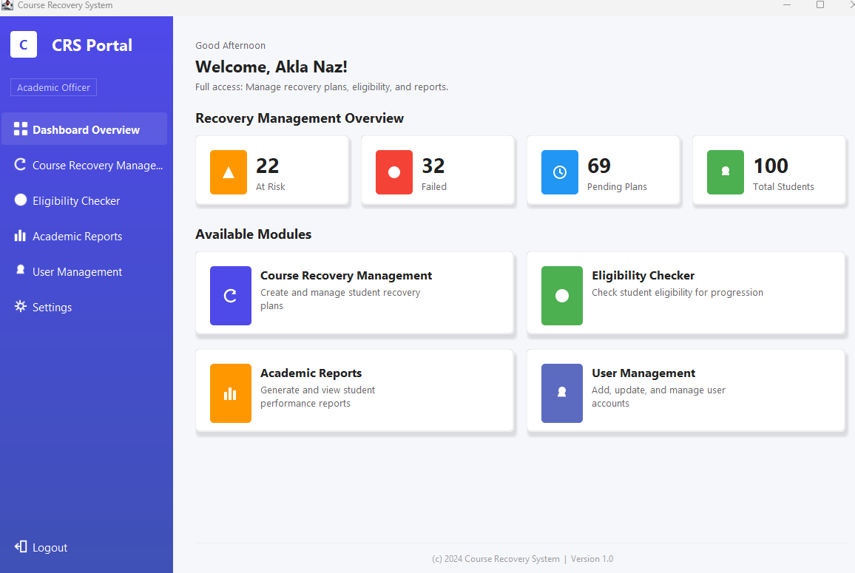
Figure 5.1.1: Main Dashboard

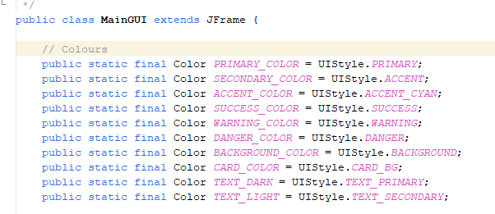
Figure 5.1.2: Custom dashboard code (colors)
The main intention for the dashboard is to create an attractive, user-friendly interface with custom colors, cards and navigation to allow easy access to the required portals.

5.2 Real Time Filter and Search
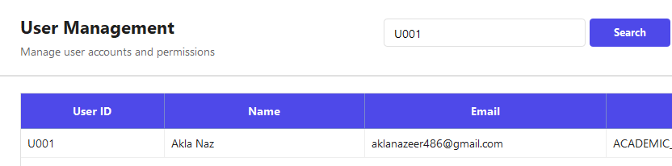
Figure 5.2.1: Searching by ID
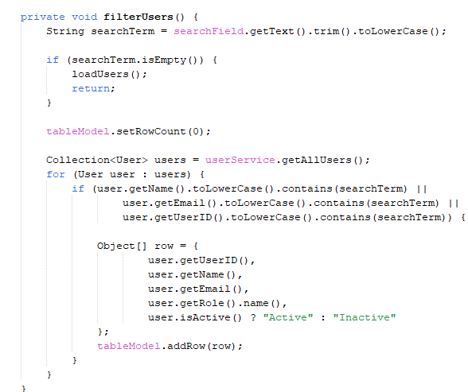
Figure 5.2.2: Filtering method

Real-time search that filters users by name, email, or ID as you type in the search field. Shows only matching results instantly without page refresh, this allows the system to be more user friendly

5.3 Visual Status Indicators with Custom Colors

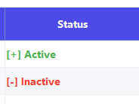
Figure 5.3.1: Colored Status Indicator

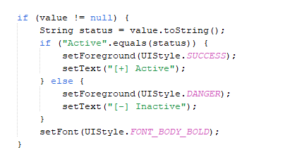
Figure 5.3.2: Status Indicator code

Custom table cell renderer displays status with colored text (Green ✓ for Active, Red ✗ for Inactive) and checkmark/cross symbols instead of plain text, allowing for better visual display and interpretation.

5.4 Refresh Button for Data Reload

Figure 5.4.1: Refresh Button

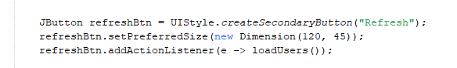
Figure 5.4.2: Refresh Button code

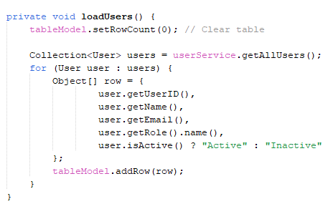
Figure 5.4.3: Load data method

This is an extremely useful function that allows the users to refresh the panel once selecting a student or user and performing an action, Once the action is done, the user can simply refresh and reload the students instead of reopening the system again.

5.5 Professional PDF generation.

Figure 5.5.1: Academic Report PDF

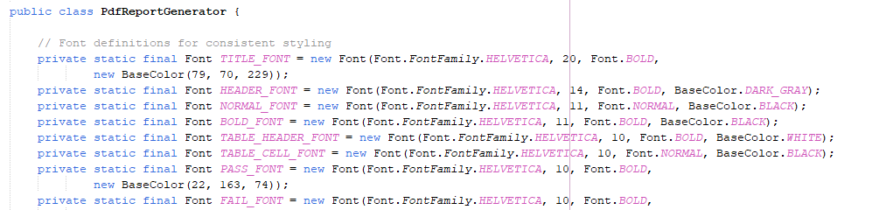
Figure 5.5.2 : Code to style PDF

Generates professional PDF reports using iText library with custom fonts, centered titles, formatted tables with headers, and pass/fail status. PDFs are saved locally and attached to emails, not just plain text export This ensures the system is user friendly.

5.6 Summary Panel in Academic Performance


Figure 5.6.1: Summary Panel

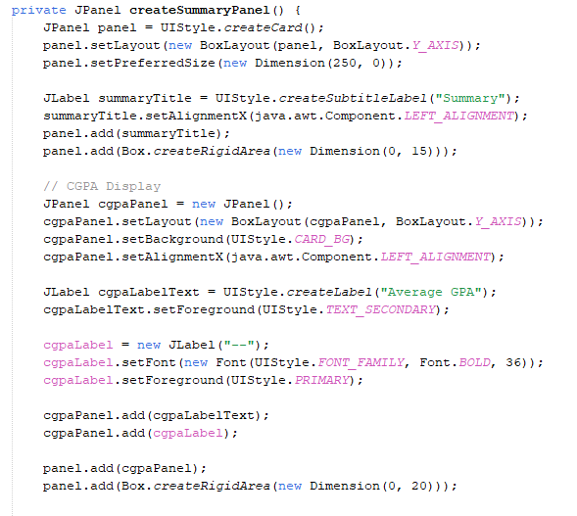
Figure 5.6.2: Summary Panel code

The summary panel method allows the user to see the academic performance of the selected student instantly instead of having to generate PDF text or check manually component by component.

6. Limitations:
The existing implementation of the Course Recovery System (CRS) successfully provides the primary functional requirements for authentication, role-based access control, eligibility checking, academic reporting, user management, and course recovery. However, a number of technical and functional limitations are still present in the current version.
- File based and single machine data storage All student, grade, recovery, and recommendations are contained in local text or binary files (e.g. users.txt, student_information (1).txt, course_assessment_with_grades.txt, data/recovery_records.txt), (Oracle Corporation, 2023). There is no database engine, no transaction management, and no support for concurrent access to the database by multiple users on different machines. As a result, the system is appropriate for single machine use and small amounts of data, and the backups of these flat files are of a manual nature.
- Hard coded file paths and email configuration Several file names and locations are hard coded in the application (for example, the paths for user, student and grade files in MainGUI). Similarly, the setup for the sending of email notifications (SMTP setup, sender credentials) are hard coded in the code. Any change to the location of files or email settings requires adjusting and rebuilding the application as opposed to adjusting a configuration file (portability and maintainability).
- Rules for eligibility and grading that are fixed Eligibility is based on a set of fixed rules (CGPA >= 2.0 and maximum of three failed courses) and the conversion of scores from the percentage to 4.0 grade points is implemented as a set of fixed mapping in code. These thresholds and mappings cannot be modified through the user interface or some external configuration file, (Treehouse Community, 2015) If there is a change in institutional policies (e.g., different CGPA cut-offs, different limits for failing, different grading scales), the source code has to be modified and redeployed.

7. Conclusion:
The Course Recovery System (CRS) effectively fulfils the aims of the assignment in that it offers a formalized, GUI-based solution to the operation of the academic recovery of academic processes in an educational organization. The system incorporates several important academic activities such as user management, checking of eligibility, academic performance reports, course recovery planning, and automated email messages into one unified system.
By introducing the Course Recovery Plan module, the system allows the academic officers to set the failed components, determine the recovery efforts, impose recovery milestones and recommendations, and track the recovery efforts successfully. The recovery workflow makes sure that the students are taken through a just and transparent process of recovery and strict institutional policies are imposed (i.e. limited recovery attempts and maximum scores). Automated email notices and recovery plans in the form of PDF add to the communication and accountability between academic officers and students. (GeeksforGeeks, 2019)
Technically, the CRS exhibits high usage of the Object-Oriented Programming concepts. To achieve maintainability, scalability, and separation of concern, abstraction, encapsulation, inheritance (where objects are reused), polymorphism, and modularity are used throughout the system, (Oracle Corporation, 2024) The design supports the modular package structure and design based on services which enables the system to be easily extended or enhanced in future.
Although there are some constraints like file-based data storage and predetermined academic regulations, the existing implementation gives a good basis when it comes to academic recovery in a real-life academic setting, (Modern Operating Systems, 2022) All in all, the Course Recovery System addresses the functional and technical needs of the assignment and reflects a successful implementation of the concepts of the object-oriented design in the resolution of an academic management issue.

8. Appendix:

8.1 GUI Code Snippets
Code | Snippet
Login Card | 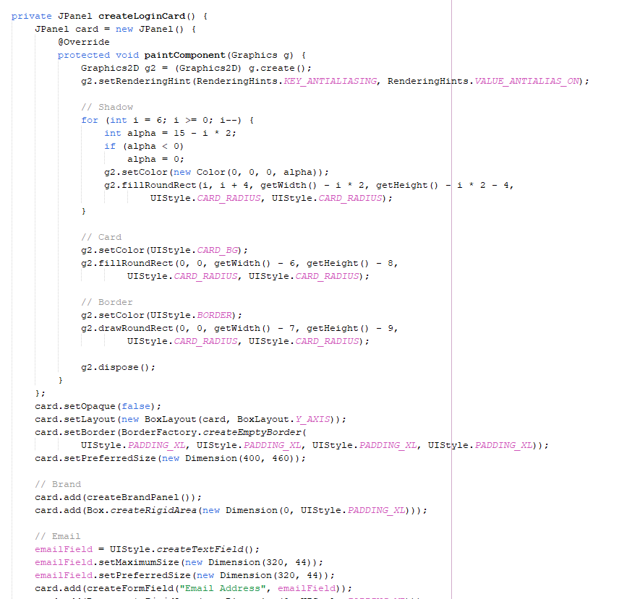
Validation for login | 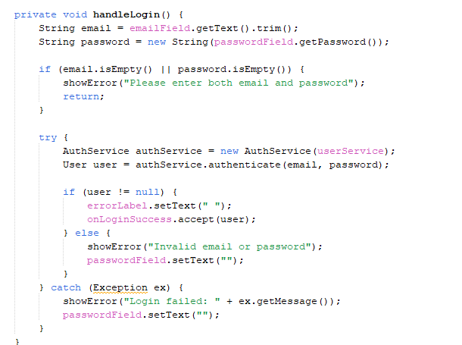
Main Dashboard navigation | 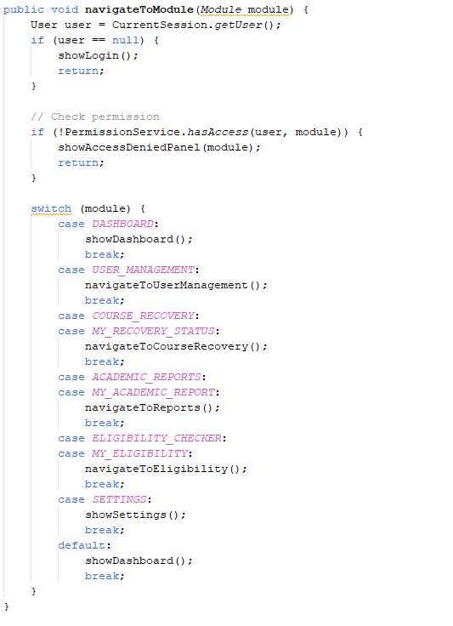
Role access for Academic Officer VS Course Admin | 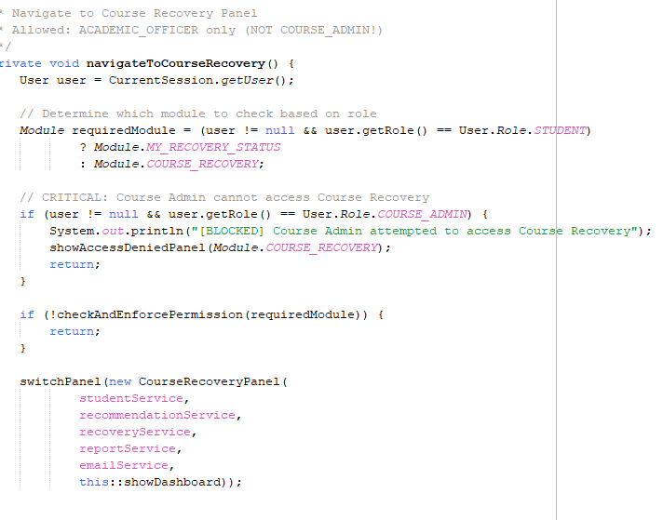
Add user | 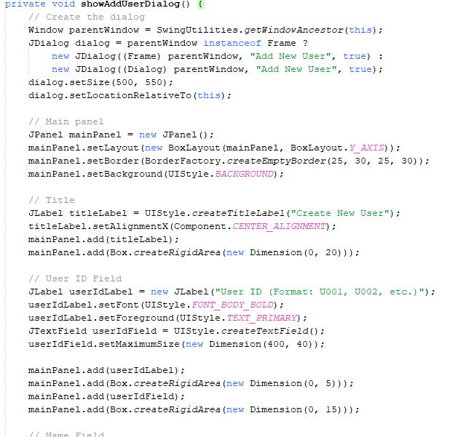
Add User input validation | 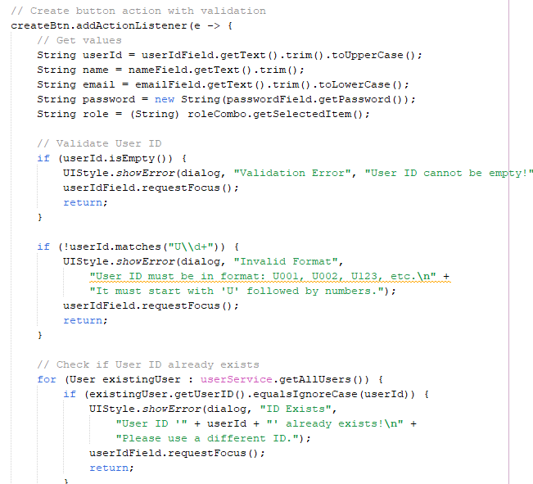
Edit user | 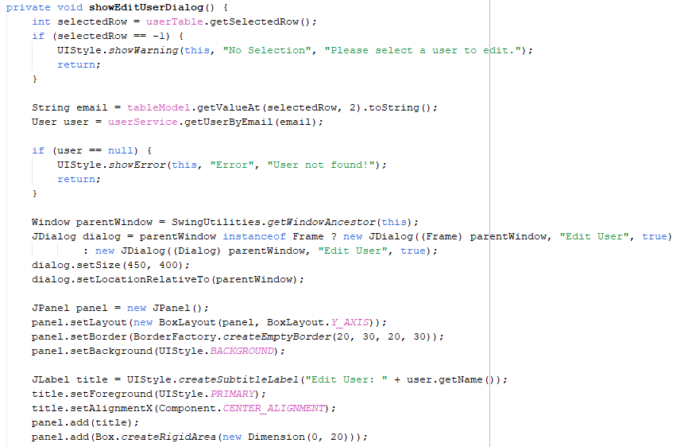
Toggle activation status | 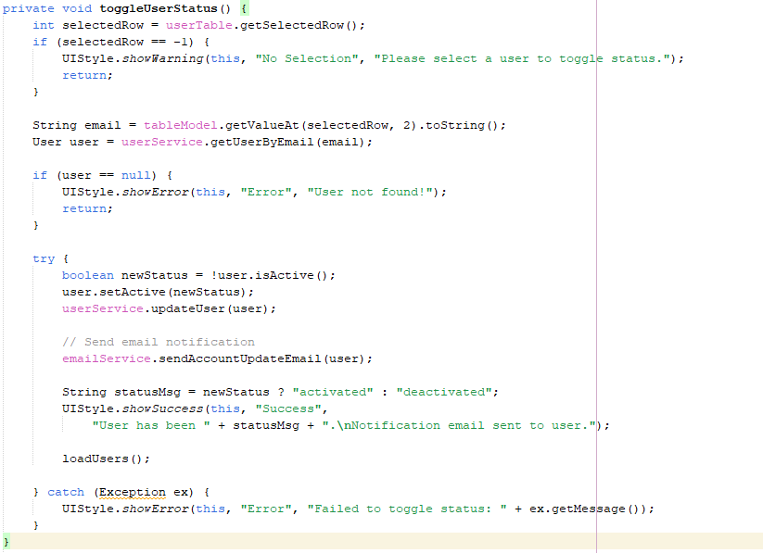
Reset Password | 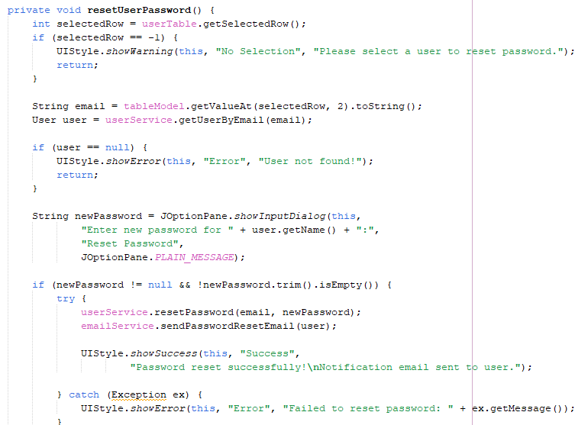

Code | Snippet
Login email | 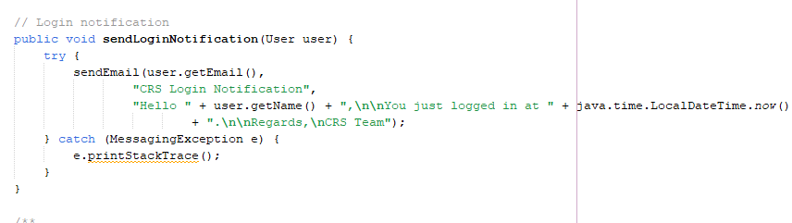
Password reset and Account Update email (same as activation) | 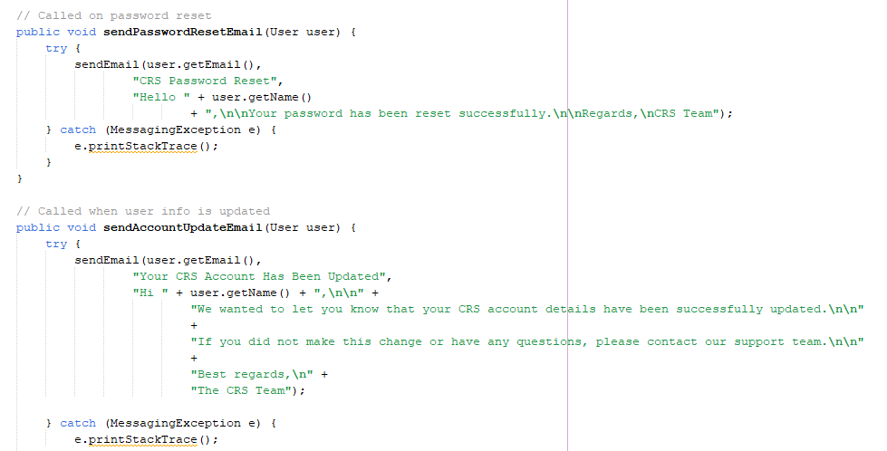
Recovery Plan Email with PDF | 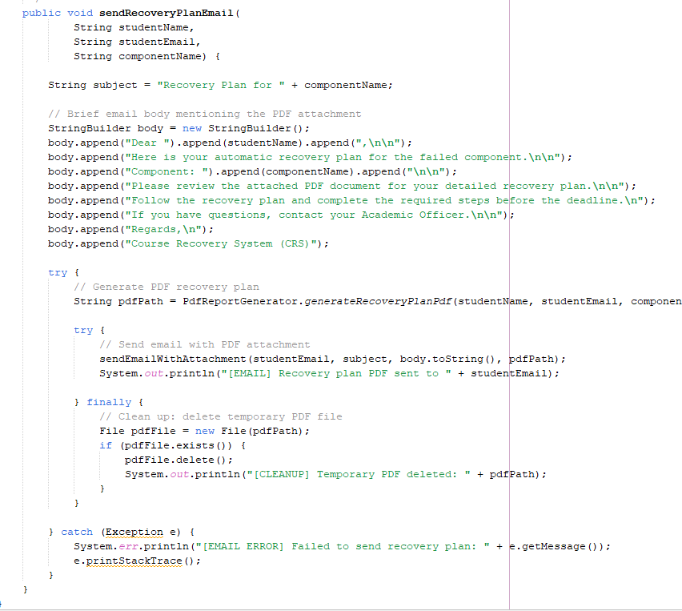
Academic Report Email with PDF | ode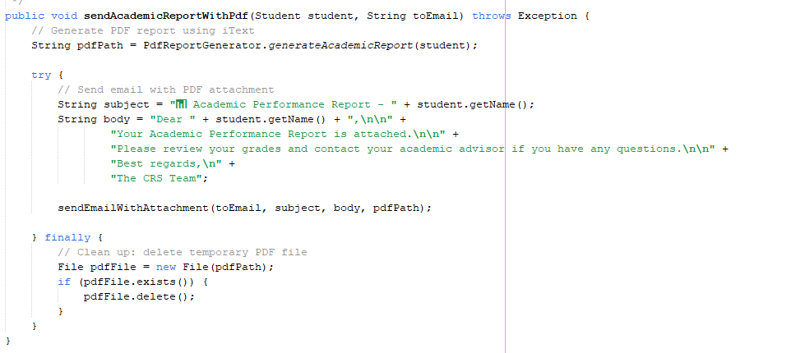

Code | Snippet
Student Selection For Course Recovery | 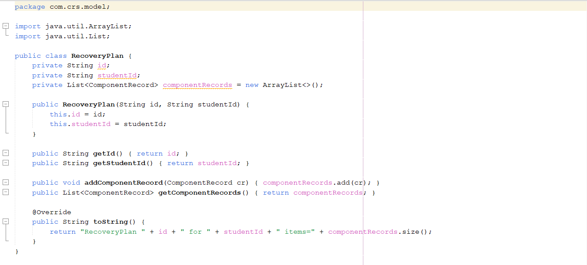
Failed Components And Recovery Status Listing | 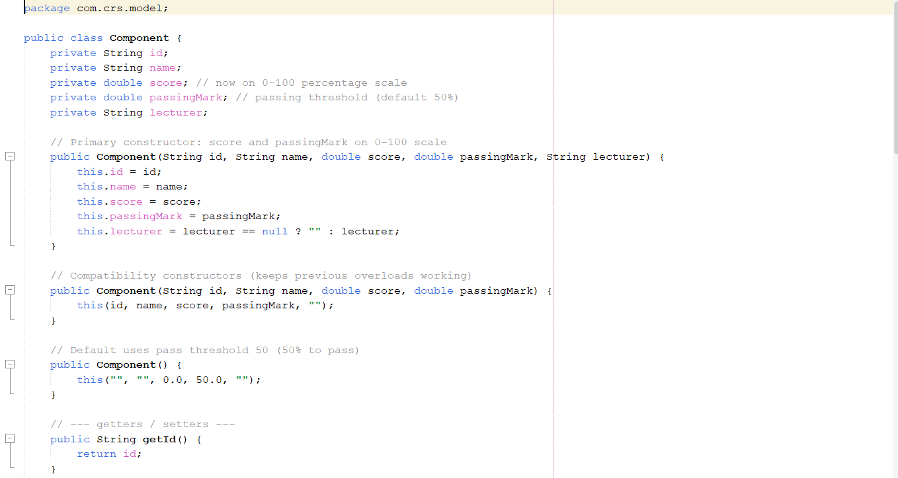
Recovery Attempts and Eligibility Rules | 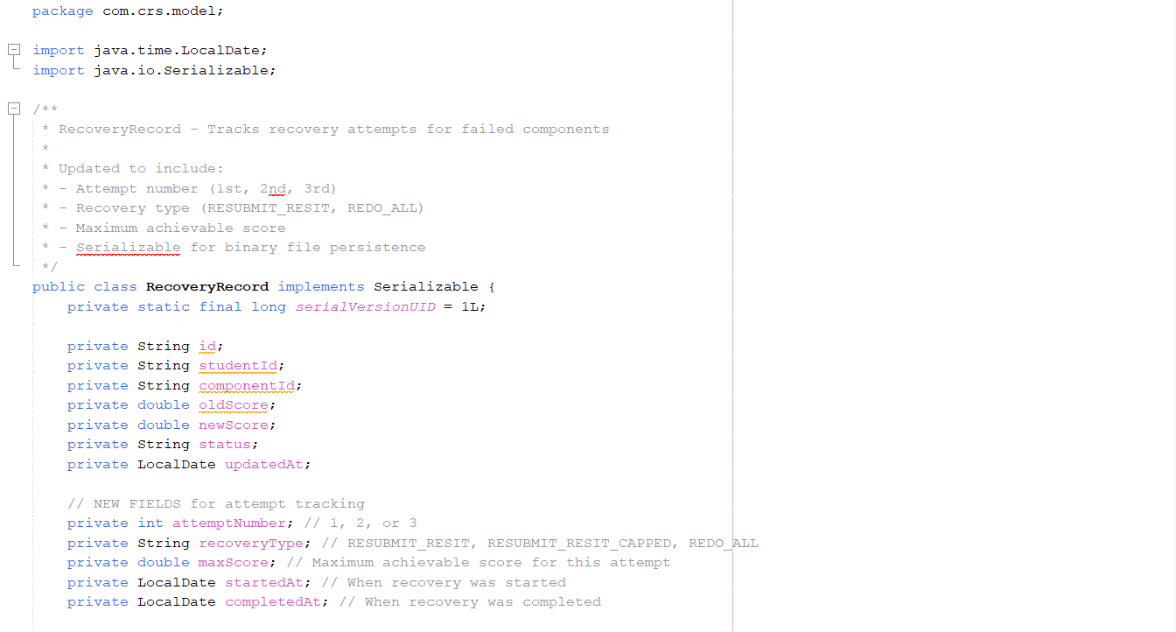
Starting/Completing a Recovery Attempt
Notifying Student Of Recovery Status | 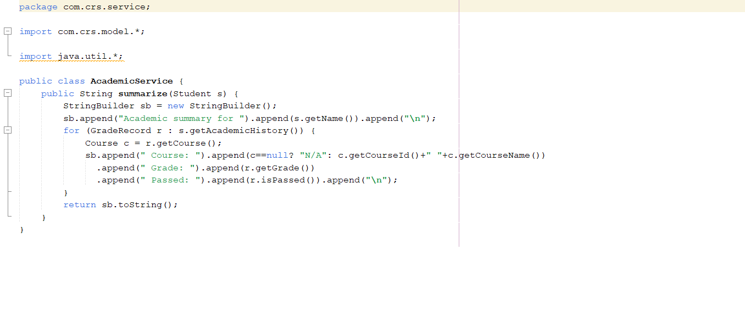
Generated Recovery Plain PDF | 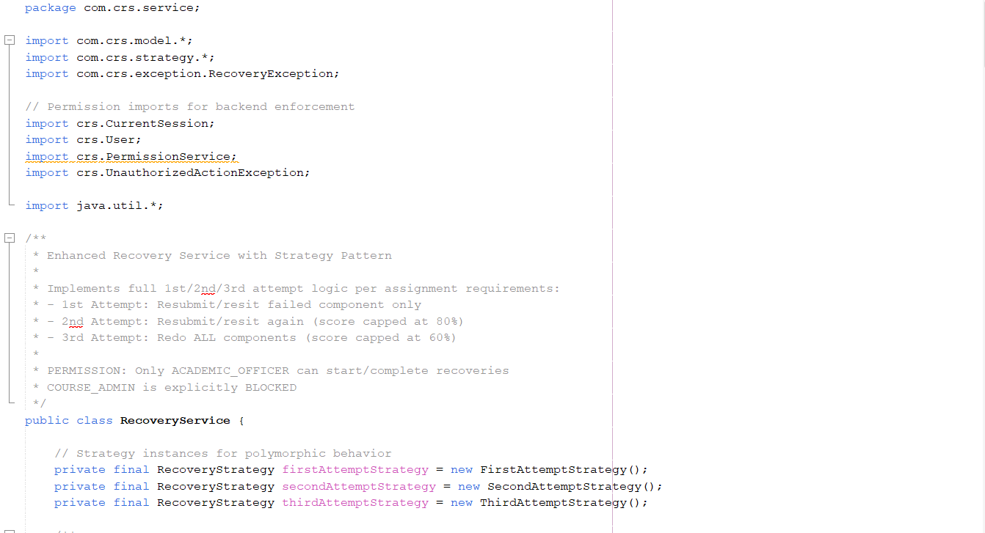

code | snippet
Main Dashboard | 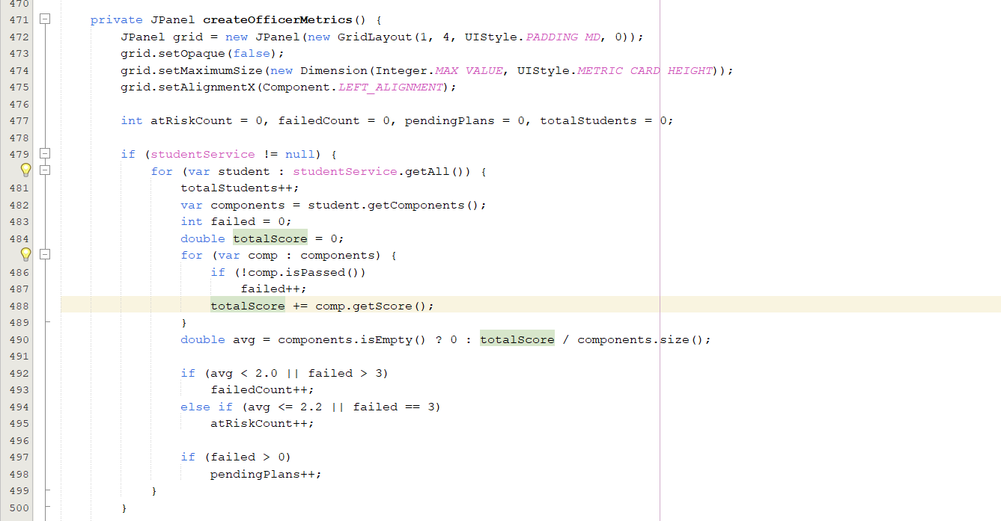  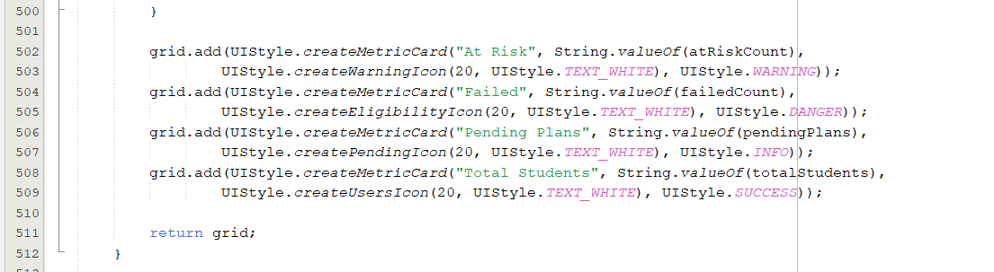
Detailed Eligibility | 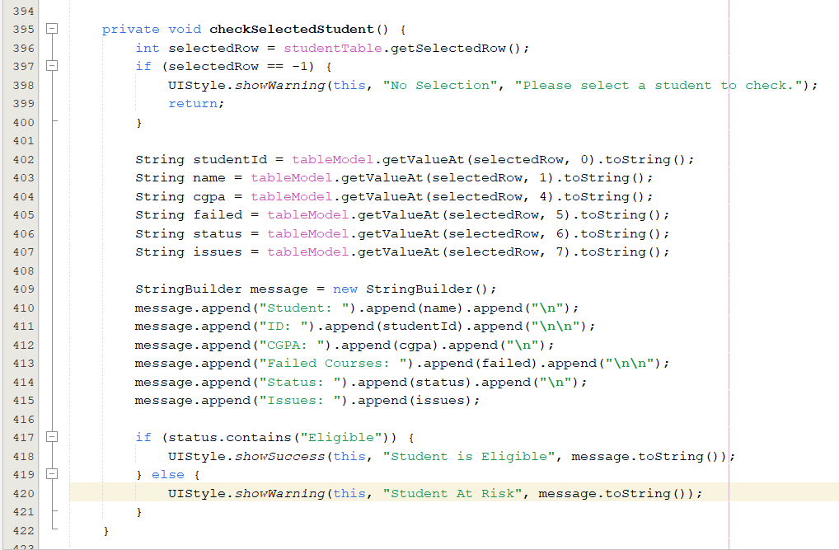  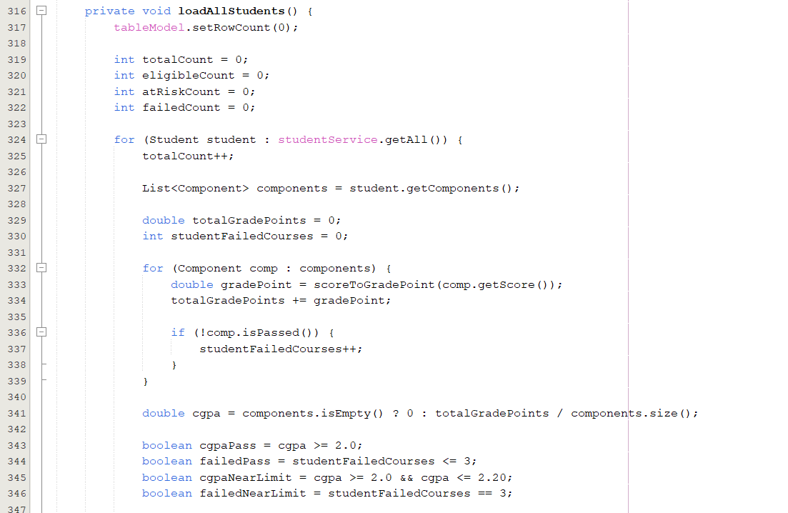  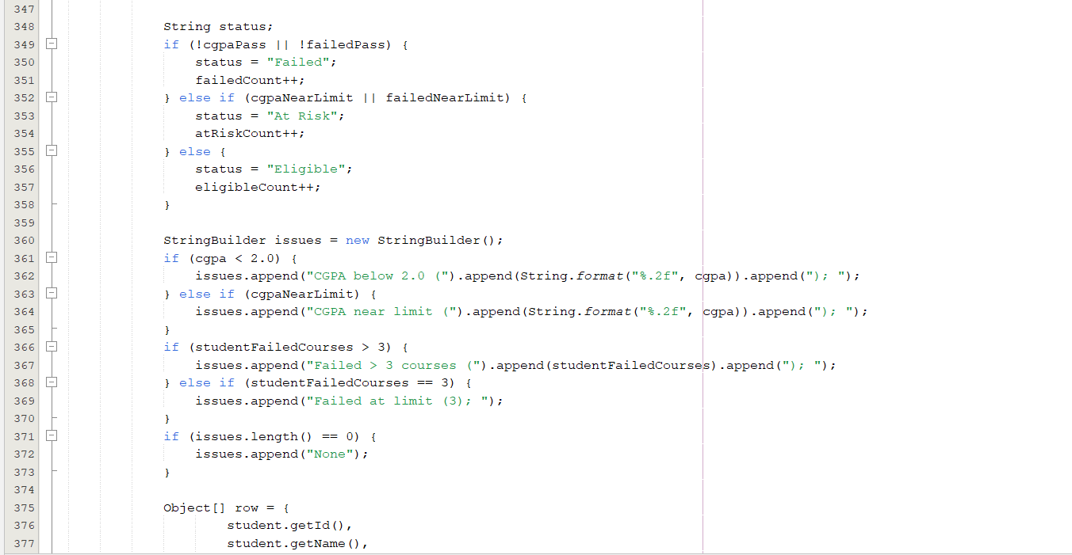  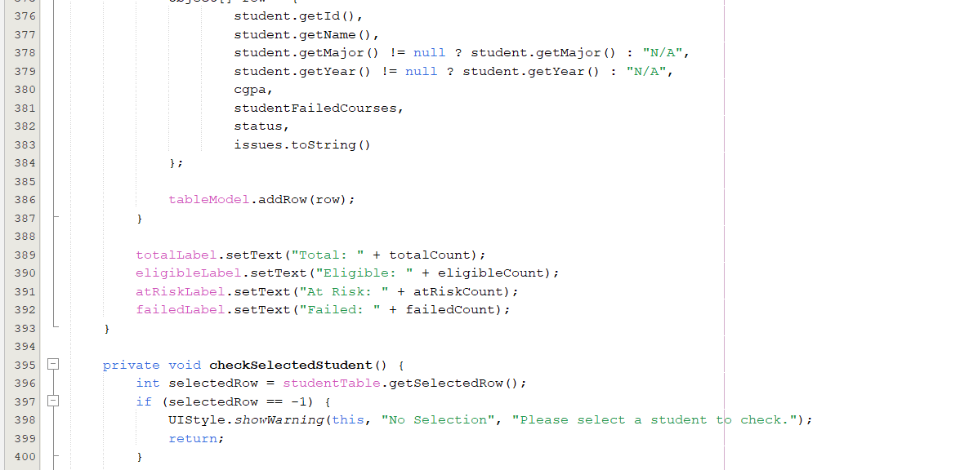
Notification sent confirmation | 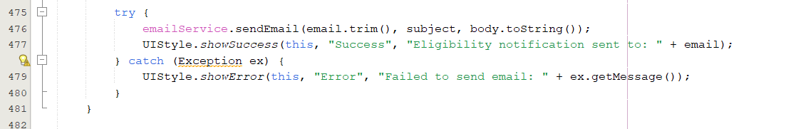
Email inbox | 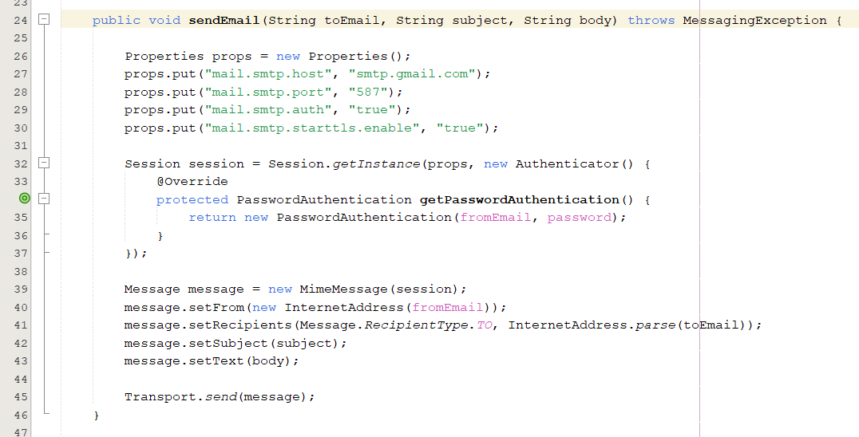

Code | Snippet
Academic Performance Report Interface | 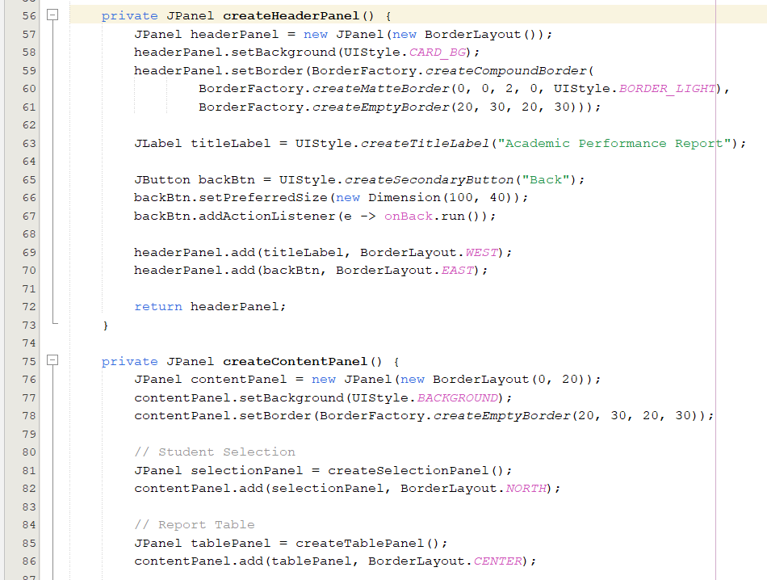  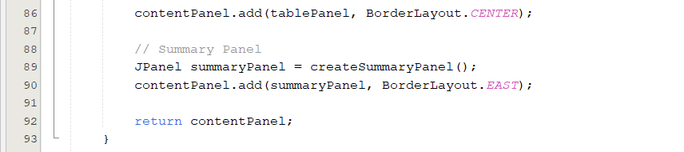
Student Selection for Academic Report Generation | 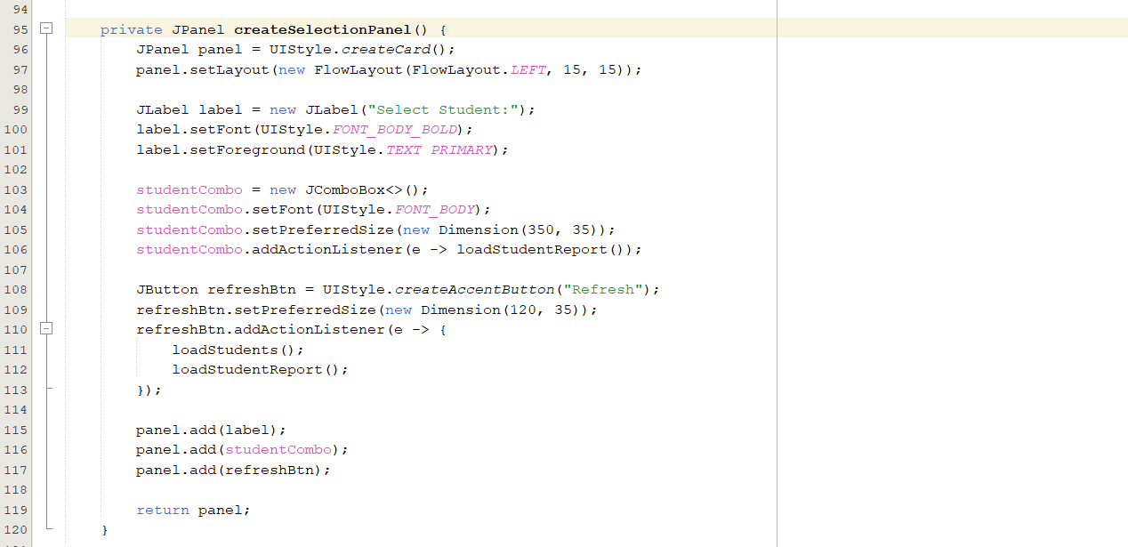
Loaded course performance and GPA Summary | 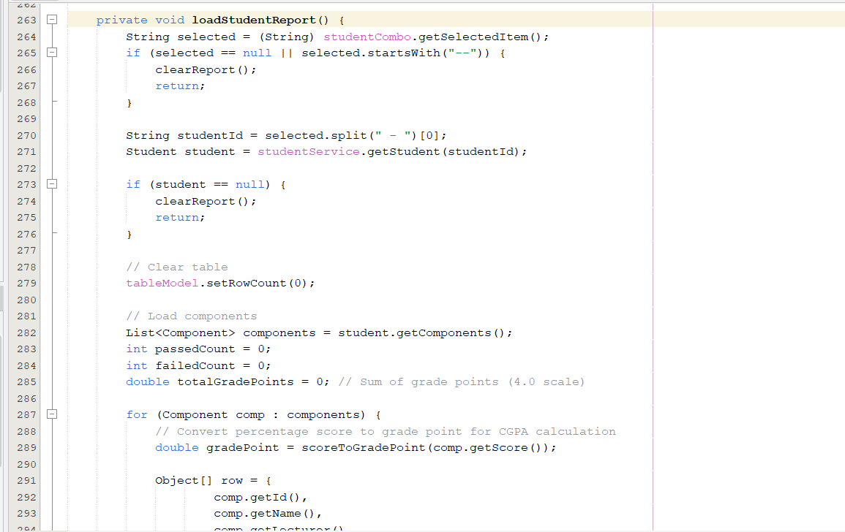  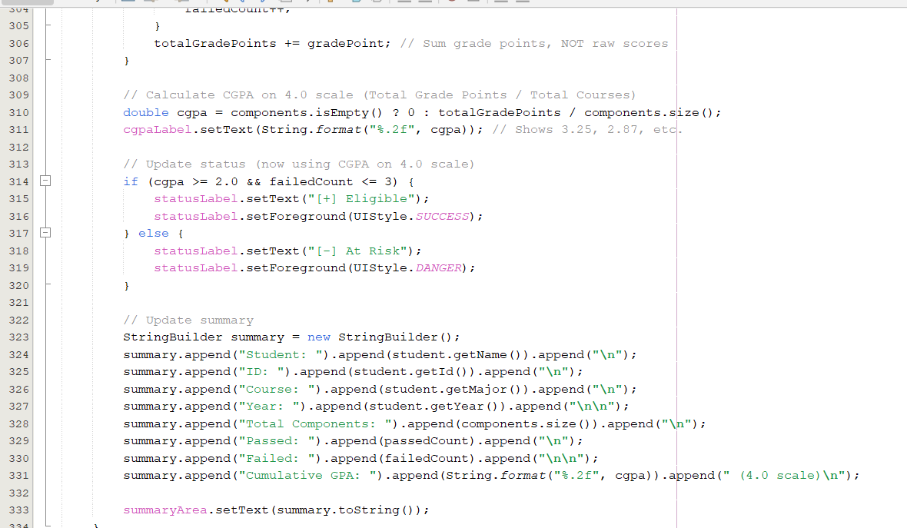
Email Academic Report (PDF) | 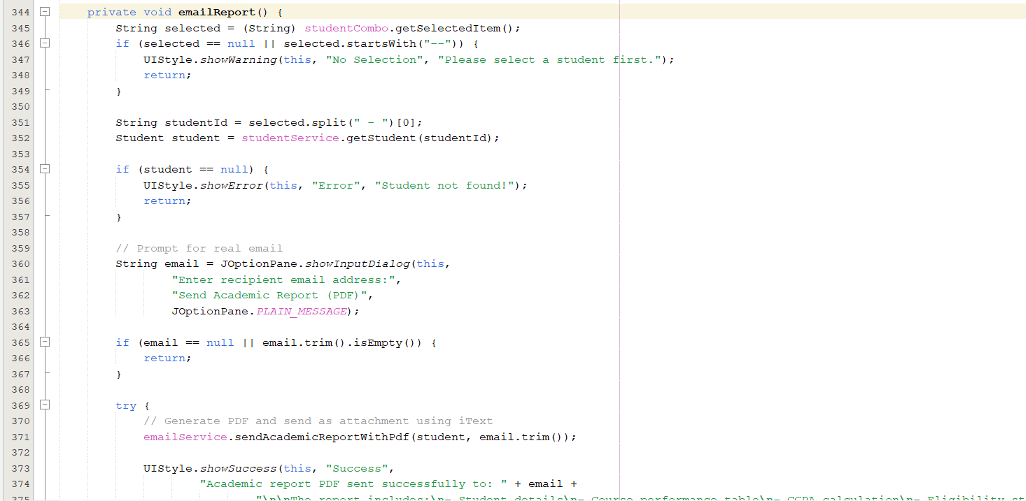  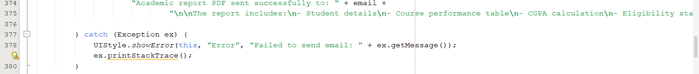
Generated Academic Performance Report(PDF View) | 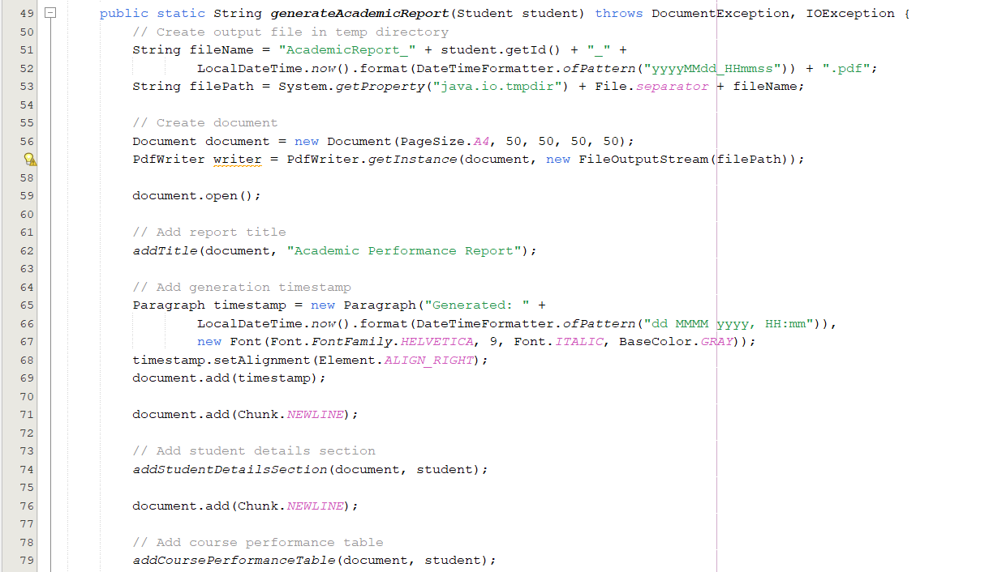  
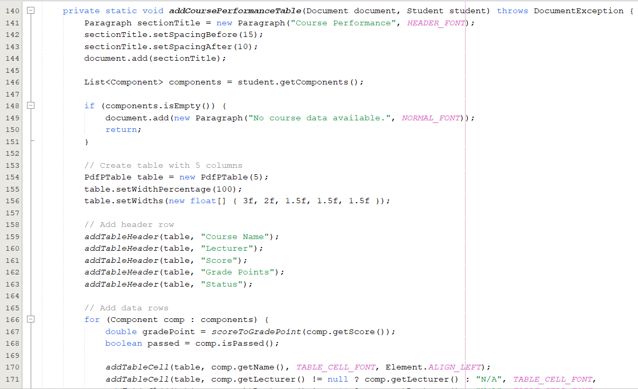
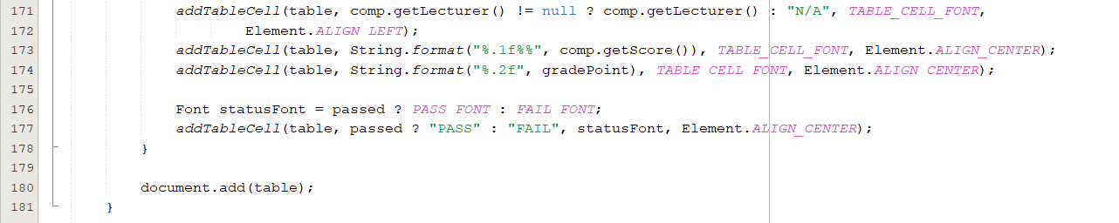

Console-Based Academic Report Output | 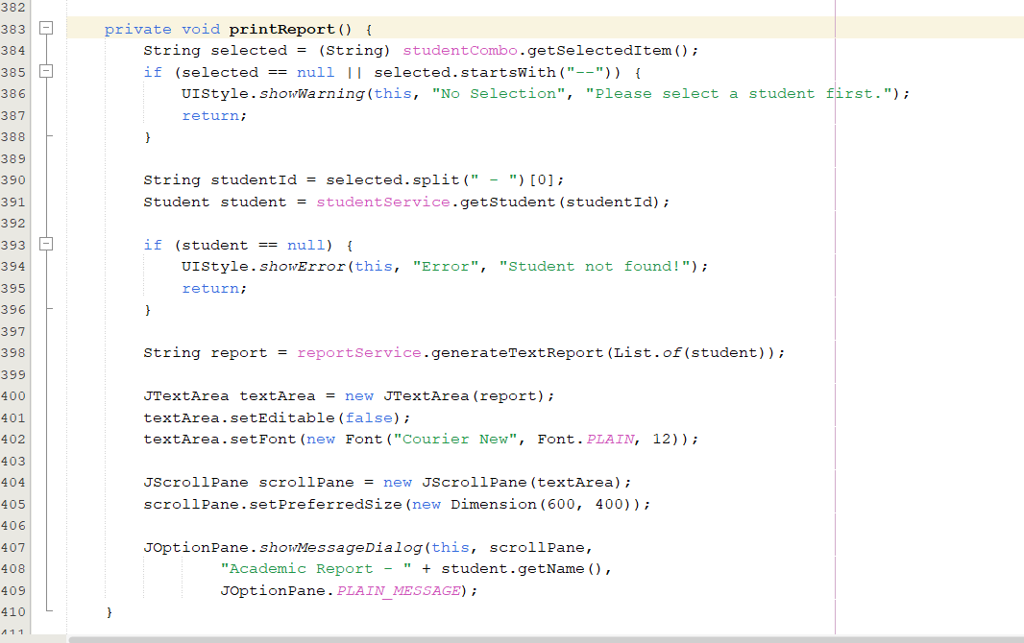
Generate text Report | 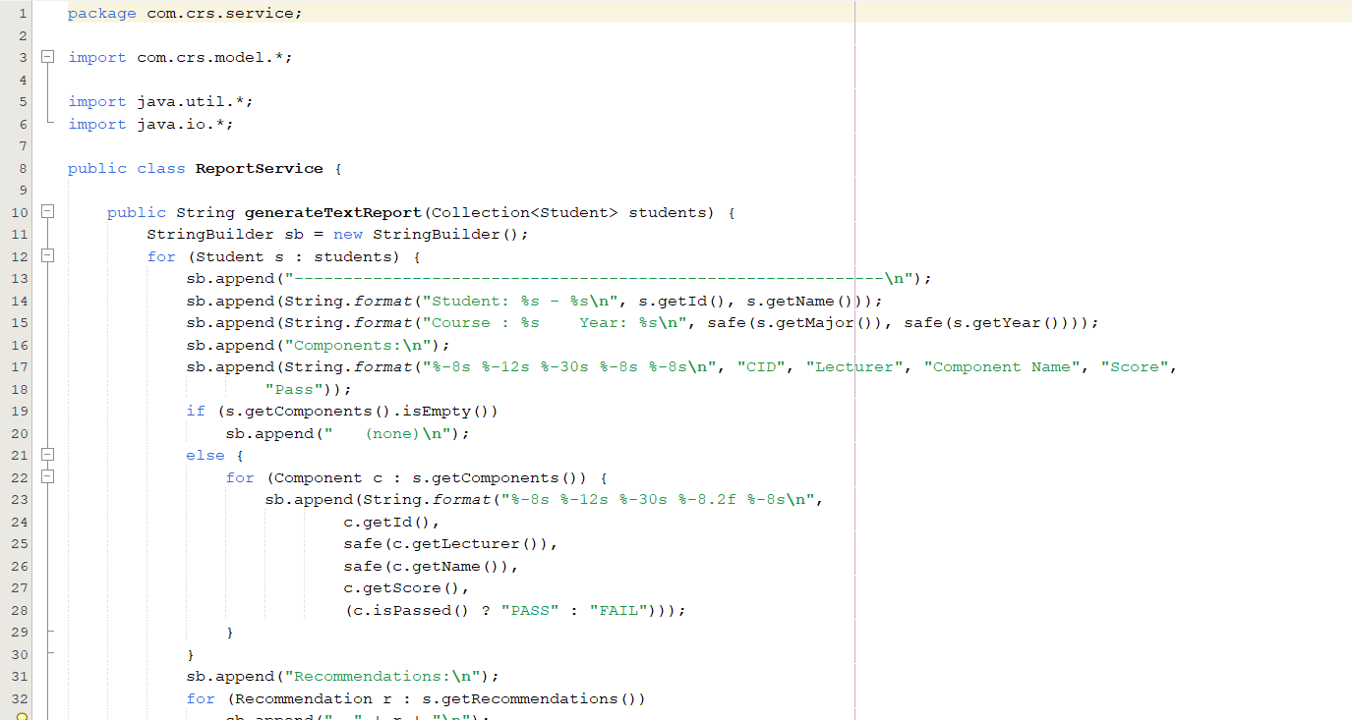  

8.2 Workload Matrix
Name | TP number | Task Divison | Total Contribution
Nazeer Fathima Akla | TP084989 | - User Management + Email API code and documentation  - Extra Features documentation  - Design | 100%
Youssef Ahmed Said Ahmed Ghazy | TP084982 | - Eligibility Checker + Academic Performance Reporting  code and documentation  - Introduction  - Design | 100%
Hazaa Salem Mubarak Obeid Awadh | TP083920 | - Core Course Recovery System code and documentation  - Conclusion  - Design | 100%

8.3 References:
GeeksforGeeks. (2019, February 14). Java programming basics. GeeksforGeeks.
https://www.geeksforgeeks.org/java/java-programming-basics/

Java Programs source code (Example) | Treehouse Community. (2015, November 16). Treehouse.
https://teamtreehouse.com/community/java-programs-source-code

Modern Operating Systems. (2022). Www.pearson.com.
https://www.pearson.com/en-us/subject-catalog/p/modern-operating-systems/P200000003295/9780137618880

Oracle Corporation. (2023). JavaMail API documentation.
https://www.oracle.com/java/technologies/javamail-api.html

Oracle Corporation. (2024). Java SE documentation.
https://docs.oracle.com/en/java/javase/

‌

